Industrial-scale nonmetal current collectors designed to regulate heat transfer and enhance battery safety
Lun Li^{1,6}, Jinlong Yang*^{2,6}, Rui Tan^{3,6}, Wei Shu^{1,2,6}, CheeTong John Low³, Zixin Zhang¹, Yu Zhao¹, Cheng Li⁵, Yajun Zhang⁵, Xingchuan Li¹, Huazhang Zhang⁴, Xin Zhao⁴, Zongkui Kou¹, Yong Xiao¹, Francis Verpoort¹, Hewu Wang⁵, Liqiang Mai*¹, Daping He*^{1,4}
¹ State Key Laboratory of Advanced Technology for Materials Synthesis and Processing, State Key Laboratory of Silicate Materials for Architectures, School of Materials Science and Engineering, Wuhan University of Technology, Wuhan 430070, China
² Guangdong Research Center for Interfacial Engineering of Functional Materials, College of Materials Science and Engineering, Shenzhen University, Shenzhen 518060, China
³ Warwick Electrochemical Engineering Group, WMG, Energy Innovation Centre, University of Warwick, Warwick, CV4 7AL U
⁴ Hubei Engineering Research Center of RF-Microwave Technology and Application, School of Science, Wuhan University of Technology, Wuhan 430070, China
⁵ School of Vehicle and Mobility, Tsinghua University, Beijing 100084, China
⁶ These authors contributed equally: Lun Li, Jinlong Yang, Rui Tan, Wei Shu

*Corresponding authors: Jinglong Yang (yangjl18@szu.edu.cn), Liqiang Mai (mlq518@whut.edu.cn), Daping He (hedaping@whut.edu.cn)

Supplementary Fig. S1. Industrial fabrication of the large-area Gr using GO+3%PEA precursor. a, Coating. b, Drying. c, Dry precursor film. d, Cutting. e, Annealing, f, Rolling Compression.

Supplementary Fig. S2. Photo of the large-sized GO film (roll-type) at hundreds-meter level.
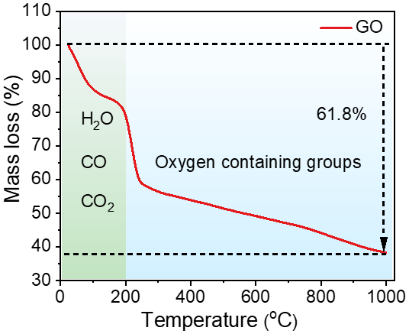
Supplementary Fig. S3. TGA curves of the GO films under Ar atmosphere by heating to 1000 ºC at a rate of 10 ºC min⁻¹. Fig. S3 shows the TGA curves of GO films, all processes were conducted in Ar atmosphere. The mass loss was 21.1% at 200 ºC, which associates with the removal of intercalated water and release of CO and CO₂. After 200 ºC, GO underwent a carbonization process with the loss of oxygen-based groups indicated by a reduced mass of 40.7% between 200 and 1000 ºC. Finally, the total mass loss is 61.8% in the whole process.
Supplementary Fig. S4. FTIR spectra of GO, C film, Gr film, and Gr foil³¹.

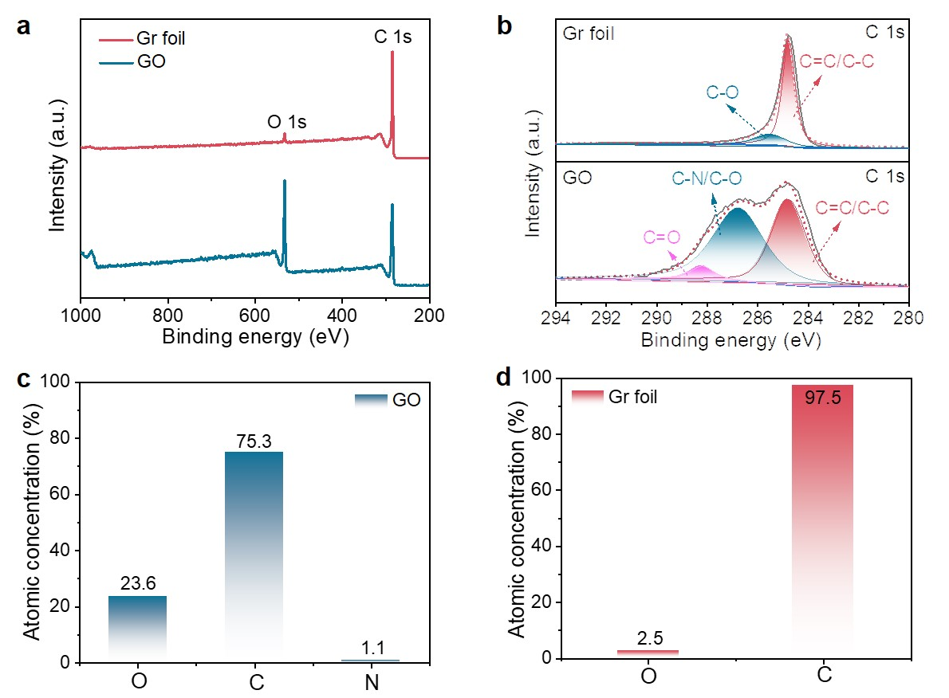
Supplementary Fig. S5. XPS characterization of GO film and Gr foil. a, XPS full spectra of GO film and Gr foil. b, Binding energy at C 1s regions of GO film and Gr foil. c, d, Elemental analysis: atomic ratio of O, C, and N of (c) GO and (d) Gr foil.
Supplementary Fig. S6. The uniformity of meter-scale Gr foil. a, Sampling location of Gr foil for the uniformity testing of thickness, electrical, and thermal conductivity. b, Testing samples for thermal conductivity and thickness. c, Stable measurement results of thickness.

Supplementary Table S1. Uniformity of synthesized Gr foil materials.
Sample | Thickness (µm) | Resistance (mΩ) | Electrical conductivity (S m⁻¹) | thermal diffusivity (mm² s⁻¹) | Thermal conductivity  (W m⁻¹ K⁻¹)
#1 | 17 | 44.7 | 1.32×10⁶ | 819.2 | 1409.0
#2 | 17 | 44.9 | 1.31×10⁶ | 817.6 | 1406.3
#3 | 17 | 44.8 | 1.31×10⁶ | 808.8 | 1391.1
#4 | 18 | 43.8 | 1.27×10⁶ | 821.3 | 1412.6
#5 | 17 | 45.0 | 1.31×10⁶ | 807.0 | 1388.0
#6 | 17 | 43.8 | 1.34×10⁶ | 810.2 | 1393.5
#7 | 17 | 44.5 | 1.32×10⁶ | 810.9 | 1394.7
#8 | 17 | 44.9 | 1.31×10⁶ | 820.4 | 1411.1
#9 | 17 | 45.3 | 1.30×10⁶ | 809.6 | 1392.5
#10 | 17 | 44.6 | 1.32×10⁶ | 819.0 | 1408.7
Results in Supplementary Table S1 show that the Gr foil has a constant thickness of 17 ± 1 µm, a sheet resistance of 44.6 ± 0.8 mΩ, an electrical conductivity of (1.31 ± 0.03)×10⁶ S m⁻¹, an thermal diffusivity of (814 ± 7.2) mm² s⁻¹, an thermal conductivity of (1400.3 ± 12.3) W m⁻¹ K⁻¹, and an tensile strength of , demonstrating that Gr foil has a high consistency and uniformity.

Supplementary Table S2. Physical properties of different materials.
Materials | Thickness  (μm) | Density  (g cm⁻³) | Specific heat capacity  (J/g⁻¹ K⁻¹) | Thermal diffusivity  (mm² s⁻¹) | Thermal conductivity  (W m⁻¹ K⁻¹)
C film | 78 | 0.27 | 0.80 | 70.6 | 15.3
Gr film | 174 | 0.29 | 0.80 | 558.7 | 129.6
Gr foil | 17 | 2.15 | 0.80 | 814.4 | 1400.8
Al foil | 12 | 2.70 | 0.88 | 69.9 | 166.1
Cu foil | 8 | 8.90 | 0.39 | 54.1 | 187.8

Supplementary Table S3. Pouch cell-level Al/NCM811||graphite/Cu parameters.
Al||Cu pouch cell
Cathode CC | Al (12 µm) | Anode CC | Cu (8 µm)
Cathode | NCM811 | Anode | Graphite
S.C. mAh/g | 200 | S.C. mAh/g | 340
Loading | 94% | Loading | 95.2%
Conductor | 2%sp+2%ks-6 | Conductor | 1%SP
Binder | 2%-PVDF | Binder | 1.5%CMC+2.3%SBR
C.W. (mg cm⁻²) | 17.2 | C.W. (mg cm⁻²) | 10.5
P.D. (g/cc) | 3.40 | P.D. | 1.55
Electrolyte | C004
Separator | PP (20 µm)
Cell Balance | 1.05

Supplementary Table S4. Pouch cell-level Gr/NCM811||Graphite/Gr parameters.
Gr||Gr pouch cell
Cathode CC | Gr foil (17 µm) | Anode CC | Gr (17 µm)
Cathode | NCM811 | Anode | Graphite
S.C. mAh/g | 200 | S.C. mAh/g | 340
Loading | 94% | Loading | 95.2%
Conductor | 2%sp+2%ks-6 | Conductor | 1%SP
Binder | 2%-PVDF | Binder | 1.5%CMC+2.3%SBR
C.W. (mg cm⁻²) | 17.2 | C.W. (mg cm⁻²) | 10.5
P.D. (g/cc) | 3.40 | P.D. (g/cc) | 1.55
Electrolyte | C004
Separator | PP (20 µm)
Cell Balance | 1.05

Supplementary Fig. S7. Fitting of the 2D band in Raman maps. The 3 peaks include two Lorentzian curves for AB stacked graphite (2D₁ and 2D₂) as shown in the fitted spectrum and one for turbostratic stacking (2D_{T}). The degree of AB stacking quantified by I(2D₂) / I(2D₂ + 2D_{T}) is around 85.7%.

Supplementary Fig. S8. TEM characterization of Gr nanosheets. a, TEM image of Gr nanosheets. b, Corresponding SAED pattern.

Supplementary Fig. S9. Comparison of mechanical properties of Gr foil with those reported in the literatures.

Supplementary Fig. S10. Infrared thermal photos. a, Thermal imaging images of Gr, Al, and Cu foil. b, Thermal imaging images of Cu/graphite, Gr/graphite, Gr/NCM811, and Al/NCM811 electrodes.

Supplementary Fig. S11. Cooling of pouch cells based on different CCs after removal from the hot table of 60 ºC to the open air.

Supplementary Fig. S12. Welding Gr CCs with Al and Cu tabs by an improved pulse resistance welding. a, Welded positive and negative electrodes. b, Solder joint between Al tabs and Gr foil. c, Solder joint between Cu tabs and Gr foil. d, Resistance of the multimeter when it is not loaded. e, Resistance of solder joint between Al tabs and Al foil. f, Resistance of solder joint between Al tabs and Gr foil. g, Resistance of solder joint between Cu tabs and Cu foil. h, Resistance of solder joint between Cu tabs and Gr foil. Our Gr CCs can be well welded with Al and Cu tabs by an improved pulse resistance welding method (Supplementary Fig. S12a-c). The resistance of solder joint between Gr CCs and metal tabs is not far different from that between metal CCs and metal tabs (Supplementary Fig. S12d-h).
Supplementary Fig. S13. Mechanical properties of tabs welded to pouch cells with Gr foil. a, Stress-offset curves of Gr foil. b, Photo after pulling apart the metal tabs with the CCs. The tensile strength of the solder joint can reach up to 101.3MPa, and the breakage appears on the Gr CCs, while the solder joint can still maintain a solid connection between the metal tab and Gr CCs, suggesting a reliable solidity of the weld.

Supplementary Fig. S14. Charge/discharge curves of the full cells fabricated using conventional Al/Cu CCs and Gr CCs. a, b, Galvanostatic charge (0.1 C)–discharge (0.1-3 C) voltage profiles of the (a) Gr||Gr and (b) Al||Cu full cells between 3.0 and 4.25 V.
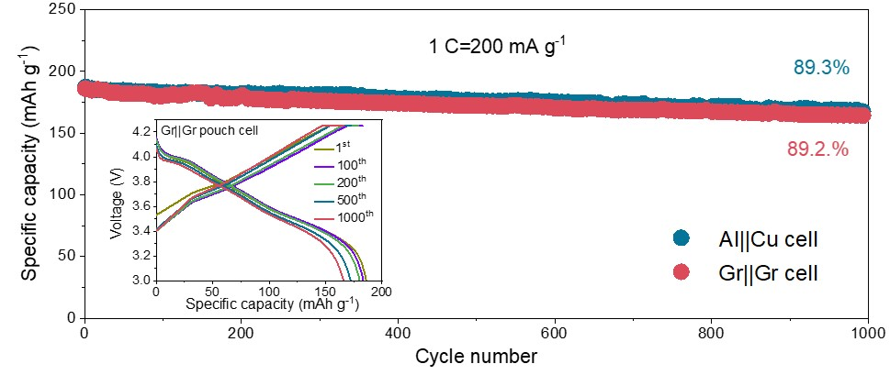
Supplementary Fig. S15. Cycling stability of the full cells. Discharge capacities of Al||Cu and Gr||Gr full cells at 1 C (200 mA g⁻¹) within 1000 cycles. Inset: Galvanostatic charging/discharging Curves of Gr||Gr full cell.
Supplementary Fig. S16. Interface characterization between electrode materials and CCs. a, b, Contact angels of NCM811 slurry on (a) Al foil and (b) Gr foil. c, d, Cross-sectional SEM images of the interface between (c) Cu-graphite and (d) Gr-graphite. We first investigated the interface between CCs and active materials. The Gr/NCM811 interface exhibited a smaller contact angle of 34.0° compared to that of Al/NCM811 (43.7°) (Supplementary Fig. S16a, b). Similarly, the SEM images reveal an almost seamless interface for Gr/graphite, distinctively different from that of Cu/graphite which shows an obvious separation (Supplementary Fig. S16c, d). These results collaboratively indicate a tight interfacial contact between Gr CC and the electrode material, resulting in a lower internal contact resistance.

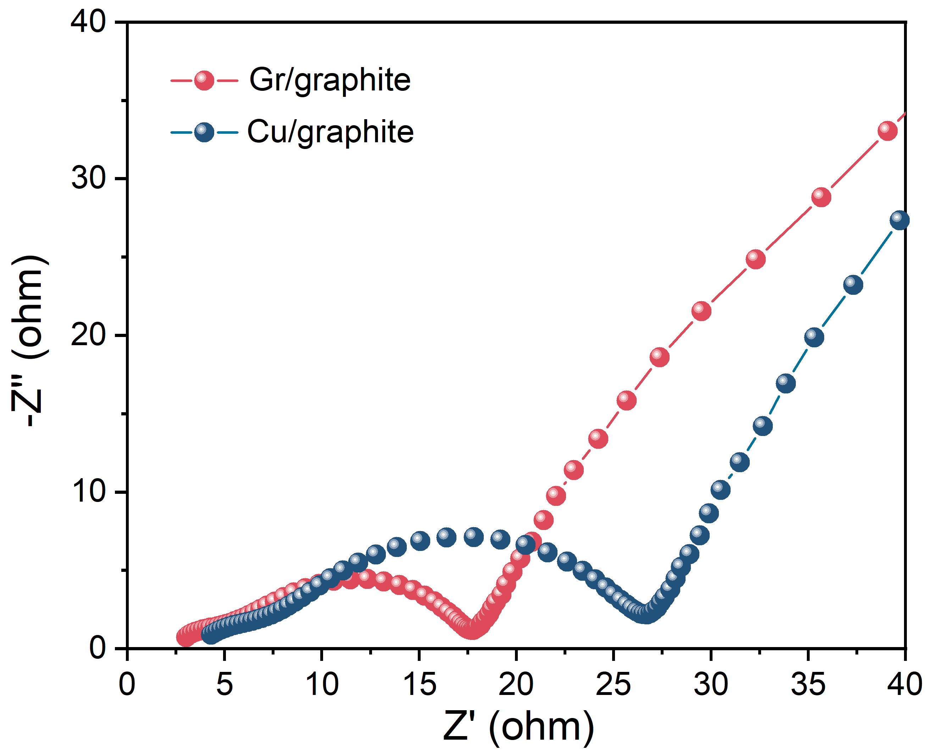
Supplementary Fig. S17. Electrochemical impedance spectra of graphite anode on Cu and Gr CCs.

Supplementary Fig. S18. Temperature distribution of Al||Cu and Gr||Gr pouch cells at fast charging and discharging (4 C). a, b, Temperature evaluation of Al||Cu cells from (a) charging process: stages Ⅱ to Ⅴ and (b) discharging process: stages Ⅵ to Ⅸ. c, d, Temperature evaluation of Gr||Gr cells from (c) charging process: stages Ⅱ to Ⅴ and (d) discharging process: stages Ⅵ to Ⅸ.
Supplementary Fig. S19. Temperature maps of 2.0 Ah pouch cells at fast charging and discharging (4 C). a, b, Thermal imaging images of Al||Cu and Gr||Gr cells at (a) stages Ⅳ and (b) Ⅸ, respectively. c, d, Temperature evaluation of Al||Cu and Gr||Gr cells at (c) stages Ⅳ and (d) Ⅸ from cathode to anode.
Supplementary Fig. S20. COMSOL simulation. a, Theoretical model of thermal generation and diffusion. b, c, COMSOL simulated heat distribution for (a) Al||Cu and (b) Gr||Gr cells.
The heat conduction process inside the battery is controlled by the energy conservation law (Eq.1) and the Fourier’s law (Eq.2).

$0=-∇⋅q+Q_{V}$ (1)
$q=-κ∇T$ (2)
In the above two equations, $T$ is the temperature, $q$ is the heat flux, $Q_{V}$ is the power density of the battery heat generation (including the battery reaction heat generation, and the Joule heat of the positive and negative terminals), and $κ$ is the thermal conductivity of the materials.
On the surface of the battery, the heat exchange with environment includes the contributions of heat convection and heat radiation. Therefore,
$q⋅n=q_{c}+q_{r}$ (3)
where $n$ is the unit vector pointing out of the surface, and are the fluxes for heat convection and heat radiation, respectively. We use the Newton’s law of cooling to calculate the flux of the heat convection
$q_{c}=h\left(T-T_{\text{amb}}\right)$ (4)
and the Stefan-Boltzmann equation for the heat radiation
$q_{r}=εσ\left(T^{4}-T_{\text{amb}}^{4}\right)$ (5)
whereis the ambient temperature,natural convection heat transfer coefficient of air,is the material surface emissivity, and$σ=5.67037×10^{-8}\text{ W/}\left(m^{2}⋅K^{4}\right)$ is the Stefan-Boltzmann constant.

Supplementary Fig. S21. Galvanostatic charge voltage profiles of the Al||Cu and Gr||Gr pouch cells at 0.05 C before nail penetration. Prior to nail penetration, all pouch cells with capacity of 2.0 Ah were fully charged at 0.05 C with 100% state of charge.

Supplementary Fig. S22. Trigger equipment of pouch cells during TR. a, Sealed chamber. b, The installation of pouch cells inside.
Supplementary Fig. S23. Total gas content for each type of pouch cell.

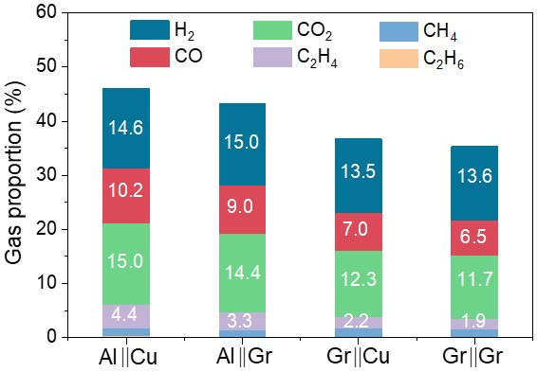
Supplementary Fig. S24. Various gas proportion of four types of pouch cells: Al||Cu cell, Al||Gr cell, Gr||Cu cell and Gr||Gr cell.

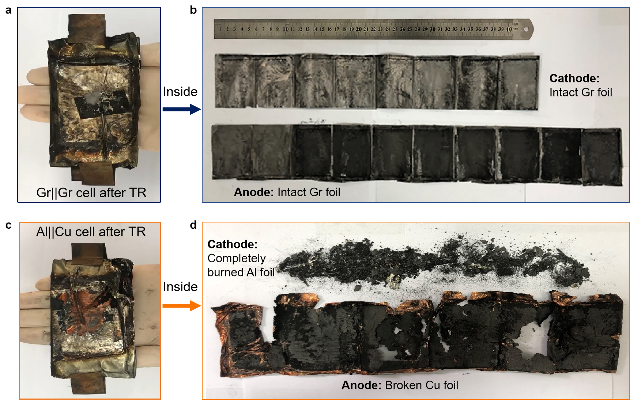
Supplementary Fig. S25. Burned Al||Cu and Gr||Gr pouch cells after TR. a, b, Appearance and corresponding wrecks of the unfold rolled electrodes inside Gr||Gr pouch cells. c, d, Appearance and the corresponding wrecks of the rolled electrodes inside Al||Cu pouch cells.

Supplementary Fig. S26. DSC and TG profiles of Al and Cu foil.

Supplementary Fig. S27. Ignition heating process of a Cu foil.
Supplementary Fig. S28. Structure and phase changes of Al foil after a high-temperature treatment. a, SEM images of pristine Al foil. b-d, Al foil after heating at 700, 750, and 800 ºC. Insets are the appearance of pristine Al foil, heated Al foil at 700, 750, and 800 ºC. e, XRD patterns of the heated Al foil at 700, 750, and 800 ºC.

Supplementary Fig. S29. Ignition heating process of an Al foil.
Supplementary Fig. S30. Structure and phase changes of Al/NCM811 electrodes after a high- temperature treatment. a, Al/NCM811 electrodes before and after heating at 700 ºC, 750 ºC, and 800 ºC. b, XRD patterns of the heated Al/NCM811 electrodes at 700, 750, and 800 ºC.

Supplementary Fig. S31. XRD patterns of Al/NCM811 cathode after a thermal treatment at 800 ºC and the detached electrode materials in Al||Cu pouch cell after TR. As observed from Supplementary Fig. S34, the integrity of Al/NCM811 cathode was broken and discontinuous fragments were formed after heating at 750 ºC. As shown in Supplementary Fig. S36, the Al, Ni and NiO were detected in the residuals, which are the results of the decomposition of NCM811. However, the large amount of metallic Ni and almost no Al/NiO phase was undesirably detected in the failed Al||Cu pouch cell after TR, indicating the involvement of Al and NiO in the chemical reaction. As a result, we assumed that metallic Al has high activity after melting at high temperature and is prone to aluminothermic reactions which is described as 2Al + 3MO→3 M+ Al₂O₃ (M=Ni/Co/Mn) where the reaction of 2Al + 3NiO→3 Ni+ Al₂O₃ dominates. This process is accompanied by large amounts of generated heat and thus making the TR more violent and explosive. On the other hand, the electrolyte decomposition includes a series of gases consisting of H₂, HF, CO, CO₂, C₂H₄ et al. HF is easily to react with the highly reactive Al, generating more H₂ by hydrogen evolution reaction (2Al + 6HF →2AlF₃ + 3H₂↑), as further confirmed by the results of the gas analysis in the above battery TR experiments. Generated H₂ and HF also participated in other dramatic and dangerous chemical rations, NiO+H₂ → Ni + H₂O and Al₂O₃ + 6HF → 3H₂O↑+2AlF₃.

Supplementary Fig. S32. Characterization of Gr after TR. a, XRD patterns. b, Raman spectrum of Gr foil after TR.

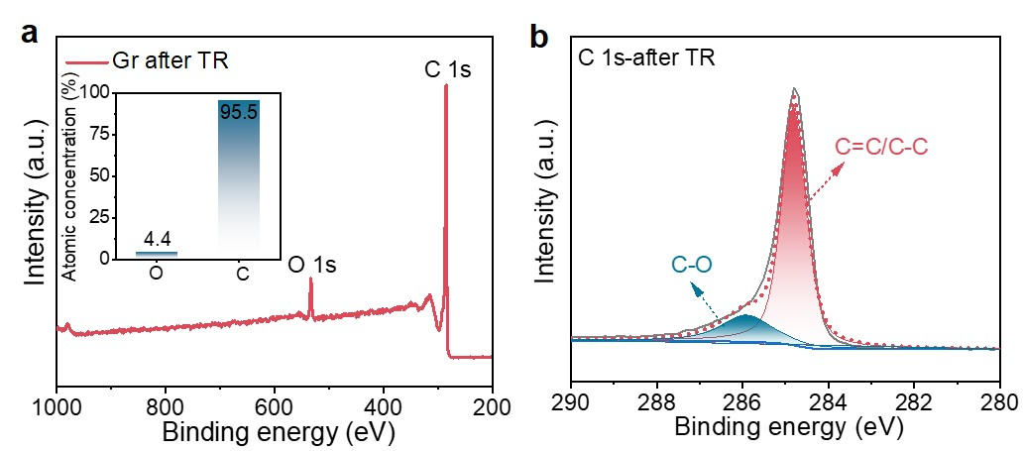
Supplementary Fig. S33. Characterization of Gr foil after TR. a, XPS full spectra Gr foil after TR. Inset is the elemental analysis: atomic ratio of O and C. b, XPS spectrum from the C 1s region of Gr after TR.

Supplementary Fig. S34. Photos of Gr foil after high temperature (700, 750, and 800 ºC). Gr foil can well keep its excellent flexibility and morphology integrity after heating at 700, 750, and 800 ºC.
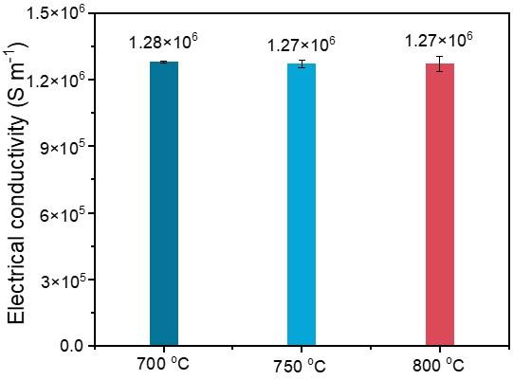
Supplementary Fig. S35. Electronic conductivities of Gr foil after high-temperature treatments at 700, 750, and 800 ºC in air, respectively. Gr foil can well keep its superior electrical conductivity after heating at 700, 750, and 800 ºC.

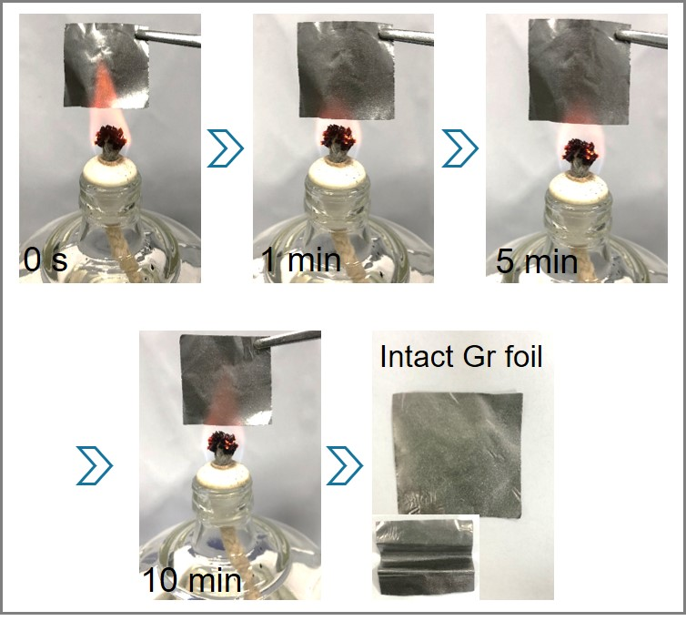
Supplementary Fig. S36. Ignition heating process of Gr foil. Exposed to flame, Al foil immediately burned to efflorescence and destroyed to a porous structure within 30 s. Cu foil was oxidized in 3 s and rapidly spread over the entire surface. By comparison, the Gr foil can maintain the original state throughout the whole igniting process. Moreover, the Gr foil keeps its excellent flexibility and morphology integrity in flame over 10 mins.
Supplementary Fig. S37. Characterization of Gr foil after TR. a, Surface SEM images. b, Cross-sectional images of Gr foil after TR. Even after TR, the surface morphology and cross-sectional microstructure remained as their original states. Therefore, Gr foil served as CCs can be recycled and reused although the battery is dead, conforming to eco-friendly and low-cost energy strategy.
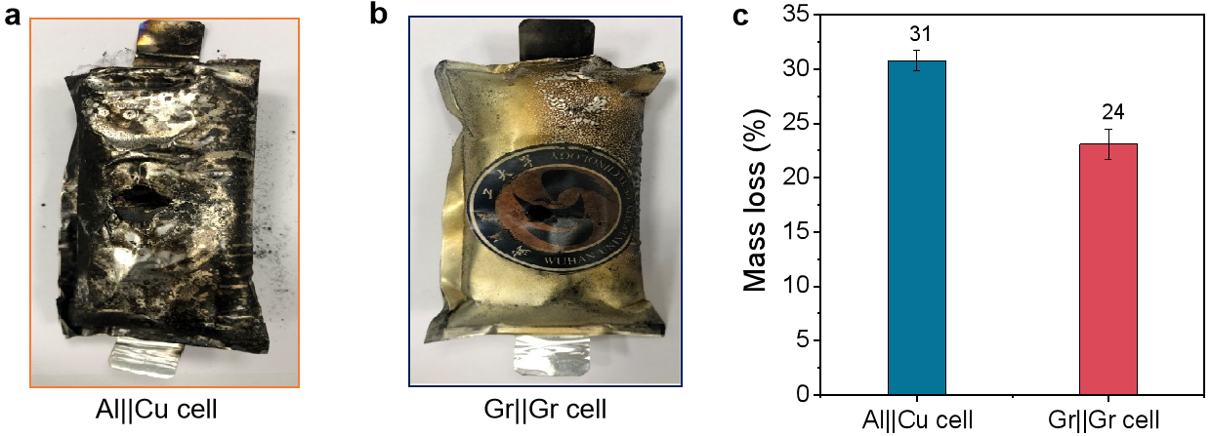
Supplementary Fig. S38. Comparison of the two batteries after nail penetration. a, b, Destroyed (a) Al||Cu and (b) Gr||Gr pouch cells after nail penetration. c, Mass loss of different pouch cells after nail penetration. After the nail penetration process, the Al||Cu cell (Supplementary Fig. S38a) is more severely damaged than the Gr||Gr pouch cell due to the fast exothermic aluminothermic and hydrogen-evolution reactions (Supplementary Fig. S38b). The mass loss of Gr||Gr pouch cells with Gr CCs is 24% after nail penetration (Supplementary Fig. S38c), while, that of Al||Cu cells is increased to 31%, implying a more violent thermal runaway in Al||Cu battery.

Supplementary Fig. S39. Time-resolved phase-field simulations of thermal dispersion for pouch cells with Al||Cu CCs and Gr||Gr CCs, respectively.

Finite element transient calculation is used to simulate the dynamic temperature change with time.
The heat conduction process inside the battery is controlled by the thermal conductivity differential Eq.6
$ρc\frac{∂T}{∂t}=-∇⋅q+Q_{V}$, (6)
and the Fourier’s law
$q=-κ∇T$. (7)
In the above two equations, q is the heat flux, $Q_{V}$is the volume heat source, T is the temperature, is the material density, c is the specific heat capacity, and the is the thermal conductivity.
The material volume heat source includes two parts: (a) the line heat source through the upper and lower bottom of the model symmetry axis (to simulate the heat from battery short circuit), (b) the body heat source inside the electrolyte (to simulate the released heat from electrolyte decomposition when the temperature reaches a certain value),
$Q_{V}=Q_{1}+Q_{2}$ (8)
The calculation assumes that the linear heat source Q₁ of the battery short circuit decays exponentially with time
$Q_{1}=Q_{10}\exp\left(-\frac{t}{t_{0}}\right)$ (9)
The calculation assumes that Q₁₀ is 100 kW/m and t₀ is 1 s. The body heat source of electrolyte decomposition Q₂ takes a non-zero value only when the electrolyte temperature reaches the threshold temperature T_{c},
$Q_{2}=Q_{20}u\left(T-T_{c}\right)$ (10)
Where u is the unit step function, and the assumed calculation parameter Q₂₀ is 10¹⁰ W/m³ and T_{c} is 470 K.
Convection heat transfer at the battery surface is described by the following Newton cooling formula
$q⋅n=h\left(T-T_{\text{amb}}\right)$ (11)
Where n is the normal direction of the outer surface of the battery, T_{amb} is the ambient temperature, and h is natural convection heat transfer coefficient of air.

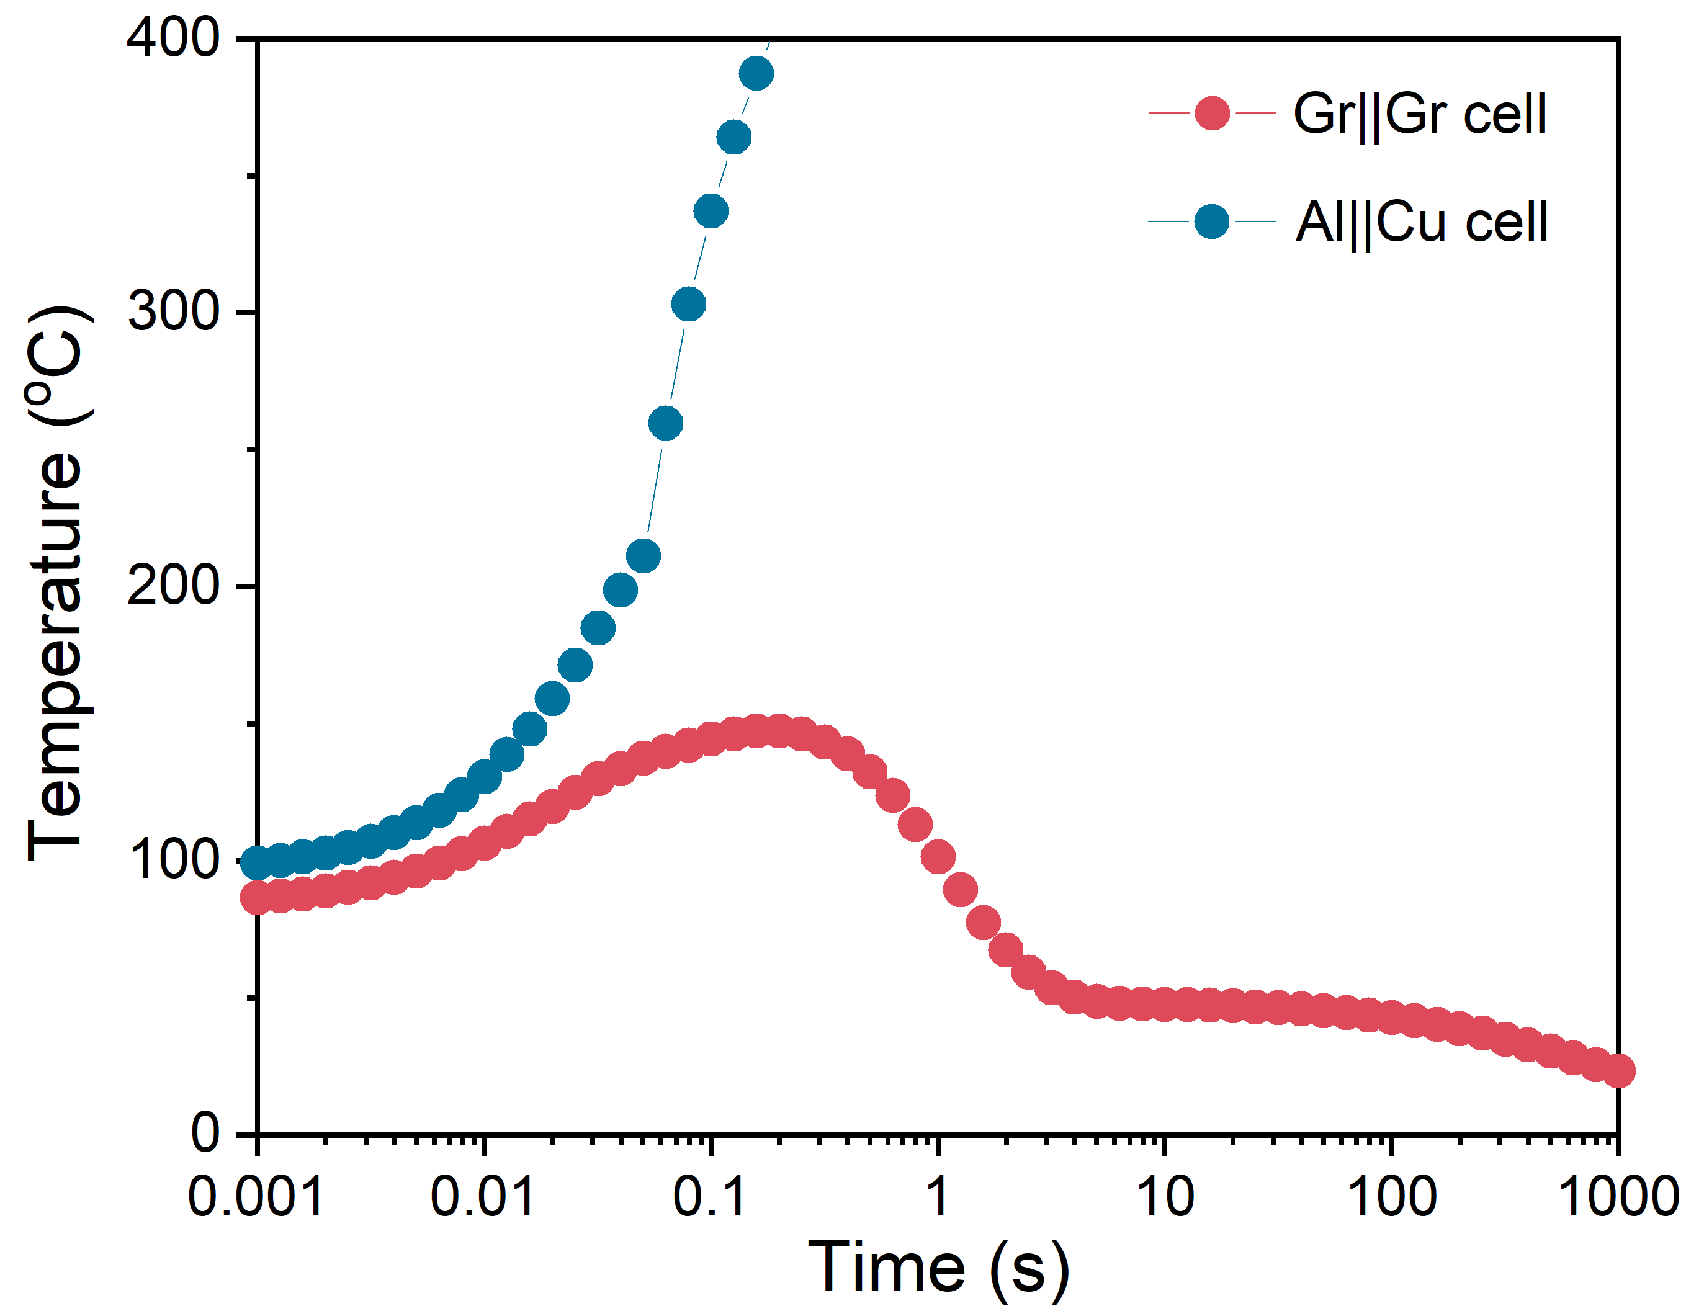
Supplementary Fig. S40. Time-dependent phase-field simulations of temperature distribution for pouch cells with Gr||Gr CCs and Al||Cu CCs, respectively.

References
1. Chen, Y. et al. Reduced graphene oxide films with ultrahigh conductivity as Li-ion battery current collectors. Nano Lett. 16, 3616-3623 (2016).
2. Zhang, Z. et al. Continuous epitaxy of single-crystal graphite films by isothermal carbon diffusion through nickel. Nat. Nanotechnol. 17, 1258-1264 (2022).
3. Gwon, H. et al. Flexible energy storage devices based on graphene paper. Energy Environ. Sci. 4, 1277-1283 (2011).
4. Shi, Y. et al. Graphene-based integrated electrodes for flexible lithium ion batteries. 2D Mater. 2, 024004 (2015).
5. Akbari, A. et al. Highly ordered and dense thermally conductive graphitic films from a graphene oxide/reduced graphene oxide mixture. Matter 2, 1198–1206 (2020).
6. Huang, H. et al. Electrochemical strategy for flexible and highly conductive carbon films: the role of 3-dimensional graphene/graphite aggregates. ACS Appl. Mater. Interfaces 11, 1239-1246 (2019).
7. Peng, L. et al. Ultrahigh thermal conductive yet superflexible graphene films. Adv. Mater. 29, 1700589 (2017).
8. Chen, X. et al. Graphitization of graphene oxide films under pressure. Carbon N. Y. 132, 294-303 (2018).
9. Zhang, P. et al. Oxidating fresh porous graphene networks toward ultra-large graphene oxide with electrical conductivity. Adv. Funct. Mater. 32, 2202697 (2022).
10. Murakami, M., Tatami, A. & Tachibana, M. Fabrication of high quality and large area graphite thin films by pyrolysis and graphitization of polyimides. Carbon N. Y. 145, 23-30 (2019).
11. Zhao, Y. et al. Highly reduced graphene assembly film as current collector for lithium ion batteries. ACS Sustain. Chem. Eng. 9, 8635-8641 (2021)
12. Wang, Z. et al. High conductive graphene assembled films with porous micro-structure for freestanding and ultra-low power strain sensors. Sci. Bull. 65, 1363-1370 (2020).
13. Luo, S. et al. Flexible large-area graphene films of 50-600 nm thickness with high carrier mobility. Nano-Micro Lett. 15, 61 (2023).
14. Cui, L. F., Wang, X. P., Chen, N., Zhang, G. F. & Qu, L. T. A versatile graphene foil. J. Mater. Chem. A 5, 14508-14513 (2017).
15. Shen, B., Zhai, W. & Zheng, W. Ultrathin flexible graphene film: An excellent thermal conducting material with efficient EMI shielding. Adv. Funct. Mater. 24, 4542-4548 (2014).
16. Xiong, Z., Yun, X., Tang, B. & Wang, X. Ultratough cellular films from graphene oxide hydrogel: A way to exploit rigidity and flexibility of two-dimensional honeycomb carbon. Carbon N. Y. 107, 548-556 (2016).
17. Qian, W. et al. Superhigh electromagnetic interference shielding of ultrathin aligned pristine graphene nanosheets film. Adv. Mater. 32, 1907411 (2020)
18. Liu, Z. et al. A facile and scalable method of fabrication of large-area ultrathin graphene oxide nanofiltration membrane. ACS Nano 15, 15294-15305 (2021).
19. Zhong, J. et al. Efficient and scalable synthesis of highly aligned and compact two-dimensional nanosheet films with record performances. Nat. Commun. 9, 3484 (2018).
20. Xie, Y. et al. Ultra-broadband strong electromagnetic interference shielding with ferromagnetic graphene quartz fabric. Adv. Mater. 34, 2202982 (2022).

21. Li, N., Chen, Z., Ren, W., Li, F. & Cheng, H. M. Flexible graphene-based lithium ion batteries with ultrafast charge and discharge rates. Proc. Natl. Acad. Sci. U. S. A. 109, 17360-17365 (2012).
- Zhao, Y. et al. Highly reduced graphene assembly film as current collector for lithium ion batteries. ACS Sustain. Chem. Eng. 9, 8635-8641 (2021).
- Wu, Q. et al. Lifting the energy density of lithium ion batteries using graphite film current collectors. J. Power Sources 455, 227991 (2020).
- Hou, B.-W. et al. The effect of amine additives on the thermal runaway inhibition of SiC ||NCM811 batteries. Journal of Electrochemistry 29, 2211141, (2023).
- Li, Y. et al. Thermal runaway mechanism of lithium-ion battery with LiNi_{0.8}Mn_{0.1}Co_{0.1}O₂ cathode materials. Nano Energy 85, 105878 (2021).
- Hou, J. et al. Unlocking the self-supported thermal runaway of high-energy lithium-ion batteries. Energy Storage Mater. 39, 395-402 (2021).
- Wang, Y. et al. Reductive gas manipulation at early self-heating stage enables controllable battery thermal failure. Joule 6, 2810-2820 (2022).
- Li, C. et al. An experimental study on thermal runaway behavior for high-capacity Li(Ni_{0.8}Co_{0.1}Mn_{0.1})O₂ pouch cells at different state of charges. J. Electrochem. Energy Convers. Storage 18, 021012 (2021).
- Young instruments science & technology Co., Ltd. Study on adiabatic thermal runaway characteristics of large-capacity high nickel lithium-ion batteries. Application case (2023).
- Wang, Y., Ren, D., Feng, X., Wang, L. & Ouyang, M. Thermal runaway modeling of large format high-nickel/silicon-graphite lithium-ion batteries based on reaction sequence and kinetics. Appl. Energy 306, 117943 (2022)
- Lin, D. et al. Layered reduced graphene oxide with nanoscale interlayer gaps as a stable host for lithium metal anodes. Nat. Nanotechnol. 11, 626-632 (2016).
- Wang, Z. et al. High conductive graphene assembled films with porous micro-structure for freestanding and ultra-low power strain sensors. Sci. Bull. 65, 1363-1370 (2020).
- Xiong, Z., Liao, C., Han, W. & Wang, X. Mechanically tough large-area hierarchical porous graphene films for high-performance flexible supercapacitor applications. Adv. Mater. 27, 4469-4475 (2015).
- Sheng, L. et al. Multilayer-folded graphene ribbon film with ultrahigh areal capacitance and high rate performance for compressible supercapacitors. Adv. Funct. Mater. 28, 1800597 (2018).
- Xu, Y., Bai, H., Lu, G., Li, C. & Shi, G. Flexible graphene films via the filtration of water-soluble noncovalent functionalized graphene sheets. J. Am. Chem. Soc. 130, 5856-5857 (2008).
- Choe, J. H. et al. Flexible graphene stacks for sodium-ion storage. ChemElectroChem 4, 716-720 (2017).
- Kim, K. W., Kim, J. H., Cho, S., Shin, K. & Kim, S. H. Scalable high-performance graphene paper with enhanced electrical and mechanical properties. Thin Solid Films 632, 50-54 (2017).

