Extended Data

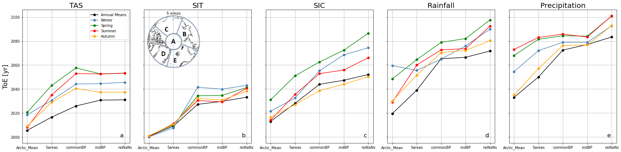

Extended Data Figure 1. Arctic mean ToE of a) TAS, b) SIT, c) SIC, d) rainfall and e) total precipitation, per season/annual (line colours) and method (x-axis, in order of increasing spatial resolution). Five methods were used in the calculation of Arctic mean ToE, “Arctic Mean”: breakpoint and ToE were calculated on the Arctic mean of each variable, “5areas”: the breakpoint and ToE calculations were performed on the weighted means of five areas (Central Arctic - A, East Siberia - B, Chukchi Sea - C, Greenland and Canada - D, Barents Sea - E; see figure insert) and then averaged over the Arctic, “commonBP”: the breakpoint and ToE calculations were performed per gridpoint, using one breakpoint per variable (year 1980 for TAS, 1960 for SIT, 1980 for SIC, 1990 for rainfall and 1980 for precipitation) after which the Arctic mean was calculated, “indBP” as in “commonBP” but with individual breakpoints per gridpoint and per variable, “noNaNs”, as in “indBP” but with gridpoints failing to produce a ToE during the 21st century being assigned a ToE-value of 2101.

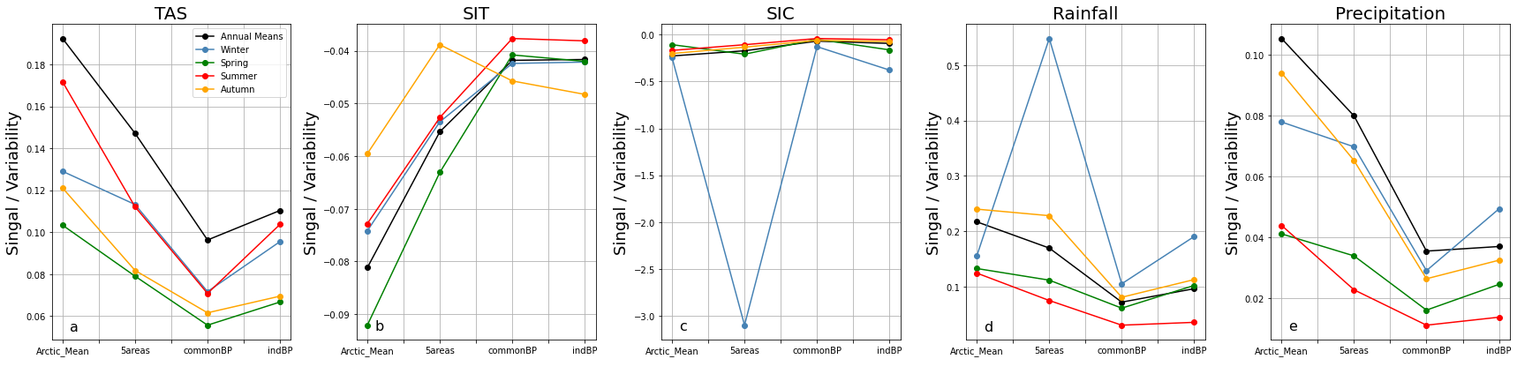

Extended Data Figure 2. Arctic mean trend/variability ratio of a) TAS, b) SIT, c) SIC, d) rainfall and e) total precipitation, per season (line colours) and method (x-axis, in order of increasing spatial resolution). Four methods were used in the calculation of the ratio, “Arctic Mean”: breakpoint, signal and variability were calculated on the Arctic mean of each variable, “5areas”: the breakpoint, signal and variability calculations were performed on the weighted means of five areas (see caption and insert of Supplementary Figure 1) and then averaged, “commonBP”: the breakpoint, signal and variability calculations were performed per gridpoint, using one common breakpoint per variable (year 1980 for TAS, 1960 for SIT, 1980 for SIC, 1990 for Rainfall and 1980 for Precipitation) after which the Arctic mean was calculated, “indBP” as in “commonBP” but with individual breakpoints per gridpoint and variable. Outliers occur for regions/variables/methods with very low temporal variability.

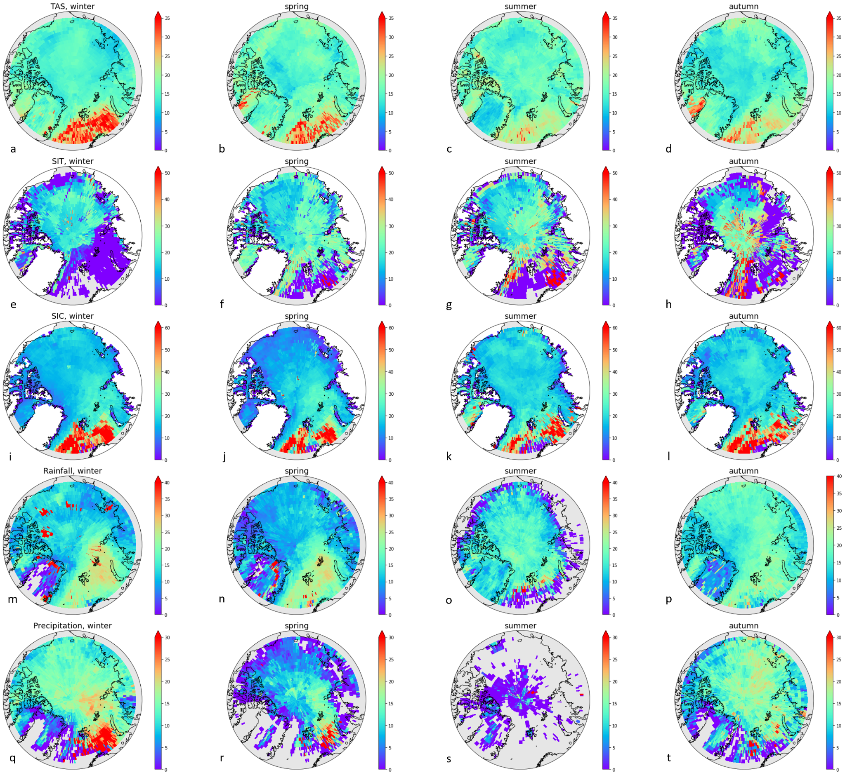

Extended Data Figure 3. Geographical distributions of model spread for surface temperature (first row), sea ice thickness (second row), sea ice cover (third row), rainfall (fourth row), and total precipitation (fifth row). Model spread is calculated as standard deviation of ToE estimates from all CMIP6 models (20 for TAS, precipitation and rainfall, 18 for SIC and 9 for SIT), for winter (DJF, first column), spring (MAM, second column), summer (JJA, third column), and autumn (SON, fourth column). Note the different colour scales per variable. Grey colours depict regions where less than 50% of the models yielded a ToE-value ≤ 2100, while white colours depict land without SIT and SIC.

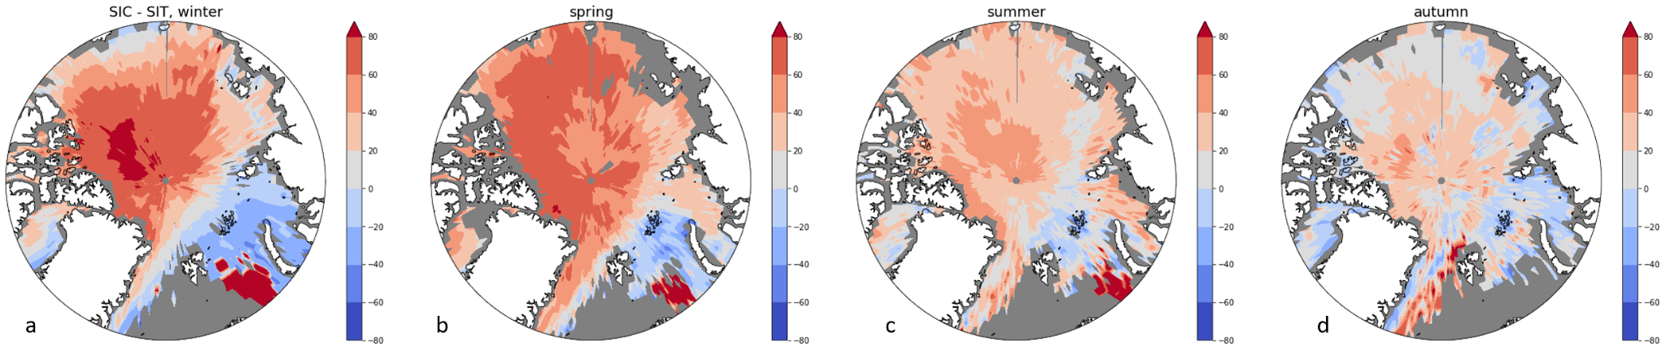

Extended Data Figure 4. Geographical distribution of the difference in ToE for SIC and SIT, for all four seasons. Grey colours depict regions where less than 50% of the models yielded a ToE-value ≤ 2100, while white colours depict land without SIT and SIC.

