Supplemental information
Supplemental Fig S1. Chlorophyll synthesis rates of WT and wlp3
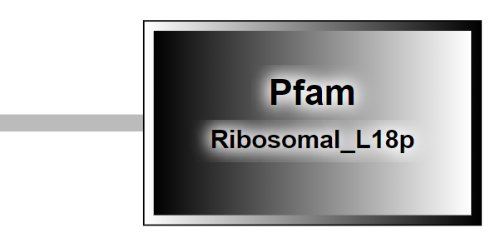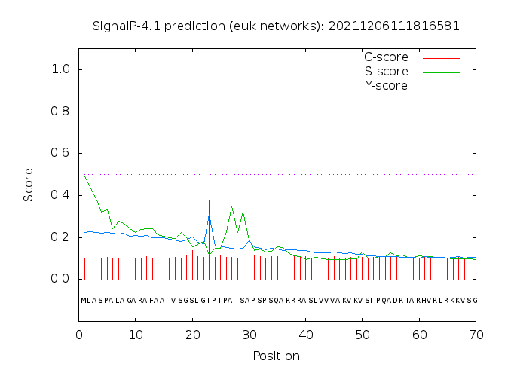
D
C
F
E
E
Supplemental Fig S2. Bioinformatics analysis of WLP3. Bioinformatics analysis of WLP3. (A) Multiple sequence alignment of WLP3. (B) Pfam domain of WLP3. (C) Signal peptide prediction of WLP3. (D) 3D structure prediction of WLP3, red clipped Heads represent beta sheets, black arrows represent alpha helices, and red boxes represent mutation sites of WLP3. (E) GO enrichment analysis of WLP3.

C
D
B
A
Supplemental Fig S3. Responses of WT and wlp3 to drought stress. (A) phenotype map of WT and wlp3 before drought treatment ,bar=3 cm; (B) expression of genes related to drought tolerance before drought treatment of WT and wlp3; (C) phenotype map of WT and wlp3 after drought treatment ,bar=3 cm; (D) Gene expression levels related to drought tolerance in WT and wlp3 after drought treatment.
F
B
E
D
C
A
Supplemental Fig S4. Responses of WT and wlp3 to salt stress. (A) Phenotypic maps of WT and wlp3 before salt treatment, bar=2 cm; (B) expression levels of genes related to salt tolerance in WT and wlp3 before salt treatment; (D) stem length and wlp3 of WT and wlp3 before salt treatment Root length; (D) phenotype maps of WT and wlp3 after salt treatment ,bar=2 cm; (E) expression of genes related to salt tolerance in WT and wlp3 after salt treatment; (F) WT and wlp3 after salt treatment stem length and root length.

A
B
C
Supplemental Fig S5. wlp3 interacts with other ribosomal subunits and interactional protein localization. (A) Verification of bimolecular fluorescence complementation of wlp3. (B) Subcellular localization of interacting proteins. (C) Colocalization of WLP3 with other ribosomal subunits

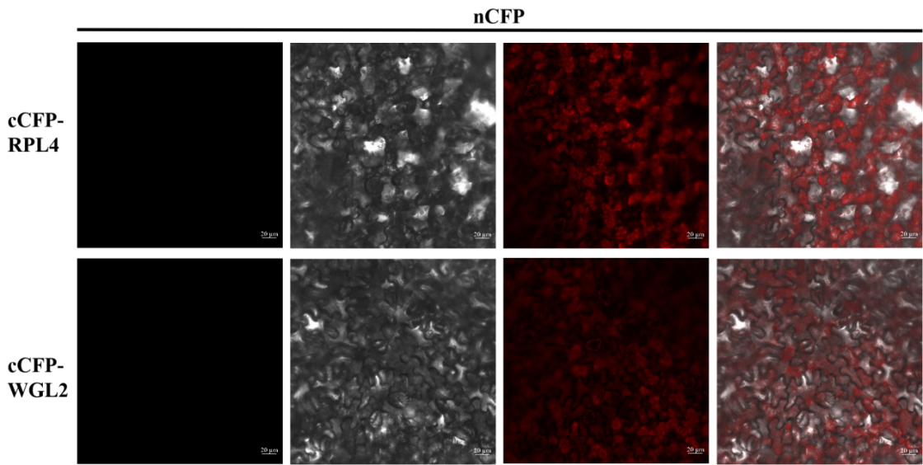
Supplementary Fig S6. Negative control of yeast two-hybrid and BiFC

