Article title: Can Conventional MRI Features Predict H3K27M Mutation Status of Diffuse Midline Gliomas?

Journal name: Journal of Neuro-Oncology
Author names:
Richa Chauhan, Singh,
Karthik Kulanthaivelu
Nihar Kathrani,
Abhishek Kotwal,
Maya Bhat, Dattatraya,
Jitender Saini,
Chandrajit Prasad,
Dhritiman Chakrabarti,
Vani Santosh,
Alok Uppar, Mohan,
Dwarakanath Srinivas,

Affiliation and e-mail address of the corresponding author:
Dr. Maya Dattatraya Bhat
Phone +919480829713
mayabhat05@yahoo.co.in
Faculty quarters, NIMHANS,
Hosur Road, Near Bangalore Milk Dairy, Bengaluru, Karnataka, India – 5600029.

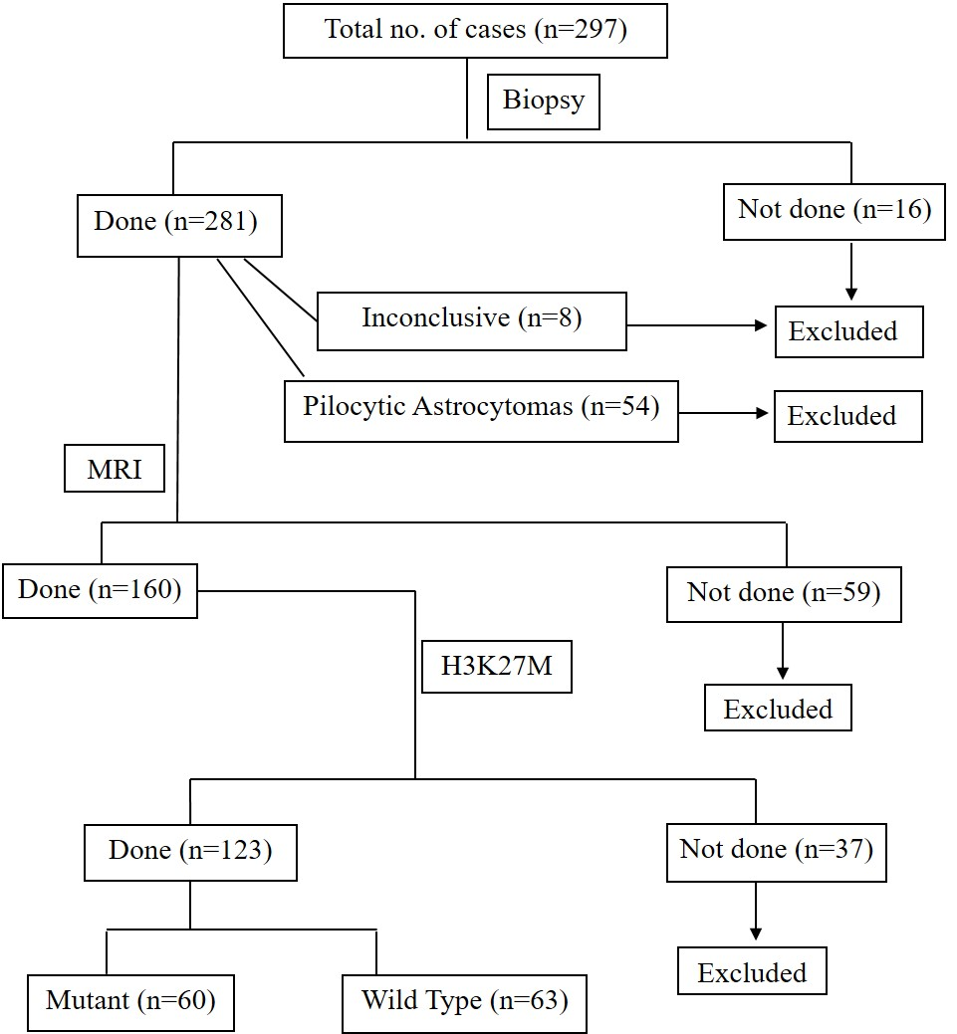

Online Resource 1 Flow chart depicting the cases included in the study

