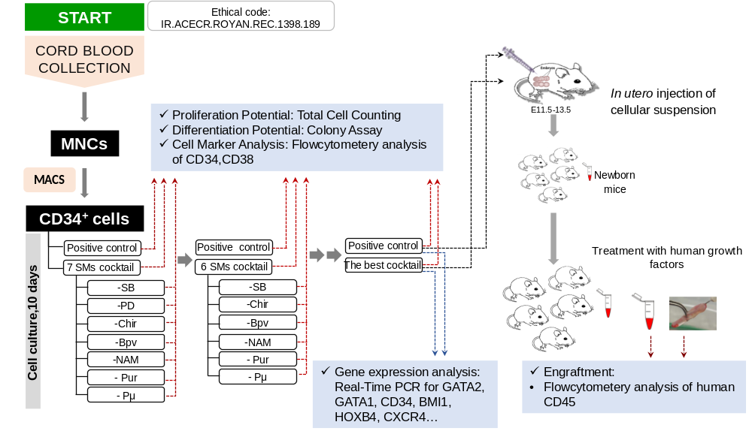
Supplementary information
Figure S1. Schematic illustration of procedure to find the best combination of small molecules to expand UCB-HSCs.
Set  Concentration | Initial  Concentration | References | Small molecules
10 μM | 10 μM | 10.1007/s12015-013-9473-0 | SB431542 (SB)
0.25 μM | 1 μM | 10.1007/s12015-013-9473-0 | PD0325901 (PD)
4 μM | 4 μM | 10.1371/journal.pone.005649 | Purmorphamin (Pur)
0.3 μM | 3 μM | 10.1007/s12015-013-9473-0 | Chir99021 (Chir)
2.5 mM | 2.5 mM | 1016/j.exphem.2011.12.005 | Nicotinamide (NAM)
5 μM | 5 μM | 10.1111/j.1474-9726.2011.00704.x. | Bpv
2.5 μM | 10 μM | 10.1186/1476-4598-10-115 | Pifithrin-µ (Pμ)
Table S1. Initial concentration of small molecules based on previous studies and their proper concentration based on MTS assay.
Gene Name | Primer sequence (5’ 3’) | TM (°C) | Size (bp)
GAPDH | F: CTC ATT TCC TGG TAT GAC AAC GA  R: CTT CCT CTT GTG CTC TTG CT | 121 | 59
RUNX1 | F: CCA CTC CAC TGC CTT TAA CC  R: GGT ATT GGT AGG ACT GAT CGT | 199 | 60
FOG1 | F: CCG CAG TGA TCA ACA AAG AC  R: CTC TTT GGG CTT CTC GTC TG | 155 | 60
BMI1 | F: GTG TGC TTT GTG GAG GG  R: AGT AGT GGT CTG GTC TTG TG | 148 | 60
HOXB4 | F: AGA CAG AAA GAG AAA TAG GAG G  R: CGG CAG AGG AAA CAA GAC | 126 | 60
LMO2 | F: AAC TGG GCC GGA AGC TCT  R: CTT GAA ACA TTC CAG GTG ATA CA | 143 | 65
TAL1 | F: CTC GGC AGC GGG TTC TTT G  R: CGT CTT GCA GGA GGT CAT CTG | 94 | 61
GATA1 | F: GGG ATC ACA CTG AGC TTG C  R: ACC CCT GAT TCT GGT GTG G | 202 | 60
GATA2 | F: AAG GCT CGT TCC TGT TCA GA  R:GGC ATT GCA CAG GTA GTG G | 102 | 60
PU1 | F: CAC AGC GAG TTC GAG AGC TT  R: GAT GGG TAC TGG AGG CAC AT | 194 | 61
OCT4 | F: GTT CTT CAT TCA CTA AGG AAG G  R: CAA GAG CAT CAT TGA ACT TCA C | 148 | 60
JUN | F: GGT AGC AGA TAA GTG TTG AG  R: GGG CAG TTA GAG AGA AGG | 185 | 60
CXCR4 | F: AAC TTC AGT TTG TTG GCT GC  R: CAT TTC CTC GGT GTA GTT ATC TG | 142 | 60
Table S2. List of primer sequences used in the present study.

