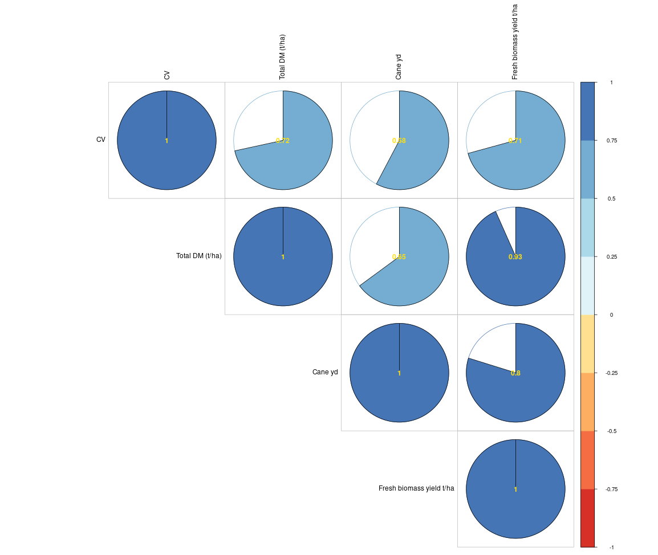
Fig. S 1 Correlogram for biomass contributing traits in energy canes

