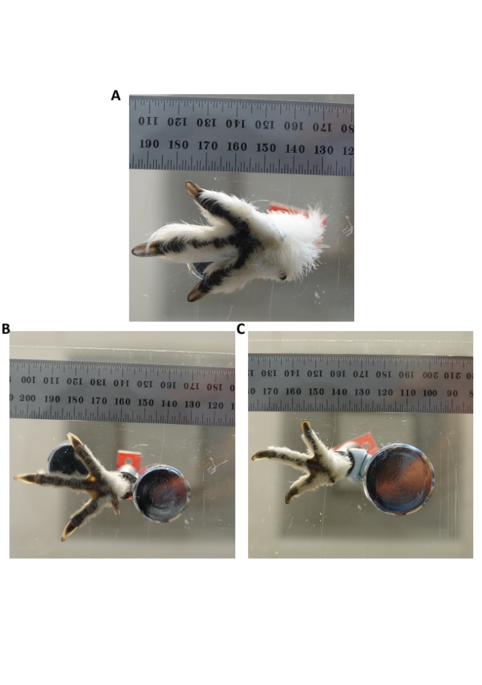
Supplementary Figure 1. Photographs taken of a feathered (A) Svalbard rock ptarmigan, (B) willow ptarmigan, and (C) mainland rock ptarmigan foot. Surface area of feathered feet was taken by uploading images to ImageJ, whereas surface area of ‘unfeathered’ feet were taken by uploading images to ImageJ and pinpointing the outline of the foot, excluding feathers.

