6 Extended Data

6.1 Population projections
Urban Fraction Smoothing Factor | RMSE |  |  |  | Percentage cells where population difference exceeds
Urban Fraction Smoothing Factor | Non-adjusted |  | UN-adjusted |  | 1 person/ cell |  | 10 people/ cell |  | 100 people/ cell
Urban Fraction Smoothing Factor | 3 arc-second | 30 arc- second | 3 arc-second | 30 arc- second | 3 arc-second | 30 arc- second | 3 arc-second | 30 arc- second | 3 arc-second | 30 arc- second
1.0 | 13.46 | 10.73 | 13.30 | 6.87 | 6.02 | 3.51 | 0.25 | 0.19 | 0.03 | 0.02
0.8 | 12.10 | 10.15 | 11.95 | 6.20 | 6.06 | 3.49 | 0.26 | 0.19 | 0.03 | 0.02
0.6 | 10.60 | 9.46 | 10.46 | 5.43 | 6.12 | 3.45 | 0.27 | 0.20 | 0.03 | 0.02
0.4 | 8.88 | 8.61 | 8.78 | 4.49 | 6.23 | 3.43 | 0.28 | 0.19 | 0.02 | 0.01
0.2 | 6.73 | 7.42 | 6.73 | 3.21 | 6.49 | 3.49 | 0.31 | 0.16 | 0.01 | 0.00

Extended Data Table 1: Comparison of model performance, applying urban smoothing factors, with Worldpop 2020. Comparison of modelled population projections, with varying urban smoothing factors applied, for 2020 compared to WorldPop 2020 population projections using root mean square error (RMSE) and the percentage of cells exceeding thresholds of difference at 3 arc-second (Worldpop 100m dataset) and 30 arc-second (Worldpop 1km dataset). For the RMSE calculations, modelled population is compared to both UN adjusted and non-adjusted WorldPop 2020 population distributions and resolutions. The percentage of cells at 3-arc and 30 arc-second resolutions in which the projected population in 2020 differed from the WorldPop 2020 population (non-adjusted) population distribution by more than 1 person, 10 people or 100 people is summarised. The Urban Fraction Smoothing Factor for which there was the smallest number of cases differed between the projected population and WorldPop is highlighted in bold.

Population dataset | Resolution at equator | Estimated Malawi population 2020/million | Percentage difference to World Bank 2020 population
WorldPop 2020 | 100m | 17.94 | -6.22
WorldPop UN-  adjusted 2020 | 100m | 19.90 | +4.00
WorldPop 2020 | 1km | 18.43 | -3.68
WorldPop UN-  adjusted 2020 | 1km | 23.00 | +20.18
Landscan 2020 | 1km | 28.61 | +49.55
Boke-Olen et al., ⁴⁰ population projection | 1km | 20.72 | +8.32
Hinton et al., population projection | 100m | 19.06 | -1.64
Extended Data Table 2: Population of Malawi as estimated from different available gridded population distributions for 2020. Predicted population compared to the WorldBank 2020 population to estimate the percentage error.

6.2 Latrine adoption scenarios
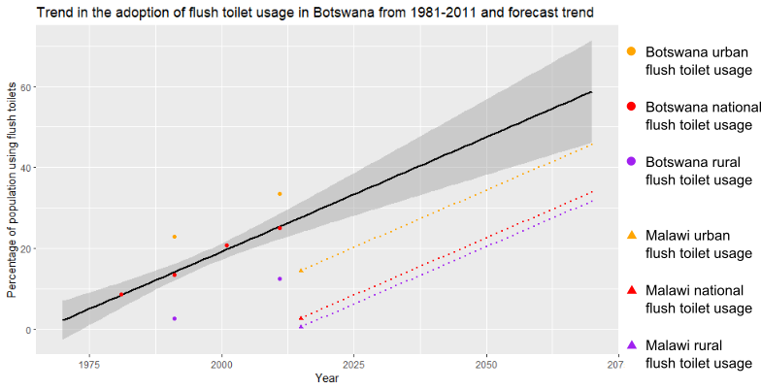
Extended Data Figure 1: Forecast percentage of the population using flush toilets for Malawi if Malawi follows the rate of flush toilet adoption seen in Botswana from 1981-2011. The trend in Botswana’s flush toilet adoption is shown with data-points as circles. The 2015 DHS survey results for the level of flush latrine adoption in Malawi are represented by the triangles. Orange signifies flush toilet usage in urban areas, red is national and purple is in rural areas. The projected trend for Malawi’s flush toilet usage is shown in dashed lines.
 | Urban area 1 | Urban area 2 | Urban area 3 | Rural area 1 | Rural area 2 | Rural area 3
Population | 6,787 | 1,200 | 2,998 | 51,207 | 107,404 | 87,706
Pit-  Latrines | 934 | 73 | 168 | 3,320 | 10,084 | 6,178
Extended Data Table 3: Summary of 3 urban and rural case-studies in Chikwawa used to estimate the population per pit-latrine. The population was estimated from the 2017 WorldPop population distribution for Chikwawa and summed within each of the areas. The number of pit-latrines within each area was summed from the CJFWFP pit-latrine survey (largely in 2017) in which Chikwawa was most comprehensively mapped.

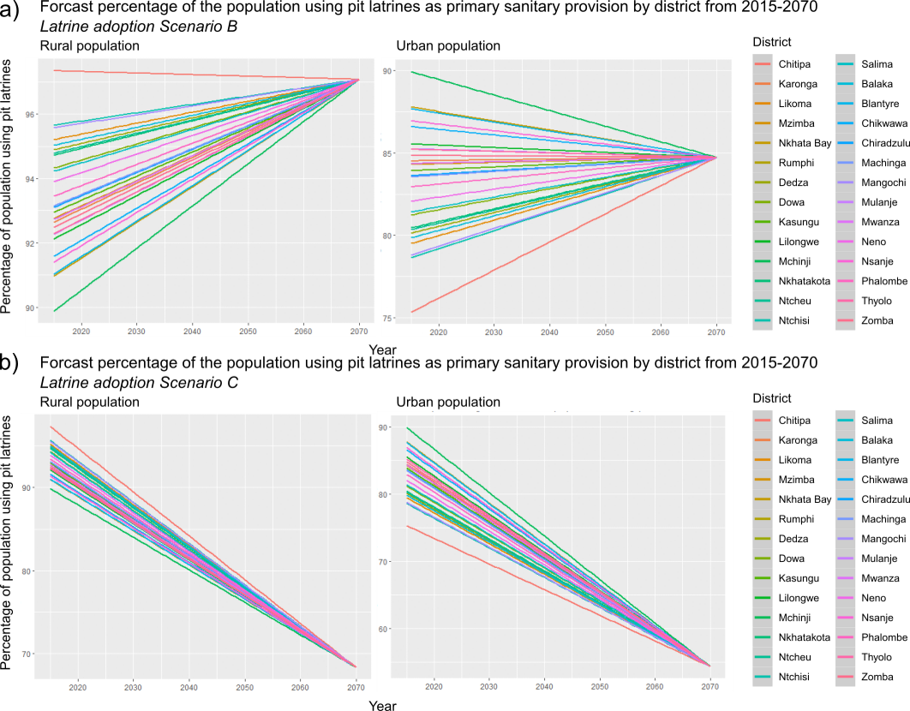
Extded Data Figure 2: Summary of pit-latrine using population in sanitation scenarios B and C. a) Forecast percentage of the population using pit-latrines as their primary source of sanitation for rural and urban contexts for different districts in Malawi under latrine adoption Scenario B (increasing pit-latrine usage). Districts have a level of pit-latrine usage in 2015 from the DHS 2015/16 survey. All districts are assumed to have the national average projected level of pit-latrine usage in 2070. b) Forecast percentage of the population using pit-latrines as primary source of sanitation for rural and urban contexts for different districts in Malawi under latrine adoption scenario C (decreasing pit-latrine usage). Districts have a level of pit-latrine usage in 2015 from the DHS 2015/16 survey. All districts are assumed to have the national average projected level of pit-latrine usage in 2070. The level of pit-latrine usage in 2070 is projected by modelling the adoption of flush toilets based on the observed trend in flush toilet usage in Botswana from 1981-2011.
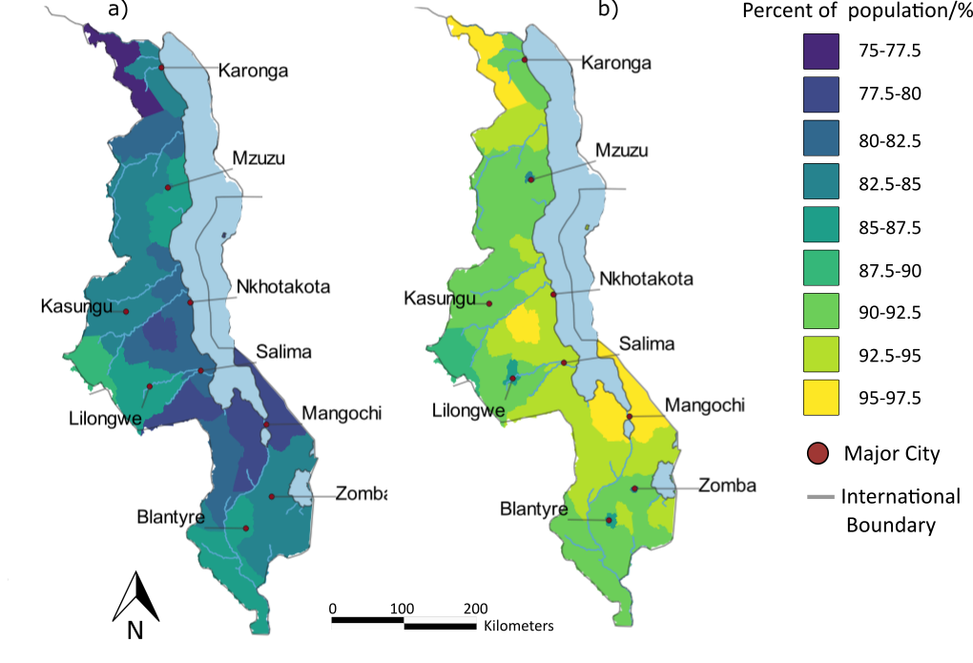
Extended Data Figure 3: Spatial variation of pit-latrine usage. Percentage of the 2015 population using pit-latrines as their primary form of sanitation in (a) urban contexts and (b) rural contexts, data from DHS 2015-16 survey.

6.3 Faecal loading
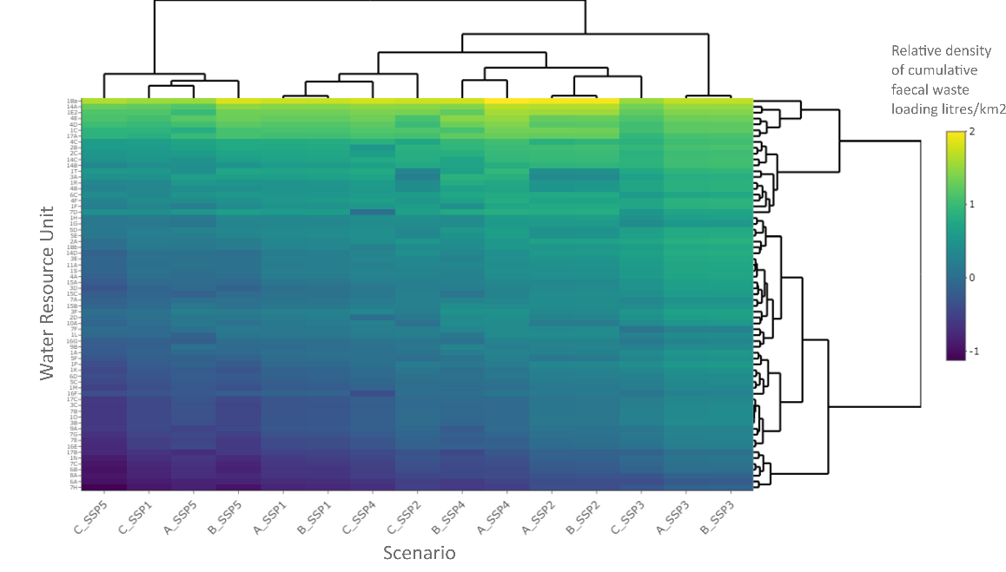
Extended Data Figure 4: Double dendrogram showing results of unsupervised hierarchical clustering analysis of faecal loading under multiple sanitation policy and socioeconomic scenarios. Water Resource Unit (WRU) clustering units are organised by row and pit-latrine/ socioeconomic scenarios are clustered by column (Sanitation policy scenario A, B and C and SSP scenarios 1-5). The scale bar is a logarithmic scale of the relative density of cumulative faecal waste loading for the year 2070 with the WRUs with the highest density of faecal waste loading with the highest value. Similarity between WRUs (shown in y-axis) and scenarios (x-axis) is represented by the height of the nodes in the plot with more similar scenarios having shorter nodes. Pit-latrine scenarios A and B show high similarity for all SSP scenarios; however, sanitation policy scenario C typically shows higher similarity to sanitation policy scenarios A and B of lower population growth and urbanisation SSP scenarios.

6.4 Latrine Density
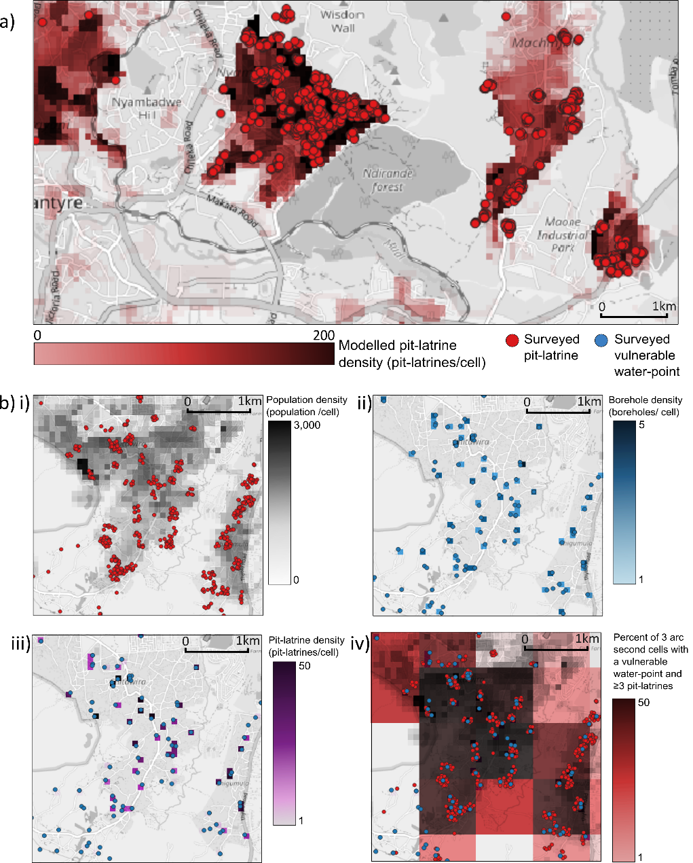
Extended Data Figure 5: Example of methodology and results compared with CJFWFP survey data, 2017, for Blantyre. Images made with QGIS using Open Street Map background. a) Example region of North-East Blantyre. Estimation of pit-latrine density for Malawi, 2017 (darker areas have a higher estimated number of pit-latrines). The locations of mapped pit-latrines based on the 2012-2020 CJFWFP sanitation survey are shown as red points (majority of surveys in this region were conducted in 2017).
b) Example of steps in the methodology, applying an example of an area of Southern Blantyre. i) Population density is shown in grey with higher population densities as a darker colour. The locations of mapped pit-latrines are shown as red points. ii) The density of water-points is shown in blue with darker blue with higher densities of water-points within 3 arc-second grid cells. Locations of known waterpoints as blue points. iii) The density of pit-latrines projected as being within the same 3 arc-second grid cell as water-points in shown in purple. Locations of known water-points as blue points. iv) Aggregated data to 30 arc-second grid resolution, the percentage of water-points in a 30 arc-second resolution grid in which there are 3 latrines or more within the same 3 arc-second grid cell as the water-point. Locations of known water-points as blue points and locations of mapped pit-latrines are shown in red.

Number of latrines in 3 arc-second grid | 2020 | 2030 | 2040 | 2050 | 2060 | 2070 | Percentage change
No  latrines | 1,081,167 | 1,061,816 | 1,042,209 | 1,025,595 | 1,015,103 | 1,008,596 | -6.7%
1-2 latrines | 185,588 | 375748 | 564,178 | 724,138 | 827,361 | 908,633 | +390%
3-9 latrines | 37,418 | 36,647 | 33,094 | 28,034 | 19,046 | 11,765 | -68.6%
10-29 latrines | 10,557 | 13,013 | 20,421 | 27,002 | 33,362 | 15,242 | +44.4%
30-49 latrines | 1,671 | 2,333 | 4,332 | 6,401 | 7,511 | 9,125 | +446%
50-99 latrines | 613 | 1,388 | 2,681 | 4,171 | 6,131 | 9,445 | +1,441%
100+  latrines | 162 | 393 | 888 | 1,986 | 3,237 | 7,511 | +4,536%
Extended Data Table 4: Number of cases with given densities of pit-latrines per 3 arc-second grid cell across the whole of Malawi for 2020-2070. For the years 2020-2070. SSP 2, Sanitation policy scenario A.

Number of latrines in 3 arc-second grid | 2020 | 2030 | 2040 | 2050 | 2060 | 2070 | Percentage change from 2020 to  2070
No  latrines | 37,889 | 35,092 | 32,574 | 30,670 | 29,523 | 28,394 | -25.1%
1-2 latrines | 3,590 | 6,297 | 8,667 | 10,449 | 11,557 | 12,332 | +244%
3-9 latrines | 1,002 | 962 | 803 | 647 | 408 | 1,312 | +30.9%
10-29 latrines | 242 | 340 | 562 | 723 | 891 | 253 | +4.6%
30-49 latrines | 39 | 47 | 97 | 160 | 193 | 170 | +336%
50-99 latrines | 20 | 32 | 54 | 85 | 136 | 181 | +805%
Over 100  latrines | 11 | 23 | 36 | 59 | 85 | 151 | +1,273%
Extended Data Table 5: Risk to vulnerable water-points. Number of cases of pit-latrines within the same 3 arc-second grid cell in cells as a vulnerable water-point (domestically used borehole, tube well or dug-well) at given thresholds of pit-latrine density for the whole of Malawi. For the years 2020-2070. SSP 2, Sanitation policy scenario A.

