Western blotting
CDK8 knockdown: SKP2 knockdown:
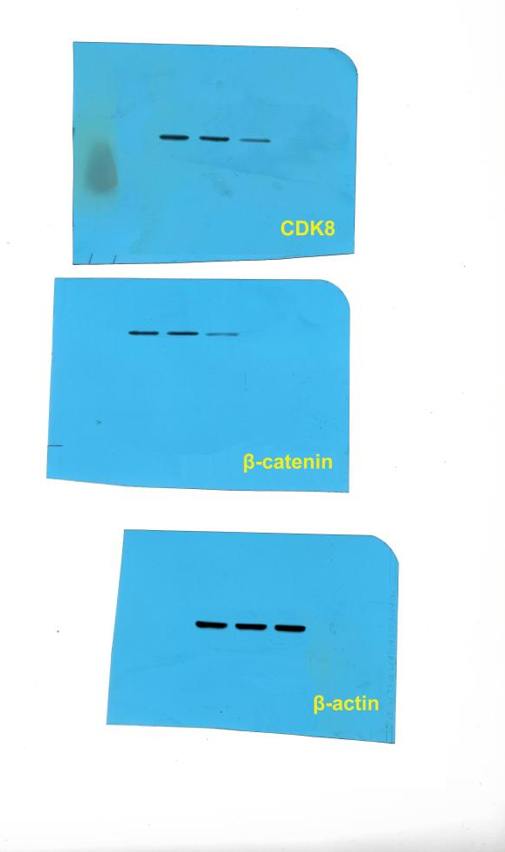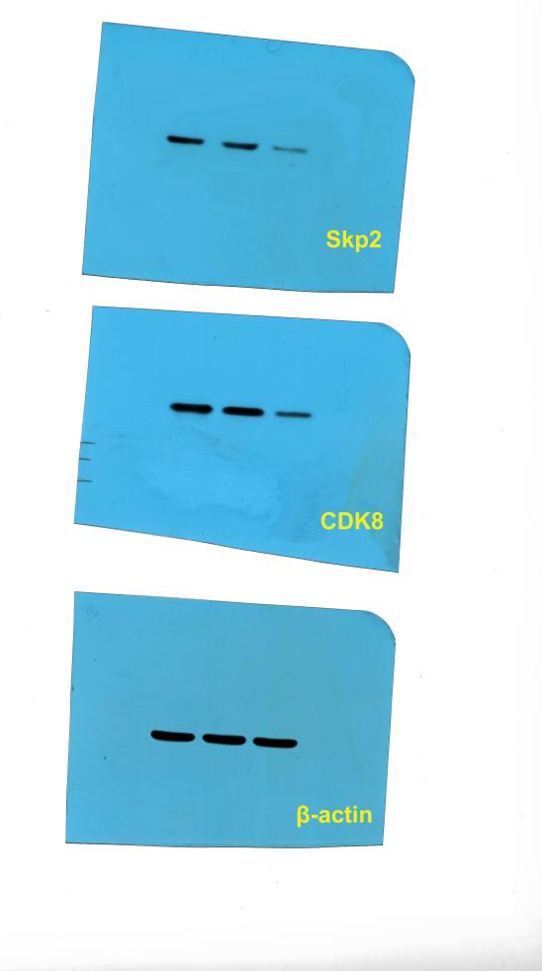

MG132 treatment:
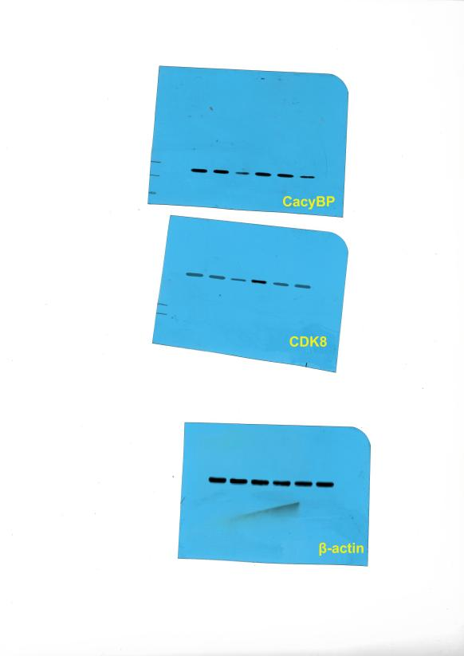
Knockdown validation:

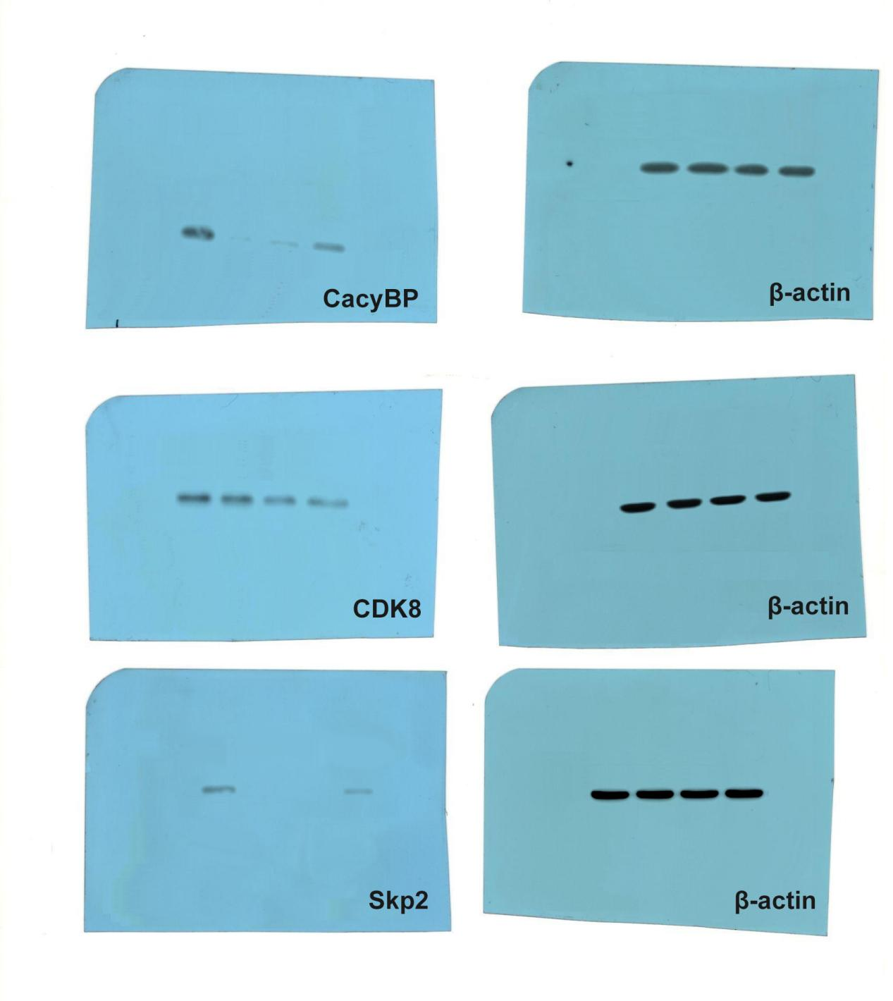

RNA electropherogram
SW480-CacyBP-KD
SW480-CacyBP-KD+NC siRNA
SW480-CacyBP-KD+CDK8 siRNA
SW480-CacyBP-KD
SW480-CacyBP-KD+NC siRNA
SW480-CacyBP-KD+Skp2 siRNA
28s

18s

28s

18s
SW480
SW480-NC
SW480-CacyBPsh-1

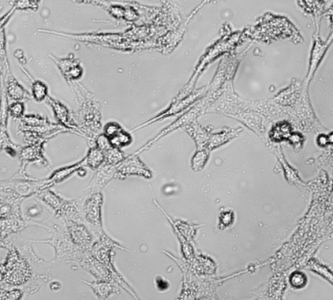
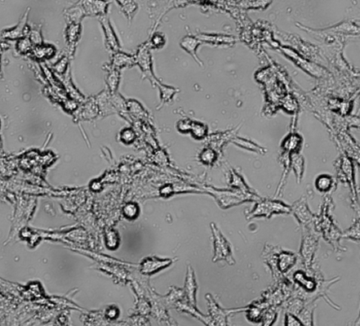
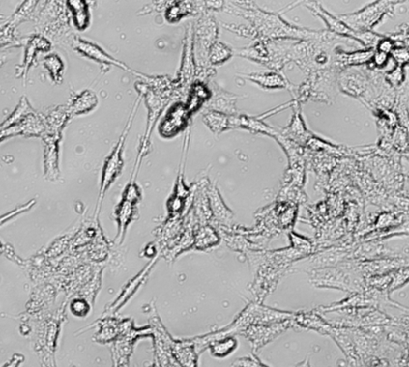
SW480 Photogrammetry
SW480 SW480-NC SW480-CacyBPsh-1

400×

Fluorescence verification of transfection efficiency
SW480 SW480-NC SW480-CacyBPsh-1

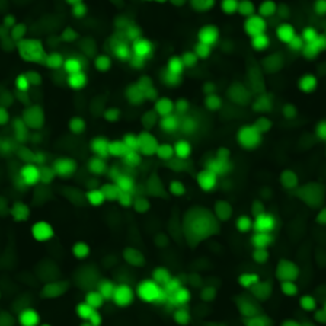
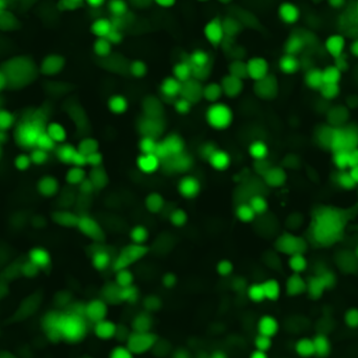
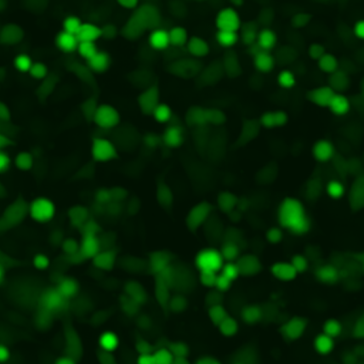

400×

SW480 SW480-NC SW480-CDK8sh-2
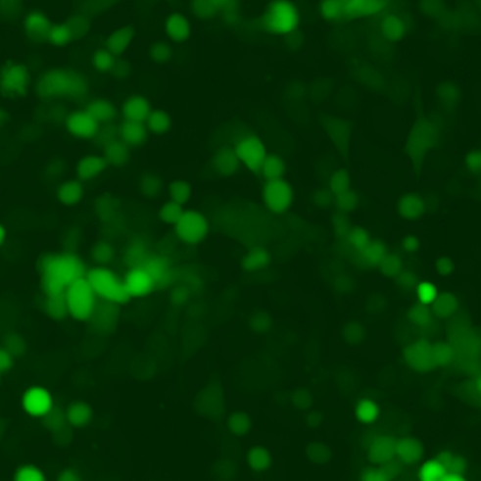
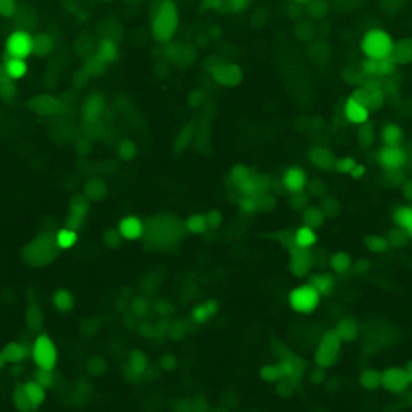
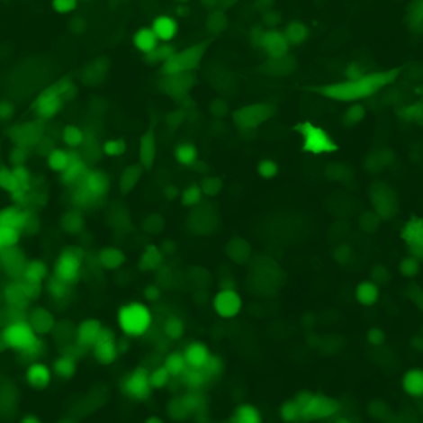
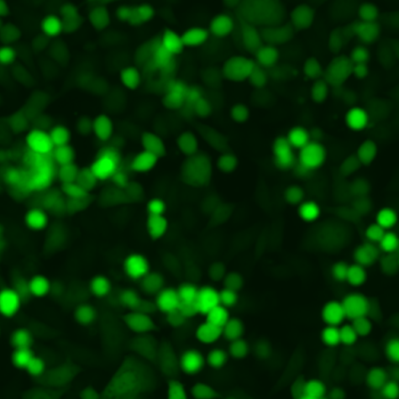
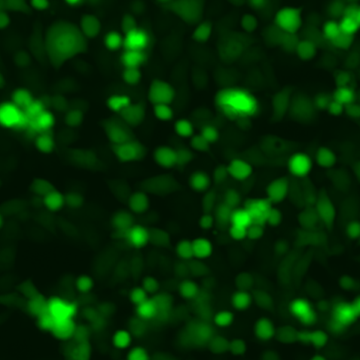
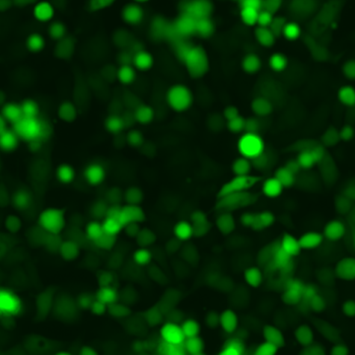
400×
400×
SW480 SW480-NC SW480-SKP2sh-3

400×
400×
400×

SW480
SW480-NC
SW480-CacyBPsh-1

