Supplementary Data Genetic Comparison of Bed Bugs
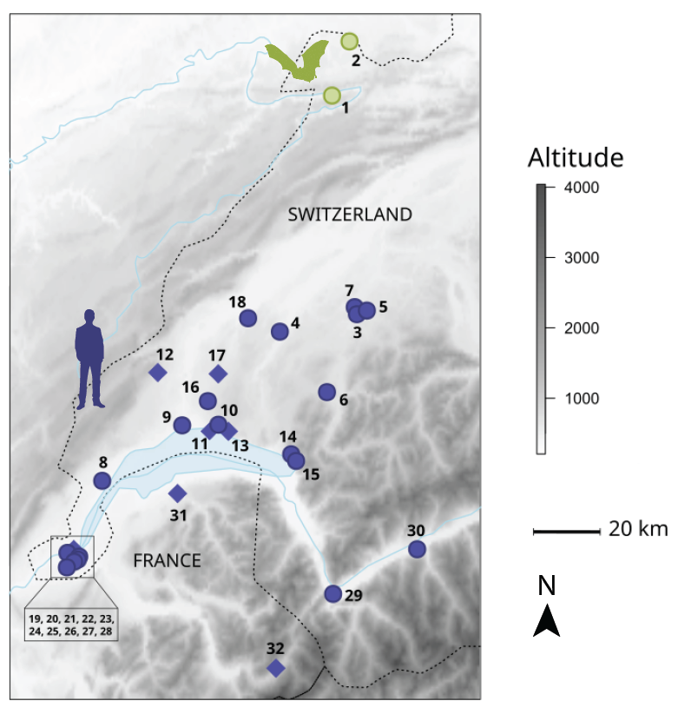
Fig. S1. Map of the 32 sites used in the study. Diamonds means the coordinates are approximated because they were unavailable. The bat roosts are in green, and the human shelters are in purple. The sites 19 to 28 are all located in the Geneva canton.

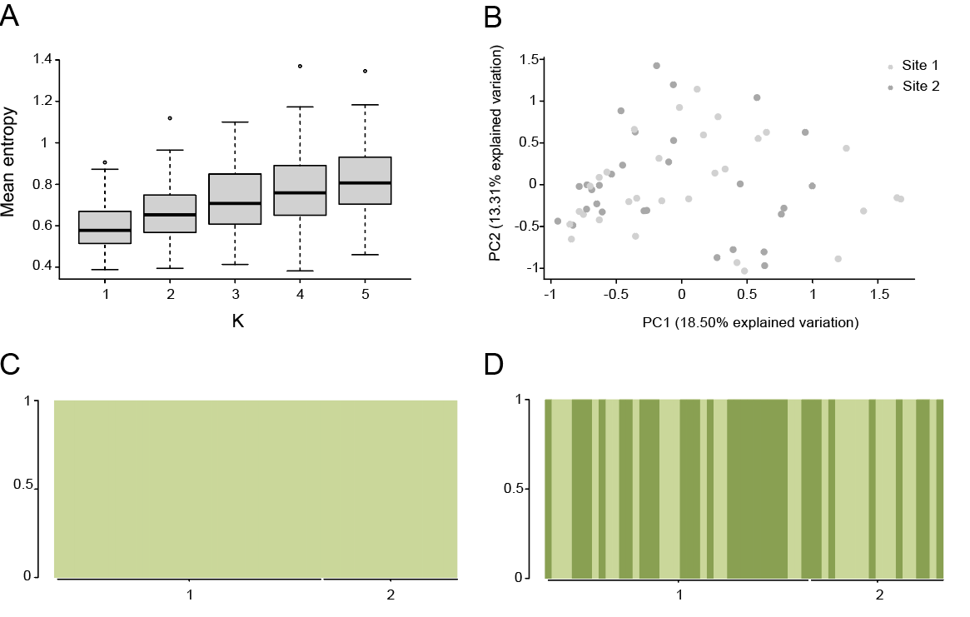
Fig. S2. Genetic structure of the bat-associated bed bugs. A) Variation of the cross-entropy criterion for K ranging from 1 to 5 for the bat-associated bugs. B) PCA coloured by the different bat sites. C) Population structure for K=1 and D) for K=2 Each column represents one individual from a particular sampling site and each colour a genetic cluster. The proportion of the genome belonging to a genetic cluster is on the y axis.

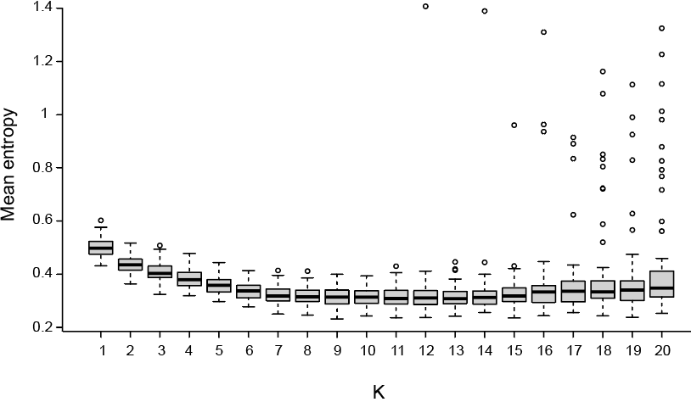
Fig. S3. Variation of the cross-entropy criterion for K ranging from 1 to 20 for the human-associated bugs. The minimum mean entropy criterion is for K13. However, the minimum entropy criterion over all repetitions is for K9.
Table S1. Number of individuals sequenced from the 32 sites for the different analyses. In the host column, B stands for bat and H for human.

 |  |  | Analysis
Host | Site | Total sample size | Mitochondrial | Microsatellites | Kdr haplotypes
B | 1 | 39 | 27 | 39 | 38
B | 2 | 20 | 20 | 20 | 17
H | 3 | 18 | 14 | 15 | 15
H | 4 | 11 | 7 | 11 | 11
H | 5 | 11 | 10 | 11 | 11
H | 6 | 3 | 3 | 0 | 3
H | 7 | 2 | 0 | 0 | 2
H | 8 | 6 | 0 | 5 | 5
H | 9 | 30 | 0 | 30 | 30
H | 10 | 3 | 3 | 0 | 2
H | 11 | 10 | 2 | 0 | 5
H | 12 | 3 | 2 | 0 | 0
H | 13 | 13 | 11 | 0 | 0
H | 14 | 24 | 10 | 0 | 24
H | 15 | 11 | 0 | 11 | 11
H | 16 | 1 | 0 | 0 | 1
H | 17 | 1 | 1 | 0 | 0
H | 18 | 1 | 1 | 0 | 1
H | 19 | 14 | 12 | 14 | 14
H | 20 | 21 | 20 | 21 | 21
H | 21 | 27 | 23 | 26 | 26
H | 22 | 1 | 1 | 0 | 0
H | 23 | 5 | 4 | 5 | 4
H | 24 | 30 | 25 | 29 | 29
H | 25 | 7 | 4 | 7 | 2
H | 26 | 4 | 3 | 0 | 1
H | 27 | 39 | 25 | 38 | 38
H | 28 | 34 | 29 | 34 | 23
H | 29 | 1 | 1 | 0 | 0
H | 30 | 6 | 6 | 5 | 6
H | 31 | 5 | 5 | 0 | 0
H | 32 | 14 | 2 | 0 | 0
 | TOTAL SITES |  | 27 | 17 | 25
 | TOTAL INDIVIDUALS |  | 271 | 321 | 340

Table S2. P-values of genotypic disequilibrium per pair of loci. Adjusted p-value for 5% nominal level is 0.0011. Genotypic disequilibrium was estimated with Delta’.

 | BB21B | BB29B | BB31B | BB38B | BB42B | Clec6 | Clec11 | Clec37 | Clec48 | Clec99
BB21B | 0
BB29B | 0.152 | 0
BB31B | 0.523 | 0.474 | 0
BB38B | 0.564 | 0.114 | 0.923 | 0
BB42B | 0.283 | 0.137 | 0.130 | 0.961 | 0
Clec6 | NA | NA | NA | NA | NA | 0
Clec11 | 0.848 | 0.783 | 0.296 | 0.921 | 0.432 | NA | 0
Clec37 | 0.010 | 0.038 | 0.719 | 0.254 | 0.391 | NA | 0.704 | 0
Clec48 | 0.559 | 0.797 | 0.852 | 0.431 | 0.363 | NA | 0.641 | 0.683 | 0
Clec99 | 0.212 | 0.624 | 0.098 | 0.112 | 0.728 | NA | 0.508 | 0.788 | 1.000 | 0

Table S3. Rarefied allelic count per locus and sampling site. The first two sites are bat-associated.

 | 1 | 2 | 3 | 4 | 5 | 8 | 9 | 15 | 19 | 20 | 21 | 23 | 24 | 25 | 27 | 28 | 30
BB21B | 1.673 | 1.718 | 1.545 | 1 | 1.167 | 1 | 1.066 | 1.325 | 1.464 | 1.672 | 1.075 | 1.356 | 1 | 1 | 1.084 | 1.054 | 1.356
BB29B | 1.474 | 1.570 | 1.515 | 1 | 1 | 1 | 1 | 1.623 | 1.680 | 1.685 | 1.672 | 1 | 1 | 1 | 1.609 | 1.355 | 1
BB31B | 1.440 | 1.527 | 1.500 | 1 | 1 | 1 | 1 | 1 | 1.700 | 1.633 | 1.568 | NA | 1 | 1.733 | 1 | 1.149 | 1.356
BB38B | 1.534 | 1.676 | 1.405 | 1.455 | 1.485 | 1 | 1.341 | 1 | 1.508 | 1.444 | 1.340 | 1 | 1 | 1.495 | 1.425 | 1.576 | 1.200
BB42B | 1.734 | 1.792 | 1.077 | 1 | 1 | 1 | 1.756 | 1.479 | 1 | 1 | 1.212 | NA | 1 | 1 | 1.274 | 1.456 | 1
Clec6 | 1 | 1 | 1 | 1 | 1 | 1 | 1 | 1 | 1.271 | 1.438 | 1.177 | 1 | 1 | 1.485 | 1 | 1.344 | 1
Clec11 | 1.421 | 1.450 | 1.480 | 1 | 1 | 1 | 1 | 1 | 1.476 | 1.470 | 1.483 | 1 | 1 | 1 | 1.548 | 1.435 | 1
Clec37 | 1.312 | 1.367 | 1 | 1 | 1 | 1 | 1.066 | 1.523 | 1.566 | 1.610 | 1.398 | 1 | 1 | 1.409 | 1 | 1.496 | 1.533
Clec48 | 1.075 | 1.296 | 1 | 1 | 1 | 1 | 1 | 1 | 1 | 1 | 1 | 1 | 1 | 1 | 1 | 1 | 1
Clec99 | 1 | 1.224 | 1.519 | 1 | 1 | 1 | 1.494 | 1 | 1.775 | 1.758 | 1.487 | 1 | 1.349 | 1.648 | 1 | 1.105 | 1.200

Table S4. Estimation of C. lectularius genetic differentiation between bat and human-associated population from 17 locations in Western Switzerland represented by pairwise F_{ST}, after Bonferroni correction.
 | 1 | 2 | 3 | 4 | 5 | 8 | 9 | 15 | 19 | 20 | 21 | 23 | 24 | 25 | 27 | 28
2 | 0.0769
3 | 0.5235 | 0.4637
4 | 0.6865 | 0.6434 | 0.7606
5 | 0.6822 | 0.6392 | 0.7571 | -0.0380
8 | 0.6644 | 0.6134 | 0.7197 | 0.8858 | 0.8464
9 | 0.6808* | 0.6520* | 0.6643* | 0.7899* | 0.7848* | 0.7705*
15 | 0.6326 | 0.5688 | 0.6314 | 0.7048 | 0.6949 | 0.5175 | 0.6973*
19 | 0.4881 | 0.4350 | 0.4279 | 0.6290 | 0.6218 | 0.5971 | 0.6220* | 0.5320
20 | 0.4819 | 0.4293* | 0.4010 | 0.5881* | 0.5824 | 0.5646 | 0.5883* | 0.4923* | 0.0020
21 | 0.5900 | 0.5462* | 0.5608 | 0.7175 | 0.7062 | 0.6883 | 0.6585* | 0.6505 | 0.3251 | 0.2336
23 | 0.5356 | 0.4850 | 0.5484 | 0.8482 | 0.8359 | 0.9375 | 0.5981 | 0.5697 | 0.3211 | 0.3370 | 0.5013
24 | 0.7592* | 0.7624* | 0.8206 | 0.9514 | 0.9452 | 0.9611 | 0.8250* | 0.8746* | 0.7128* | 0.6056* | 0.5683* | 0.9248
25 | 0.5638 | 0.5062 | 0.5744 | 0.8384 | 0.8196 | 0.8113 | 0.6698 | 0.6378 | 0.3276 | 0.2544 | 0.2356 | 0.5838 | 0.7397
27 | 0.6460 | 0.6018* | 0.6312 | 0.7608 | 0.7525 | 0.7673* | 0.6703* | 0.6733* | 0.5259* | 0.4747* | 0.5637* | 0.6276 | 0.7316* | 0.5111
28 | 0.6286 | 0.5608 | 0.6193 | 0.7009 | 0.6912 | 0.6463 | 0.6811* | 0.5995* | 0.4379* | 0.3544* | 0.3630* | 0.5966 | 0.6613* | 0.4046 | 0.5227*
30 | 0.5521 | 0.5243 | 0.5816 | 0.8737 | 0.8624 | 0.8693 | 0.7167* | 0.6867 | 0.4279 | 0.4223 | 0.5548 | 0.6806 | 0.9183* | 0.6559 | 0.6364* | 0.6181

*Statistically significant.
Table S5. Sample information for the knock-down resistance mutation on amino acid V419 and L925 for C. lectularius. V419: Valine = wild-type; 419L: Leucine = mutated. L925: Leucine = wild-type; 925I: Isoleucine = mutated. The bat-associated sites are 1 and 2.

 |  |  | V419L |  | L925I
Site | Sample Size | Host species | V419 | 419L | L925 | 925I
1 | 38 | Myotis myotis | 38 | 0 | 38 | 0
2 | 17 | Myotis myotis | 17 | 0 | 17 | 0
3 | 15 | Homo sapiens | 15 | 0 | 0 | 15
4 | 11 | Homo sapiens | 11 | 0 | 0 | 11
5 | 11 | Homo sapiens | 11 | 0 | 0 | 11
6 | 3 | Homo sapiens | 3 | 0 | 0 | 3
7 | 2 | Homo sapiens | 2 | 0 | 0 | 2
8 | 5 | Homo sapiens | 5 | 0 | 0 | 5
9 | 30 | Homo sapiens | 30 | 0 | 0 | 30
10 | 2 | Homo sapiens | 2 | 0 | 0 | 2
11 | 5 | Homo sapiens | 5 | 0 | 0 | 5
14 | 24 | Homo sapiens | 24 | 0 | 2 | 22
15 | 11 | Homo sapiens | 11 | 0 | 0 | 11
16 | 1 | Homo sapiens | 1 | 0 | 0 | 1
18 | 1 | Homo sapiens | 1 | 0 | 0 | 1
19 | 14 | Homo sapiens | 14 | 0 | 0 | 14
20 | 21 | Homo sapiens | 21 | 0 | 0 | 21
21 | 26 | Homo sapiens | 26 | 0 | 0 | 26
23 | 4 | Homo sapiens | 4 | 0 | 0 | 4
24 | 29 | Homo sapiens | 29 | 0 | 0 | 29
25 | 2 | Homo sapiens | 2 | 0 | 0 | 2
26 | 1 | Homo sapiens | 1 | 0 | 0 | 1
27 | 38 | Homo sapiens | 38 | 0 | 0 | 38
28 | 23 | Homo sapiens | 23 | 0 | 0 | 23
30 | 6 | Homo sapiens | 6 | 0 | 0 | 6

