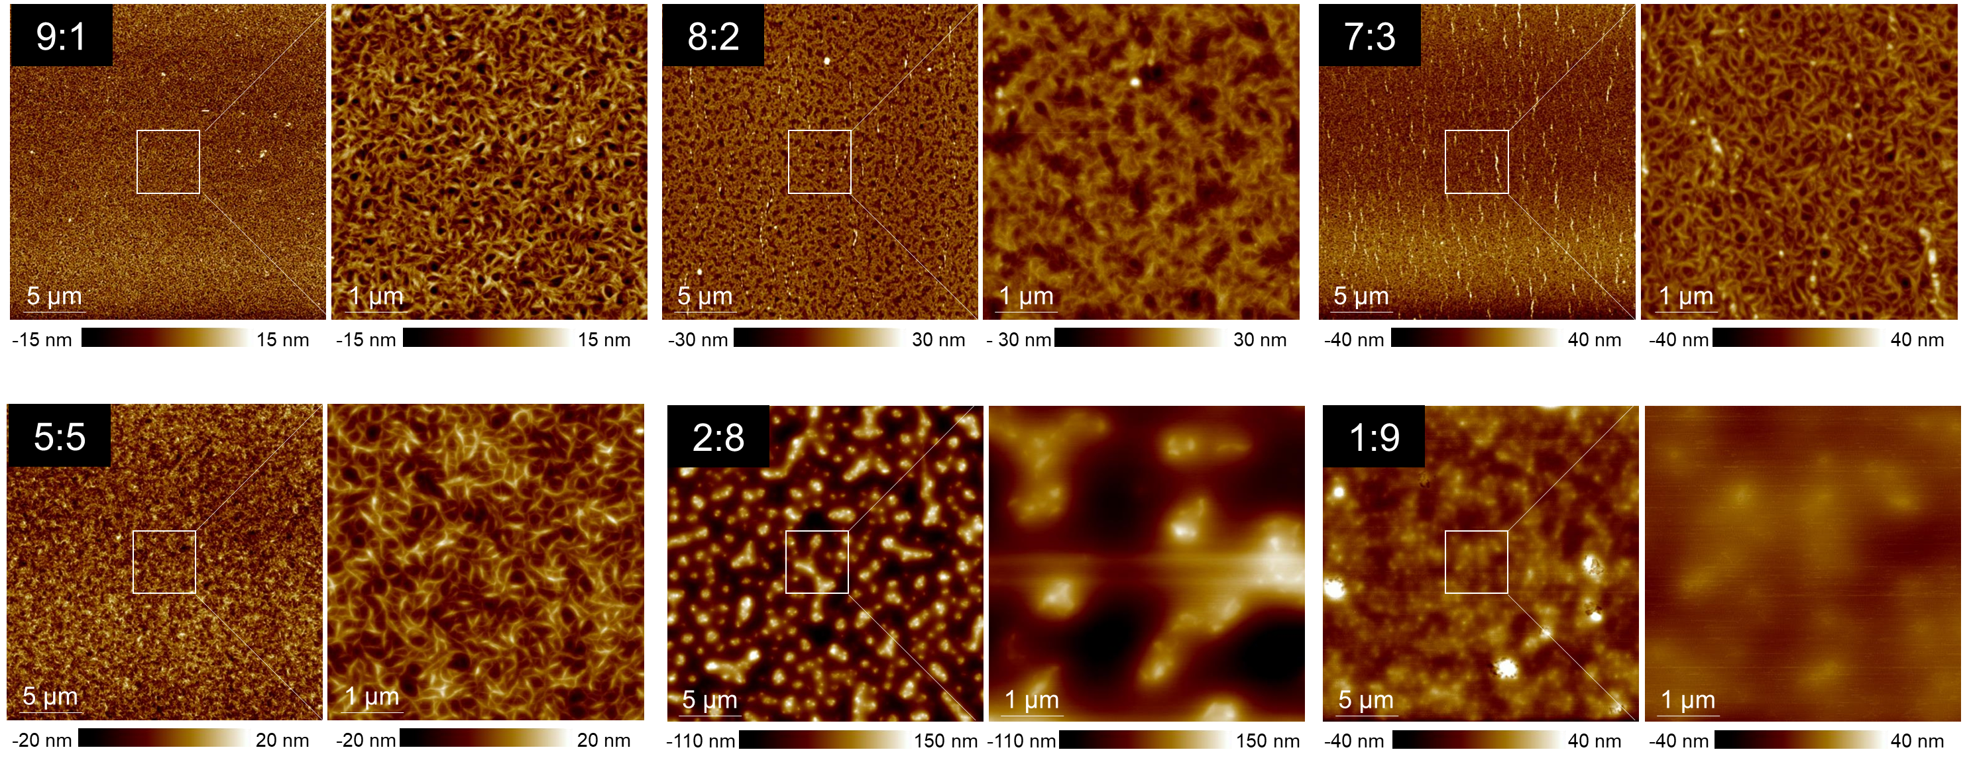

Extended Data Fig. 1. AFM height images of the blend films with various weight ratios (DPPT-TT:SHE, 9:1 to 1:9).

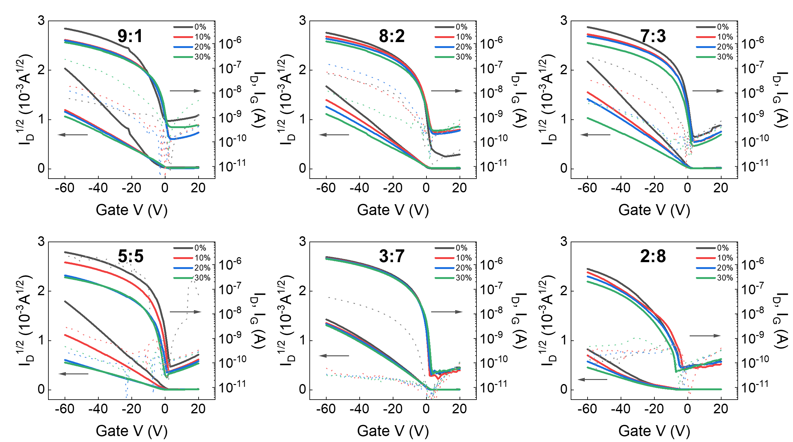

Extended Data Fig. 2. Transfer characteristics of DPPT-TT:SHE films with various blend ratios under 0% to 30% uniaxial strain.

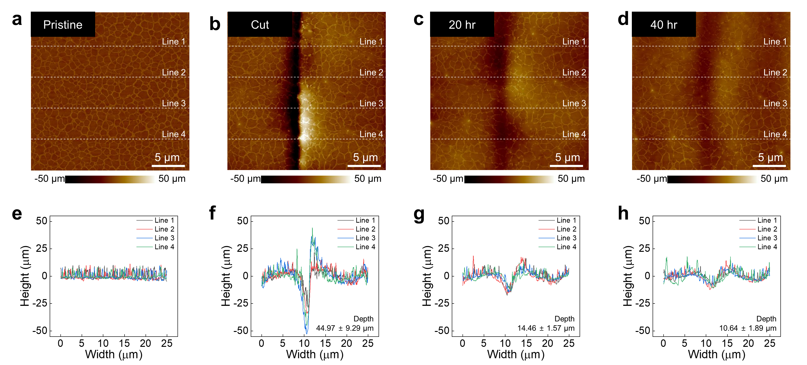

Extended Data Fig. 3. AFM height images of the DPPT-TT:SHE films for self-healing process: a, pristine b, after cut, c, after 20 hours and d, after 40 hours states. Line height profiling of the AFM height image e, pristine, f, after cut, g, after 20 h and h, after 40 h states. As time flows, the cutting line was healed without any treatment.

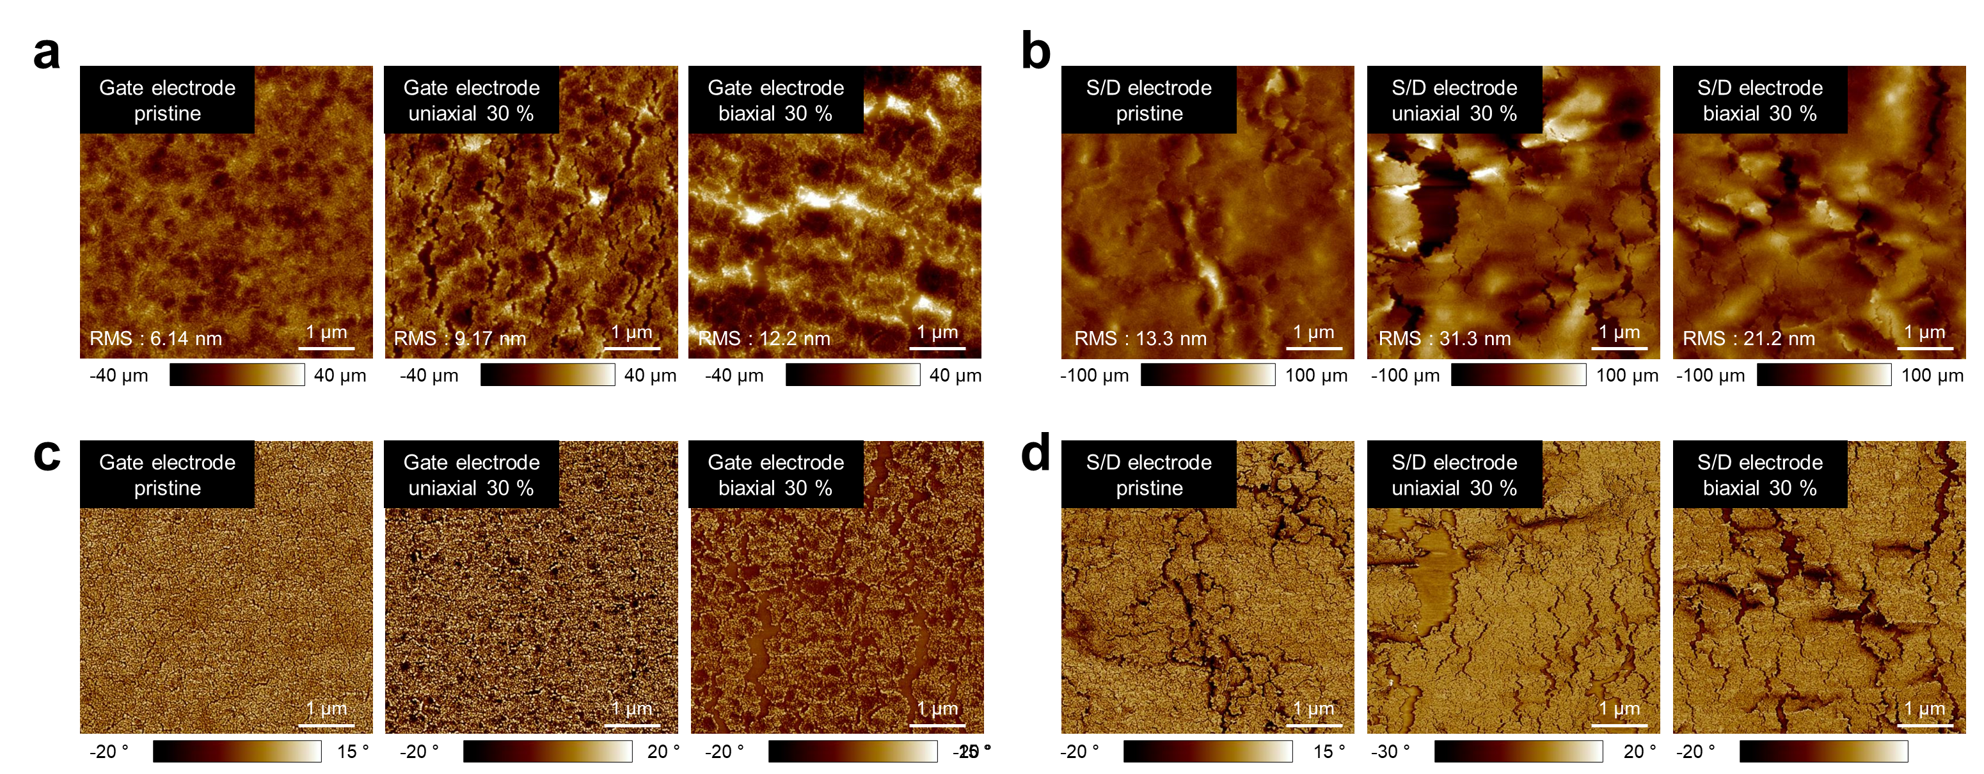

Extended Data Fig. 4. AFM a,b, height and c,d, phase images of Ag metallized SHE substrate for gate and DPPT-TT:SEBS semiconductor for source and drain on 0% (left), 30% uniaxial (middle), and biaxial (right) strains, respectively.

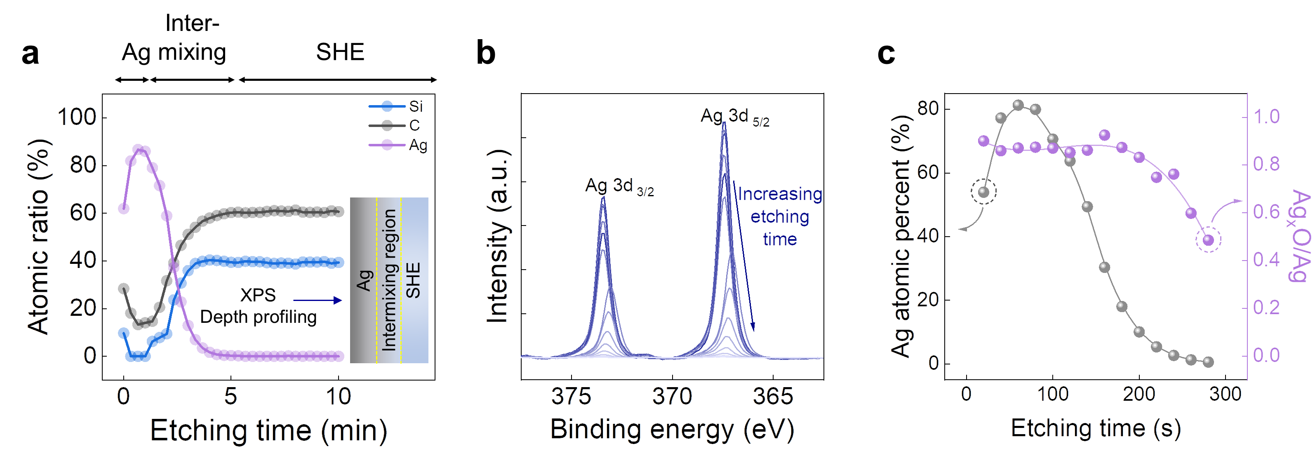
Extended Data Fig. 5. a, XPS depth profiling of Ag/SHE film. b, XPS spectra of Ag 3d peak and c, Ag atomic percent and Ag_{x}O/Ag ratio as a function of etching time.

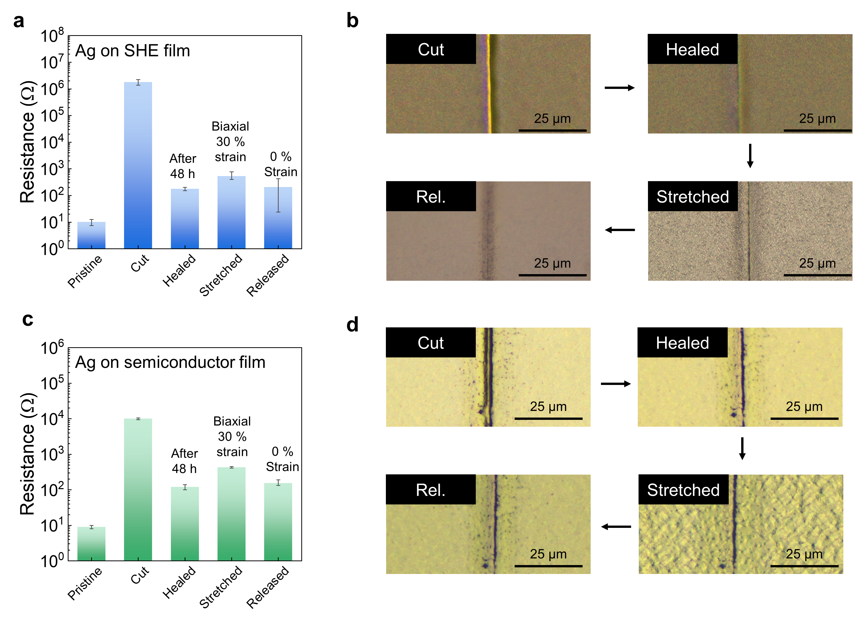

Extended Data Fig. 6. a, Resistance changes (n = 3) and b, OM images of silver electrode on SHE films for a healing cycle in sequence of cutting (3 μm cut width), healing (after 48 h), stretching (30 % biaxially strain after healing) and releasing strain (0% strain). c, Resistance changes (n = 3) and d, OM images of silver electrode for a healing cycle in sequence of cutting (3 μm cut width), healing (after 48 h), stretching (30 % biaxially strain after healing) and releasing strain (0% strain). All processes were conducted at room temperature.

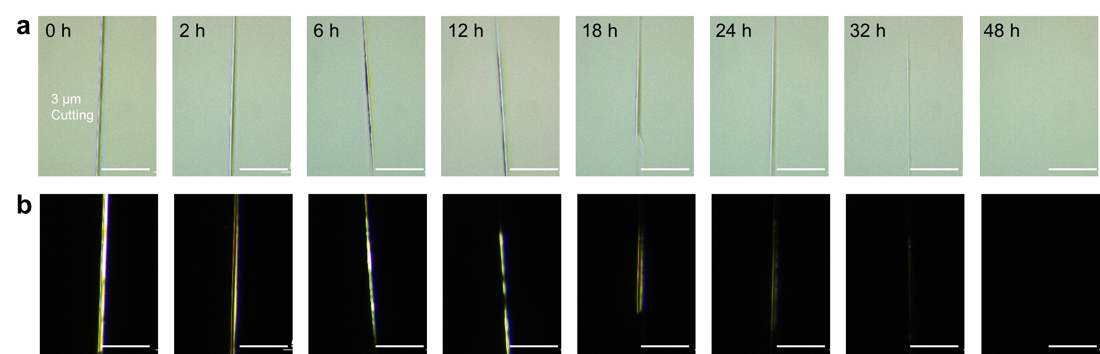

Extended Data Fig. 7. OM images of SHE dielectric film for autonomous healing as a function of time at room temperature: a, bright field images and b, dark field images. Cutting width is about 3 μm.

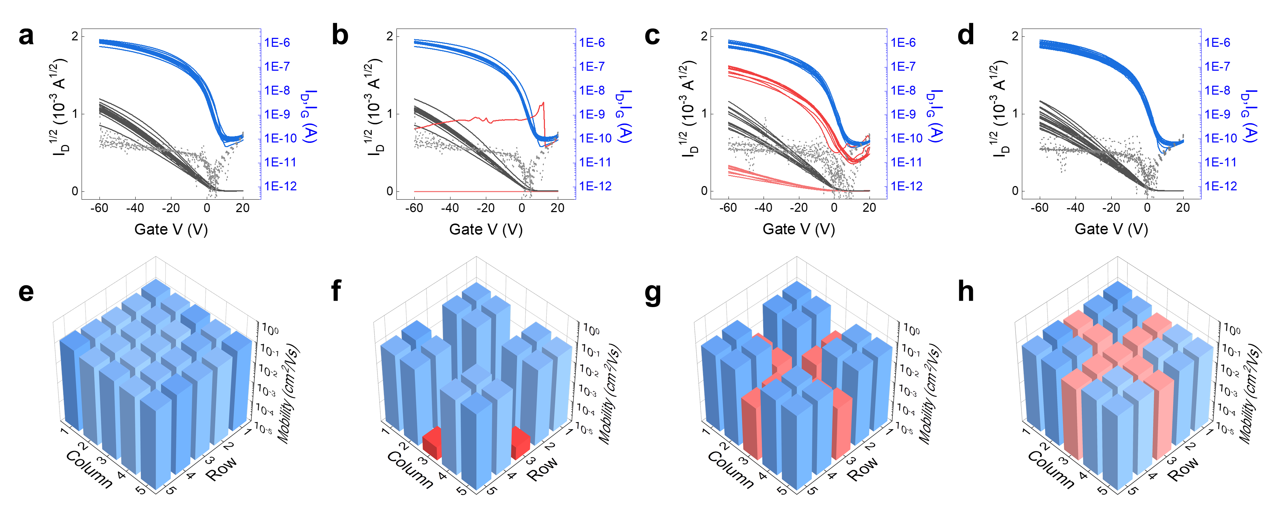

Extended Data Fig. 8. Autonomous self-healing process of 5 by 5 transistor array. Transfer characteristics of a, pristine, b, cut, c, healing, d, healed states at room temperature. Field effect mobility mapping of e, pristine, f, cut, g, healing (24 h), h, healed (48 h) states in 5 by 5 passive arrays. The cutting was conducted in a cross shape, along rows and columns, through the center.

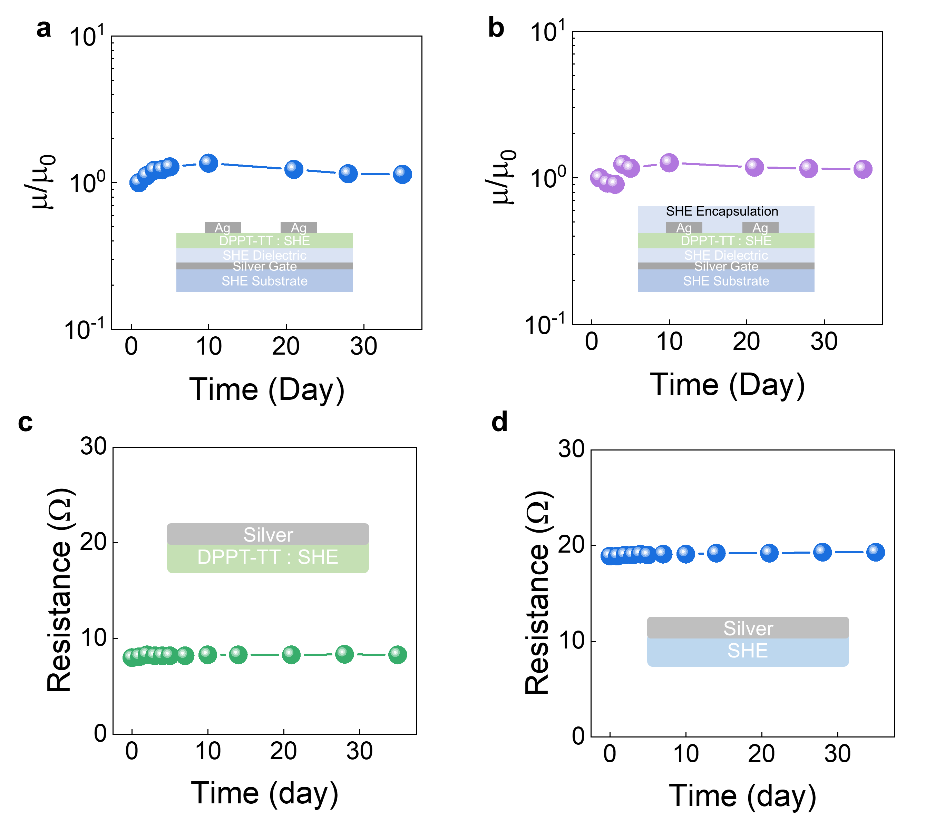

Extended Data Fig. 9. Normalized field-effect mobility changes in ambient air condition: a, without encapsulation and b, with SHE encapsulation. Resistance changes of silver electrode on c, semiconductor and d, SHE film in ambient air condition.

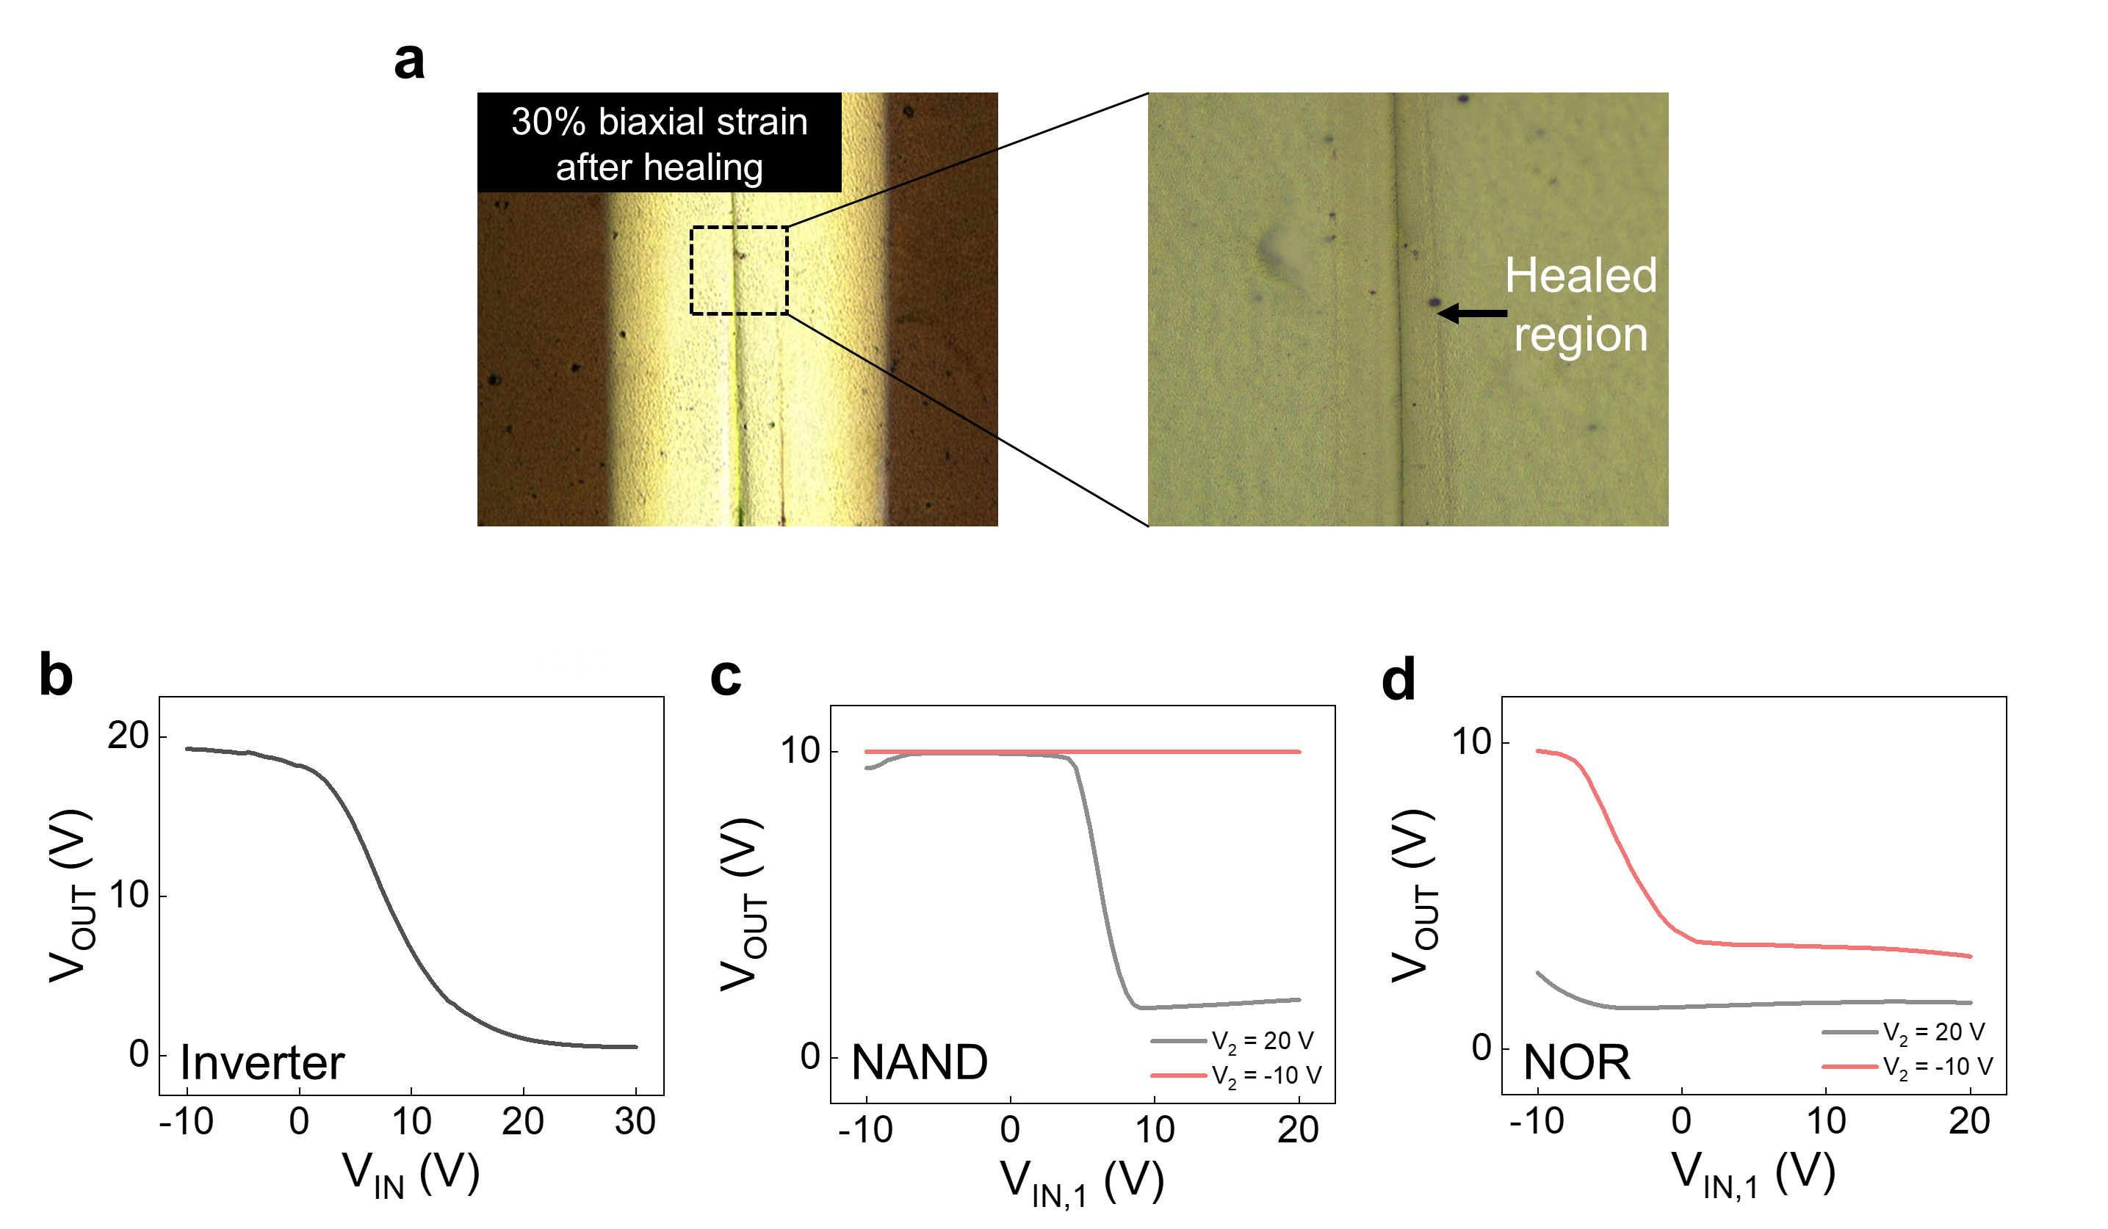

Extended Data Fig. 10. a, OM images of 30 % biaxially stretched drive transistor of healed logic device. VTCs of 30% biaxially stretched b, inverter, c, NAND and d, NOR logic device after healing.

