Supporting Information
Dual Interstitials Doping to Advance PbSe Thermoelectric at Wide Temperatures

Liqing Xu,^{1,2} Xiaoying Wang,¹ Yang Wang,¹ Zhibin Gao,¹ Xiangdong Ding,¹ and Yu Xiao^{2,*}

¹State Key Laboratory for Mechanical Behavior of Materials, Xi'an Jiaotong University, Xi'an 710049, China.
²School of Materials and Energy, University of Electronic Science and Technology of China, Chengdu 611731, China.

*Corresponding author: xiaoyu@uestc.edu.cn

Supplementary Methods
Lorenz number calculation. According to the Single Parabolic Band (SPB) model, the Lorenz number (L) is used to evaluate the electronic thermal conductivity (κ_{ele}) with a Wiedemann-Franz law of κ_{ele}=LσT, where the σ is the electrical conductivity, T denotes working temperature. The L can be obtained by fitting the Seebeck coefficient (S) to the reduced chemical potential (η) with following equations:
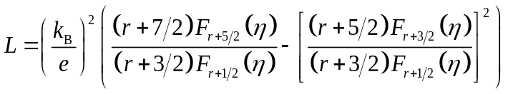 (S1)
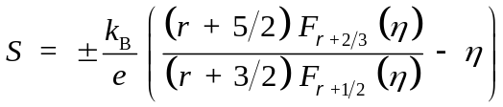 (S2)
where the F_{n}(η) is the n-th order Fermi integral:
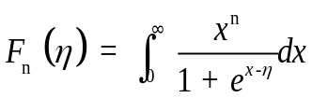 (S3)
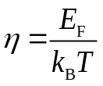 (S4)
where k_{B}, e and E_{F} denotes the Boltzmann constant, electron charge and Fermi level, r is the scattering factor, and the acoustic phonon scattering has been assumed as the main carrier scattering mechanism with r=-1/2.

Heat capacity calculation. The heat capacity in this work was theoretically evaluated by Debye model. The Debye model considers the individual contributions of phonons and effects of thermal expansion of lattice. The temperature-dependent total heat capacity (C_{p, tot}) can be obtained with following relationships:
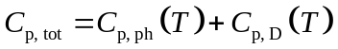 (S5)
where C_{p, ph} and C_{p, D} denote heat capacity originated from phonon and lattice dilation, respectively. The phonon heat capacity C_{p, ph} can be calculated by:
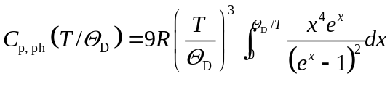 (S6)
where Θ_{D} is Debye temperature, R is molar gas constant, x=ℏω/k_{B}T, in which ℏ and ω denotes reduced Planck constant and phonon vibration frequency, respectively.
The effects of lattice dilation on heat capacity C_{p, D} can be obtained from:
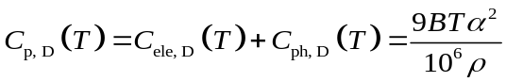 (S7)
where B is the isothermal bulk modulus, α is the linear coefficient of thermal expansion, and ρ is sample density. Notably, the electron heat capacity is not taken into account due to its negligible effects on lattice dilation compared with phonon.

Supplementary Figure 1. Phase identification of Pb_{1+x}Se (x=0.00-0.03) and Pb_{1.02}Se-y%Cu (y=0.0-1.0). (a) PXRD patterns. (b) Lattice parameter as a function of fraction x (%). (c) PXRD patterns. (d) Lattice parameter as a function of fraction y.

Supplementary Figure 2. Electrical transport properties in Pb_{1+x}Se (x=0.005-0.030) and Pb_{1.02}Se-y%Cu (y=0.0-1.0). (a) Room-temperature carrier density and carrier mobility as a function of fraction x (%). (b) Room-temperature carrier density and carrier mobility as a function of fraction y.
Supplementary Figure 3. Thermoelectric transport properties in Pb_{1+x}Se (x=0.005-0.030). (a) Electrical conductivity. (b) Seebeck coefficient. (c) Power factor. (d) Total thermal conductivity. (e) Lattice thermal conductivity. (f) ZT values.

Supplementary Figure 4. Thermoelectric properties in Pb_{1+x}Se (x=0.005-0.030). (a) Thermal diffusivity. (b) Heat capacity. (c) Lorenz number. (d) Electronic thermal conductivity.

Supplementary Figure 5. Thermoelectric transport properties in Pb_{1.02}Se-y%Cu (y=0.0-1.0). (a) Electrical conductivity. (b) Seebeck coefficient. (c) Power factor. (d) Total thermal conductivity. (e) Lattice thermal conductivity. (f) ZT values.

Supplementary Figure 6. Thermoelectric properties in Pb_{1.02}Se-y%Cu (y=0.0-1.0). (a) Thermal diffusivity. (b) Heat capacity. (c) Lorenz number. (d) Electronic thermal conductivity.

Supplementary Figure7. Phase identification and carrier density of PbSe, Pb_{1.02}Se, PbSe-0.2%Cu and Pb_{1.02}Se-0.2%Cu. (a) PXRD patterns. (b) Lattice parameter and carrier density.
Supplementary Figure 8. Defects formation energies for Pb-rich condition as a function of Fermi energy in PbSe. The energy level is reference to the valence band maximum (VBM) of the host.^{[5]}

Supplementary Figure 9. Electron localization functions (ELF) for (a) pristine PbSe and (b) PbSe with Pb interstitial, Cu interstitial and Se vacancy.

Supplementary Figure 10. Microstructural characterization of the pristine PbSe. (a) The low magnification annular dark filed (ADF) image. (b) The enlarged STEM image. (c) The presence of a large number of intrinsic Pb vacancies.

Supplementary Figure 11. The interstitial Cu atoms observed from the [100] axis. (a) The low magnification annular dark filed (ADF) image. (b) The enlarged high angle annular dark field (HAADF) STEM image and (c) its corresponding annular bright field (ABF) STEM image.

Supplementary Figure 12. Thermoelectric transport properties in Pb_{1.02}Se, PbSe-0.2%Cu and Pb_{1.02}Se-0.2%Cu. (a) Thermal diffusivity. (b) Heat capacity. (c) Lorenz number. (d) Electronic thermal conductivity.

Supplementary Figure 13. Comparison of thermoelectric transport performance in n-type PbSe-based thermoelectric materials with interstitial doping. (a) PF_{ave} values in 300-773 K. (b) ZT_{ave} values in 300-773 K.
Supplementary Table 1. Carrier density, effective mass and carrier mobility in Pb_{1+x}Se (x=0.005-0.030), PbSe-0.2%Cu and Pb_{1.02}Se-y%Cu (y=0.2-1.0).
Samples |  | n (10¹⁸ cm⁻³) | m* (m_{e}) | μ (cm² V⁻¹ s⁻¹)
Pb_{1+x}Se | x=0.005 | 2.67 | 0.51 | 618.21
Pb_{1+x}Se | x=0.010 | 2.76 | 0.50 | 716.84
Pb_{1+x}Se | x=0.015 | 2.94 | 0.45 | 744.30
Pb_{1+x}Se | x=0.020 | 3.13 | 0.44 | 843.40
Pb_{1+x}Se | x=0.025 | 3.32 | 0.45 | 741.84
Pb_{1+x}Se | x=0.030 | 3.43 | 0.46 | 751.32
PbSe-0.2%Cu |  | 16.92 | 0.43 | 772.77
Pb_{1.02}Se-y%Cu | y=0.2 | 12.64 | 0.54 | 600.87
Pb_{1.02}Se-y%Cu | y=0.4 | 22.36 | 0.51 | 546.60
Pb_{1.02}Se-y%Cu | y=0.6 | 29.22 | 0.53 | 498.53
Pb_{1.02}Se-y%Cu | y=0.8 | 33.92 | 0.53 | 468.22
Pb_{1.02}Se-y%Cu | y=1.0 | 34.29 | 0.53 | 486.15

Supplementary References
- G. Kresse, J. Furthmüller, Phys. Rev. B 1996, 54, 11169.
- G. Kresse, J. Furthmüller, Comp. Mater. Sci. 1996, 6, 15.
- G. Kresse, D. Joubert, Phys. Rev. B 1999, 59, 1758.
- J. P. Perdew, A. Ruzsinszky, G. Csonka, O. Vydrov, G. Scuseria, L. Constantin, X. Zhou, K. Burke, Phys. Rev. Lett. 2008, 100, 136406.
- X. Qian, D. Wang, Y. Zhang, H. Wu, S. Pennycook, L. Zheng, P. Poudeu, L.-D. Zhao, J. Mater. Chem. A 2020, 8, 5699.

