Additional file 1
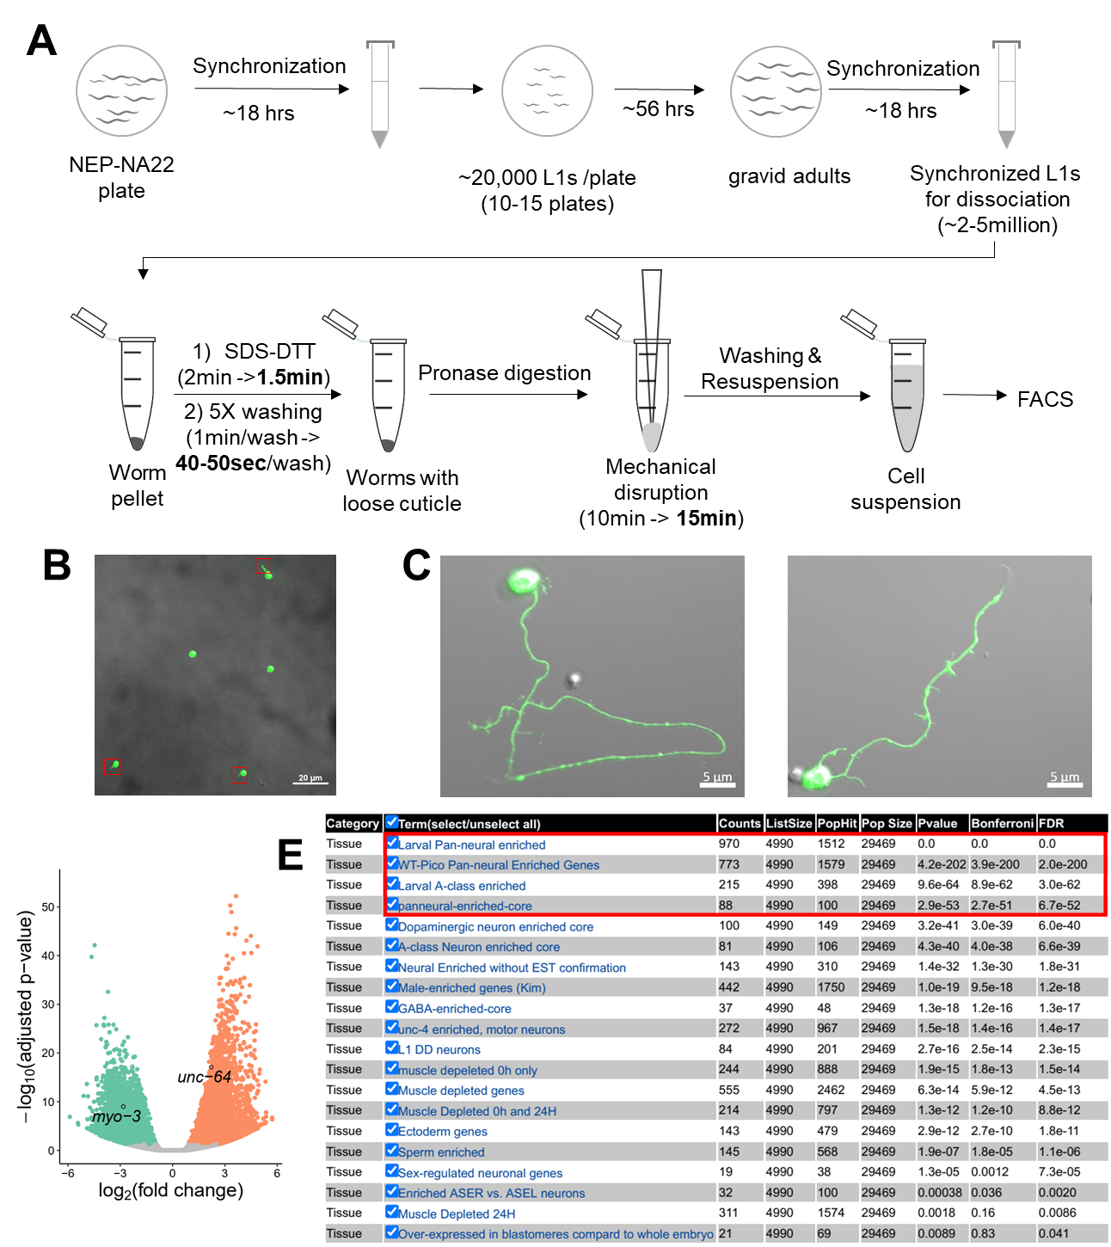

Figure S1. Dissociation and sorting of L1 worms.
(A) Steps of L1 worm preparation and dissociation for FACS. Optimized conditions are in bold.
(B) Representative confocal image of sorted cells. Note the short neurites (red rectangles) of some cells. Scale bar: 20 μm.
(C) Confocal images showing sorted neurons after five-day culture at 20ºC. Scale bars are 5 μm. (D) Volcano plot showing differentially expressed genes between the sort group and the whole group. myo-3 and unc-64 are labeled.
(E) Output from WormExp for gene set enrichment search using upregulated genes in the neurons in our dataset. Red rectangle highlights the top 4 hits.

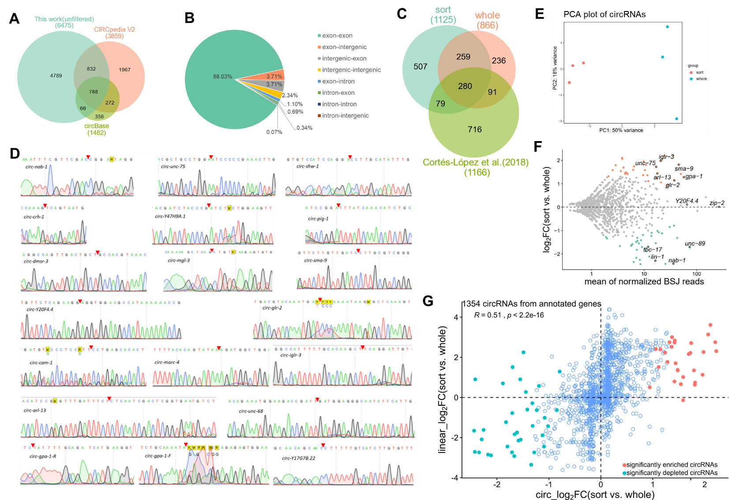
Figure S2. circRNA analysis and experimental validation.
(A) Overlap of circRNAs identified in this work and circRNAs of C. elegans in two databases (CIRCpedia V2 and circBase).
(B) Ratios of junction types of filtered circRNAs.
(C) Overlap of filtered circRNAs in this work and filtered circRNAs in work of Cortés-López et al (1).
(D) Sanger sequencing results of the BSJ sequences of selected circRNAs. Red triangles denote the joint sites.
(E) PCA plot of circRNAs in the sort group and the whole group.
(F) MA plot showing differentially expressed (DE) circRNAs between the sort group and the whole group. Significantly DE circRNAs are highlighted by colors. The gene names of some circRNA genes are labeled.
(G) Scatter plot showing the correlation of log2 fold change of circRNAs and their cognate linear RNAs in the sort group and whole group. The Pearson correlation coefficient (R) and p value (p) are shown. Significantly DE circRNAs are shown by colored dots.

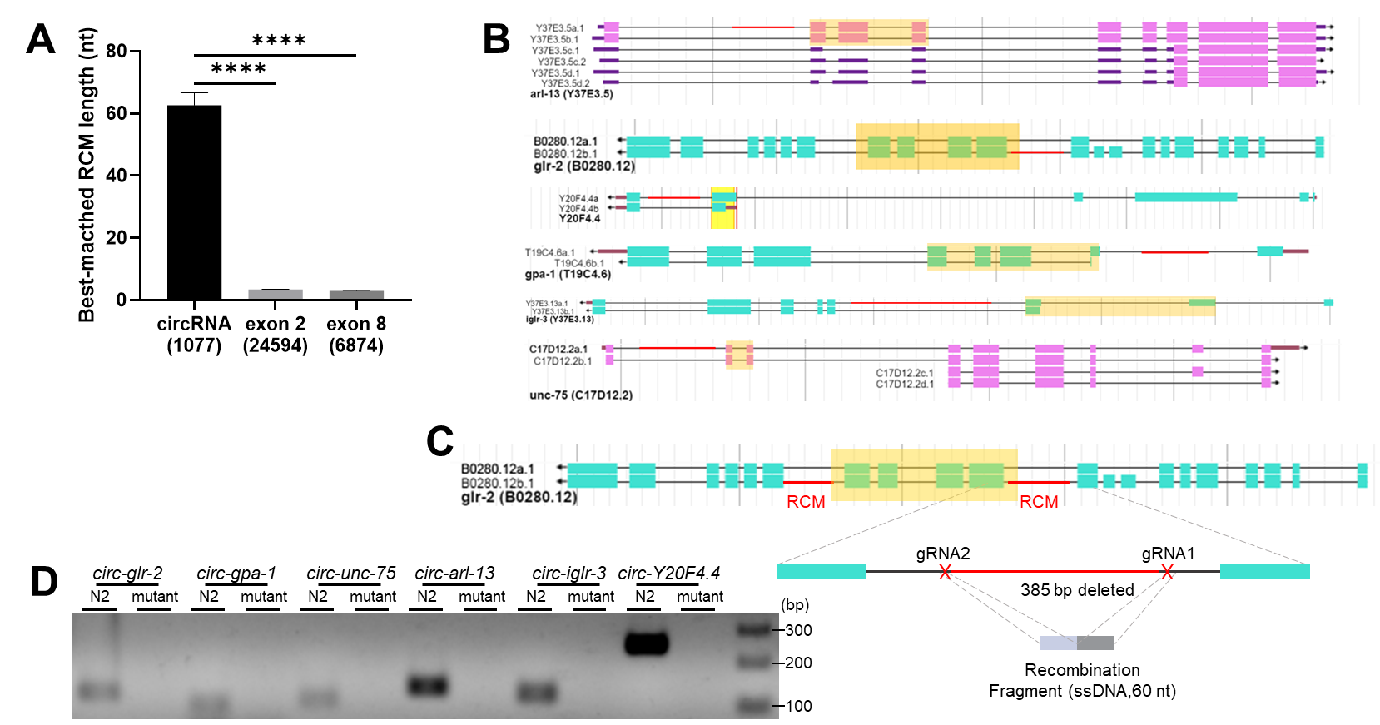
Figure S3. circRNA-flanking intron analysis and RCM deletions in circRNA genes.
(A) Lengths of best-matched RCMs in one pair of circRNA-flanking introns compared with those in non-circRNA control exons (exon 2 and exon 8). Values are shown as mean ± SEM. Numbers in the brackets are numbers of intron pairs for analysis. p values are from Kruskal-Wallis test with Dunn’s post-hoc test for multiple comparisons. ****, p < 0.0001.
(B) Positions of deleted RCMs (red line) of the 6 circRNA genes. Exons in orange shadows are to form circRNAs.
(C) Illustration of RCM deletion in glr-2. Red lines in introns are RCMs. Red crosses denote gRNA positions.
(D) Cropped gel image of amplification of circRNA using divergent primers in wildtype N2 strain and RCM-deletion strains (mutant) of 6 circRNA genes.

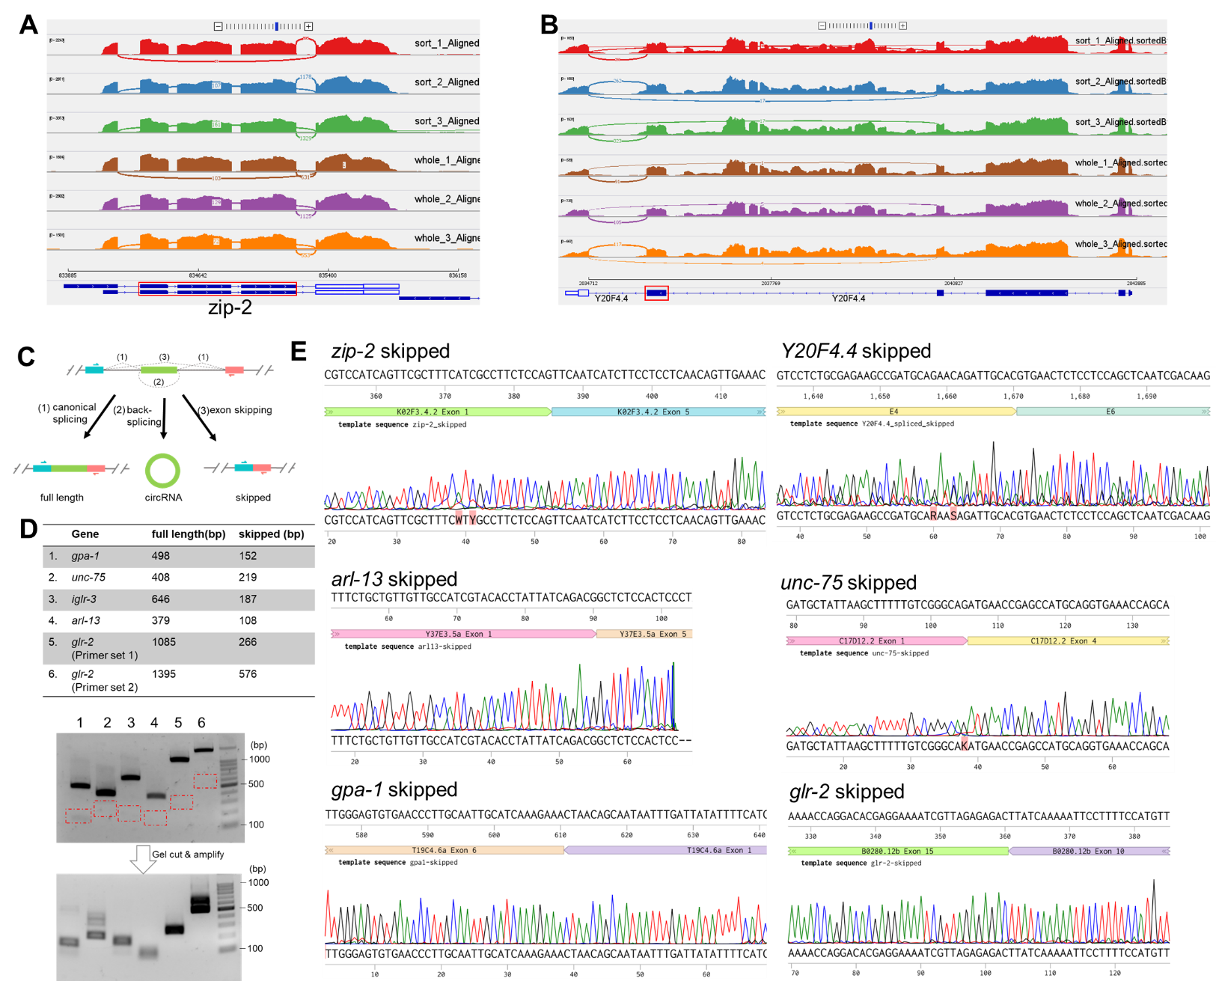
Figure S4. Skipped transcripts in circRNA genes.
(A & B) Sashimi plots showing the number of exon-skipping junction reads in zip-2 and Y20F4.4 in our RNA-seq dataset. Exon(s) in red rectangles are circularized to form circRNAs.
(C) Illustration of a circRNA-producing gene producing 3 transcripts: full-length, circular and skipped. Primers used to detect both the full length and the skipped transcripts are shown.
(D) Amplification of the skipped transcripts from several circRNA genes by 2-round PCRs. Red rectangles mark the gel areas to be cut. Gel images were cropped for clarity.
(E) Confirmation of sequences of the skipped transcripts in 6 circRNA genes.

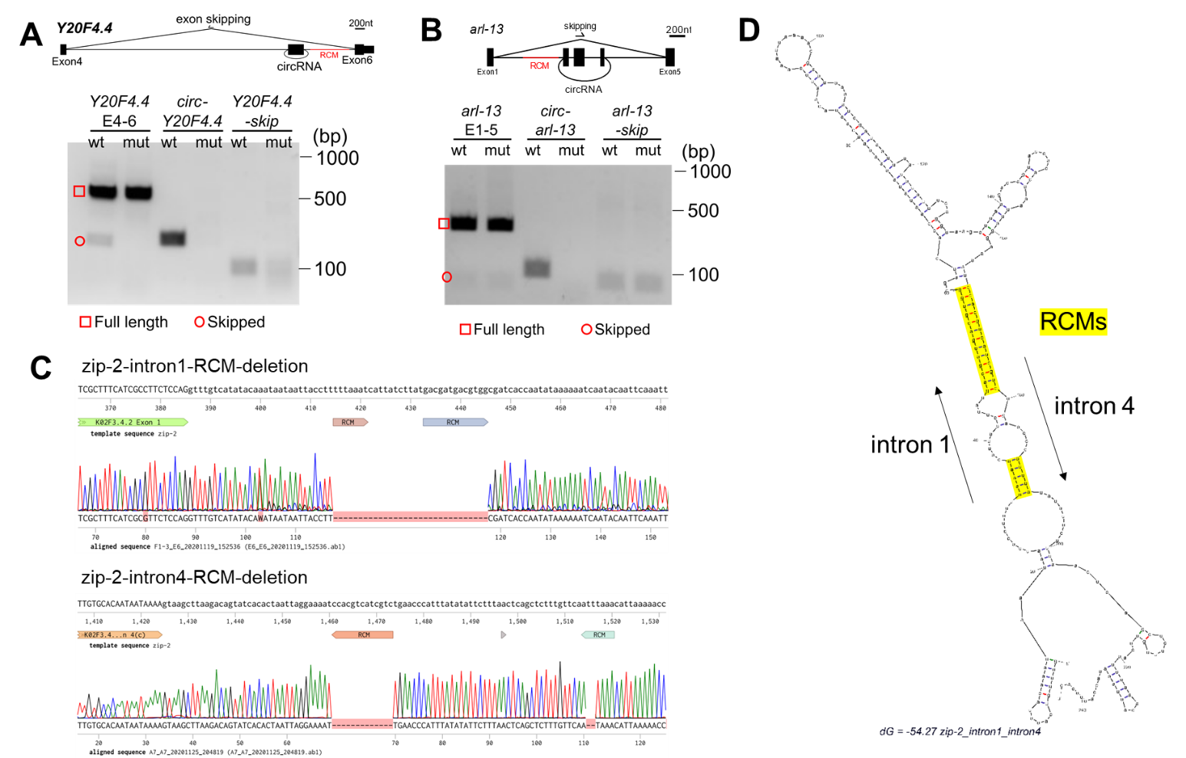
Figure S5. Effect of RCM-deletion on exon-skipping.
(A) RT-PCR detection of Y20F4.4 transcripts in wildtype N2 strain (wt) and the RCM-deleted Y20F4.4 strain (mut). Gel image was cropped for clarity.
(B) RT-PCR detection of arl-13 transcripts in wildtype N2 strain (wt) and the RCM-deleted arl-13 strain (mut). Gel image was cropped cropped for clarity.
(C) Deleted RCM sequences in intron 1 and intron 4 of zip-2.
(D) Folding prediction of intron 1 and intron 4 of zip-2 by Mfold (http://www.unafold.org/mfold/applications/rna-folding-form.php). RCM sequences are highlighted.

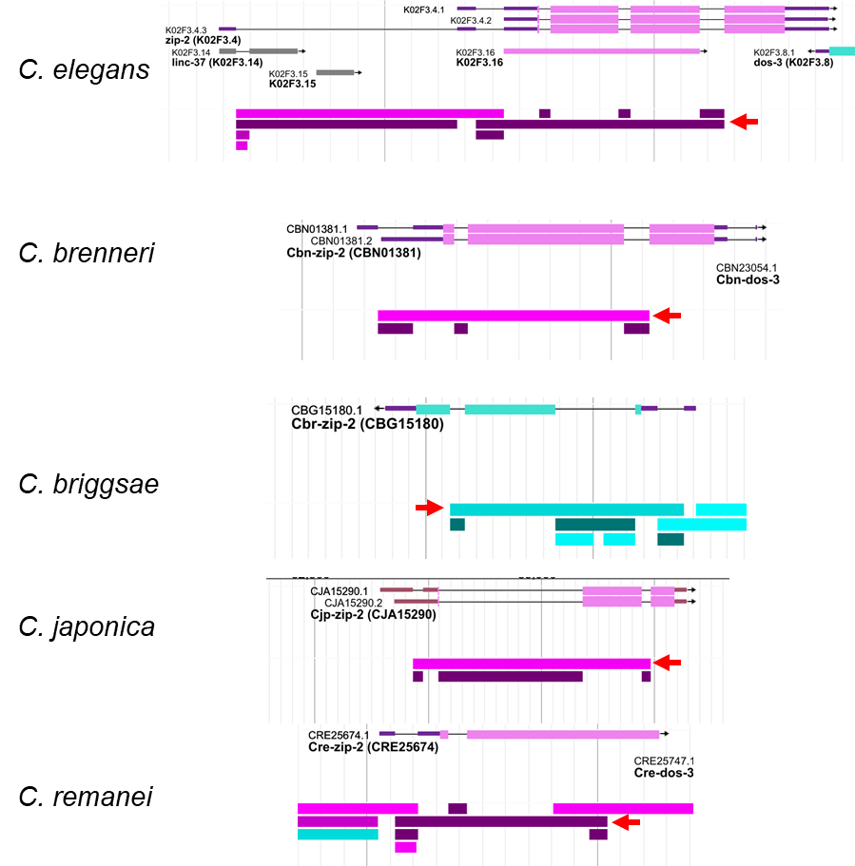
Figure S6. Gene structures of zip-2 ortholog genes.
Gene structures of ortholog zip-2 genes in indicated nematode species are shown. The splicing patterns of these genes are also shown (from WormBase). Red arrows indicate the splice junctions of the skipped transcripts.
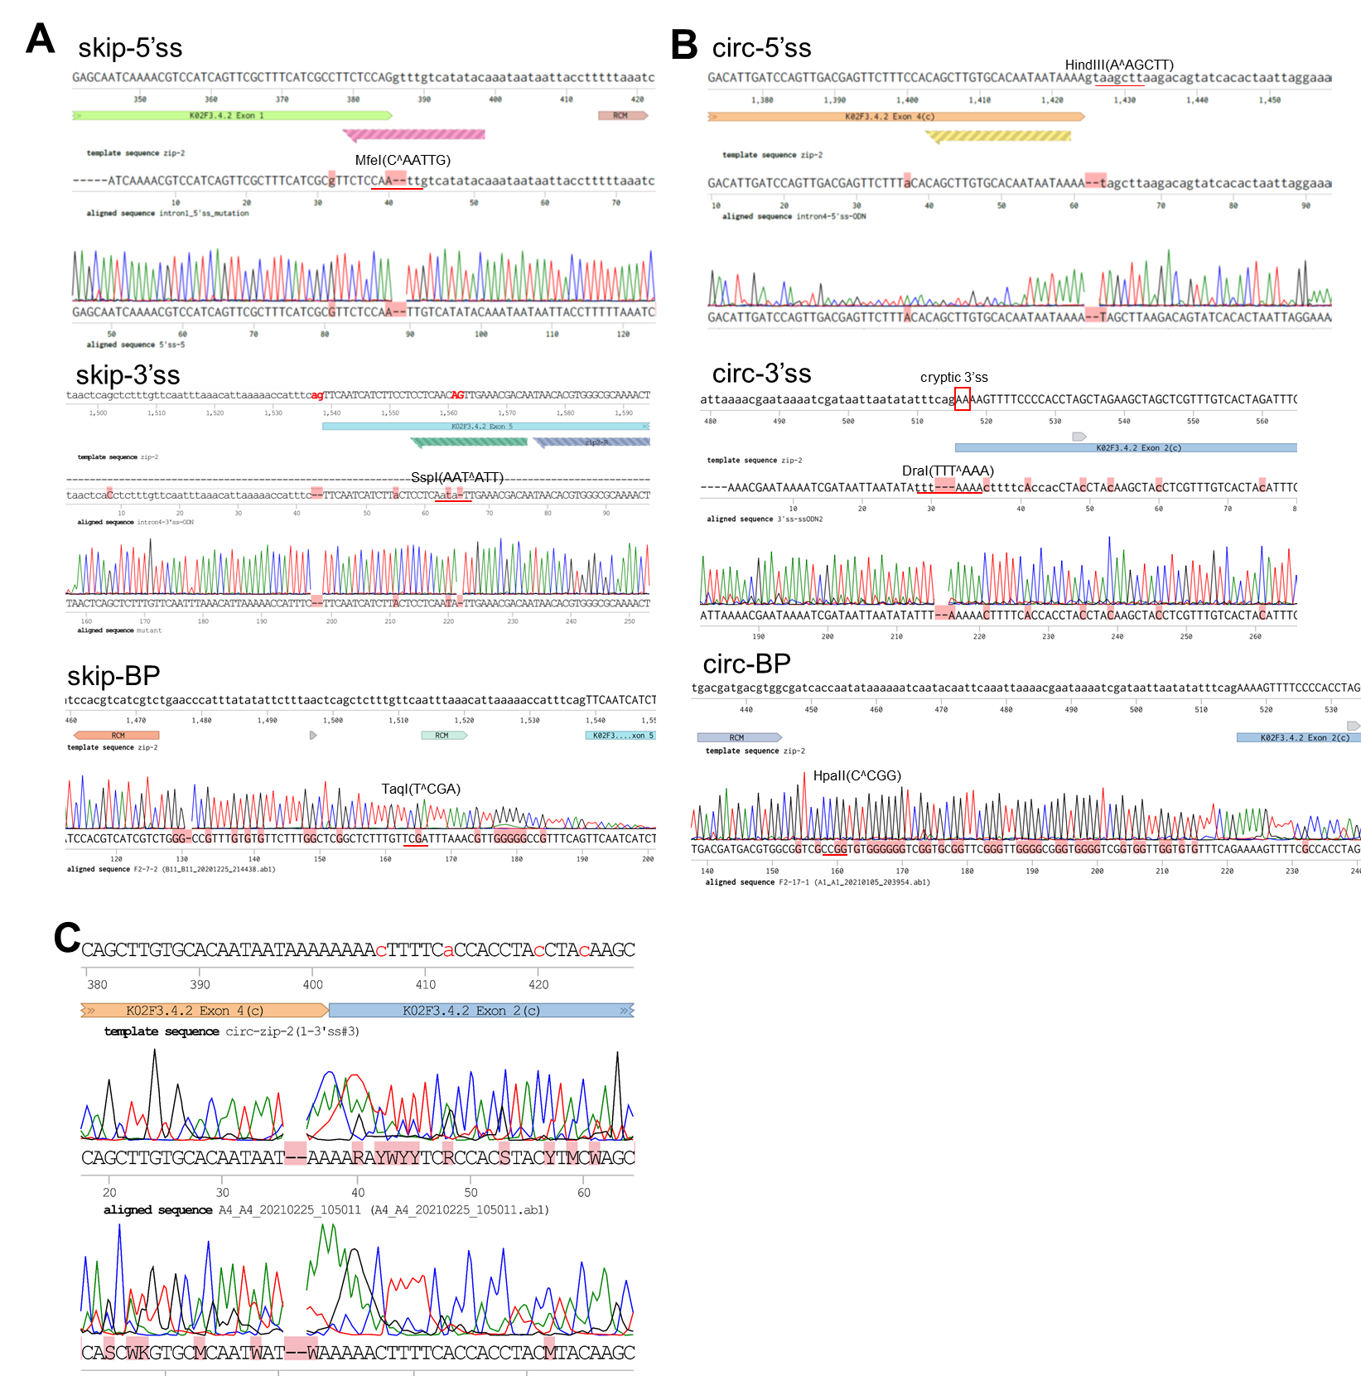
Figure S7. Sequence confirmation of mutated ss and BP sites in zip-2.
(A, B) Sanger sequence results of splicing sites and branch points mutation in intron 1 and intron 4 of zip-2. The enzyme digestion sites used to distinguish wildtype sequences and mutated sequences are labeled. The position of the cryptic 3’ss in circ-3’ss mutation is labeled.
(C) Sanger sequence of circ-zip-2 produced from the zip-2(circ-3’ss) strain. Note that amplified sequences are 2 nt shorter than the predicted BSJ sequences.

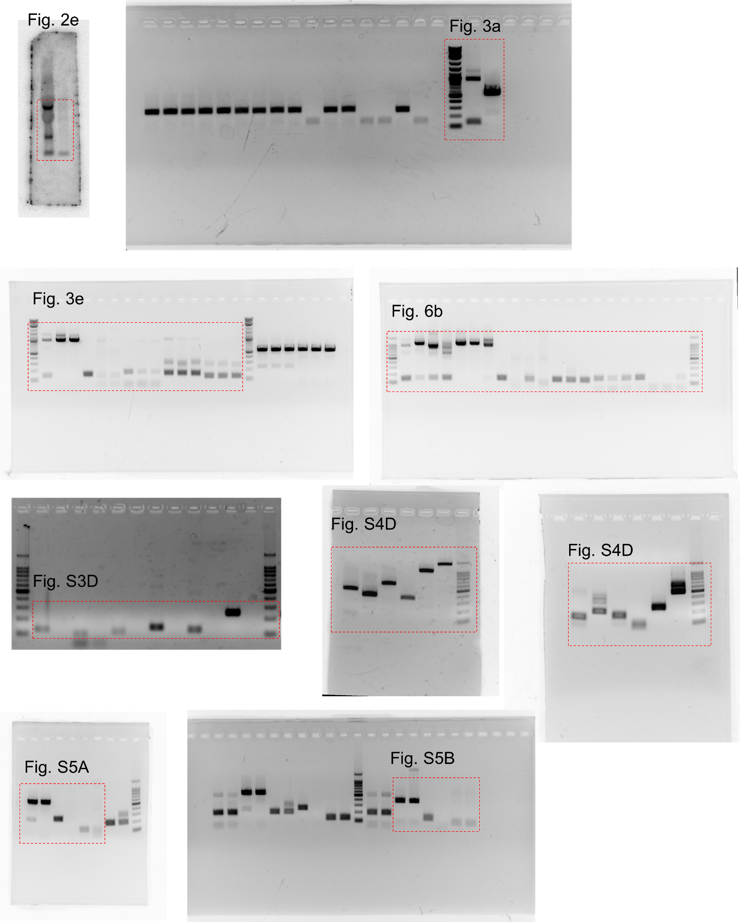
Figure S8: Orignial full images of northern blot and agarose gels. The corresponding figure numbers are labeled. Kept areas are in red rectanges.
References:
1. M. Cortes-Lopez et al., Global accumulation of circRNAs during aging in Caenorhabditis elegans. BMC Genomics 19, 8 (2018).

