Supporting Material
Effect of para-substituent on copolymerization and thermal degradation kinetics of styrene copolymers composed with maleic anhydride derivative
Changlei Yangª, Yanping Wangª, Yufei Liu^{a,b}, Jun Qin ^{c}, Min He^{a,}*, Shuhao Qin^{a,b}, and Jie Yu^{a,b}
ª Department of Polymer Material and Engineering, College of Materials and Metallurgy, Guizhou University, Guiyang 550025, China;
^{b} National Engineering Research Center for Compounding and Modification of Polymeric Materials, Guiyang 550014, China;

To whom correspondence should be addressed: liuyf@gzu.edu.cn (Y. Liu); hemin851@126.com (M. He).

1. Synthesis of monomer
1.1 Synthesis of NPMI
(a) The MAH (0.05 mol, 4.90 g) was accurately weighed using an electronic balance and dissolved in DMF(40.00 mL).
(b) The aniline (0.05 mol, 4.65 g) was dissolved in DMF(40.00 mL).
(c) The solution from (b) was dropwise added to the solution from (a) over a period of 15-30 min and the reaction was carried out at 25°C for 2 h.
(d) Anhydrous sodium acetate (AcNa, 0.012 mol, 1.00 g) and the chain transfer agent hydroquinone (0.008 mol, 0.85 g) were added to the mixture from (c).
(e) Acetic anhydride (AC2, 4.00 mL) was added to the mixture from (d) and the temperature was raised to 50°C for 2 h.
(f) After cooling, the resulting solution from (e) was poured onto crushed ice, left to stand for 3-5 min, filtered, and washed with distilled water. The obtained filter cake was dried at 40°C and subjected to recrystallization. The resulting pale yellow crystals had a yield of 76.8% and a melting point of 89.5°C. ¹H NMR (400 MHz, CDCl₃) δ 7.47 (t, J = 7.6 Hz, 2H), 7.36 (dd, J = 16.6, 7.3 Hz, 3H), 6.85 (s, 2H). ¹³C NMR (101 MHz, CDCl₃) δ 169.56 (s), 134.23 (s), 131.22 (s), 129.18 (s), 127.92 (s), 126.02 (s).
1.2. Synthesis of CPMI
(a) The MAH (5.50 mol, 539.00 g) was accurately weighed and dissolved in DMF(2000 mL).
(b) The p-aminobenzoic acid (5.00 mol, 685.00 g) was dissolved in DMF(1000 mL).
(c) The solution from (b) was dropwise added to the solution from (a) over a period of 15-30 min and the reaction was carried out at 25°C for 2 h.
(d) The catalyst AcNa (1.22 mol, 100.00 g), the chain transfer agent hydroquinone (0.77 mol, 85.00 g), and the dehydrating agent acetic anhydride (500.00 mL) were added to the mixture from (d) and the temperature was raised to 55-60°C for 2 h.
(e) After the reaction, the solution was cooled to room temperature and poured into an excess mixture of ice and water, left to stand for 3-5 min, and filtered. The obtained filter cake was repeatedly washed with distilled water and then dried at 50°C. The yield of the product was 93% with a melting point of 240.3°C.¹H NMR (400 MHz, DMSO) δ 13.09 (s, 1H), 8.06 (d, J = 8.7 Hz, 2H), 7.51 (d, J = 8.7 Hz, 2H), 7.23 (s, 2H). ¹³C NMR (101 MHz, DMSO) δ 170.00 (s), 167.34 (s), 135.97 (s), 135.28 (s), 130.39 (s), 130.03 (s), 126.58 (s).
1.3. Synthesis of FPMI
(a) The MAH (5.50 mol, 539.00 g) was accurately weighed and dissolved in DMF(2500.00 mL).
(b) The fluorobenzene amine (5.8 mol, 555.00 g) was dissolved in DMF(2500.00 mL).
(c) The solution from (b) was dropwise added to the solution from (a) over a period of 15-30 min and the reaction was carried out at 25°C for 2 h.
(d) The catalyst AcNa (1.22 mol, 100.00 g), the chain transfer agent hydroquinone (0.77 mol, 85.00 g), and the dehydrating agent acetic anhydride (500 mL) were added to the mixture from (c) and the temperature was raised to 55-60°C for 2 h.
(e) After cooling to room temperature, the reaction solution was poured into an excess mixture of ice and water, left to stand for 3-5 min, and then filtered. The obtained filter cake was repeatedly washed with distilled water and dried at 50°C. The resulting product was subjected to recrystallization, yielding rose gold-colored crystals with a yield of 93% and a melting point of 154.1°C.¹H NMR (400 MHz, DMSO) δ 7.36 (t, 2H), 7.30 (t, J = 8.9 Hz, 2H), 7.16 (s, 2H). ¹³C NMR (101 MHz, DMSO) δ 170.11 (s), 162.55 (s), 160.12 (s), 134.91 (s), 129.31 (s), 128.04 (s), 115.90 (s). ¹⁹F NMR (565 MHz, DMSO) δ 113.81 (s).

Figure S 1Synthesis roadmap of maleic anhydride derivative monomer

Figure S2 Melting points: (a) NPMI and (b) MAH

Figure S3 Melting points: (a) CPMI and (b) NPMI

Figure S4 Melting points: (a) FPMI, (b) NPMI and (c) CPMI

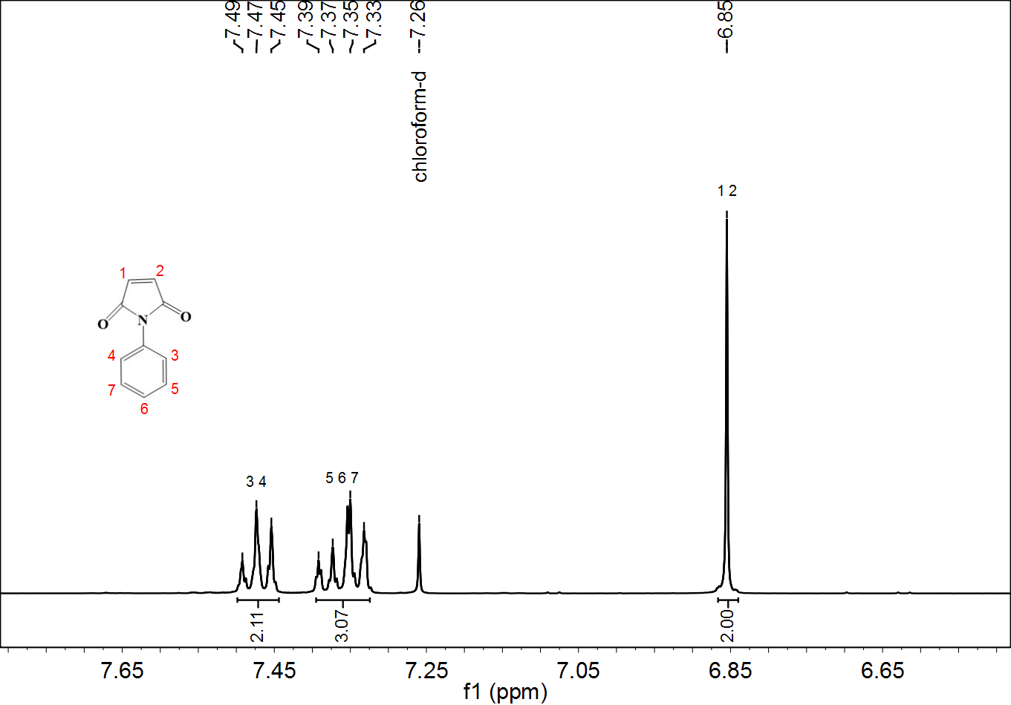
Figure. S5. ¹H NMR spectrum of NPMI

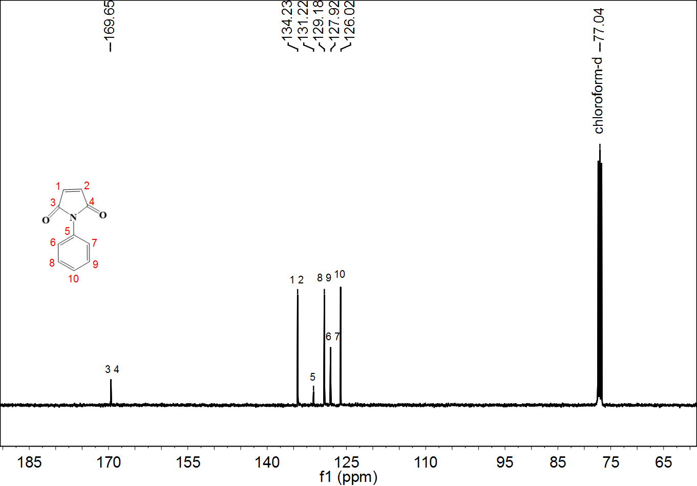附Figure. S6. ¹³C NMR spectrum of NPMI

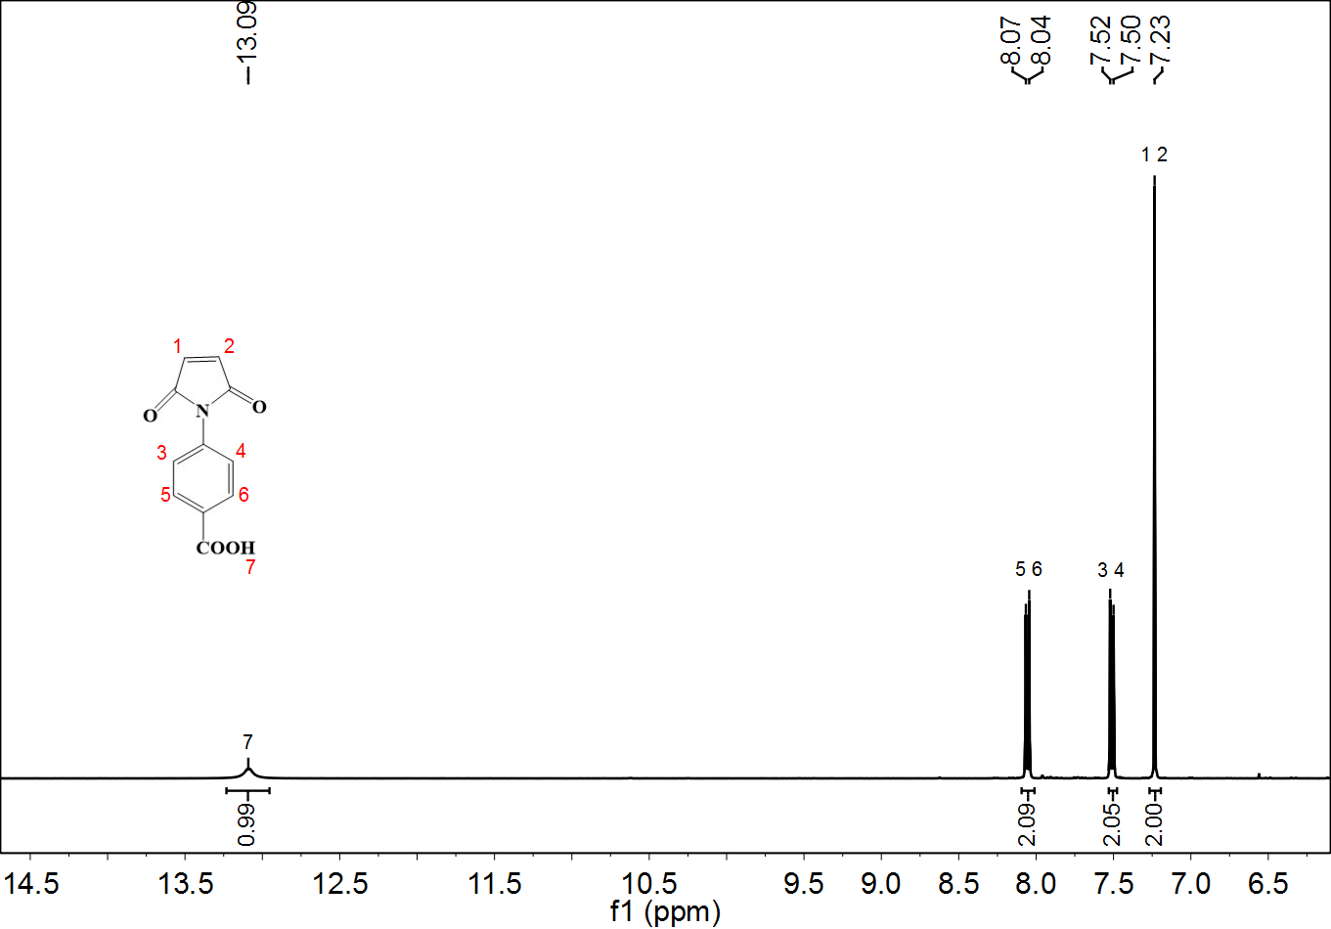Figure. S7. ¹H NMR spectrum of CPMI

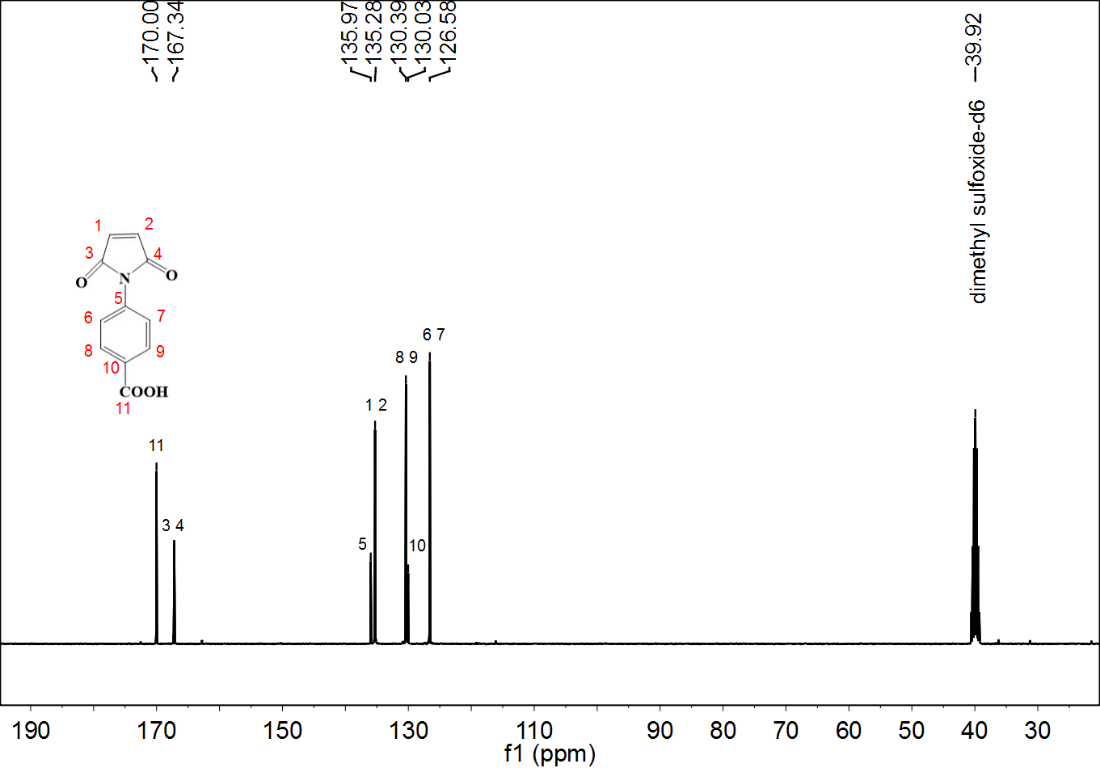
Figure. S8. ¹³C NMR spectrum of CPMI

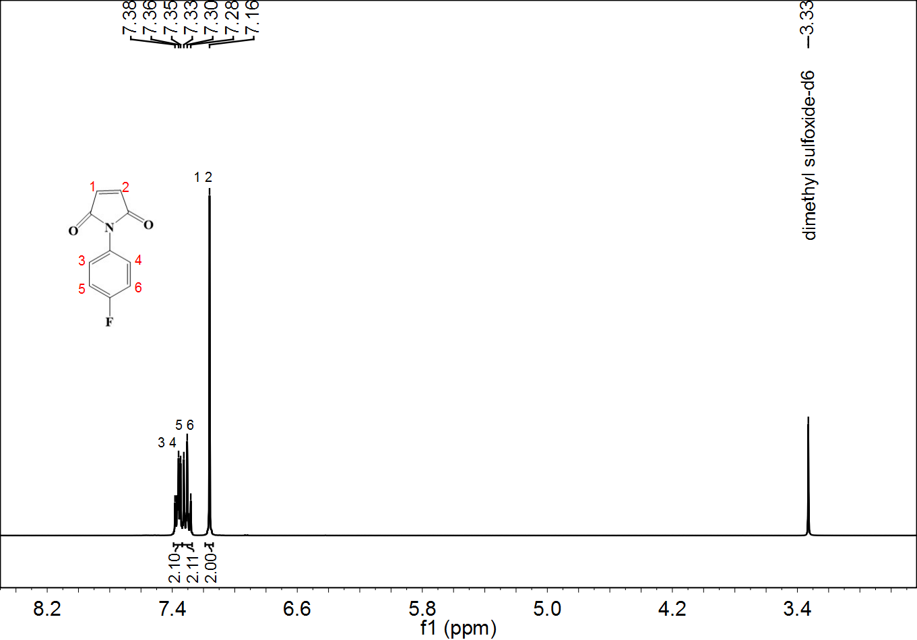
Figure. S9. ¹H NMR spectrum of FPMI

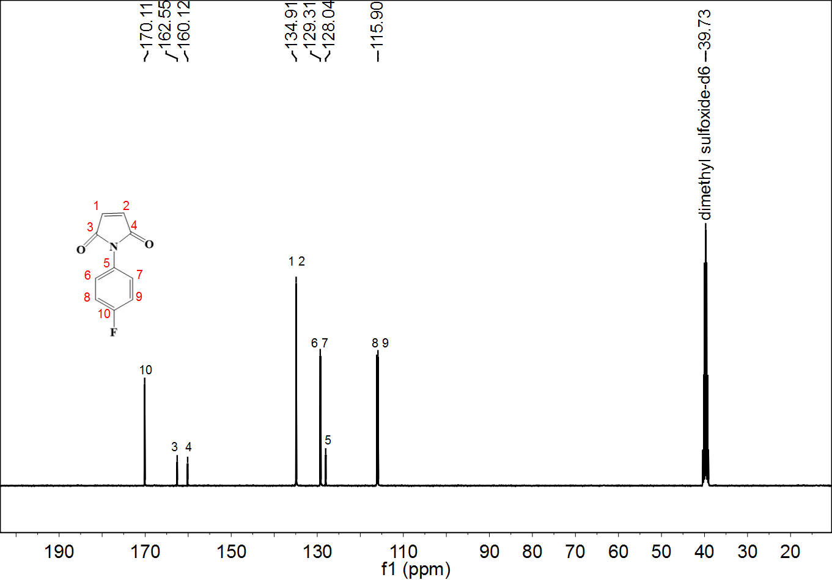
Figure. S10. ¹³C NMR spectrum of FPMI

Corresponding author. E-mail address: liuyf@gzu.edu.cn (Y. Liu); hemin851@126.com (M. He).

