A synchronous atmosphere-cryosphere-land response to climate at Northern Antarctic Peninsula, since Mid-Holocene

Heitor Evangelista¹, Sergei Verkulich², Bulat Mavlyudov³, Mariza P. Echer⁴, Marcus Vinicius Licinio⁵, Gerd Dercon⁶, Felipe García-Rodríguez^{7,8}, Arthur A. Neto⁹, Stephanie Kusch¹⁰, Rodrigo C. Abuchacra⁹, Anna B.J. Oaquim¹, Sérgio J. Gonçalves Jr.^{1*}, Zinaida Pushina², Marília H Shimizu¹¹, Maria Heiling⁶, Johanna Slaets⁶, Christian Resch⁶, Alejandra Castillo¹², Roman Gruber⁶

Supplementary material – A1

King George Island (KGI) climate, proglacial environment and sampling sites
KGI is the largest island of the South Shetland archipelago, located at the northwestern end of the Northen Antarctic Peninsula, between 61°54'S-62°06'S and 057°35'W-059°02'W. Its highest elevation is 702 m a.s.l., enclosing a total surface area of 1,250 km², of which 92% is covered by snow and ice. Most of the air masses acting at KGI derive from the Pacific sector of the Southern Ocean (classified as maritime polar; mP), from advections north and northwest at 60°S latitude (classified as maritime tropical; mT) (Fossum et al., 2018), and cold air incursions from continental Antarctica that bring extremely low temperatures to the region. This results in severe weather conditions of high instability that are constantly affected by synoptic systems carrying warm air, moisture accompanied by strong winds, snow and rain from lower latitudes (Bintanja, 1995; Ferron, et al., 2004). The local climate is classified as Maritime Antarctic, which is characterized by mean temperatures reaching above zero levels during the summer-to-autumn season and negative values during the remaining seasons, reaching average values around -6 °C in winter (Olivia et al., 2016).

This study focuses on two important ice-free areas of KGI: (a) Fildes Peninsula and (b) Admiralty Bay. Fildes Peninsula is the largest in extent and is located in the Southwestern sector of KGI bordered by the Drake passage, the Maxwell Bay and the Bellingshausen ice dome. According to Barsch and Mäusbacher (1986) Fildes Peninsula was still partially glaciated at altitudes between 15 m and 20 m prior to 6,000 to 5,000 yr B.P. The geomorphological features suggest rapid shrinking of the ice cover to nearly the present extent. Due to depressions created during moraine formation and the intense erosion from melting freshwater discharge during deglaciation, a lake sequence is found across the peninsula. At Fildes we have sampled two sediment cores in February 2015: one of them dating from the mid-Holocene at an “isolated” lake (Long Lake) and the other consisted of a shallow core retrieved in the catchment of Bellingshausen ice dome, dated from the beginning of the 20th Century.
A second important ice-free area on KGI is set on Admiralty Bay. This bay is formed by irregular fjords of tectonic origin containing inlets and coves and a deep main channel reaching to a maximum depth of 535 m. It is surrounded by temperate glaciers terminating on land and tidewater whose fronts terminate close the shoreline. Since the 1950s, progressive retreats of their ice front positionings have been reported (Braun and Gossmann, 2002). At the interface between the shoreline and the Warszawa icefield (WI) and Krakow icefield (KI), we have sampled seven shallow sediment cores, all dating from the beginning of the 20th Century, Fig A1-1. Table A1-1 provides geographic data of the shallow sediment cores sampled at KGI.

Table A1-1. Location and characteristics of the shallow sediment cores sampled at King George Is.

Site ID | Location | Latitude  (ºS) | Longitude  ( ºW) | Sediment core  length (cm) | Site  characteristics
01 | Hannequin Point | 62°07’18” | 058°23’45” | 8 | Water melting pond
02 | Patelnia A | 62°13’ 9” | 058°28’12” | 22 | Proglacial Lake
03 | Patelnia B | 62°13’ 3” | 058°28’6” | 15 | Proglacial lake
04 | Agat Point B | 62°10’8” | 058°26’8” | 16 | Proglacial lake
05 | Sphinks Glacier front A | 62°10’9” | 058°26’8” | 15 | Proglacial lake
06 | Sphinks Glacier front D | 62°11’6” | 058°43’9” | 26 | Water melting pond
07 | Glacier Sphinks front E | 62°11’6” | 058°26’37” | 23 | Water melting pond
08 | Bellingshausen  Glacier front | 62°10’46” | 058°54’39” | 38.5 | Proglacial lake

At all sites of Admiralty Bay, sampling was conducted in lakes immediately connected to glacier runoff. Sediments are delivered to these shallow lakes from erosion of the glacier drainage basins. Since the beginning of glacier monitoring at Admiralty Bay (mid 1950s), significant ice loss has been observed. It is estimated that approximately 22.5 km² of ice loss have occurred within the period 1956-2000 (Arigony, 2001). Glacier retreat has been mapped by compiling various data including digitalized maps, satellite images and a mosaic of satellite images (see Arigony, 2001), complemented by GPS field campaigns in 2005 and 2007. For the Baranowski glacier front retreat, the 1956 reference line was drawn from the King George map (scale of 1:100.000) made by the “Foreign and Commonwealth Office, BAS 1968”. The 1979 reference line was obtained using two maps: The Admiralty Bay Polish map (scale of 1:65.000), geo-referenced to the Gauss-Kruger projection and the map of the SSSI-8 region provided by the Polish Antarctic Program 2002 (scale of 1:12 500). Steps of retreat for 1988 and 1995 were obtained by satellite images SPOT-1 XS 725-478 and SPOT-3 XS 725-477, respectively, while an image gallery mosaic of SPOT satellite was used for the year 2000, as proposed by Braun et al. (2001).
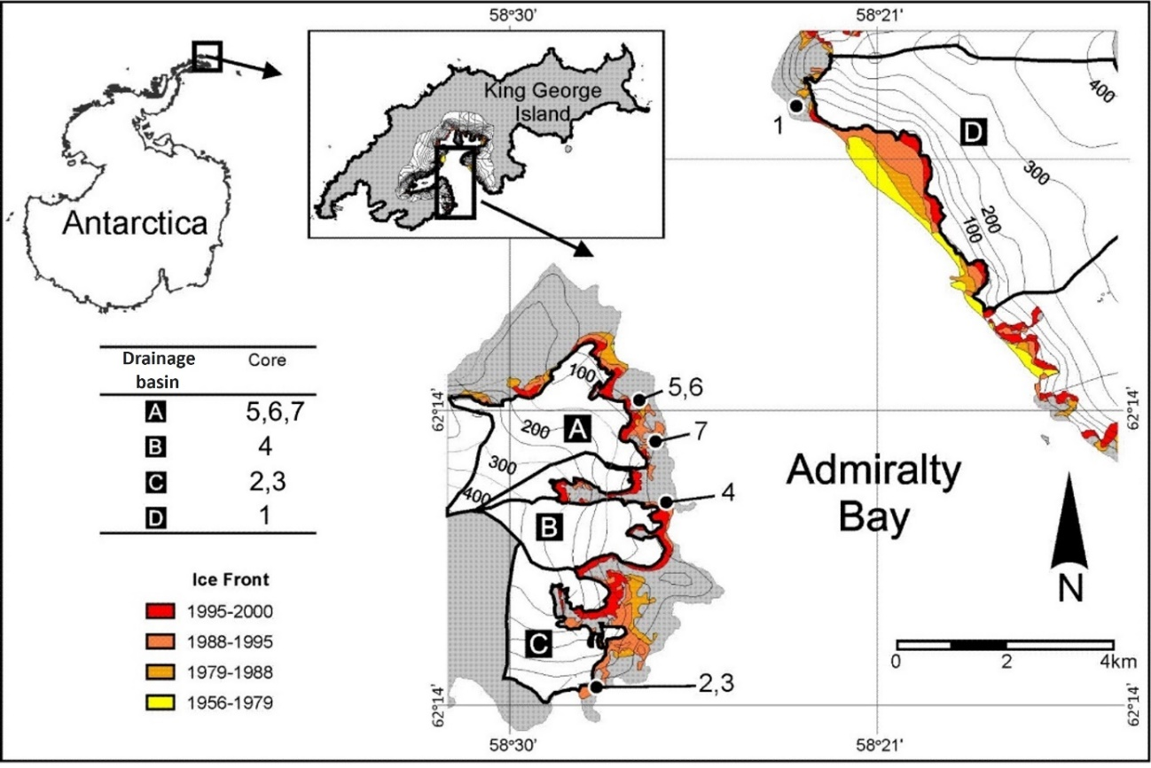
Figure A1-1. Location of proglacial lakes and sediment coring sites at Admiralty Bay and corresponding drainage basins. (adapted from: Rosa, et al., 2020).

With regard to the coring site at Fildes peninsula (length of 35 cm) sediments are delivered by erosion of small streams from sub-catchments associated to the Bellingshausen glacier.

Reference
Fossum, K.N., Ovadnevaite, J., Ceburnis, D. et al. (2018). Summertime Primary and Secondary Contributions to Southern Ocean Cloud Condensation Nuclei. Sci Rep 8, 13844. doi:10.1038/s41598-018-32047-4.

Bintanja, R. (1995). The local surface energy balance of the Ecology Glacier, King George Island, Antarctica: measurements and modelling. Antarctic Science, 7(03). doi:10.1017/s0954102095000435.

Ferron, F.A., Simões, F.C., Aquino, F.E., Setzer, A.W. (2004). Air temperature time series for King George Island, Antarctica. Pesquisa Antártica Brasileira 4: 155-169.

Oliva, M., Navarro, F., Hrbáček, F., Hernández, A., Nývlt, D., Pereira, P., … Trigo, R. (2017). Recent regional climate cooling on the Antarctic Peninsula and associated impacts on the cryosphere. Science of The Total Environment, 580, 210–223. doi:10.1016/j.scitotenv.2016.12.030.

Barsh, D., Mäusbacher, R. (1986). New data on the relief development of the South Shetland Islands, Antarctica.Interdisciplinary Science Review, v. 11, p. 211-219.

Braun, M., Gossmann, H. (2002). Glacial Changes in the Areas of Admiralty Bay and Potter Cove, King George Island, Maritime Antarctica Ecological Studies, 154 L. (eds.) Geoecology of Antarctic Ice-Free Coastal Landscapes. Springer-Verlag Berlin Heidelberg.75-89.

Arigony N., J., Simões, J. C., Bremer, U.F., Aquino, F.E. (2001). Detecção de Mudanças Ambientais na Antártica através de Dados de Sensoriamento Remoto e Mapas Históricos. Pesquisas Em Geociências, 28(2), 337–342. doi:10.22456/1807-9806.20307.

Braun M, Saurer H, Vogt S, Simões JC and Goßmann H. (2001). The influence of large-scale atmospheric circulation on surface energy balance on the ice cap of King George Island. Int J Climatol 21: 21–36

Rosa, K.K. da, Perondi, C., Veettil, B.K., Auger, J.D., Simões, J.C. (2020). Contrasting responses of land-terminating glaciers to recent climate variations in King George Island, Antarctica. Antarctic Science, 1–10. doi:10.1017/s0954102020000279.

Supplementary material – A2

South Shetland archipelago air temperature
An extended South Shetlands air temperature time series since 1968 was obtained from the Bellingshausen Russian station (62°11′55″S;058°57′38″W, 14 m a.s.l.) and March Station (Chilean Air Force) (62°11'27"S;058°59'12"W, 45 m a.s.l.) databases, both located at Fildes Peninsula/King George Is., and from the Deception Island station (62°58′31″S;060°41′52″W, 7 m) spanning the period 1947 to 1968 (Fig. A2-1).

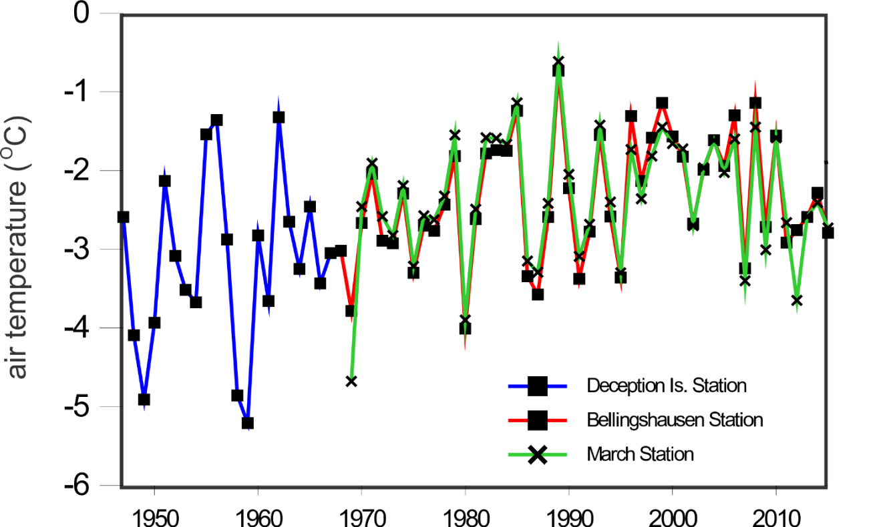
Figure A2-1. South Shetland mean annual air temperature time series from three Antarctic Stations.

Supplementary material – A3

Sedimentation rates and glacier surface melting
All eight shallow sediment cores presented similar sedimentation rate profiles, exhibiting a relatively steady increase in sedimentation rate towards the present with a rapid increase between the years 1990 and 2000. The averaged sedimentation rate is presented in Figure 2 of main text.
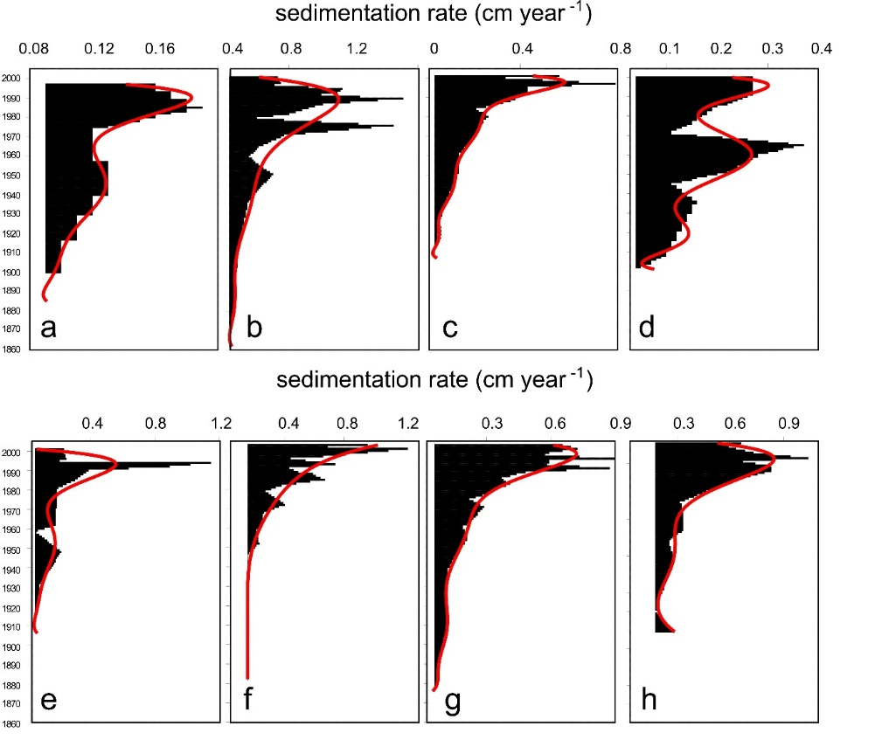
Figure A3-1. Proglacial lake sedimentation rates inferred by the ²¹⁰Pb-CRS chronological model measured at Admiralty Bay/King George Is.: (a) Hannequin Point, (b) Patelnia A, (c) Patelnia B, (d) Agat Point B, (e) Sphinks Glacier front A, (f) Sphinks Glacier front D, (g) Glacier Sphinks front E, and at Fildes Peninsula: (h) Bellingshausen Glacier front. See calculated mean sedimentation for all lakes in Fig. 1.

In order to infer the glacier surface snow melting, we carried out a rough analysis based on a field campaign at Ecology glacier/King George Island in 2005 making use of lysimeters and an AWS (automatic weather station) (Sakai et al., 2004). From the experiment we inferred a close relationship between the surface percolation and the air temperature measured by the AWS during the experiment (r=+0.9) (Figure A3-1a). During the field experiment, the lysimeters were elaborated with a set of eigth 15-cm-long cylindrical acrylic tubes of different diameter i.e., 10, 15, 20 and 25 cm. The tubes were gently pushed into the snow surface with minimum disturbance. Then flasks were filled up with snow, weighed and reintroduced in the snow in a way that the flaks surfaces were parallel to the plan snow field. This set was positioned 5 m from an in situ AWS. Half of the flasks had eyelets in the bottom surface. The set of tubes were exposed to the free atmosphere for 24 hours and reweighed thereafter. The difference of mass in flasks without eyelets was attributed to evaporation while the difference of mass in flasks with eyelets reflect combined evaporation and percolation. The difference in mass between both sets provided the percolation. For each 24-hour period, we obtained the percolation as g/m²/s. To extend the results to the whole glacier basin, we have multiplied the mean percolation value by the surface area of the glacier drainage basin. By considering that air temperature changes with altitude, we used balloon temperature profile databases from sea level to altitudes above the higher KGI ice sheets to correct percolation values with altitude. We used the database of four profiles (Figure A3-1b) provided by the Ozone balloon group from INPE/Brazil (Brazilian National Institute of Research). Average temperature-altitude relationship was ≈ 1º /100 m. Surface areas were calculated using the Idrisi 3/Clark labs software.
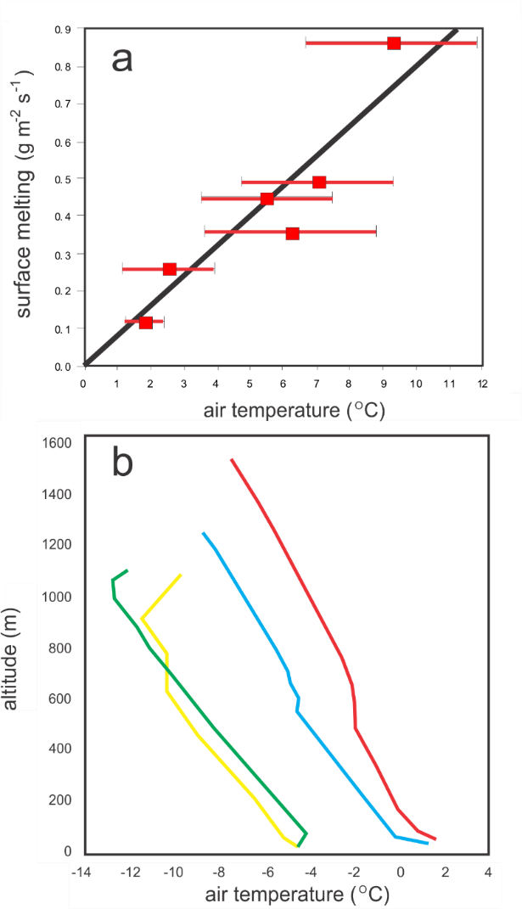
Figure A3-2. (a) Regression between surface melting and air temperature for the ablation experiments at Ecology glacier/King George Is. during austral summer of 2005. From the six experiment runs the surface melting rate was Q_{melting} = (air temperature) x 0.806; Pearson correlation r = 0.9; (b) balloon profile soundings for air temperature variations performed at the Brazilian Antarctic Station Comandante Ferraz (Source: Ozone Group/INPE/Brazil).

Reference
Sakai, A., F. Koji, K., Jumpei. (2004). Evaporation and percolation effect on melting at debris-covered Lirung Glacier, Nepal Himalayas, 1996. Bulletin of Glaciological Research, 21: 9-15.

Supplementary material – A4

Long Lake age-depth model
AMS analysis of the Long Lake sediment core LL2-IAEA was performed by Beta Analytics. Bulk sediments were acid-alkali-acid treated following standard protocols and results are reported in conventional ¹⁴C ages according to Stuiver & Polach (1977). Conventional ¹⁴C ages were calibrated using the SHCal20 calibration curve (Hogg et al., 2020). AMS results are presented in Table A4-1.

Table A4-1. AMS ¹⁴C analysis for Long Lake sediment core LL2-IAEA. Sediments below 64 cm had insufficient carbon for analysis.
Depth | Material | ID | Conventional  Radiocarbon  Age (yr B.P.) | Calibrated  Age (yr cal B.P.) | δ¹³C | C (%)
20-21cm | Bulk sediment | Beta - 433860 | 2630 (± 30) | 2738 (± 21) | -18.1 | 4.02
37-38 cm | Bulk sediment | Beta - 433861 | 3410 (± 30) | 3605 (± 36) | -18.6 | 3.14
63-64cm | Bulk sediment | Beta - 433862 | 4390 (± 30) | 4915 (± 71) | -20.9 | 0.27
64-65cm | Bulk sediment | Beta - 437994 | - | - | - | <0.02
80-81 cm | Bulk sediment | Beta - 433863 | - | - | - | <0.02
85-86cm | Bulk sediment | Beta - 437993 | - | - | - | <0.02
91-92cm | Bulk sediment | Beta - 440224 | - | - | - | <0.02
97-98cm | Bulk sediment | Beta - 435804 | - | - | - | <0.02
98-99cm | Bulk sediment | Beta - 433864 | - | - | - | <0.02

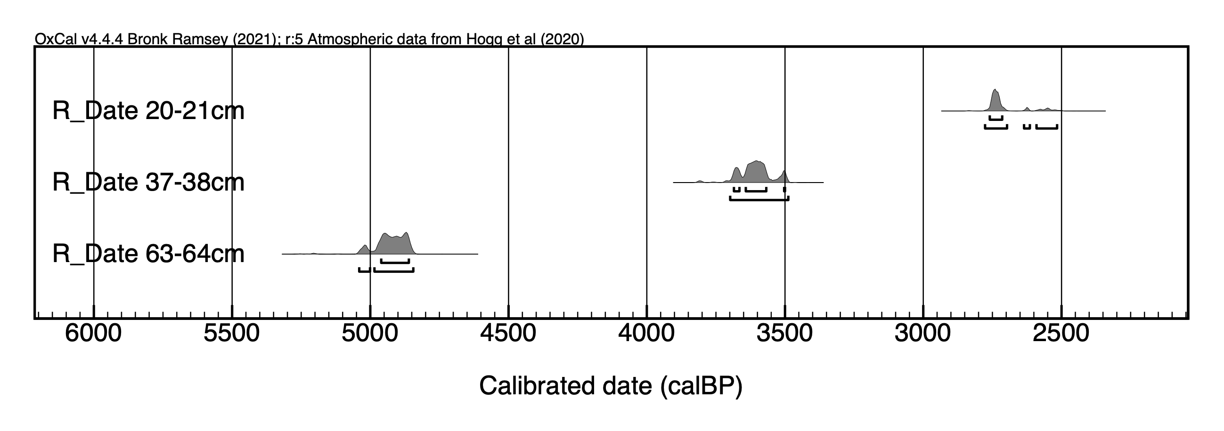 Figure A4-2. Calibration results using the SHCal20 calibration curve (Hogg et al., 2020).

Sediment samples below 64 cm depth have insufficient carbon for ¹⁴C analysis. A comparison of the linear regression from our results (Year (cal yr BP) = 1,703.06 + 50.61 x Z(cm); p=0.002, r=0.999) with two other chronological models for Long Lake, one by Watcham et al. (2011) and another by Ho II Yoon et al. (2006), showed comparable ages for the surface sediment (Z=0 cm). In the present study, a linear trend of our data points to a core-top age of 1,703.06 yr BP, while for Watcham et al. (2011) we find approximately 1,800 yr cal BP and for Ho II Yoon et al. (2006) approximately 1,900 yr cal BP. From the three chronological models presented in Table A4-1 we assumed that the a linear sedimentation rate for the top 1.0 m of the sediment core at Long Lake. Therefore, our sediment core spans a sedimentation interval from 1,703.06 yr BP – 6,764.06 yr BP. Top extrapolated sediment chronology from our result is 1,703.06 yr BP, that is comparable to date inferred by Watcham et al. (2011), i.e., 1,634 – 1,882 yr BP (2σ).

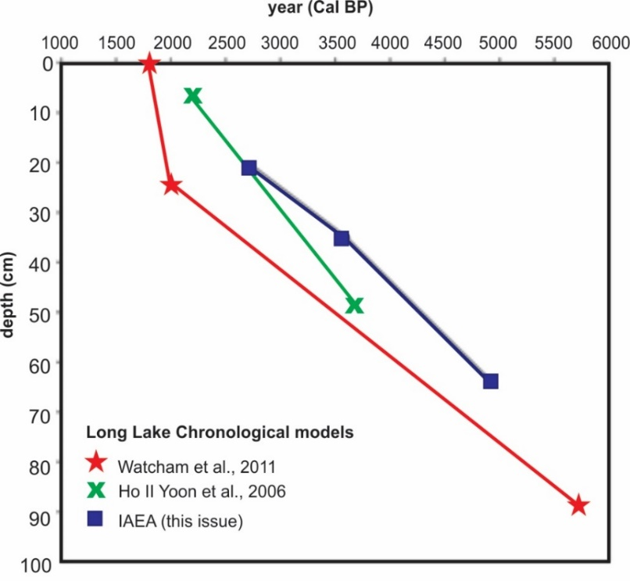
Figure A4-3. Comparison of the three ¹⁴C age-depth models for Lake Long top sediments: this study, Watcham et al. (2011) and Ho II Yoon et al. (2006).

References
Stuiver, M., & Polach, H. A. (1977). Discussion Reporting of 14C Data. Radiocarbon, 19(03), 355–363. doi:10.1017/s0033822200003672.

Hogg, A. G., Heaton, T.J., Hua, Q., Palmer, J.G., Turney, C.S.M., Southon, J., Bayliss, A., Blackwell, P.G., Boswijk, G., Bronk Ramsey, C., Pearson, C., Petchey, F., Reimer, P., Reimer, R., Wacker, L. (2020) SHCal20 Southern Hemisphere Calibration, 0–55,000 years cal BP. Radiocarbon 62(4), 759-778.
Yoon, HI., Khim B.−K., Lee K., Park Y.−H., Yoo K.−C. (2006) Reconstruction of postglacial paleoproductivity in Long Lake, King George Island, West Antarctica. Polish Polar Research 27(3):189–206.

Watcham, E. P., Bentley, M. J., Hodgson, D. A., Roberts, S. J., Fretwell, P. T., Lloyd, J. M., Larter, R.D., Whitehouse, P.L., Leng, M.J., Monien, P., Moreton, S. G. (2011). A new Holocene relative sea level curve for the South Shetland Islands, Antarctica. Quaternary Science Reviews, 30(21-22), 3152–3170. doi:10.1016/j.quascirev.2011.07.021.

Supplementary material – A5
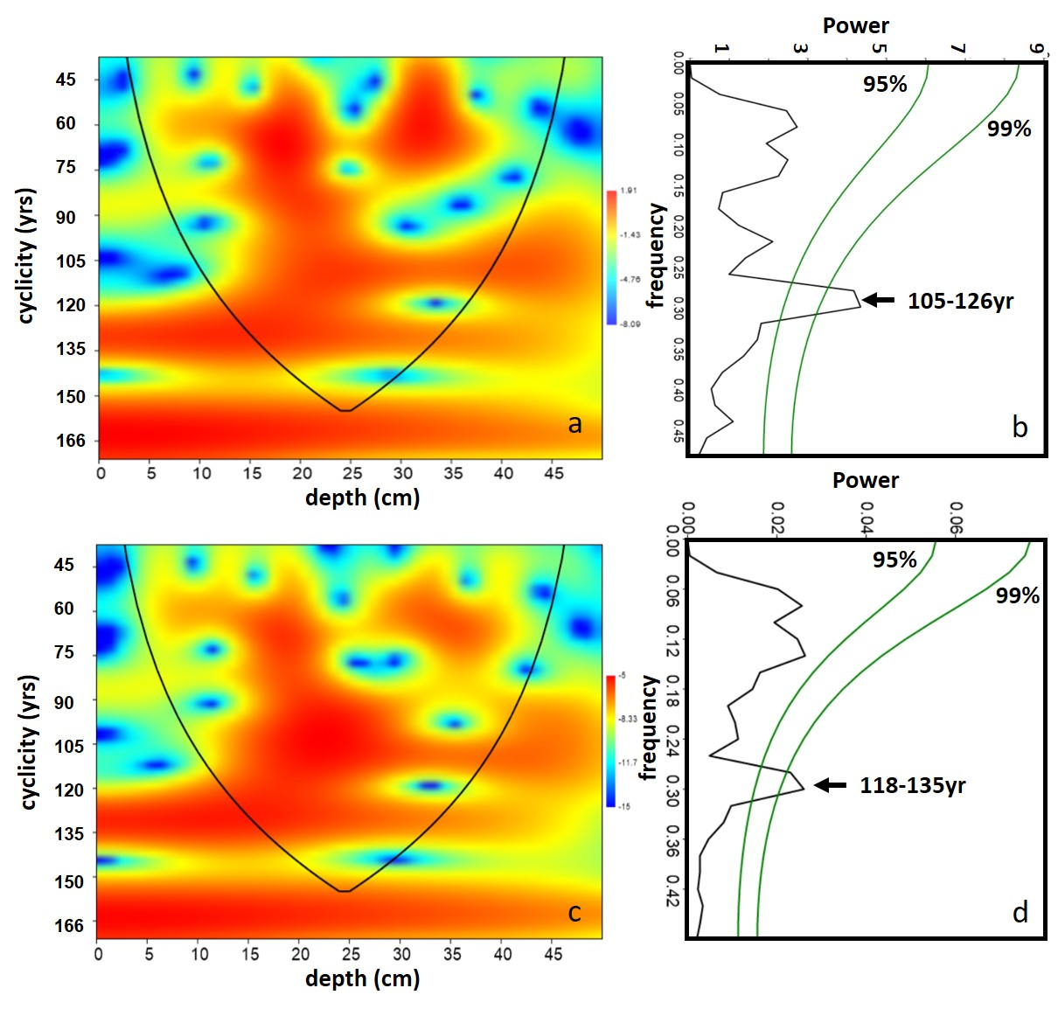
Figure A5. Cyclicity pattern determined for the C content in the top 50 cm of Long Lake sediment core: (a) from Morlet Wavelet Analysis and (b) using FFT analysis; (c) and (d) the same for N, respectively.

Supplementary material – A6

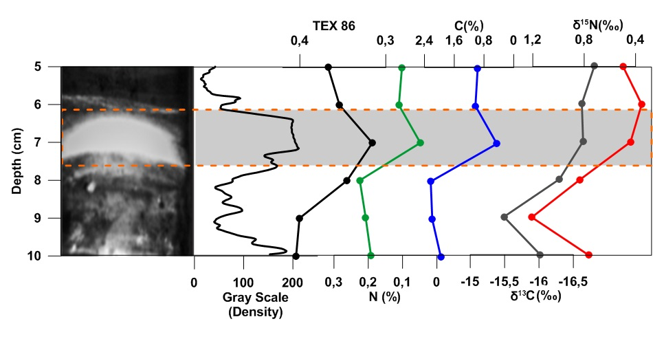
Figure A6-1. Detail of a section (5-10cm from top to bottom) of dark-and-light stratification for Long Lake sediment core. The grey scale density profile and geochemical parameters are indicated with a dashed box. As indicated by TEX₈₆, a temperature proxy related to the cyclization of isoprenoidal GDGT (glycerol dialkyl glycerol tetraether) lipids produced by archaea, light layers correspond to colder phases of the local environment. TEX₈₆ data are uncalibrated. TEX₈₆ correlates positively and linearly with SST and fresh waters (Tierney and Tingley, 2015). Darker layers correspond to more productive periods when total C and N increase in the bottom of the lake. Slight changes of δ¹³C and δ¹⁵N are also observed.

Reference
Tierney, J., Tingley, M. (2015). A TEX₈₆ surface sediment database and extended Bayesian calibration. Sci Data 2, 150029. https://doi.org/10.1038/sdata.2015.29.

