A synchronous atmosphere-cryosphere-land response to climate at Northern Antarctic Peninsula, since Mid-Holocene

Heitor Evangelista¹, Sergei Verkulich², Bulat Mavlyudov³, Mariza P. Echer⁴, Marcus Vinicius Licinio⁵, Gerd Dercon⁶, Felipe García-Rodríguez^{7,8}, Arthur A. Neto⁹, Stephanie Kusch¹⁰, Rodrigo C. Abuchacra⁹, Anna B.J. Oaquim¹, Sérgio J. Gonçalves Jr.^{1*}, Zinaida Pushina², Marília H Shimizu¹¹, Maria Heiling⁶, Johanna Slaets⁶, Christian Resch⁶, Alejandra Castillo¹², Roman Gruber⁶

Supplementary material – A1

King George Island (KGI) climate, proglacial environment and sampling sites
KGI is the largest island of the South Shetland archipelago, located in the northwest end of the NAP, between the coordinates 61°54'S-62°06'S and 057°35'W-059°02'W. Its highest elevation is near 700 m, enclosing a total surface area of 1,250 km², where 92% is covered by snow and ice. Most of the air masses acting at KGI derive from the Pacific sector of the Southern Ocean, classified as maritime polar (mP), from advections of north and northwest of 60°S latitude, classified as maritime tropical (mT) (Fossum et al., 2018), and cold air incursions namely continental Antarctic that brings extremely low temperatures to the region. This results in severe weather conditions of high instability that are constantly affected by synoptic systems carrying warm air, moisture accompanied by strong winds, snow and eventually rain from lower latitudes (Bintanja, 1995; Ferron, et al., 2004). The local climate is classified as Maritime Antarctic, which is characterized by average temperatures reaching above zero levels during the summer-to-autumn season and negative along the remaining seasons reaching average values around -6 ºC in JJA (Olivia et al., 2017).

This sedimentary study focuses in two important ice-free areas of KGI: (a) Fildes Peninsula and (b) Admiralty Bay. Fildes Peninsula is the largest one in extent and is located at its Southwestern sector limited by the Drake passage, the Maxwell Bay and the Bellingshausen ice dome. According to Barsch and Mäusbacher (1986) before 6,000 to 5,000 yr B.P. Fildes Peninsula was still partially glaciated at altitudes between 15 m and 20 m. Their actual landscape geomorphological features suggest a probable rapid shrinking of the ice cover to nearly the present extent. Due to depressions created during moraine formations throughout the time and the intense erosion from melting fresh water flows during the deglaciation, a lake sequence is found at the peninsula. At Fildes we have sampled 2 sediment cores in February 15th, 2015: 1 dated from the mid-Holocene at an “isolated” lake (Long Lake) and 1 shallow core retrieved in the catchment of Bellingshausen ice dome, dated from the beginning of the 20th century.
A second important ice-free area at KGI is the Admiralty Bay. This bay is formed by irregular fjords of tectonic origin containing inlets and coves and a main deep channel reaching to a maximum depth of 535 m. It is surrounded by temperate glaciers terminating on land and tidewater glaciers whose fronts terminate close the shore line. Since the 50’s, progressive retreats of their ice front positionings have been reported (Braun and Gossmann, 2002). At the interface between the shoreline and the Warszawa icefield (WI) and Krakow icefield (KI) we have sampled 7 shallow sediment cores, all dated from the begging of the 20th century, according to their drainage basins, Fig A1-1. Table A1-1 provides basic data of the shallow sediment cores sampled at KGI.

Table A1-1. Location and characteristics of the shallow sediment cores sampled at King George Is.

Site ID | Location | Latitude  (ºS) | Longitude  ( ºW) | Sediment core  length (cm) | Site  characteristics
01 | Hannequin Point | 62°07’18” | 058°23’45” | 8 | Water Melting Pond
02 | Patelnia A | 62°13’ 9” | 058°28’12” | 22 | Proglacial Lake
03 | Patelnia B | 62°13’ 3” | 058°28’6” | 15 | Proglacial Lake
04 | Agat Point B | 62°10’8” | 058°26’8” | 16 | Proglacial Lake
05 | Sphinks Glacier front A | 62°10’9” | 058°26’8” | 15 | Proglacial t Lake
06 | Sphinks Glacier front D | 62°11’6” | 058°43’9” | 26 | Water Melting Pond
07 | Glacier Sphinks front E | 62°11’6” | 058°26’37” | 23 | Water Melting Pond
08 | Bellingshausen  Glacier front | 62°10’46” | 058°54’39” | 38.5 | Proglacial Lake

At all sites of Admiralty Bay and Fildes Peninsula, samplings were conducted at lakes immediately connected to glacier melting waters. Sediments are delivered to these shallow lakes from erosion of the pathways at glacier’s drainage basins. Since the begging of glaciers monitoring at the Admiralty Bay (mid 50’s decade), significant ice loss has been observed. It is estimated that approximately 22.5 km² of ice loss have occurred at that site within the period 1956-2000, Arigony et al. (2001). An illustration of the glacier fronts retreats was made by a composition of several information enclosing digitalized maps, satellite images and mosaic of satellite images (compiled at Arigony, 2001), complemented by GPS field campaigns in 2005 and 2007. For the Baranowski glacier front retreat, the 1956 reference line was drawn from the King George map (scale of 1:100.000) made by the “Antarctic Place Names Committee” that belongs to the “Foreign and Commonwealth Office, BAS 1968”. The 1979 reference line was obtained by 2 maps: The Admiralty Bay Polish map (scale of 1:65.000), geo-referenced to the Gauss-Kruger projection and the map of SSSI-8 region provided by the Polish Antarctic Program (scale of 1:12 500), 2002. Steps of retreat for 1988 and 1995 were obtained by satellite images SPOT-1 XS 725-478 (1988) and SPOT-3 XS 725-477 (1995), while for the year 2000, it was employed an image gallery mosaic of SPOT satellite, as proposed by Braun et al. (2001).
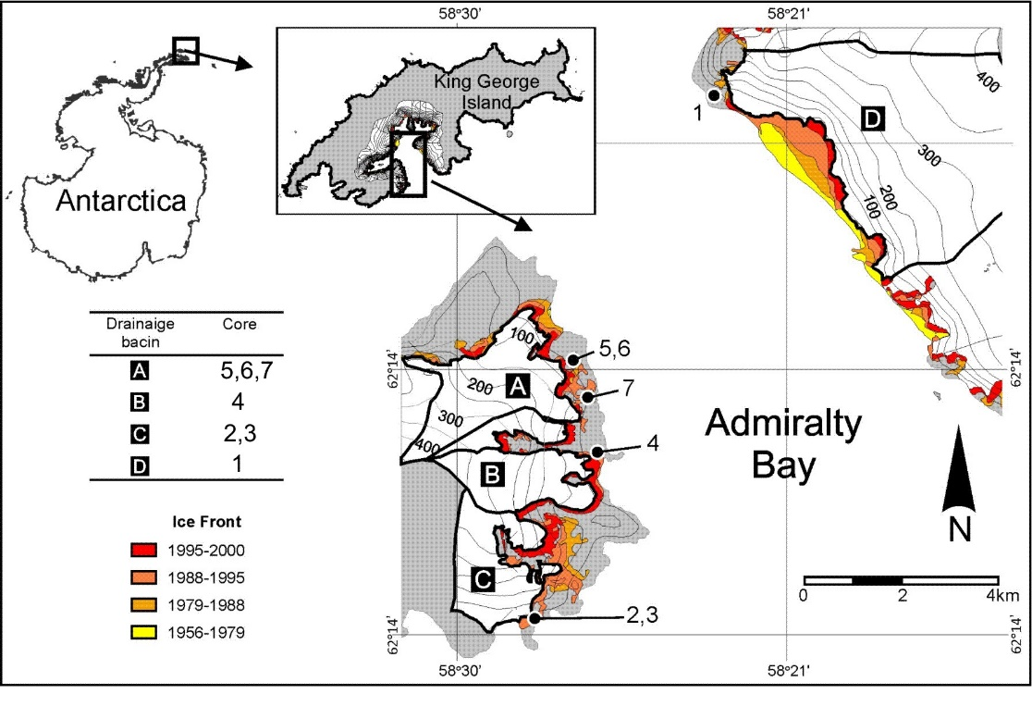
Figure A1-1. Location of proglacial lakes and sediment coring sites at Admiralty Bay and corresponding drainage basins. (adapted from: Rosa, et al., 2020).

For the coring site at Fildes peninsula, of 3.5 cm, its sediments are delivered by small streams from sub-catchments associated to the Bellingshausen glacier. In this lake, and for all at Admiralty Bay, the sedimentation is a function of the snow-melting intensity during the austral summer season.

Reference
Fossum, K.N., Ovadnevaite, J., Ceburnis, D. et al. (2018). Summertime Primary and Secondary Contributions to Southern Ocean Cloud Condensation Nuclei. Sci Rep 8, 13844. doi:10.1038/s41598-018-32047-4.

Bintanja, R. (1995). The local surface energy balance of the Ecology Glacier, King George Island, Antarctica: measurements and modelling. Antarctic Science, 7(03). doi:10.1017/s0954102095000435.

Ferron, F.A., Simões, F.C., Aquino, F.E., Setzer, A.W. (2004). Air temperature time series for King George Island, Antarctica. Pesquisa Antártica Brasileira 4: 155-169.

Oliva, M., Navarro, F., Hrbáček, F., Hernández, A., Nývlt, D., Pereira, P., … Trigo, R. (2017). Recent regional climate cooling on the Antarctic Peninsula and associated impacts on the cryosphere. Science of The Total Environment, 580, 210–223. doi:10.1016/j.scitotenv.2016.12.030.

Barsh, D., Mäusbacher, R. (1986). New data on the relief development of the South Shetland Islands, Antarctica.Interdisciplinary Science Review, v. 11, p. 211-219.

Braun, M., Gossmann, H. (2002). Glacial Changes in the Areas of Admiralty Bay and Potter Cove, King George Island, Maritime Antarctica Ecological Studies, 154 L. (eds.) Geoecology of Antarctic Ice-Free Coastal Landscapes. Springer-Verlag Berlin Heidelberg.75-89.

Arigony N., J., Simões, J. C., Bremer, U.F., Aquino, F.E. (2001). Detecção de Mudanças Ambientais na Antártica através de Dados de Sensoriamento Remoto e Mapas Históricos. Pesquisas Em Geociências, 28(2), 337–342. doi:10.22456/1807-9806.20307.

Braun M, Saurer H, Vogt S, Simões JC and Goßmann H. (2001). The influence of large-scale atmospheric circulation on surface energy balance on the ice cap of King George Island. Int J Climatol 21: 21–36

Rosa, K.K. da, Perondi, C., Veettil, B.K., Auger, J.D., Simões, J.C. (2020). Contrasting responses of land-terminating glaciers to recent climate variations in King George Island, Antarctica. Antarctic Science, 1–10. doi:10.1017/s0954102020000279.

Supplementary material – A2

South Shetland archipelago air temperature.
Most extended South Shetlands air temperature time series was obtained based on the Bellingshausen Russian station (62°11′55″S;058°57′38″W, 14 m a.s.l.) and March Station (Chillean air force) (62°11'27"S;058°59'12"W, 45 m a.s.l.) databases, since 1968, both located at Fildes Peninsula/King George Is., and from the Deception Is. station (62°58′31″S;060°41′52″W, 7 m) spanning the period 1947 to 1968 (Fig. A2-1).

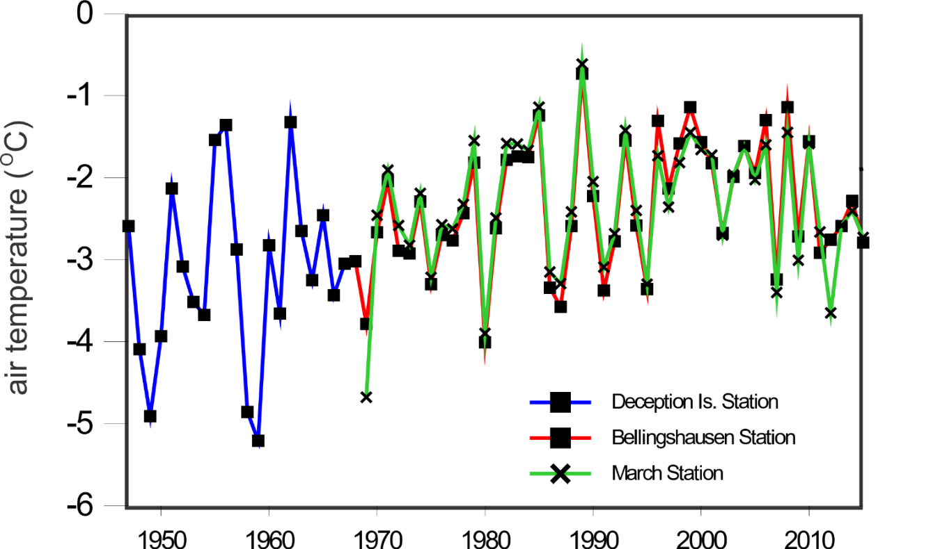
Figure A2-1. South Shetland annual mean air temperature time series from 3 Antarctic Stations.

Supplementary material – A3

Sedimentation rates and surface snow melting
All eight shallow sediment cores, Table A1-1, presented similar profiles exhibiting approximate steady increase in sedimentation rates towards present day with a rapid increase between the years 1990 and 2000. Averaged sedimentation rate is presented in Figure 2 of main text.
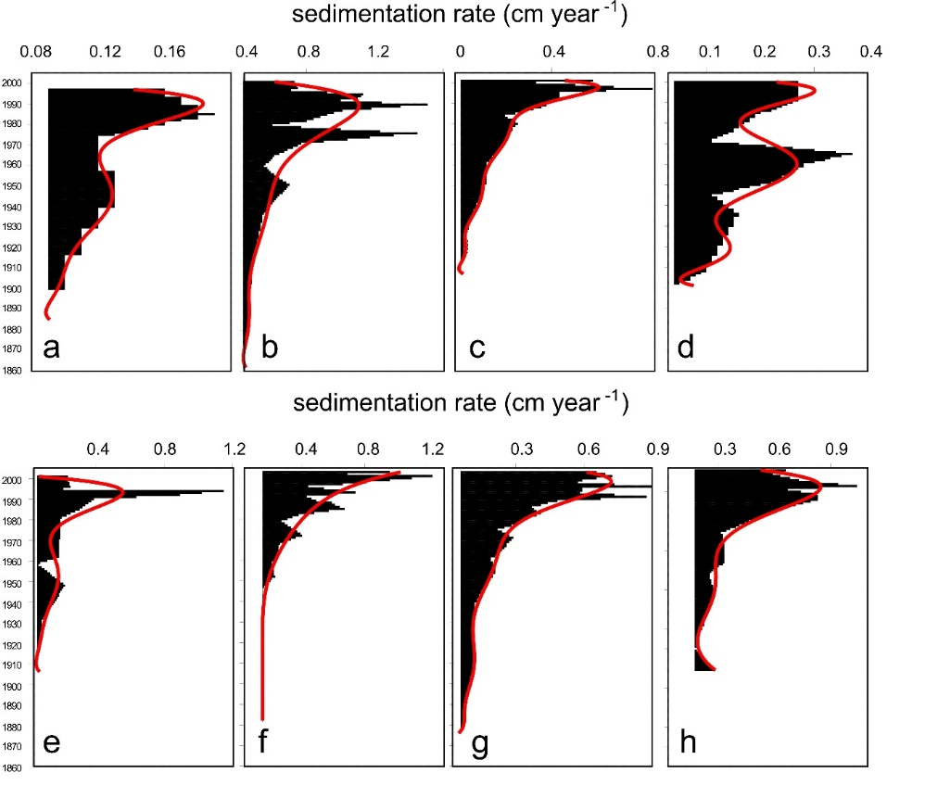
Figure A3-1. Proglacial lakes sedimentation rates inferred by the CRS chronological model measured at Admiralty Bay/King George Is.: (a) Hannequin Point, (b) Patelnia A, (c) Patelnia B, (d) Agat Point B, (e) Sphinks Glacier front A, (f) Sphinks Glacier front D, (g) Glacier Sphinks front E, and at Fildes Peninsula: (h) Bellingshausen Glacier front.

In order to infer the surface snow melting, we have carried out a rough analysis based on a field campaign at Ecology glacier/King George Island in 2005 making use of lysimeters and an AWS (automatic weather station) (Sakai et al., 2004). From the experiment we find a close relationship between the surface percolation and the air temperature measured by the AWS during the experiment (r=+0.9) (Figure A3-1a). In the field experiment, the lysimeters were made of a set of 8 cylindrical acrylic tubes of 15 cm depth and diameters of 10, 15, 20 and 25 cm. The tubes were gently introduced in the snow surface with minimum disturbance. Then flasks were filled up with snow, weighted and reintroduced in the snow in a way that the flaks surfaces were parallel to the plan snow field. This set was positioned 5 m from an in situ AWS. Half of the flasks had eyelets in the bottom surface. The set of tubes were exposed to the free atmosphere during 24 hours and reweighed thereafter. The difference of mass in flasks without eyelets is attributed to evaporation while the difference of mass in flasks with eyelets to evaporation+percolation. The difference in mass between both sets provides the percolation. For each 24-hour run we obtained the percolation as g/m²/s. To extend the result to the totality of the glacier basin, we have multiplied the mean percolation value to the surface area of the glacier drainage basin. Considering that air temperature changes with altitude we used balloon temperature profiles databases from sea level to altitudes higher above the higher KGI ice sheets to correct percolation values with altitude. We used the database of 4 profiles (Figure A3-1b) provided by the Ozone balloon group from INPE/Brazil (Brazilian National Institute of Research). Average temperature-altitude relation was ~ 1°C/100 m. Surface areas were calculated using the Idrisi 3/Clark labs software.
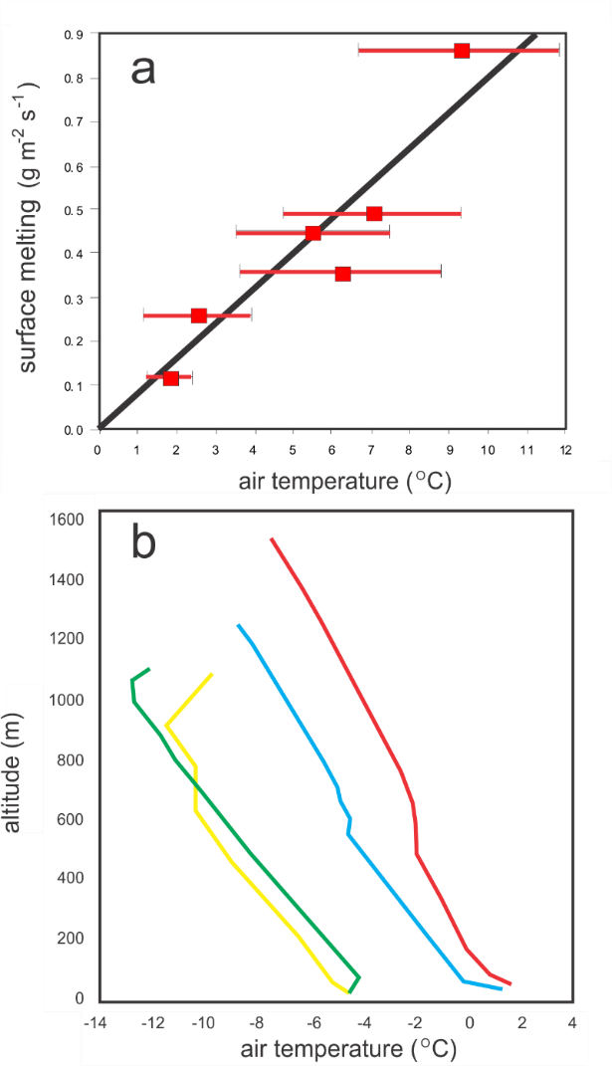
Figure A3-3. (a) regression between surface melting and air temperature for the ablation experiment during austral summer of 2005 at Ecology glacier/King George Is. From the six experiment runs the surface melting rate was Q_{melting} = (air temperature) x 0.806; r-Pearson correlation value was +0.9; (b) balloon profile soundings for air temperature variations performed at the Brazilian Antarctic Station Comandante Ferraz (Source: Ozone Group/INPE/Brazil).

Reference
Sakai, A., F. Koji, K., Jumpei. (2004). Evaporation and percolation effect on melting at debris-covered Lirung Glacier, Nepal Himalayas, 1996. Bulletin of Glaciological Research, 21: 9-15.

Supplementary material – A4

Long Lake chronological model
AMS analysis of the Long Lake sediment LL2-IAEA core was performed at the Beta Analytic Radiocarbon Dating Laboratory. Bulk sediments were acid-alkali-acid treated following standard protocols and results are reported in conventional ¹⁴C ages according to Stuiver and Polach (1977). Conventional ¹⁴C ages were calibrated using the SHCal13 calibration curve. AMS results are presented in Table A4-1.

Table A4-1. ¹⁴C datings and attempts for Long Lake sediment core, LL2-IAEA. (BDL: Bellow Detection Limit).

Depth | Material | ID | Conventional  Radiocarbon  Age (yr B.P.) | Calibrated  Age (yr B.P.) | δ¹³C | C (%)
20-21cm | Bulk sediment | Beta - 433860 | 2630 (± 30) | 2738 (± 21) | -18.1 | -
37-38 cm | Bulk sediment | Beta - 433861 | 3410 (± 30) | 3606 (± 36) | -18.6 | -
63-64cm | Bulk sediment | Beta - 433862 | 4390 (± 30) | 4912 (± 68) | -20.9 | -
64-65cm | Bulk sediment | - | BDL | BDL | - | <0,02
80-81 cm | Bulk sediment | - | BDL | BDL | - | <0,02
85-86cm | Bulk sediment | - | BDL | BDL | - | <0,02
91-92cm | Bulk sediment | - | BDL | BDL | - | <0,02
97-98cm | Bulk sediment | - | BDL | BDL | - | <0,02
98-99cm | Bulk sediment | - | BDL | BDL | - | <0,02

Sampled sediment at sections below 64 cm of LL2-IAEA sediment core the amount of carbon was not enough to provide accurate measure of the ¹⁴C isotope. A comparison of the linear regression from our results (Year (Cal BP) = 2049.9+37.73*Z(cm)) with 2 other chronological models for Long Lake, one by Watcham et al. (2011) and another by Ho II Yoon et al. (2006), showed comparable ages for the surface sediment (Z=0 cm). In this issue the linear trend of our data points to 2,049 yr BP, for Watcham et al. (2011) approximately 1,800 yr BP and for Ho II Yoon et al. (2006) approximately 2,000 yr BP. From the 3 chronological models presented in Figure A4-1 we may assume that the sedimentation rate behaved almost linearly in the top 1 m sediment core at Long Lake. Therefore, our sediment core spans a sedimentation interval 2,049 – 5,822 yr BP.

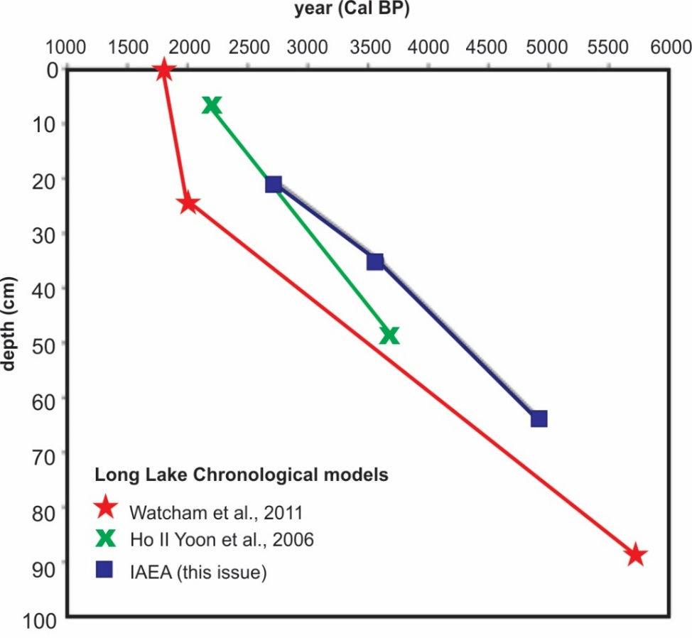
Figure A4-1. Three ¹⁴C chronological models for Lake Long top sediments: this issue, Watcham et al. (2011) and Ho II Yoon et al. (2006).

References
Stuiver, M., & Polach, H. A. (1977). Discussion Reporting of 14C Data. Radiocarbon, 19(03), 355–363. doi:10.1017/s0033822200003672.

Ho−Il YOON, Boo−Keun KHIM, Kyung LEE, Yu−Hyeon PARK and Kyu−Cheul YOO. (2006). Reconstruction of postglacial paleoproductivity in Long Lake, King George Island, West Antarctica. Polish Polar Research 27(3):189–206.

Watcham, E. P., Bentley, M. J., Hodgson, D. A., Roberts, S. J., Fretwell, P. T., Lloyd, J. M., Larter, R.D., Whitehouse, P.L., Leng, M.J., Monien, P., Moreton, S. G. (2011). A new Holocene relative sea level curve for the South Shetland Islands, Antarctica. Quaternary Science Reviews, 30(21-22), 3152–3170. doi:10.1016/j.quascirev.2011.07.021.

Supplementary material – A5
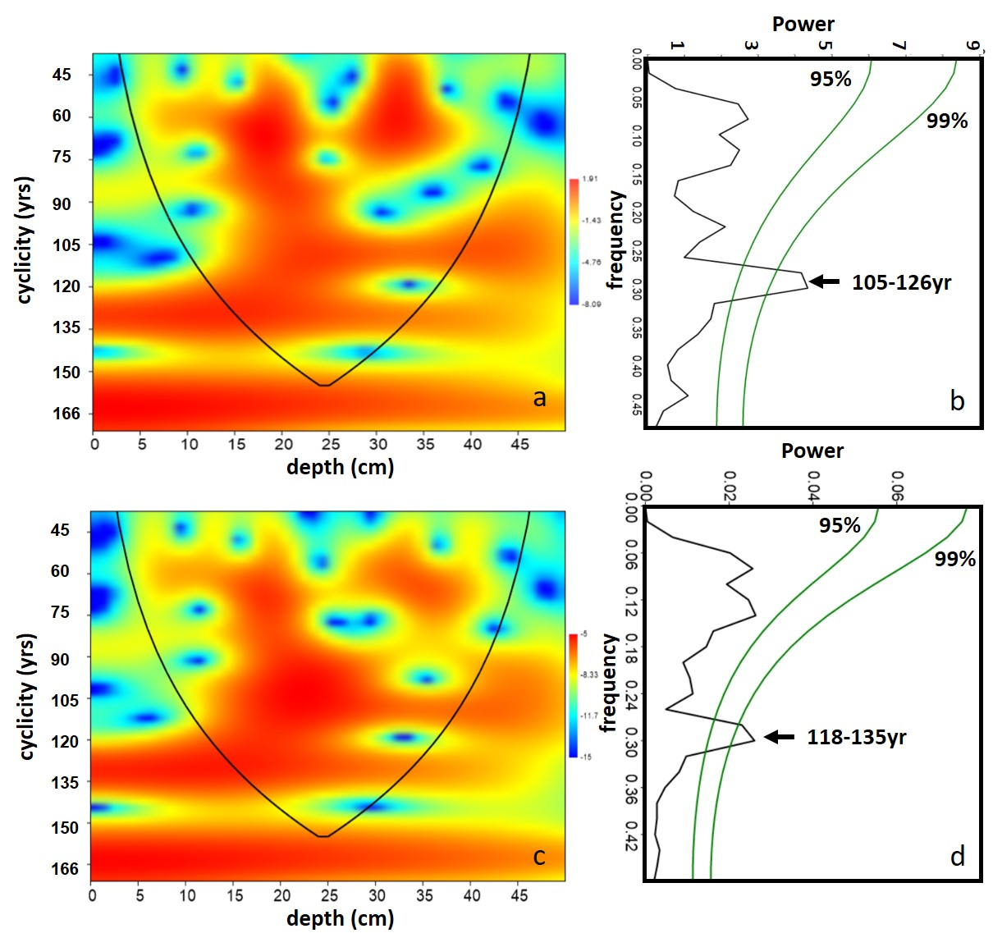
Figure A5. Cyclicity pattern determined for the C content in the top 50 cm of Long Lake sediment core: (a) from Morlet Wavelet Analysis and (b) using FFT analysis; (c) and (d) the same for N, respectively.

Supplementary material – A6

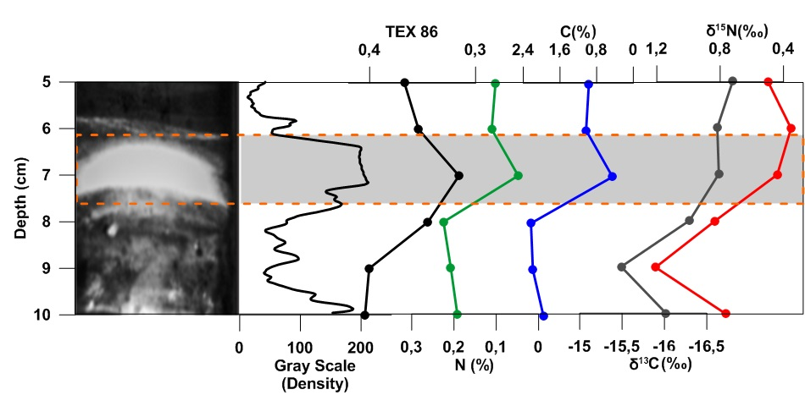
Figure A6-1. Detail of a section (5cm-10cm from top to bottom) of dark-and-light stratification for Long Lake sediment core/KGI. It is shown the density profile from the grey scale and geochemical parameters. As indicated by the TEX₈₆, a temperature proxy related to the cyclization of isoprenoidal GDGT (glycerol dialkyl glycerol tetraether) lipids produced by archaea, light layers correspond to warmer phases of the local environment. TEX₈₆ data is uncalibrated data. TEX₈₆ correlates positively and linearly with SST and fresh waters (Tierney and Tingley, 2015). Darker layers correspond to more productive periods when total C and N increase in the bottom of the lake. Slighly changes of δ¹³C and δ¹⁵N are also observed.

Reference
Tierney, J., Tingley, M. (2015). A TEX₈₆ surface sediment database and extended Bayesian calibration. Sci Data 2, 150029. https://doi.org/10.1038/sdata.2015.29.

