Amorphous ternary transition metal catalytic coating for highly efficient oxygen evolution water splitting reaction

Zishuai Zhang#, Daniela Vieira#, Jake E Barralet‡, Geraldine Merle‡*

Z. Zhang, D. Vieira, Prof. J. E. Barralet, Prof. G. Merle
Faculty of Medicine, McGill University, Montreal, H3A 0C5, Canada

Current affiliation Prof. G. Merle,
Email: geraldine.merle@polymtl.ca
Chemical Engineering Department, Ecole Polytechnique de Montréal, P.O. Box 6079 Station, Montreal, QC H3C 3A7, Canada
# These authors contributed equally to this work
* Corresponding author

Table S1. Compositions for screening NiCoV catalysts and their corresponding potentials at the current density of 10 mA cm⁻².
Samples | Ni²⁺ (at. %) | Co²⁺ (at. %) | VO²⁺ (at. %) | η (10 mA cm⁻²) (V vs. RHE) | Tafel slope (mV dec⁻¹)
1 | 100 | 0 | 0 | 1.53 | 215
2 | 0 | 100 | 0 | 1.57 | 151
3 | 40 | 60 | 0 | 1.59 | 290
4 | 15 | 80 | 5 | 1.52 | 168
5 | 10 | 85 | 5 | 1.51 | 168
6 | 80 | 10 | 10 | 1.57 | 214
7 | 60 | 30 | 10 | 1.57 | 202
8 | 30 | 60 | 10 | 1.51 | 161
9 | 10 | 80 | 10 | 1.48 | 130
10 | 5 | 85 | 10 | 1.49 | 156
11 | 5 | 80 | 15 | 1.51 | 142
12 | 10 | 75 | 15 | 1.52 | 157
13 | 25 | 40 | 35 | 1.52 | 177
14 | 35 | 30 | 35 | 1.54 | 163
15 | 30 | 35 | 35 | 1.54 | 172
16 | 25 | 40 | 35 | 1.53 | 157
17 | 20 | 45 | 35 | 1.56 | 168
18 | 10 | 50 | 40 | 1.57 | 152
19 | 20 | 40 | 40 | 1.56 | 164
20 | 30 | 30 | 40 | 1.58 | 193
21 | 40 | 20 | 40 | 1.73 | 260
22 | 50 | 10 | 40 | 1.74 | 270
23 | 25 | 35 | 40 | 1.61 | 166
24 | 15 | 45 | 40 | 1.59 | 167
25 | 60 | 0 | 40 | 1.76 | 420
26 | 0 | 60 | 40 | 1.57 | 157
27 | 50 | 0 | 50 | 1.8 | 450
28 | 40 | 10 | 50 | 1.74 | 222
29 | 10 | 40 | 50 | 1.59 | 172
30 | 20 | 30 | 50 | 1.58 | 173
31 | 30 | 20 | 50 | 1.69 | 216
32 | 20 | 10 | 70 | 1.69 | 206
33 | 10 | 20 | 70 | 1.65 | 187
34 | 0 | 0 | 100 | >1,70 | >500

Table S2. Compositions of single metallic catalysts (Ni, Co, V), binary metallic catalysts (NiCo, NiV, CoV) and ternary metallic catalysts (NiCoV).

Catalyst abbreviation | Ni²⁺ (at. %) | Co²⁺ (at. %) | VO²⁺ (at. %)
Ni | 100 | 0 | 0
Co | 0 | 100 | 0
V | 0 | 0 | 100
NiCo | 40 | 60 | 0
NiV | 60 | 0 | 40
CoV | 0 | 60 | 40
NiCoV | 10 | 80 | 10

Table S3. Summary of the OER overpotentials (at a current density of 10mA cm⁻²) and Tafel slope of reported Co- and Ni- based OER catalysts.

Catalyst | Substrate | Solution | Overpotential (mA, at 10mA cm⁻²) | Tafel slope | Ref.
NiCoV/mesh | Stainless steel mesh | 1M KOH | 220 | 40 | This work
RuO₂/mesh | Stainless steel mesh | 1M KOH | 190 | 73 | This work
Ni₃S₂/NF | Ni foam | 1M KOH | 350 | 108 | [1]
CoS₂ nanoparticles | Ni foam | 1M KOH | 430 | 81.4 | [2]
CoSe₂ nanoparticles | Ni foam | 1M KOH | 424 | 78.3 | [2]
Co(S_{0.22}Se_{0.78})₂ | Ni foam | 1M KOH | 283 | 65.6 | [2]
MoS₂/ Ni₃S₂ | Ni foam | 1M KOH | 218 | 88 | [3]
Ni₂P nanoparticles | Glassy carbon | 1M KOH | 290 | 59 | [4]
FeNiO | Ni foam | 1M KOH | 297 | 37 | [5]
NiCoP/C nanobox | Glassy carbon | 1M KOH | 330 | 115 | [6]
Ni₃FeN nanosheets | Glassy carbon | 1M KOH | 280 | 46 | [7]
Ni₃B | Glassy carbon | 1M KOH | 302 | 52 | [8]
NiCo₂O₄ nanowires | Conductive electrode | 1M KOH | 460 | 90 | [9]
Co_{9−x}Ni_{x}S₈ nanocages | Conductive electrode | 1M NaOH | 364 | 74.7 | [10]
P-Co₃O₄ | Conductive electrode | 1M KOH | 280 | 51.6 | [11]

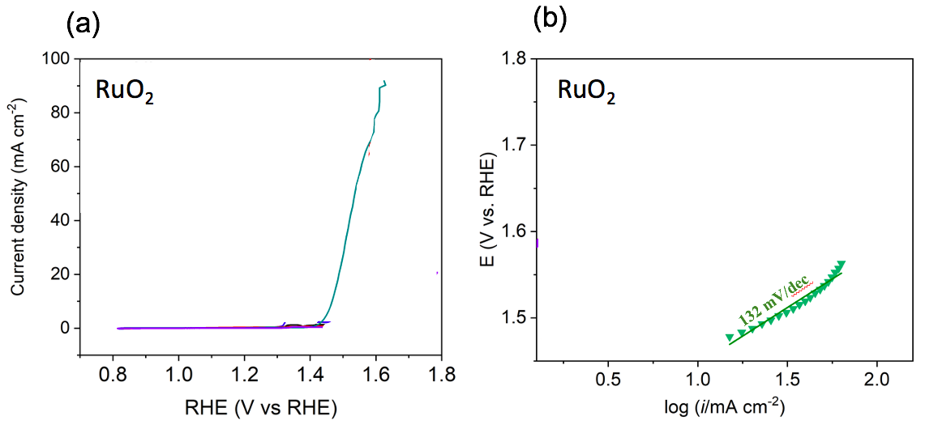
Figure S1. Electrochemical performance of RuO₂ catalysts on glassy carbon electrodes. (a) polarization curves of oxygen evolution reaction for different catalysts at a scan rate of 20 mV s⁻¹ in 1M KOH, and (b) Tafel slopes of RuO₂ catalysts on glassy carbon electrodes.
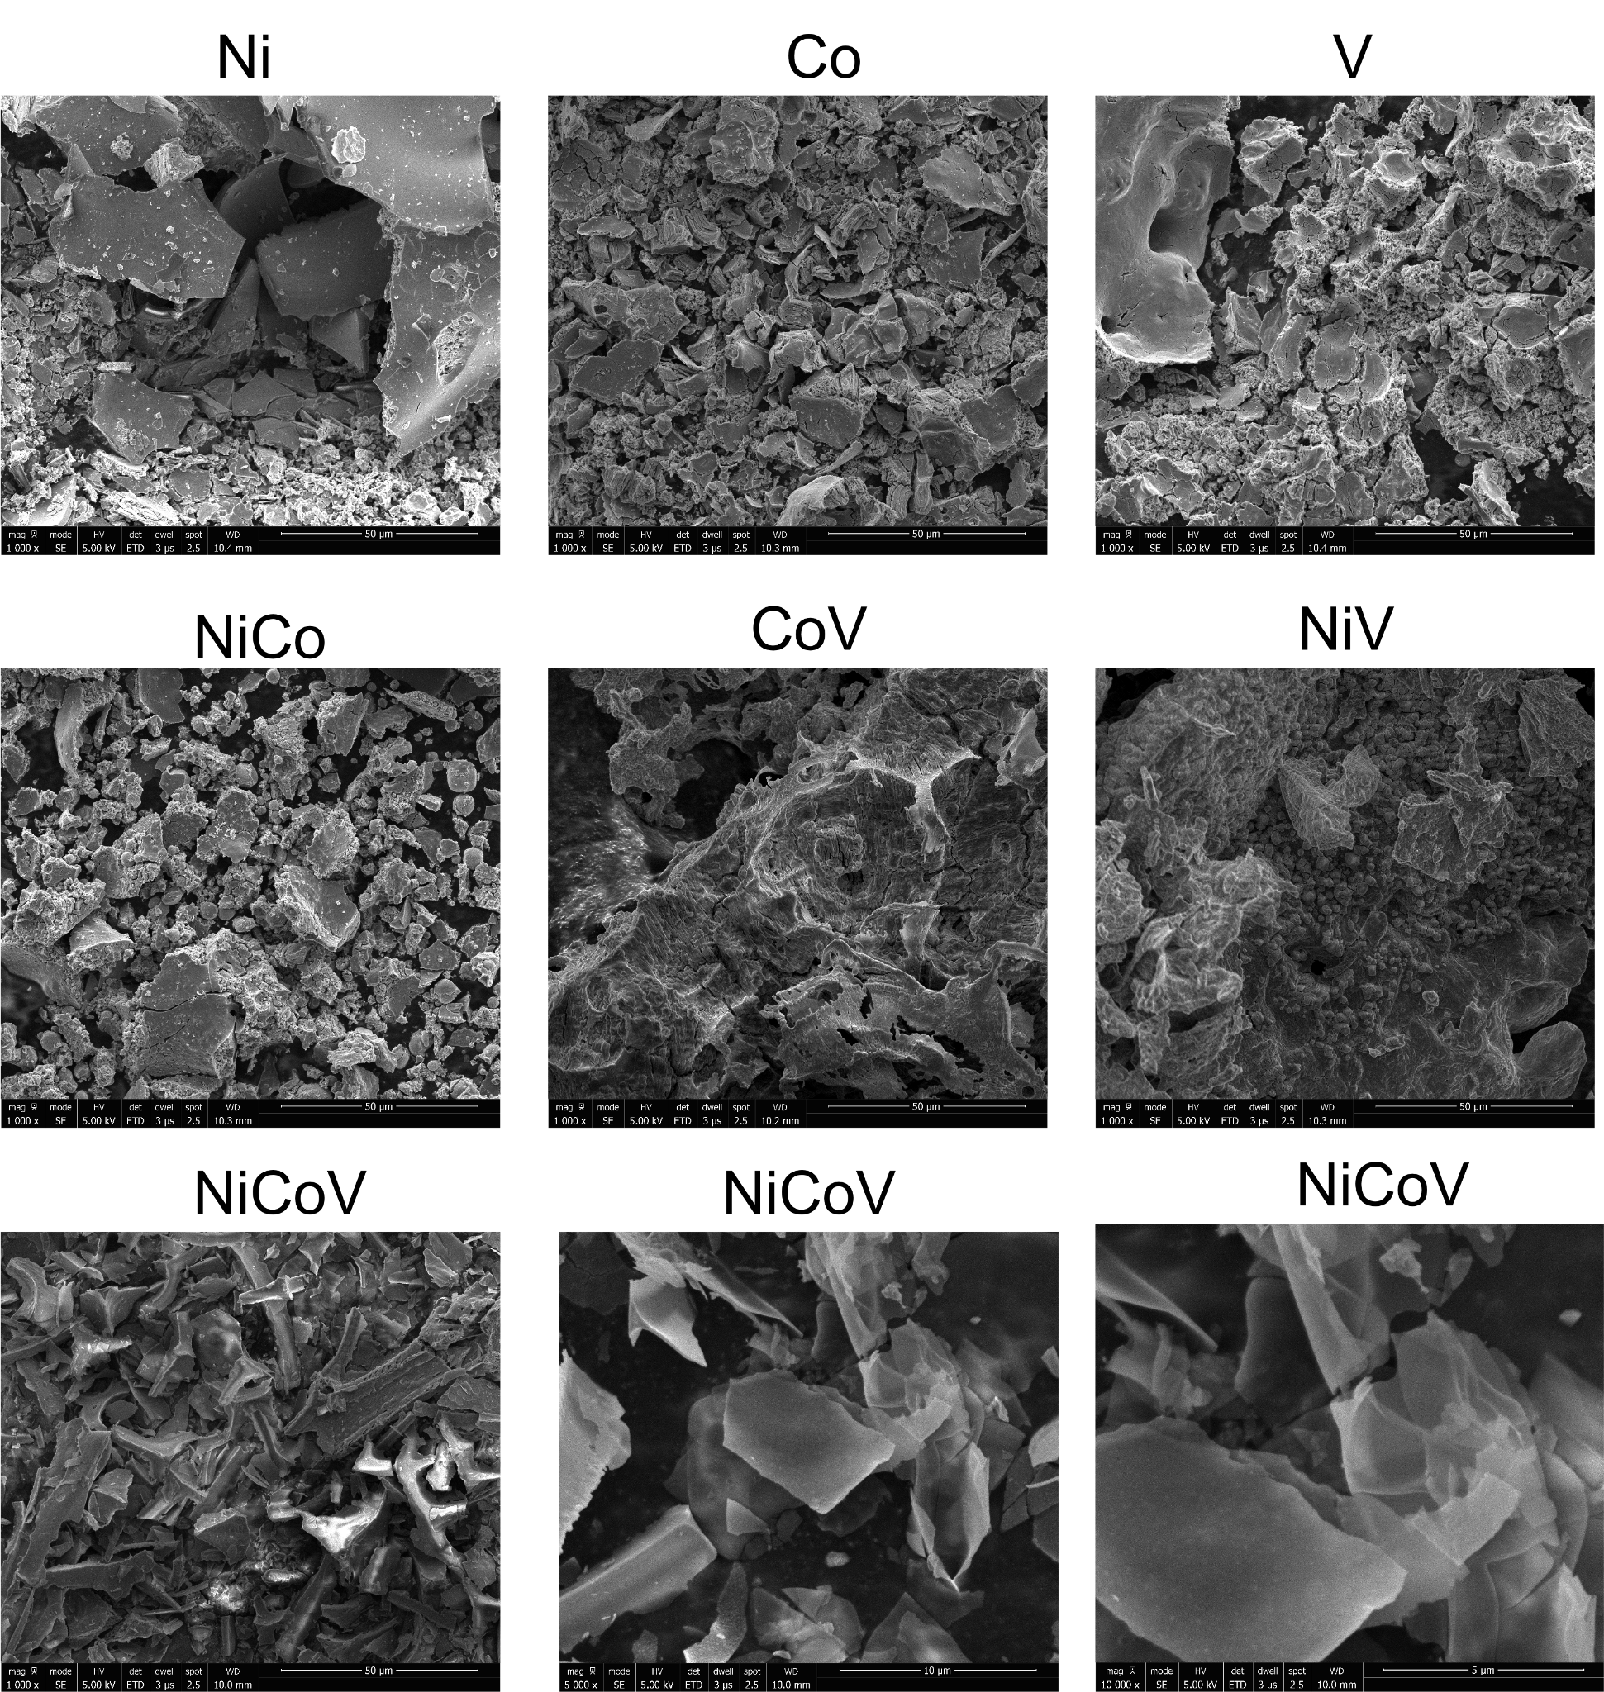
Figure S2. SEM images of various components of Ni, Co, V based catalysts. See details about each sample component in Table S2.

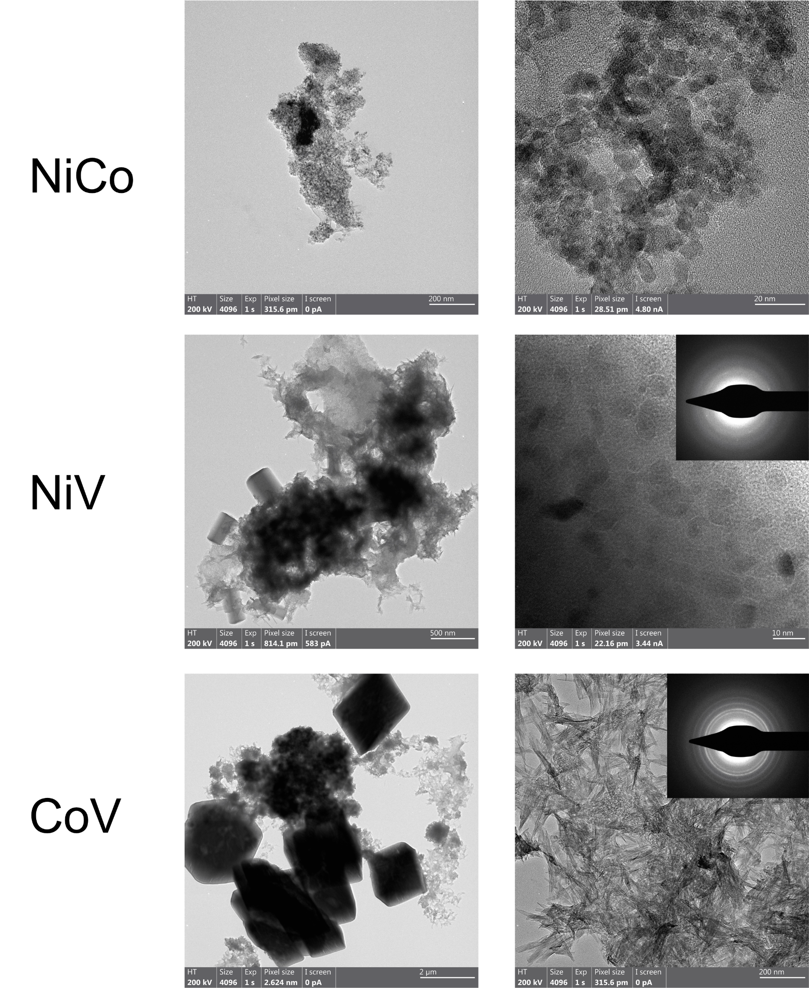

Figure S3. TEM images of NiCo, NiV and CoV.

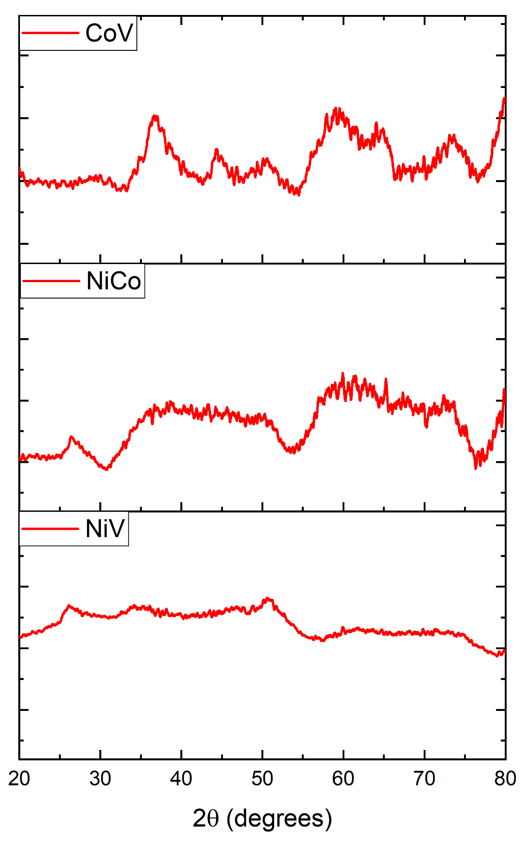

Figure S4. XRD patterns of CoV, NiCo and NiV samples. NiV shows less pronounced crystalline structure compared to NiCo and CoV.

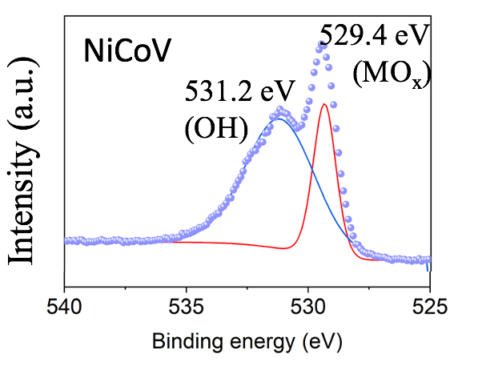
Figure S5. High resolution XPS spectra of O 1s for the NiCoV sample.

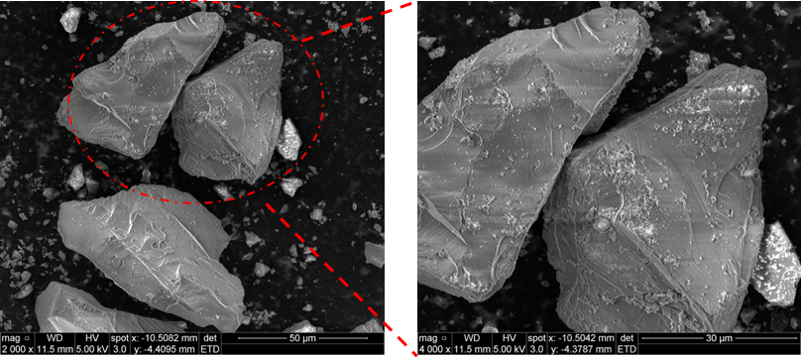
Figure S6. SEM images of corundum coated by NiCoV catalyst.
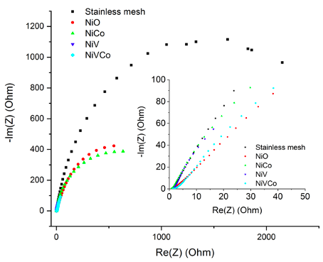
Figure S7. Nyquist plots of blank mesh, Ni, NiCo, NiV and NiCoV coated meshes.

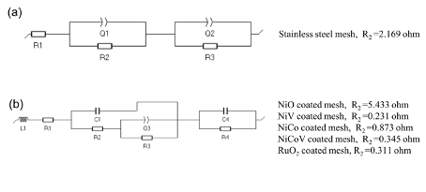
Figure S8. Corresponding equivalent electrical circuits for stainless steel mesh (a) and catalyst coated mesh (b) based on the Nyquist plots.

[1] M. Dincă, Y. Surendranath, D.G. Nocera, Nickel-borate oxygen-evolving catalyst that functions under benign conditions, Proc. Natl. Acad. Sci. U. S. A. 107 (2010) 10337–10341.
[2] L. Fang, W. Li, Y. Guan, Y. Feng, H. Zhang, S. Wang, Y. Wang, Tuning unique peapod-like co(S x Se1- x )2 nanoparticles for efficient overall water splitting, Adv. Funct. Mater. 27 (2017) 1701008.
[3] J. Zhang, T. Wang, D. Pohl, B. Rellinghaus, R. Dong, S. Liu, X. Zhuang, X. Feng, Interface Engineering of MoS2 /Ni3 S2 Heterostructures for Highly Enhanced Electrochemical Overall-Water-Splitting Activity, Angewandte Chemie International Edition. 55 (2016) 6702–6707. https://doi.org/10.1002/anie.201602237.
[4] L.-A. Stern, L. Feng, F. Song, X. Hu, Ni2P as a Janus catalyst for water splitting: the oxygen evolution activity of Ni2P nanoparticles, Energy & Environmental Science. 8 (2015) 2347–2351. https://doi.org/10.1039/c5ee01155h.
[5] K. Fominykh, P. Chernev, I. Zaharieva, J. Sicklinger, G. Stefanic, M. Döblinger, A. Müller, A. Pokharel, S. Böcklein, C. Scheu, T. Bein, D. Fattakhova-Rohlfing, Iron-doped nickel oxide nanocrystals as highly efficient electrocatalysts for alkaline water splitting, ACS Nano. 9 (2015) 5180–5188.
[6] B. Liu, H.-Q. Peng, C.-N. Ho, H. Xue, S. Wu, T.-W. Ng, C.-S. Lee, W. Zhang, Mesoporous Nanosheet Networked Hybrids of Cobalt Oxide and Cobalt Phosphate for Efficient Electrochemical and Photoelectrochemical Oxygen Evolution, Small. 13 (2017). https://doi.org/10.1002/smll.201701875.
[7] X. Jia, Y. Zhao, G. Chen, L. Shang, R. Shi, X. Kang, G.I.N. Waterhouse, L.-Z. Wu, C.-H. Tung, T. Zhang, Ni3FeN Nanoparticles Derived from Ultrathin NiFe-Layered Double Hydroxide Nanosheets: An Efficient Overall Water Splitting Electrocatalyst, Adv. Energy Mater. 6 (2016) 1502585.
[8] W.-J. Jiang, S. Niu, T. Tang, Q.-H. Zhang, X.-Z. Liu, Y. Zhang, Y.-Y. Chen, J.-H. Li, L. Gu, L.-J. Wan, J.-S. Hu, Crystallinity-modulated electrocatalytic activity of a nickel(II) borate thin layer on Ni3 B for efficient water oxidation, Angew. Chem. Int. Ed Engl. 56 (2017) 6572–6577.
[9] X. Yu, Z. Sun, Z. Yan, B. Xiang, X. Liu, P. Du, Direct growth of porous crystalline NiCo2O4 nanowire arrays on a conductive electrode for high-performance electrocatalytic water oxidation, J. Mater. Chem. A. 2 (2014) 20823–20831. https://doi.org/10.1039/c4ta05315j.
[10] J. Kim, H. Jin, A. Oh, H. Baik, S.H. Joo, K. Lee, Synthesis of compositionally tunable, hollow mixed metal sulphide CoxNiySz octahedral nanocages and their composition-dependent electrocatalytic activities for oxygen evolution reaction, Nanoscale. 9 (2017) 15397–15406.
[11] Z. Xiao, Y. Wang, Y.-C. Huang, Z. Wei, C.-L. Dong, J. Ma, S. Shen, Y. Li, S. Wang, Filling the oxygen vacancies in Co 3 O 4 with phosphorus: an ultra-efficient electrocatalyst for overall water splitting, Energy Environ. Sci. 10 (2017) 2563–2569.

