Three South African silcrete sources can be identified regardless of heat treatment using solution ICP-MS and LA-ICP-MS
Jayde N. Hirniak^{1,2*}, John K. Murray^{1,2}, and Andrew M. Zipkin^{2,3}

¹Institute of Human Origins, Arizona State University, PO Box 878404, Tempe, AZ, 85287-8404, USA
² School of Human Evolution and Social Change, Arizona State University, PO Box 872402, Tempe, AZ, 85287‐4101, USA
³Eurofins EAG Laboratories, Materials Science, 103 Commerce Blvd, Liverpool, NY, USA

*Corresponding author: jhirniak@asu.edu

Jayde N. Hirniak: https://orcid.org/0000-0001-6491-8097
John K. Murray: https://orcid.org/0000-0002-8413-350X
Andrew M. Zipkin: https://orcid.org/0000-0002-3813-8051

Supplementary Files

Supplementary Figure 1. Change in concentration of elements (ppm) following heating for source E3. Values below the dotted line indicate a decrease in concentrations following heating.

Supplementary Figure 2. Change in concentration of elements (ppm) following heating for source I14. Values below the dotted line indicate a decrease in concentrations following heating.

Supplementary Figure 3. Change in concentration of elements (ppm) following heating for source D9. Values below the dotted line indicate a decrease in concentrations following heating.

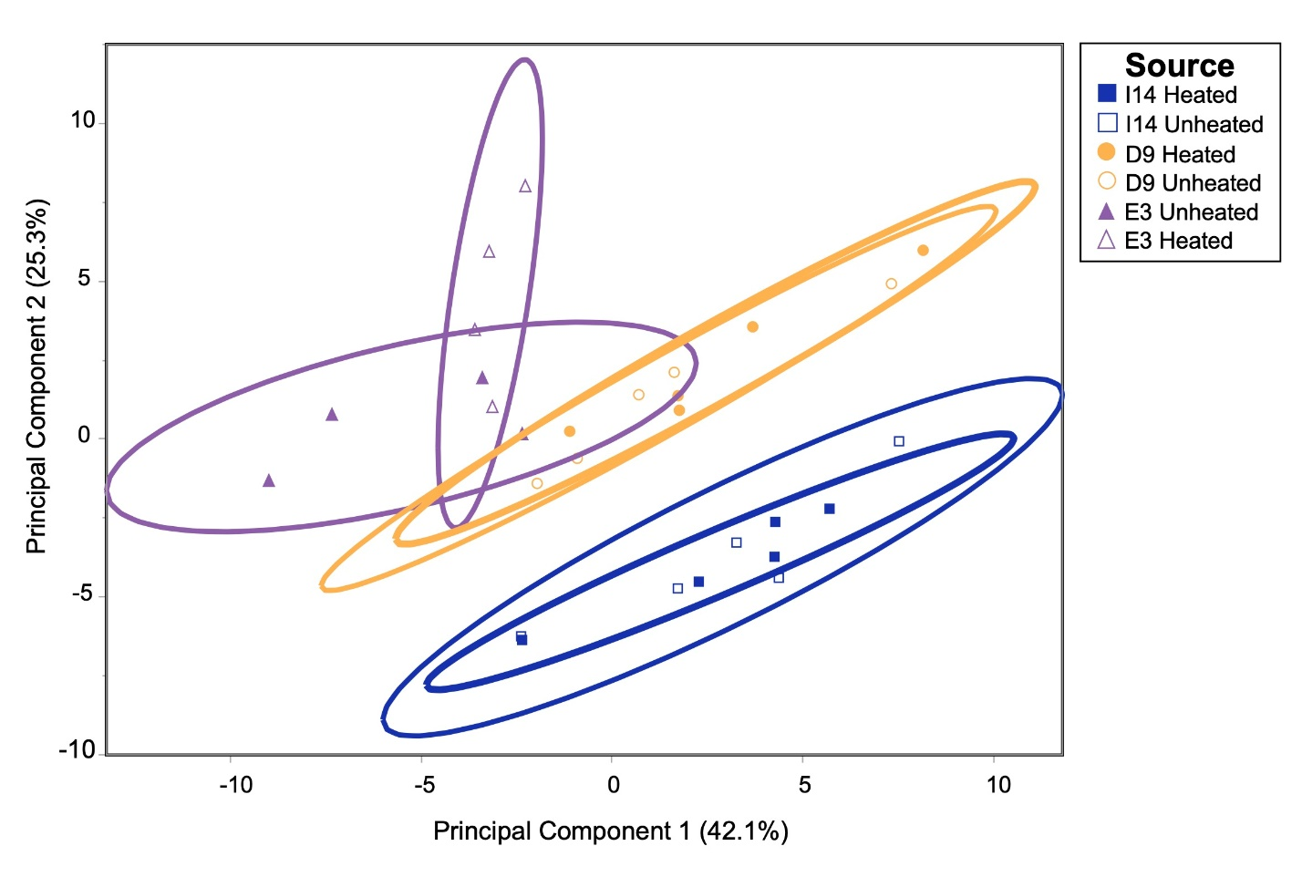
Supplementary Figure 4. Results from a Principal Component Analysis for source and treatment on solution ICP-MS data. Analyses were completed using JMP Statistical Software. All data is log transformed. We included all elements (n=68) in this analysis). Principal Component 1 accounts for 42.1% of variation and Principal Component 2 accounts for 25.3% of variation.

