Supporting information

Towards a more efficient breast cancer therapy using active human cell membrane-coated metal-organic frameworks
Pablo Graván,^{a,b,c,d,e,f} Sara Rojas,^{g} Darina Francesca Picchi,^{h} Francisco Galisteo-González,ª Patricia Horcajada,^{h,}* and Juan Antonio Marchal ^{b,c,d,e,f,}*
[a] Department of Applied Physics, Faculty of Science, University of Granada, 18071 Granada, Spain.
[b] Department of Human Anatomy and Embryology, Faculty of Medicine, University of Granada, 18016 Granada, Spain.
[c] Instituto de Investigación Biosanitaria de Granada (ibs.GRANADA), 18012 Granada, Spain.
[d] Biopathology and Regenerative Medicine Institute (IBIMER), Centre for Biomedical Research (CIBM), University of Granada, 18016 Granada, Spain.
[e] Excellence Research Unit Modelling Nature (MNat), University of Granada, 18016 Granada, Spain.
[f] BioFab i3D - Biofabrication and 3D (bio)printing laboratory, University of Granada, 18100 Granada, Spain.
[g] Department of Inorganic Chemistry, Faculty of Science, University of Granada, Av. Fuentenueva s/n, 18071 Granada, Spain.
[h] Advanced Porous Materials Unit, IMDEA Energy Institute, Av. Ramón de la Sagra 3, 28935 Móstoles, Spain.
E-mail: patricia.horcajada@imdea.org; jmarchal@ugr.es

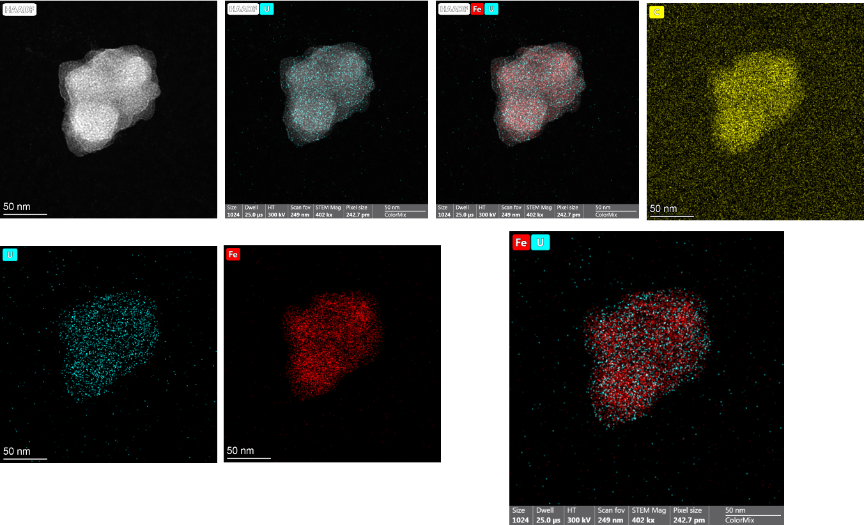
Figure S1. HR-TEM images and EDX-elemental mapping confirming the successful cell membrane coating of MIL-100(Fe) NPs (Fe: red, U: blue, C: yellow).

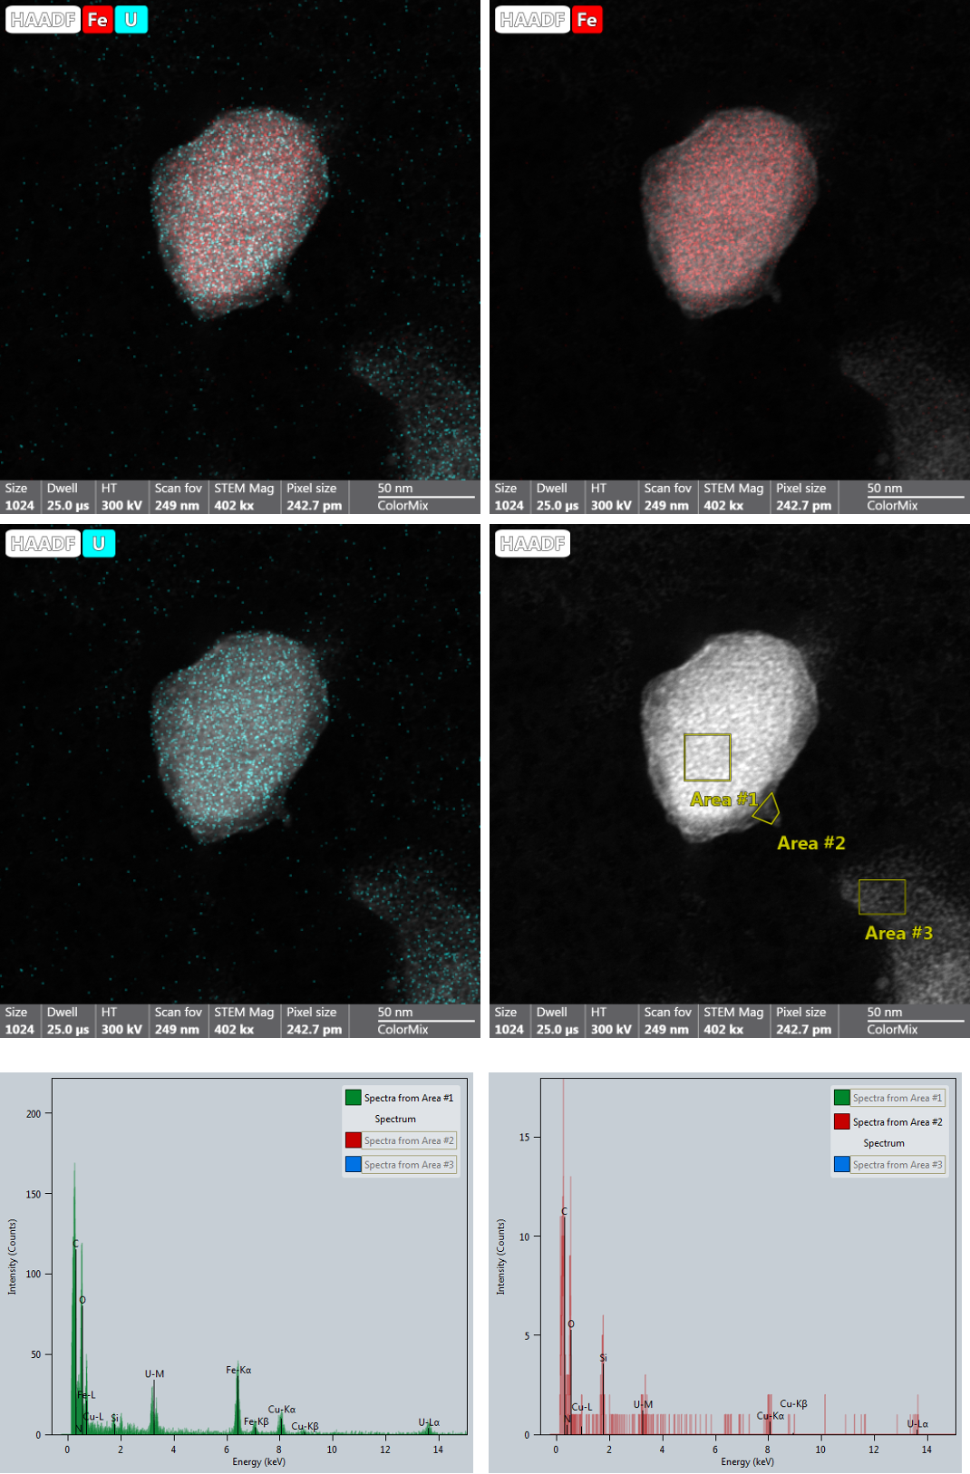
Figure S2. HR-TEM images and EDX-elemental mapping/counts of internal and external area of CS_MIL-100(Fe) NPs confirming differences in the Fe:U ratio (Fe: red, U: blue, C: yellow).

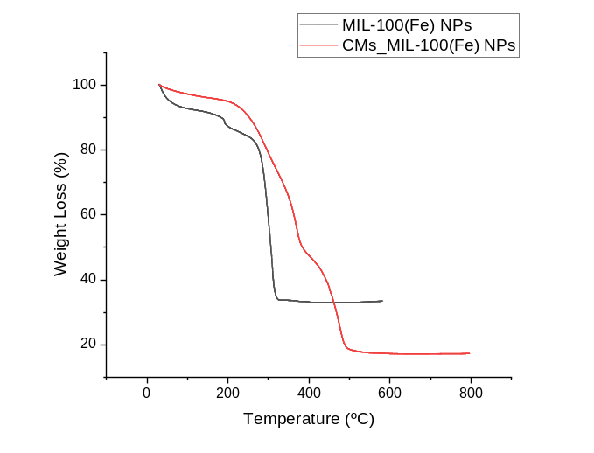

Figure S3. TGA trace for MIL-100(Fe) (black) and CMs_MIL-100(Fe) NPs (red).

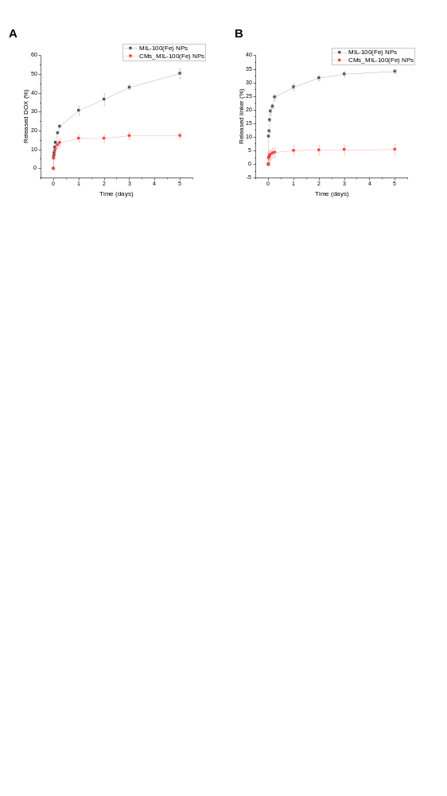

Figure S4. Released DOX (A) and H₃BTC ligand (B; representing MOF degradation) over 5 days from MIL-100(Fe) (black) and CMs_MIL-100(Fe) NPs (red) under simulated biological conditions. Note that lines are only visual guides.

