Supplementary material

Intense browsing by sika deer (Cervus nippon) drives the genectic differentiation of
hairy nettle (Urtica thunbergiana) populations

Tetsuo I. Kohyama, Mei Yoshida, Masahito T. Kimura and Hiroaki Sato

Supplement 1 F_{ST} outliers of 546 AFLP loci detected by the BayeScan programme (logarithm of posterior odds, log₁₀ (PO) > 0.5). Allele frequency more than 0.5 are in bold face. F_{ST} values less than 0.05 are in bold face. TO, Todaiji; NO, Noto; KO, Kohoboji; NWU, Nara Women’s University campus; SA, Sakurai; TA, Takatori; KC, Kouchidani; FDR, false discovery rate.

Locus ID TO NO KO NW SA TA KC FDR log₁₀ (PO)

6 0.63 0.43 0.70 0.97 0.20 0.87 0.07 0.049 0.65
7 0.47 0.23 0.20 0.93 0.07 0.03 0.00 0.064 0.58
11 0.63 0.47 0.13 0.07 0.63 1.00 0.97 0.000 2.66
24 0.00 0.00 0.00 0.03 0.00 0.77 0.93 0.000 1000
25 0.63 0.27 0.27 1.00 0.97 0.73 0.80 0.013 1.12
31 0.07 0.00 0.07 1.00 0.83 0.47 0.23 0.000 1000
41 0.20 0.00 0.27 0.97 0.03 0.03 0.00 0.007 1.21
52 0.80 0.97 0.90 1.00 0.83 0.87 0.00 0.000 3.30
55 0.50 0.20 0.47 0.97 0.87 0.03 0.30 0.010 1.20
153 1.00 0.83 0.73 0.97 1.00 0.83 0.00 0.000 1000
216 0.67 0.27 0.57 0.97 0.83 0.03 0.60 0.024 0.95
259 0.70 0.37 0.43 0.03 0.97 0.13 0.40 0.043 0.73
268 0.93 0.97 0.90 1.00 0.97 1.00 0.00 0.000 1000
269 0.00 0.00 0.00 0.07 0.00 1.00 0.03 0.000 1000
275 0.70 0.40 0.87 0.03 0.97 0.97 0.87 0.002 1.93
354 0.03 0.07 0.00 0.03 0.97 0.57 0.07 0.000 3.70
357 0.13 0.27 0.13 0.97 0.07 0.03 0.00 0.070 0.52
358 0.93 0.93 0.97 0.03 0.93 1.00 1.00 0.001 2.27
404 0.67 0.47 0.03 0.03 0.30 0.00 0.00 0.034 0.78
425 0.93 0.60 0.00 0.37 0.30 0.30 0.17 0.016 1.12
429 0.30 0.57 0.07 0.03 0.83 0.03 0.03 0.039 0.74
430 1.00 1.00 0.43 0.57 1.00 0.80 1.00 0.054 0.65
436 0.97 0.93 0.40 0.97 0.23 0.77 0.53 0.059 0.62
458 0.53 0.93 0.60 0.00 0.30 0.07 0.23 0.001 2.18
461 0.90 0.57 0.00 0.17 0.53 0.00 0.03 0.000 4.00
465 0.53 0.40 0.53 0.97 0.03 0.03 0.47 0.029 0.86
482 0.67 0.23 0.73 0.97 1.00 1.00 0.73 0.002 2.12
509 0.90 0.90 0.40 0.00 0.23 0.50 0.97 0.000 3.70
514 0.37 0.57 0.50 0.07 0.00 0.93 0.77 0.003 1.75
515 0.53 0.70 0.00 0.00 0.20 0.13 0.03 0.020 0.97
Supplement 2 Mantel test for a correlation between pairwise geographic distances and pairwise genetic differentiation quantified by pairwise F_{ST} (Table 2). Mantel’s r = 0.066, P = 0.44.

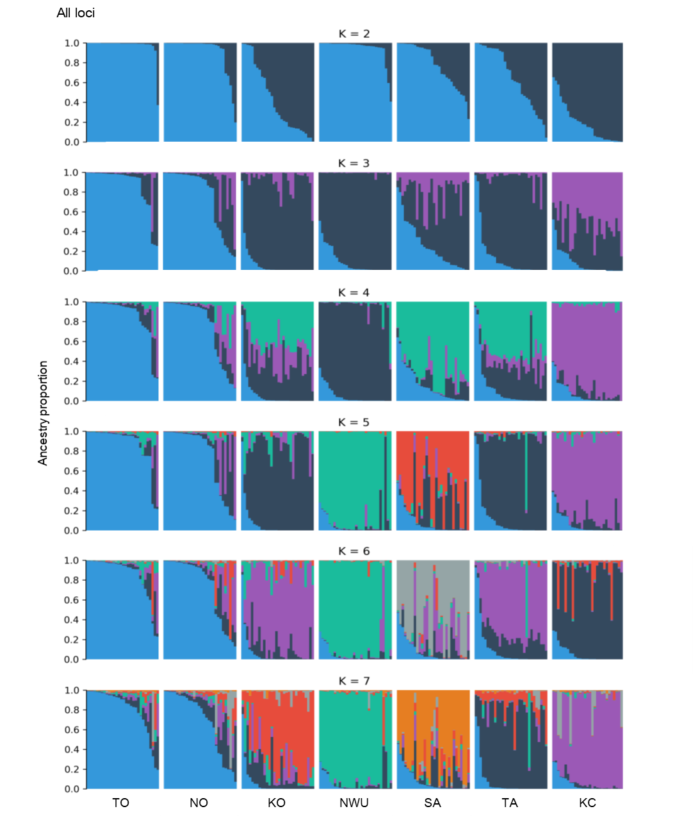
Supplement 3a Results of STRUCTURE analyses for k = 2 to 7 using all-loci dataset. Each vertical coloured bar represents one individual. Fractional proportions of k-coloured segments in a bar indicate assignment probability of the individual to each of k-genetic clusters.

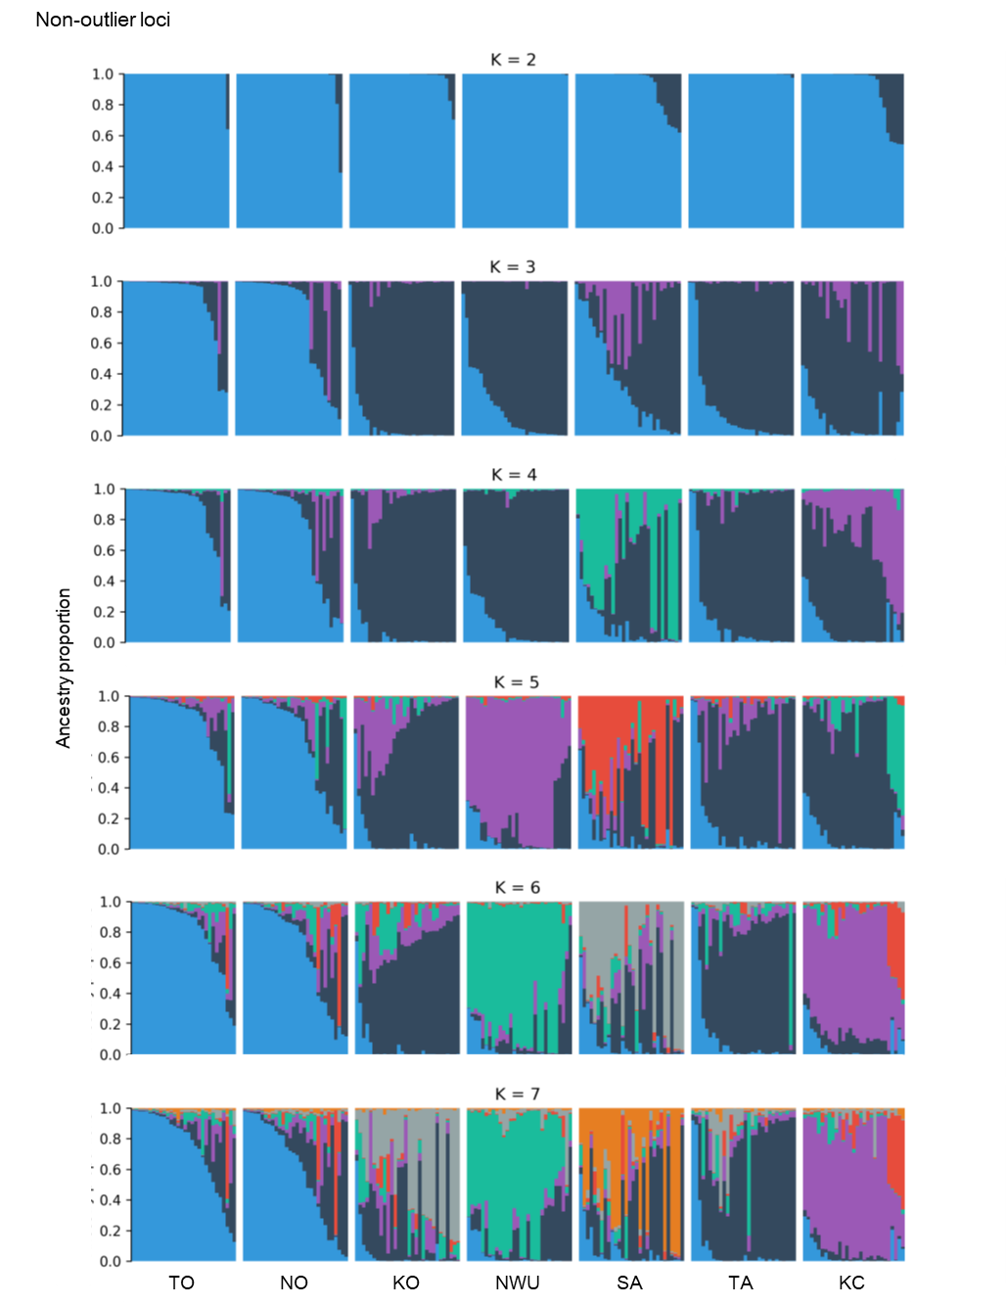
Supplement 3b Results of STRUCTURE for k = 2 to 7 using non-outlier loci dataset.

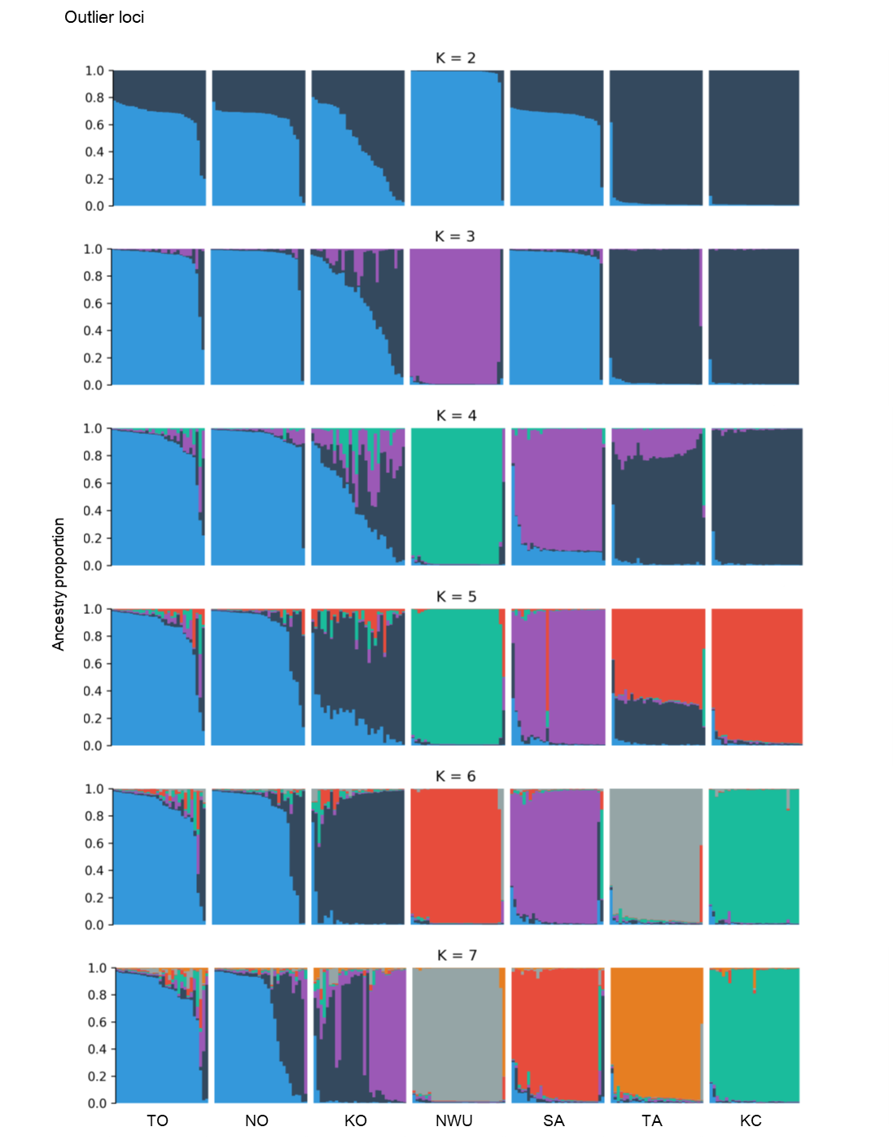
Supplement 3c Results of STRUCTURE for k = 2 to 7 using non-outlier loci dataset.

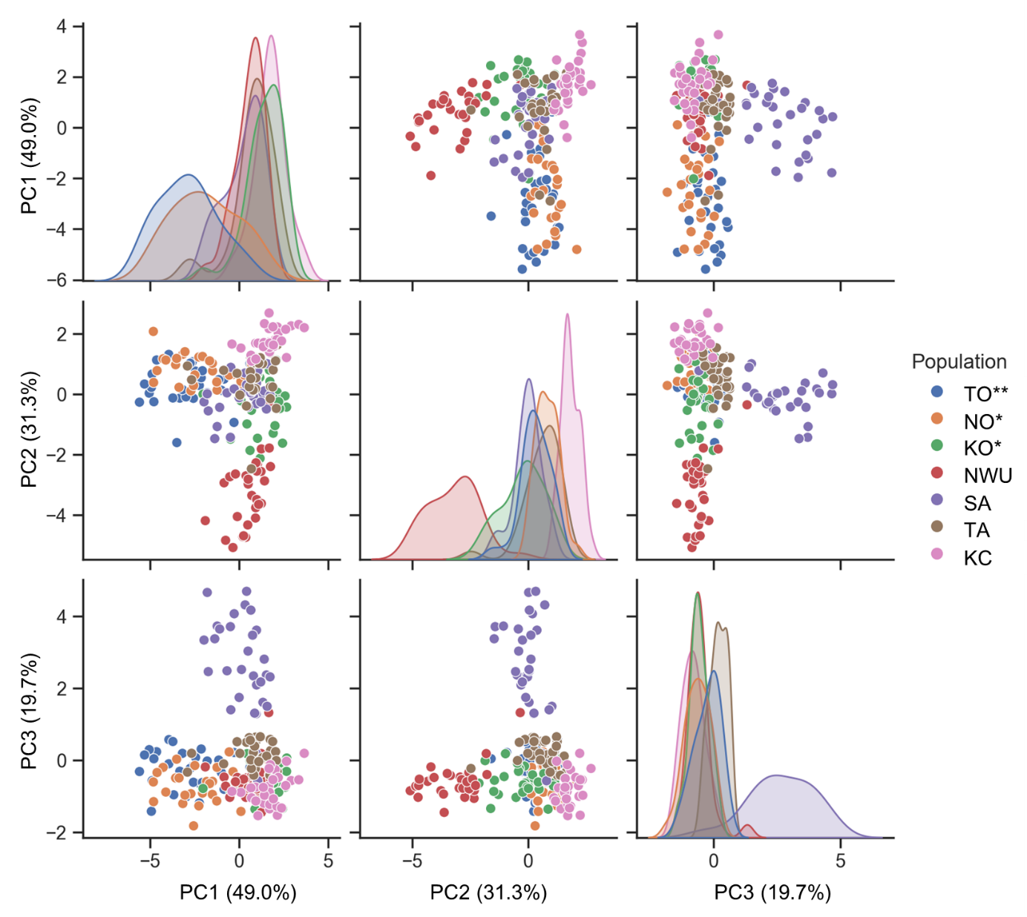
Supplement 4a PCoA biplot matrix with three principal components based on Eucalidian distance using all-loci dataset.

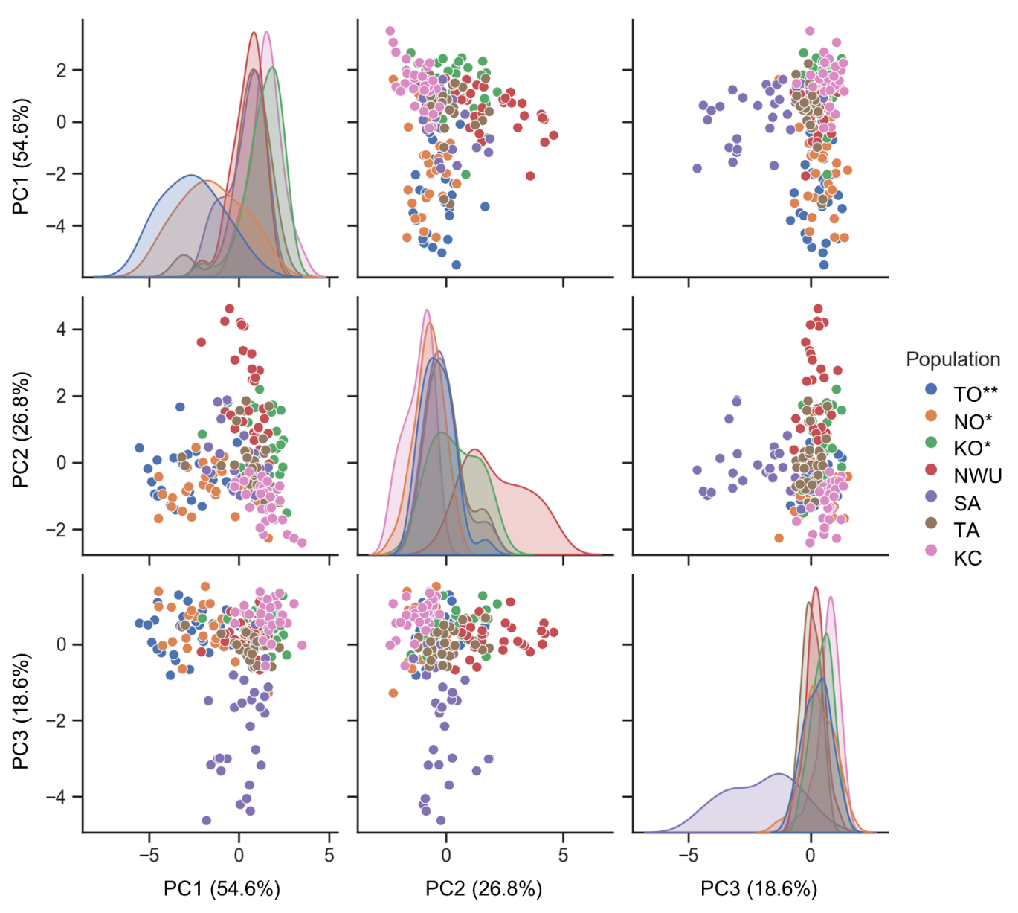
Supplement 4b PCoA biplot matrix with three principal components based on Eucalidian distance using non-outlier loci dataset.

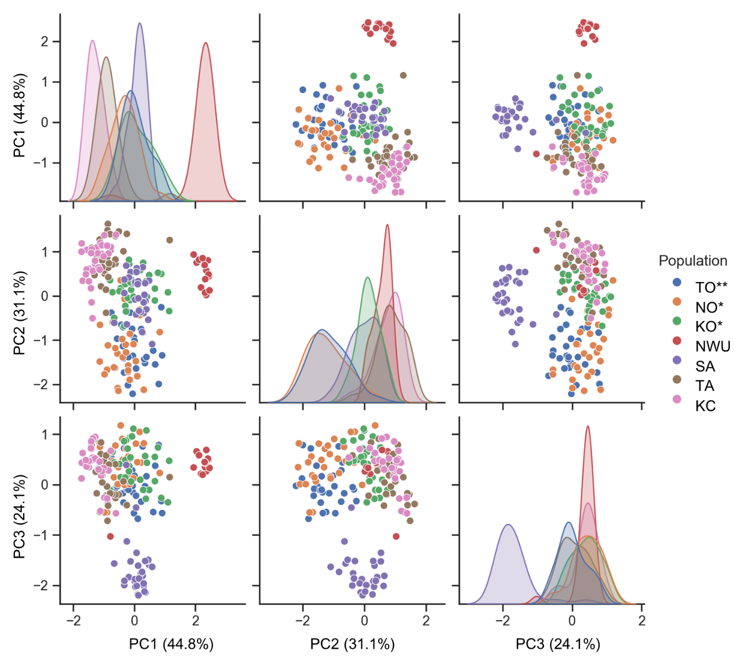
Supplement 4c PCoA biplot matrix with three principal components based on Eucalidian distance using outlier loci dataset.

