SUPPLEMENTAL INFORMATION

for

Title: Influence of Point Mutations on PR65 Conformational Adaptability: Insights from Nanoaperture Optical Tweezer Experiments and Molecular Simulations

SUPPLEMENTAL FIGURES

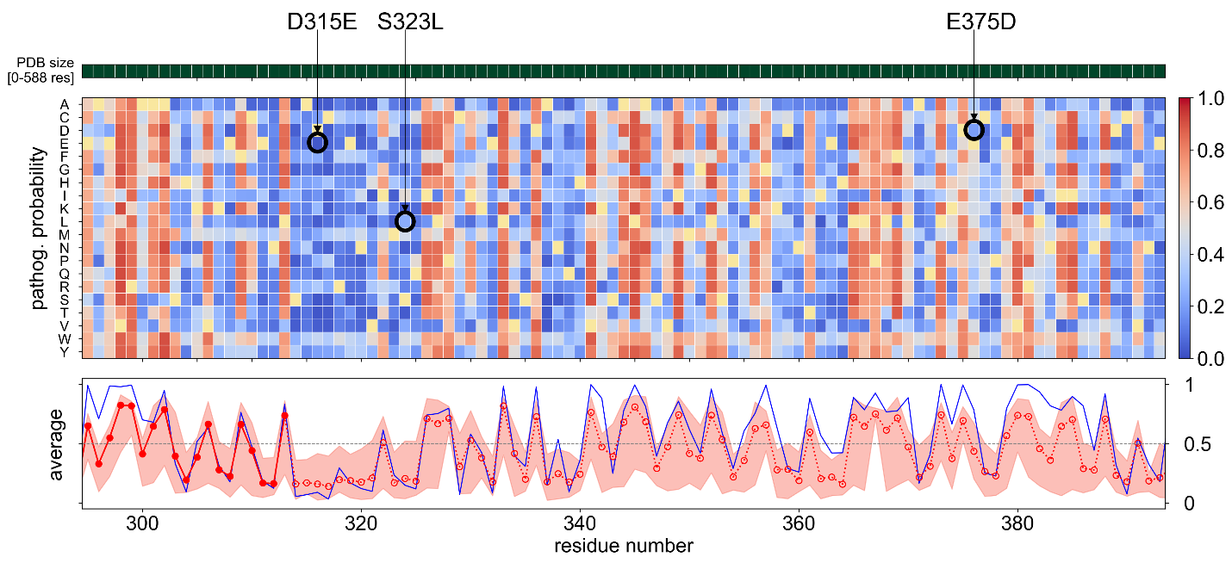
Figure S1. In silico saturation mutagenesis map generated for PR65 residues 296-394. Residues (along the abscissa) are color-coded according to their pathogenicity probability associated with all possible 19 mutations (ordinate), as predicted by Rhapsody ¹ for each residue. The wt residue is shown in cream. The color-coded entries represent the probability of having a pathogenic effect, with the scores 0 and 1 corresponding to fully neutral (blue) and fully pathogenic (red) effects. The mutations D315E, S323L and E375D are indicated by black circles. The curve underneath represents the averages over all entries in the corresponding column for each sequence position, providing a measure of the overall pathogenicity potential of each residue (red dots) regardless of the specific substitution. The pink shade provides the variance in the pathogenicity score (among all 19 substitutions) for each position, and the blue curve represents the result from PolyPhen-2 ². The entire pathogenicity profile can be obtained by running saturation mutagenesis on PR65 at the Rhapsody webserver (http://rhapsody.csb.pitt.edu/sat_mutagen.php). .

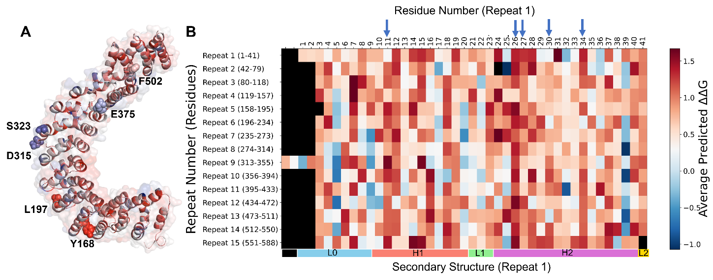
Figure S2. ProTSPoM-predicted average change ΔΔG folding free energy, across all single point mutations for each residue of PR65. (A) The apo form of PR65 color-coded by the average ΔΔG of all possible mutations as predicted by ProTSPoM³ for each residue, and (B) corresponding heat map. The color varies from deep blue suggesting a maximal stabilization (-1.07 kcal/mol) to red suggesting maximal destabilization (1.67 kcal/mol) induced by mutations (averaged over all 19 substitutions) for each position (abscissa) along each repeat unit (ordinate) of PR65.

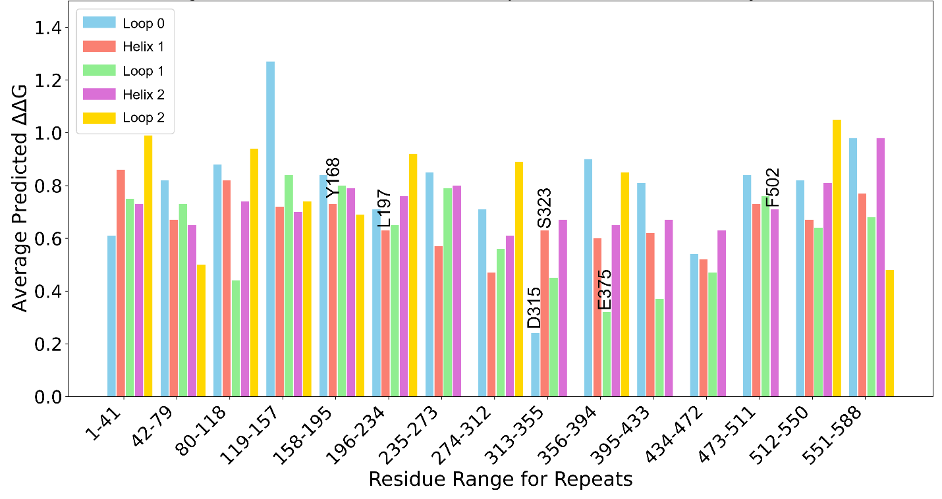
Figure S3. ProTSPoM-predicted ΔΔG values across secondary structures for the 15 HEAT repeats.

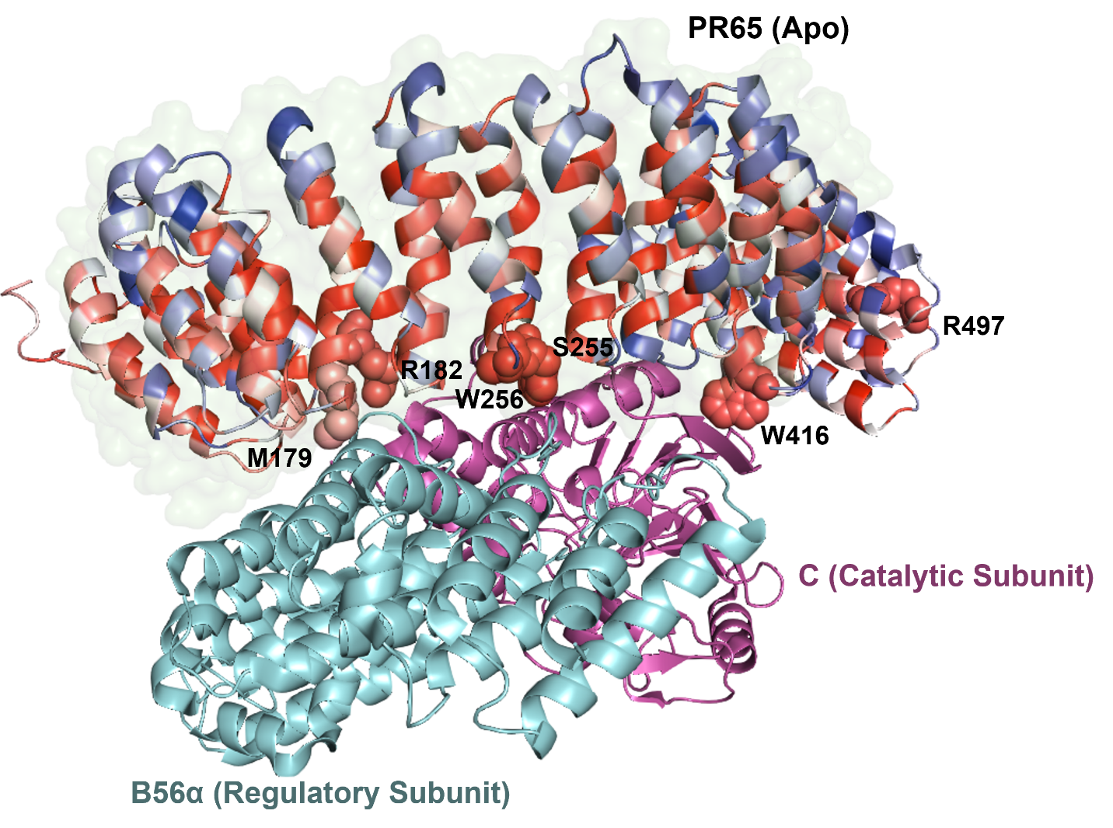
Figure S4. Maximally destabilizing and pathogenic point mutations of PR65 at the interface between the catalytic and regulatory subunits. The PR65 mutations M179H (ΔΔG = 1.52 kcal/mol, pathogenicity probability = 0.71), R182T (ΔΔG = 1.46 kcal/mol, pathogenicity = 0.77), S255F (ΔΔG = 1.47 kcal/mol, pathogenicity = 0.86), W256H (ΔΔG = 2.09, pathogenicity = 0.82) at the interface with the regulatory subunit, and the mutations W416F (ΔΔG = 1.23 kcal/mol, pathogenicity = 0.82), R497T (ΔΔG = 1.34 kcal/mol, pathogenicity = 0.81) at the interface with the catalytic subunit were distinguished in Rhapsody and ProTSPom analyses to be strongly destabilizing and potentially pathogenic.

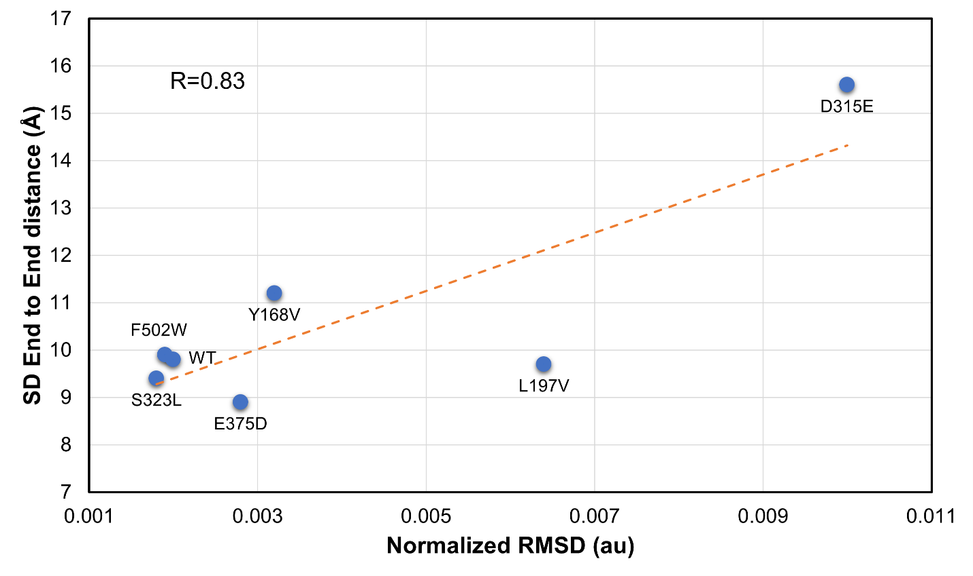
Figure S5. Standard deviation of end-to-end distance is highly correlated with normalized RMSD for the six mutants.

SUPPLEMENTAL TABLES

Table S1: Residue ranges in different structural elements of the 15 HEAT repeats in PR65 (PDB: 1B3U)
HEAT Repeat | Loop 0 | Helix 1 | Loop 1 | Helix 2 | Loop 2
1 (1-41) | 1-9 | 10-20 | 21-23 | 24-40 | 41-41
2 (42-79) | 42-42 | 43-57 | 58-61 | 62-73 | 74-79
3 (80-118) | 80-84 | 85-97 | 98-100 | 101-117 | 118-118
4 (119-157) | 119-119 | 120-136 | 137-139 | 140-150 | 151-157
5 (158-195) | 158-158 | 159-174 | 175-177 | 178-194 | 195-195
6 (196-234) | 196-196 | 197-213 | 214-216 | 217-233 | 234-234
7 (235-273) | 235-235 | 236-252 | 253-255 | 256-273 | -
8 (274-312) | 274-274 | 275-291 | 292-294 | 295-311 | 312-312
9 (313-355) | 313-315 | 316-334 | 335-337 | 338-355 | -
10 (356-394) | 356-356 | 357-373 | 374-376 | 377-393 | 394-394
11 (395-433) | 395-395 | 396-412 | 413-415 | 416-433 | -
12 (434-472) | 434-434 | 435-451 | 452-454 | 455-472 | -
13 (473-511) | 473-473 | 474-490 | 491-493 | 492-511 | -
14 (512-550) | 512-512 | 513-529 | 530-532 | 533-549 | 550-550
15 (551-588) | 551-551 | 552-568 | 569-571 | 572-585 | 586-588

Table S2: Computational and experimental characterization of selected mutations at PR65 hinge sites
Repeat | Mutant | ΔΔG (kcal/mol)  [-1.49-2.21]¹ | Pathogenicity prob²  [0-1] | Hinge Mode | Solvent accessibility [0-9]³ | Seq conservation [1-9]⁴ | Mutation group | Experimentally observed expression or solubility
2 | L72S  (Helix 2) | 1.62 | 0.89 | [4] | 0 | 8 | a | No soluble protein
3 | L111S  (Helix 2) | 1.49 | 0.86 | [3] | 0 | 6 | a | No soluble protein
3 | I114N  (Helix 2) | 1.56 | 0.82 | [3] | 0 | 7 | a | No soluble protein
5 | Y168V  (Helix 1) | 1.95 | 0.18 | [2] | 2 | 1 | b3 | Significant amount of soluble protein
5 | R182T  (Helix 2) | 1.46 | 0.77 | [5] | 3 | 8 | a | No soluble protein
5 | E190W  (Helix 2) | 0.68 | 0.61 | [5] | 2 | 1 | a | No expression (no band on SDS PAGE in soluble or insoluble fractions)
6 | L197V  (Helix 1) | 1.78 | 0.04 | [6] | 4 | 1 | b3 | Significant amount of soluble protein
7 | Y260D  (Helix 2) | 1.59 | 0.61 | [6] | 3 | 6 | a | No soluble protein (insoluble band only)
8 | R298T  (Helix 2) | 1.53 | 0.77 | [3] | 1 | 9 | a | No soluble protein
8 | E310L  (Helix 2) | -1.47 | 0.10 | [1] | 3 | 1 | b1 | Small amount of soluble protein
9 | D315E  (Loop 0) | -0.67 | 0.03 | [1] | 6 | 1 | b1 | Significant amount of soluble protein
9 | S323L  (Helix 1) | -1.16 | 0.24 | [1] | 5 | 1 | b1 | Significant amount of soluble protein
10 | L372V  (Helix 1) | 1.65 | 0.70 | [4] | 0 | 9 | a | Small amount of soluble protein
10 | E375D  (Loop 1) | -0.60 | 0.20 | [4] | 7 | 5 | b1 | Significant amount of soluble protein
10 | L381W  (Helix 2) | 1.62 | 0.63 | [4] | 3 | 7 | a | No expression
10 | I383G  (Helix 2) | 1.54 | 0.83 | [4] | 0 | 8 | a | No expression
10 | E392Q  (Helix 2) | -1.34 | 0.14 | [4] | 7 | 1 | b1 | No expression
12 | E440Q  (Helix 1) | -0.61 | 0.14 | [2] | 5 | 4 | b1 | Small amount of soluble protein
12 | L445G  (Helix 1) | 1.49 | 0.75 | [2] | 0 | 6 | a | No expression
13 | F502W  (Helix 2) | 1.09 | 0.36 | [3] | 2 | 4 | b2 | Significant amount of soluble protein
14 | K541S  (Helix 2) | 1.09 | 0.64 | [6] | 3 | 7 | a | No soluble protein
¹ ΔΔG values computed using ProTSPoM ³, represent the effect of mutation on folding stability, more positive values suggesting more destabilizing mutations. ΔΔG<0 kcal/mol is considered stabilizing, 0<ΔΔG<1.25 kcal/mol is considered mildly destabilizing and ΔΔG>1.25 kcal/mol is considered highly destabilizing
² Pathogenicity probability computed using Rhapsody ¹. It is a change in functionality metric varying in the range [0-1], with higher values indicating higher probability of having a pathogenic effect.
³ Solvent accessibility computed using STRIDE ⁴. A higher value suggests higher accessibility to water.
⁴ Residue conservation score computed using ConSurf⁵. Values vary in the range 1 (least conserved or highly variable) to 9 (fully conserved). A higher value means more conserved residue.

Table S3: Experimentally determined melting temperatures of PR65 WT and mutants. Mean and standard deviation are listed from technical triplicates.
Mutation | Melting temperature (°C)
WT | 51.3± 0.1
Y168V | 50.9± 0.2
L197V | 50.4± 0.3
D315E | 50.4± 0.3
S323L | 49.7± 0.2
E375D | 51.0± 0.2
F502W | 51.9± 0.2

References

1. Ponzoni, L.; Peñaherrera, D. A.; Oltvai, Z. N.; Bahar, I., Rhapsody: predicting the pathogenicity of human missense variants. Bioinformatics 2020, 36 (10), 3084-3092.
2. Adzhubei, I. A.; Schmidt, S.; Peshkin, L.; Ramensky, V. E.; Gerasimova, A.; Bork, P.; Kondrashov, A. S.; Sunyaev, S. R., A method and server for predicting damaging missense mutations. Nat Methods 2010, 7 (4), 248-9.
3. Banerjee, A.; Mitra, P., Estimating the Effect of Single-Point Mutations on Protein Thermodynamic Stability and Analyzing the Mutation Landscape of the p53 Protein. J Chem Inf Model 2020, 60 (6), 3315-3323.
4. Heinig, M.; Frishman, D., STRIDE: a web server for secondary structure assignment from known atomic coordinates of proteins. Nucleic Acids Res 2004, 32 (Web Server issue), W500-2.
5. Ashkenazy, H.; Abadi, S.; Martz, E.; Chay, O.; Mayrose, I.; Pupko, T.; Ben-Tal, N., ConSurf 2016: an improved methodology to estimate and visualize evolutionary conservation in macromolecules. Nucleic Acids Res 2016, 44 (W1), W344-50.

