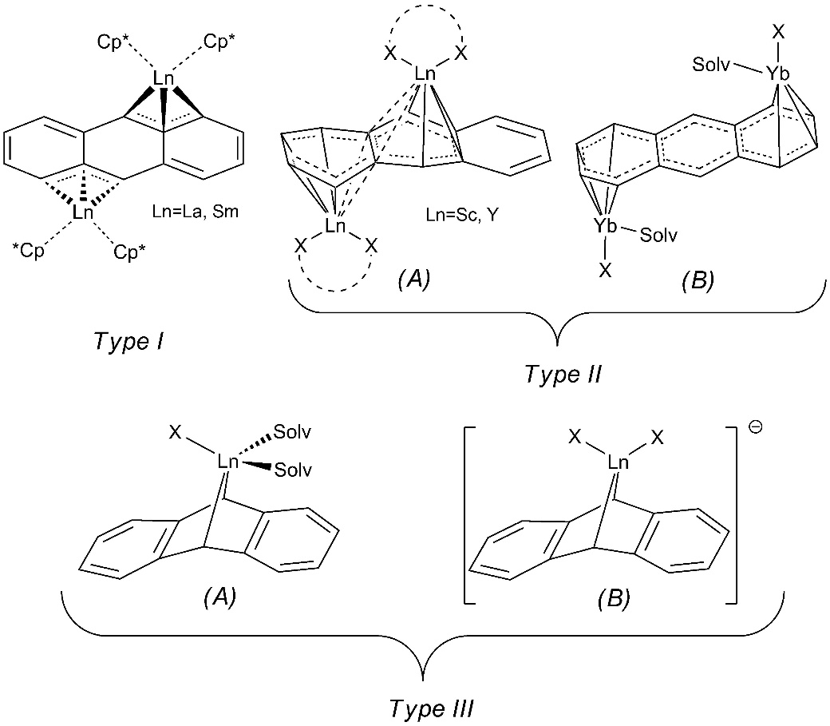
Scheme 1. Three types of anthracenide rare earth complexes and different types of the dianionic ligand coordination mode: (Type I) bis-allylic μ₂-η³:η³ bridging mode, (Type II) μ₂-η⁴:η⁴ or μ₂-η⁶:η⁶ bridging modes, (Type III) η²-coordination mode.

Scheme 2. A one-pot synthesis of complexes [(η⁵-Ph_{n}C₅H_{5-n})(η²-2,6-R₂C₁₄H₈)Ln(THF)₂] (Ln=Lu, Y; n=2,3; R=H, ^{t}Bu).

Scheme 3. Polymerization tests.

