Interactive effects of selected pharmaceutical products (metronidazole, diclofenac, ibuprofen) and differently functionalized nanoplastics on marine algae Chlorella sp.
Camil Rex, Bikram Poddar, Soupam Das and Amitava Mukherjeeª*

Centre for Nanobiotechnology, VIT, Vellore, Tamil Nadu, India
* Corresponding Author
Amitava Mukherjee
Senior Professor and Director
Centre for Nanobiotechnology
Vellore Institute of Technology, Vellore 632014, India
Email: amitav@vit.ac.in, amit.mookerjea@gmail.com
Supplementary Information
Tables:
Table S1. Composition of Artificial Sea Water per 1000 ml

Chemicals | Grams
Sodium Chloride | 26.29
Potassium chloride | 0.74
Calcium chloride | 0.99
Magnesium chloride | 6.09
Magnesium sulphate heptahydrate | 3.94

Table S2. Preparation of Conway medium
Table S2.1 Preparation of stock 1 per 100 ml
Chemicals | Grams
Zinc chloride | 2.1
Cobalt chloride | 2.0
Ammomium molybdate | 0.9
Copper sulphate | 2.0

Table S2.2 Preparation of stock 2 per 100ml
Chemicals | Milligrams
Vitamin B12 | 10
Vitamin B6 | 10

Table S2.3 Preparation of stock 3 per L
Chemicals | Grams
Iron chloride hexahydrate | 1.3
Manganese chloride | 0.36
Boric chloride | 33.6
Ethylenediaminetetraacetic acid | 45.0
Sodium dihydrogen phosphate dehydrate | 20.0
Sodium nitrate | 100

Materials and Methods
Methods S1: Chemical used
Metronidazole, Diclofenac sodium salts, Ibuprofen and 2′ ,7′ -dichlorofluorescein diacetate (DCFH-DA) were purchased from Sigma Aldrich. Aminated (NH₂) and carboxylated (COOH) polystyrene nanoplastics (600 nm) were purchased from Corpuscular, Inc, USA. DMSO (Dimethyl sulfoxide), Hydrogen peroxide (H₂O₂), and nitro blue tetrazolium (NBT) dye were purchased from SDFCL (Mumbai). Triton-X-100, Hydroxylamine hydrochloride, Trichloroacetic acid (TCA), and thiobarbituric acid (TBA) were purchased from Hi- Media Pvt. Ltd (Mumbai, India).
Methods S2: Growth inhibition
Following a 72-hour incubation period, the algal cell density was (OD 680) was determined using ultraviolet-visible spectrophotometer (Evolution 220, Thermofisher). The percentage of growth inhibition in algal cultures was determined by comparing them to a control group. Mathematically, the percentage of growth inhibition was calculated using the formula given below (Fan et al., 2019; Thiagarajan et al., 2021).
% Growth inhibition = (Control-Test) / Control × 10
Methods S3: Independent action modelling
The expected toxicity (C_{Exp}) of the mixture was determined by combining the individual toxicities of PPs and PSNPs using equation (1).
C_{Exp} = P+N – (P*N/100) (1)

In the equation, P and N represent the respective toxicity induced by PPs and PSNPs. Once C_{Exp} is calculated, the ratio of inhibition (R_{I}) is determined using the provided equation (2).
R_{I} = Observed Toxicity (C_{Obs}) / Expected Toxicity (C_{Exp}) (2)
Where C_{Obs} represent the observed toxicity resulting from the combination of PPs and PSNPs. The nature of interaction is determined based on the computed value of R_{I}. If the R_{I} value is equal to 1, the interaction is considered additive. If the calculated R_{I} value is less than 1, the interaction is deemed antagonistic. Conversely, if the R_{I} value obtained is greater than 1, the interaction is characterized as synergistic.
To validate the computed R_{I} value, statistical significance between C_{Obs} and C_{Exp} values was assessed using Two-way ANOVA (Bonferroni post-test). Despite the obtained R_{I} values, the interaction between PPs and PSNPs was regarded as additive when the toxicity difference between C_{Obs} and C_{Exp} was statistically insignificant (p > 0.05) (Thiagarajan, Iswarya, et al., 2019).
Method S4: Determination of observed concentration of pharmaceutical products
The observed concentration of PPs were determined using ultra performance liquid chromatography (UPLC). The samples were filtered using a 0.22 µm filter before undergoing analysis. A C18 1.7µm (2.1 × 150 mm) column was utilized for the separation and quantification of all PPs. In the case of metronidazole, the mobile phase was isocratically eluted at a flow rate of 0.5 mL/min, consisting of water:acetonitrile (90:10, v/v) (Soares et al., 2023) . Similarly, for diclofenac, a mobile phase of 0.05 M acetate buffer (pH 2.5) and acetonitrile (50:50, v/v) was employed with a flow rate of 0.5 ml/min (Elzayat et al., 2017). Likewise, the mobile phase for ibuprofen was a mixture of acetonitrile and water (pH 3 adjusted by diluted acetic acid). The separation system comprised 50% acetonitrile and 50% H2O, with a flow rate of 0.2 mL/min (Ahmed-Anwar et al., 2023).
Method S5: Estimation of Total ROS production
DCFH-DA, a dye capable of permeating cells and serving as an indicator for reactive oxygen species (ROS), was employed to quantify the level of ROS production. The total ROS content was assessed in both the control and experimental groups. After a 72-hour period, a 10 ml suspension of algal cells was exposed to DCFH-DA (100 mM) in a light-restricted environment for 30 minutes. Subsequently, the fluorescence intensity of the samples was measured using a spectrofluorometer with excitation and emission wavelengths set at 485 nm and 530 nm, respectively. The quantity of ROS generated was then determined by comparing it to the fluorescence intensity of untreated algal cells (Natarajan, Jenifer, et al., 2022; Roy et al., 2020).
Method S6: Estimation of MDA content
After a 72-hour incubation period, the treated samples underwent centrifugation at 4 °C for 10 minutes at a speed of 7000 rpm. The resulting cell pellets were subsequently subjected to treatment with a 0.25% solution of TBA (prepared in a 10% TCA solution) and placed in a water bath at 95 °C for 30 minutes. To halt the reaction, the heated sample mixtures were rapidly transferred to an ice bath and then centrifuged at 7000 rpm for 10 minutes. The absorbance of the supernatant containing the MDA enzyme released was measured at 530 nm. By subtracting the absorbance at 600 nm, the desired measurement was obtained (Roy et al., 2020; Thiagarajan, Natarajan, et al., 2019).

Methods S7: Antioxidant enzyme activity
For SOD analysis, following a 72-hour interaction, the algal cells were harvested through centrifugation at 7000 rpm for 10 minutes at 4°C. Subsequently, they were rinsed with 0.5 M phosphate buffer saline (PBS). The samples were then homogenized in PBS and subjected to further centrifugation at 13,000 rpm for 20 minutes at 4°C. The resulting supernatant was collected and combined with various chemicals, including hydroxylamine hydrochloride (20 mM), nitro blue tetrazolium chloride (96 mM), Na₂CO₃ buffer (50 mM, pH 10), and Triton X-100 (0.6%). This mixture was exposed to visible light for 20 minutes. The reaction mixture's absorbance was measured using a UV–Vis microplate reader (xMARK microplate absorbance spectrophotometer, BIO-RAD) at a wavelength of 560 nm.
For catalase activity assessment, algal cells exposed to the treatment for 72 hours were subjected to centrifugation at 7000 rpm for 10 minutes at a temperature of 4°C. The resulting cell pellet was processed in a similar manner as previously described for SOD activity. A spectrophotometer (Thermofisher Evolution 220) was utilized to record the decrease in absorbance at 240 nm over a 3-minute period following the addition of 800 µl of freshly prepared H₂O₂ solution (0.3% v/v) to 200 µl of the supernatant. A reaction solution without H₂O₂ served as a blank reference. (Giri et al., 2023; Natarajan, Soupam, et al., 2022).
Methods S8: Photosynthetic parameters assessment
In this investigation, a photosynthesis yield analyzer (Mini PAM, Heinz Walz, Germany) was employed to assess the photochemical quantum yield of the PS II system, represented by the Fv/Fm ratio, and the electron transport rate (ETR) in both the treated and control algal cells. Following a 72-hour interaction period, the control and treated cells underwent a dark incubation of 15 minutes. Subsequently, 400 µl of the sample was introduced into the instrument chamber, and high-intensity Actinic light was applied to record the Fv/Fm ratio and ETR values of the samples (Das et al., 2022).

Figures
Fig. S1. Percentage cell viability on exposure to 1 mg/L of 50% ethanol

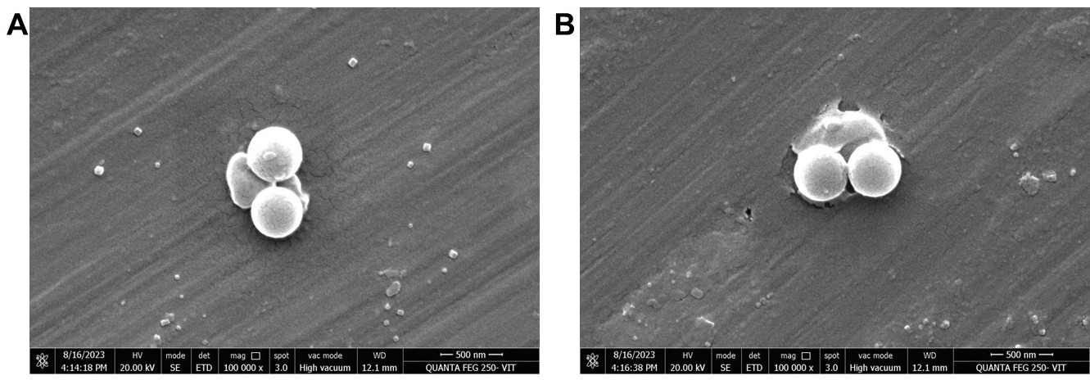
Fig. S2. FE-SEM image of (A) NH₂ NPs (B) COOH NPs

Fig. S3. Percentage growth inhibition of algal cells on exposure to metronidazole (MET), diclofenac (DIC) and ibuprofen (IBU). Note: ‘*’ represents the significant difference noted between the control and test groups. The significant difference between the pristine NPs and the binary mixtures of NPs with PPs are represented using ‘α’, and ‘γ’ (α = p < 0.001) and (γ = p < 0.05)

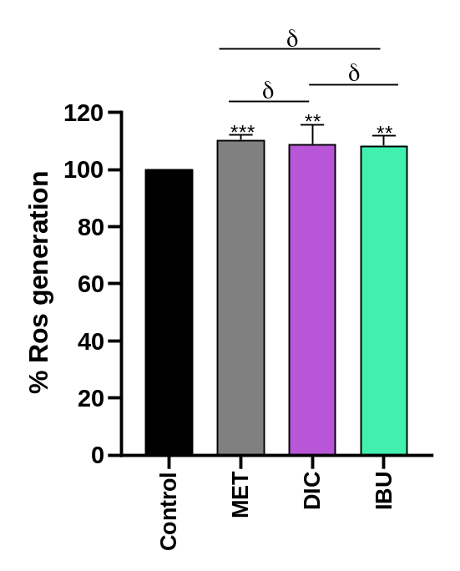
Fig. S4. Total ROS produced on exposure to metronidazole (MET), diclofenac (DIC) and ibuprofen (IBU). The ROS generation is presented in RFU (in relative fluorescent units). Note: ‘*’ represents the significant difference noted between the control and test groups. The symbol ‘δ’ denotes no significance (δ = p > 0.05)

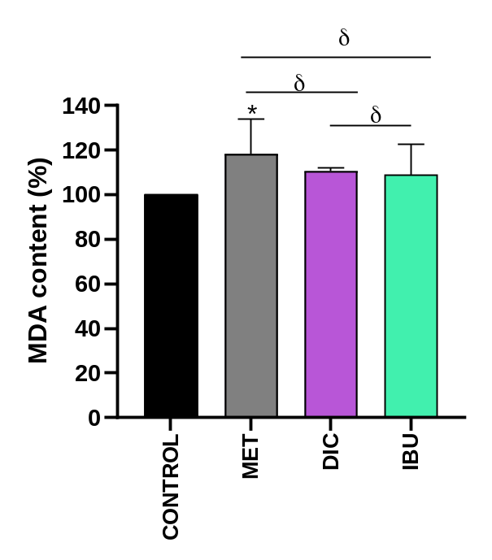

Fig. S5. Changes in the MDA content on exposure to metronidazole (MET), diclofenac (DIC) and ibuprofen (IBU). Note: ‘*’ represents the significant difference noted between the control and test groups. The symbol ‘δ’ denotes no significance (δ = p > 0.05)

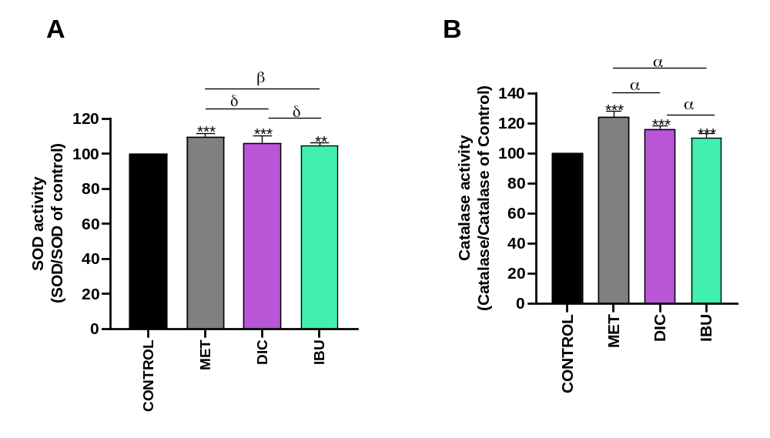

Fig. S6. (A) Changes in the SOD activity and (B) Catalase activity on exposure to metronidazole (MET), diclofenac (DIC) and ibuprofen (IBU). Note: ‘*’ represents the significant difference noted between the control and test groups. The significant difference between the pristine NPs and the binary mixtures of NPs with PPs are represented using ‘α’, ‘β’ and δ (α = p < 0.001), (β = p < 0.001 and ‘δ’ denotes no significance (δ = p > 0.05)

Fig. S7. (A) Percentage of maximum quantum yield of PS II (B) electron transport rate in algal cells on exposure to metronidazole (MET), diclofenac (DIC) and ibuprofen (IBU). Note: ‘*’ represents the significant difference noted between the control and test groups. The significant difference between the pristine NPs and the binary mixtures of NPs with PPs are represented using ‘α’, ‘β’, ‘γ ‘and δ (α = p < 0.001), (β = p < 0.01), (γ = p > 0.05) and ‘δ’ denotes no significance (δ = p > 0.05)

References

Ahmed-Anwar, A. A., Mohamed, M. A., Farghali, A. A., Mahmoud, R., & Hassouna, M. E. M. (2023). Green UPLC method for estimation of ciprofloxacin, diclofenac sodium, and ibuprofen with application to pharmacokinetic study of human samples. Scientific Reports, 13(1), 17613. https://doi.org/10.1038/s41598-023-44846-5
Das, S., Thiagarajan, V., Chandrasekaran, N., Ravindran, B., & Mukherjee, A. (2022). Nanoplastics enhance the toxic effects of titanium dioxide nanoparticle in freshwater algae Scenedesmus obliquus. Comparative Biochemistry and Physiology Part C: Toxicology & Pharmacology, 256, 109305. https://doi.org/10.1016/J.CBPC.2022.109305
Elzayat, E. M., Ibrahim, M. F., Abdel-Rahman, A. A., Ahmed, S. M., Alanazi, F. K., & Habib, W. A. (2017). A validated stability-indicating UPLC method for determination of diclofenac sodium in its pure form and matrix formulations. Arabian Journal of Chemistry, 10, S3245–S3254. https://doi.org/https://doi.org/10.1016/j.arabjc.2013.12.022
Fan, G., Bao, M., Wang, B., Wu, S., Luo, L., Li, B., & Lin, J. (2019). Inhibitory effects of Cu2O/SiO2 on the growth of Microcystis aeruginosa and its mechanism. Nanomaterials, 9(12), 1669.
Giri, S., Christudoss, A. C., Chandrasekaran, N., Peijnenburg, W. J. G. M., & Mukherjee, A. (2023). The role of algal EPS in reducing the combined toxicity of BPA and polystyrene nanoparticles to the freshwater algae Scenedesmus obliquus. Plant Physiology and Biochemistry, 197, 107664.
Natarajan, L., Jenifer, M. A., Chandrasekaran, N., Suraishkumar, G. K., & Mukherjee, A. (2022). Polystyrene nanoplastics diminish the toxic effects of Nano-TiO2 in marine algae Chlorella sp. Environmental Research, 204, 112400.
Natarajan, L., Soupam, D., Dey, S., Chandrasekaran, N., Kundu, R., Paul, S., & Mukherjee, A. (2022). Toxicity of polystyrene microplastics in freshwater algae Scenedesmus obliquus: Effects of particle size and surface charge. Toxicology Reports, 9, 1953–1961.
Roy, B., P.K., S., Chandrasekaran, N., & Mukherjee, A. (2020). UVB pre-irradiation of titanium dioxide nanoparticles is more detrimental to freshwater algae than UVA pre-irradiation. Journal of Environmental Chemical Engineering, 8(5), 104076. https://doi.org/https://doi.org/10.1016/j.jece.2020.104076
Soares, G. A., Rodrigues, G. S., Buranello, L. P., de Oliveira, R. B., & de Arruda Miranda, J. R. (2023). Pharmacomagnetography assessment of the prokinetic effect on metronidazole absorption. Journal of Pharmacy and Pharmacology, rgad088. https://doi.org/10.1093/jpp/rgad088
Thiagarajan, V., Alex, S. A., Seenivasan, R., Chandrasekaran, N., & Mukherjee, A. (2021). Toxicity evaluation of nano-TiO2 in the presence of functionalized microplastics at two trophic levels: Algae and crustaceans. Science of the Total Environment, 784, 147262.
Thiagarajan, V., Iswarya, V., P., A. J., Seenivasan, R., Chandrasekaran, N., & Mukherjee, A. (2019). Influence of differently functionalized polystyrene microplastics on the toxic effects of P25 TiO2 NPs towards marine algae Chlorella sp. Aquatic Toxicology, 207(December 2018), 208–216. https://doi.org/10.1016/j.aquatox.2018.12.014
Thiagarajan, V., Natarajan, L., Seenivasan, R., Chandrasekaran, N., & Mukherjee, A. (2019). Tetracycline affects the toxicity of P25 n-TiO2 towards marine microalgae Chlorella sp. Environmental Research, 179, 108808. https://doi.org/https://doi.org/10.1016/j.envres.2019.108808

