Self-Reporting Photodynamic Nanobody Conjugate for Precise and Sustainable Large-Volume Tumor Treatment
Yingchao Chen, Tao Xiong, Qiang Peng, Jianjun Du, Wen Sun, Jiangli Fan*, Xiaojun Peng
Y.C. Chen, T. Xiong, Q. Peng, Prof. J.J. Du, W. Sun, J.L. Fan, X.J. Peng
State Key Laboratory of Fine Chemicals, Frontiers Science Center for Smart Materials Oriented Chemical Engineering, Dalian University of Technology, No. 2 Linggong Road, Dalian 116024, China
E-mail: fanjl@dlut.edu.cn

Characterization
¹H nuclear magnetic resonance (¹H NMR) and ¹³C NMR spectra of all compounds were detected by Bruker AvanceⅡ500 MHz spectrometer. The mass spectrometric (MS) data were obtained with electrospray ionization (EIS)-high resolution mass spectrometry (HRMS) instruments. Absorption spectra were performed with a Lambda 60 UV-visible (UV-Vis) spectrophotometer (PerkinElmer, USA). And fluorescence spectra were tested in a VAEIAN CARY Eclipse fluorescence spectrophotometer (Serial No. FL0812-M018). The cell imaging experiments were performed on confocal laser scanning microscope (CLSM, Olympus FV3000, Japan). Cytotoxicity assays were analyzed by Thermo Varioskan™ LUX multifunctional microplate reader (USA). The in vivo imaging experiments were carried out on NightOWL II LB983 small animal in vivo imaging system (Germany). Flow cytometry was analyzed by Attune NxT Acoustic Focusing Cytometer.

Cell-based enzyme linked immunosorbent assay
A431 and NIH-3T3 cellls (100 μL, 1×10³ cells) were seeded into 96-well cell culture plates containing DMEM medium supplemented with 1% penicillin-streptomycin and 10% FBS and cultured overnight. Afterwards, the cells were washed three times with PBS solution. Then, 4% paraformaldehyde (125 μl) was added into each well and the cells were incubated at 37 ºC for 30 min to fix the cells. The cells were then washed with PBS solution, and 5% (w/v) skim milk powder (200 μl) was added and the cells were incubated at 37°C for 1 h. Next, 200 μL of 7D12-fGly and MNB-Pyra Nbs (30 μg/ml) were added and the cells were incubated at 37°C for another 1 h. Subsequently, the cells were incubated with 200 μl of anti-6×His primary antibody solution (Sangon Biotech, China, diluted 1:2000 in PBS) for 1 h at 37°C, and followed by incubation with a 200 μl solution of secondary HRP-conjugated Goat Anti-Mouse IgG antibody (Sangon Biotech, China, diluted 1:2000 in PBS) at 37°C for 1 h. Finally, the cells were incubated with TMB working solution (200 μl) for 20 min, and followed by adding 50 μl of stop solution. OD₄₅₀ nm value of the resulting solution in the well was measured using a microplate reader.

Subcellular localization of MNB-Pyra Nbs
A431 cells (1×10⁴) were seeded into the cell dish and cultured overnight. The cells were first incubated with MNB-Pyra Nbs (100 nM) for 2 h, and then Lyso-Tracker Green (1 µM, Beyotime Biotechnology) was added. The cells were incubated for another 30 min, followed by washing with PBS buffer thrice. The cells were then imaged using CLSM under 488 nm and 640 nm excitation.

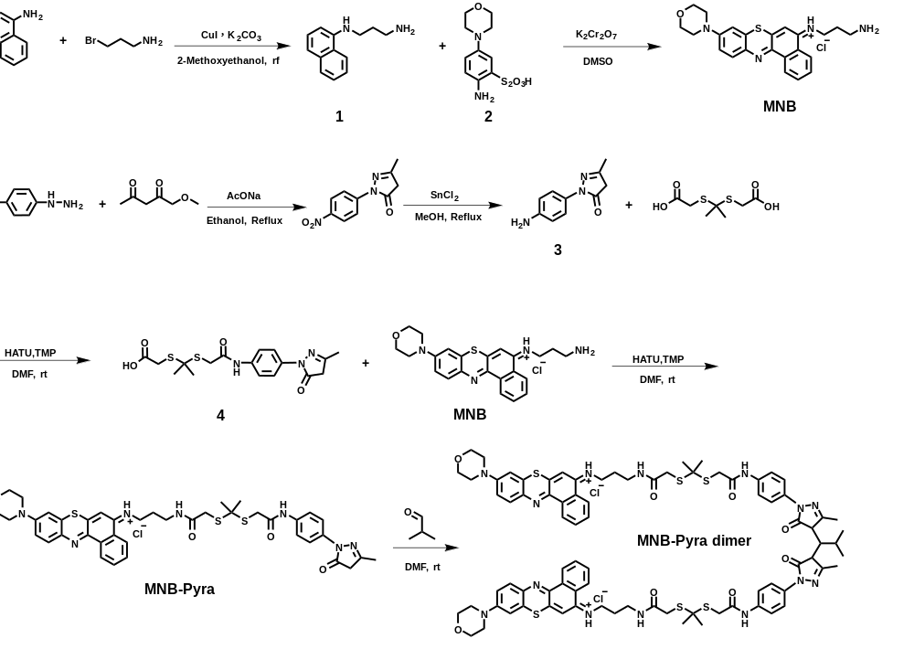
Scheme S1 the synthesis route of MNB-Pyra and MNB-Pyra dimer
Synthesis of compound 1
1-naphthylamine (1 g, 7 mmol) and 3-bromopropionamide (2.1 g, 14 mmol) were dissolved in 20 mL 2-methoxyethanol, then K₂CO₃ (1 g, 7 mmol) and CuI (190 mg, 1 mmol) was added into the mixture, the reaction was stirred under reflux for 12 h. After rotary evaporator, the crude product was purified by column chromatography (petroleum ether: DCM= 10:1 v/v) to give an oil product compound 1 (1.26 g, 6.3 mmol, 90%). HRMS (ESI): m/z for C₁₃H₁₇N₂⁺ ([M+H]⁺): calc. 201.1386; found 201.1392.
Synthesis of compound MNB
After Al₂(SO₄)₃ (2 g, 6 mmol) was dissolved in 10 mL water, 4-morpholinoaniline (1 g, 6 mmol), Na₂S₂O₃ (2 g, 12 mmol) and ZnCl₂ (1 g, 6 mmol) were added into this solution one by one, then K₂Cr₂O₇ (600 mg, 2 mmol) was slowly added into mixture under ice-bath. The reaction was stirred under 0-4 ºC for 2 h. The gray solid compound 2 was gathered after filtration and washes of acetone. To prepare the compound MNH₂, compound 1 (400 mg, 2 mmol) and compound 2 (700 mg, 2.4 mmol) were dissolved in dimethyl sulfoxide (20 mL), and then K₂Cr₂O₇ (600 mg, 2 mmol) was slowly poured into flask under mixture. After 20 min reaction, the purple mixture was dropped into methanol (200 mL), the pH was adjusted using HCl (8 mL, 1M), then blue solution was obtained after 45 min reaction. After rotary evaporator, the crude product was purified by column chromatography (CH₂Cl₂:CH₃OH= 20:1 v/v) to give a blue solid (650 mg, 73%). HRMS (ESI): m/z for C₂₃H₂₅N₄OS⁺ ([M]⁺): calc. 405.1744; found 405.1747.
Synthesis of compound 3
4-nitrophenylhydrazine (2 g, 13mmol), ethyl acetoacetate (2 g, 15mmol) and sodium acetate (1 g, 13mmol) were added into 30 mL ethanol, and the mixture was stirred at 78 °C under N₂ atmosphere for 12h. The solvent was then evaporated under reduced pressure and the residue was used for next step reaction. The residue and SnCl₂ (5 g, 26 mmol) were dissolved in 100 mL methanol and the mixture was stirred at 64 °C for 10 h. After removal of the solvent under reduced pressure, the residue was subjected to silica gel chromatography with CH₂Cl₂/CH₃OH (10/1, v/v) as the eluent. Finally, compound 3 as brown gummy liquid (46 mg, 60%) was afforded. HRMS (ESI): m/z for C₁₀H₁₂N₃O⁺ ([M+H]⁺): calc. 190.0975; found 190.0977.
Synthesis of compound 4
Compound 3 (100 mg, 0.53 mmol), HATU (402 mg, 1 mmol) and TMP (128 mg, 1 mmol) were dissolved in 3 mL DMF and stirred under room temperature. Then 2,2'-[propane-2,2-diylbis(thio)]diacetic acid (240 mg, 1mmol) was added into the mixture and the reaction was stirred room temperature for 8h. The solvent was then evaporated under reduced pressure and the residue purified by silica gel column chromatography by using CH₂Cl₂/CH₃OH 5:1 (v/v) as eluent, affording compound 4 (125 mg, 60%) as colorless gummy liquid. HRMS (ESI): m/z for C₁₇H₂₂N₃O₄S₂⁺ ([M+H]⁺): calc. 396.1046; found 396.1048.
Synthesis of MNB-Pyra
Compound 4 (100 mg, 0.25 mmol), HATU (190 mg, 0.5 mmol) and TMP (60 mg, 0.5 mmol) were dissolved in 3 mL DMF and stirred under room temperature. Then MNH₂ (220 mg, 0.5mmol) was added into the mixture and the reaction was stirred room temperature for 8h. The solvent was then evaporated under reduced pressure and the residue purified by silica gel column chromatography by using CH₂Cl₂/CH₃OH 10:1 (v/v) as eluent, affording MNB-Pyra (150 mg, 80%) as blue solid. HRMS (ESI): m/z for C₄₀H₄₄N₇O₄S₃⁺ ([M]⁺): calc. 782.2611; found 782.2601. m/z for C₄₀H₄₅N₇O₄S₃²⁺ ([M+H]²⁺): calc. 396.6342; found 396.6336. 1H NMR (500 MHz, DMSO-d6) δ 10.17 (s, 1H), 10.05 (s, 1H), 9.03 (d, J = 8.3 Hz, 1H), 8.52 (d, J = 7.7 Hz, 1H), 8.25 – 8.21 (m, 1H), 8.05 (d, J = 9.3 Hz, 1H), 8.00 – 7.96 (m, 1H), 7.92 (t, J = 7.3 Hz, 1H), 7.65 (s, 1H), 7.58 (s, 2H), 7.56 (s, 3H), 5.32 (s, 1H), 3.79 – 3.75 (t, J = 4.2 Hz, 4H), 3.75 – 3.68 (s, 4H), 3.49 (t, J = 5 Hz, 4H), 3.28 – 3.24 (t, J = 11.6 Hz, 2H), 2.07 (s, 2H), 2.04 – 1.97 (m, 2H), 1.95 – 1.91 (t, J = 6.5 Hz, 2H), 1.59 (s, 6H), 1.24 (s, 3H). ¹³C NMR (151 MHz, MeOD) δ 159.28, 157.64, 154.20, 152.51, 141.55, 136.71, 136.26, 133.59, 133.18, 131.58, 130.55, 130.41, 125.58, 124.73, 122.86, 121.48, 120.27, 120.06, 118.97, 117.30, 106.22, 102.92, 66.21, 57.30, 54.39, 46.95, 46.53, 41.83, 36.92, 35.69, 34.66, 31.82, 29.81, 29.54, 29.24, 28.32, 22.54, 16.24, 13.58, 8.29.
Synthesis of MNB-Pyra dimer
M1 (50 mg, 0.06 mmol) and isobutyraldehyde (2.16 mg, 0.03 mmol) were dissolved in 2 mL DMF and the mixture was stirred at room temperature for 24 h. The solvent was then evaporated under reduced pressure and the residue purified by silica gel column chromatography by using CH₂Cl₂/CH₃OH 8:1 (v/v) as eluent, affording MNB-Pyra dimer (72 mg, 70%) as blue solid. HRMS (ESI): m/z for C₈₄H₉₄N₁₄O₈S₆²⁺ ([M]²⁺): calc. 1618.5692; found 1618.5286. ¹H NMR (500 MHz, DMSO) δ 10.22 (s, 2H), 9.93 (s, 2H), 8.86 (d, J = 7.9 Hz, 2H), 8.39 (d, J = 7.9 Hz, 2H), 8.25 (d, J = 5.5 Hz, 2H), 7.85 (dt, J = 15.0, 7.1 Hz, 6H), 7.63 (s, 2H), 7.56 (s, 4H), 7.50 (s, 2H), 7.42 (d, J = 9.9 Hz, 2H), 7.34 (d, J = 14.2 Hz, 2H), 3.78 – 3.70 (t, 7.5 Hz, 4H), 3.67 – 3.56 (t, 4.3 Hz, 12H), 3.50 – 3.47 (t, 5.4 Hz, 4H), 3.27 – 3.24 (t, 4.7 Hz, 4H), 3.17 (s, 2H), 2.96 (d, J = 11.0 Hz, 2H), 2.18 (s, 6H), 2.04 – 1.97 (m, 1H), 1.92 (dt, J = 13.2, 6.5 Hz, 4H), 1.59 (s, 12H), 1.49 – 1.41 (m, 1H), 1.23 (s, 6H), 0.81 (d, J = 6.1 Hz, 6H). ¹³C NMR (126 MHz, DMSO) δ 169.01, 167.51, 153.56, 151.97, 145.69, 140.50, 136.14, 135.00, 132.92, 132.22, 131.43, 130.15, 129.93, 124.96, 124.26, 123.14, 120.89, 119.51, 119.35, 117.29, 106.40, 103.69, 73.86, 65.71, 59.99, 57.98, 56.42, 48.56, 46.63, 41.99, 36.86, 36.63, 35.37, 35.08, 34.31, 30.21, 28.62, 28.28, 28.03, 21.41, 13.90, 11.50.

Compound | Φ_{f} in CH₃CN | Φ_{f} in H₂O
MNB-Pyra | 12.4% | 4.6%
MNB-Pyra dimer | 4.1% | 0.9%
MNB-Pyra Nbs | / | 0.8%

Table S1. The absolute fluorescence quantum yield of MNB-Pyra, MNB-Pyra dimer and MNB-Pyra Nbs in organic different solutions.

Figure S1. (a) Absorption and (b) fluorescence spectrum of MNB-Pyra (10 μM) in different solvents. (c) Absorption and (d) fluorescence spectrum of MNB-Pyra dimer (5 μM) in different solvents.
Figure S2. Fluorescence intensity of MNB-Pyra and MNB-Pyra dimer in biological solutions. Data are shown as mean ± SD (n = 5).

Figure S3. (a) The detection of ¹O₂ generation by MNB-Pyra and MNB-Pyra dimer using DPBF probe. (b) O₂ ^{−•} generation of MNB-ROS and MNB-ROS dimer detected by DHR123 probe.

Figure S4. The HRMS analysis of cleavaed product after fluorescence recovery in MNB-Pyra dimer.
Figure S5. Evaluating the cell binding of MNB-Pyra Nbs using cell-based ELISA. A431 cells were used as the EGFR positive cells, and NIH-3T3 cells were used as the negative control. Data are shown as mean ± SD (n = 5).

Figure S6. The detection of cleavaed product after fluorescence recovery in MNB-Pyra Nbs.
Figure S7. Imaging of MNB-Pyra Nbs (0.2 µM) in different cells. Scale bar = 20 µm.

Figure S8. Imaging of MNB-Pyra and MNB-Pyra dimer in different cells. Scale bar = 20 µm.
Figure S9. Co-localization of MNB-Pyra Nbs fluorescence with lysosomes after incubating MNB-Pyra Nbs with A431 cells for 2 h. Scale bar = 20 µm.

Figure S10. Live/death cells imaging of A431 cells with PDT treatment under normoxia or hypoxia conditions using Calcien-AM/PI kit. Calcein-AM: E_{x}: 488 nm, E_{m}: 490–520 nm; PI: E_{x}: 488 nm, E_{m}: 600–700 nm. Scale bar = 200 µm.

Figure S11. Live/death cells imaging of different cells with or without PDT treatment (630 nm, 30 mW /cm², 20 min) using Calcien-AM/PI kit. Calcein-AM: E_{x}: 488 nm, E_{m}: 490–520 nm; PI: E_{x}: 488 nm, E_{m}: 600–700 nm. Scale bar = 200 µm.

Figure S12. The wound healing assay for comparing of recovery rate using MNB-Pyra Nbs in different cells. Scale bar = 200 µm.

Figure S13. The apoptosis detection using flow cytometry in A431 cells.
Figure S14. (a) MNB-Pyra dime and (b) MNB-Pyra Nbs for in vivo imaging at 4 h postinjection.

Figure S15. Real-time tracking of MNB-Pyra in vivo after intratumorally injection.

Figure S16. The tumor picture at the end of experiment in different groups. Scale bar = 1 cm.
Figure S17. H&E analysis of the major organs (heart, liver, spleen, lung, and kidney) tissues collected from mice in the different groups at the end of treatment. Scale bar = 50 µm.
Figure S18. HRMS spectrum of compound 1.

Figure S19. HRMS spectrum of MNB.

Figure S20. HRMS spectrum of compound 3.

Figure S21. HRMS spectrum of compound 4.

Figure S22. HRMS spectrum of MNB-Pyra.

Figure S23. ¹H NMR spectrum of MNB-Pyra.

Figure S24. ¹³C NMR spectrum of MNB-Pyra.

Figure S25. HRMS spectrum of MNB-Pyra dimer.

Figure S26. ¹H NMR spectrum of MNB-Pyra dimer.

Figure S27. ¹³C NMR spectrum of MNB-Pyra dimer.

