Supplementary Materials
SRRM2 is a target for the immunotherapy of AML with rationally designed CAR-T cells

Wan-qiu Zhang^{1-5,†}, Meng-meng Fan^{1-5,†}, Zhi-mai Gao⁶, Hui-ping Wang¹⁻⁵, Jin-jing Guo^{1-5,7},Qian Li¹⁻⁵,Xue Liang¹⁻⁵, Qian-shan Tao¹⁻⁵, Si-qi Gong¹⁻⁵, Hao Xiao¹⁻⁵, Cong Li^{1-5,*}, Zhi-min Zhai^{1-5,*}

¹Department of Hematology, The Second Affiliated Hospital of Anhui Medical University, Hefei, Anhui 230000, China
²Hematological Lab, the Second Affiliated Hospital of Anhui Medical University, Hefei, Anhui 230000, China
³Hematology Diagnosis and Treatment Center, the Second Affiliated Hospital of Anhui Medical University, Hefei, Anhui 230000, China
⁴Center of Hematology Research, Anhui Medical University, Hefei, Anhui 230000, China
⁵Institute of Hematology and Clinical Immunology, the Second Affiliated Hospital of Anhui Medical University, Hefei, Anhui 230000, China
⁶Department of Laboratory, ZENO Biotechnology (Shenzhen) Co., Shenzhen, Guangzhou 518000, P.R. China
⁷Fuyang People's Hospital, Fuyang 236000, P.R. China

*Correspondence
Zhi-min Zhai, Cong Li
Department of Hematology, The Second Affiliated Hospital of Anhui Medical University, No. 678 Furong Road, Economic and Technological Development Zone, Hefei, Anhui 230000, China.
E mail: zzzm889@163.com; licongdd@163.com

†These authors contributed equally to this work and share first authorship.

Table S1. General characteristics of the 65 patients with AML
Item | Group | Expression of SRRM2 | p value
Gender | Male | (26.16±16.21) | 0.586
Gender | Female | 16.36(9.90,41.63) | 0.586
Age | <65y | 19.19(12.86,34.95) | 0.361
Age | ≥65y | 15.20(10.20,36.73) | 0.361
WBC(×10⁹/L) | <10 | 20.49(12.60,41.37) | 0.387
WBC(×10⁹/L) | ≥10 | (23.62±16.41) | 0.387
LDH(U/L) | <245 | 11.80(9.55,30.14) | 0.155
LDH(U/L) | ≥245 | 23.59(13.58,40.77) | 0.155
Blast(%) | <20 | 15.20(13.37,24.06) | 0.503
Blast(%) | ≥20 | 26.25(10.52,41.19) | 0.503
MRD(New diagnosis) | <45.84 | 19.19(11.81,39.67) | 0.811
MRD(New diagnosis) | ≥45.84 | (26.60±17.71) | 0.811
Disease  state | ND | (18.55±10.55) | 0.002
Disease  state | RR | (33.49±19.53) | 0.002
Hazard stratification | Favorable | (28.68±17.38) | 0.062
Hazard stratification | Intermediate | (36.56±20.11) | 0.062
Hazard stratification | Adverse | 15.89(9.58,30.13) | 0.062
Cytogenetics | Normal | (18.61±11.05) | 0.006
Cytogenetics | Abnormal | (31.56±16.33) | 0.006
Molecular | Negative | (19.97±12.18) | 0.033
Molecular | Mutation | 27.11(15.64,46.83) | 0.033
Molecular | FLT3 mut(+) | (43.94±15.60) | 0.002
Molecular | non-FLT3 mut(+) | 16.58(10.52,31.58) | 0.002
Molecular | CEBPA mut(+) | (17.53±9.66) | 0.000*
Molecular | DNMT3A mut(+) | (19.53±10.81) | 0.003*
Molecular | NPM1 mut(+) | (25.52±17.57) | 0.037*
Molecular | RUNX1 mut(+) | (20.33±10.01) | 0.019*
Note. *: Were compared with FLT3-positive groups.

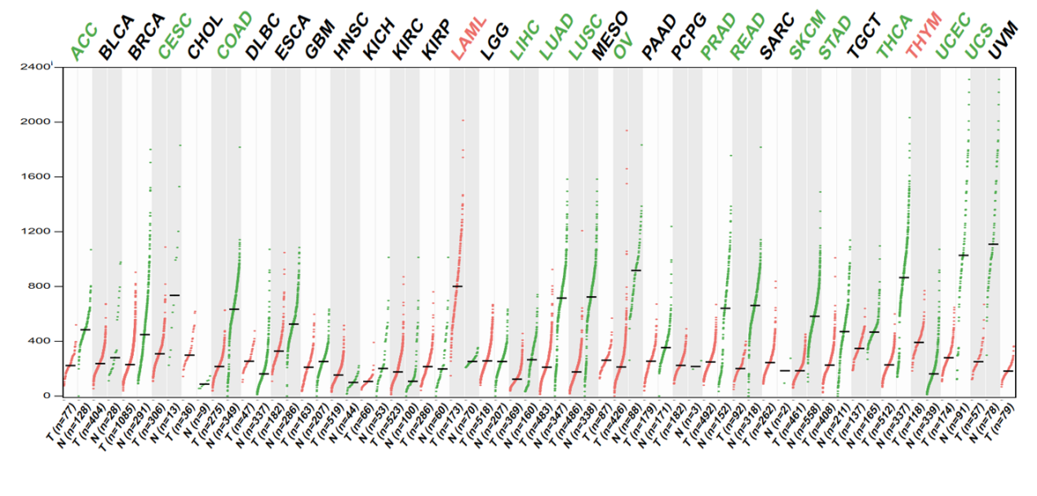
Figure S1. Pan-cancer analyze of SRRM2 from the GEPIA online database. The gene expression profile across all tumor samples and paired normal tissues. Each dots represent expression of mRNA levels SRRM2 were significantly up-regulated in AML patients and were much higher than normal controls, as well as in other tumors (http://gepia.cancer-pku.cn).

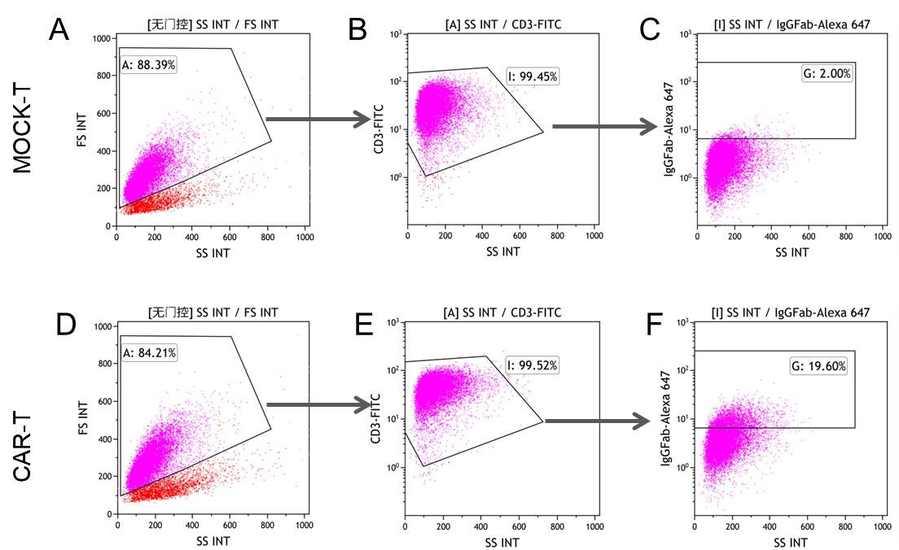
Figure S2. Flow cytometry protocol employed to detect the cell membrane surface expression of SRRM2. First, set a gate A in the whole gate to obtain live cells; Gate I was subsequently circled according to the expression of CD3-FITC; The expression of MOCK-T was used as a baseline to determine the transfection rate of CAR-T. As shown in the image.

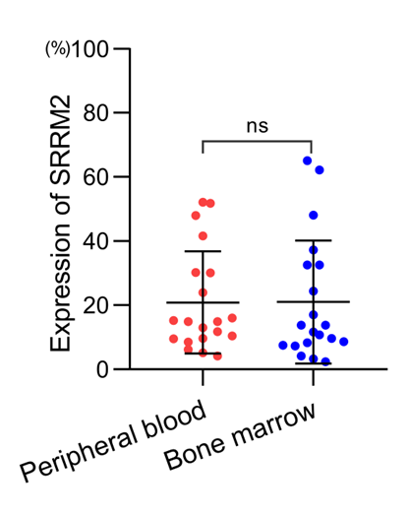
Figure S3. SRRM2 expression in bone marrow and peripheral blood of the same patient.

Figure S4. Flow cytometry protocol employed to detect the transduction efficiency of T cells with SRRM2-CAR lentivirus. First, set up a P1 gate in the whole gate according to FSC and SSC, thereby removing cell debris that is not completely dissolved in the test sample; Then lymph (P4), mononuclear (P5), granules (P6) and tumor blasts (P3) were distinguished according to CD45-PC7/SSC in the P2 gate. Finally, the expression of SRRM2 in different cell populations was obtained using the isotype control (ISO) as the baseline.

