Environmental Management

Supplementary Information

Title:
Opportunities and barriers for promoting biodiversity in Danish beef production
Ejrnæs, R.*¹, Dalby L,¹, Bladt¹, J., Søndergaard, S. ¹, Dümke², L., Fløjgaard, C. ¹, Bruun, L. ³, Ejrnæs, D. ¹, Moeslund, J. E. ¹& Bruun, H. H. ⁴

- Examples of categories of grazing areas
Examples of the four conservation value classes. From upper left: 1) a cultivated field by Roden Skov dominated by sown grasses and clover (C), 2) improved meadow of low conservation value at Skals Å influenced by eutrophication, drainage and mowing (L), 3) tall herb community in a mire by Brabrand Sø dominated by native species and potentially habitat for red-listed species (M), 4) species rich alkaline fen at Dover Kiil and a habitat for red-listed species (H). See the species lists in the table below. The species lists for conservation classes C and L contain a list of characteristic species from these habitats (Ejrnæs et al. 2009) whereas classes M and H contain actual species lists from field inventory of the depicted sites.
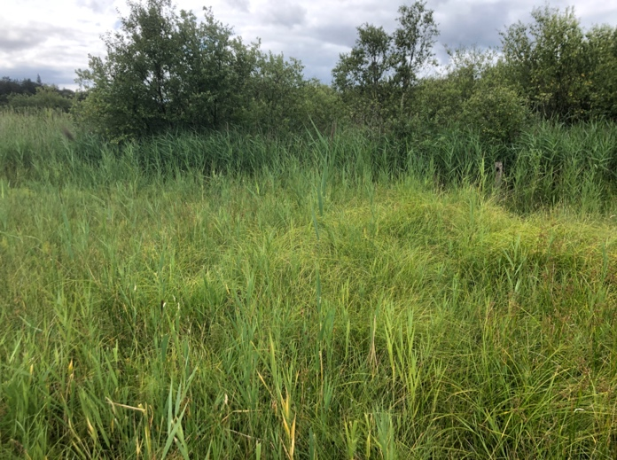
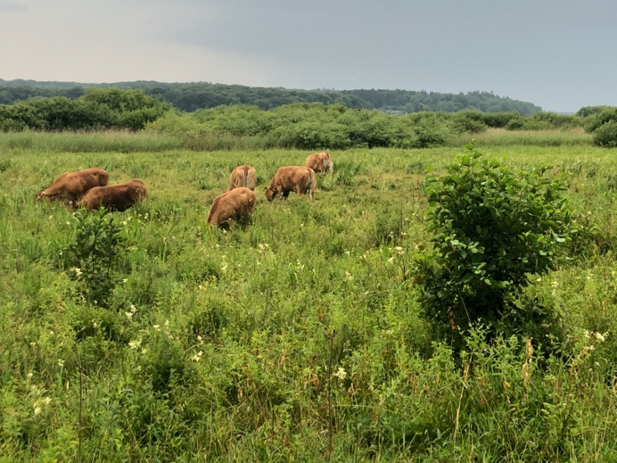
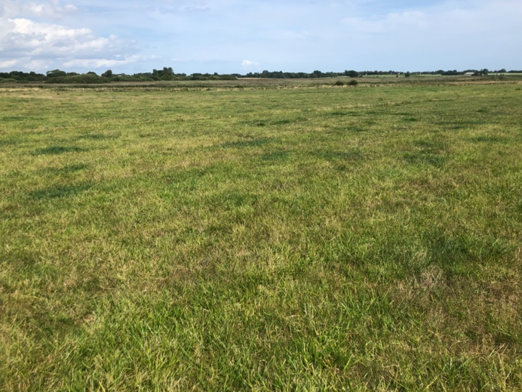
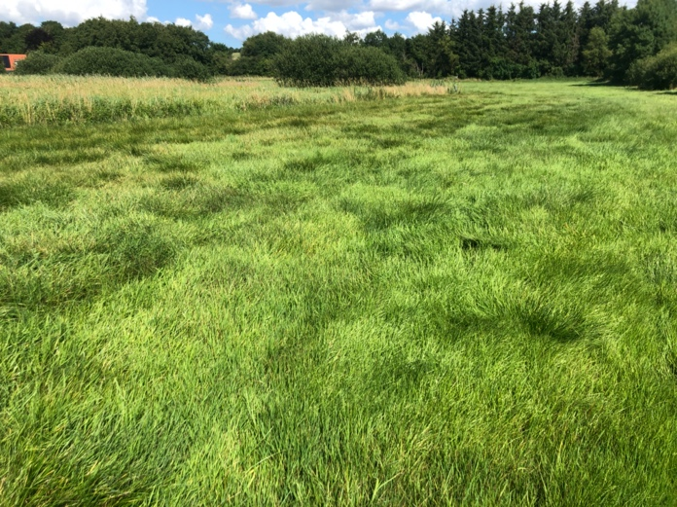

Species lists relating to the four conservation classes. Species noted with a * were observed outside the documentation field.
Cultivated (C) | Low value (L) | Medium value (M) | High value (H)
Lolium perenne L. (LC) | Lolium perenne L. (LC) | Phragmites australis (Cav.) Trin. ex Steud. (LC) | Phragmites australis (Cav.) Trin. ex Steud. (LC)
Poa pratensis L. (LC) | Poa pratensis L. (LC) | Carex acuta L. (LC) | Holcus lanatus L. (LC)
Poa trivialis L. (LC) | Poa trivialis L. (LC) | Iris pseudacorus L. (LC) | Agrostis stolonifera L. (LC)
Holcus lanatus L. (LC) | Holcus lanatus L. (LC) | Alnus glutinosa (L.) Gaertn. (LC) | Agrostis capillaris L. (LC)
Festuca rubra L. (LC) | Festuca rubra L. (LC) | Acer pseudoplatanus L. (LC) | Festuca rubra L. (LC)
Phleum pratense L. (LC) | Alopecurus geniculatus L. (LC) | Rumex hydrolapathum Huds. (LC) | Eleocharis palustris (L.) Roemer & Schultes (LC)
Ranunculus repens L. (LC) | Agrostis stolonifera L. (LC) | Rumex conglomeratus Murray (LC) | Eriophorum angustifolium Honck. (LC)
Trifolium repens L. (LC) | Deschampsia cespitosa (L.) P. Beauv. (LC) | Taraxacum sp. (L.) F.H.Wigg. (LC) | Schoenoplectus tabernaemontani (C.C.Gmel.) Palla (LC)
Plantago major L. (LC) | Trifolium pratense L. (LC) | Lathyrus palustris L. (LC) | Triglochin palustris L. (LC)
Taraxacum sp. (L.) F.H.Wigg. (LC) | Trifolium repens L. (LC) | Epilobium sp. L. (LC) | Carex rostrata Stokes (LC)
 | Juncus effusus L. (LC) | Lysimachia vulgaris L. (LC) | Carex nigra (L.) Reichard (LC)
 | Plantago major L. (LC) | Galium palustre L. | Carex paniculata L. (LC)
 |  | Mentha aquatica L. (LC) | Carex echinata Murray (LC)
 |  | Scutellaria galericulata L. (LC) | Carex panicea L. (LC)
 |  | Lycopus europaeus L. (LC) | Juncus articulatus L. (LC)
 |  | Lythrum salicaria L. (LC) | Juncus subnodulosus Schrank (LC)
 |  | Calystegia sepium (L.) R. Brown (LC) | Luzula multiflora (Retz.) Lej. (LC)
 |  | Cicuta virosa L. (LC) | Epipactis palustris (L.) Crantz (NT)
 |  | Peucedanum palustre (L.) Moench (LC) | Dactylorhiza incarnata (L.) Soó (LC)
 |  | Comarum palustre L. (LC) | Typha latifolia L. (LC)
 |  | Filipendula ulmaria (L.) Maxim. (LC) | Betula pubescens Ehrh. (LC)
 |  |  | Salix cinerea L. (LC)
 |  |  | Salix pentandra L. (LC)
 |  |  | Salix sp. L.
 |  |  | Thelypteris palustris Schott (LC)
 |  |  | Menyanthes trifoliata L. (LC)
 |  |  | Viola palustris L. (LC)
 |  |  | Drosera sp. L.
 |  |  | Galium palustre L. (LC)
 |  |  | Galium uliginosum L. (LC)
 |  |  | Epilobium palustre L. (LC)
 |  |  | Lysimachia thyrsiflora L. (LC)
 |  |  | Lotus pedunculatus Cav. (LC)
 |  |  | Lathyrus palustris L. (LC)
 |  |  | Cerastium fontanum Baumg. (LC)
 |  |  | Lychnis flos-cuculi L. (LC)
 |  |  | Stellaria alsine Grimm (LC)
 |  |  | Prunella vulgaris L. (LC)
 |  |  | Mentha aquatica L. (LC)
 |  |  | Ranunculus acris L. (LC)
 |  |  | Caltha palustris L. (LC)
 |  |  | Comarum palustre L. (LC)
 |  |  | Filipendula ulmaria Maxim. (LC)
 |  |  | Potentilla erecta (L.) Raeusch. (LC)
 |  |  | Cirsium palustre (L.) Scop. (LC)
 |  |  | Pedicularis palustris* L. (NT)
 |  |  | Parnassia palustris* L. (NT)
 |  |  | Carex limosa* L. (NT)
 |  |  | Carex lasiocarpa* Ehrh. (LC)
 |  |  | Sagina nodosa* L. (NT)
 |  |  | Rhinanthus serotinus* (Schönh.) Oborny (NT)
 |  |  | Desarmillaria ectypa* (Fr.) R.A.Koch & Aime (NT)

B. Association between field classification of conservation value and median bioscore of the national biodiversity map. All levels are significantly different from each other (ANOVA, Tukey HSD, P < 0.001).

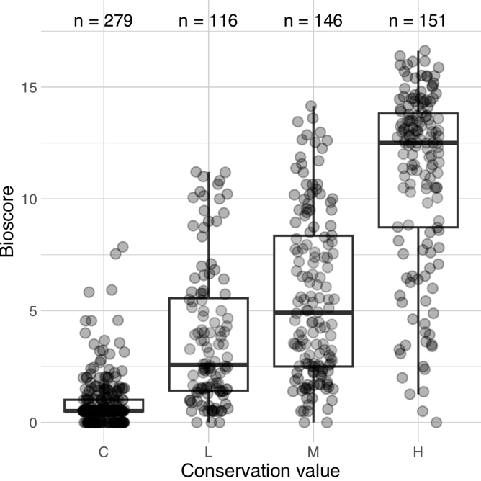

C. The distribution of observations of insects in the Danish arthropod species of four different orders from the portal arter.dk. For ease of comparison the absolute number of observations are scaled from 0-1. In the graph we indicate the window from week 16-38 used for the calculation of animal density in the grazing management of beef producers (Møller et al. 2020).
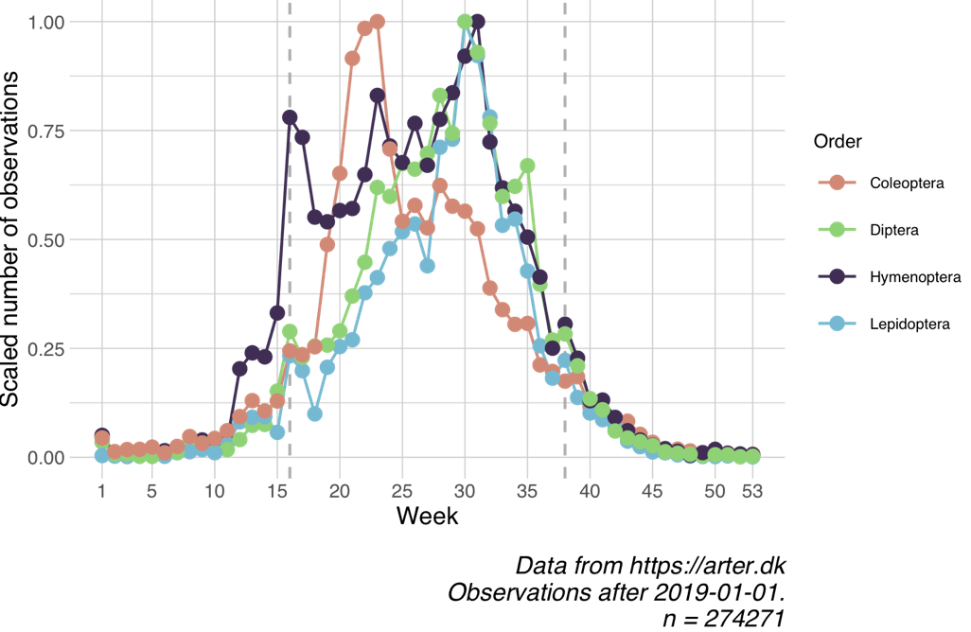

D. Tabulated weights for different breeds of cattle
Breed | Weight, calf, 6 mths (kg) | Weight, cow, 4 yrs (kg)
Hereford | 270 | 600
Holstein | 250 | 650
Limousin | 300 | 700
Galloway | 200 | 500
Angus | 270 | 600
Hereford/Limousin | 280 | 650
Simmental | 300 | 700
Shorthorn | 280 | 650
Charolais | 300 | 700
Angus/Limousin | 280 | 650

References for suppl.
Møller J, Wenøe Breddam D, Calabuig I, Skovgaard Mathorne J, Skipper L (2020). Species recordings from the Danish National portal Arter.dk. Miljøstyrelsen / The Danish Environmental Protection Agency. Occurrence dataset https://doi.org/10.15468/q3yy4u accessed via arter.dk API on 2022-11-17

