Supporting Information
Diatom-Inspired Silicification Process for Development of Green Flexible Silica Composite Aerogels
Valerie Tan¹, Florian Berg¹, Hajar Maleki^{1,2, *}
¹Department of Chemistry, Institute of Inorganic Chemistry, University of Cologne, 50939 Cologne, Germany
²Center for Molecular Medicine Cologne, CMMC Research Center, Robert-Koch-Str. 21, 50931 Cologne, Germany
*Email: h.maleki@uni-koeln.de

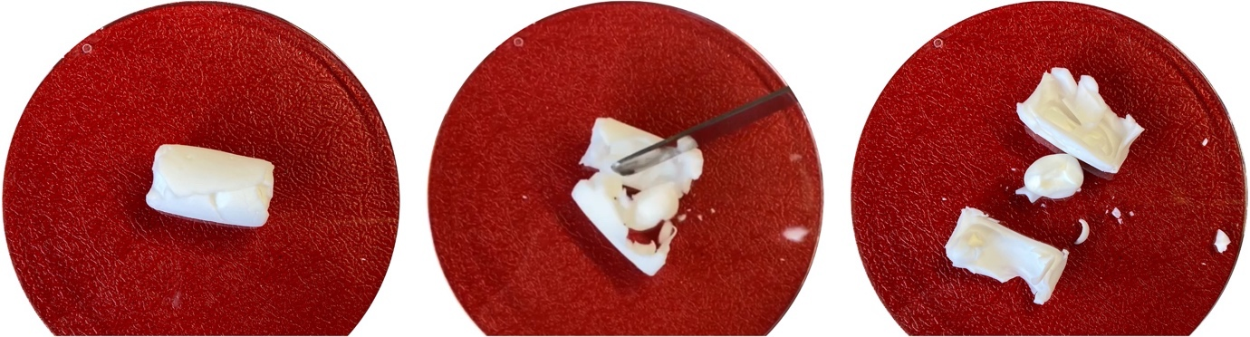
Figure S1: Photograph of SFO:PEI:SiO₂-0.5-3 which exposes a core structure upon breakage with a spatula

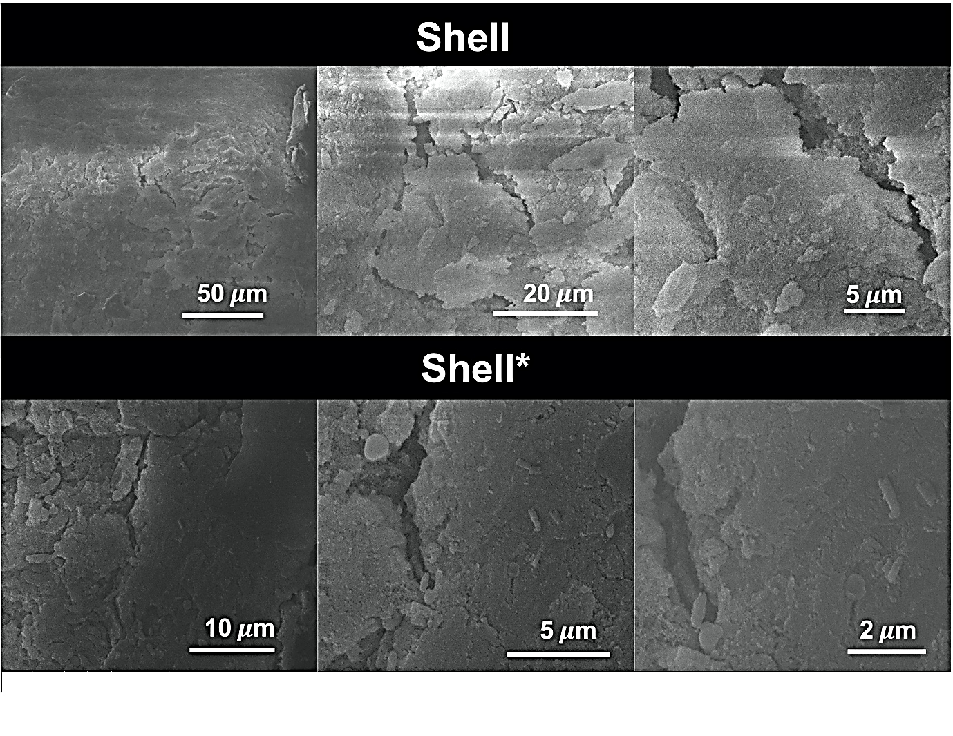
Figure S2: SEM images obtained from shell of supercritically dried aerogels with composition SFO:PEI:SiO₂-0.5-3* and SFO:PEI:SiO₂-0.5-3 (*Hydrophobization performed)

