MATLAB Programming for carbonation batch trial study
MATLAB Programming for the carbonation batch trial study was done as per above mentioned chemical equations. Complete programming details are as follows;
MATLAB Programming for determination of reaction rate ‘k1’ and ‘k3’
clear all

time(1) = 0;
A(1) = 41.11;
B(1)=0;
C(1)= 16.29;
dt = 0.01;
k1=0.0216;
k2=0.0040;
k3=k2*55*1.45/(2.36)^2;;
Cs=1.45;
for i = 1:6000
A(i+1) = A(i) + dt * (-k2*Cs*A(i)+k3*B(i)^2+k1*B(i)*C(i));
B(i+1) =B(i) +dt*(2*k2*Cs*A(i)-k3*B(i)^2-k1*B(i)*C(i)) ;
C(i+1) =C(i) +dt*( -k1* B(i) *C(i));

time(i+1)=time(i) +dt;
end
figure(1)
plot(time, A)
hold on
plot(time, B)
plot(time, C)

t_expt = [0 30 60];
A_expt=[41.11 44.24 55.66];
B_expt=[0 0 2.36];
C_expt=[16.29 8.23 0];
plot(t_expt,A_expt, 'o')
plot(t_expt,B_expt, 'sq')
plot(t_expt,C_expt, '^')
legend('Na_2CO_3', 'NaHCO_3', 'NaOH', 'Na_2CO_3', 'NaHCO_3', 'NaOH')

clear all

time(1) = 0;
A(1) = 33.22;
B(1)=0;
C(1)= 13.21;
dt = 0.01;
k1=0.0216;
k2=0.0040;
k3=k2*55*1.45/(2.36)^2;;
Cs=1.45;
for i = 1:9000
A(i+1) = A(i) + dt * (-k2*Cs*A(i)+k3*B(i)^2+k1*B(i)*C(i));
B(i+1) =B(i) +dt*(2*k2*Cs*A(i)-k3*B(i)^2-k1*B(i)*C(i)) ;
C(i+1) =C(i) +dt*( -k1* B(i) *C(i));

time(i+1)=time(i) +dt;
end
figure(1)
plot(time, A)
hold on
plot(time, B)
plot(time, C)

t_expt = [0 30 60 90];
A_expt=[33.22 39.68 46.78 54.91];
B_expt=[0 0 0 0];
C_expt=[13.21 10.54 4.46 2.01];
plot(t_expt,A_expt, 'o')
plot(t_expt,B_expt, 'sq')
plot(t_expt,C_expt, '^')
legend('Na_2CO_3', 'NaHCO_3', 'NaOH', 'Na_2CO_3', 'NaHCO_3', 'NaOH')

MATLAB Programming for determination of reaction rate ‘k2’
%cabonation 3
clear all
t = [0 30 60 90];
A=[41.11 44.24 55.66 48.32];
B=[0 0 2.36 10.01];
C=[16.29 8.23 0 0];
AB=A+B;
ABC=A+B+C;
Cs=1.45;%gpL
k2avg=0.004;
for i = 1:2
%k2(i)=((AB(i+1)-AB(i))/30)/(0.5*(A(i)+A(i+1))*Cs)
k1=-(((ABC(i+1)-ABC(i))/30) - k2avg*Cs*0.5*(A(i)+A(i+1))) / (0.5*(B(i+1)+B(i))*0.5*(C(i+1)+C(i)))
end

The time vs. concentration graph was drawn using MATLAB programming as shown in Figure 5. In Figure 5, the blue, red, and yellow color line represents the simulation concentration values of Na₂CO₃, NaHCO₃, and NaOH respectively whereas, symbols (O, □ and Δ) represents the experimental trials concentration values respectively. After 60 minutes, NaOH is consumed completely in the chemical reaction. It denotes the equilibrium position due to an increase in Na₂CO₃ and NaHCO₃.
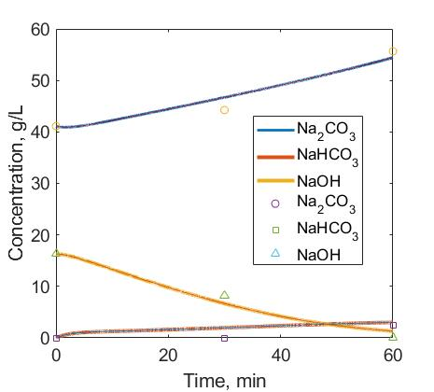

Figure 5. Validation graphical analysis using MATLAB Programming for carbonation of process liquor in the mining and mineral processing industry.

