Supplementary Materials for: A Global Assessment of Regional Forest Carbon Leakage

S1. Supplementary Results

Harvest leakage by forest biome scenario. For forest biome scenarios, harvest leakage is positive in the early periods, ranging from +10 to +61%, and then consistently declines over the length of time measured (Fig S1). As with carbon, harvest leakage declines with the level of implementation, following a similar trend as the ‘all forests’ scenario. Harvest leakage rates are higher for tropical and boreal biomes that enroll in extended rotations compared to temperate forests due to variation in regional timber productivity. Set aside harvest leakage rates are consistent across both length of measurement and the level of implementation and are always positive across forest biome and implementation rate, ranging from an average of +5% for temperate natural to +33% for tropical natural forests.
Detailed output example. Our approach highlights how evaluating leakage at the global level using a dynamic model that differentiates across multiple forest ecosystems, market mechanisms, and time can help capture key dynamics that might be missed if measured at a different scale. This outcome happens because regional harvest and carbon sequestration impacts vary widely across the two different forest carbon projects, as illustrated in the case where 10% of all forests eligible for harvest are enrolled in a carbon project (Fig. S5a-d). For extended rotations, harvests that are deferred in early periods are partially offset through harvests in the non-project areas situated in different regions – anywhere in the world (Fig. S5a). When these forests under deferred harvests reach their new rotation age, the project area harvests increase relative to the baseline, causing a reduction in harvests elsewhere during this period. As a result, harvest leakage rates for extended rotation projects will vary depending on the period measured and regions accounted for. Over the long run (out to 2100), cumulative harvests only increase relative to the baseline in Africa in the 10% implementation rate case. A permanent reduction in project area harvests from set asides will result in a relatively consistent response in harvests in non-project areas (Fig. S5b), with most of the harvest leakage occurring in the US, Asia and South America.

Overall carbon sequestration impacts typically follow the reverse trend of the harvest impacts, but not always. That is, a harvest reduction and subsequent leakage to non-project regions in the first period results in large increases in carbon in the project area, but less carbon in most of the forest not enrolled in a carbon project (Fig. S6c-d). This impact is diminished over time, especially in the deferred harvest case, as forests reach a new equilibrium under the alternative rotation ages (Fig S6c). As for the set aside scenario, carbon sequestration increases in the project area at the onset, with some leakage occurring in other regions, but not to the same extent as the extended rotation case (Fig. S6d). This is because the enrollment in the set asides provides a long run market signal that there will be a consistent loss of timber harvest, thereby incentivizing those outside of the project area to increase their management and plant additional forests in response to higher timber prices, potentially leading to an increase in carbon sequestration. In addition, as the set aside forests mature, their annual growth rate is diminished, thereby providing relatively lower (but still positive) carbon sequestration rates.
Harvest Leakage Drivers Analysis. We found that ten variables contributed 84% of the relative influence for the harvest leakage rate model (Fig. S2). Forest biome had the highest influence, followed by timber yield, carbon project type, project-level harvested wood product (HWP) carbon stocks, and model region, and global harvest change. These findings suggest that while the variation in the general characteristics of a forest biome is an important driver of harvest leakage, several variables tied directly to the yield potential (i.e., m3/ha) or amount of timber harvested for a given scenario is also a key factor of determining harvest leakage, as one would expect (Table S4).

S2. Supplementary Figures and Tables
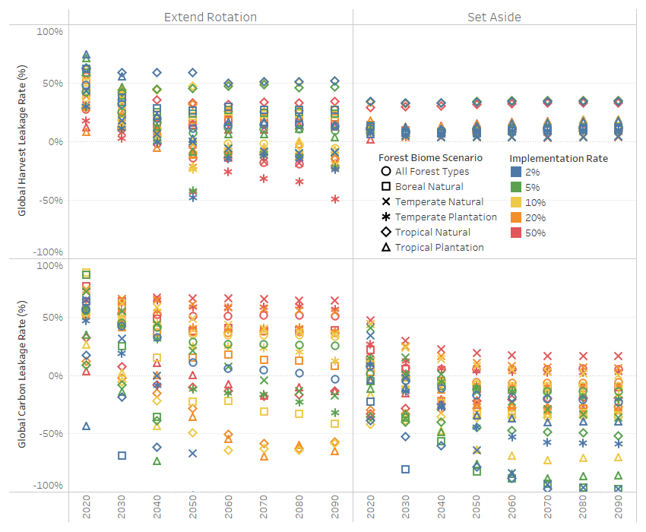
Fig. S1. Harvest and carbon leakage estimates for global forest carbon project scenarios under alternative forest biome enrollment eligibility scenarios and implementation rates. Years represent the period that the leakage rate is measured out to, (e.g., the 2080 estimate represents the leakage value if it were measured over 60 years, from 2020-2080).

Fig. S2. Key drivers of a) carbon and b) harvest leakage based on non-parametric GBM analysis.

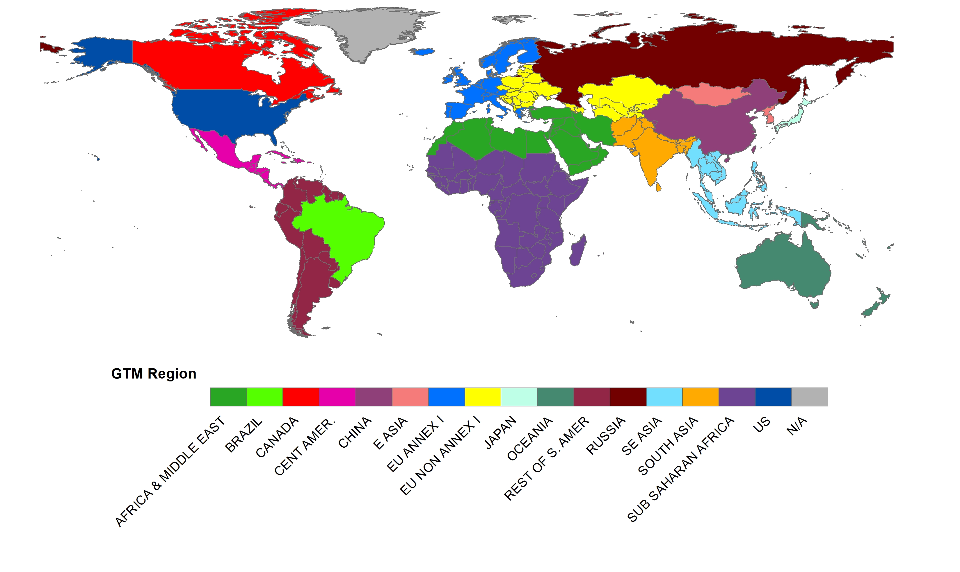
Fig. S3. Global Timber Model regions (Note: each region contains several forest types that vary by area, age class distribution, growth function, etc.)

Fig. S4. US southern pine plantation yield curves by forest carbon project scenario. Extended rotation extends harvest age from 30 to 40 years while set aside eliminates harvesting.

Fig. S5. Change in regional and net global harvests (Mm3/yr) and carbon sequestration (MtC/yr) over time when forest carbon projects are applied to 10% of all accessible forests (approx. 100 Mha). The large negative project harvest change in 2020 shows immediate response to project enrollments, while variation in harvests in future periods highlights dynamic adjustment to new rotation cycle. Net change is the sum of project and non-project estimates.

Table S1. Key GTM global baseline estimates, 2020-2100
Year | Forest Area (Mha) | Forest Carbon Stock (GtC) | Annual Forest C Flux* (MtC/yr) | Annual Timber Harvest (Mm3/yr) | Roundwood Price ($/m3)
2020 | 3,899 | 957 | -239 | 2,259 | $86
2030 | 3,911 | 959 | -467 | 2,354 | $103
2040 | 3,866 | 964 | -634 | 2,461 | $114
2050 | 3,837 | 970 | -761 | 2,568 | $119
2060 | 3,818 | 978 | -817 | 2,608 | $124
2070 | 3,806 | 986 | -870 | 2,797 | $121
2080 | 3,803 | 995 | -958 | 2,826 | $124
2090 | 3,801 | 1,004 | -920 | 3,062 | $120
2100 | 3,800 | 1,013 | -911 | 3,168 | $122
Annual Change | -1.2 | 0.73 | -8.4 | 11 | $0.45
Annual Change (%) | -0.03% | 0.07% | 1.69% | 0.42% | 0.44%
*Negative number indicates net increase in forest carbon sequestration
Table S2. Carbon and harvest leakage rates for forest biome forest project eligibility scenarios by implementation rate.
Eligible Biome | Leakage time estimate | Extended Rotation Scenarios  Implementation Rate |  |  |  |  |  | Set Aside Scenarios  Implementation Rate
Eligible Biome | Leakage time estimate | 2% | 5% | 10% | 20% | 50% |  | 2% | 5% | 10% | 20% | 50%
 |  | Carbon Leakage Rates (%)
All Forest Types | 20 year average | 49% | 50% | 49% | 48% | 54% |  | 1% | -2% | 4% | 5% | 10%
All Forest Types | 50 year average | 29% | 39% | 42% | 42% | 52% |  | -9% | -8% | -3% | -2% | 7%
All Forest Types | 80 year average | 19% | 34% | 39% | 40% | 52% |  | -14% | -10% | -5% | -4% | 6%
Temperate Natural | 20 year average | 48% | 63% | 67% | 69% | 69% |  | 15% | 28% | 33% | 34% | 38%
Temperate Natural | 50 year average | -15% | 40% | 57% | 64% | 67% |  | -29% | 4% | 19% | 21% | 27%
Temperate Natural | 80 year average | -57% | 20% | 49% | 61% | 66% |  | -54% | -10% | 12% | 15% | 23%
Tropical Natural | 20 year average | -1% | 0% | 1% | 5% | 20% |  | -46% | -38% | -41% | -32% | -31%
Tropical Natural | 50 year average | -85% | -53% | -27% | -17% | 1% |  | -64% | -42% | -38% | -30% | -26%
Tropical Natural | 80 year average | -155% | -83% | -40% | -33% | -5% |  | -79% | -45% | -37% | -29% | -24%
Boreal Natural | 20 year average | -3% | 55% | 68% | 72% | 70% |  | -52% | -21% | -2% | -5% | 13%
Boreal Natural | 50 year average | -210% | -31% | 21% | 43% | 53% |  | -124% | -54% | -19% | -19% | -1%
Boreal Natural | 80 year average | -312% | -83% | 0% | 31% | 47% |  | -154% | -70% | -25% | -22% | -4%
Temperate Plantation | 20 year average | 32% | 49% | 54% | 56% | 63% |  | -3% | 8% | 6% | 6% | 19%
Temperate Plantation | 50 year average | -32% | 20% | 40% | 49% | 61% |  | -26% | -3% | -4% | -2% | 10%
Temperate Plantation | 80 year average | -65% | 4% | 32% | 46% | 60% |  | -38% | -9% | -8% | -6% | 7%
Tropical Plantation | 20 year average | -89% | 10% | 14% | 46% | 24% |  | -8% | -22% | -26% | -4% | -25%
Tropical Plantation | 50 year average | -255% | -85% | -50% | 0% | 10% |  | -22% | -51% | -46% | -13% | -25%
Tropical Plantation | 80 year average | -338% | -131% | -82% | -24% | 1% |  | -29% | -64% | -56% | -20% | -26%
Area Weighted Avg* | 20 year average | 11% | 26% | 31% | 35% | 43% |  | -24% | -22% | -20% | -5% | -1%
Area Weighted Avg* | 50 year average | -75% | -21% | 7% | 20% | 33% |  | -54% | -33% | -26% | -10% | -4%
Area Weighted Avg* | 80 year average | -137% | -49% | -7% | 9% | 29% |  | -72% | -40% | -29% | -12% | -5%
 |  | Harvest Leakage Rates (%)
All Forest Types | 20 year average | 40% | 34% | 28% | 20% | 19% |  | 10% | 10% | 10% | 9% | 8%
All Forest Types | 50 year average | 25% | 20% | 13% | 5% | 2% |  | 10% | 10% | 10% | 10% | 8%
All Forest Types | 80 year average | 21% | 17% | 7% | -1% | -6% |  | 11% | 11% | 11% | 10% | 9%
Temperate Natural | 20 year average | 31% | 31% | 30% | 26% | 19% |  | 6% | 6% | 7% | 7% | 6%
Temperate Natural | 50 year average | 12% | 12% | 12% | 9% | 3% |  | 5% | 5% | 5% | 5% | 5%
Temperate Natural | 80 year average | 4% | 4% | 4% | 1% | -5% |  | 4% | 4% | 5% | 4% | 4%
Tropical Natural | 20 year average | 61% | 52% | 51% | 53% | 46% |  | 33% | 33% | 33% | 33% | 29%
Tropical Natural | 50 year average | 58% | 48% | 48% | 41% | 38% |  | 33% | 34% | 33% | 33% | 30%
Tropical Natural | 80 year average | 55% | 48% | 49% | 36% | 36% |  | 34% | 34% | 34% | 34% | 31%
Boreal Natural | 20 year average | 50% | 46% | 44% | 39% | 31% |  | 10% | 11% | 11% | 10% | 12%
Boreal Natural | 50 year average | 37% | 34% | 32% | 28% | 22% |  | 8% | 9% | 9% | 9% | 10%
Boreal Natural | 80 year average | 33% | 30% | 28% | 25% | 19% |  | 9% | 9% | 10% | 10% | 10%
Temperate Plantation | 20 year average | 20% | 20% | 22% | 19% | 10% |  | 7% | 7% | 7% | 6% | 6%
Temperate Plantation | 50 year average | -4% | -3% | 3% | 4% | -10% |  | 8% | 8% | 8% | 7% | 6%
Temperate Plantation | 80 year average | -9% | -7% | -3% | -3% | -20% |  | 8% | 8% | 8% | 8% | 7%
Tropical Plantation | 20 year average | 65% | 59% | 41% | 16% | 22% |  | 9% | 11% | 12% | 15% | 7%
Tropical Plantation | 50 year average | 34% | 26% | 11% | 1% | 16% |  | 11% | 12% | 13% | 15% | 12%
Tropical Plantation | 80 year average | 28% | 19% | 6% | -1% | 15% |  | 13% | 14% | 14% | 16% | 14%
Area Weighted Avg* | 20 year average | 42% | 38% | 37% | 36% | 30% |  | 19% | 19% | 19% | 18% | 16%
Area Weighted Avg* | 50 year average | 30% | 26% | 27% | 23% | 18% |  | 18% | 19% | 19% | 18% | 17%
Area Weighted Avg* | 80 year average | 26% | 23% | 24% | 17% | 12% |  | 19% | 19% | 19% | 19% | 17%
* Average of separate forest biome scenarios, weighted by eligible forest area

Table S3. Forest carbon leakage by individual forest type for ‘All Forest’ carbon project scenario with a 10% implementation rate.

GTM Region & Forest Type | Extended Rotation |  |  |  | Set Aside
GTM Region & Forest Type | 20-yr average | 50-yr average | 80-yr average |  | 20-yr average | 50-yr average | 80-yr average
Africa Natural | 154% | 143% | 141% |  | 122% | 96% | 84%
Africa Plantation | 96% | 87% | 84% |  | -36% | -46% | -50%
Brazil Natural | -26% | -33% | -35% |  | -19% | -19% | -18%
Brazil Plantation | 165% | 111% | 95% |  | -175% | -192% | -203%
Canada Coastal | 52% | 50% | 50% |  | 9% | -5% | -11%
Canada Interior | 21% | 19% | 18% |  | 1% | -9% | -13%
Cen/S America Natural | -16% | -37% | -42% |  | -1% | -6% | -7%
Cen/S America Plantation | 214% | 188% | 174% |  | 13% | -3% | -10%
China + East Asia Nat- Long Rot | 67% | 62% | 59% |  | 58% | 46% | 40%
China + East Asia Natural | 47% | 42% | 40% |  | 29% | 18% | 15%
China Plantation | 52% | 34% | 29% |  | -11% | -15% | -16%
EU Nordic Plantation | -16% | -19% | -20% |  | -17% | -19% | -20%
EU Natural | 66% | 62% | 60% |  | 26% | 12% | 7%
EU Plantation | 92% | 87% | 86% |  | 30% | 21% | 17%
Japan Plantation | 1% | -1% | -1% |  | -31% | -30% | -29%
Japan Temperate | -4% | -5% | -4% |  | -51% | -43% | -40%
Oceania Natural | 100% | 98% | 93% |  | -13% | -9% | -7%
Oceania Plantation | 134% | 131% | 131% |  | -20% | -33% | -38%
Russia East | 60% | 58% | 57% |  | 8% | 7% | 7%
Russia European | 28% | 19% | 20% |  | -37% | -26% | -20%
S/SE Asia Mixed | 17% | 16% | 14% |  | -45% | -39% | -35%
S/SE Asia Plantation | 650% | 602% | 616% |  | 21% | 13% | 11%
SE Asia Dipterocarp | -8% | -18% | -21% |  | -22% | -21% | -20%
US Northern HW | 49% | 50% | 50% |  | 35% | 27% | 24%
US Northern SW | 65% | 65% | 66% |  | 44% | 33% | 29%
US Southern HW | 44% | 47% | 48% |  | 23% | 14% | 11%
US Southern Pine | 16% | 18% | 18% |  | -31% | -38% | -40%
US West | 54% | 58% | 58% |  | 39% | 31% | 28%
US West Valuable SW | 43% | 43% | 43% |  | 6% | -3% | -7%
Table S4. Random effects regression model for carbon and harvest leakage drivers assessment.
Variable | Value | Std.Error | t-value | p-value
Carbon Leakage Model
Intercept | 10.3712*** | 1.497 | 6.926 | 0.000
Year | -0.0051*** | 0.001 | -7.161 | 0.000
Proj_Area | -0.0037*** | 0.001 | -3.158 | 0.002
ProjType Set Aside | -0.1903*** | 0.031 | -6.066 | 0.000
P_NetCchg | 0.0001*** | 0.000 | 4.242 | 0.000
ScenPct | 1.0771*** | 0.128 | 8.439 | 0.000
G_GrossHarvchg | 0.0016*** | 0.000 | 4.931 | 0.000
P_FECstock | 0.0000* | 0.000 | -1.702 | 0.089
G_CLeak | -0.0001*** | 0.000 | -3.947 | 0.000
G_HLeak_pct | 0.5803*** | 0.127 | 4.553 | 0.000
P_TotH | 0.0001 | 0.000 | 0.471 | 0.638
G_GrossHWPCchg | 0.0002*** | 0.000 | 3.717 | 0.000
P_HWPCstock | 0.0001*** | 0.000 | 2.680 | 0.008
P_TotC | 0.0000*** | 0.000 | 2.832 | 0.005
 | N | AIC | BIC | logLik
 | 560 | 1120.62 | 1193.76 | -543.31
Harvest Leakage Model
Intercept | 1.5533*** | 0.481 | 3.232 | 0.001
Year | -0.0005* | 0.000 | -1.892 | 0.059
ProjType Set Aside | -0.0937*** | 0.009 | -9.893 | 0.000
ScenPct | -0.1239*** | 0.041 | -2.988 | 0.003
Proj_Area | -0.0002 | 0.000 | -1.553 | 0.121
P_HWPCstock | -0.0001*** | 0.000 | -9.145 | 0.000
G_GrossHarvchg | -0.0008*** | 0.000 | -5.697 | 0.000
G_GrossHWPCchg | -0.0001*** | 0.000 | -3.221 | 0.001
G_PulpP | -0.0061*** | 0.001 | -8.368 | 0.000
P_NetCchg | -0.00001*** | 0.000 | -4.313 | 0.000
 | N | AIC | BIC | logLik
 | 560 | -825.63 | -769.60 | 425.81
Significance: *** = 1%, ** = 5%, *=10%

Table S5. GTM region-forest type combinations modeled for leakage analysis.
Region - Forest Type | Multi-Region Forest Biome | Aggregate GTM Forest Types | Total Forest Area (Mha) | Mean Baseline Rotation (years) | Base Yield (m3/ha) | Mean Base NPV ($/ha)
US Southern Pine | Temperate Plantation | 2 | 19.7 | 30 | 241 | $3,371
US Southern HW | Temperate Natural | 4 | 15.9 | 60 | 181 | $520
US Northern HW | Temperate Natural | 4 | 14.2 | 75 | 182 | $252
US West Valuable SW | Temperate Plantation | 2 | 3.1 | 50 | 539 | $2,300
US Northern SW | Temperate Natural | 4 | 2.4 | 70 | 235 | $395
US West | Temperate Natural | 8 | 5.6 | 78 | 240 | $261
China Plantation | Temperate Plantation | 2 | 31.9 | 35 | 91 | $1,334
China + East Asia Natural | Temperate Natural | 13 | 27.2 | 56 | 116 | $321
China + East Asia Nat - Long | Temperate Natural | 3 | 29.5 | 87 | 75 | $56
Brazil Plantation | Tropical Plantation | 1 | 2.3 | 30 | 305 | $8,396
Brazil Natural | Tropical Natural | 3 | 86.2 | 67 | 36 | $89
Canada Coastal | Temperate Natural | 6 | 15.0 | 70 | 199 | $156
Canada Interior | Boreal Natural | 12 | 57.9 | 79 | 125 | $117
Russia European | Boreal Natural | 3 | 76.0 | 100 | 150 | $64
Russia East | Temperate Natural | 4 | 37.8 | 105 | 124 | $38
EU Plantation | Temperate Plantation | 4 | 108.5 | 98 | 344 | $168
EU N. Plantation | Boreal Plantation | 1 | 54.3 | 80 | 148 | $448
EU Natural | Temperate Natural | 6 | 57.8 | 83 | 75 | $86
Cen/S Amer Plantation | Tropical Plantation | 2 | 2.8 | 20 | 176 | $3,875
Cen/S Amer Natural | Tropical Natural | 6 | 82.4 | 67 | 20 | $49
S/SE Asia Plantation | Tropical Plantation | 2 | 6.5 | 60 | 200 | $719
S/SE Asia Mixed | Tropical Natural | 3 | 64.6 | 57 | 43 | $215
SE Asia Dipterocarp | Tropical Natural | 1 | 60.7 | 50 | 106 | $609
Oceania Plantation | Temperate Plantation | 1 | 2.6 | 30 | 374 | $3,656
Oceania Natural | Temperate Natural | 3 | 43.3 | 43 | 18 | $274
Japan Plantation | Temperate Plantation | 1 | 10.3 | 30 | 54 | $380
Japan Temperate | Temperate Natural | 1 | 13.4 | 50 | 57 | $124
Africa Plantation | Tropical Plantation | 2 | 2.3 | 25 | 100 | $1,285
Africa Natural | Tropical Natural | 4 | 76.6 | 60 | 13 | $47
All Forest Types | All Forest Types | 108 | 1,010.8 | N/A | N/A | N/A

Table S6. Variables used in leakage model drivers analysis
Category | Description | Variable Code Name
Dependent Variables | Harvest Leakage Rate (%) | G_HLeak_pct
Dependent Variables | Carbon Leakage Rate (%) | G_CLeak_Pct
Scenario Assumptions | Project location (forest type) | ForType
Scenario Assumptions | Project Type (Set aside, ext rot) | ProjType
Scenario Assumptions | Scenario Coverage (% area) | ScenPct
Scenario Assumptions | Project Area (Mha) | Proj_Area
Model Inputs | GTM Region | GTM_Reg
Model Inputs | Biome (Tropical Temperate, Boreal) | For_Biome
Model Inputs | Mgmt Intensity (Natural, Plantation) | Mgmt_Intens
Model Inputs | Total Forest Area (Mha) | Tot_ForTypeArea
Model Inputs | Optimal Rotation Age (years) | Opt_Age
Model Inputs | Timber Yield at Harvest (m3/ha) | T_Yield
Model Inputs | Carbon Yield (tC/ha) | C_Yield
Model Inputs | Net Present Value ($/ha) | NPV
Model Inputs | Sawlog Proportion (%) | Saw_Prop
Model Inputs | Initial Stocking | Init_Stock
Model Inputs | Regen Cost ($/ha) | Regen_Cost
Model Inputs | Stocking Rate (% max) | Stock_Rate
Model Inputs | Land Rent ($/ha) | Rent
Model Outputs | Model Year | Year
Model Outputs | Global Carbon Leakage(MtC) | G_CLeak
Model Outputs | Global Forest Area (Mha) | G_ForArea
Model Outputs | Global Forest Ecosystem C Stock (MtC) | G_FECstock
Model Outputs | Global Gross Carbon Change (MtC) | G_GrossCchg
Model Outputs | Global Gross Forest C Change (MtC) | G_GrossForCchg
Model Outputs | Global Gross Harvest Change (Mm3) | G_GrossHarvchg
Model Outputs | Global Gross Product C Change (MtC) | G_GrossHWPCchg
Model Outputs | Global Harvest Leakage (Mm3) | G_Hleak
Model Outputs | Global Harvested Wood C Stock (MtC) | G_HWPstock
Model Outputs | Global Pulpwood Harvest (Mm3) | G_PulpH
Model Outputs | Global Pulpwood Price ($/m3) | G_PulpP
Model Outputs | Global Roundwood Price ($/m3) | G_RoundP
Model Outputs | Global Sawtimber Harvest (Mm3) | G_SawH
Model Outputs | Global Sawtimber Price ($/m3) | G_SawP
Model Outputs | Global Total Carbon Stock (MtC) | G_TotCstock
Model Outputs | Global Total Harvest (Mm3) | G_TotH
Model Outputs | Project Forest Ecosystem C Stock (MtC) | P_FECstock
Model Outputs | Project Harvested Wood C Stock (MtC) | P_HWPCstock
Model Outputs | Project Net Carbon Change (MtC) | P_NetCchg
Model Outputs | Project Net Forest C Change (MtC) | P_NetForCchg
Model Outputs | Project Net Harvest Change (Mm3) | P_NetHchg
Model Outputs | Project Net Product C Change (MtC) | P_NetHWPCchg
Model Outputs | Project Total Carbon Stock (MtC) | P_TotC

