Graphic Abstract:
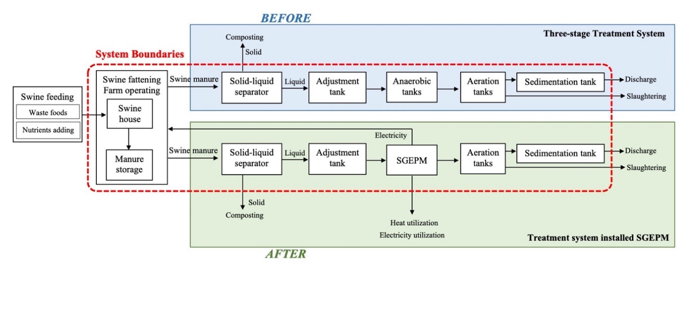
Exploring the environmental and economic potential for biogas produced from swine manure wastewater by life cycle assessment

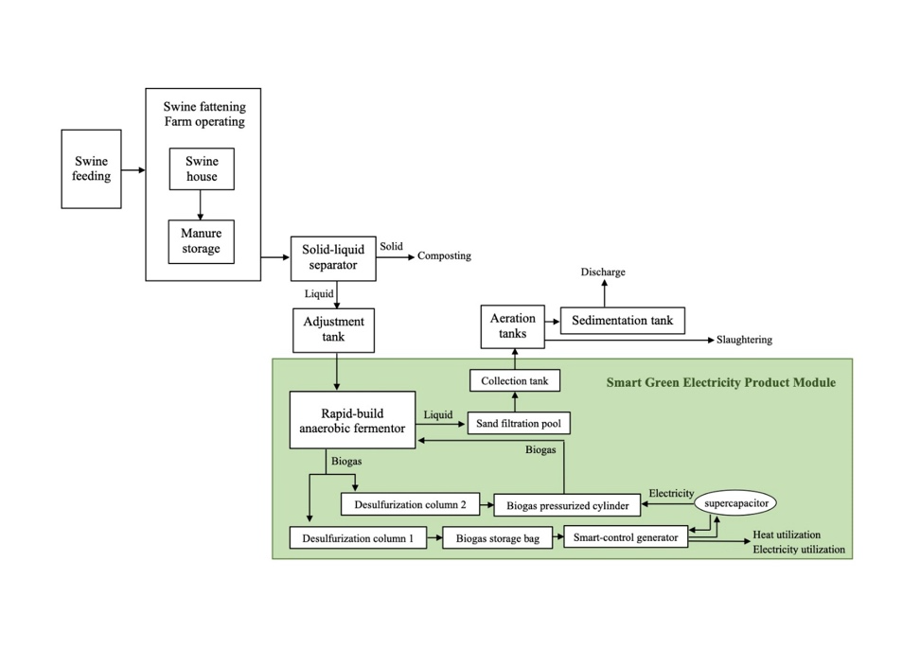

+ 46.38 m³/day biohythane
+16.69 USD/day income
-22.56% kg CO₂-eq
-51.75% CH₄
-92.65% SO_{X}
-74.18% NO_{X}
-54.70% CO
-28.56% N2O
-95.41% TSP
-80% NMVOC.
After installing SGEPM into original system

