LAMC2 promotes oral squamous cell carcinoma growth by activating the p-ERK/c-Myc signaling pathway

Bo Qiao^{1†}, Nenghao Jin^{1, 2†}, Min Zhao^{4, 5}, Liang Zhu¹, Liangbo Li^{1, 2}, Bin Gu^{1*}, Ning Wen^{1, 3*}, Haizhong Zhang^{1*}
¹Department of Stomatology, The First Medical Centre, Chinese PLA General Hospital, Beijing, 100853, China;
²Medical School of Chinese PLA, Beijing, 100853, China;
³Institute of Stomatology, Oral Maxilla Facial Key Laboratory, The First Medical Centre, Chinese PLA General Hospital, Beijing, 100853, China;
⁴Research Center of Medical Big Data, Chinese PLA General Hospital, Beijing, 100853, China;
⁵Pharmaceutical Diagnostics, GE Healthcare, Beijing, 100176, China.

Table S1 PCR primers
Genes | Forward primers(5‘-3’) | Reverse primers(5‘-3’)
LAMC2 | 5’-GACAAACTGGTAATGGATTCCGC-3′ | 5’-TTCTCTGTGCCGGTAAAAGCC-3′
GAPDH | 5’-ATGACCCCTTCATTGACCTCA-3’ | 5’-GAGATGATCACCCTT TTGGCT-3’

Table S2 shRNA target sequences of LAMC2
Forward | Reverse
5’CCGGGCTCACCAAGACTTACACATTCTCG-AGAATGTGTAAGTCTTGGTGAGCTTTTTG-3′ | 5’AATTCAAAAAGCTCACCAAGACTTACAC-ATTCTCGAGAATGTGTAAGTCTTGGTGAGC-3′

Table S3 GO terms for the top 8 hub genes
Gene symbol | Gene Description | Gene function
MYBL2 | MYB proto-oncogene like 2 | GO:0003700 DNA-binding transcription factor activity  GO:0090307 mitotic spindle assembly  GO:0031523 Myb complex  GO:0005654 nucleoplasm  GO:0005654 nucleoplasm
LAMC2 | Laminin subunit gamma 2 | GO:0007155 cell adhesion  GO:0005938 cell cortex  GO:0008544 epidermis development  GO:0022617 extracellular matrix disassembly  GO:0030198 extracellular matrix organization
TK1 | Thymidine Kinase 1 | GO:0000166 nucleotide binding  GO:0004797 thymidine kinase activity GO:0005515 protein binding  GO:0005524 ATP binding IEA  GO:0008270 zinc ion binding
MICAL2 | Microtubule associated monooxygenase, calponin and LIM domain containing 2 | GO:0003779 actin binding  GO:0030042 actin filament depolymerization  GO:0007010 cytoskeleton organization  GO:0071949 FAD binding  GO:0007507 heart development
FSCN1 | Fascin actin-bundling protein 1 | GO:0003779 actin binding  GO:0015629 actin cytoskeleton  GO:0030036 actin cytoskeleton organization  GO:0051015 actin filament binding  GO:0051017 actin filament bundle assembly
FOXM1 | Forkhead box M1 | GO:0007049 cell cycle  GO:0005737 cytoplasm  GO:0003677 DNA binding  GO:0006978 DNA damage response, signal transduction by p53 class mediator resulting in transcription of p21 class mediator  GO:0006281 DNA repair
ELF4 | E74 like ETS transcription factor 4 | GO:0030154 cell differentiation  GO:0000981 DNA-binding transcription factor activity, RNA polymerase II-specific  GO:0005794 Golgi apparatus  GO:0045087 innate immune response  GO:0001787 natural killer cell proliferation
TPX2 | TPX2 microtubule nucleation factor | GO:0032147 activation of protein kinase activity  GO:0006915 apoptotic process  GO:0005524 ATP binding  GO:0043203 axon hillock  GO:0051301 cell division

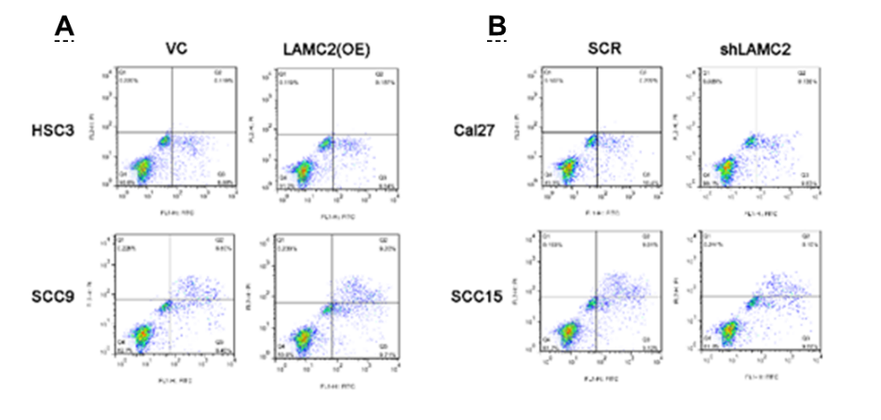
Fig. S1 Apoptosis markers in HSC3, SCC9, Cal27 and SCC15 cell lines. A The apoptosis markers in LAMC2-overexpressed HSC3 and SCC9 cell lines. B The apoptosis markers in LAMC2-overexpressed Cal27 and SCC15 cell lines.

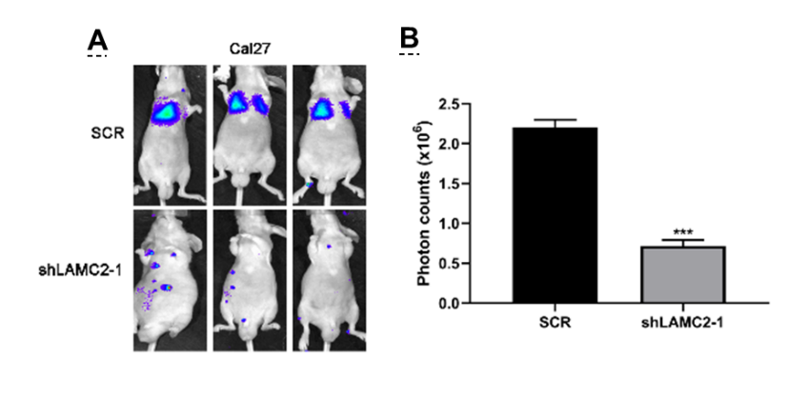
Fig. S2 The impact of LAMC2 deficiency on the migration and invasion abilities of OSCC cells in orthotopic mouse model. A Control and LAMC2 knockdown luci-Cal27 OSCC cells (1 × 105 cells/mouse) were injected into tail vein of each nude mouse (n = 6 for each group). Representative images showing luciferase expression from lung metastasis of both Cal27 control and shLAMC2 group at the 4th weeks after injection. B quantification of luciferase expression of lung metastasis also decreased significantly in LAMC2-knockdown group. Data are presented as mean ± SD. ** P < 0.01, *** P < 0.001 compared to NC group, * P < 0.05, ** P < 0.01 and *** P < 0.001.

