Supplementary File 1
COA of Bacillus clausii
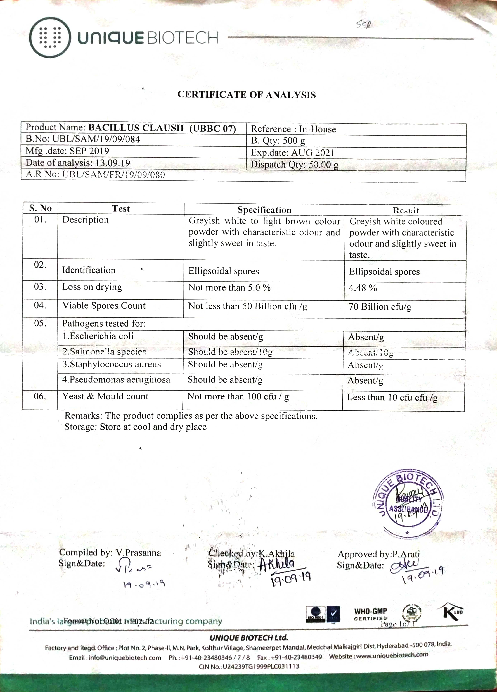
COA of Lactobacillus plantarum

