Supplementary information

Potentiometric determination of aliphatic amines by a synthetized allyltrifluoromethanesulfonyl imide ([C₄H₅O₂F₃NS]⁻) cation exchanger

Jiayu Fei, Jinwei Shi, Ning Yuan, Xiaofeng Chen and Ming Li*
* College of Environmental Science and Engineering, Yangzhou University, Yangzhou 225127, P. R. China

Fig.S1 FT-IR spectrum of [C₄H₅NO₂SF₃]Li

Fig.S2 Mass spectrum of [C₄H₅NO₂SF₃]⁻
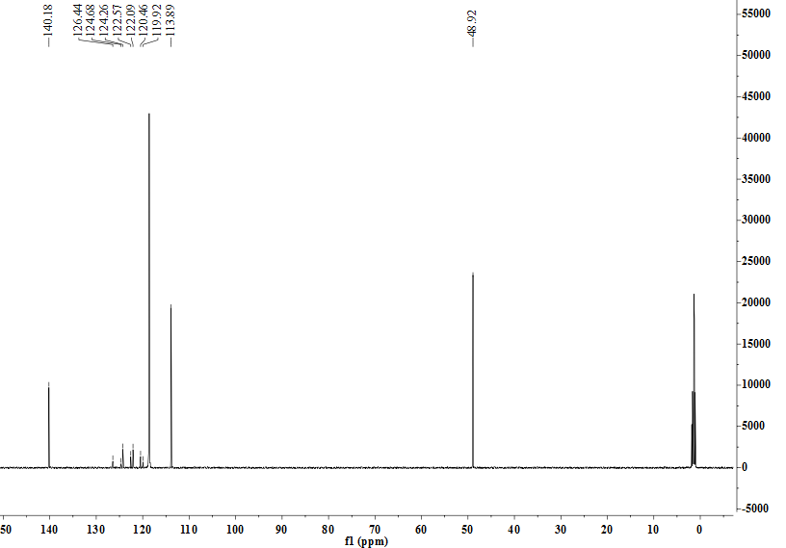

Fig.S3 13C-NMR spectrum of [C₄H₅O₂F₃NS]Li, CD₃CN as solvent

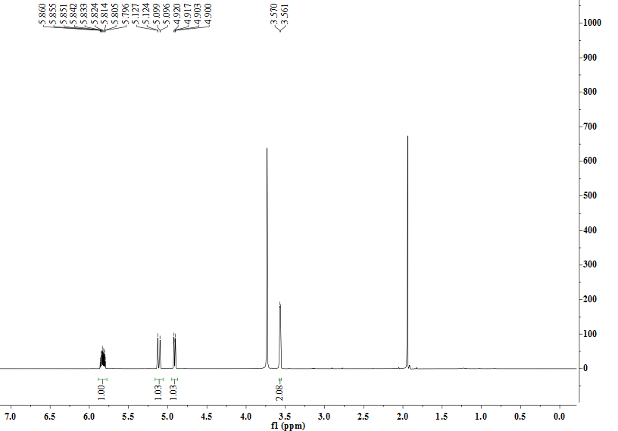
Fig.S4 1H-NMR spectrum of [C₄H₅O₂F₃NS]Li

