Supplementary Information

Anomalous optical resonance on supramolecularly chiral metaspheres with swirl topology

Osamu Oki,^{1,2}* Wenbo Lin,³ Sota Nakayama,¹ Hiroshi Yamagishi,¹ Fumio Sasaki,^{1,4} Satoshi Iwamoto,³ Yohei Yamamoto¹*

¹ Department of Materials Science, Institute of Pure and Applied Sciences, and Tsukuba Research Center for Energy Materials Science (TREMS), University of Tsukuba, 1-1-1 Tennodai, Tsukuba, Ibaraki 305-8573, Japan

2 Institute for Complex Molecular Systems and Laboratory of Macromolecular and Organic Chemistry, Eindhoven University of Technology, 5600 MB Eindhoven, The Netherlands

³ Research Center for Advanced Science and Technology, The University of Tokyo, 4-6-1 Komaba, Meguro-ku, Tokyo 153-8505, Japan

⁴ Research Institute for Advanced Electronics and Photonics, National Institute of Advanced Industrial Science and Technology, Tsukuba, Ibaraki 305-8568, Japan

- General

Materials and Methods.
All chemicals and reagents were purchased from Sigma‒Aldrich, TCI, and Merck. Solvents were obtained from Fujifilm Wako Chemicals. Unless otherwise noted, all reagents and solvents were used as received. The chiral copolymers poly(9,9-bis((S)-3,7-dimethyloctyl)-2,7-fluorene-alt-benzothiadiazole) ((S,S)-PFBT, Fig. 1a, number-average molecular weight M_{n} = 5.5 kg mol^{–1}, polydispersity index PDI = 2.20) and poly(9,9-bis((R)-3,7-dimethyloctyl)-2,7-fluorene-alt-benzothiadiazole) ((R,R)-PFBT, Supplementary Fig. 4a, M_{n} = 9.5 kg mol^{–1}, PDI = 2.17) were synthesized according to the reported procedure.^{S1} The achiral copolymer poly(9,9-dioctylfluorene-alt-benzothiadiazole) (a-PFBT, Fig. 1f, M_{n} = 25 kg mol^{–1}, PDI < 3) was purchased from Sigma‒Aldrich. Photoabsorption spectra were recorded on a JASCO V-630 spectrophotometer. Steady-state PL spectra were measured on a JASCO FP-8300 spectrofluorometer. SEM microscopy was performed on a Hitachi model S-3700N SEM operating at 20 kV. Optical, FL, and POM observations were carried out using an Olympus model BX53 Upright Microscope. HSC images were obtained on an EBA JAPAN model SIS-H Spectral Imaging System set on an optical microscope.

2. Simulation of the WGM index.
Simulations of the WGMs were conducted using Eq. 1 and Eq. 2 for transverse magnetic (TM) and electric (TE) mode emissions, respectively. ^{S2}
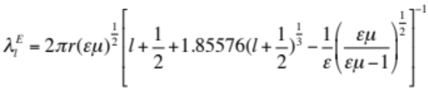
(eq. S1)

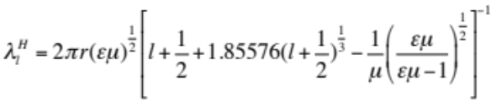
(eq. S2)

where λ_{l}^{E} and λ_{l}^{H} are the wavelengths of the l-th TM and TE modes, respectively, ε (= n²) is the dielectric permittivity, µ (= 1) is the magnetic permeability, and r is the radius of the sphere. Here, higher-order terms were neglected. For simulation of the PL lines, TE and TM modes were calculated using Eqs. S1 and S2. Within the margin of error of the radius of the sphere (obtained by optical microscopy), the simulation adapts a radius such that both the TE and TM modes agree well for given order l, effectively determining the radius with much higher precision.
- Numerical analysis of the λ-dependent angular shift of the WGM
As illustrated below, suppose ξ is the angle between p and $\hat{θ}$ (normal to the WGM circle $\hat{φ}$), p is described as
$p=\cos{ξ}\hat{θ}+sin{ξ}\hat{φ}$ (eq. S3)
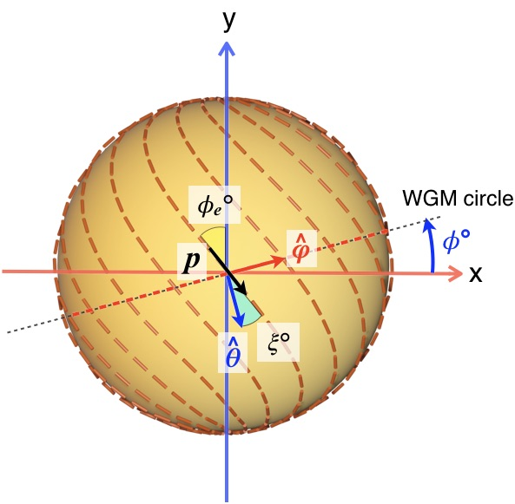
Because the orientation of the PFBT main chain at the surface is latitudinally variant and longitudinally invariant, the orientation of the PFBT main chain is characterized by the angle of p along the y-axis (x = 0). Here, we define f(y) as the orientation of the polymer main chain at the surface, as shown below:
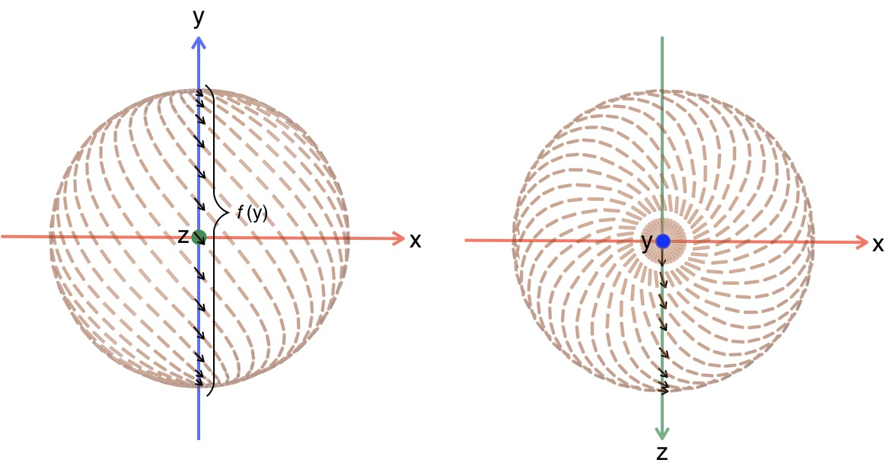
When the orbit of the WGM is tilted from the x-axis towards the y-axis by φ, the y-coordinate can be written as
$$y=\frac{d}{2}\left(\cos{θ}\cos{ϕ}+\sin{θ}\cos{φ}\sin{ϕ}\right)$$
Since f(y) is an angle in the $\hat{x}$-$\hat{y}$ basis, it must be rotated by $\arctan\left(\frac{\sin{φ}\sin{ϕ}}{-\cos{θ}\cos{φ}\sin{ϕ}+\sin{θ}\cos{ϕ}}\right)$ to convert it into an angle in the $\hat{θ}$-$\hat{φ}$ basis, yielding
$ξ=\arctan\left(\frac{\sin{φ}\sin{ϕ}}{-\cos{θ}\cos{φ}\sin{ϕ}+\sin{θ}\cos{ϕ}}\right)+f\left(\frac{d}{2}\left(\cos{θ}\cos{ϕ}+\sin{θ}\cos{φ}\sin{ϕ}\right)\right)$(eq. S4)
Assuming a TE mode WGM, the dielectric constant tensor ε for $E=(E_{θ},E_{φ})$ is written as
$$ε=\left(\begin{matrix}{n_{e}}^{2}\cos^{2}{ξ}+{n_{o}}^{2}\sin^{2}{ξ} & \left({n_{e}}^{2}-{n_{o}}^{2}\right)\cos{ξ}\sin{ξ} \\ \left({n_{e}}^{2}-{n_{o}}^{2}\right)\cos{ξ}\sin{ξ} & {n_{o}}^{2}\cos^{2}{ξ}+{n_{e}}^{2}\sin^{2}{ξ}\end{matrix}\right)$$
Here, we define the expected value of the dielectric constant $〈ε〉$ as
$$〈ε〉=\frac{\int{E^{*}εEdr}}{\int{E^{*}Edr}}$$
From Supplementary Figs. 11 and 13d, the WGM trajectory is localized on the sphere surface, and the perpendicular spreading of the trajectory is small in the range of $18°<ϕ<45°$. Therefore, the cross section of the WGM trajectory can be approximated as a point, and $〈ε〉$ can be approximated as the integral of Φ on a sphere at $θ=π/2$. Furthermore, Fig. 4e indicates that the travelling direction component $E_{φ}$ of the WGM is small and negligible compared to the vertical component $E_{θ}$. Eventually, these assumptions yield
$$〈ε〉≈\frac{1}{2π}\int_{0}^{2π}{{n_{e}}^{2}\cos^{2}{ξ\left(φ\right)}+{n_{o}}^{2}\sin^{2}{ξ\left(φ\right)}dφ}$$
and
$$ξ\left(φ\right)=\arctan\left(\frac{\sin{φ}\sin{ϕ}}{\cos{φ}}\right)+f\left(\frac{d}{2}\cos{φ}\sin{ϕ}\right)$$
Here, we assume $f\left(y\right)=ϕ_{e}\sqrt{1-{\left(\frac{2y}{d}\right)}^{2}}$ as a function to dictate a TB configuration, where φ_{e} represents the angle at which the ETDM crosses the equator of (S)-TB-MS.
To confirm that our analytical model described above correctly depicts the arrangement of the PFBT main chain on the sphere surface, we suppose φ_{e} = 0° as the simplest example. In this case, the orientation of PFBT on the sphere surface should be a simple bipolar configuration (nontwisted). As expected, 3D plots of p with φ_{e} = 0° simulated by this analytical model successfully give a bipolar configuration. In addition, the simulated φ-dependent cos²ξ and sin²ξ are well consistent with the geometrical features of the bipolar configuration, namely, φ = 0° (red WGM circuit) and φ = 90° (blue WGM circuit) give only an n_{e} contribution (cos²ξ = 1, sin²ξ = 0) and an n_{o} contribution (cos²ξ = 0, sin²ξ = 1), respectively. Note that the electric field of the TE mode is perpendicular to the WGM travelling direction.
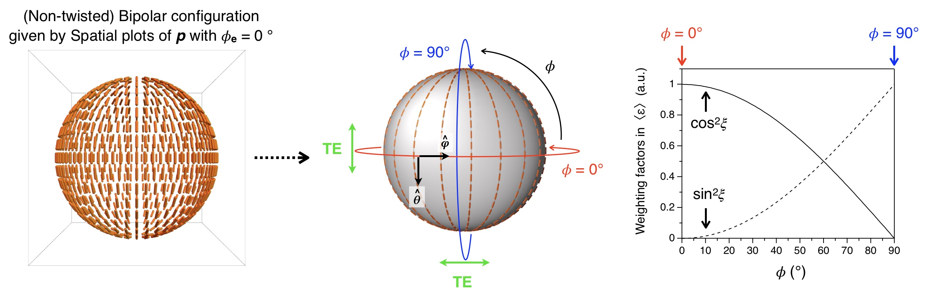
Likewise, when a nonzero φ_{e} is used in this analytical model, it gives the corresponding twisted patterns and φ-dependent cos²ξ and sin²ξ shown below.
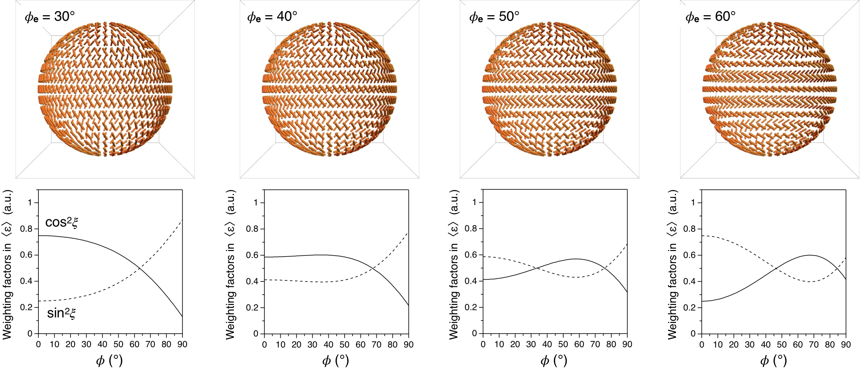

- Supplementary Figures

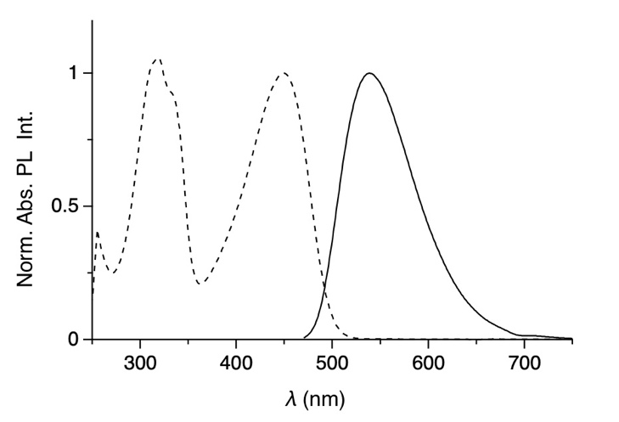

Supplementary Figure 1. Photoabsorption (dashed curve) and PL (solid curve) spectra of (S,S)-PFBT (λ_{ex} = 450 nm).

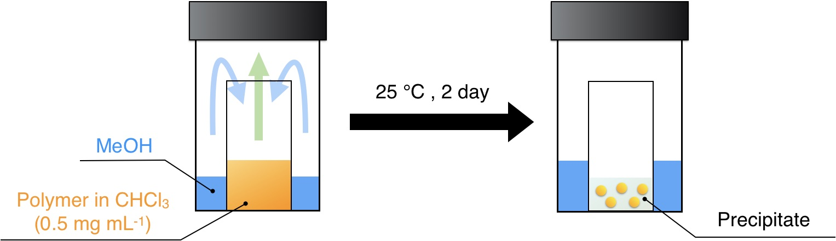

Supplementary Figure 2. Schematic representation of a typical preparation procedure of polymer microspheres by the VD method.

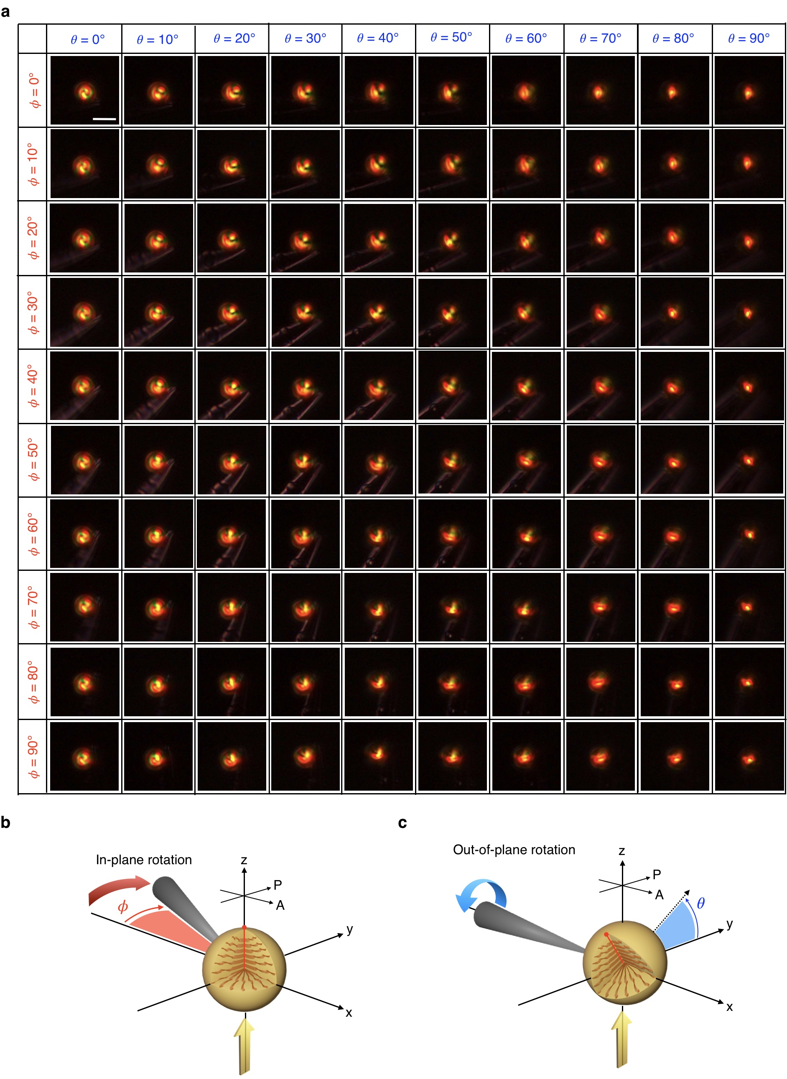

Supplementary Figure 3. a-c, Series of POM micrographs of an identical (S)-TB-MS (a) upon in-plane (𝜙) (b) and out-of-plane (𝜃) (c) rotation. The (S)-TB-MS was mounted on the tip of a microneedle. The scale bar depicted in the micrograph of (𝜙, 𝜃) = (0°, 0°) is 5 µm.

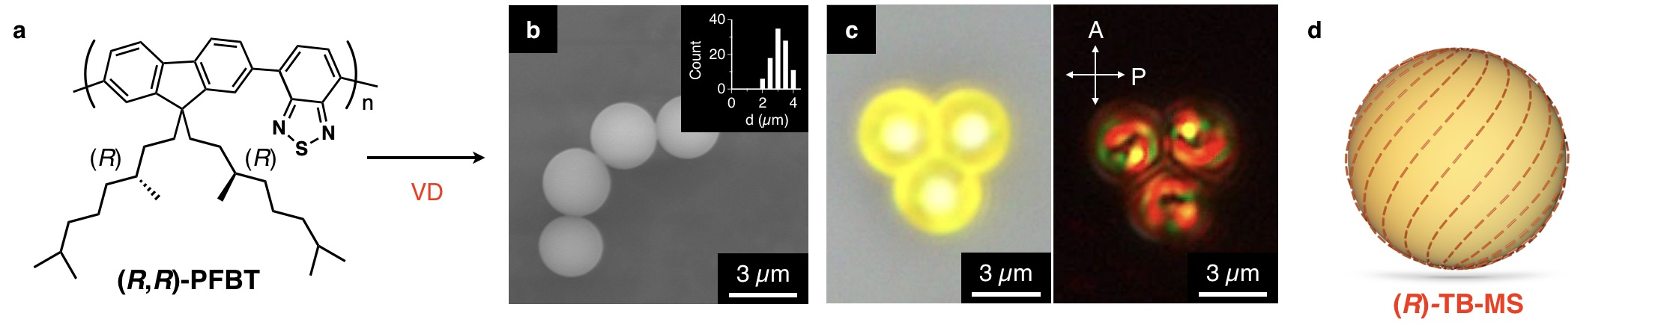

Supplementary Figure 4. a, Molecular structure of (R,R)-PFBT. b, SEM micrograph of (R)-TB-MS. The inset shows a histogram of d. c, Optical (left) and POM (right) micrographs of (R)-TB-MS. d, Schematic representation of the TB molecular orientation in (R)-TB-MS.

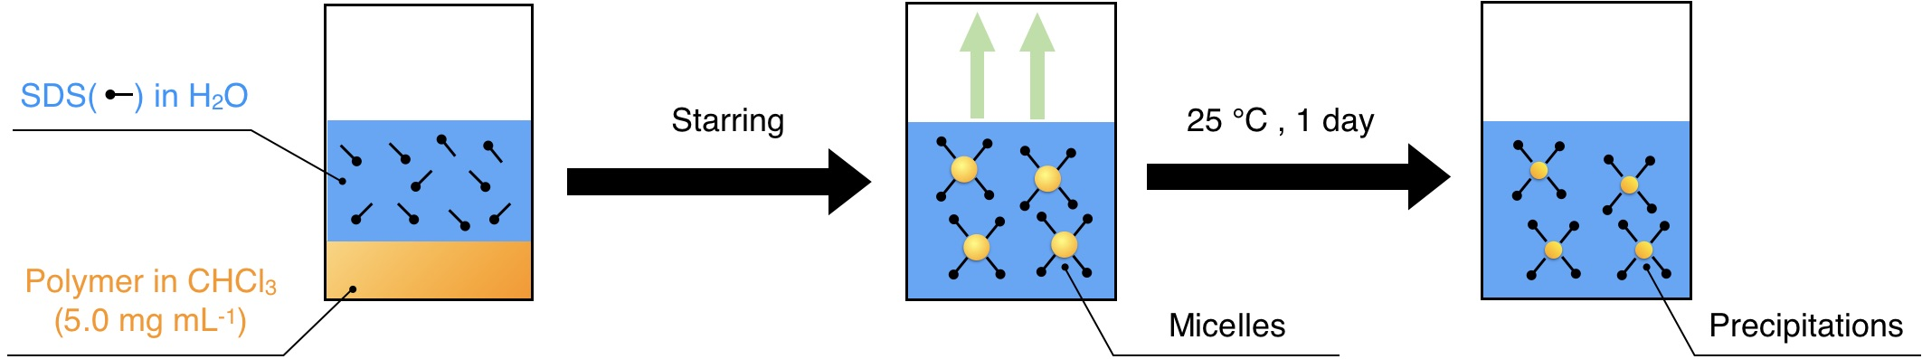

Supplementary Figure 5. Schematic representation of a typical preparation procedure of polymer microspheres by the ME method.

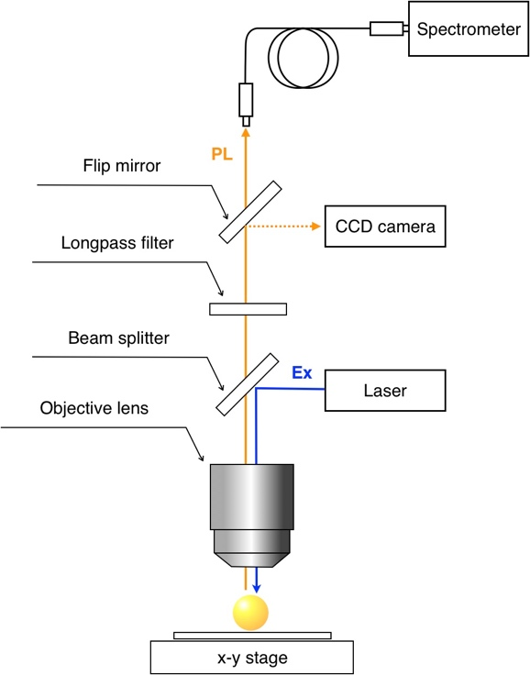

Supplementary Figure 6. Schematic representation of the experimental setup of μ-PL measurements.

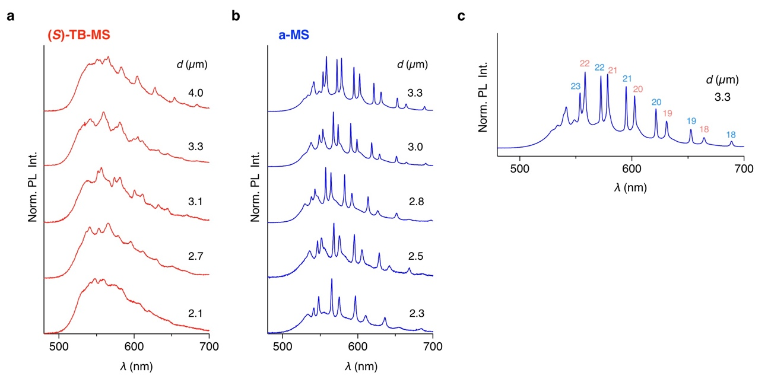

Supplementary Figure 7. a, b, PL spectra of a single (S)-TB-MS (a) and a-MS (b) with different d values upon irradiation with a CW laser (λ = 450 nm). c, PL spectra of a single a-MS with d = 3.3 µm. The blue and red numeric symbols indicate indices of WGMs with TE and TM modes, respectively, calculated with Eqs. S1 and S2.

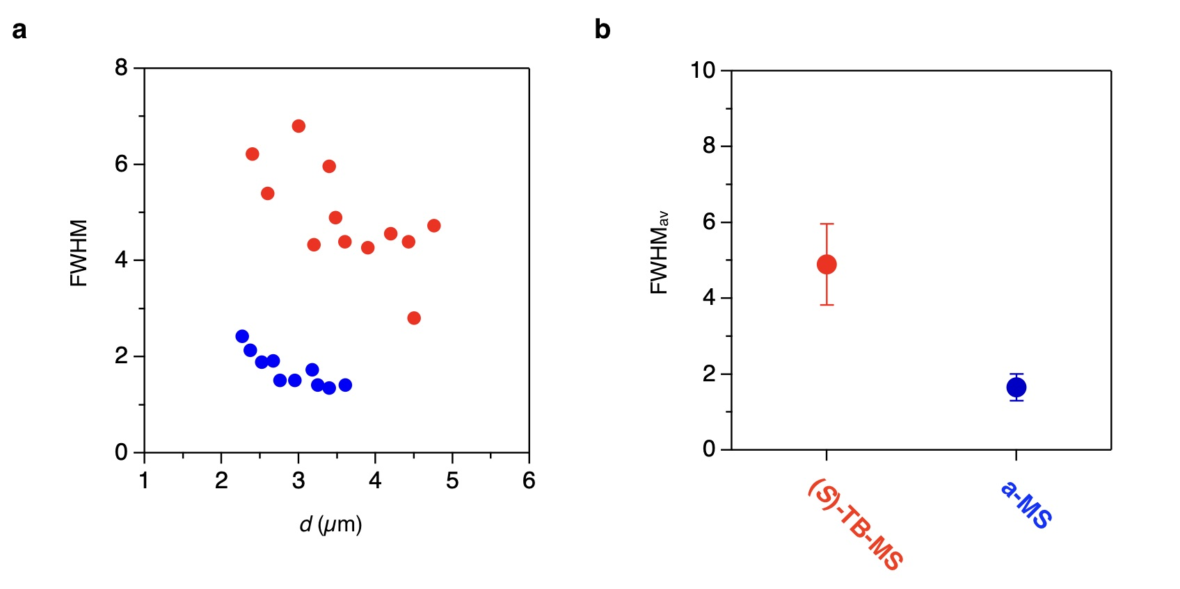

Supplementary Figure 8. a, Plots of the FWHM of (S)-TB-MS (red) and a-MS (blue) with d. b, Plots of the FWHM_{av} of (S)-TB-MS (red) and a-MS (blue).

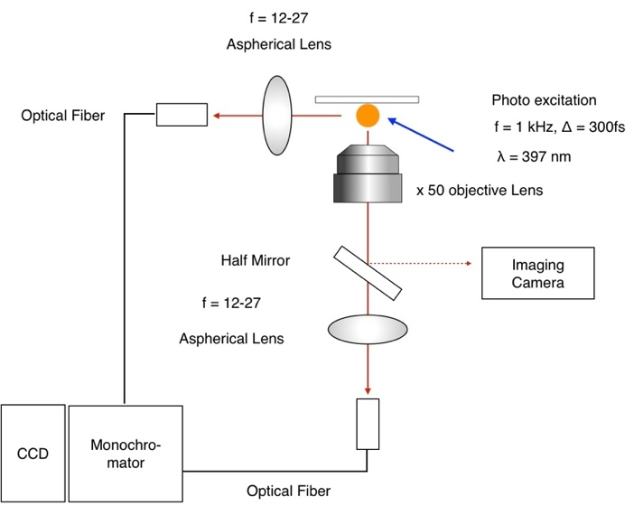

Supplementary Figure 9. Schematic representation of the experimental setup of µ-PL measurements with fs-laser pumping.

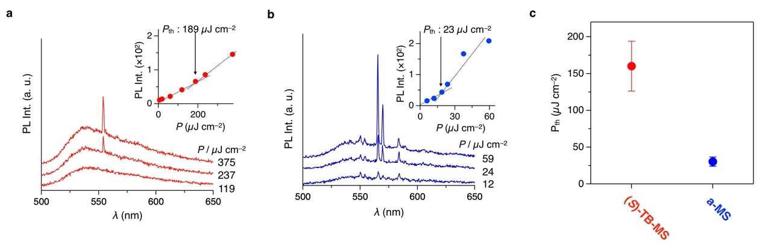
Supplementary Figure 10. a, b, µ-PL spectra of a single (S)-TB-MS (a) and a-MS (b) upon fs pulse laser irradiation. The inset shows a plot of the PL intensity versus P, showing a lasing threshold of 189 µJ cm⁻² (a) and 23.0 µJ cm⁻² (b). c, Plots of the average lasing thresholds of (S)-TB-MS (red) and a-MS (blue).

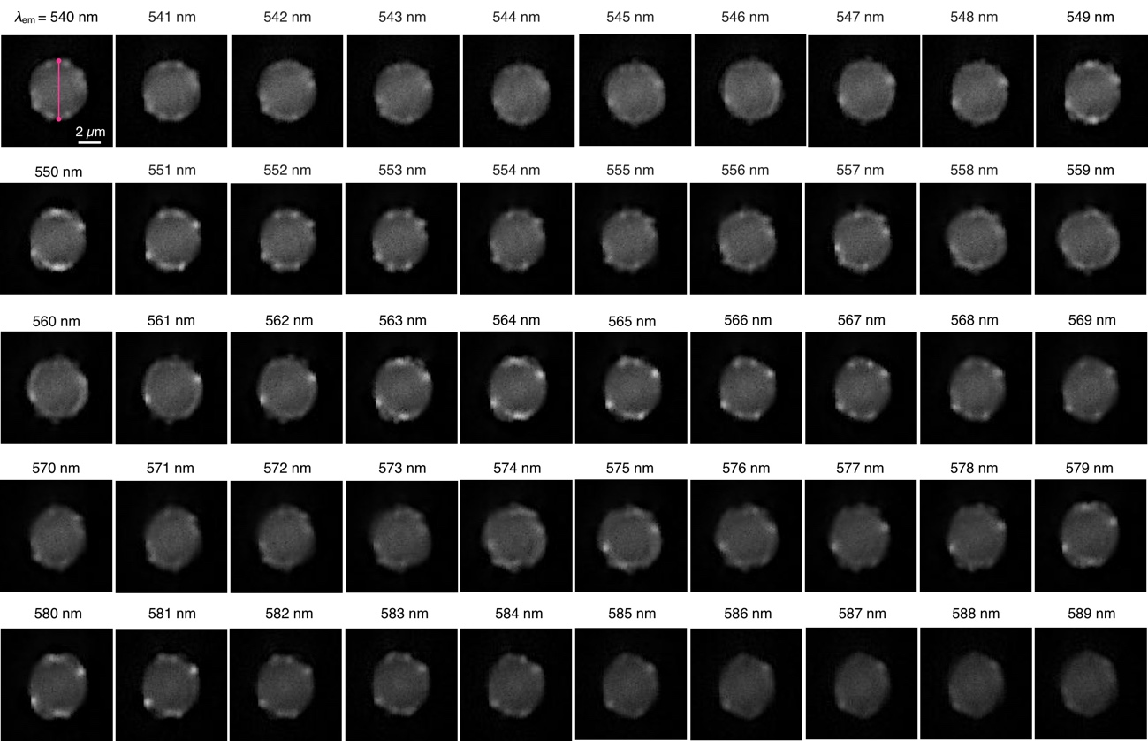

Supplementary Figure 11. λ_{em}-dependent FL micrographs of (S)-TB-MS at θ = 90° from λ_{em} = 540 to 589 nm. The magenta line depicted in the micrograph of λ_{em} = 540 represents the bipolar axis of (S)-TB-MS.

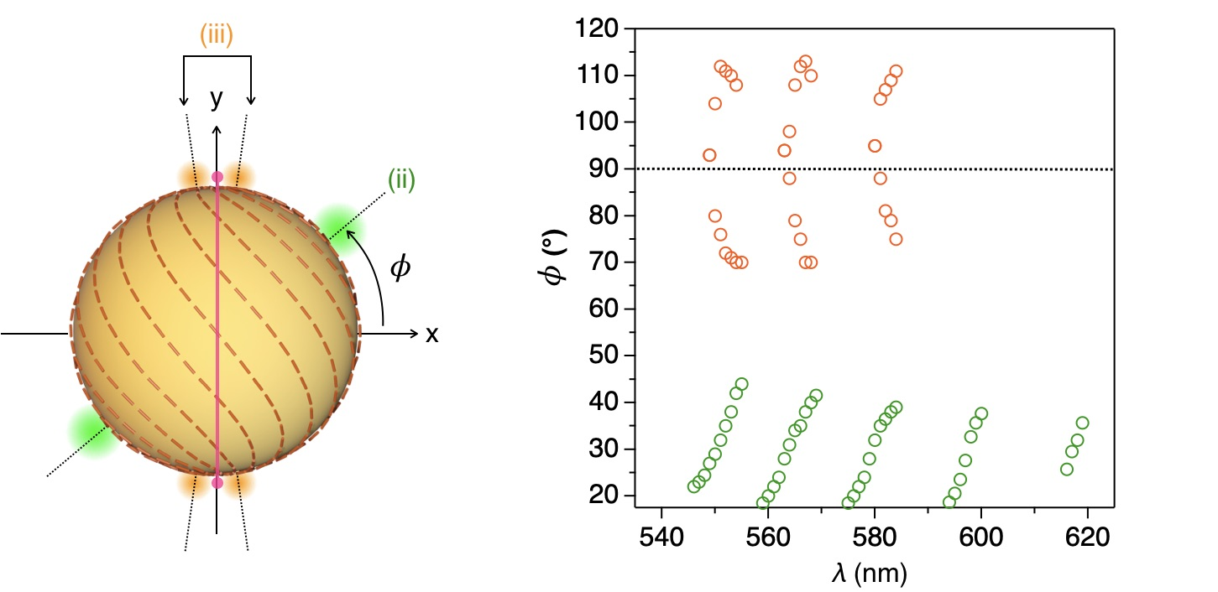

Supplementary Figure 12. Plots of the φ of bright spot (ii) (green circle) and bright spot (iii) (orange circle) versus λ_{em}. Spot (iii) is plotted down to 584 nm, as the bright spot is hard to see after that λ_{em}.

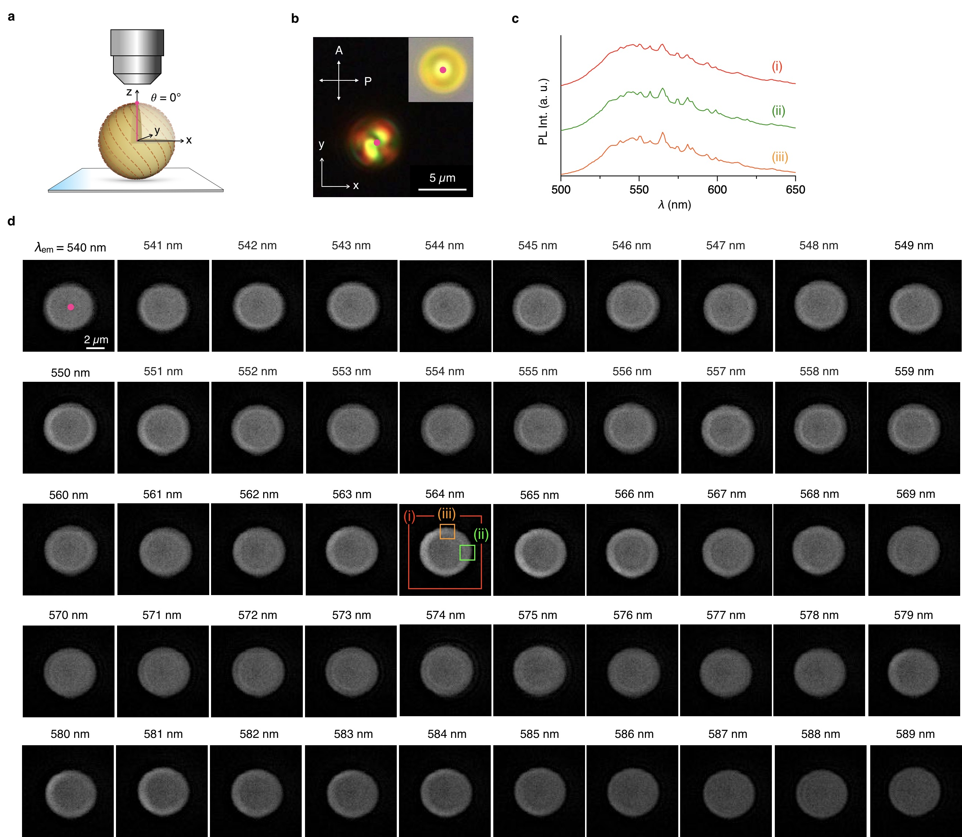

Supplementary Figure 13. a, Schematic illustration of (S)-TB-MS at θ = 0° on a substrate. The magenta line represents the bipolar axis of (S)-TB-MS. b, POM and optical (inset) micrographs of (S)-TB-MS. The depicted magenta point represents the bipolar pole. c, Spatially resolved PL spectra collected from the entire microsphere (i) and rim (ii, iii). d, λ_{em}-dependent FL micrographs of (S)-TB-MS at θ = 0° from λ_{em} = 540 to 589 nm.

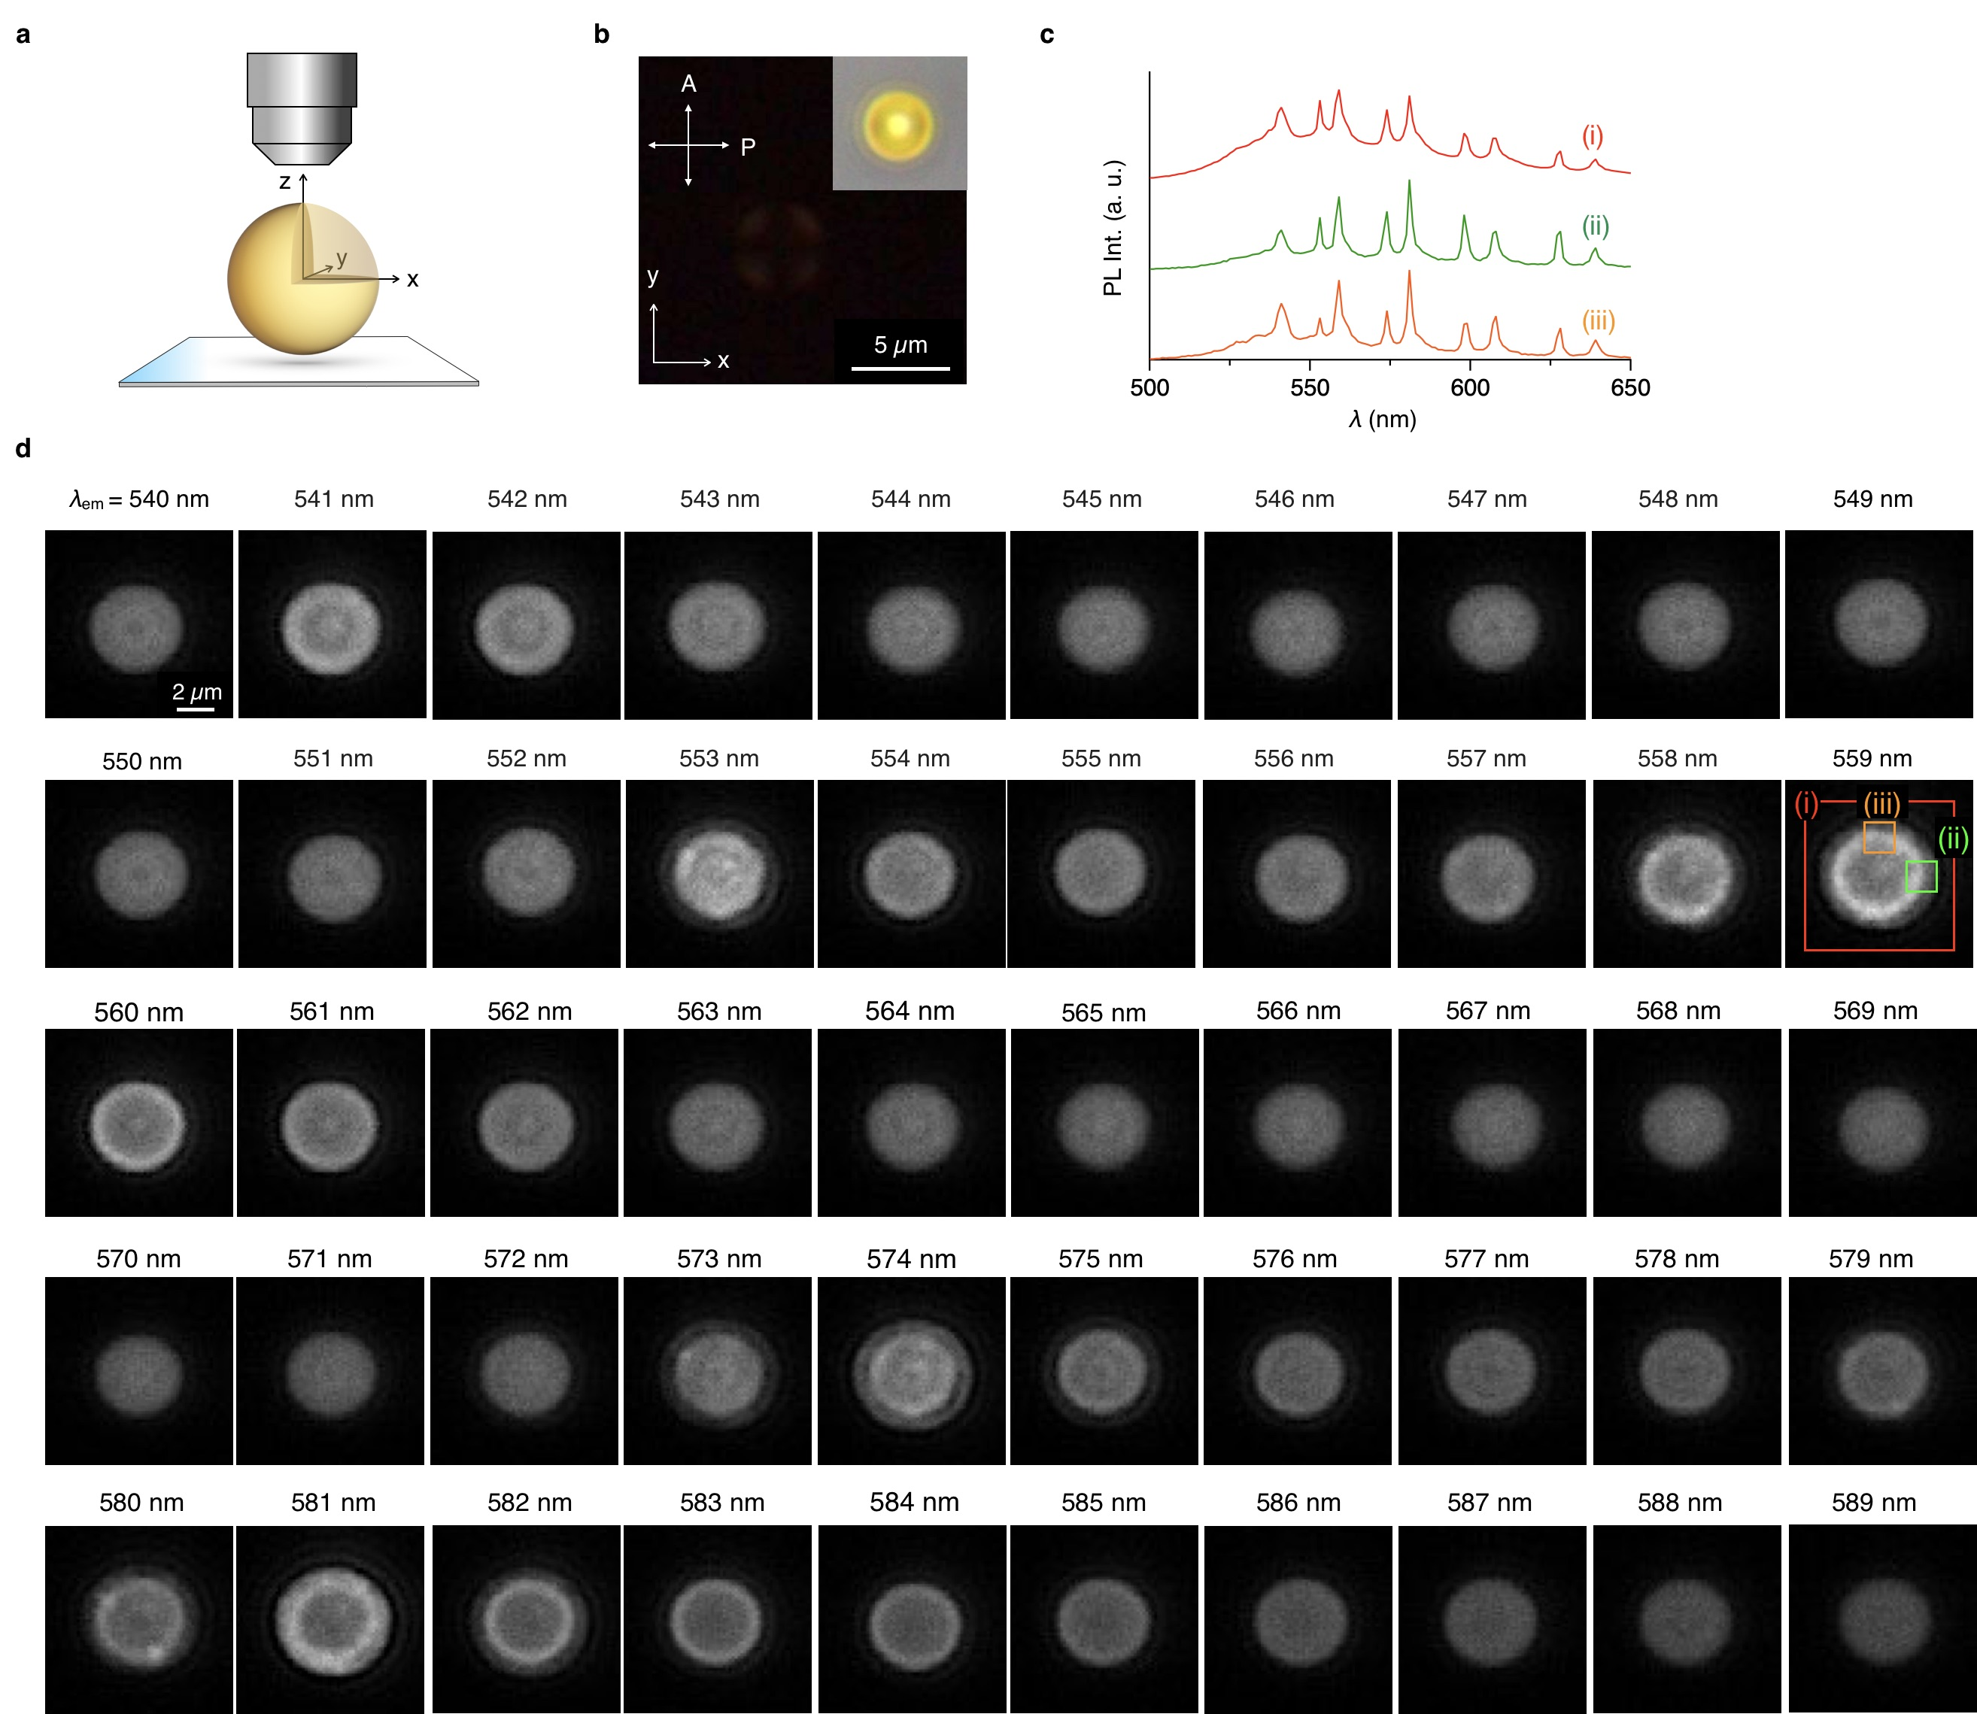

Supplementary Figure 14. a, Schematic illustration of a-MS on a substrate. b, POM and optical (inset) micrographs of a-MS. c, Spatially resolved PL spectra collected from the entire microsphere (i) and rim (ii, iii). d, λ_{em}-dependent FL micrographs of a-MS at θ = 0° from λ_{em} = 540 to 589 nm.

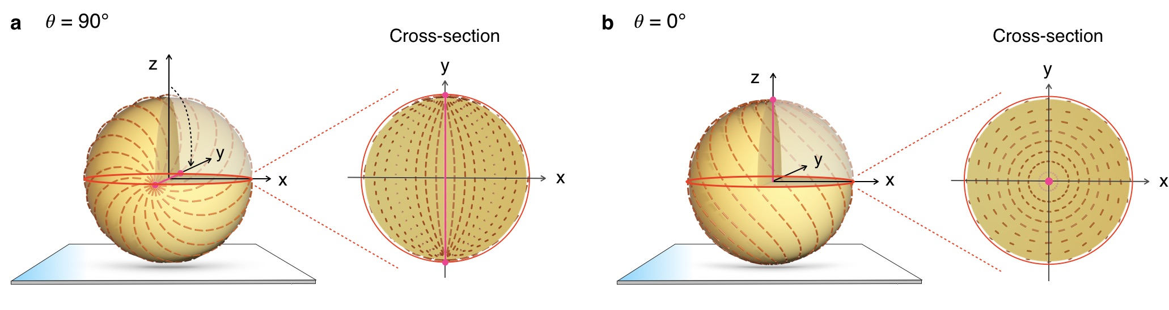

Supplementary Figure 15. a, b, Schematic representations of cross-sectional views of the meridional plane (a) and equatorial plane (b) of (S)-TB-MS.

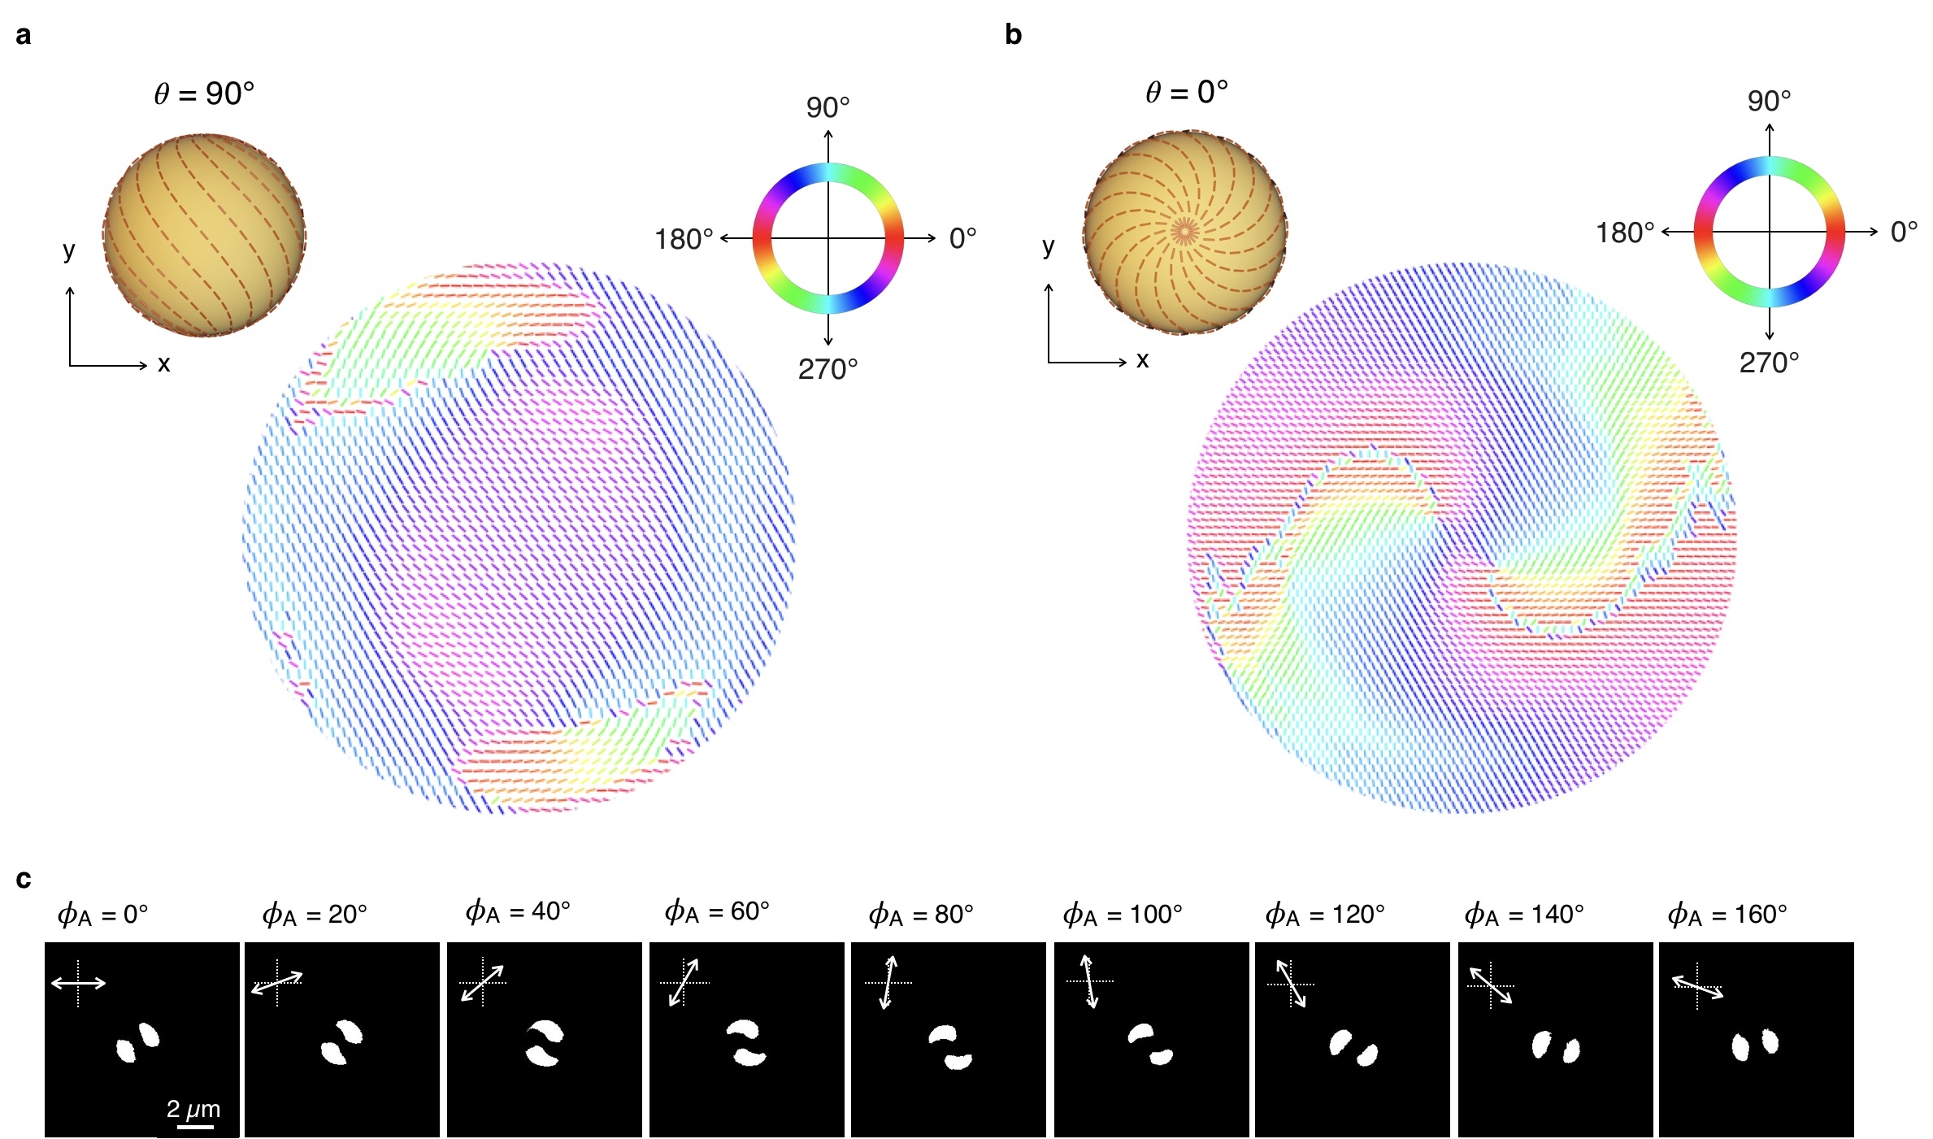

Supplementary Figure 16. a, b, Polarization maps by coloured bars of (S)-TB-MS, projected from the series of polarization-dependent FL images collected at θ = 90° (a) and 0° (b). The colour of each bar indicates the polarization direction that exhibits the maximum PL intensity upon rotation of the analyser. c, Polarization-dependent FL micrographs of (S)-TB-MS collected at θ = 0°. The white areas indicate that the grey value of the FL intensity is above 150.

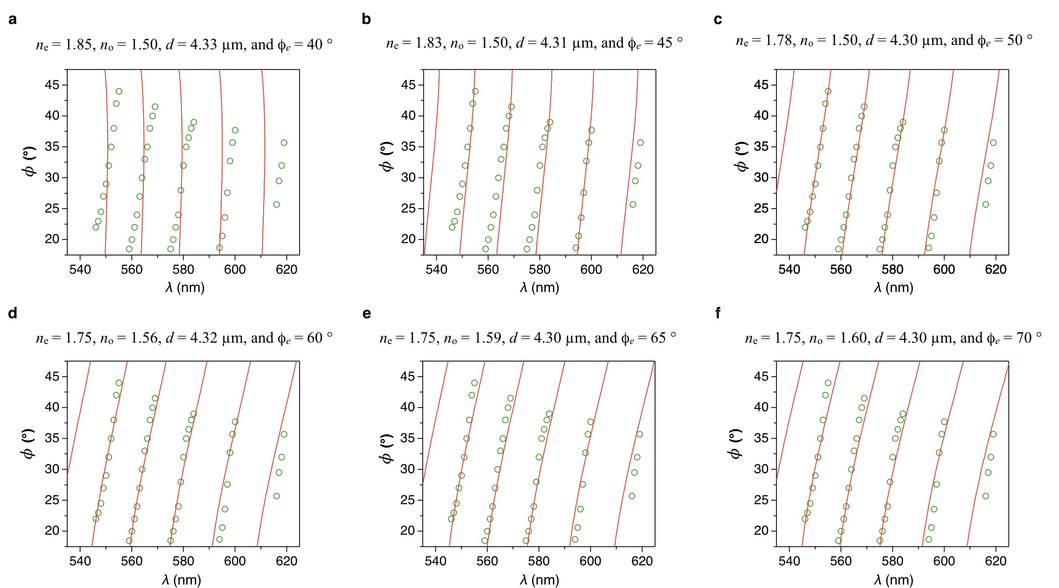

Supplementary Figure 17. Simulated λ-dependent resonance angles (red curves) with φ_{e} = 40° (a), 45° (b), 50° (c), 60° (d), 65° (e), and 70° (f), overlayed on the experimental data (green circle, shown in Fig. 3e).

Supplementary Table 1. Simulated values of the λ-dependent resonance angles with different φ_{e} values shown in Supplementary Fig. 17. A small residual sum of squares (RSS) indicates that the fitting curve well matches the experimental plots.

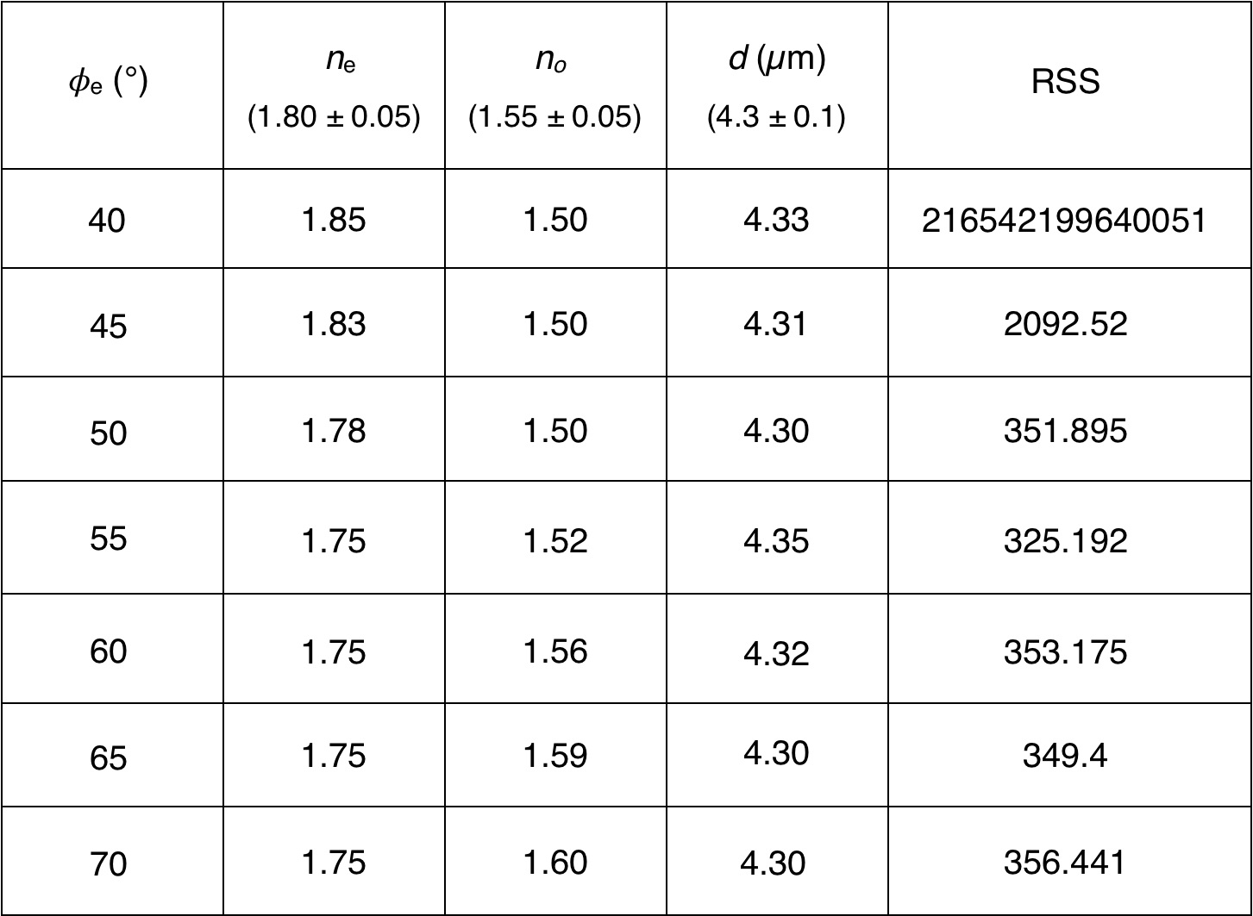

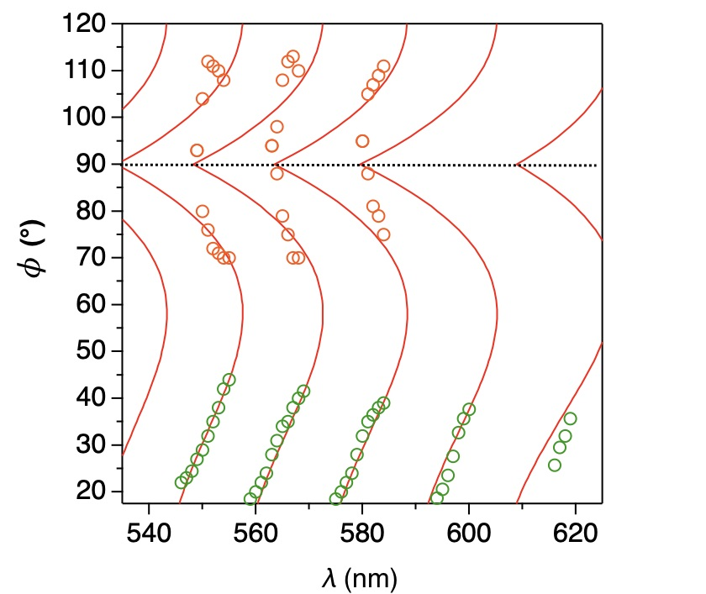

Supplementary Figure 18. Simulated λ-dependent resonance angles (red curves) with parameters n_{e} = 1.75, n_{o} = 1.52, d = 4.35 µm, and φ_{e} = 55°, overlayed on the experimental data (green circles and orange circles, shown in Supplementary Fig. 12). The simulated curves indicate that multiple resonance spots simultaneously appear for an arbitrary λ.

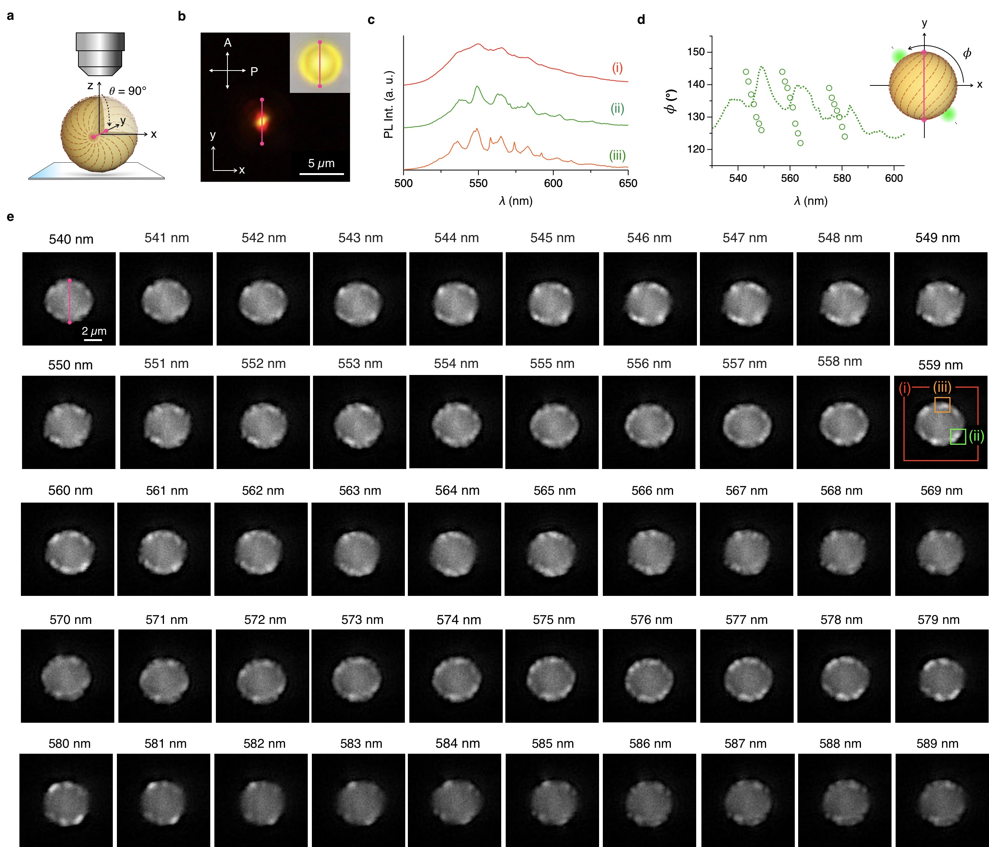

Supplementary Figure 19. a, Schematic illustration of (R)-TB-MS at θ = 90° on a substrate. b, POM and optical (inset) micrographs of R-TB-MS. c, Spatially resolved PL spectra collected from the entire microsphere (i), one of the diametrically opposite bright spots in the 2nd and 4th quadrants (ii) and a position around the topological defect (iii). d, Plot of the migration angle φ of bright spot (ii) with λ_{em}. e, λ_{em}-dependent FL micrographs of (R)-TB-MS from λ_{em} = 540 to 589 nm.

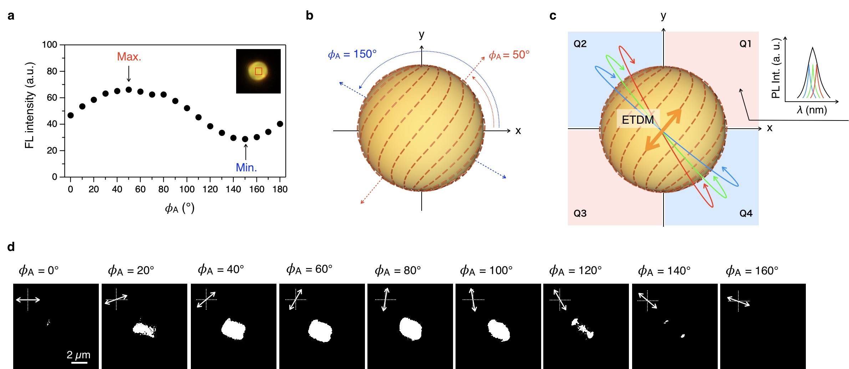

Supplementary Figure 20. a, Plot of the polarization-dependent grey values of the FL intensity for (R)-TB-MS. The inset shows an FL micrograph of (R)-TB-MS, with the calculation area indicated by a red square. b, Schematic representation of the proposed molecular organization on TB-MS. c, Schematic representation of the asymmetric WGM pathways viewed from the z-axis. Red, blue, and green pathways represent different optical pathlength WGM trajectories. d, Polarization-dependent FL micrographs of (R)-TB-MS. The white areas indicate that the grey value of the FL intensity is above 45.

- Supporting References

[S1] R. Abbel, A. P. H. J. Schenning, E. W. Meijer, Macromolecules 2008, 41, 7497−7504.

[S2] A. N. Oraevsky, Quant. Elect. 2002, 32, 377.

