Supporting Information

Functional cellulose paper with high transparency, high haze, and UV-blocking for perovskite solar cells

Yanhua Guanª, Haodong Heª, Dexi Tangª, Xiaoqin Han^{c}, Haixia Zhang^{c}, Jiayun Xu^{d}, Lin Dai*^{a,b,c}, Zhanhua Huang*^{b}, Chuanling Si*ª

ªState Key Laboratory of Biobased Fiber Manufacturing Technology, Tianjin Key Laboratory of Pulp and Paper, College of Light Industry and Engineering, Tianjin University of Science and Technology, Tianjin 300457, China
^{b}Key Laboratory of Bio‑Based Material Science and Technology, Ministry of Education, College of Material Science and Engineering, Northeast Forestry University, Harbin, China
^{c}Wuzhou Special Paper Group Co., Ltd., Quzhou, China
^{d}Laboratory of Natural Materials Technology, Åbo Akademi University, Turku FI-20500, Finland

*Corresponding author.
E-mail: dailin@tust.edu.cn (L. Dai), huangzh1975@163.com (Z. Huang), sichli@tust.edu.cn (C. Si).
Tel: 8622-60601313
Table of Contents
1. Supplementary Tables
Table S1. Dimension of cellulose fiber.
2. Supplementary Figures
Fig. S1. FTIR spectra of the cellulose paper, CMC film, TA, TH paper, and FTH paper.
Fig. S2. The transparency of the cellulose paper with different density.
Fig. S3. The haze of the cellulose paper with different density
Fig. S4. 40g/m², 30g/m², 25g/m², and 20g/m² of cellulose paper with 1wt% CMC solution.
Fig. S5. The transparency of the cellulose paper with different amount of CMC.
Fig. S6. The haze of the cellulose paper with with different amount of CMC.
Fig. S7. The transparency of TA solution with different concentration.
Fig. S8. The transparency of FTH paper with 16 wt% CMC and different amount of TA.

Table S1. Dimension of cellulose fiber.
Fiber type | Average length | Average width
Bleached kraft softwood pulp (BKP) | 1.666 mm | 30.9 μm

Fig. S1. FTIR spectra of the cellulose paper, CMC film, TA, TH paper, and FTH paper.

Fig. S2. The transparency of the cellulose paper with different density.

Fig. S3. The haze of the cellulose paper with different density.

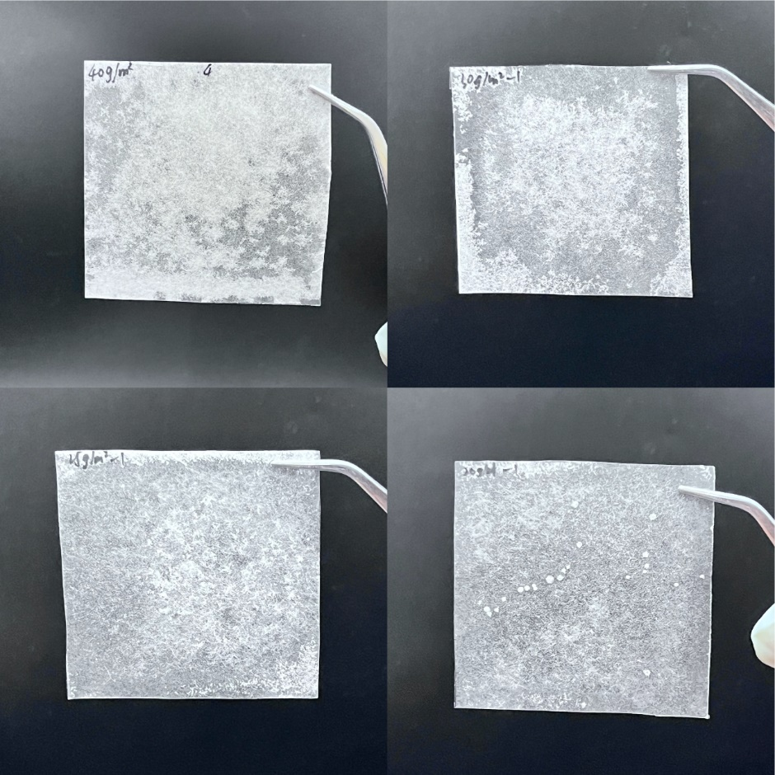
Fig. S4. 40g/m², 30g/m², 25g/m², and 20g/m² of cellulose paper with 1wt% CMC solution.

Fig. S5. The transparency of the cellulose paper with different amount of CMC.

Fig. S6. The haze of the cellulose paper with with different amount of CMC.

Fig. S7. The transparency of TA solution with different concentration.

Fig. S8. The transparency of FTH paper with 16 wt% CMC and different amount of TA.

