Supplementary Methods
These methods have been provided by the authors to give readers additional information about their methods and work.
Table of Contents
Data Collection 2
Ascertainment/Processing/Cleaning 2
Analysis 7
Supplementary Tables 7
Supplementary Figures 10
REFERENCES 14

DATA COLLECTION
Demographic and outcomes data were extracted from the electronic medical record at Massachusetts General Brigham using the Research Patient Data Registry (RPDR) for structured data, and radiology reports and clinical notes for unstructured data. A second researcher verified all data to ensure accuracy.

Ascertainment/Processing/Cleaning
We include the following description of relevant decision rules regarding ascertainment and cleaning of retrospective data.

Age was derived by using the date of encounter minus the date of birth, rounding down to the year. Sex, race, and ethnicity were obtained through structured RPDR.

Past medical history used the following diagnosis codes on admission (except for ischemic stroke) or prior to admission atrial fibrillation (Afib), hypertension, and stroke.
Afib (ICD-9: [427.31, 427.32, 427.33], ICD-10: [I48.91, I48.1, I48.0, I48.92, I48.3, I48.4, I48.9])
Hypertension (Any of the following validated diagnosis codes[1] present on admission or prior to admission of interest in RPDR: ICD-9: [401.x, 402.x, 403.x, 404.x, 405.x], ICD-10: [I10.x, I11.x, I12.x, I13.x, I15.x]); Heart Failure (Any of the following validated diagnosis codes[2] present on admission or prior to admission of interest in RPDR: ICD-9: [428, 398.91, 402.01, 402.11, 402.91, 404.01, 404.03, 404.11, 404.13, 404.91, 404.93], ICD-10: [I50.1 to I50.9, I11.0, I13.0, I13.2])
Stroke[3] (Any of the following diagnosis codes present prior to admission of interest in RPDR: ICD-9: [433.x1, 434.x1, 435.x, 436, 362.3], ICD-10: [I63.x, I64.x, H34.1, G45.x]).

Procedures/Treatments included:
IV tissue-Plasminogen Activator (tPA) was obtained through RPDR and verified using clinical patient note reviews: Keywords: [“Mechanical,” “Thrombectomy,” “Solitaire,” “Endovascular,” “Recanal,” “Catheter,” “Stent,” “Pass,” “Penumbra,” “Clot retrieval,” “MERC/MERS,” “IA therapy,” “IA intervention,” “Intraarterial,” “Embolectomy”]. For instances in which RPDR and clinical patient notes were in conflict, (for example RPDR tPA was not recorded but clinical notes indicated that tPA was administered at an outside hospital) clinical patient notes were favored.)
Mechanical Thrombectomy was obtained through RPDR using procedural codes and clinical patient note reviews. Reviewed from clinical notes; keywords including [“mechanical”, “thrombectomy”, “solitaire”, “endovascular”, “recanal”, “catheter”, “stent”, “pass”, “penumbra”, “clot retrieval”, “MERC”, “MERS”, “IA therapy”, “IA intervention”, “intraarterial”, “embolectomy”]. For instances in which RPDR and clinical patient notes were in conflict, clinical patient notes were favored.
Mechanical Thrombectomy Time was determined by clinical note review. Types of reports including: “H&P,” “Consults,” “Final reports of FL Carotid Stenting,” “FL stroke Intervention,” “FL embolization,” “FL Catheter Placement,” “IR Acute Stroke Intervention.” If mechanical thrombectomy time was not explicitly documented (especially if it was given OSH), MT time was determined to be missing.
Decompressive Hemicraniectomy (DHC) was obtained through RPDR using procedural codes (CPT 61322, CPT 61323, CPT 61304) radiology reports, and clinical note review. Any discrepancies were reviewed by the clinical team to ensure accuracy.
Surgery Time was determined by clinical note review (anesthesia start, surgery start). For clinical note that did not have surgery time listed, the date time of the first radiology report showing surgical decompression was used.

Stroke Characteristics
Last seen well (LSW) date times were identified via clinical notes. LSW was considered the last time before a patient had a significant deficit as inferred by National Institutes of Health Stroke Score (NIHSS) (symptoms of numbness, tingling, or other symptoms that would result in NIHSS < 3 were not taken as the time of LSW). LSW without exact times or only reference to time were labeled as “inferred”. If LSW was prior to an in-hospital surgery, the surgery time was identified. If no surgery start time was identified, surgery was assumed to be at 7:00AM. If LSW referred to “last night before bed,” with no exact time, then LSW was assumed to be 10:00 PM. All last seen well data underwent supervisor review (CJO).
NIHSS was extracted from history and/or physical exam. In cases in which multiple NIHSS were reported, the last one (after any procedures took place) was used. Documented NIHSS via clinical notes. NIHSS after any thrombolytic procedure at BWH or MGH. Thrombolytic procedure included Therapeutic IV-tPA, Intra-arterial tPA, Mechanical thrombectomy with IA tPA, and Mechanical thrombectomy without IA tPA. If post-procedure NIHSS at BWH or MGH was not documented, then NIHSS upon arrival at BWH or MGH using the arrival exam was used. If the documented arrival and post-procedure NIHSS were not available, then NIHSS at the outside hospital (OSH) before the patient was transferred to BWH or MGH was used. If any thrombolytic agent was given OSH, then post-administration NIHSS was used. If post-procedure NIHSS at OSH was not available, then the arrival NIHSS at OSH was used. Inferred NIHSS (Previous studies have shown that the NIHSS can be estimated from the review of medical records with a high degree of reliability and validity.⁴For the cases where admission NIHSS was not explicitly stated in the patient’s admission record, it was inferred based on the available history and physical exam by a rater who was previously trained and certified in the administration of the NIHSS. Items on the scale were only scored if they were written in the HPI or physical exam portion of the admission note. Patient’s intubation status was assessed from recorded vital signs. Level of consciousness (scale item 1), best language (9), and dysarthria (10) were scored based on the HPI and mental status exam. Cranial nerve examination was used to score best gaze (item 2), visual fields (3), and facial palsy (4). The motor exam was used for motor arm (5) and motor leg (6). Limb ataxia (7) and sensory (8) were acquired from the ataxia and sensory sections of the neurological exam. Often, motor and sensory scores was inferred based on the patient’s reaction to noxious stimuli. For example, if the patient triple flexed to noxious stimuli, sensation was scored as "normal" and motor as “some effort against gravity” on the scale. Extinction and inattention (11) were scored based on mental status, cranial nerve, and sensory examinations. In cases where sections of the neurological exam were either incomplete or absent, those items were not scored on the scale.⁴ We made the table of inferred NIHSS available in our Missing Value table (Supplementary Table 6)
Large LVO location (All CT Angiograms (CTA)) were reviewed and classified as a large vessel occlusion (LVO) based on radiology reports. The most proximal vessel involved (Internal Carotid Artery, M1, M2, M3/M4) was used for the large LVO location. Anterior Cerebral Artery (ACA) was also identified as occluded or not. In instances in which reports described vessel occlusion but did not explicitly name vessel occluded, M1 was assigned if occlusion was described to begin prior to bifurcation/trifurcation.

Laboratory/Vital Sign Values were obtained through structured RPDR database. The first value present within eight hours before and up to thirty-six hours after the designated presentation date were used to account for labs that occurred prior to first radiographic scan and/or clinically determined presentation date time. Mean time from presentation to first laboratory value was 3 minutes (0.05 hours) with a standard deviation of 4.08 hours. Reasons for lab values taken prior to presentation time is due to presentation time definition—labs in the emergency department occasionally predated official “presentation time.” Vital signs were taken from chart review of the History and Physical (Supplementary Figure 1).

Histogram of mean time from presentation to first laboratory value
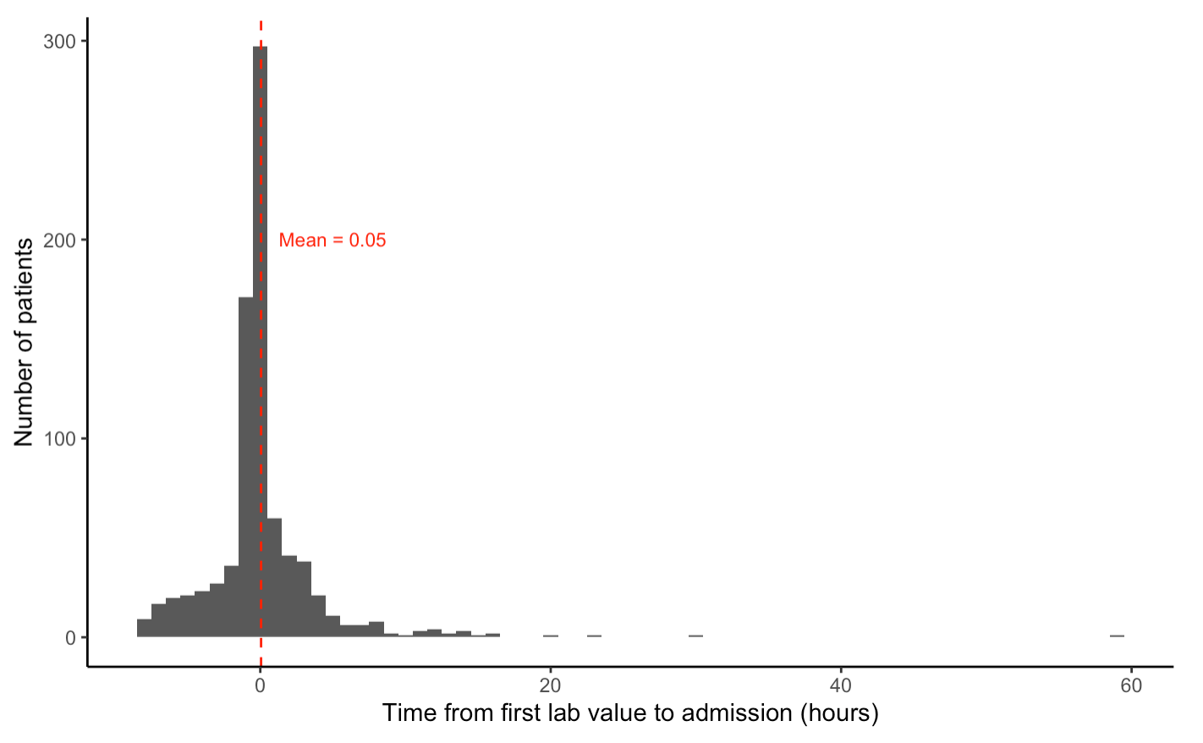
Glucose was obtained through structured RPDR. Logical Observation Identifiers Names and Codes (LOINC) determined by internal review: 2345-7, 2341-6, X1727-7, 6777-7, 2339-0, and XC425-9.
White Blood Cell Count (WBC) was obtained through structured RPDR. LOINC determined by internal review: 6690-2, 6743-9, 11156-7.
Sodium was obtained through structured RPDR. LOINC determined by internal review: 2951-2, X1737-6, X1015-7, 2947-0.
Creatinine was obtained through structured RPDR. LOINC determined by internal review: 2160-0, X1742-6, X1006-6, X7059-9, X1490-2.
Blood Pressure (In patients from 2015-2021, available longitudinal blood pressure data during admission was used from the Partners enterprise data warehouse (EDW). In patients prior to 2015, all patients underwent chart review to obtain admission blood pressure from clinical notes. In cases in which multiple blood pressures were recorded in a clinical note, the most recent blood pressure from the examination portion of the note was used.
Temperature (In patients from 2015-2021, available longitudinal temperature data during admission was used from the Partners EDW)
Pulse (In patients from 2015-2021, available longitudinal pulse data during admission was used from the Partners EDW)

To remove clearly erroneous lab or vital sign errors due to incorrect chart entry, each longitudinal measurement was assigned a Z-score based on the distribution of the data in the full cohort. Any measurement with an absolute Z-score greater than or equal to three, or 25% change from a preceding value, the observation was flagged as a potential erroneous measurement. The principal investigator examined each patient’s flagged laboratory/vital sign trajectories and determined which outlying values fit in the context of their hospital course and which needed to be removed. Temperature that appeared to be in Celsius (30°s- low 40°s) was converted to Fahrenheit. All other abnormally low temperature values were removed (ex: 78°). One sodium value of 102 mEq/L was removed after chart verification. All glucose values ≥1000 mg/dL, and one glucose measurement of 866 mg/dL was removed after chart verification

For radiographic features, we used a Natural Language Processing algorithm with high sensitivity described previously⁵ [6] to screen for patients with acute MCA stroke identified via ICD-9, ICD-10 codes. All patients with possible large acute MCA stroke were visually confirmed to have a stroke size ≥ 1/2 of the MCA territory using direct visualization of radiology images by designated, trained M.D members of the research team (SC, CJO). To be included in 1/2 MCA territory images had to have either full superior or inferior MCA division involvement, or include sufficient volume (estimate of >70cc) of both superior/inferior or deep structures to be included. All indeterminate images underwent secondary review (CJO). A random sampling of our 30 patients using an ABC/2 method⁶ demonstrated that median volume was 122 cc³.
Hemorrhage was recorded by manual inspection according to ECASS II criteria. Petechial Hemorrhage was determined to be HI1 or HI2, and Parenchymal Hemorrhage PI1 or PI2.⁷ Percent agreement between trained team members (SC, CJO) on a 10% sample was 92.5%.
The Alberta Stroke Program Early CT Score (ASPECTS) divides the brain parenchyma into 10 separate non-overlapping regions, three regions at the level just rostral to the ganglionic structures and four at the level of the thalamus.⁸ For each baseline scan, each region was deemed affected based on the radiographic evidence of ischemia of the brain parenchyma, hypodensity, loss of cortical ribbon and sulcal effacement on non-contrast CT scan (NCCT) and the restriction of diffusion on Diffusion-MRI (DWI-MRI). For an individual region to count as affected, the lesion should be at least 10% of the respective area. ASPECTS score of 10 implies a totally healthy parenchyma, only at the two levels that the regions are examined, and a score of 0 implies that all the predetermined areas have been affected by ischemia.
Midline shift was measured at the level of the septum pellucidum by a trained member of the team using imaging viewer software [Client Outlook, eUnity Diagnostic Viewer, version 6.10.2-489, for MacOs] by navigating to the level of the septum pellucidum at the slice of maximum midline shift. The reviewer created a line connecting the attachment of falx cerebri anteriorly (frontal most notch visible on the scan) and the occipital protuberance (the most posterior notch seen on the posterior aspect of the skull (Image). Windows were set at W:30 L:30. The distance between the midline and the septum pellucidum at both the most lateral and medial boundaries was measured by adding a line perpendicular to the midline. The average of the lateral and medial boundary was used for the final midline shift used in analysis. The results were recorded in a csv file and the difference between the manually recorded MLS and the MLS extracted from the radiology reports were calculated. Mean error was 0.19.
Pineal gland shift was measured at the level of the pineal gland, at the slice wher ethe pineal gland shift was at its maximum. A line from the midline to the point of maximum and minimum deviation was taken, and averaged, to best obtain the deviation from the center of the pineal gland. Mean error between MD reviewers (SC and BB) was 0.36 mm.

Individual Longitudinal Trajectories:
We initially investigated the longitudinal trajectories of our laboratory and vital sign data for each patient individually. We displayed these plots alongside events and outcomes of interest to gain a qualitative understanding of our cohort’s disease courses.

To make the plots, we constructed two datasets: a longitudinal dataset of all laboratory, vital sign, and radiographic imaging variables, and a wide-format dataset of all events and outcomes of interest (for example, the onset time of MLS $≥$5mm).

Our team develop a dashboard in R using the Shiny package⁹ to quickly visualize trajectories for our cohort and any new data. The dashboard in its current state is publicly available at https://onglab.shinyapps.io/labvitalplots/ and the source code is available on GitHub https://github.com/The-Ong-Lab/LabVitalPlots. We include sample dummy data for review and encourage investigators to upload their own data.

Supplementary Tables

Supplementary Table 1: Longitudinal variables median hours between measurements during first 8 days of hospital admission
Variable | Median [Q1, Q3] (hours)
Labs  Glucose | 5.4 [2.3, 8.3]
White Blood Cell Count | 20.9 [9.3, 24.4]
Creatinine | 11.3 [6.6, 22.9]
Sodium | 8.9 [6.0, 19.6]
Radiographic Values | 14.3 [5.7, 23.9]
Vital Signs
Blood Pressure | 1.0 [0.5, 1.0]
Heart rate | 1.0 [0.5, 1.0]
Temperature | 2.0 [1.0, 4.0]

Supplementary Table 2: Baseline Cohort Characteristics of Additional Outcomes
Variable | All  N=635 | PGS >4  N=153  (24.1%) | DHC  N=68  (10.7%)
Demographics
Age | 68.6 ± 15.3 | 66.9 ± 14.5 | 54.3 ± 10.3
Female | 311 (49.0%) | 73 (47.7%) | 28 (41.2%)
Race
White | 490 (77.2%) | 108 (70.6%) | 47 (69.1%)
Black | 41 (6.5%) | 12 (7.8%) | 6 (8.8%)
Asian | 26 (4.1%) | 11 (7.2%) | 5 (7.4%)
Otherª | 78 (12.3%) | 22 (14.4%) | 10 (14.7%)
Past Medical History
Hypertension | 465 (73.2%) | 108 (70.6%) | 37 (54.4%)
Atrial Fibrillation | 315 (49.6%) | 66 (43.1%) | 15 (22.1%)
Heart Failure | 198 (31.2%) | 47 (30.7%) | 13 (19.1%)
Prior Stroke | 73 (11.5%) | 14 (9.2%) | 3 (4.4%)
Home Medication
Antiplatelets | 205 (32.3%) | 44 (28.8%) | 9 (13.2%)
Anticoagulants | 85 (13.4%) | 20 (13.1%) | 4 (5.9%)
Statins | 196 (30.9%) | 49 (32.0%) | 9 (13.2%)
Presentation Information
Inpatient Care Prior to Stroke | 49 (7.7%) | 12 (7.8%) | 2 (2.9%)
Right Sided Stroke | 329 (51.8%) | 94 (61.4%) | 38 (55.9%)
Admission ASPECTS | 4.7 ± 3.0 | 4.2 ± 3.0 | 3.5 ± 2.6
NIHSS | 17.3 ± 5.9 | 17.6 ± 5.1 | 18.0 ± 5.5
Large Vessel Occlusion Location
Internal Carotid Artery | 134 (44.2%) | 36 (49.3%) | 20 (62.5%)
M1 | 117 (38.6%) | 25 (34.2%) | 9 (28.1%)
M2 or more distal | 49 (16.2%) | 12 (16.4%) | 3 (9.4%)
Acute Intervention
Tissue Plasminogen Activator | 285 (44.9%) | 68 (44.4%) | 26 (38.2%)
Radiographic Values
Hemorrhagic Transformation
None | 268 (42.2%) | 28 (18.3%) | 11 (16.2%)
Petechial only | 309 (48.7%) | 97 (63.4%) | 33 (48.5%)
Parenchymal  DHC  Death at discharge | 58 (9.1%) | 28 (18.3%) | 24 (35.3%)
Parenchymal  DHC  Death at discharge | 68 (10.7%) | 32 (20.9%) | 68 (100%)
Parenchymal  DHC  Death at discharge | 239 (37.6%) | 64 (41.8%) | 16 (23.5%)
Abb.: ASPECTS (Alberta Stroke Program Early CT Score); DHC (Decompressive Hemicraniectomy); MLS (Midline Shift); NIHSS (National Institutes of Health Stroke Scale); PGS (pineal Gland Shift)
ªOther Races, includes American Indian, Alaska Native, Native Hawaiian, Pacific Islander, Not Recorded, Not Given or Unknown.
Missing values: NIHSS = 47 (7.4%).

Supplementary Table 3: Average Longitudinal Variables during first 8 days of hospitalization prior to outcome
Variable | All  N=635 | Non-MLS5  N=413  (65.0%) | MLS $≥$5mm  N=222  (35.0%) | PGS >4mm  N=153 (24.1%) | DHC  N=68  (10.7%)
Labs
Glucose (mg/dL) | 157 ± 60 | 156 ± 58 | 165 ± 64 | 166 ± 66 | 160 ± 51
White Blood Cell Count (K/UL) | 11.3 ± 3.9 | 11.2 ± 3.9 | 11.7 ± 3.9 | 12.3 ± 4.7 | 11.7 ± 3.6
Creatinine (mg/dL) | 1.0 ± 0.8 | 1.0 ± 0.8 | 1.2 ± 1.0 | 1.2 ± 1.0 | 1.0 ± 0.5
Sodium (mEq/L) | 142 ± 7 | 142 ± 7 | 142 ± 6 | 142 ± 7 | 143 ± 7
Vital Signs | N=166 | N=101 | N=65 | N=47 | N=30
Systolic Blood Pressure (mmHg) | 139 ± 25 | 138 ± 24 | 141 ± 27 | 142 ± 28 | 143 ± 25
Mean Arterial Pressure (mmHg) | 94 ± 16 | 94 ± 15 | 96 ± 19 | 98 ± 19 | 97 ± 17
Pulse (beats per minute) | 80.6 ± 17.7 | 81.5 ± 17.7 | 76.9 ± 17.2 | 77.6 ± 18.7 | 73.3 ± 16.4
Temperature (Fahrenheit) | 98.9 ± 1.2 | 98.9 ± 1.2 | 98.7 ± 1.3 | 98.8 ± 1.4 | 99.1 ± 1.1
Longitudinal variables are averaged over the course of 8 days in patients without LTME and up until LTME in patients with the outcome of interest

Supplementary Figures

Supplementary Figure 1: Heatmaps of available longitudinal variables in 12-hour time intervals for laboratory values (from 635 patients), and vital signs (from 165 patients). Note that available values decrease as patients are censored (meet outcome, expire, or are discharged from the ICU).

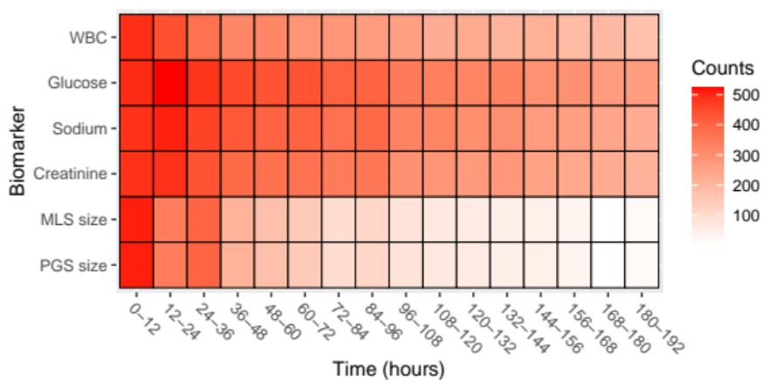
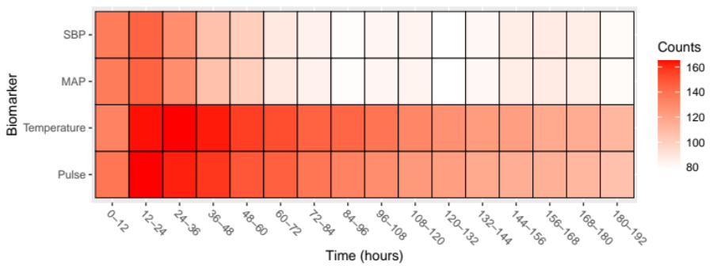

Supplementary Figure 2: Cumulative Incidence Plots of MLS$≥$5mm, PGS>4mm and DHC

Cumulative incidence (95% CI) | MLS≥5mm | PGS>4mm | DHC
24 hrs | 8.9% (6.7%, 11.1%) | 7.0% (5.0%, 9.0%) | 3.4% (2.0%, 4.8%)
48 hrs | 22.1% (18.8%, 25.4%) | 14.7% (11.9%, 17.5%) | 7.6% (5.5%, 9.7%)
72 hrs | 29.4% (25.8%, 33.0%) | 20.5% (17.3%, 23.7%) | 9.6% (7.2%, 11.9%)
96 hrs | 32.8% (29.1%, 36.5%) | 22.6% (19.2%, 25.9%) | 9.7% (7.4%, 12.1%)
120 hrs | 34.6% (30.8%, 38.4%) | 23.8% (20.4%, 27.3%) | 10.3% (7.9%, 12.7%)
144 hrs | 35.7% (31.9%, 39.5%) | 24.4% (20.9%, 27.9%) | 10.3% (7.9%, 12.7%)
168 hrs | 36.3% (32.4%, 40.2%) | 25.2% (21.7%, 28.7%) | 10.4% (8.0%, 12.9%)
192 hrs | 37.3% (33.3%, 41.2%) | 26.2% (22.6%, 29.8%) | 11.3% (8.8%, 13.9%)

Supplementary Figure 3: Forward- and backward-looking scatterplots of variables in relation to radiographic and clinical outcomes. Purple represents non-cases and orange represents cases.

Supplementary Figure 4: Backward-looking trajectory of MLS size prior to PGS >4mm.

REFERENCES:

1. Quan H, Khan N, Hemmelgarn BR, Tu K, Chen G, Campbell N, Hill MD, Ghali WA, McAlister FA, Hypertension O, Surveillance Team of the Canadian Hypertension Education P. Validation of a case definition to define hypertension using administrative data. Hypertension. 2009;54(6):1423-8. PubMed PMID:19858407.
2. Agarwal MA, Fonarow GC, Ziaeian B. National Trends in Heart Failure Hospitalizations and Readmissions From 2010 to 2017. JAMA Cardiol. 2021;6(8):952-6. PubMed PMID:33566058; PMCID:PMC7876620.
3. Kokotailo RA, Hill MD. Coding of stroke and stroke risk factors using international classification of diseases, revisions 9 and 10. Stroke. 2005;36(8):1776-81. PubMed PMID:16020772.
4. Kasner SE, Chalela JA, Luciano JM, Cucchiara BL, Raps EC, McGarvey ML, Conroy MB, Localio AR. Reliability and validity of estimating the NIH stroke scale score from medical records. Stroke. 1999;30(8):1534-7. PubMed PMID:10436096.
5. Ong C, Zhang R, Orfanoudaki A, Caprasse F, Hutch M, Liang M, Fard D, Minnig M, Smirnakis S, Bertsimas D. New Methods of Natural Language Processing using Machine Learning Methods to Identify Ischemic Stroke Presence, Acuity, and Location from Clinical Radiology Reports. Machine Learning For Healthcare; Ann Arbor, MI2019.
6. Sims JR, Gharai LR, Schaefer PW, Vangel M, Rosenthal ES, Lev MH, Schwamm LH. ABC/2 for rapid clinical estimate of infarct, perfusion, and mismatch volumes. Neurology. 2009;72(24):2104-10. PubMed PMID:19528517; PMCID:PMC2697964.
7. Larrue V, von Kummer RR, Muller A, Bluhmki E. Risk factors for severe hemorrhagic transformation in ischemic stroke patients treated with recombinant tissue plasminogen activator: a secondary analysis of the European-Australasian Acute Stroke Study (ECASS II). Stroke. 2001;32(2):438-41. PubMed PMID:11157179.
8. Barber PA, Demchuk AM, Zhang J, Buchan AM. Validity and reliability of a quantitative computed tomography score in predicting outcome of hyperacute stroke before thrombolytic therapy. ASPECTS Study Group. Alberta Stroke Programme Early CT Score. Lancet. 2000;355(9216):1670-4. PubMed PMID:10905241.
9. Winston Chang, Joe Cheng, JJ Allaire, Carson Sievert, Barret Schloerke, Yihui Xie, Jeff Allen, Jonathan McPherson, Alan Dipert and Barbara Borges (2021). shiny: Web Application Framework for R. R package version 1.7.1. https://CRAN.R-project.org/package=shiny )

