Supplement:
Q-CHAT-10 Items
Please answer the following questions about your child by selecting the best answer.
click if you have read the above instructions

- Does your child look at you when you call his/her name?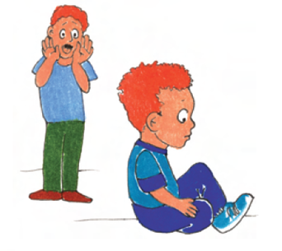
  - Always
  - Usually
  - Sometimes
  - Rarely
  - Never
- How easy is it for you to get eye contact with your child?
  - Very easy
  - Quite easy
  - Quite difficult
  - Very difficult
  - Impossible
- Does your child point to indicate that s/he wants something (e.g., a toy that is out of reach)?
  - Many times a day
  - A few times a day
  - A few times a week
  - Less than once a week
  - Never
- Does your child point to share interest with you (e.g., pointing at an interesting sight)?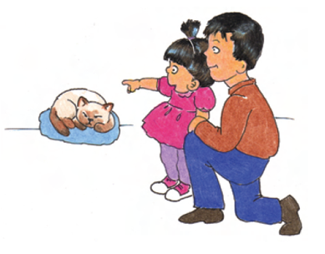
  - Many times a day
  - A few times a day
  - A few times a week
  - Less than once a week
  - Never
- Does your child pretend (e.g., care for dolls, talk on a toy phone)?
  - Many times a day
  - A few times a day
  - A few times a week
  - Less than once a week
  - Never
- Does your child follow where you're looking?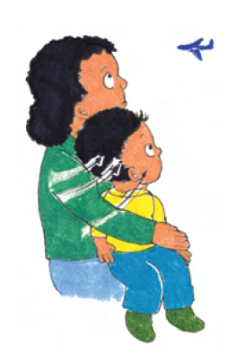
  - Many times a day
  - A few times a day
  - A few times a week
  - Less than once a week
  - Never
- If you or someone else in the family is visibly upset, does your child show signs of wanting to comfort them (e.g., stroking their hair, hugging them)?
  - Always
  - Usually
  - Sometimes
  - Rarely
  - Never
- Would you describe your child's first words as: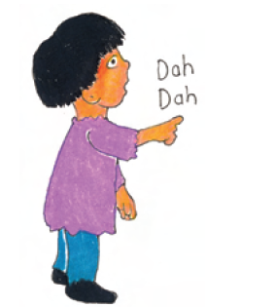
  - Very typical
  - Quite typical
  - Slightly unusual
  - Very unusual
  - My child doesn't speak
- Does your child use simple gestures (e.g., wave goodbye)?
  - Many times a day
  - A few times a day
  - A few times a week
  - Less than once a week
  - Never
Does your child stare at nothing with no apparent purpose?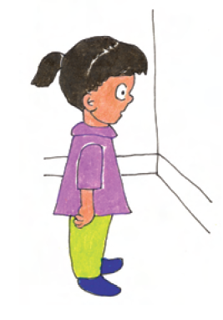
- Many times a day
- A few times a day
- A few times a week
- Less than once a week
- Never

