Supplementary information
Supplementary Table 1: Descriptive table of speech connectedness and reading performance

Descriptive table | Mean | SD | Min | Max | p-value (Shapiro-Wilk) | Sample size
Word speed (1ª session - March) | 316.92 | 361.59 | 26 | 3096 | 1.44792E-18 | 195
Word speed (3ª session - June) | 202.8 | 251.66 | 18 | 1620 | 1.09725E-17 | 161
Word speed (5ª session - October) | 199.68 | 247.27 | 18 | 1620 | 3.8179E-19 | 205
Word accuracy (1ª session - March) | 54.81 | 40.43 | 0 | 100 | 3.3077E-15 | 195
Word accuracy (3ª session - June) | 70.7 | 34.1 | 0 | 100 | 5.06678E-15 | 162
Word accuracy (5ª session - October) | 69.73 | 36.24 | 0 | 100 | 2.76326E-17 | 205
Text speed (1ª session - March) | 50.63 | 31.64 | 4.5 | 132 | 8.9333E-05 | 123
Text speed (3ª session - June) | 54.49 | 32.8 | 7.5 | 137 | 0.000203634 | 138
Text speed (5ª session - October) | 58.86 | 36.93 | 4 | 158 | 9.10806E-05 | 167
Text comprehension (1ª session - March) | 3.43 | 1.96 | 0 | 6 | 6.47999E-13 | 248
Text comprehension (3ª session - June) | 4.17 | 1.86 | 0 | 6 | 1.35871E-14 | 226
Text comprehension (5ª session - October) | 4.46 | 1.85 | 0 | 6 | 2.81799E-16 | 217
Reading percentile (1ª session - March) | 76.37 | 27.38 | 3 | 100 | 3.41151E-11 | 123
Reading percentile (3ª session - June) | 77.95 | 26.2 | 3 | 100 | 4.06944E-12 | 138
Reading percentile (5ª session - October) | 73.69 | 31.53 | 3 | 100 | 4.1256E-14 | 167
Phonological awareness (1ª session - March) | 13.3 | 4.36 | 0 | 20 | 3.32704E-07 | 249
Phonological awareness (3ª session - June) | 14.82 | 3.88 | 2 | 20 | 1.07602E-08 | 228
Phonological awareness (5ª session - October) | 15.51 | 3.62 | 4 | 20 | 4.6792E-09 | 221
LCC (1ª session - March) | 20.31 | 2.31 | 11.25 | 24.5 | 4.1186E-09 | 240
LCC (3ª session - June) | 20.81 | 2.29 | 7.85 | 25.6 | 4.40963E-12 | 217
LCC (5ª session - October) | 20.79 | 2.4 | 6 | 24.97 | 1.10116E-12 | 205
LSC (1ª session - March) | 12.2 | 3.75 | 1 | 18.86 | 6.62361E-08 | 240
LSC (3ª session - June) | 12.91 | 3.7 | 2 | 18.36 | 4.88833E-09 | 217
LSC (5ª session - October) | 13.03 | 4.01 | 1 | 18.41 | 7.29848E-12 | 205
RE (1ª session - March) | 1.68 | 1.09 | 0 | 8.41 | 4.56739E-15 | 240
RE (3ª session - June) | 1.41 | 0.9 | 0 | 6 | 1.02411E-08 | 217
RE (5ª session - October) | 1.46 | 1.03 | 0 | 6.33 | 3.1293E-11 | 205
Age (years) | 6.27 | 0.63 | 5 | 8 | 8.97357E-18 | 249
Legend: SD = standard deviation; range given from minimum (Min) and maximum (Max) values, p-values from normality test (Shapiro-Wilk test), and sample size.
Supplementary Table 2: Kruskal-Wallis test

variable | n | statistic | p | effect size | magnitude | p  session 1-3* | p  session 1-5*
LCC | 1160 | 11.45979 | 0.0219 | 0.006459 | small | 0.015 | 0.008
LSC | 1160 | 11.41734 | 0.0223 | 0.006422 | small | 0.013 | 0.001
RE | 1160 | 10.52708 | 0.0324 | 0.005651 | small | 0.005 | 0.013

Legend: Significant p-values from the Kruskal-Wallis test are indicated in bold. The effect size for the Kruskal-Wallis test was calculated as the eta squared based on the H-statistic: eta2[H] = (H - k + 1)/(n - k); small effect: 0.01- < 0.06; moderate effect: 0.06 - < 0.14; large effect: >= 0.14 (Tomczak & Tomczak, 2014).
* Pairwise comparisons Wilcoxon test with significant p-values indicated in bold. Correction for two comparisons: alpha = 0.025.

Supplementary Table 3: Pairwise comparisons Wilcoxon test

var1 | var2 | n1 | n2 | statistic | p
LCC_1 | LCC_2 | 237 | 223 | 25179.5 | 0.382
LCC_1 | LCC_3 | 237 | 216 | 22195 | 0.015
LCC_1 | LCC_4 | 237 | 206 | 23840 | 0.671
LCC_1 | LCC_5 | 237 | 205 | 20741 | 0.008
LCC_2 | LCC_3 | 223 | 216 | 21907 | 0.101
LCC_2 | LCC_4 | 223 | 206 | 23453 | 0.706
LCC_2 | LCC_5 | 223 | 205 | 20608 | 0.078
LCC_3 | LCC_4 | 216 | 206 | 24785 | 0.043
LCC_3 | LCC_5 | 216 | 205 | 21738 | 0.748
LCC_4 | LCC_5 | 206 | 205 | 18551.5 | 0.033
LSC_1 | LSC_2 | 237 | 223 | 23245.5 | 0.026
LSC_1 | LSC_3 | 237 | 216 | 22143.5 | 0.013
LSC_1 | LSC_4 | 237 | 206 | 21804 | 0.052
LSC_1 | LSC_5 | 237 | 205 | 19946 | 0.001
LSC_2 | LSC_3 | 223 | 216 | 24078 | 0.997
LSC_2 | LSC_4 | 223 | 206 | 23437.5 | 0.715
LSC_2 | LSC_5 | 223 | 205 | 21955.5 | 0.481
LSC_3 | LSC_4 | 216 | 206 | 22845 | 0.634
LSC_3 | LSC_5 | 216 | 205 | 21376 | 0.541
LSC_4 | LSC_5 | 206 | 205 | 19794 | 0.273
RE_1 | RE_2 | 237 | 223 | 29168 | 0.054
RE_1 | RE_3 | 237 | 216 | 29516.5 | 0.005
RE_1 | RE_4 | 237 | 206 | 27820.5 | 0.011
RE_1 | RE_5 | 237 | 205 | 27629.5 | 0.013
RE_2 | RE_3 | 223 | 216 | 25044.5 | 0.47
RE_2 | RE_4 | 223 | 206 | 23619 | 0.613
RE_2 | RE_5 | 223 | 205 | 23631.5 | 0.545
RE_3 | RE_4 | 216 | 206 | 21908 | 0.786
RE_3 | RE_5 | 216 | 205 | 21962 | 0.887
RE_4 | RE_5 | 206 | 205 | 21274.5 | 0.895
Legend: Pairwise comparisons Wilcoxon test with significant original p-values indicated in bold. Correction for two comparisons: alpha = 0.025.

Supplementary Table 4: Spearman correlations between graph attributes and reading performance

graph attributes  (3ª session - June) | reading performance  (5ª session - October) | Rho | p
LCC | reading percentile | 0.05234 | 0.509641
LSC | reading percentile | 0.021737 | 0.784321
RE | reading percentile | 0.011816 | 0.881738
LCC | text comprehension | 0.145696 | 0.035299
LSC | text comprehension | 0.174148 | 0.011674
RE | text comprehension | -0.05335 | 0.442977
LCC | text speed | 0.040789 | 0.607436
LSC | text speed | 0.019874 | 0.80241
RE | text speed | 0.024147 | 0.761088
LCC | word accuracy | 0.126769 | 0.076634
LSC | word accuracy | 0.206262 | 0.003726
RE | word accuracy | -0.02539 | 0.723951
LCC | phonological awareness | 0.219564 | 0.001365
LSC | phonological awareness | 0.225576 | 0.000995
RE | phonological awareness | -0.14084 | 0.041455
LCC | word speed | -0.08416 | 0.240906
LSC | word speed | -0.10592 | 0.139526
RE | word speed | 0.018581 | 0.796029
Legend: Spearman correlations with significant p-values are indicated in bold. Correction for two comparisons: alpha = 0.025.

Supplementary Figure 1: Original graph measures show no difference between the three stimulus
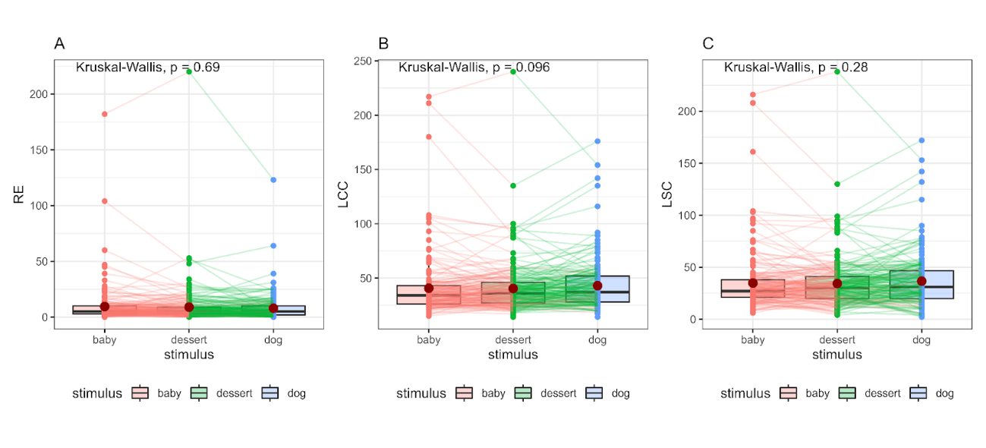
Legend: Red dots represent the average of graph attributes in each stimulus.

