Supplementary Results
Negative Study: Sex Differences in Recognition Memory Based on Order
To determine if sex of picture had an effect on recognition memory, a mixed factorial Sex of Picture (Male, Female) x Sex of Participant (Male, Female) x Emotion (Negative-Neutral, Neutral-Negative, Neutral-Neutral) ANOVA was performed on picture memory. There were no main effects. There was an Emotion x Sex of Participant interaction, F(1,30) = 3.469, p = .038. Post hoc t-tests revealed that female participants remembered faces with negative-neutral sentence order (M = 0.577, SE = 0.043) more than neutral-neutral sentence order, (M = 0.498, SE = 0.043), t(15) = 2.195, p = .004. Female participants also remembered faces with neutral-negative sentence order (M = 0.579, SE = 0.053) more than neutral-neutral sentence order, t(15) = .866, p < .05. Female participants showed no significant difference between memory for faces of negative-neutral and neutral-negative sentence order. Male participants showed no difference for facial memory between different sentence order (see Supplemental Figure 1).

Supplemental Figure 1
Sex Differences in Recognition Memory Based on Order
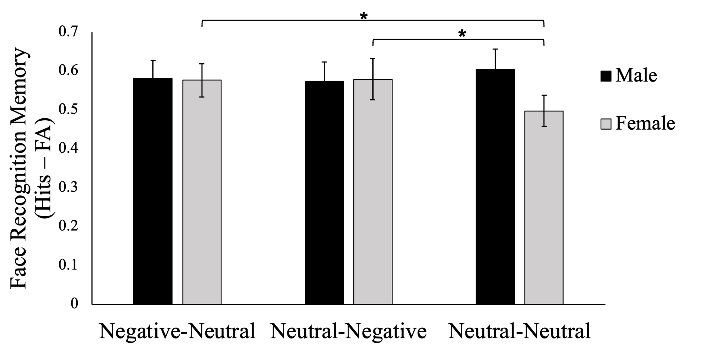
Note. Corrected recognition memory for faces paired with either Negative-Neutral, Neutral-Negative, or Neutral-Neutral sentence pairs, separated by sex. Corrected recognition memory refers to correct “old” responses (hits) subtracted by incorrect “old” responses (false alarms, abbreviated FA). Post-hoc t-tests indicated that female participants showed enhanced recognition memory for faces paired with negative information (Negative-Neutral and Neutral-Negative) as compared to only neutral information (Neutral-Neutral). This effect was not seen in males. The asterisk (*) indicates p < .05

Both Studies: Differences in Recognition Memory Based on Anxiety
A mixed measures ANCOVA was conducted on correctly recognized faces (hits) across Condition (Emotional – Neutral, Neutral – Emotional, Neutral – Neutral) x Study (Negative Experiment, Positive Experiment) with the Beck Anxiety Inventory (BAI) as a covariate. A significant interaction between BAI score and condition was found, F(2, 122) = 3.656, p = .029, η_{p}² = .057. Post-hoc correlations revealed that higher anxiety scores were correlated with higher corrected recognition memory hits for Emotional – Neutral order, r(63) = .260, p = .038. Anxiety scores were not correlated with recognition hits for Neutral – Emotional (r(63) = .048, p = .706) or Neutral - Neutral (r(63) = .050, p = .693) contextual order.

