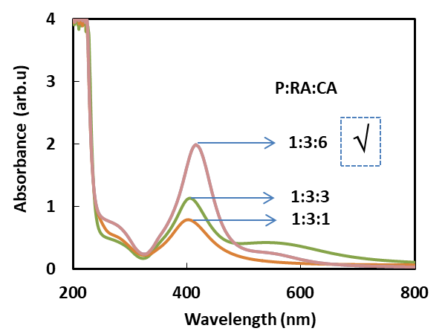
Fig. S1. UV‒vis absorption spectra of colloidal dispersions of AgNPs coated with TSC at various molar ratios collected just after the synthesis.

