Electronic Supplementary Material

Cobalt sulfide flower-like derived from metal organic frameworks on nickel foam as an electrode for fabrication of asymmetric supercapacitors
Farzaneh Nasiriª, Lida Fotouhi^{a, b*}, Saeed Shahrokhian^{c}, Mohammad Zirak^{d}

ªDepartment of Analytical Chemistry, Faculty of Chemistry, Alzahra University, Tehran, Iran
^{b}Analytical and Bioanalytical Research Centre (ABRC), Alzahra University, Tehran, Iran
^{c}Department of Chemistry, Sharif University of Technology, Tehran 11155–9516, Iran
^{d}Department of Physics, Hakim Sabzevari University, P. O. Box 961797647, Sabzevar, Iran

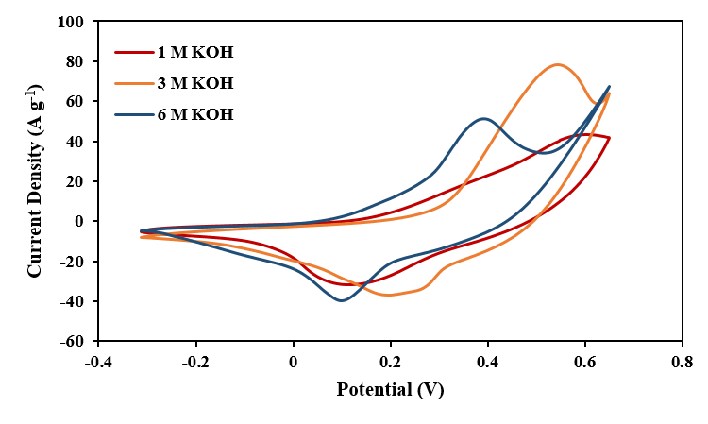
Fig. S1. The CV curves of the CoS electrode in 1M, 3M and 6M KOH electrolytes.

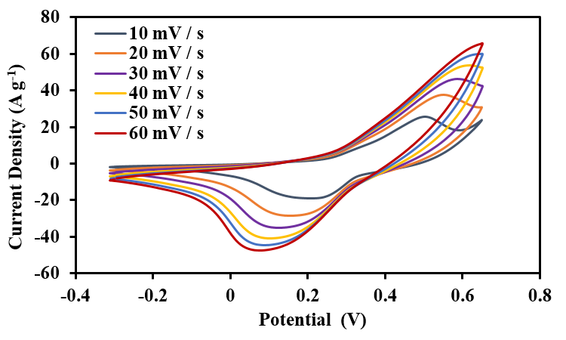
Fig. S2. The CVs of Co-MOF at the different scan rates.

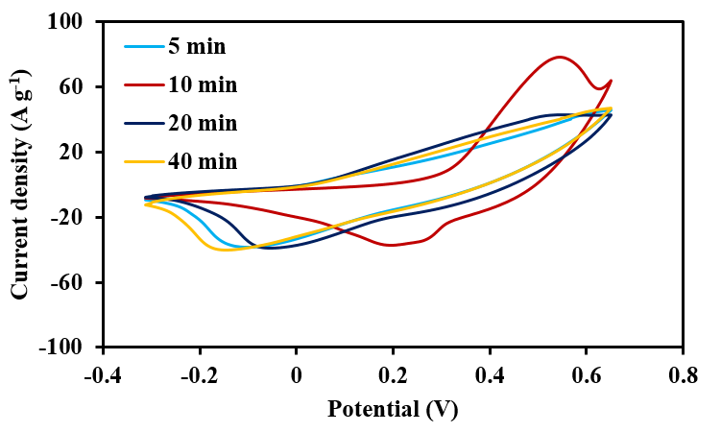
Fig. S3. The CVs of CoS electrode in various reaction time.

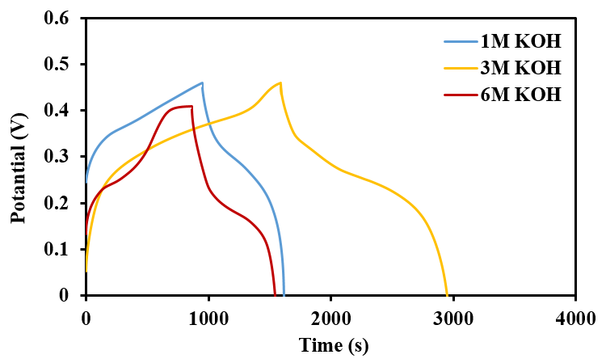
Fig. S4. The GCD curves of Co-S electrode in 1M, 3M and 6M KOH electrolytes

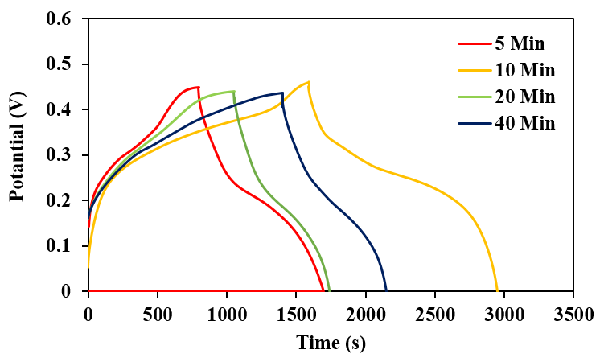
Fig. S5. The GCD curves of Co-S with various sulfidation times

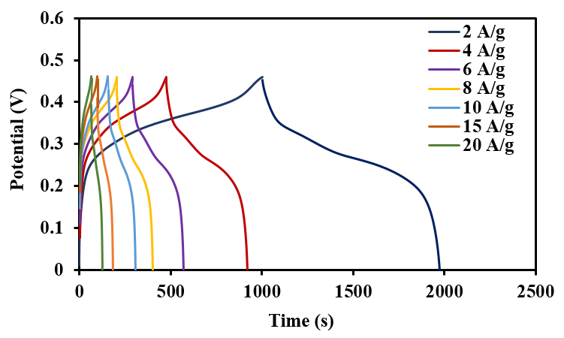
Fig. S6. The GCD curves of Co-MOF electrode at various current densities.

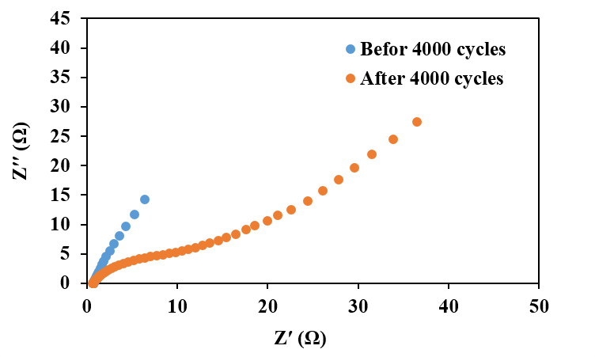
Fig. S7. The Nyquist plots of CoS before and after 4000 cycles.

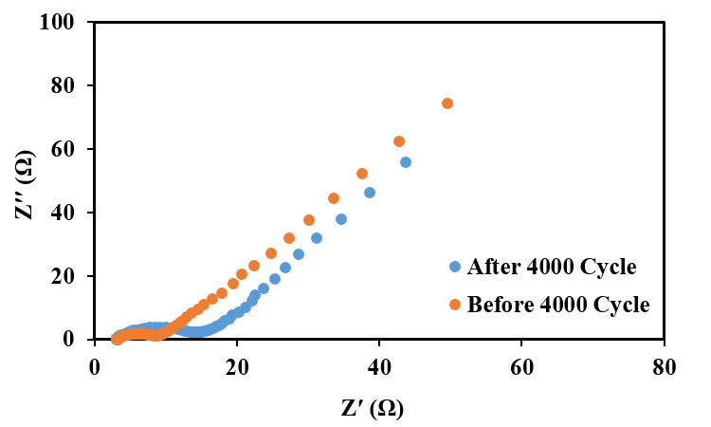
Fig. S8. The Nyquist plots of CoS//AC before and after 4000 cycles.

