Supplementary Fig. 1 Interferons and related cytokines associated with cognitive function.
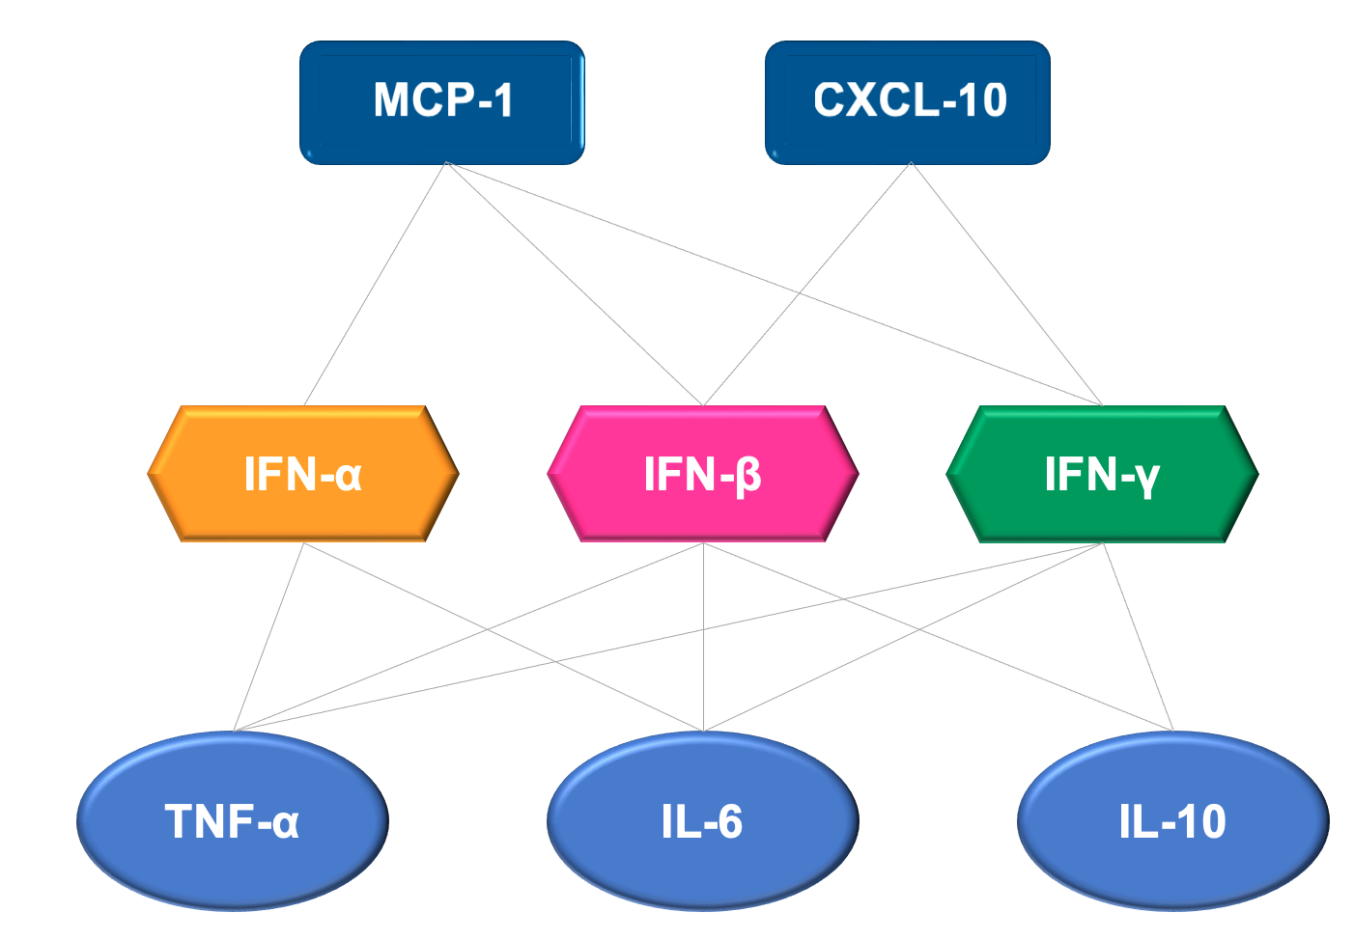
Based on the literature research, we designed an MSD assay kit containing different types of interferons, related chemokines and effector cytokines that have been reported to be associated with cognition function.

Supplementary Fig. 2 Flow diagram of subjects selected
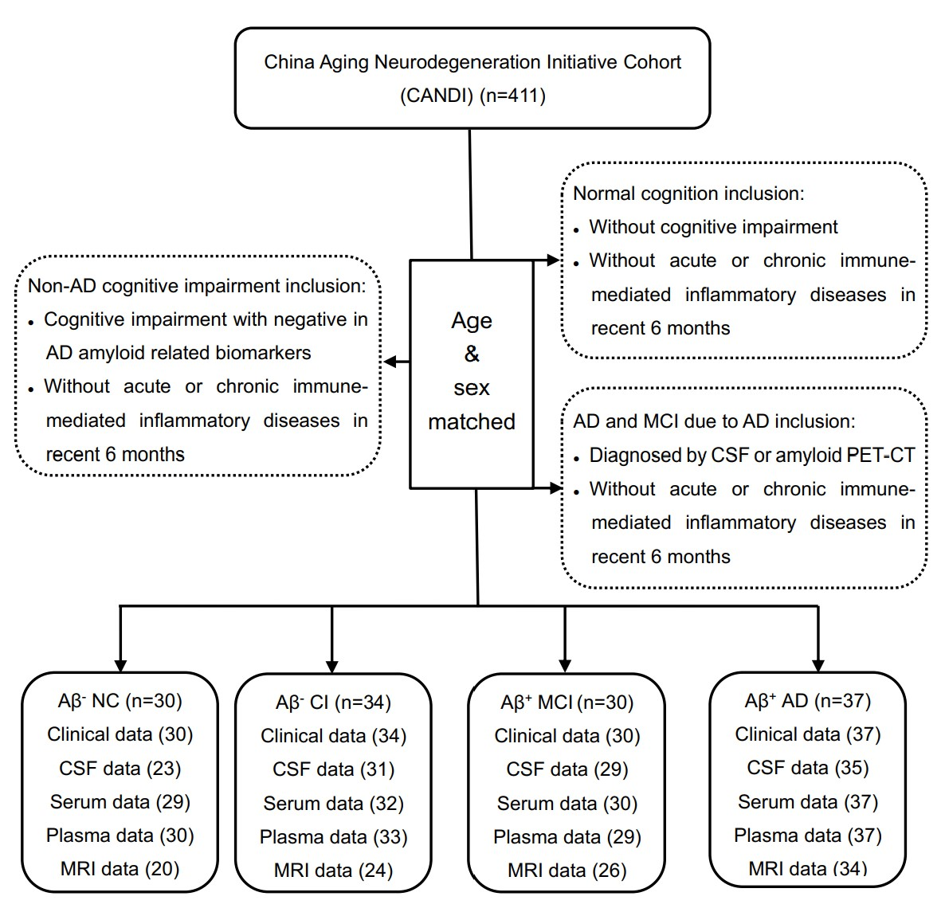
Abbreviations: AD, Alzheimer’s disease; MCI, mild cognitive impairment; CSF, cerebrospinal fluid; Aβ⁺, Aβ positive; Aβ⁻, Aβ negative; NC, normal cognitive; CI, cognitively impaired; MRI, magnetic resonance imaging.

Supplementary Fig. 3 Comparison of serum IFN-related cytokines among groups.
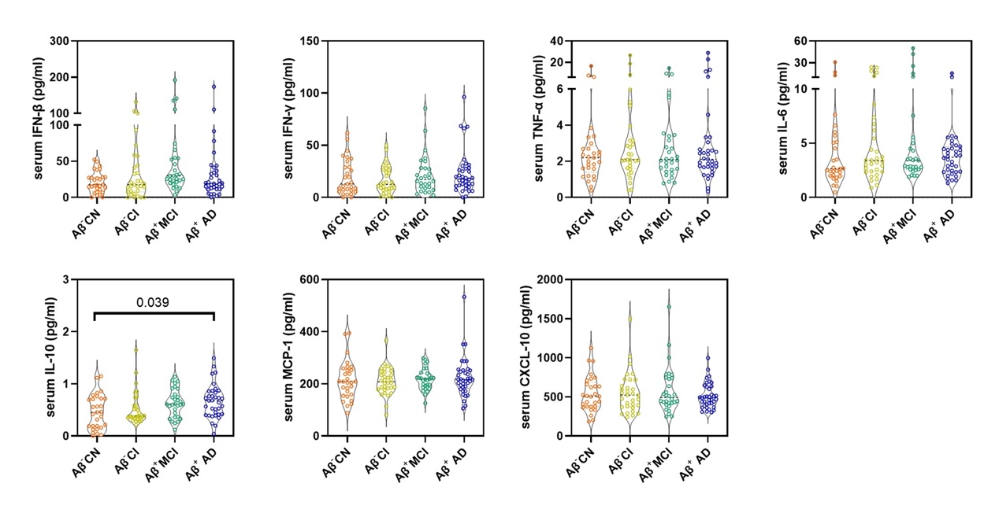
Dot and violin plots depicting the levels of each IFN-related cytokines in each group. Violin plots depict the median (horizontal bar) and interquartile range (IQR, dashed bars). p values are assessed by one-way analysis of covariance adjusted for age and sex, followed by Bonferroni corrected pairwise multiple comparisons.

Supplementary Fig. 4 Correlation analysis of IFN-related cytokines with AD core biomarkers in the blood.
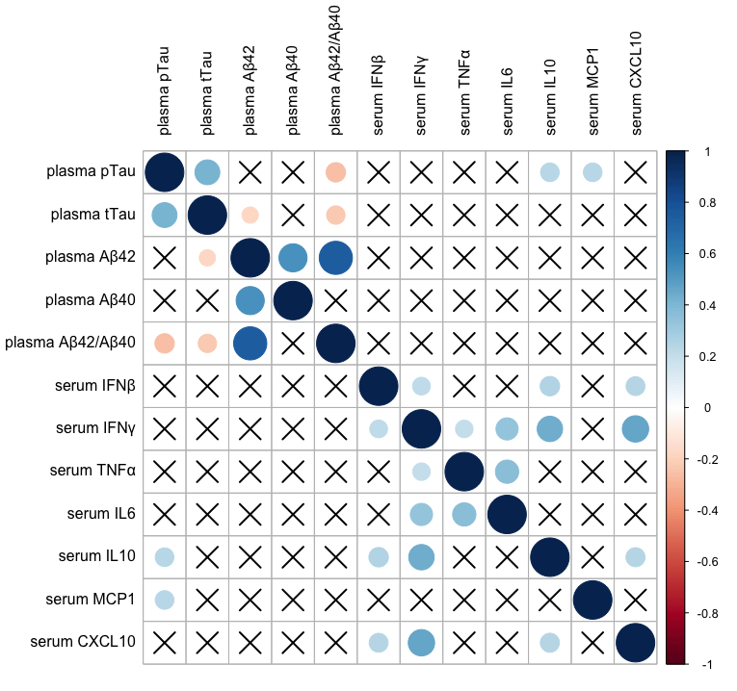
Partial correlations between serum IFN-related cytokines and plasma AD core biomarkers, corrected for age, sex, and APOE ε4 status. Red colour indicates negative correlation and blue indicates positive correlation. The colour intensity and size of the circle are proportional to the correlation coefficient (r). The crossed cells showed no significant correlations.

Supplementary Fig. 5 APOE Ɛ4 carriers mediated effects on IFN-elated cytokines.
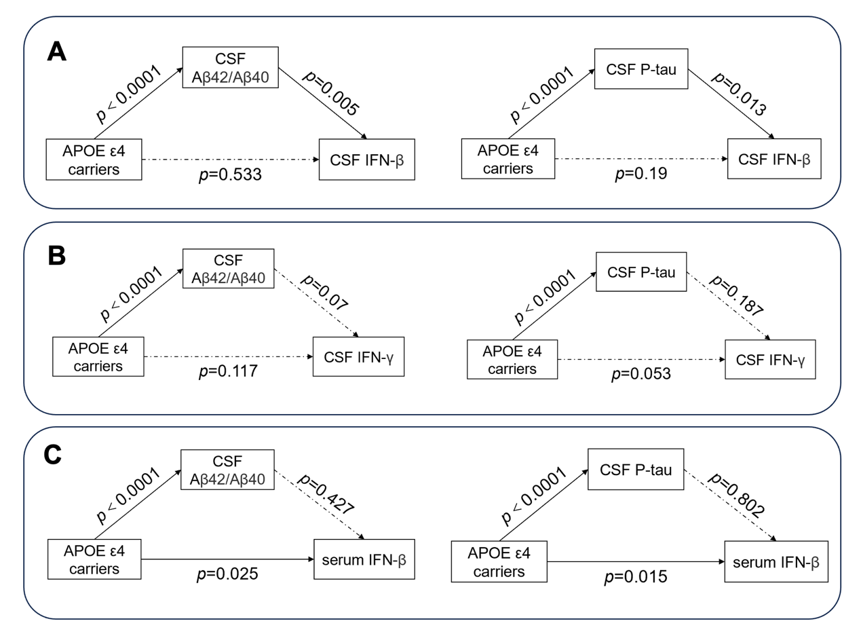
Models of mediation for CSF IFN-β (A), CSF IFN-γ (B) and serum IFN-β (C) with APOE Ɛ4 carriers. p values for effects are noted. Solid arrows indicate significant direct effect and a broken arrows indicate non-significant direct effect.

Supplementary Fig. 6 Association of serum IFN-related cytokines with cognitive performance.
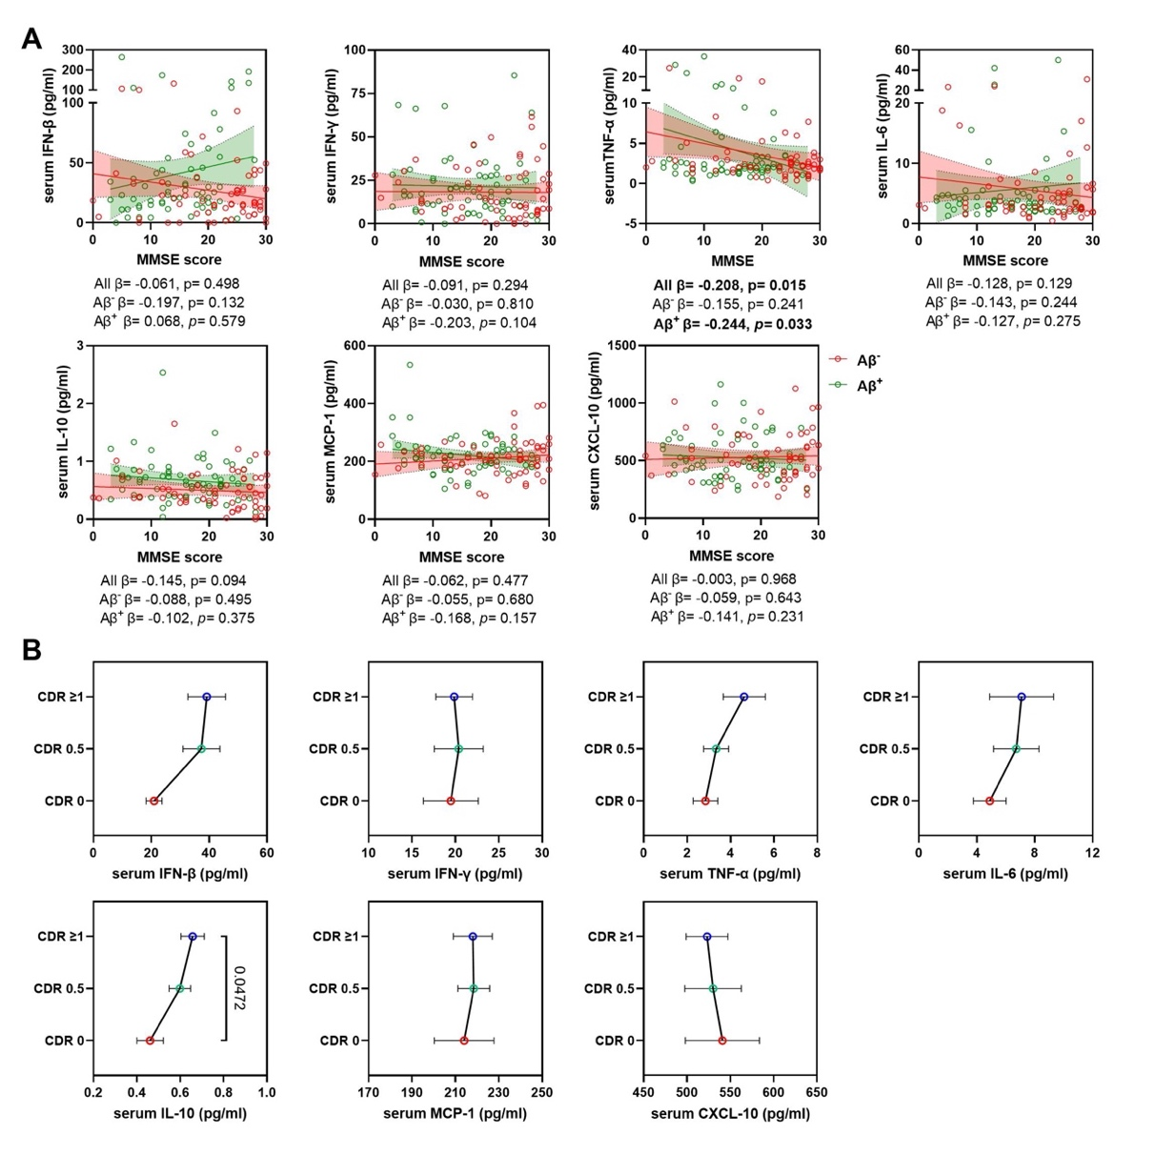
Scatter plots and line charts display the association of each IFN-related cytokines in the serum with MMSE score (A) and CDR score (B) in all individuals. (A) Each point depicts the value of the IFN-related cytokines of an individual and the solid lines indicate the regression line for each index in Aβ⁻ and Aβ⁺ groups. Red circle indicates Aβ⁻ individuals and green indicates Aβ⁺ individuals. The standardized regression coefficients (β) and p values are shown and analyzed using a linear regression model adjusted for age, sex, APOE ε4 status and the years of education. (B) The levels of each IFN-related cytokines among subjects with different CDR score. Data are mean ± SEM. p value < 0.05 means significant.

Supplementary Fig. 7 Serum TNF-α mediated effects on MMSE score.
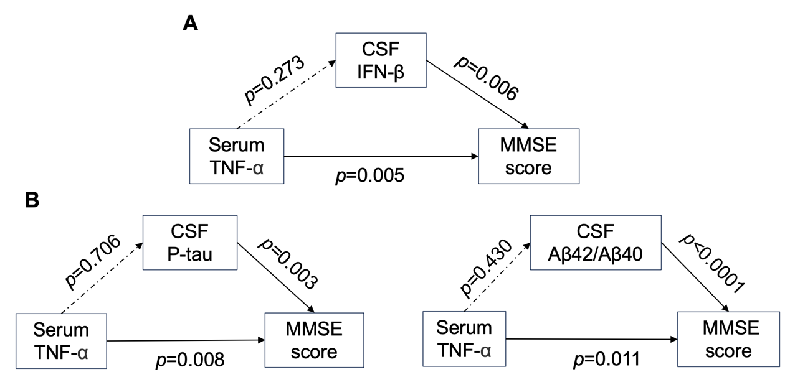
Models of mediation for MMSE score with serum TNF-α. p values for effects are noted. Solid arrows indicate significant direct effect and a broken arrows indicate non-significant direct effect.

Supplementary Fig. 8 Comparison of measures of interest in brain MRI among groups.
Dot and violin plots depicting the measures of interest in brain MRI with CSF IFN-β in each group. Violin plots depict the median (horizontal bar) and interquartile range (IQR, dashed bars). p values were assessed by one-way ANOVA followed by Tukey’s multiple comparisons.

Supplementary Fig. 9 CSF IFN-β mediated effects on measures of interest in brain MRI.
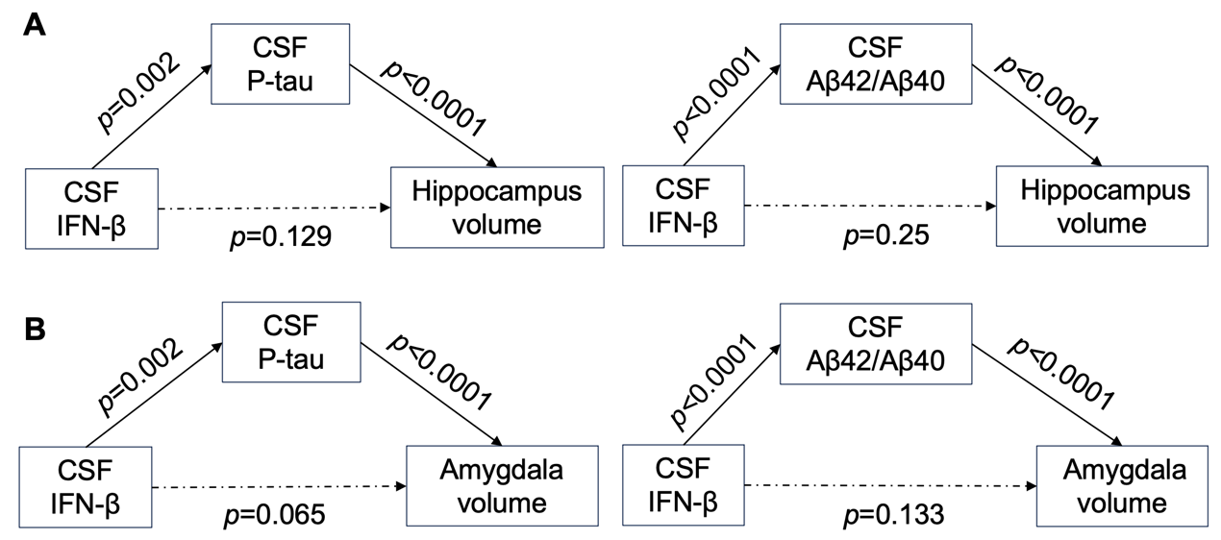

Models of mediation for hippocampus volume (A) and amygdala (B) with CSF IFN-β. p values for effects are noted. Solid arrows indicate significant direct effect and a broken arrows indicate non-significant direct effect.

Supplementary Fig. 10 Association of measures of interest in brain MRI with CSF IL-6.
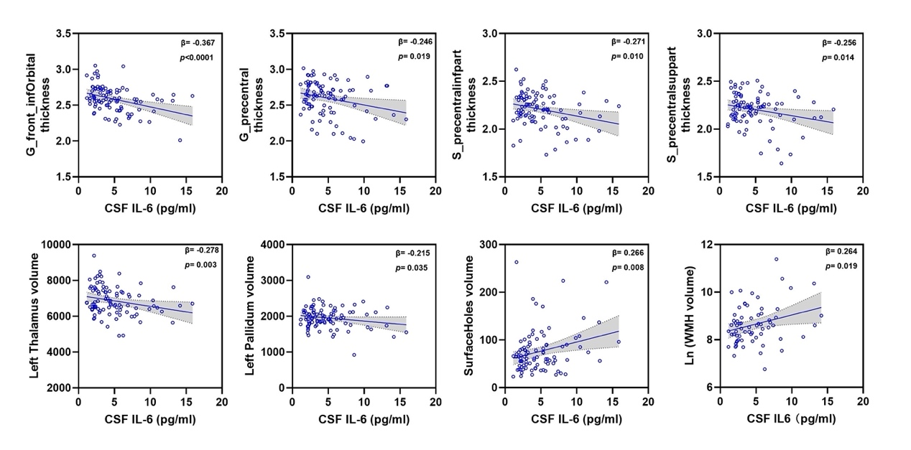
Scatter plots representing the association of each measure of interest in brain MRI with CSF IL-6 in all individuals. Each point depicts the value of the measures of an individual and the solid lines indicate the regression line for each index. The standardised regression coefficients (β) and p values are shown and analysed using a linear regression model adjusted for age and sex. p value < 0.05 means significant.

Supplementary Fig. 11 CSF IL-6 mediated effects on measures of interest in brain MRI.
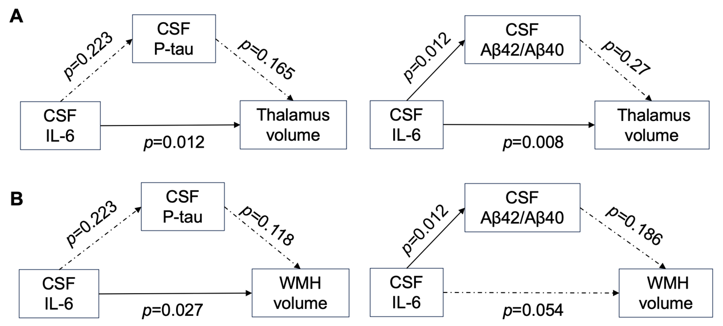
Models of mediation for thalamus volume (A) and WMH volume (B) with CSF IL-6. p values for effects are noted. Solid arrows indicate significant direct effect and a broken arrows indicate non-significant direct effect.

Supplementary Table 1 The list of the regions of brain MRI anatomical parcellations were analysed in this study.

number | name | number | name | number | name | number | name
1 | lh_G_and_S_frontomargin_thickness | 31 | lh_G_rectus_thickness | 61 | lh_S_oc-temp_med_and_Lingual_thickness | 91 | Left-Accumbens-area
2 | lh_G_and_S_occipital_inf_thickness | 32 | lh_G_subcallosal_thickness | 62 | lh_S_orbital_lateral_thickness | 92 | Left-VentralDC
3 | lh_G_and_S_paracentral_thickness | 33 | lh_G_temp_sup-G_T_transv_thickness | 63 | lh_S_orbital_med-olfact_thickness | 93 | Left-vessel
4 | lh_G_and_S_subcentral_thickness | 34 | lh_G_temp_sup-Lateral_thickness | 64 | lh_S_orbital-H_Shaped_thickness | 94 | Left-choroid-plexus
5 | lh_G_and_S_transv_frontopol_thickness | 35 | lh_G_temp_sup-Plan_polar_thickness | 65 | lh_S_parieto_occipital_thickness | 95 | 5th-Ventricle
6 | lh_G_and_S_cingul-Ant_thickness | 36 | lh_G_temp_sup-Plan_tempo_thickness | 66 | lh_S_pericallosal_thickness | 96 | Optic-Chiasm
7 | lh_G_and_S_cingul-Mid-Ant_thickness | 37 | lh_G_temporal_inf_thickness | 67 | lh_S_postcentral_thickness | 97 | CC_Posterior
8 | lh_G_and_S_cingul-Mid-Post_thickness | 38 | lh_G_temporal_middle_thickness | 68 | lh_S_precentral-inf-part_thickness | 98 | CC_Mid_Posterior
9 | lh_G_cingul-Post-dorsal_thickness | 39 | lh_Lat_Fis-ant-Horizont_thickness | 69 | lh_S_precentral-sup-part_thickness | 99 | CC_Central
10 | lh_G_cingul-Post-ventral_thickness | 40 | lh_Lat_Fis-ant-Vertical_thickness | 70 | lh_S_suborbital_thickness | 100 | CC_Mid_Anterior
11 | lh_G_cuneus_thickness | 41 | lh_Lat_Fis-post_thickness | 71 | lh_S_subparietal_thickness | 101 | CC_Anterior
12 | lh_G_front_inf-Opercular_thickness | 42 | lh_Pole_occipital_thickness | 72 | lh_S_temporal_inf_thickness | 102 | BrainSegVol
13 | lh_G_front_inf-Orbital_thickness | 43 | lh_Pole_temporal_thickness | 73 | lh_S_temporal_sup_thickness | 103 | BrainSegVolNotVent
14 | lh_G_front_inf-Triangul_thickness | 44 | lh_S_calcarine_thickness | 74 | lh_S_temporal_transverse_thickness | 104 | lhCortexVol
15 | lh_G_front_middle_thickness | 45 | lh_S_central_thickness | 75 | lh_MeanThickness_thickness | 105 | lhCerebralWhiteMatterVol
16 | lh_G_front_sup_thickness | 46 | lh_S_cingul-Marginalis_thickness | 76 | BrainSegVolNotVent | 106 | lhSurfaceHoles
17 | lh_G_Ins_lg_and_S_cent_ins_thickness | 47 | lh_S_circular_insula_ant_thickness | 77 | eTIV | 107 | SurfaceHoles
18 | lh_G_insular_short_thickness | 48 | lh_S_circular_insula_inf_thickness | 78 | Left-Inf-Lat-Vent | 108 | EstimatedTotalIntraCranialVol
19 | lh_G_occipital_middle_thickness | 49 | lh_S_circular_insula_sup_thickness | 79 | Left-Cerebellum-White-Matter | 109 | WMH
20 | lh_G_occipital_sup_thickness | 50 | lh_S_collat_transv_ant_thickness | 80 | Left-Cerebellum-Cortex
21 | lh_G_oc-temp_lat-fusifor_thickness | 51 | lh_S_collat_transv_post_thickness | 81 | Left-Thalamus
22 | lh_G_oc-temp_med-Lingual_thickness | 52 | lh_S_front_inf_thickness | 82 | Left-Caudate
23 | lh_G_oc-temp_med-Parahip_thickness | 53 | lh_S_front_middle_thickness | 83 | Left-Putamen
24 | lh_G_orbital_thickness | 54 | lh_S_front_sup_thickness | 84 | Left-Pallidum
25 | lh_G_pariet_inf-Angular_thickness | 55 | lh_S_interm_prim-Jensen_thickness | 85 | 3rd-Ventricle
26 | lh_G_pariet_inf-Supramar_thickness | 56 | lh_S_intrapariet_and_P_trans_thickness | 86 | 4th-Ventricle
27 | lh_G_parietal_sup_thickness | 57 | lh_S_oc_middle_and_Lunatus_thickness | 87 | Brain-Stem
28 | lh_G_postcentral_thickness | 58 | lh_S_oc_sup_and_transversal_thickness | 88 | Left-Hippocampus
29 | lh_G_precentral_thickness | 59 | lh_S_occipital_ant_thickness | 89 | Left-Amygdala
30 | lh_G_precuneus_thickness | 60 | lh_S_oc-temp_lat_thickness | 90 | CSF

Supplementary Table 2 Post-mortem human brain cases demographic information.

Case | Number | Case | Number
Non-AD | BB041 | AD | BB017
Non-AD | BB050 | AD | BB019
Non-AD | PTB293 | AD | BB020
Non-AD | PTB304 | AD | BB029
Non-AD | PTB306 | AD | BB034
Non-AD | PTB332 | AD | BB035
Non-AD | PTB346 | AD | BB036
Non-AD | PTB384 | AD | BB039
Non-AD | PTB397 | AD | BB042
Non-AD | PTB401 | AD | BB043
AD | BB010 | AD | BB046
AD | BB016 | AD | BB048

Supplementary Table 3 Effect of APOE Ɛ4 carriers on IFN-related cytokines.
Cytokines | APOE ε4, M (SD)
Cytokines | Non-carriers | carriers | p values
CSF IFN-β | 29.7 (2.576) | 42.0 (5.251) | 0.037*
CSF IFN-γ | 5.7 (0.584) | 8.2 (0.926) | 0.014*
CSF TNF-α | 0.6 (0.056) | 0.7 (0.068) | 0.399
CSF IL-6 | 5.2 (0.378) | 5.4 (0.595) | 0.763
CSF IL-10 | 0.3 (0.019) | 0.3 (0.033) | 0.564
CSF MCP-1 | 332 (11.028) | 357 (15.856) | 0.227
CSF CXCL-10 | 675 (32.373) | 675 (36.220) | 0.934
Serum IFN-β | 27.9 (3.089) | 47.0 (8.671) | 0.023*
Serum IFN-γ | 19.9 (1.736) | 19.9 (2.863) | 0.981
Serum TNF-α | 3.9 (0.586) | 3.5 (0.879) | 0.565
Serum IL-6 | 6.7 (1.555) | 6.1 (1.482) | 0.697
Serum IL-10 | 0.5 (0.035) | 0.7 (0.065) | 0.058
Serum MCP-1 | 219 (7.460) | 214 (7.749) | 0.695
Serum CXCL-10 | 529 (22.095) | 530 (30.337) | 0.877

Each IFN-related cytokines in CSF and serum are assessed by a multiple linear regression model with age, sex and APOE ε4 as main effects. Mean (M) and standard deviation (SD) for APOE ε4. p values are derived from multiple comparisons using Bonferroni adjustment. *Significant values. Abbreviations: IFN, interferon; TNF-α, tumor neurosis factor α; IL-6, interleukin 6; IL-10, interleukin10; MCP-1, monocyte chemoattractant protein-1; CXCL-10, C-X-C Motif Chemokine Ligand 10.

Supplementary Table 4 Summary of significant correlation measures of brain MRI with CSF IFN-β.
ROI in brain MRI | Full name of ROI in brain MRI | r | p values
lh_G_cingulPostdorsal_thickness | Posterior-dorsal part of the cingulate gyrus | -0.258 | 0.0136*
lh_G_pariet_infAngular_thickness | Supramarginal gyrus | -0.208 | 0.0482*
lh_G_parietal_sup_thickness | Superior parietal lobule | -0.207 | 0.0493*
lh_G_precuneus_thickness | Precuneus | -0.207 | 0.0485*
lh_S_cingulMarginalis_thickness | Marginal branch (or part) of the cingulate sulcus | -0.211 | 0.0450*
lh_S_collat_transv_ant_thickness | Anterior transverse collateral sulcus | -0.232 | 0.0270*
lh_S_intrapariet_and_P_trans_  thickness | Intraparietal sulcus (interparietal sulcus) and transverse parietal sulci | -0.221 | 0.0349*
lh_S_subparietal_thickness | Subparietal sulcus | -0.261 | 0.0125*
LeftHippocampus volume | Left hippocampus | -0.220 | 0.0367*
LeftAmygdala volume | Left Amygdala | -0.252 | 0.0159*
OpticChiasm volume | Optic Chias | -0.220 | 0.0358*
CC_Mid_Anterior volume | corpus callosum mid-anterior | -0.230 | 0.0288*
CC_Anterior volume | corpus callosum anterior | -0.329 | 0.0014*

Correlation between CSF IFN-β and brain MRI measures are assessed using partial correlations adjusted for age and sex. The significant correlation measures and related correlation coefficients (r) are shown in the table. *Significant values. p value < 0.05 means significant. Abbreviations: ROI, region of interest; lh, left hemisphere; G, gyrus; S, sulci; CC, corpus callosum.

Supplementary Table 5 Summary of significant correlation measures of brain MRI with CSF IL-6.

ROI in brain MRI | Full name of ROI in brain MRI | r | p values
lh_G_front_infOrbital_thickness | Inferior frontal gyrus in the orbital region | -0.371 | 0.000*
LeftThalamus | Thalamus | -0.306 | 0.004*
LeftPallidum | Pallidum | -0.222 | 0.037*
lh_S_precentralinfpart_thickness | Precentral sulcus in the inferior part | -0.279 | 0.008*
lh_S_precentralsuppart_thickness | Precentral sulcus in the superior part | -0.260 | 0.014*
lh_G_precentral_thickness | Precentral gyrus | -0.254 | 0.016*
SurfaceHoles | Total number of detect holes in surfaces prior to fixing | 0.285 | 0.007*
WMH volume | Volume of white matter hyperintensity | 0.287 | 0.019*

Correlation between CSF IL-6 and brain MRI measures are assessed using partial correlations adjusted for age and sex. The significant correlation measures and related correlation coefficients (r) are shown in the table. *Significant values. p value < 0.05 means significant. Abbreviations: ROI, region of interest; lh, left hemisphere; G, gyrus; S, sulci; WMH, white matter hyperintensity.

