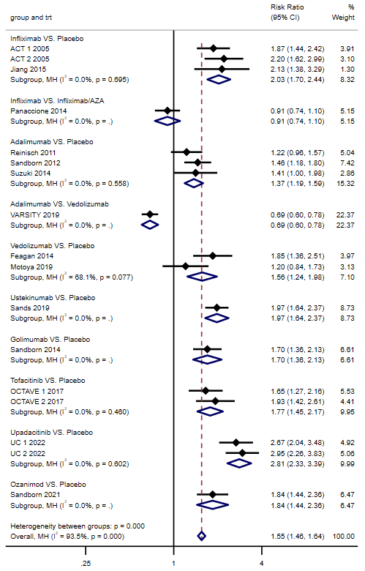
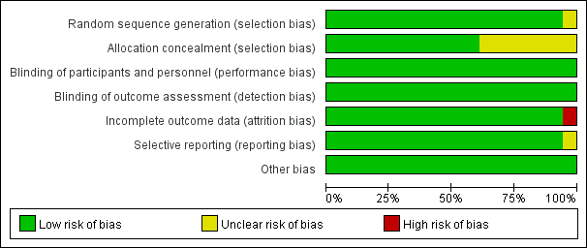
Figure 2. Quality assessment diagram
Figure 3A. Forest plot of direct meta-analysis of clinical response rate in induction phase
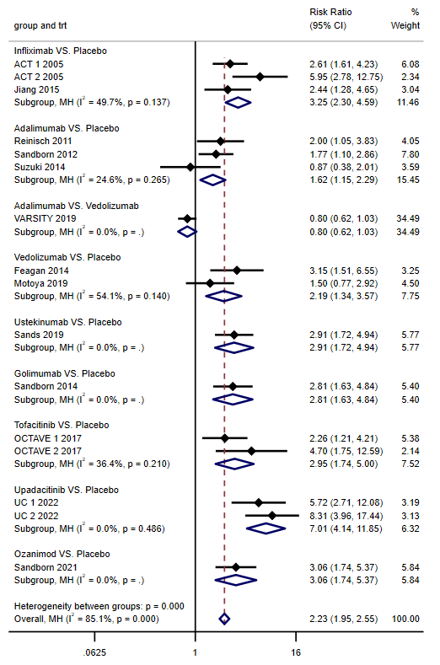
Figure 3B. Forest plot of direct meta-analysis of clinical remission rate in induction phase

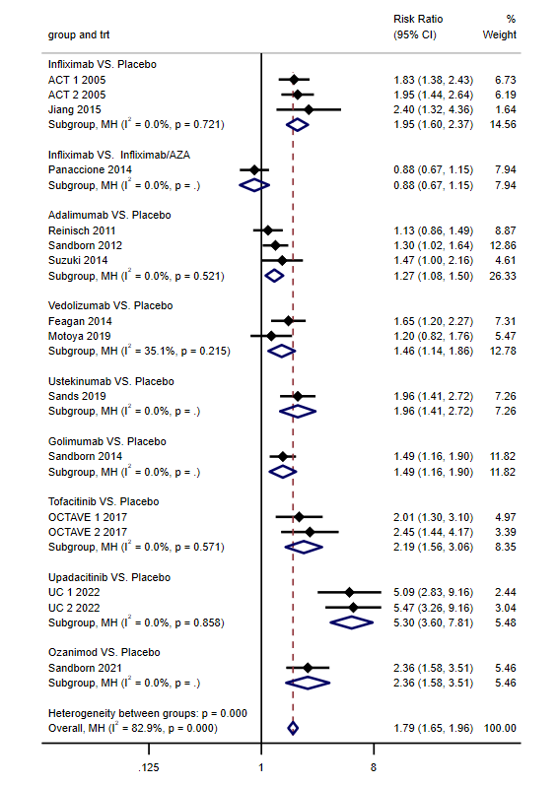

Figure 3C. Forest plot of direct meta-analysis of endoscopic improvement rate in induction phase

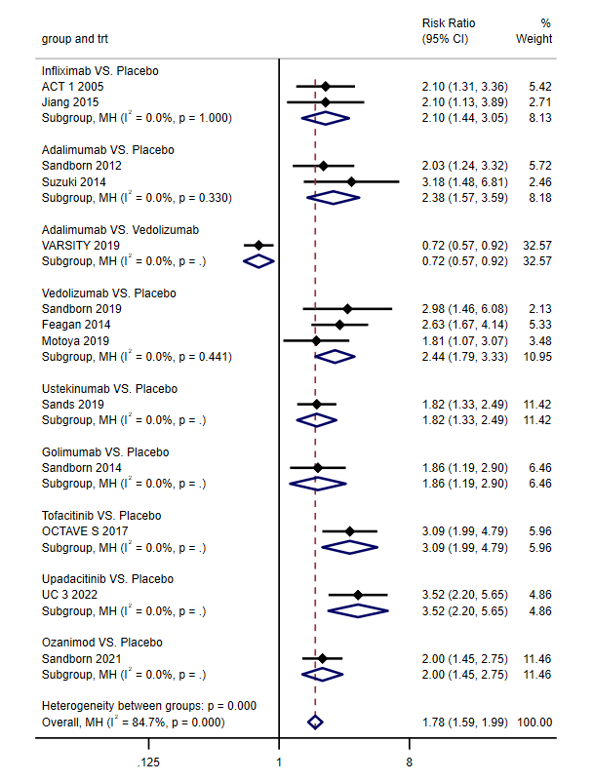
Figure 3D. Forest plot of direct meta-analysis of clinical remission rate in maintenance phase

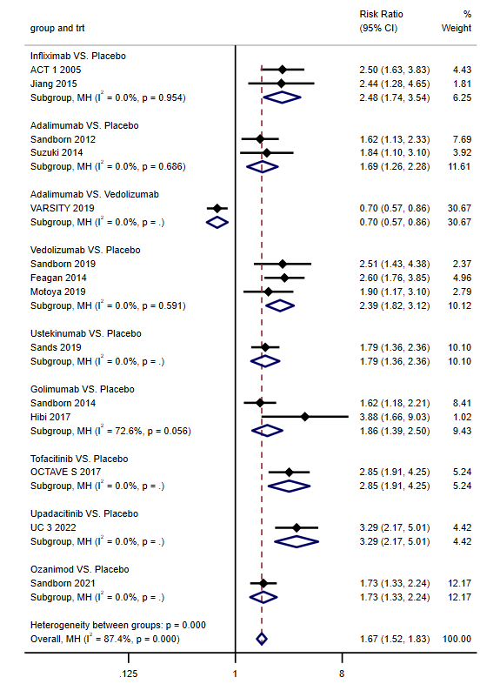
Figure 3E. Forest plot of direct meta-analysis of endoscopic improvemen rate in maintenance phase

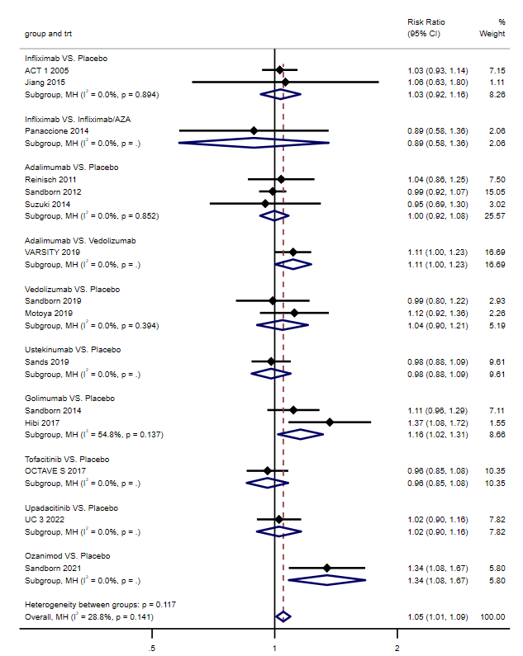
Figure 3F. Forest plot of direct meta-analysis of AE rate

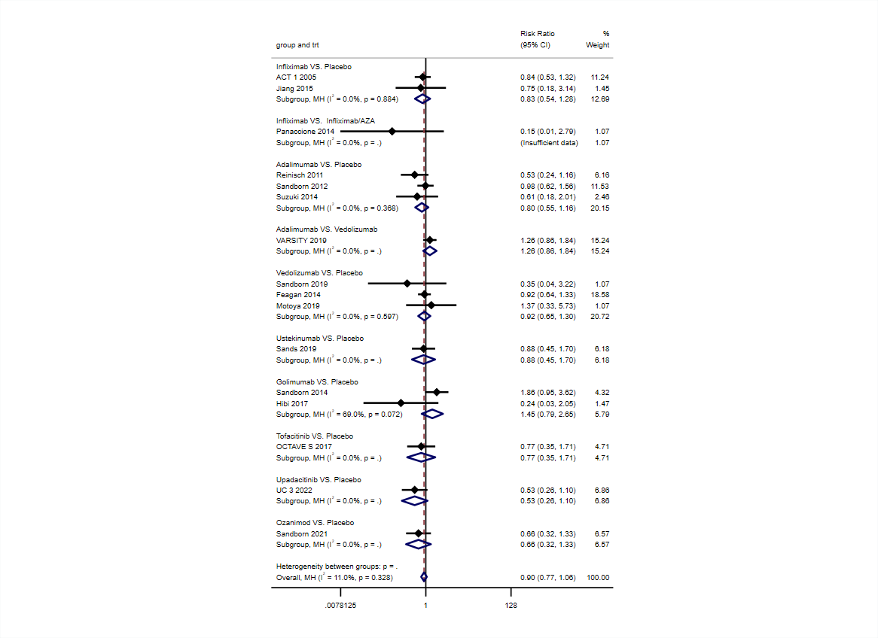
Figure 3G. Forest plot of direct meta-analysis of SAE rate
Table 3B. Network meta-analysis of clinical remission rate during induction
Infliximab
2.70  (1.54,4.71) | Adalimumab
2.01  (1.12,3.60) | 0.74 (0.55,1.00) | Vedolizumab
1.44  (0.70,2.98) | 0.53 (0.27,1.04) | 0.72 (0.36,1.43) | Ustekinumab
1.47  (0.70,3.10) | 0.55 (0.27,1.09) | 0.73 (0.36,1.49) | 1.02 (0.45,2.34) | Golimumab
1.46  (0.71,3.02) | 0.54 (0.28,1.05) | 0.73 (0.37,1.45) | 1.02 (0.45,2.28) | 0.99 (0.43,2.28) | Tofacitinib
0.50  (0.24,1.02) | 0.18 (0.10,0.36) | 0.25 (0.13,0.49) | 0.35 (0.16,0.77) | 0.34 (0.15,0.77) | 0.34 (0.15,0.76) | Upadacitinib
1.33  (0.63,2.84) | 0.49 (0.25,1.00) | 0.66 (0.32,1.36) | 0.93 (0.40,2.14) | 0.91 (0.39,2.13) | 0.91 (0.39,2.11) | 2.68 (1.17,6.14) | Ozanimod
4.70  (3.02,7.34) | 1.74 (1.24,2.45) | 2.34 (1.61,3.42) | 3.27 (1.84,5.80) | 3.20 (1.75,5.82) | 3.21 (1.81,5.69) | 9.43 (5.38,16.54) | 3.52 (1.91,6.50) | Placebo
Table 3C. Network meta-analysis of endoscopic improvement rate during induction
Infliximab
0.74 (0.39,1.39) | Infliximab/  AZA
2.31 (1.49,3.57) | 3.13 (1.45,6.74) | Adalimumab
1.96 (1.19,3.22) | 2.66 (1.19,5.94) | 0.85 (0.55,1.32) | Vedolizumab
1.48 (0.87,2.51) | 2.00 (0.88,4.57) | 0.64 (0.40,1.04) | 0.75 (0.44,1.29) | Ustekinumab
1.87 (1.13,3.10) | 2.53 (1.13,5.69) | 0.81 (0.51,1.27) | 0.95 (0.57,1.59) | 1.26 (0.73,2.18) | Golimumab
1.27 (0.75,2.16) | 1.72 (0.75,3.93) | 0.55 (0.34,0.89) | 0.65 (0.38,1.11) | 0.86 (0.49,1.52) | 0.68 (0.40,1.17) | Tofacitinib
0.41 (0.24,0.72) | 0.56 (0.24,1.30) | 0.18 (0.11,0.30) | 0.21 (0.12,0.37) | 0.28 (0.15,0.51) | 0.22 (0.13,0.39) | 0.33 (0.18,0.59) | Upadacitinib
1.19 (0.67,2.14) | 1.62 (0.68,3.82) | 0.52 (0.30,0.89) | 0.61 (0.34,1.10) | 0.81 (0.44,1.50) | 0.64 (0.35,1.16) | 0.94 (0.51,1.74) | 2.88 (1.52,5.46) | Ozanimod
3.42 (2.42,4.83) | 4.63 (2.25,9.53) | 1.48 (1.14,1.93) | 1.74 (1.22,2.49) | 2.31 (1.55,3.46) | 1.83 (1.27,2.64) | 2.69 (1.80,4.01) | 8.25 (5.33,12.77) | 2.87  (1.79,4.57) | Placebo
Table 3D. Network meta-analysis of clinical remission rate during maintenance
Infliximab
1.13  (0.61,2.10) | Adalimumab
0.74  (0.40,1.37) | 0.66  (0.49,0.88) | Vedolizumab
1.15  (0.58,2.29) | 1.02  (0.57,1.82) | 1.56  (0.88,2.76) | Ustekinumab
1.29  (0.61,2.75) | 1.15  (0.59,2.22) | 1.74  (0.90,3.36) | 1.12  (0.54,2.30) |  | Golimumab
0.68  (0.32,1.42) | 0.60  (0.32,1.14) | 0.92  (0.49,1.73) | 0.59  (0.29,1.19) |  | 0.53  (0.24,1.14) |  | Tofacitinib
0.53  (0.24,1.15) | 0.47  (0.23,0.93) | 0.71  (0.36,1.41) | 0.46  (0.22,0.96) |  | 0.41  (0.18,0.92) |  | 0.78  (0.35,1.72) |  | Upadacitinib
1.10  (0.56,2.14) | 0.98  (0.56,1.70) | 1.49  (0.86,2.58) | 0.95  (0.51,1.79) |  | 0.85  (0.42,1.72) |  | 1.62  (0.82,3.21) |  | 2.09  (1.01,4.33) |  | Ozanimod
2.84  (1.71,4.74) | 2.52  (1.77,3.59) | 3.84  (2.71,5.42) | 2.46  (1.56,3.89) |  | 2.20  (1.26,3.84) |  | 4.18  (2.46,7.12) |  | 5.39  (2.99,9.74) |  | 2.58  (1.68,3.96) |  | Placebo
Table 3E. Network meta-analysis of endoscopic improvement during maintenance
Infliximab
1.84  (1.03,3.30) | Adalimumab
1.03  (0.57,1.86) | 0.56  (0.43,0.73) | Vedolizumab
1.47  (0.75,2.86) | 0.80  (0.47,1.36) | 1.43  (0.83,2.45) |  | Ustekinumab
1.51  (0.78,2.95) | 0.82  (0.48,1.40) | 1.47  (0.86,2.53) |  | 1.03  (0.55,1.92) |  | Golimumab
0.97  (0.48,1.98) | 0.53  (0.29,0.95) | 0.95  (0.52,1.71) |  | 0.66  (0.34,1.29) |  | 0.64  (0.33,1.26) |  | Tofacitinib
0.70  (0.33,1.48) | 0.38  (0.20,0.72) | 0.68  (0.36,1.29) |  | 0.48  (0.24,0.97) |  | 0.46  (0.23,0.94) |  | 0.72  (0.34,1.53) |  | Upadacitinib
1.64  (0.87,3.10) | 0.89  (0.54,1.46) | 1.60  (0.97,2.64) |  | 1.12  (0.62,2.02) |  | 1.09  (0.60,1.96) |  | 1.69  (0.89,3.20) |  | 2.34  (1.18,4.62) |  | Ozanimod
3.85  (2.33,6.34) | 2.09  (1.55,2.81) | 3.73  (2.73,5.10) |  | 2.62  (1.68,4.07) |  | 2.54  (1.63,3.95) |  | 3.95  (2.39,6.53) |  | 5.47  (3.14,9.53) |  | 2.34  (1.58,3.46) |  | Placebo

Table 3F. Network meta-analysis of AE rate
Infliximab
0.83 (0.43,1.60) | Infliximab/  AZA
1.13 (0.61,2.09) | 1.35 (0.55,3.32) |  | Adalimumab
1.42 (0.73,2.76) | 1.71 (0.67,4.33) |  | 1.26 (0.96,1.67) |  | Vedolizumab
1.30 (0.61,2.77) | 1.55 (0.57,4.23) |  | 1.15 (0.65,2.02) |  | 0.91 (0.49,1.68) |  | Ustekinumab
0.75 (0.36,1.56) | 0.90 (0.33,2.40) |  | 0.66 (0.39,1.13) |  | 0.52 (0.29,0.94) |  | 0.58 (0.29,1.15) |  | Golimumab
1.38 (0.67,2.84) | 1.66 (0.63,4.39) |  | 1.22 (0.73,2.04) |  | 0.97 (0.55,1.71) |  | 1.07 (0.54,2.10) |  | 1.85 (0.96,3.55) | Tofacitinib
1.06 (0.49,2.32) | 1.28 (0.46,3.53) |  | 0.94 (0.52,1.71) |  | 0.75 (0.39,1.42) |  | 0.82 (0.39,1.72) |  | 1.42 (0.69,2.92) | 0.77 (0.38,1.55) |  | Upadacitinib
0.70 (0.36,1.39) | 0.85 (0.33,2.17) |  | 0.63 (0.40,0.98) |  | 0.49 (0.30,0.82) |  | 0.54 (0.29,1.02) |  | 0.94 (0.52,1.73) | 0.51 (0.28,0.91) |  | 0.66 (0.34,1.28) |  |  | Ozanimod
1.18 (0.67,2.08) | 1.42 (0.60,3.36) |  | 1.05 (0.82,1.34) |  | 0.83 (0.59,1.17) |  | 0.91 (0.55,1.51) |  | 1.58 (0.98,2.54) | 0.86 (0.55,1.34) |  | 1.11 (0.65,1.90) |  |  | 1.68 (1.15,2.44) |  | Placebo
Table 3G. Network meta-analysis of SAE rate
Infliximab
0.14 (0.01,2.78) |  | Infliximab/  AZA
0.87 (0.45,1.68) |  | 6.20 (0.29,130.88) |  | Adalimumab
0.98 (0.51,1.87) |  | 6.95 (0.33,146.67) |  | 1.12 (0.79,1.59) |  | Vedolizumab
0.91 (0.36,2.27) |  | 6.44 (0.28,145.42) |  | 1.04 (0.46,2.32) |  | 0.93 (0.42,2.06) |  | Ustekinumab
0.49 (0.20,1.20) |  | 3.46 (0.15,77.82) |  | 0.56 (0.26,1.22) |  | 0.50 (0.23,1.09) |  | 0.54 (0.20,1.48) | Golimumab
1.04 (0.38,2.87) |  | 7.36 (0.32,171.48) |  | 1.19 (0.48,2.97) |  | 1.06 (0.43,2.64) |  | 1.14 (0.37,3.50) | 2.13 (0.71,6.41) |  | Tofacitinib
1.59 (0.60,4.21) |  | 11.24 (0.49,258.61) |  | 1.81 (0.76,4.34) |  | 1.62 (0.68,3.86) |  | 1.75 (0.59,5.16) | 3.25 (1.12,9.44) |  | 1.53 (0.47,4.91) |  | Upadacitinib
1.23 (0.48,3.14) |  | 8.72 (0.38,198.25) |  | 1.41 (0.61,3.22) |  | 1.25 (0.55,2.86) |  | 1.35 (0.47,3.87) | 2.52 (0.90,7.07) |  | 1.18 (0.38,3.69) |  | 0.78 (0.26,2.33) | Ozanimod
0.79 (0.45,1.37) |  | 5.57 (0.27,115.51) |  | 0.90 (0.64,1.27) |  | 0.80 (0.57,1.12) |  | 0.87 (0.42,1.79) | 1.61 (0.80,3.26) |  | 0.76 (0.32,1.77) |  | 0.50 (0.22,1.11) | 0.64 (0.30,1.36) |  | Placebo
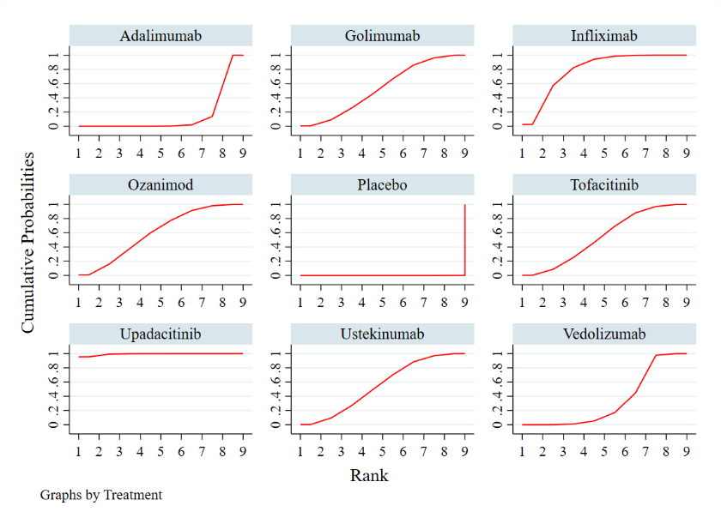
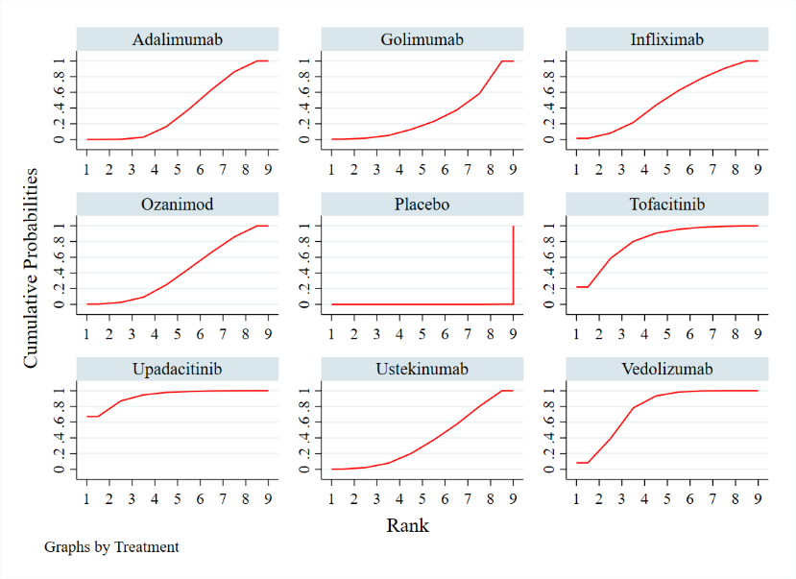
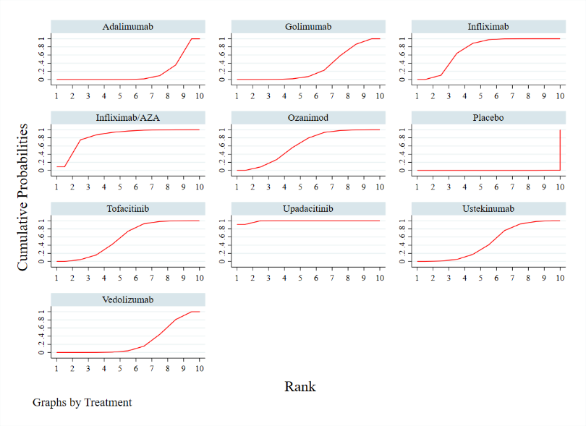
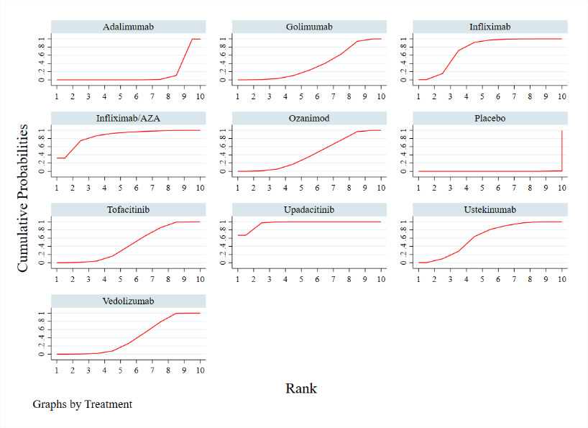
Figure 4A Figure 4B
Figure 4C Figure 4D
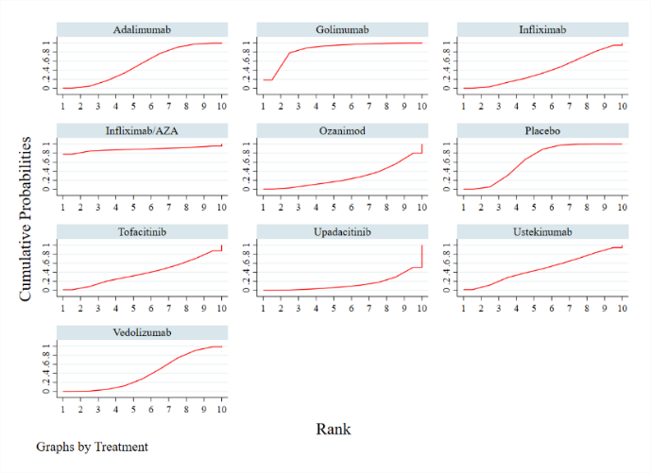
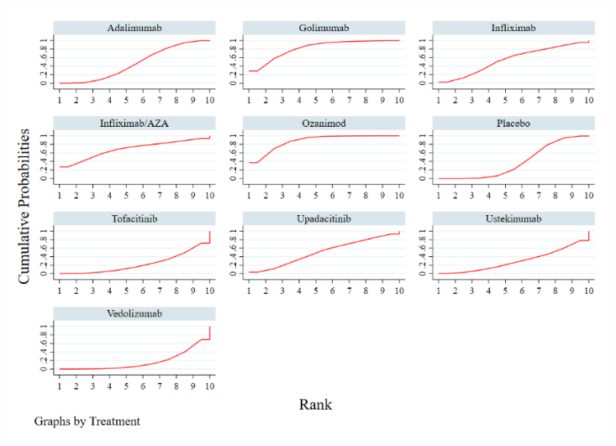
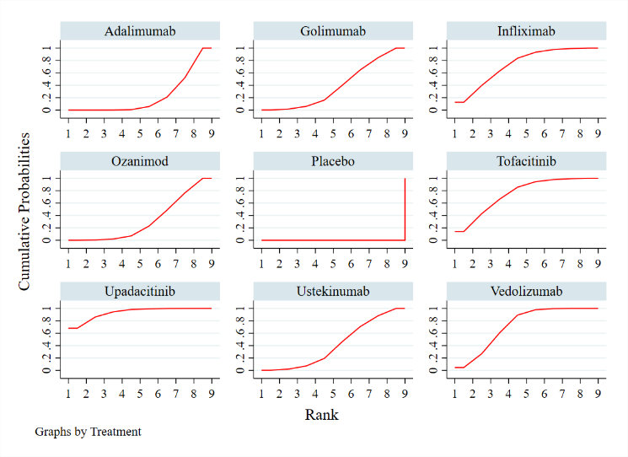
Figure 4E Figure 4F Figure 4G
Figure 4A-4G. (4A):The SUCRA probability ranking of clinical response rate during induction.(4B):The SUCRA probability ranking of clinical remission rate during induction. (4C):The SUCRA probability ranking of endoscopic improvement rate during induction. (4D):The SUCRA probability ranking of clinical remission rate during maintenance. (4E):The SUCRA probability ranking of endoscopic improvement rate during maintenance. (4F):The SUCRA probability ranking of AE rate. (4G):The SUCRA probability ranking of SAE rate.

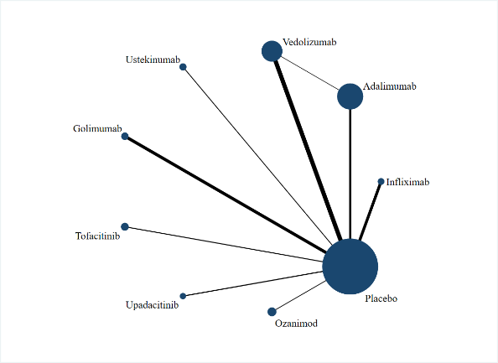
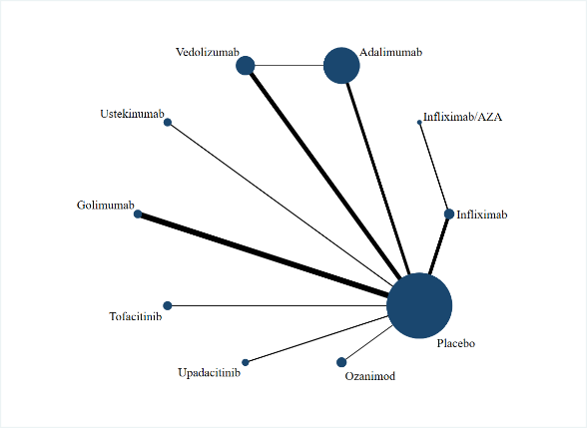
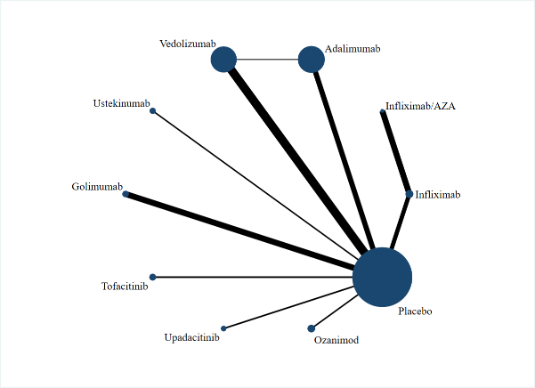
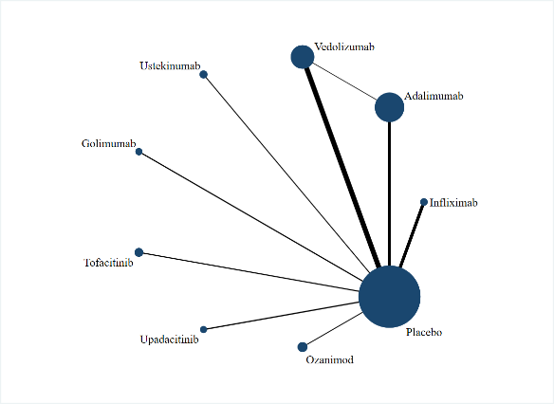
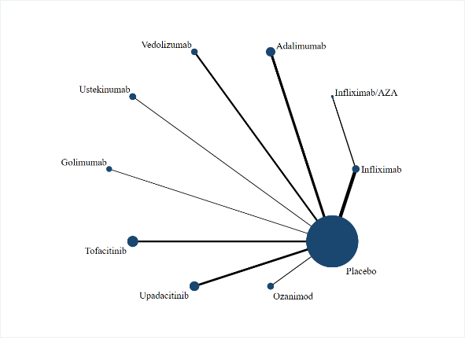
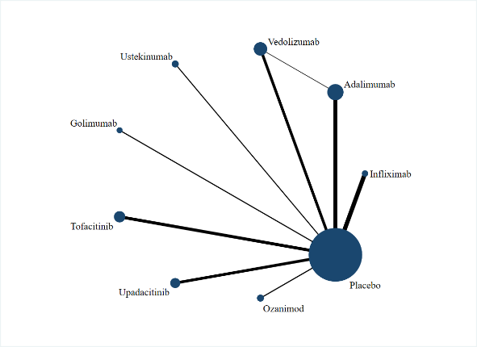
Figure 5B Figure 5C Figure 5D
Figure 5E Figure 5F Figure 5G
Figure 5B-5G. (5B): Network diagram of clinical remission during induction. (5C): Network diagram of endoscopic improvement during induction. (5D): Network diagram of clinical remission during maintenance. (5E): Network diagram of endoscopic improvement during maintenance. (5F): Network diagram of AE. (5G): Network diagram of SAE.
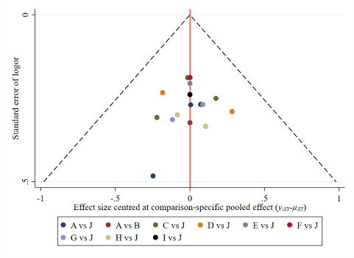
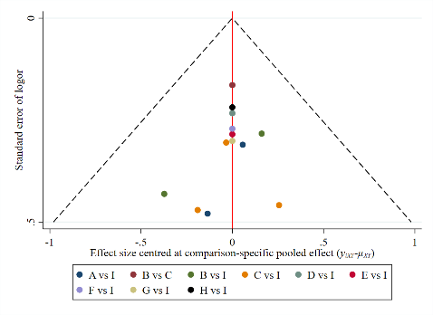
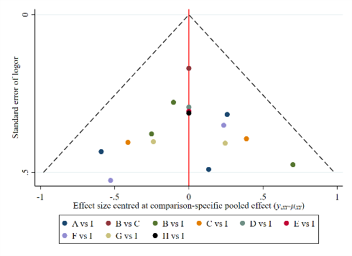
Figure 6A (A-J respectively stands for Infliximab、Infliximab/AZA、 Figure 6B (A-I respectively stands for Infliximab、Adalimumab、 Figure 6C (A-I respectively stands for Infliximab、Adalimumab、 Figure 6D (A-J respectively stands for Infliximab、Infliximab/AZA 、
Adalimumab、Vedolizumab、Ustekinumab、Golimumab、Tofacitinib、 Vedolizumab、Ustekinumab、Golimumab、Tofacitinib、Upadacitinib、 Vedolizumab、Ustekinumab、Golimumab、Tofacitinib、Upadacitinib、 Adalimumab、Vedolizumab、Ustekinumab、Golimumab、
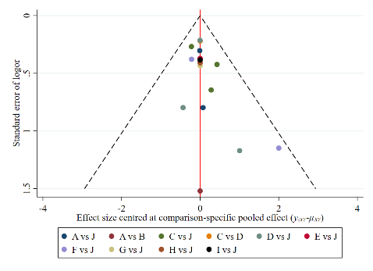
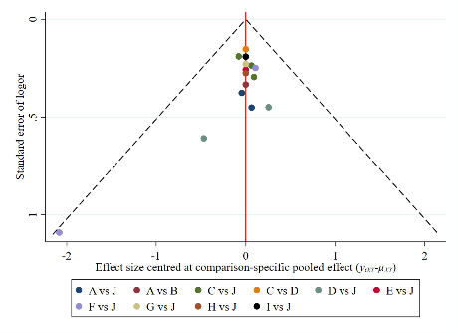
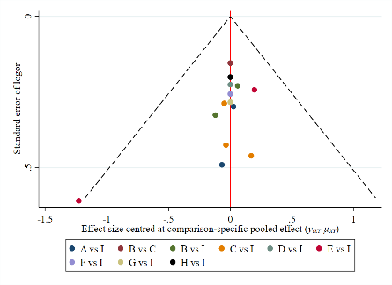
Upadacitinib、Ozanimod、Placebo) Ozanimod、Placebo) Ozanimod、Placebo) Tofacitinib、Upadacitinib、Ozanimod、Placebo)
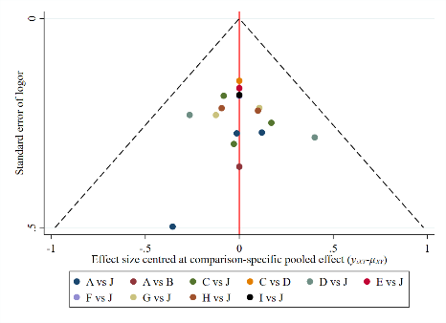
Figure 6E (A-I respectively stands for Infliximab、Adalimumab、 Figure 6F (A-J respectively stands for Infliximab、Infliximab/AZA、 Figure 6G (A-J respectively stands for Infliximab、Infliximab/AZA 、
Vedolizumab、Ustekinumab、Golimumab、Tofacitinib、Upadacitinib、 Adalimumab、Vedolizumab、Ustekinumab、Golimumab、 Adalimumab、Vedolizumab、Ustekinumab、Golimumab、Tofacitinib、
Ozanimod、 Placebo) Tofacitinib、Upadacitinib、Ozanimod、Placebo) Upadacitinib、Ozanimod、Placebo)
Figure 6A-6G. (6A): Funnel plot of clinical response during induction. (6B): Funnel plot of clinical remission during induction. (6C): Funnel plot of endoscopic improvement during induction. (6D): Funnel plot of clinical remission during maintenance. (6E): Funnel plot of endoscopic improvement during maintenance. (6F): Funnel plot of AE. (6G): Funnel plot of SAE.

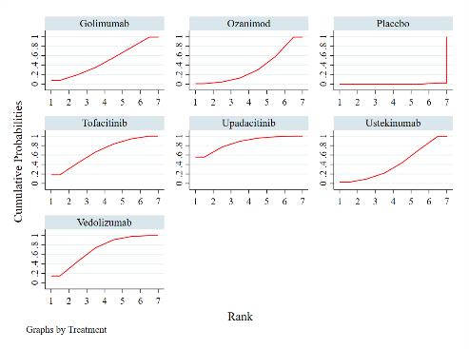
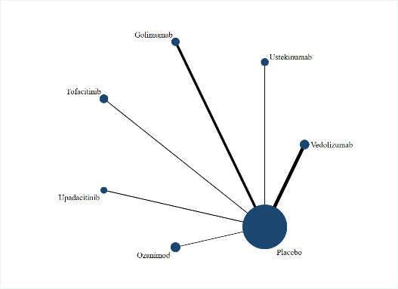
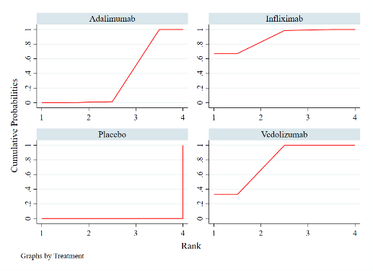
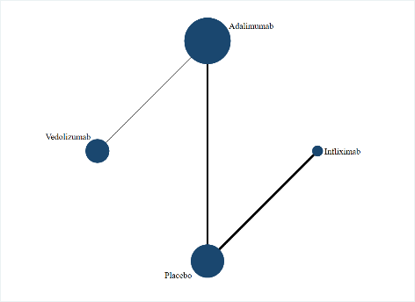
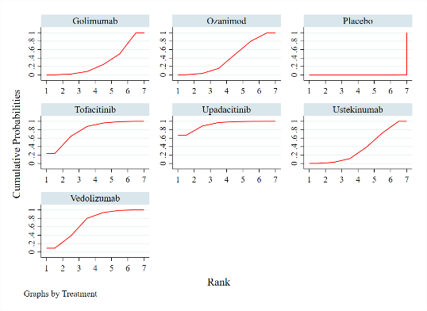
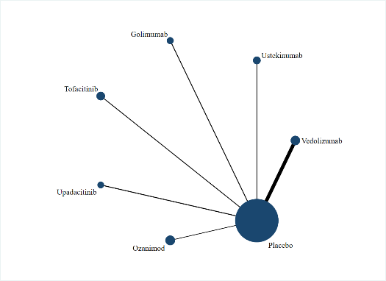
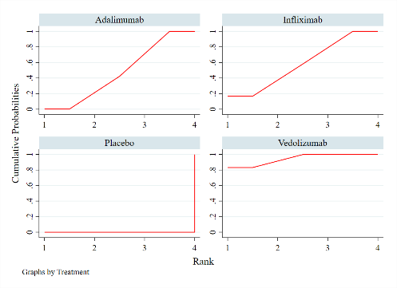
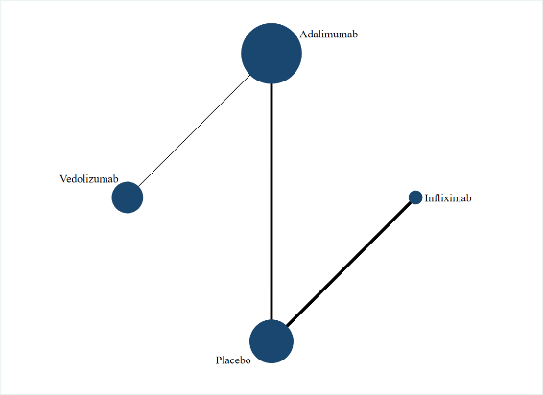
Figure 7A Figure 7B Figure 7C Figure 7D
Figure 7E Figure 7F Figure 7G Figure 7H
Figure 7A-7G. (7A): Network diagram of clinical remission during maintenance in the non-randomised group. (7B): The SUCRA probability ranking of clinical remission rate during induction in the non-randomised group. (7C): Network diagram of clinical remission during maintenance in the randomised group. (7D): The SUCRA probability ranking of clinical remission rate during maintenance in the randomised group. (7E): Network diagram of endoscopic improvement during maintenance in the non-randomised group. (7F): The SUCRA probability ranking of endoscopic improvement rate during induction in the non-randomised group. (7G): Network diagram of endoscopic improvement during maintenance in the randomised group. (7H): The SUCRA probability ranking of endoscopic improvement rate during induction in the randomised group.

