Simultaneous time-resolved aqueous haloamine measurement empowers robust kinetic model analysis
Samuel H. Brodfuehrer ^{(1) ‡}, Daniel C. Blomdahl ^{(1) ‡}, David G. Wahman ⁽²⁾, Gerald E. Speitel Jr. ⁽¹⁾, Pawel K. Misztal ⁽¹⁾ and Lynn E. Katz ⁽¹⁾
- University of Texas at Austin, Department of Civil, Architectural, and Environmental Engineering, 301 E. Dean Keaton St. Stop C1786, Austin TX 78712-0284
- United States Environmental Protection Agency, Office of Research and Development, Cincinnati, OH 45268

2. Supplementary Materials
2.1: Discussion of mass spectra for NH₂Cl, NHCl₂, and NHBrCl
The molecular ions NH₂³⁵ClH⁺ (m/z 51.995) and NH₂³⁷ClH⁺ (m/z 53.992) were observed in the mass spectrum for NH₂Cl (Fig. 1A). The mass spectrum for NHCl₂ (Fig. 1B) has the molecular ions NH³⁵Cl₂H⁺ (m/z 85.956), and NH³⁵Cl³⁷ClH⁺ (m/z 87.952); however, the molecular ion NH³⁷Cl₂H⁺ was not seen or present in the mass list. The molecular ions NH³⁵ClH⁺ (m/z 50.987) and NH³⁷ClH⁺ (m/z 52.995) in the NHCl₂ spectrum are likely due to fragmentation of NHCl₂ via abstraction of Cl⁻.
The standard used to collect the mass spectrum for NHBrCl also contained NH₂Cl to ensure the NHBrCl was stable (5); so, the mass spectrum contained the parent ions NH₂³⁵ClH⁺ (m/z 51.995), NH₂³⁷ClH⁺ (m/z 53.992), NH⁷⁹Br³⁵ClH⁺ (m/z 129.904), NH³⁵Cl⁸¹BrH⁺ (m/z 131.903), NH³⁷Cl⁷⁹BrH⁺ (m/z 131.903), and NH³⁷Cl⁸¹BrH⁺ (m/z 133.900). The m/z of 131.903 was used for quantification of NHBrCl and is the sum of both NH³⁷Cl⁷⁹BrH⁺ and NH³⁵Cl⁸¹BrH⁺. NHBrCl creates a wide range of fragments that can interfere with haloamine quantification because, when the N-Cl bond breaks, it results in the observable fragments of NH₂⁷⁹BrH⁺ (m/z 95.944) and NH₂⁸¹BrH⁺ (m/z 97.942) while, when the N-Br bond breaks, NH₂³⁵ClH⁺ (m/z 51.995) and NH₂³⁷ClH⁺ (m/z 53.992) fragments form which are identical to those produced from degradation pathways for the NH₂Cl already in the standard solution.
2.2: Standard curves for haloamines
Calibration curves were made using the standards ranging in concentration from 2 μM to 200 μM which covers dilute to considerably greater concentrations than would be seen in drinking water (lower limit 2.8 and 1.4 μM and upper limit of 56 and 28 μM for monohaloamines and dihaloamines respectively). The calibration curves for all five haloamines follow linear relationships with R² > 0.98 (Fig. S2). The standards for the NH₂Br and NHBr₂ standard only went up to 50 and 116 μM, respectively, because NH₂Br standards had high ammonia concentrations that used up available H₃O⁺ in the ionization process and NHBr₂ rapidly decayed.
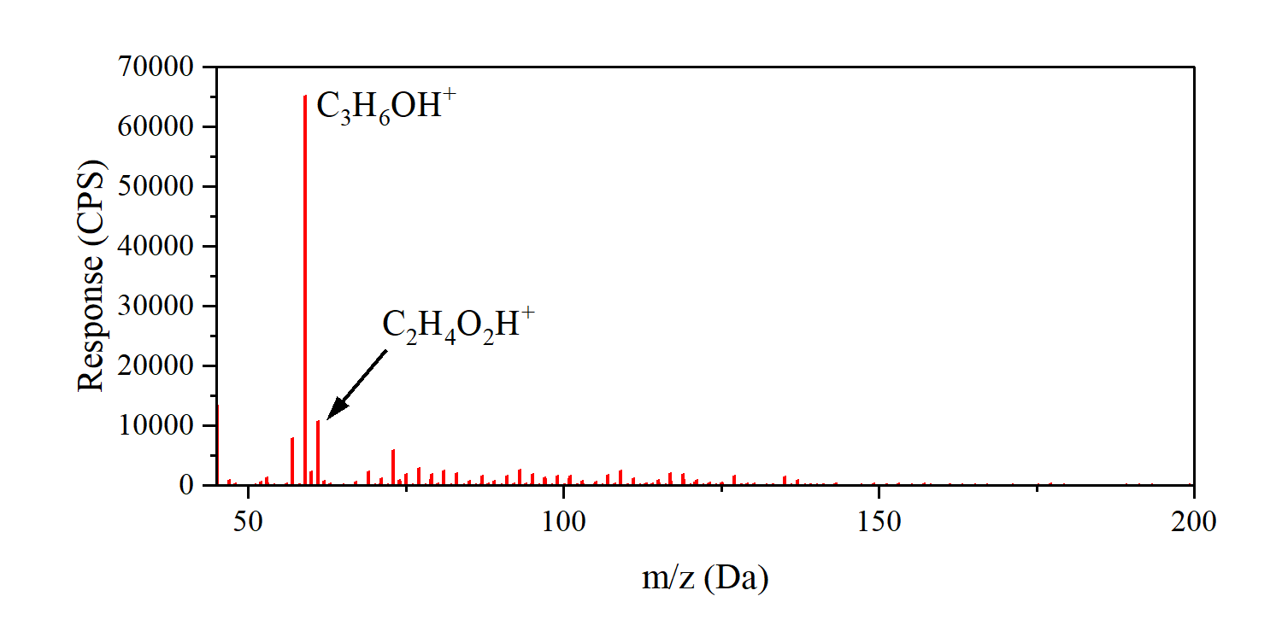
Fig. S1: Mass spectrum for ambient air during sampling period.

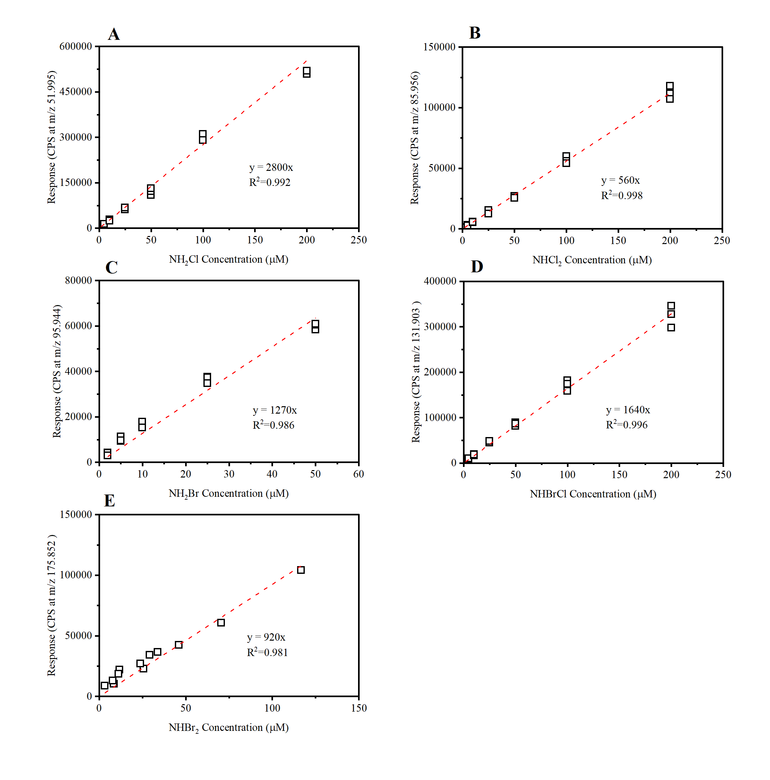
Fig. S2: PTR-ToF-MS calibration curves for haloamines: a) NH₂Cl (m/z =51.995), b) NHCl₂ (m/z = 85.956), c) NH₂Br (m/z = 95.944), d) NHBrCl (m/z = 131.903), and e) NHBr₂ (m/z 175.852). Units Counts per Second (CPS).

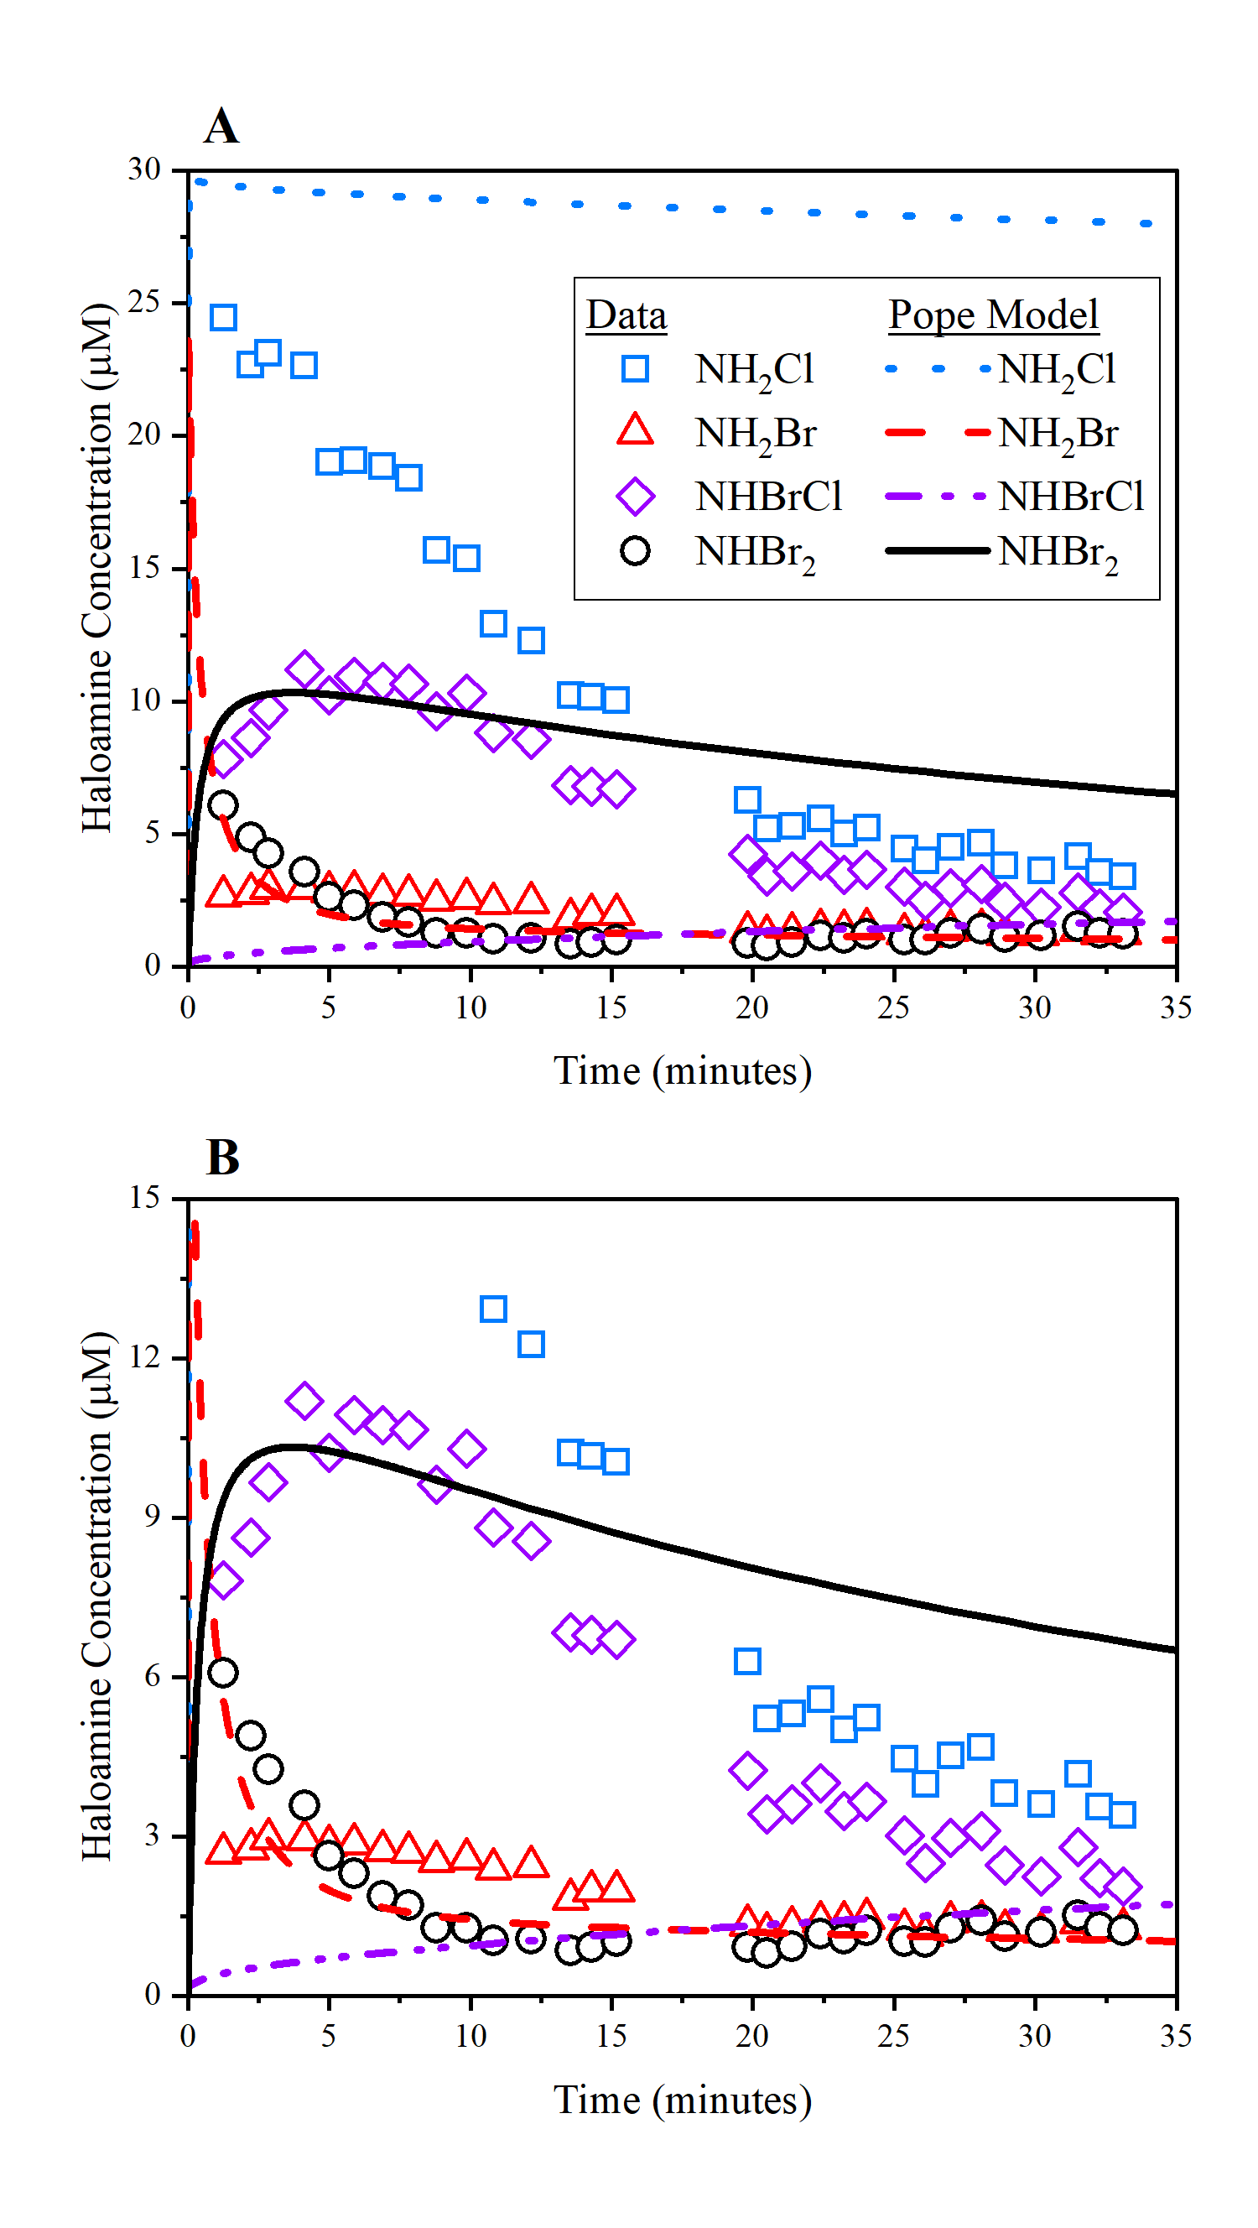
Fig. S3: Comparison of Pope (2006) model (lines) to measured haloamine concentrations during the kinetic experiment using PTR-ToF-MS. pH 7.2, 10 mM phosphate buffer, and [Br⁻] = 2 mg/L as Br⁻ (25 µM) dosed with [HOCl] = 4 mg/L as Cl₂ (56 µM) for 1 minute followed by addition of [NH₃] = 1.3 mg/L as N (93 µM). a) 0-30 μM concentration range b) 0-15 μM concentration range.

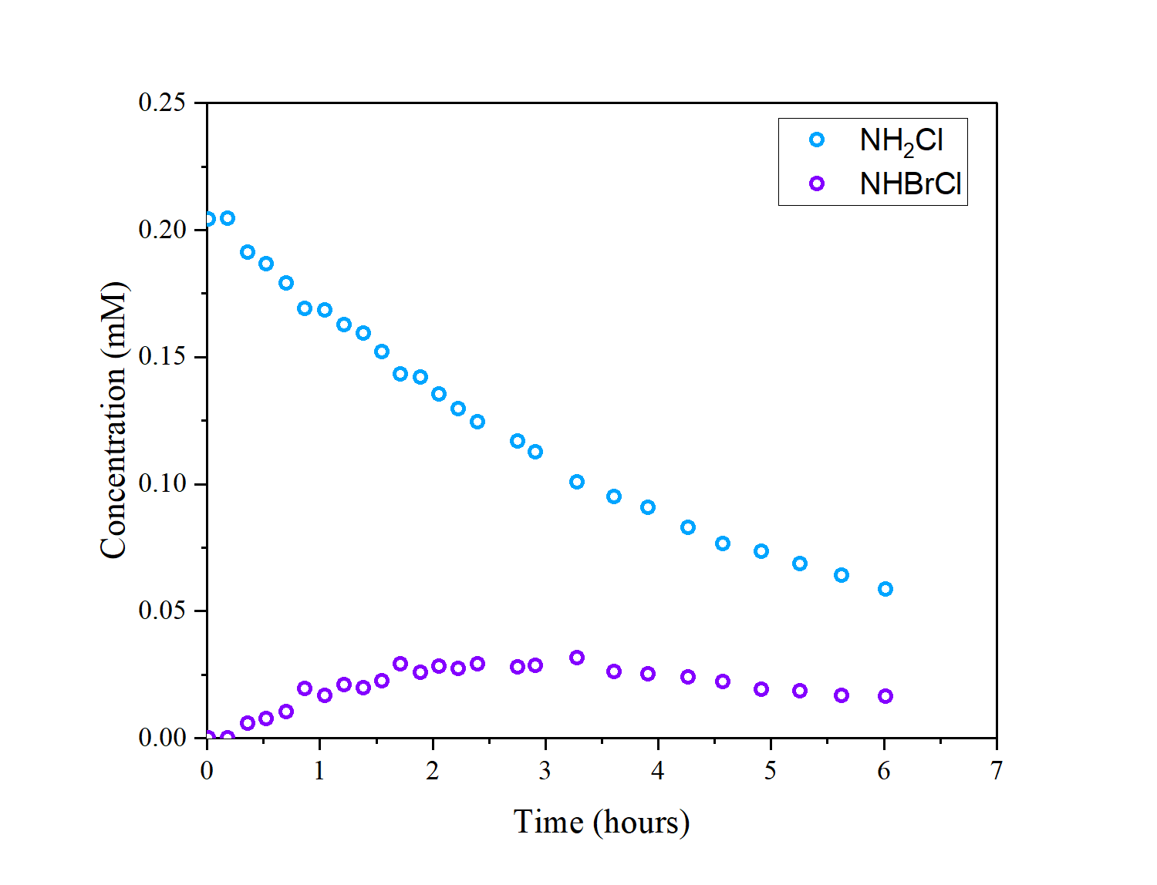
Fig. S4: Example of kinetic data collected by Luh and Mariñas (2014) to develop their haloamine model. pH 7.22, 10 mM phosphate buffer, [NH₂Cl] = 0.20 mM, [Br⁻] = 1.00, [NH₃] = 0.21 mM.

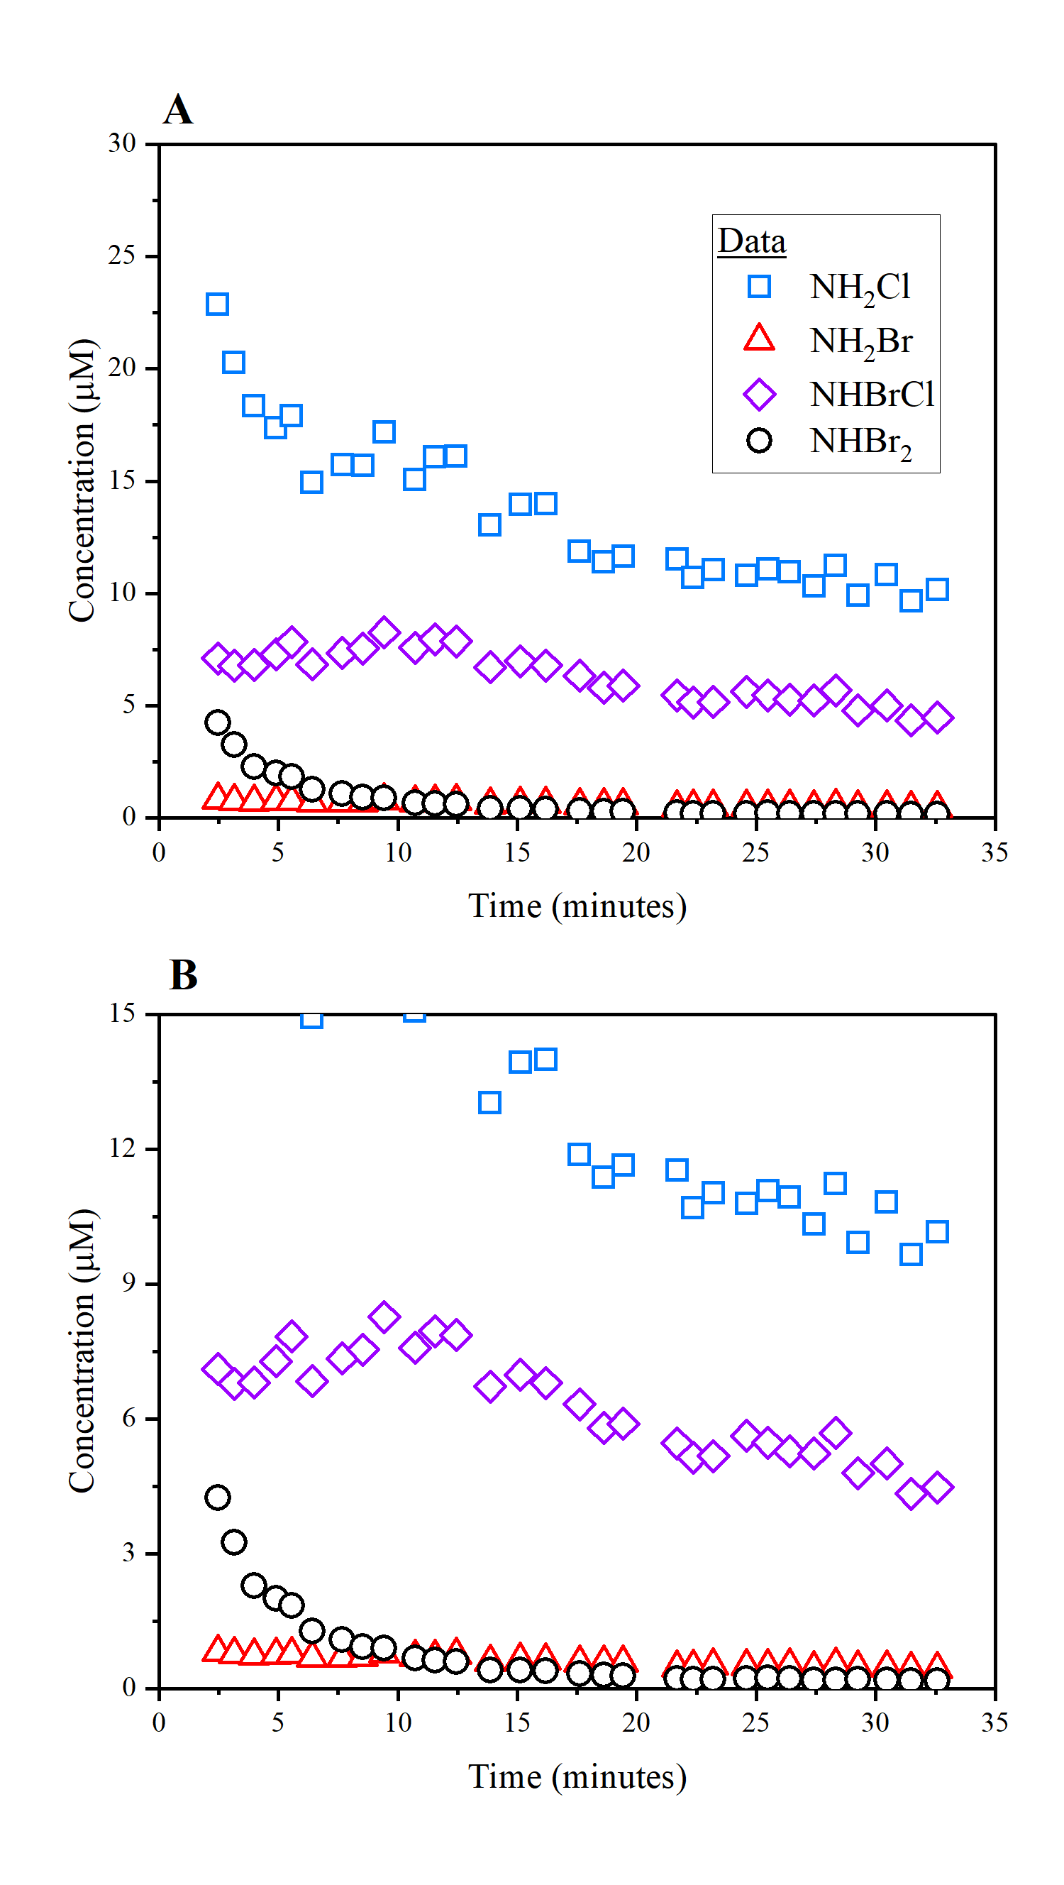
Fig. S5: Measured haloamine concentrations during the kinetic experiment using PTR-ToF-MS. pH 7.2, 10 mM phosphate buffer, and [Br⁻] = 2 mg/L as Br⁻ (25 µM) dosed with [HOCl] = 4 mg/L as Cl₂ (56 µM) for 1 minute followed by addition of [NH₃] = 1.3 mg/L as N (93 µM). [NOM] = 2 mg/L as C. a) 0-30 μM concentration range b) 0-15 μM concentration range.

Table S1: Level of Detection (LOD) and Level of Quantification (LOQ) for monochloramine (NH₂Cl), dichloramine (NHCl₂), monobromamine (NH₂Br), bromochloramine (NHBrCl), and dibromamine (NHBr₂). Unit μM.
 | NH₂Cl | NHCl₂ | NH₂Br | NHBrCl | NHBr₂
LOD | 0.90 | 0.0023 | 0.059 | 0.0086 | 0.00072
LOQ | 1.1 | 0.0045 | 0.092 | 0.016 | 0.0016

Table S2: Bromochloramine formation and decomposition model developed by Luh and Mariñas (2014)
 | Reaction | Rate Expression | Rate Constant
1 | HOCl + NH₃ → NH₂Cl + H₂O | k₁[HOCl][NH₃] | k₁ = 4.2 × 10⁶ M^{–1} s^{–1}
2 | NH₂Cl + H₂O → NH₃ + HOCl | k₂[NH₂Cl] | k₂ = 2.1 × 10^{–5} M^{–1} s^{–1}
3 | NH₂Cl + HOCl → NHCl₂ + H₂O | k₃[HOCl][NH₂Cl] | k₃ = 278 M^{–1} s^{–1}
4 | NHCl₂ + H₂O → NH₂Cl + HOCl | k₄[NHCl₂] | k₄ = 6.4 × 10^{–7} s^{–1}
5 | 2NH₂Cl → NHCl₂ + NH₃ | k₅[NH₂Cl]² | k₅ = (6.9 × 10³ M^{–2} s^{–1})[H⁺] + (0.36 M^{–2} s^{–1} )[H₂PO₄–] + 889 M^{–2} s^{–1} [H₃PO₄]
6 | NHCl₂ + NH₃ → NH₂Cl + NH₂Cl | k₆[NHCl₂][NH₃][H⁺] | k₆ = 6.0 × 10⁴ M^{–2} s^{–1}
7 | NH₂Cl + NHCl₂ → products | k₇[NH₂Cl][NHCl₂] | k₇ = 1.5 × 10^{–2} M^{–1} s^{–1}
8 | NHCl₂ + H₂O → I + 2H⁺ + 2Cl– | k₈[NHCl₂][OH–] | k₈ = 111 M^{–1} s^{–1}
9 | I + NHCl₂ → HOCl + products | k₉[I][NHCl₂] | k₉ = 2.8 × 10⁴ M^{–1} s^{–1}
10 | I + NH₂Cl → products | k₁₀[I][NH₂Cl] | k₁₀ = 8.3 × 10³ M^{–1} s^{–1}
11 | HOCl + NHCl₂ → NCl₃ + H₂O | k₁₁[HOCl][NHCl₂] | k₁₁ = (1.6 × 10⁴ M^{–2} s^{–1})[HPO₄²⁻] + (9 × 10⁴ M^{–2} s^{–1})[OCl–] + (3.3 × 10⁹ M^{–2} s^{–1})[OH–]
12 | NHCl₂ + NCl₃ + H2O → 2HOCl + products | k₁₂[NHCl₂][NCl₃][OH–] | k₁₂ = 5.6 × 10¹⁰ M^{–1} s^{–1}
13 | NH₂Cl + NCl₃ + H₂O → HOCl + products | k₁₂[NH₂Cl][NCl₃][OH–] | k₁₃ = 1.4 × 10⁹ M^{–1} s^{–1}
14 | NHCl₂ + 2HOCl +H₂O → NO₃– + 5H⁺ + 4Cl– | k₁₄ [NHCl₂][OCl⁻] | k₁₄ = 231 M^{–1} s^{–1}
15 | NH₂Cl + Br– + HA → NH₃ + BrCl + A– | k₁₅[NH₂Cl][Br⁻][H⁺] | k₁₅ = 3.8 × 10⁵ M^{–2} s^{–1}
16 | BrCl + Br– → Br₂ + Cl– | k₁₆[BrCl][Br⁻] | k₁₆ = 10⁸ M^{–1} s^{–1}
17 | BrCl + H₂O → HOBr + H⁺ + Cl– | k₁₇[BrCl] | k₁₇ = (3 × 10⁶ s⁻¹) + (10^{9.8} M⁻¹ s⁻¹)[OH⁻]
18 | HOBr + H⁺ + Cl– → BrCl + H₂O | k₁₈[HOBr][H⁺][Cl⁻] | k₁₈ = 2.3 × 10¹⁰ M⁻² s⁻¹
19 | Br₂ + H₂O → HOBr + H⁺ + Br– | k₁₉[Br₂] | k₁₉ = 97 s⁻¹ + (10^{9.8} M⁻¹ s ⁻¹)[OH⁻]
20 | HOBr + H⁺ + Br– → Br₂ + H₂O | k₂₀[HOBr][H⁺][Br⁻] | k₂₀ = 1.6 × 10¹⁰ M⁻² s⁻¹
21 | HOCl + H⁺ + Br– → BrCl + H₂O | k₂₁[HOCl][H⁺][Br⁻] | k₂₁ = 1.32 × 10⁶ M⁻² s⁻¹
22 | OCl– + H⁺ + Br– → BrCl + OH– | k₂₂[OCl⁻][H⁺][Br⁻] | k₂₂ = 3.65 × 10¹⁰ M⁻² s⁻¹
23 | HOBr + NH₃ → NH₂Br + H₂O | k₂₃[HOBr][NH₃] | k₂₃ = 7.5 × 10⁷ M⁻¹ s⁻¹
24 | NH₂Br + NH₂Br → NHBr₂ + NH₃ | k₂₄[NH₂Br][NH₂Br] | k₂₄ = 0.5 M⁻¹ s⁻¹ + (5.0 × 10⁸ M⁻² s⁻¹)[H⁺] + (290 M⁻² s⁻¹)[NH₄⁺] + (3.4 × 10⁵ M⁻² s⁻¹)[H₂PO₄⁻]
25 | NHBr₂ + NH₃ → NH₂Br + NH₂Br | k₂₅[NHBr₂][NH₃] | k₂₅ = 1.0 M⁻¹ s⁻¹ + (1.0 × 10⁹ M⁻² s⁻¹)[H⁺] + (190 M⁻² s⁻¹)[NH₄⁺] + (6.5 × 10⁴ M⁻² s⁻¹)[H₂PO₄⁻]
26 | NH₂Br + NHBr₂ → products + 3Br– | k₂₆[NH₂Br][NHBr₂] | k₂₆ = 6.2 M⁻¹ s⁻¹ + (8.3 × 10⁴ M⁻² s⁻¹)[OH⁻]
27 | NHBr₂ + NHBr₂ → HOBr + products + 3Br– | k₂₇[NHBr₂][NHBr₂] | k₂₇ = 8.9 M⁻¹ s⁻¹ + (1.4 × 10³ M⁻² s⁻¹)[HPO₄²⁻]
28 | NH₂Br + Br– + H⁺ → NH₃ + Br₂ | k₂₈[NH₂Br][Br⁻][H⁺] | k₂₈ = 3.6 × 10⁹ M⁻² s⁻¹
29 | NH₂Br + Br₂ → NHBr₂ + Br– + H⁺ | k₂₉[NH₂Br][Br₂] | k₂₉ = 4.6 × 10⁶ M⁻¹ s⁻¹
30 | NH₂Cl + Br₂ → NHBrCl + Br– + H⁺ | k₃₀[NH₂Cl][Br₂] | k₃₀ = 4.18 × 10⁸ M⁻¹ s⁻¹
31 | NH₂Cl + Br₃– → NHBrCl + 2Br– + H⁺ | k₃₁[NH₂Cl][Br₃⁻] | k₃₁ = 3.07 × 10⁷ M⁻¹ s⁻¹
32 | NH₂Cl + HOBr → NHBrCl + H₂O | k₃₂[NH₂Cl][Br₃⁻] | k₃₂ = 2.86 × 10⁵ M⁻¹ s⁻¹
33 | NH₂Cl + OBr– → NHBrCl + OH– | k₃₃[NH₂Cl][OBr⁻] | k₃₃ = 2.20 × 10⁴ M⁻¹ s⁻¹
34 | NH₂Cl + NH₂Br + H⁺ → NHBrCl + NH₃ | k₃₄[NH₂Cl][NH₂Br][H⁺] | k₃₄ = 3.1 × 10⁷ M⁻² s⁻¹
35 | NH₂Cl + NHBr₂ → NHBrCl + products | k₃₅[NH₂Cl][NHBr₂] | k₃₅ = 0.19 M⁻¹ s⁻¹
36 | NHBrCl + NHBrCl + OH– →HOBr + products +Br– | k₃₆[NHBrCl][NHBrCl] | k₃₆ = 0.52 M⁻¹ s⁻¹ + (0.0015 M⁻² s⁻¹)[OH⁻] + (139 M⁻² s⁻¹)[HPO₄²⁻]
37 | NHBrCl + NH₂Cl → products | k₃₇[NHBrCl][NH₂Cl] | k₃₇ = 5.6 × 10⁻⁶ M⁻¹ s⁻¹
38 | NHBrCl + NH₂Br → products | k₃₈[NHBrCl][NH₂Br] | k₃₈ = 0.071 M⁻¹ s⁻¹
39 | NHBrCl + NHBr₂ → HOBr + products + 2Br– | k₃₉[NHBrCl][NHBr₂] | k₃₉ = (1.4 × 10³ M⁻¹ s⁻¹) + (41.7 M⁻² s⁻¹)[OH⁻] + (1389 M⁻² s⁻¹)[HPO₄²⁻]
40 | NHBrCl + NH₃ + H⁺ → NH₂Cl + NH₂Br | k₄₀[NHBrCl][NH₃][H⁺] | k₄₀ = 3.9 × 10⁹ M⁻² s⁻¹
41 | NHBrCl + Br– + H⁺ → NH₂Cl + `Br₂ | k₄₁[NHBrCl][Br⁻][H⁺] | k₄₁ = 3.3 × 10⁹ M⁻² s⁻¹
E1 | H₂O ⇌ H⁺ + OH– |  | pK_{a,E1} = 13.8
E2 | H₃PO₄ ⇌ H⁺ + H₂PO₄– |  | pK_{a,E2} = 1.9
E3 | H₂PO₄– ⇌ H⁺ + HPO₄^{2–} |  | pK_{a,E3} = 6.79
E4 | HPO₄^{2–} ⇌ H⁺ + PO₄^{3–} |  | pK_{a,E4} = 11.62
E5 | NH₄⁺ ⇌ H⁺ + NH₃ |  | pK_{a,E5} = 9.34
E6 | HOCl ⇌ H⁺ + OCl– |  | pK_{a,E6} = 7.5
E7 | HOBr ⇌ H⁺ + OBr– |  | pK_{a,E7} = 8.42
E8 | Br₂ + Br– ⇌ Br₃– |  | pK_{a,E8} = 16.1

Table S3: Unified Haloamine Model developed by Pope (2006)
 | Reaction | Rate Expression | Rate Constant
1 | HOCl + NH₃ → NH₂Cl + H₂O | k₁[HOCl][NH₃] | k₁ = 4.2 × 10⁶ M^{–1} s^{–1}
2 | NH₂Cl + H₂O → NH₃ + HOCl | k₂[NH₂Cl] | k₂ = 2.1 × 10^{–5} M^{–1} s^{–1}
3 | NH₂Cl + HOCl → NHCl₂ + H₂O | k₃[HOCl][NH₂Cl] | k₃ = 280 M^{–1} s^{–1}
4 | NHCl₂ + H₂O → NH₂Cl + HOCl | k₄[NHCl₂] | k₄ = 6.4 × 10^{–7} s^{–1}
5* | 2NH₂Cl → NHCl₂ + NH₃ | k₅[NH₂Cl]² | k₅ = (6.9 × 10³ M^{–2} s^{–1})[H⁺] + (0.36 M^{–2} s^{–1} )[H₂PO₄–] + 889 M^{–2} s^{–1} [H₃PcO₄]
6 | NHCl₂ + NH₃ → NH₂Cl + NH₂Cl | k₆[NHCl₂][NH₃][H⁺] | k₆ = 6.1 × 10⁴ M^{–2} s^{–1}
7 | NH₂Cl + NHCl₂ → products | k₇[NH₂Cl][NHCl₂] | k₇ = 1.5 × 10^{–2} M^{–1} s^{–1}
8 | NHCl₂ + H₂O → I + 2H⁺ + 2Cl– | k₈[NHCl₂][OH–] | k₈ = 110 M^{–1} s^{–1}
9 | I + NHCl₂ → HOCl + products | k₉[I][NHCl₂] | k₉ = 2.8 × 10⁴ M^{–1} s^{–1}
10 | I + NH₂Cl → products | k₁₀[I][NH₂Cl] | k₁₀ = 8.3 × 10³ M^{–1} s^{–1}
11 | HOCl + Br– → HOBr + Cl– | k₁₁[HOCl][Br⁻] | k₁₁ = 1.55 × 10³ M⁻¹ s⁻¹
12 | HOBr + NH₃ → NH₂Br + H₂O | k₁₂[HOBr][NH₃] | k₁₂ = 7.5 × 10⁷ M⁻¹ s⁻¹
13 | OBr– + NH₃ → NH₂Br + OH– | k₁₃[OBr–][NH₃] | k₁₃ = 7.6 × 10⁴ M⁻¹ s⁻¹
14 | NH₂Br + H₂O → HOBr + NH₃ | k₁₄[NH₂Br] | k₁₄ = 1.5 × 10⁻³ s⁻¹
15* | NH₂Br + NH₂Br → NHBr₂ + NH₃ | k₁₅[NH₂Br][NH₂Br] | k₁₅ = 0.5 M⁻¹ s⁻¹ + (5.0 × 10⁸ M⁻² s⁻¹)[H⁺] + (290 M⁻² s⁻¹)[NH₄⁺] + (3.4 × 10⁵ M⁻² s⁻¹)[H₂PO₄⁻]
16* | NHBr₂ + NH₃ → NH₂Br + NH₂Br | k₁₆[NHBr₂][NH₃] | k₁₆ = 1.0 M⁻¹ s⁻¹ + (1.0 × 10⁹ M⁻² s⁻¹)[H⁺] + (190 M⁻² s⁻¹)[NH₄⁺] + (6.5 × 10⁴ M⁻² s⁻¹)[H₂PO₄⁻]
17* | NH₂Br + NHBr₂ → products + 3Br– | k₁₇[NH₂Br][NHBr₂] | k₁₇ = 6.2 M⁻¹ s⁻¹ + (8.3 × 10⁴ M⁻² s⁻¹)[OH⁻]
18* | NHBr₂ + NHBr₂ → HOBr + products + 3Br– | k₁₈[NHBr₂][NHBr₂] | k₁₈ = 8.9 M⁻¹ s⁻¹ + (1.4 × 10³ M⁻² s⁻¹)[HPO₄²⁻]
19 | NH₂Cl + HOBr → NHBrCl + H₂O | k₁₉[NH₂Cl][Br₃⁻] | k₁₉ = 2.86 × 10⁵ M⁻¹ s⁻¹
20 | NH₂Cl + OBr– → NHBrCl + OH– | k₂₀[NH₂Cl][OBr⁻] | k₂₀ = 2.20 × 10⁴ M⁻¹ s⁻¹
21 | NH₂Cl + NH₂Cl + Br–→ NHBrCl + NH₃ + Cl– | k₂₁[NH₂Cl][Br⁻][H⁺] | k₂₁ = 8.3 × 10⁵ M^{–2} s^{–1}
22 | NHBrCl + NHBrCl + H₂O → HOBr + N₂ + HBr + 2HCl | k₂₂[NHBrCl][NHBrCl] | k₂₂ = 17 M⁻¹ s⁻¹
E1 | H₂O ⇌ H⁺ + OH– |  | pK_{a,E1} = 14
E2 | H₃PO₄ ⇌ H⁺ + H₂PO₄– |  | pK_{a,E2} = 2.12
E3 | H₂PO₄– ⇌ H⁺ + HPO₄^{2–} |  | pK_{a,E3} = 7.2
E4 | HPO₄^{2–} ⇌ H⁺ + PO₄^{3–} |  | pK_{a,E4} = 11.62
E5 | NH₄⁺ ⇌ H⁺ + NH₃ |  | pK_{a,E5} = 9.24
E6 | HOCl ⇌ H⁺ + OCl– |  | pK_{a,E6} = 7.54
E7 | HOBr ⇌ H⁺ + OBr– |  | pK_{a,E7} = 8.8
* Phosphate buffer catalytic rate constants from literature were added to reactions because the original Unified Haloamine Model was intended for carbonate buffered system.

