Hydrological and geochemical properties of bottom ash landfills: Supplementary appendix

Philipp Ingoldª*, Gisela Weibelª, Christoph Wannerª, Thomas Gimmi^{a,b}, Sergey V. Churakov^{a,b}
ª Institute of Geological Sciences, University of Bern, Baltzerstrasse 1+3, 3012 Bern, Switzerland
^{b} Laboratory for Waste, Paul Scherrer Institute, Forschungsstrasse 111, 5232 Villigen, Switzerland

*Corresponding author. E-mail: philipp.ingold@unibe.ch

Supplementary Table 1: Characteristics of the investigated landfills.
Landfill compartment | Age | Deposited Bottom ash type | Deposited Volume  (Dec 2022) | Surface area | Active deposition
 |  |  | m³ | m²
I | 2006 | wet | 490’000 | 25’165 | yes
II1 | 2003 | wet | 150’000 | 11’200 | no
II2 | 2010 | wet/dry | 400’000 | 17’600 | yes
III1 | 1987 | wet | 395’000 | 10’100 | no
III2 | 2005 | wet | 235’000 | 8’300 | no
III3 | 2020 | wet/dry | 152’000 | 6’000 | yes
IV | 2017 | dry | 106’000 | 4’000 | no

Supplementary Table 2: Mineralogical composition of the investigated landfill bottom ashes of the different landfills (I - III) and the water-free bottom ash (Sample IV) sampled directly after incineration.
 | Unit | I | III | III | IV
Amorphous | wt.% | 64.7 | 61.1 | 75.4 | 50.3
Melilite | wt.% | 9.7 | 9.2 | 9.0 | 7.7
SiO₂-Phases | wt.% | 6.0 | 8.2 | 7.1 | 15.4
Pyroxenes | wt.% | 4.4 | 4.8 | 4.0 | 1.7
Fe-Oxides | wt.% | 3.9 | 2.8 | 3.0 | < 1
Fe-Alteration products | wt.% | 2.0 | 1.6 | < 1 | 1.0
Carbonates | wt.% | 4.4 | 4.8 | < 1 | 8.4
Feldspars | wt.% | 1.4 | 1.7 | n.d. | 4.2
Other Silicates | wt.% | 1.0 | 2.2 | n.d. | 2.5
Salts | wt.% | < 1 | < 1 | < 1 | 1.2
Clinker phases | wt.% | < 1 | < 1 | n.d. | 2.6
Anhydrite | wt.% | < 1 | < 1 | < 1 | 1.87
Bassanite | wt.% | < 1 | 1.61 | < 1 | < 1
Lime | wt.% | n.d. | n.d. | n.d. | < 1
Portlandite | wt.% | n.d. | n.d. | n.d. | < 1
Ti-Oxides | wt.% | < 1 | < 1 | n.d. | 1.2
Free metals | wt.% | < 1 | < 1 | < 1 | < 1
n.d. = not detected

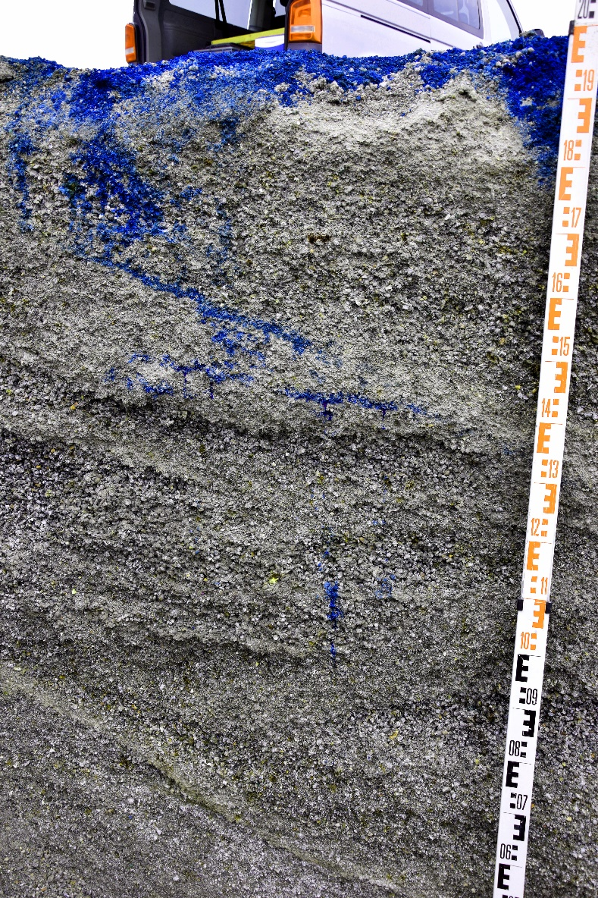
Supplementary Figure 1: Image of a vertical profile section, taken during the tracer experiment. The horizontal orientated layering of the deposited landfill and their internal structure of fine-grained (i.e., compacted) and coarse-grained (i.e., skeletal, uncompacted) layers are clearly visible. The homogeneous infiltration and the preferential flow zone are clearly visible with the Brilliant Blue FCF dye.

Supplementary Table 3.1: Mean, standard deviation (SD), minimum and maximum concentration values of selected parameters, measured in the leachate samples of all landfills, listed individually for the additional compartments (II1, II2, III1, III2, and III3), which are not shown in Table 2 or Table 3.
 | Unit | II1 |  |  |  | II2 |  |  |  | III1
 |  | Mean | SD | Min | Max | Mean | SD | Min | Max | Mean | SD | Min | Max
Q | L/min | 9.33 | 0.74 | 8.80 | 9.85 | 8.10 | 1.63 | 6.95 | 9.25 | 2.36 | 0.77 | 1.00 | 3.00
pH | - | 7.91 | 0.20 | 7.75 | 8.13 | 7.87 | 0.18 | 7.66 | 7.98 | 7.79 | 0.21 | 7.47 | 8.20
EC | mS/cm | 12.9 | 1.91 | 10.7 | 14.4 | 20.4 | 2.37 | 17.9 | 22.6 | 17.3 | 1.77 | 13.0 | 18.8
Na | mg/L | 2236 | 291 | 1901 | 2431 | 3655 | 187 | 3514 | 3867 | 3909 | 452 | 2868 | 4350
K | mg/L | 740 | 104 | 620 | 805 | 1297 | 59.1 | 1256 | 1365 | 477 | 55.6 | 333 | 509
Ca | mg/L | 270 | 45.2 | 218 | 297 | 374 | 26.3 | 346 | 398 | 178 | 34.5 | 115 | 215
Mg | mg/L | 13.6 | 1.65 | 12.6 | 15.5 | 31.0 | 4.63 | 27.6 | 36.3 | 40.2 | 3.99 | 31.1 | 45.0
Cl | mg/L | 3233 | 530 | 2632 | 3632 | 6458 | 447 | 6070 | 6947 | 3151 | 443 | 2073 | 3519
SO₄ | mg/L | 1660 | 152 | 1525 | 1824 | 1455 | 86.4 | 1404 | 1554 | 4550 | 500 | 3425 | 5120
HCO₃ | mg/L | 72.0 | 6.75 | 65.0 | 78.5 | 97.1 | 13.6 | 88.1 | 113 | 605 | 87.5 | 528 | 788
NO₃ | mg/L | 67.8 | 9.57 | 57.2 | 75.8 | 105 | 16.1 | 93.1 | 124 | 10.9 | 6.62 | 1.96 | 25.9
Al | mg/L | 1.30E-01 | 4.00E-02 | 1.10E-01 | 1.70E-01 | 8.50E-01 | 9.60E-01 | 1.80E-01 | 1.95 | 6.00E-02 | 3.00E-02 | 2.00E-02 | 8.00E-02
B | mg/L | 1.38 | 1.00E-01 | 1.27 | 1.46 | 1.06 | 5.60E-01 | 4.20E-01 | 1.40 | 12.80 | 1.56 | 9.71 | 15.10
Cr | mg/L | 3.00E-02 | 1.00E-02 | 2.00E-02 | 4.00E-02 | 4.00E-02 | 1.00E-02 | 3.00E-02 | 5.00E-02 | 8.00E-02 | 7.00E-02 | 1.00E-02 | 1.40E-01
Cu | mg/L |  |  |  | 0.06* | 2.20E-01 | 8.00E-02 | 1.50E-01 | 3.00E-01 | 7.00E-02 | 2.00E-02 | 4.00E-02 | 1.10E-01
Fe | mg/L | < 0.01 |  |  |  | 3.10E-01 | 4.20E-01 | 5.00E-02 | 8.00E-01 | 4.00E-01 | 3.70E-01 | 1.50E-01 | 1.27
Mo | mg/L | 1.30 | 2.10E-01 | 1.07 | 1.47 | 2.16 | 2.10E-01 | 1.93 | 2.35 | 2.80E-01 | 2.00E-02 | 2.40E-01 | 3.10E-01
Ni | mg/L |  |  |  | 0.01* | 2.00E-02 | 0.00 | 2.00E-02 | 3.00E-02 | 6.00E-02 | 6.00E-02 | 1.00E-02 | 1.60E-01
Pb | mg/L |  |  |  | 0.02* | 6.00E-02 | 7.00E-02 | 1.00E-02 | 1.40E-01 | 3.00E-02 | 3.00E-02 | 1.00E-02 | 5.00E-02
Sb | mg/L | 5.00E-02 | 1.00E-02 | 5.00E-02 | 6.00E-02 | 1.30E-01 | 2.00E-02 | 1.10E-01 | 1.50E-01 | 1.00E-02 | 0.00 | 1.00E-02 | 2.00E-02
V | mg/L |  |  |  | 0.01* | < 0.01 |  |  |  | < 0.01
Zn | mg/L | < 0.01 |  |  |  | 2.60E-01 | 2.70E-01 | 7.00E-02 | 4.50E-01 | 1.30E-01 | 1.40E-01 | 1.00E-02 | 4.10E-01
DOC | mg/L | 11.8 | 0.33 | 11.6 | 12.1 | 15.5 | 0.70 | 15.0 | 16.0 | 9.71 | 2.78 | 6.53 | 11.7
* single value, while other samples show concentrations below detection limit

Supplementary Table 3.2: Mean, standard deviation (SD), minimum and maximum concentration values of selected parameters, measured in the leachate samples of all compartments of the landfills I - IV (cont.).
 | Unit | III2 |  |  |  | III3 |  |  |  | IV
 |  | Mean | SD | Min | Max | Mean | SD | Min | Max | Mean | SD | Min | Max
Q | L/min | 3.63 | 1.12 | 2.60 | 5.30 | 1.40 | 1.30 | 0.60 | 4.00 | 5.70 | 6.20 | 2.40 | 24.0
pH | - | 7.57 | 0.29 | 7.19 | 7.90 | 8.41 | 0.43 | 7.95 | 9.26 | 8.13 | 0.29 | 7.93 | 8.98
EC | mS/cm | 15.5 | 4.61 | 5.58 | 20.0 | 23.0 | 4.3 | 17.7 | 30.1 | 30.4 | 2.84 | 27.7 | 37.5
Na | mg/L | 3101 | 1144 | 913 | 4343 | 4529 | 1394 | 2957 | 7259 | 7080 | 904 | 5709 | 9239
K | mg/L | 836 | 357 | 196 | 1344 | 1183 | 286 | 771 | 1712 | 1122 | 103 | 965 | 1299
Ca | mg/L | 498 | 143 | 280 | 675 | 338 | 118 | 209 | 545 | 216 | 71.3 | 88.5 | 345
Mg | mg/L | 37.4 | 10.8 | 18.6 | 54.1 | 31.2 | 10.8 | 20.0 | 47.6 | 11.3 | 3.92 | 3.33 | 17.2
Cl | mg/L | 4103 | 1618 | 817 | 5877 | 5761 | 1874 | 4019 | 9522 | 7176 | 763 | 6466 | 9175
SO₄ | mg/L | 2756 | 872 | 1190 | 3874 | 3758 | 786 | 2622 | 4804 | 6212 | 1003 | 4565 | 8529
HCO₃ | mg/L | 260 | 217 | 127 | 740 | 86.9 | 29.1 | 45.4 | 130 | 400 | 336 | 216 | 1402
NO₃ | mg/L | 284 | 68.9 | 191 | 349 | 260 | 55.1 | 201 | 342 | 588 | 62.0 | 480 | 678
Al | mg/L | 8.00E-02 | 6.00E-02 | 2.00E-02 | 1.90E-01 | 7.00E-01 | 8.50E-01 | 9.00E-02 | 2.74 | 5.70E-01 | 9.70E-01 | 2.00E-02 | 3.20
B | mg/L | 5.64 | 1.19 | 3.47 | 7.03 | 2.69 | 7.00E-01 | 1.52 | 3.73 | 9.96 | 8.10E-01 | 9.16 | 12.0
Cr | mg/L | 5.00E-02 | 3.00E-02 | 3.00E-02 | 1.10E-01 | 1.60E-01 | 1.70E-01 | 4.00E-02 | 5.60E-01 | 1.00E-01 | 5.00E-02 | 5.00E-02 | 2.20E-01
Cu | mg/L | 1.50E-01 | 1.00E-01 | 3.00E-02 | 3.40E-01 | 2.50E-01 | 8.00E-02 | 1.60E-01 | 4.10E-01 | 3.08 | 1.02 | 2.33 | 5.90
Fe | mg/L | 1.06 | 1.39 | 1.00E-02 | 4.03 | 2.60E-01 | 3.40E-01 | 1.00E-02 | 1.06 | 2.00E-02 | 2.00E-02 | 1.00E-02 | 8.00E-02
Mo | mg/L | 4.90E-01 | 3.10E-01 | 6.00E-02 | 1.11 | 2.04 | 3.40E-01 | 1.48 | 2.52 | 3.23 | 3.60E-01 | 2.61 | 3.91
Ni | mg/L | 8.00E-02 | 5.00E-02 | 2.00E-02 | 1.40E-01 | 7.00E-02 | 5.00E-02 | 2.00E-02 | 1.90E-01 | 4.00E-02 | 2.00E-02 | 3.00E-02 | 1.00E-01
Pb | mg/L | 3.00E-02 | 2.00E-02 | 2.00E-02 | 6.00E-02 | 0.02* |  |  |  | < 0.01
Sb | mg/L | 2.00E-02 | 1.00E-02 | 1.00E-02 | 5.00E-02 | 4.00E-02 | 1.00E-02 | 3.00E-02 | 4.00E-02 | 1.40E-01 | 2.00E-02 | 1.10E-01 | 1.70E-01
V | mg/L |  |  |  | 0.01* | 2.00E-02 | 1.00E-02 | 1.00E-02 | 4.00E-02 | 6.00E-02 | 2.00E-02 | 4.00E-02 | 1.00E-01
Zn | mg/L | 4.80E-01 | 2.80E-01 | 7.00E-02 | 8.90E-01 | < 0.01 |  |  |  | 2.00E-02 | 1.00E-02 | 1.00E-02 | 6.00E-02
DOC | mg/L | 19.5 | 5.87 | 11.7 | 27.9 | 29.8 | 5.81 | 23.3 | 38.3 | 102 | 9.73 | 87.8 | 119
* single value, while other samples show concentrations below detection limit

Supplementary Table 4: Phase assemblage (in moles) before and after the modelled reaction with water and Saturation indices of the used phases after the interaction with water.
Phase | Before reaction | After reaction | Delta | SI
Anhydrite | 1.29E-03 | 0 | -1.29E-03 | -1.86
Anorthite | 5.00E-03 | 4.74E-03 | -2.63E-04 | 0
Calcite | 4.40E-02 | 4.40E-02 | -9.50E-06 | 0
Diopside | 2.03E-02 | 2.03E-02 | -2.25E-10 | 0
Goethite | 3.04E-02 | 3.35E-02 | 3.10E-03 | 0
Halite | 1.13E-02 | 0 | -1.13E-02 | -5.59
Magnetite | 1.38E-02 | 1.28E-02 | -1.03E-03 | 0
Quartz | 9.99E-02 | 1.00E-01 | 1.39E-04 | 0
Gypsum | 0.00E+00 | 0.00E+00 | 0.00E+00 | -1.64
Ettringite | 0.00E+00 | 0.00E+00 | 0.00E+00 | -12.92
Gibbsite | 0.00E+00 | 4.75E-04 | 4.75E-04 | 0

