Supplementary Materials: Leave-one-out plots and funnel plots for the forward and reverse MR analyses.
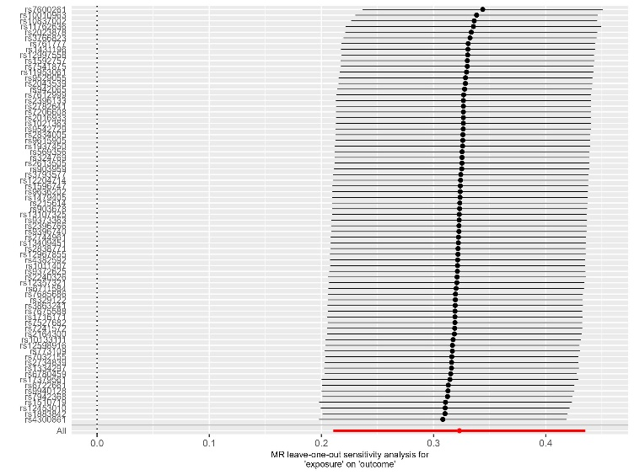
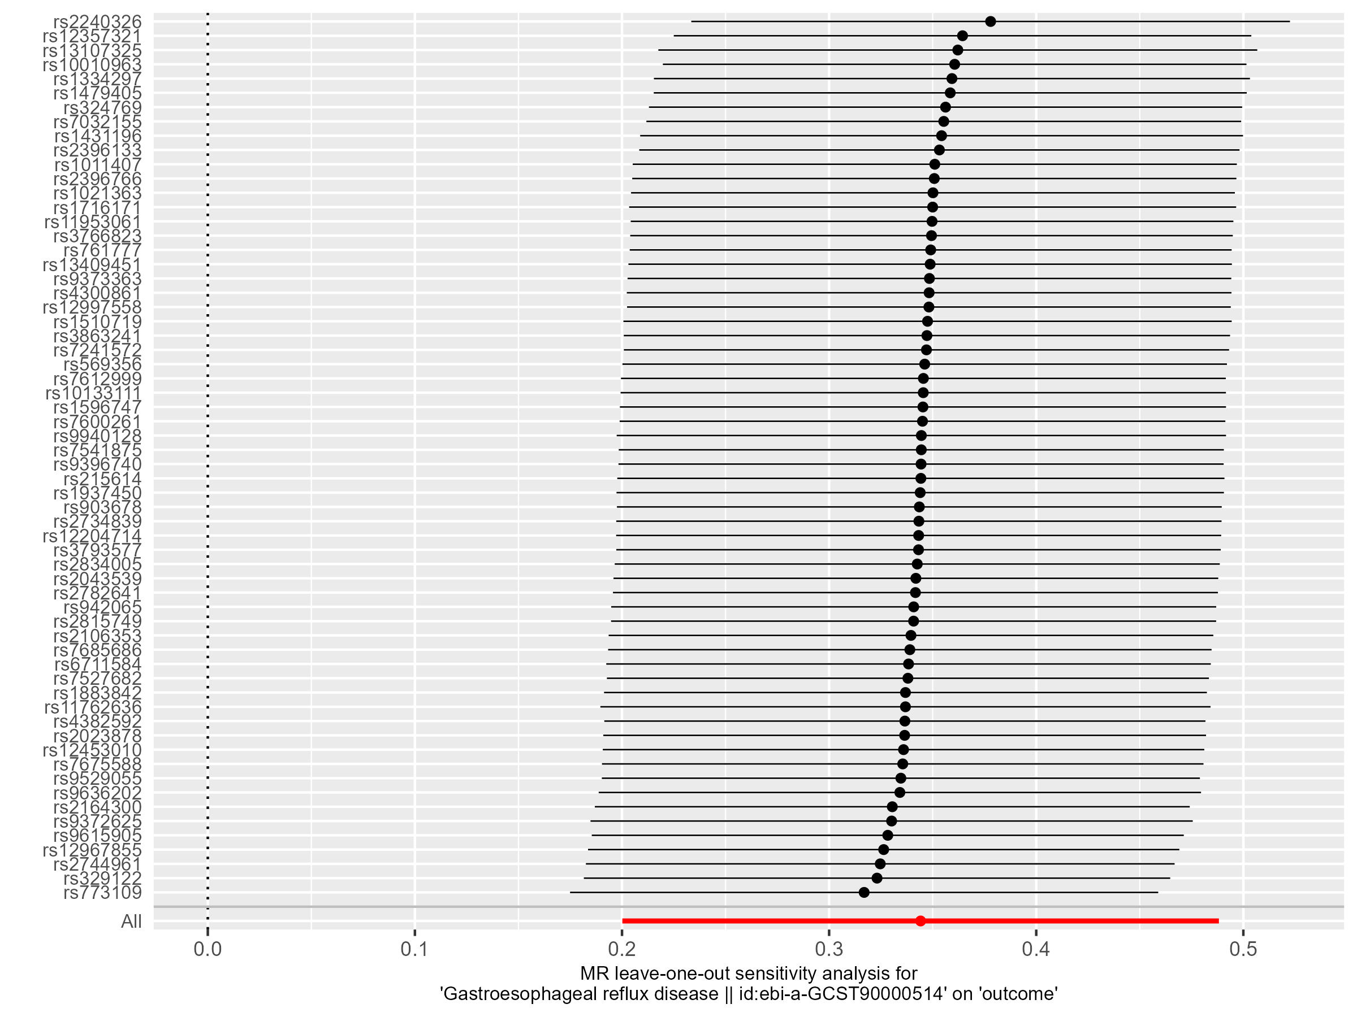

Figue1. The leave-one-out plot of MR analysis of GERD as exposure. On the left is GERD on RA discovery, on the right is GERD on RA validation. GERD, Gastroesophageal reflux disease; RA, rheumatoid arthritis.
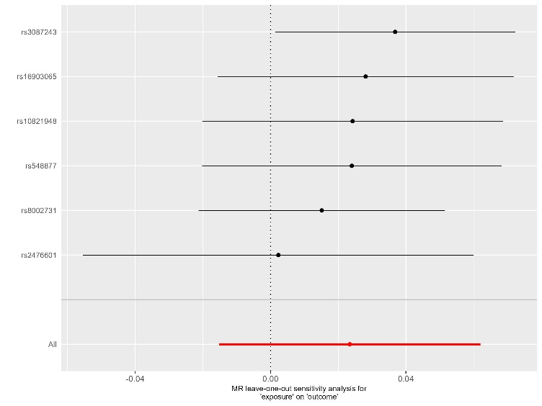
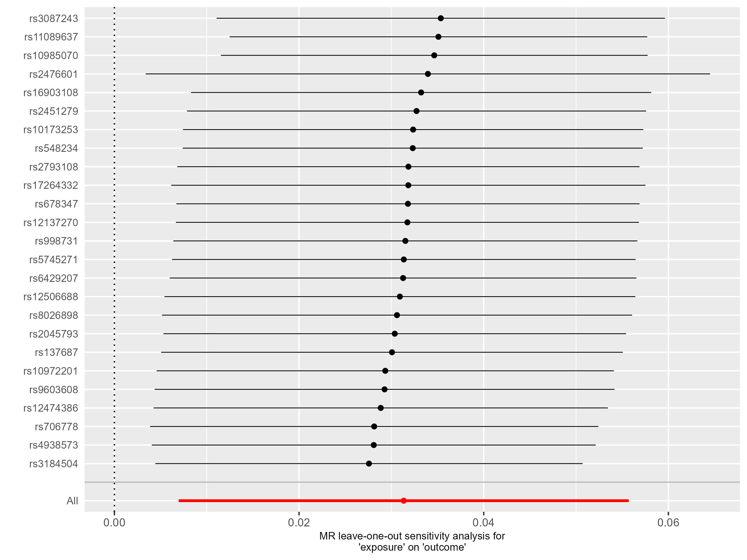

Figue2. The leave-one-out plot results of MR analysis of RA as exposure. On the left is RA discovery on GERD, on the right is RA validation on GERD.

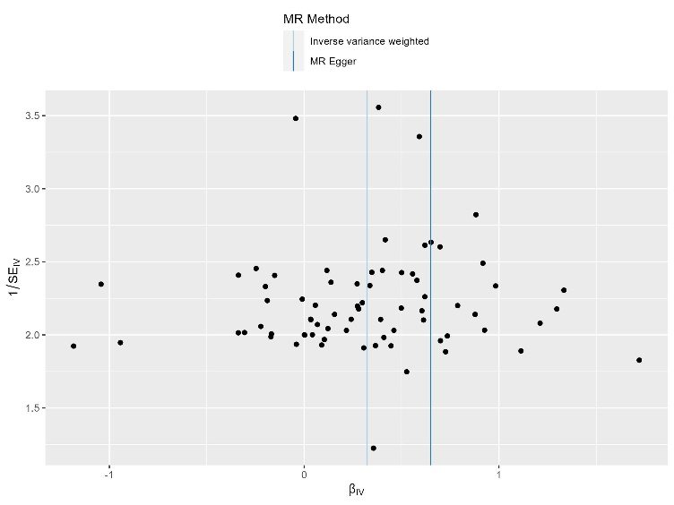
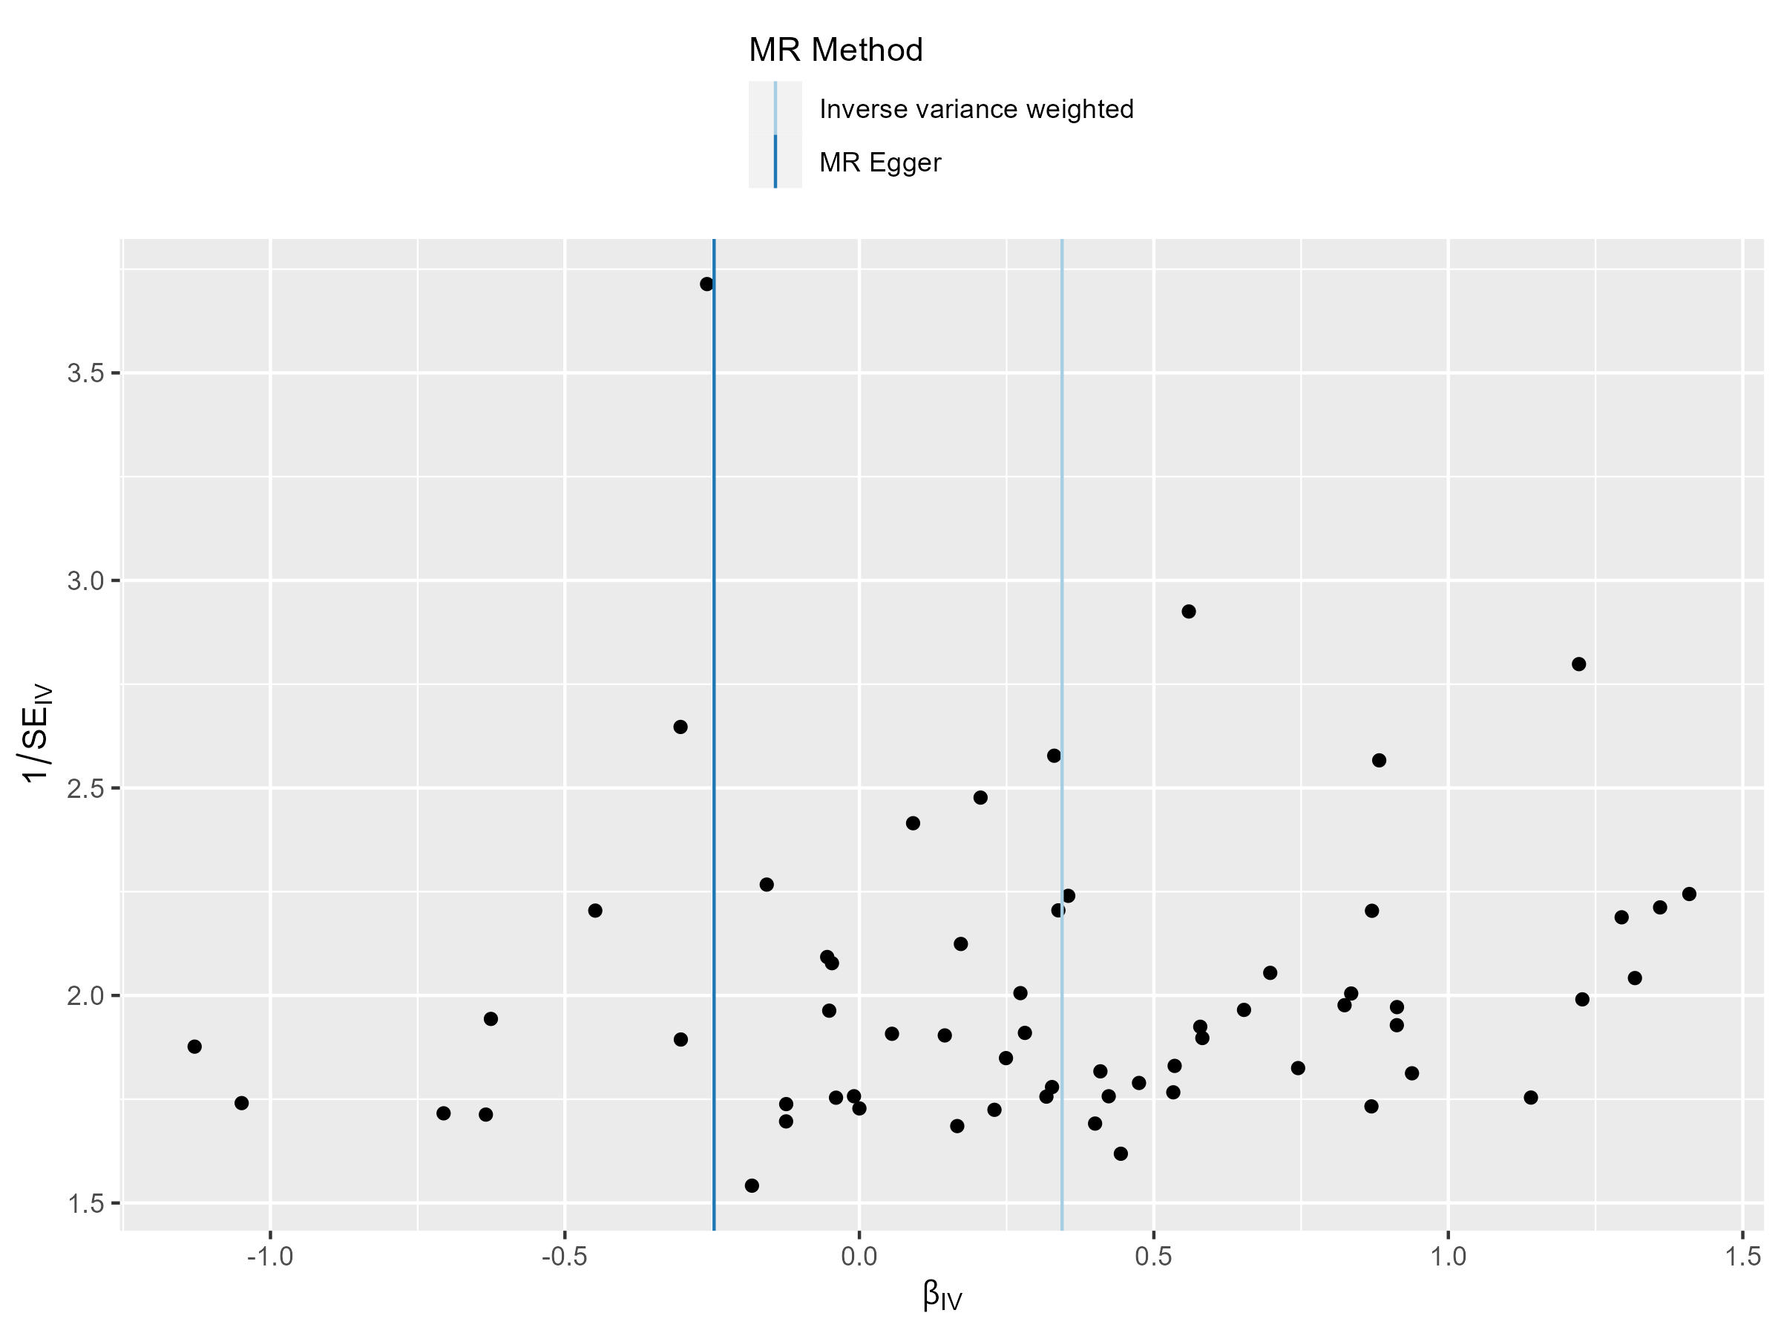
Figue3. The funnel plot results of MR analysis of GERD as exposure. On the left is GERD on RA discovery, on the right is GERD on RA validation.
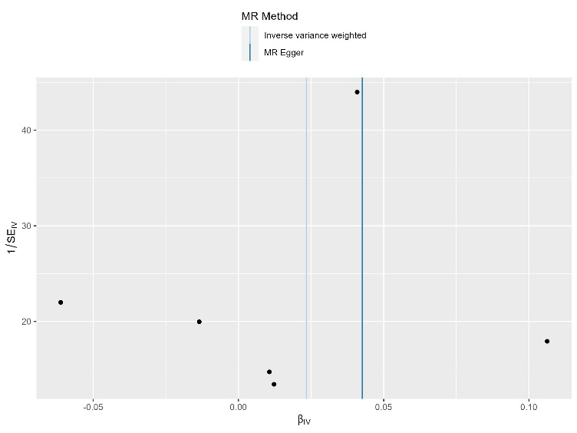
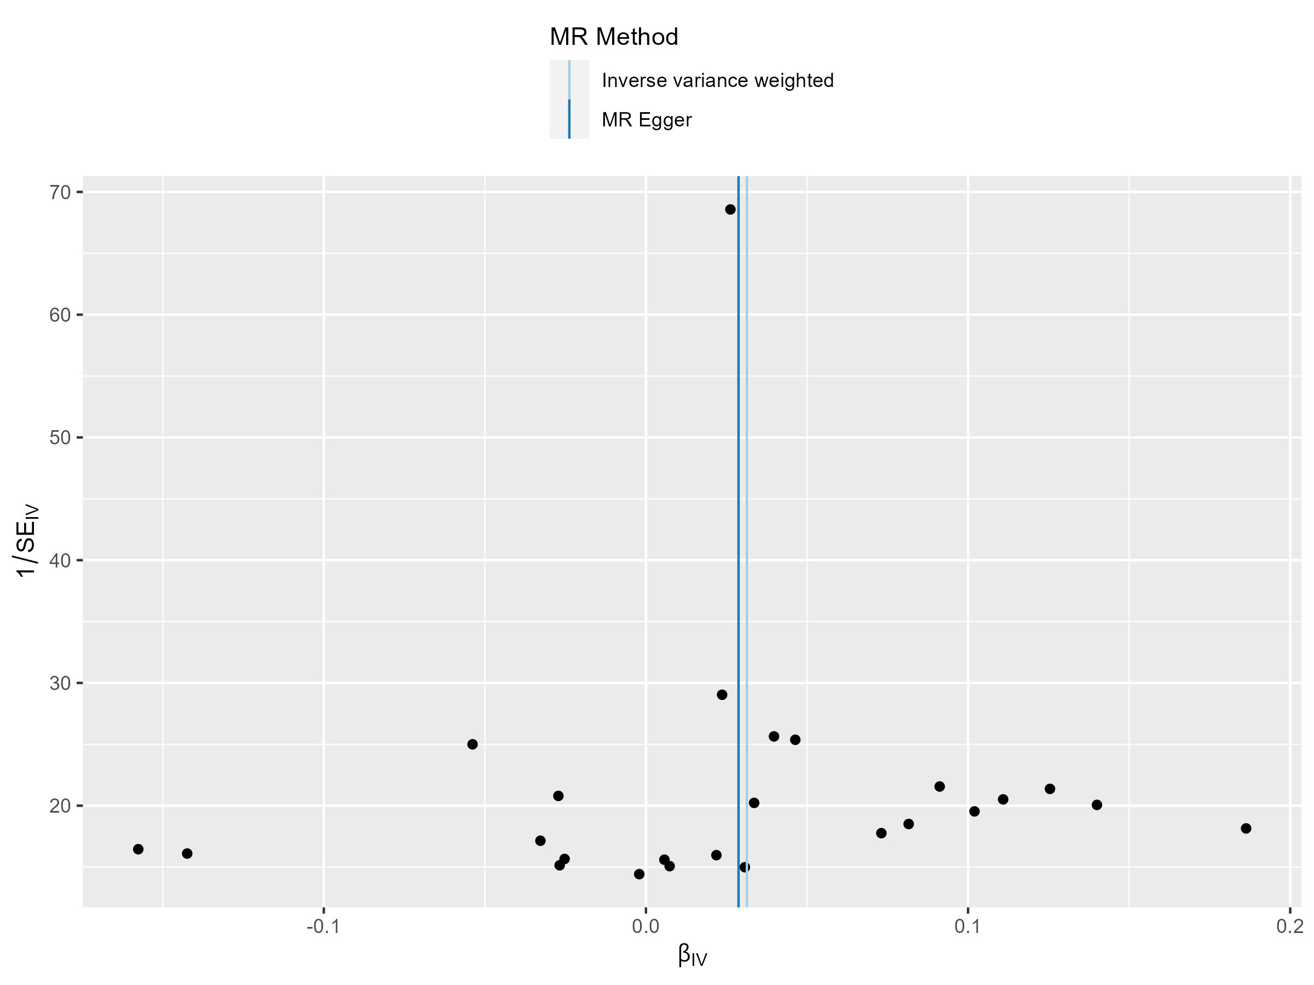

Figue4. The funnel plot results of MR analysis of RA as exposure. On the left is RA discovery on GERD, on the right is RA validation on GERD.

