Table 1: Features Data Type.
Feature | Datatype
loan amnt | Continuous
term | Categoric (Binary )
installment | Continuous
sub_grade | Categoric
emp_length | Categoric
home_ ownership | Categoric
annual_inc | Continuous
purpose | Categoric
dti | Continuous
tot_cur_bal | Discrete
open_act_il | Discrete
open_il_24m | Discrete
il_util | Discrete
avg_cur_bal | Discrete
bc_util | Continuous
num _sats | Discrete
total_rec_prncp | Continuous
last_pymnt_amnt | Continuous
total_rec_int | Continuous
int_rate | Continuous
total _ace | Discrete
tot_hi_cred_lim | Continuous
open_il_12m | Discrete
num_tl_ op_past_ 12m | Discrete
num_rev_ tl_bal_gt_ 0 | Discrete
num-rev-accts | Discrete
num_il tl | Discrete
num_bc_tl | Discrete
mths_since_recent_ inq | Discrete
application_type | Categoric
mths_since_last_ delinq | Discrete
delin q_amnt | Continuous
collections_12_mths_ex _med | Discrete
pub_ rec_bankruptcies | Continuous
ace_open_past_ 24mths | Discrete
loan status | Categoric (Binary )

Table 2: Selected features
Feature Code | Feature Name | Feature Description
X1 | loan anmt | The listed amount of the loan applied for by the borrower. If at some point in time, the credit department reduces the loan amount, then it will be reflected in this value (I000-40000)
X2 | term | The number of payments on the loan (60 months. 36 months)
X3 | grade | Assessment of the credit risk of the corresponding loan. LC assigns a grade (A-G) assessment of the credit risk of the corresponding loan.
X4 | emp_length | Employment length in years, Possible values are between 0 and 10 where 0 means less than one year and 10 means ten or more years.
X5 | home_ownership | The home ownership status provided by the borrower during registration. values are Rent, Own, Mortage, Any.
X6 | annual inc | Total amount of money borrower makes each year; and self-reported provided by the borrower registration
X7 | loan status | Status of loan Eligible or Ineligible
X8 | purpose | Purpose of Borrow the loan.
X9 | dti | Debt-to-income ratio, A personal finance measure that compares the amount of debt the borrower has to his overall income
X10 | num sats | Number of satisfactory accounts, represent the number of accounts which have been paid in full and on time
X11 | tot cur bal | The total current balance of all accounts'' total assets minus total liabilities''
X12 | int-rate | interest rate: the amount charged by a lender to a borrower and is expressed as a percentage of the principal the amount lent.

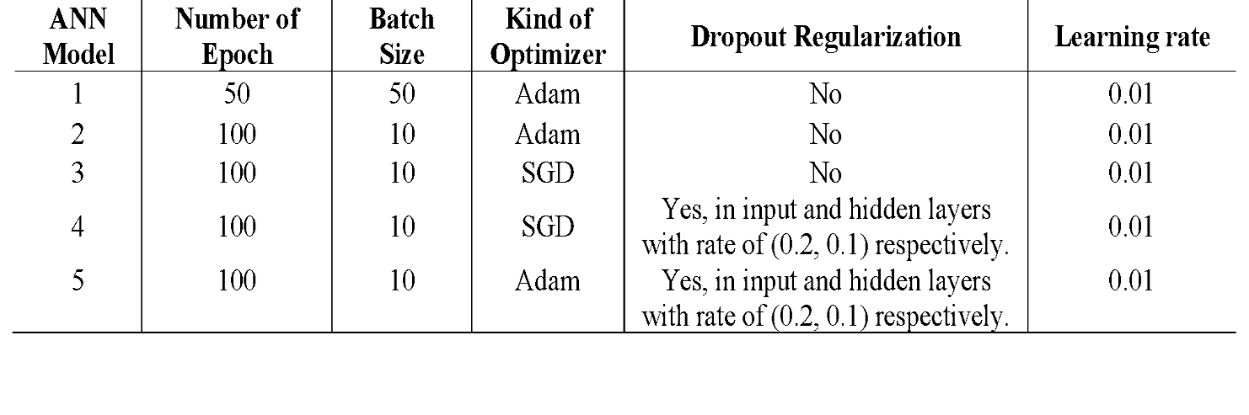
Table 3: Neural Network Models

Table 4: Performance Measurement of Eligibility Models
ANN  Model | Accuracy of Both classes Values | Precision of Both classes Values | Recall of Both classes Values | F1 score for Both classes Values | Confusion Matrix (TP, FP, FN,TN)
1 | 0.61 | 0.64 | 0.64 | 0.64 | (1751,921,969,1640)
2 | 0.64 | 0.65 | 0.64 | 0.63 | (2048,624,1280,1329)
3 | 0.63 | 0.65 | 0.62 | 0.61 | (2191,481,1491,1118)
4 | 0.64 | 0.64 | 0.64 | 0.64 | (1929,743,1166,1443)
5 | 0.65 | 0.65 | 0.62 | 0.61 | (2241,431,1536,1073)

