Supplementary information
Growth-dependent Cr(VI) reduction by Alteromonas sp. under haloalkaline conditions: toxicity, removal mechanism and effect of heavy metals
G. Kiran Kumar Reddy^{1,2,#}, K. Kavibharathi^{1,#}, Anuroop Singh¹, Y. V. Nancharaiah^{1,2*}
¹Biofouling and Biofilm Processes Section, WSCD, Chemistry Group, Bhabha Atomic Research Centre, Kalpakkam 603102, India.
²Homi Bhabha National Institute, Anushakti Nagar, Mumbai 400094, India.
#Equal contribution

*Corresponding author:
Y.V. Nancharaiah,
Biofouling and Biofilm Processes Section, WSCD, Chemistry Group,
Bhabha Atomic Research Centre, Kalpakkam 603102, India.
phone: +9144 27480500 23342; Fax: +9144 27480097.
Email: yvn@igcar.gov.in, venkatany@gmail.com

Pages: 6
Figures: 5

Figure S1. Alteromonas sp. growth in growth media with 100 mg/L Cr(IV) at different initial pH.

Figure S2. Time profiles of Cr(VI) in growth medium at different pH under abiotic conditions.
Figure S3. Cr(VI) removal kinetics in growth media (ZMB) inoculated at different cell densities of Alteromonas sp. A) Time profiles of Cr(VI) removal during 36 h. B) Cr(VI) removal efficiencies at the end of 11 h incubation.

Figure S4. Cr(VI) removal by resting cells of Alteromonas sp. in plain seawater. Seawater was inoculated with excess cell numbers (10¹² cells mL⁻¹) and for monitoring Cr(VI) removal by resting cells.

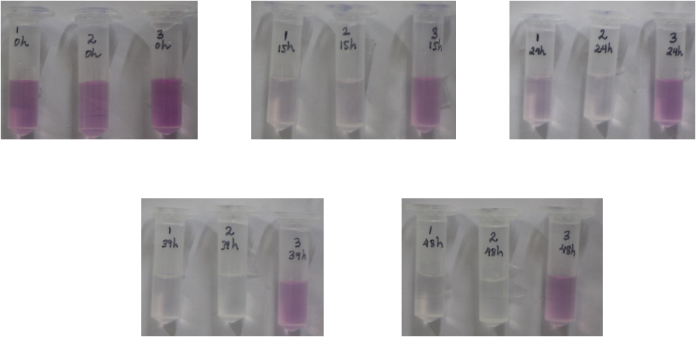
Figure S5. Cr(VI) removal by Alteromonas sp. protein extracts in the presence of NADPH. The pink color is due to Cr(VI)-DPC complex formation which indicates presence of Cr(VI) in the sample. 1: Crude extract, 2: Cytosolic protein fraction, 3: Membrane protein fraction.

