Supplementary material

Priority effects and microbial cross-feeding shape zoonotic agent spread in broiler chickens
Marcos et al.

Table of contents
Table 1: Overrepresented source metabolites for Campylobacter jejuni in the distinct enterotype.
Table 2: Differentially expressed genes in caecal host mucosa at day 35 between standard and distinct enterotypes.
Table 3: Metabolic pathways employed in the functional distillation analysis using the R package distillR.

Figure S1: Top 2% bacteria drivers of enterotypes defined by Dirichlet Multinomial Models.
Figure S2: Relative abundance of each bacterial strain for the standard and distinct enterotypes for the three sampling points, 7, 21 and 35.
Figure S3: Spanning tree of joint genome-scale metabolic network model between Campylobacter jejuni and C. coli.
Figure S4: Body weight changes between experimental trials across the three sampling time points, days 7, 21 and 35.
Figure S5: Volcano plots of Differential Gene Expression analyses.
Figure S6: Community MCI values for standard and distinct enterotypes.

Supplementary Table S1:
Overrepresented source metabolites for Campylobacter jejuni in the distinct enterotype.
Gene | p-value | Standard mean value | Distinct mean value | Difference | Adjusted_p-value
COPROPORPHYRIN_III | 2.6728E-16 | 0.02 | 0.31 | 0.29 | 1.5101E-14
CPD.31 | 1.6891E-07 | 0.02 | 0.30 | 0.28 | 1.0046E-06
SULFATE | 1.5273E-09 | 0.07 | 0.35 | 0.28 | 1.4382E-08
MOCS3.Cysteine | 1.1046E-06 | 0.04 | 0.31 | 0.27 | 5.221E-06
Thiocarboxylated.MPT.synthases | 1.1046E-06 | 0.04 | 0.31 | 0.27 | 5.221E-06
D.ERYTHRO.IMIDAZOLE.GLYCEROL.P | 2.1499E-11 | 0.06 | 0.33 | 0.27 | 7.815E-10
FMNH2 | 1.4416E-08 | 0.08 | 0.34 | 0.26 | 1.0181E-07
Dihydro.Lipoyl.Proteins | 1.4661E-06 | 0.05 | 0.31 | 0.26 | 6.3718E-06
TRP.tRNAs | 2.6447E-10 | 0.13 | 0.38 | 0.25 | 3.3206E-09
ASP.tRNAs | 2.6447E-10 | 0.13 | 0.38 | 0.25 | 3.3206E-09
TYR.tRNAs | 2.6447E-10 | 0.13 | 0.38 | 0.25 | 3.3206E-09
Protein.Histidines | 2.6066E-20 | 0.15 | 0.38 | 0.24 | 2.9454E-18
TYR | 2.7664E-11 | 0.16 | 0.39 | 0.24 | 7.815E-10
ALA.tRNAs | 2.4764E-10 | 0.16 | 0.39 | 0.22 | 3.3206E-09
XANTHINE | 0.00016904 | 0.44 | 0.65 | 0.21 | 0.0005306
CPD.597 | 8.9924E-10 | 0.20 | 0.40 | 0.20 | 1.0161E-08
N.acetyl.D.mannosamine | 1.1089E-06 | 0.27 | 0.46 | 0.20 | 5.221E-06
HS | 0.00036103 | 0.45 | 0.64 | 0.19 | 0.00109149
L.PANTOATE | 8.5958E-09 | 0.36 | 0.55 | 0.19 | 6.4755E-08
Red.Glutaredoxins | 0.00042238 | 0.48 | 0.67 | 0.19 | 0.00119324
ETOH | 8.3666E-09 | 0.23 | 0.42 | 0.19 | 6.4755E-08
MANNOSE.1P | 1.1755E-07 | 0.33 | 0.50 | 0.17 | 7.8139E-07
X2.PG | 0.00390177 | 0.50 | 0.67 | 0.17 | 0.00938084
CHOLATE | 0.00012236 | 0.41 | 0.57 | 0.16 | 0.00039505
CPD.15189 | 0.00012236 | 0.41 | 0.57 | 0.16 | 0.00039505
GLUTATHIONE | 0.00650179 | 0.53 | 0.68 | 0.15 | 0.01469404
NIACINE | 0.00036705 | 0.48 | 0.63 | 0.14 | 0.00109149
LACTALD | 2.4602E-05 | 0.49 | 0.62 | 0.13 | 9.2668E-05
X3.Hydroxy.Terminated.DNAs | 9.9857E-06 | 0.66 | 0.74 | 0.07 | 4.0299E-05
DCTP | 0.02557008 | 0.73 | 0.79 | 0.06 | 0.04897321
CPD.4211 | 0.0218647 | 0.04 | 0.04 | 0.00 | 0.04350291
Supplementary Table S2:
Differentially expressed genes in caecal host mucosa at days 7 and 35 between standard and distinct enterotypes.

Day | Gene | logFC | FDR | description
7 | LOC107055361 | -1.813867045 | 0.01946043684
7 | HBA1 | 1.394133619 | 0.03030980116 | hemoglobin subunit alpha 1
7 | HBE1 | 1.882651162 | 0.03797486673 | hemoglobin subunit epsilon 1
7 | H1F0 | 1.368723298 | 0.04274410218 | H1 histone family member 0
35 | NPTX2 | 1.260895776 | 0.002013652073
35 | WDR72 | 1.406510168 | 0.00248805704
35 | SYPL1 | 1.47579761 | 0.005875019077 | synaptophysin like 1
35 | SLC23A1 | -1.591967739 | 0.008630811
35 | LOC124417815 | -1.448936666 | 0.008913914643
35 | ABCB5 | 1.529901554 | 0.01015709323
35 | TNFRSF13B | -1.405821071 | 0.01015709323 | TNF receptor superfamily member 13B
35 | POU2AF1 | -1.237562167 | 0.01351103227 | POU class 2 homeobox associating factor 1
35 | LOC107055347 | -1.297939747 | 0.01351103227
35 | LOC112532123 | 1.484612487 | 0.01520477153
35 | IGLL1 | -1.392582362 | 0.01682239206 | immunoglobulin lambda-like polypeptide 1
35 | CYP1A1 | 3.118820256 | 0.01823410302 | cytochrome P450 family 1 subfamily A polypeptide 1
35 | DCLK2 | 1.222715467 | 0.02210893979
35 | PLA2G12B | 1.451253504 | 0.02270499991
35 | LOC121109172 | 2.872526104 | 0.02322920014
35 | AOX2 | 1.771952135 | 0.02322920014 | aldehyde oxidase 2
35 | LSAMP | -2.516523807 | 0.02336753155 | limbic system-associated membrane protein
35 | SCN3B | 1.258063206 | 0.02342815201
35 | UNC13C | 1.339991104 | 0.03344018545
35 | POU3F4 | -1.432191081 | 0.03449976386
35 | CYP1A2 | 2.179678621 | 0.03968125009 | cytochrome P450 family 1 subfamily A polypeptide 2
35 | TENM2 | -1.822964898 | 0.03968125009 | teneurin transmembrane protein 2
35 | LOC101751887 | -1.268576734 | 0.03968125009
35 | SERPINB2 | 1.890363862 | 0.04185810366
35 | XKR9 | 1.236415045 | 0.04238328498 | XK related 9
35 | CXCL13L2 | -1.279297801 | 0.04277567648 | C-X-C motif chemokine ligand 13-like 2
35 | GATD3AL2 | -1.576733854 | 0.04324779248
35 | TAAR1 | -1.287719979 | 0.04348330823
35 | SLC2A9 | -1.35637258 | 0.04390555035
35 | MMP27 | -1.753122383 | 0.04497641138 | matrix metallopeptidase 1
35 | LAG3 | -1.29466731 | 0.04633592068
35 | KCNA3 | -1.228759901 | 0.04791602393 | potassium voltage-gated channel subfamily A member 3
35 | NPW | -1.250985281 | 0.04949297101
35 | GNLY | -1.240782685 | 0.04950569715 | granulysin
35 | EVA1CL | -1.752173587 | 0.04987489453
35 | CPT1A | 1.20428051 | 0.04989214558 | carnitine palmitoyltransferase 1A

Supplementary Table S3:
Nomenclature, classification and definitions of metabolic pathways employed in the functional distillation analysis using the R package distillR.
Pathway | Element | Function | Definition
B010101 | Inosinic acid (IMP) | Nucleic acid biosynthesis | K00764 (K01945,K11787,K11788,K13713) (K00601,K11175,K08289,K11787,K01492) (K01952,(K23269+K23264+K23265),(K23270+K23265)) (K01933,K11787,(K11788 (K01587,K11808,(K01589 K01588)))) (K01923,K01587,K13713) K01756 (K00602,(K01492,(K06863 K11176)))
B010201 | Uridylic acid (UMP) | Nucleic acid biosynthesis | (K11540,((K11541 K01465),((K01954,(K01955+K01956)) ((K00609+K00610),K00608) K01465))) (K00226,K00254,K17828) (K13421,(K00762 K01591))
B010301 | UDP/UTP | Nucleic acid biosynthesis | (K13800,K13809,K09903)
B010401 | CDP/CTP | Nucleic acid biosynthesis | (K00940,K18533) K01937
B010501 | ADP/ATP | Nucleic acid biosynthesis | K01939 K01756 (K00939,K18532,K18533,K00944) K00940
B010601 | GDP/GTP | Nucleic acid biosynthesis | K00088 K01951 K00942 (K00940,K18533)
B020401 | Serine | Amino acid biosynthesis | K00058 K00831 (K01079,K02203,K22305,K25528)
B020501 | Threonine | Amino acid biosynthesis | (K00928,K12524,K12525,K12526) K00133 (K00003,K12524,K12525) (K00872,K02204,K02203) K01733
B020601 | Cysteine | Amino acid biosynthesis | (K00640,K23304) (K01738,K13034,K17069)
B020602 | Cysteine | Amino acid biosynthesis | (K01697,K10150) K01758
B020603 | Cysteine | Amino acid biosynthesis | K00789 K17462 K01243 K07173 K17216 K17217
B020701 | Methionine | Amino acid biosynthesis | (K00928,K12524,K12525) K00133 (K00003,K12524,K12525) (K00651,K00641) K01739 (K01760,K14155) (K00548,K24042,K00549)
B020801 | Valine | Amino acid biosynthesis | (K01652+(K01653,K11258)) K00053 K01687 K00826
B020901 | Isoleucine | Amino acid biosynthesis | (K01703+K01704) K00052
B020902 | Isoleucine | Amino acid biosynthesis | (K17989,K01754) (K01652+(K01653,K11258)) K00053 K01687 K00826
B021001 | Leucine | Amino acid biosynthesis | K01649 (K01702,(K01703+K01704)) K00052
B021101 | Lysine | Amino acid biosynthesis | (K00928,K12524,K12525,K12526) K00133 K01714 K00215 K00674 (K00821,K14267) K01439 K01778 (K01586,K12526)
B021102 | Lysine | Amino acid biosynthesis | K00928 K00133 K01714 K00215 K05822 K00841 K05823 K01778 K01586
B021103 | Lysine | Amino acid biosynthesis | (K00928,K12524,K12525,K12526) K00133 K01714 K00215 K03340 (K01586,K12526)
B021104 | Lysine | Amino acid biosynthesis | (K00928,K12524,K12525,K12526) K00133 K01714 K00215 K10206 K01778 (K01586,K12526)
B021105 | Lysine | Amino acid biosynthesis | K01655 ((K17450 K01705),(K16792+K16793)) K05824
B021106 | Lysine | Amino acid biosynthesis | K05827 K05828 K05829 K05830 K05831
B021201 | Arginine | Amino acid biosynthesis | K00611 K01940 (K01755,K14681)
B021202 | Arginine | Amino acid biosynthesis | K22478 K00145 K00821 K09065 K01438 K01940 K01755
B021301 | Proline | Amino acid biosynthesis | ((K00931 K00147),K12657) K00286
B021401 | Glutamate | Amino acid biosynthesis | K00673 K01484 K00840 K06447 K05526
B021402 | Glutamate | Amino acid biosynthesis | K01745 K01712 K01468 (K01479,K00603,K13990,(K05603 K01458))
B021501 | Histidine | Amino acid biosynthesis | K00765 ((K01523 K01496),K11755,K14152) (K01814,K24017) ((K02501+K02500),K01663) ((K01693 K00817 (K04486,K05602,K18649)),(K01089 K00817)) (K00013,K14152)
B021601 | Tryptophan | Amino acid biosynthesis | ((((K01657+K01658),K13503,K13501,K01656) K00766),K13497) (((K01817,K24017) (K01656,K01609)),K13498,K13501) ((K01695+(K01696,K06001)),K01694)
B021701 | Phenylalanine | Amino acid biosynthesis | (((K01850,K04092,K14187,K04093,K04516,K06208,K06209) (K01713,K04518,K05359)),K14170) (K00832,K00838)
B021801 | Tyrosine | Amino acid biosynthesis | (((K01850,K04092,K14170,K04093,K04516,K06208,K06209) (K04517,K00211)),K14187) (K00832,K00838)
B021802 | Tyrosine | Amino acid biosynthesis | (K01850,K04092,K14170) (K00832,K15849) (K00220,K24018,K15227)
B021901 | GABA | Amino acid biosynthesis | K09470 K09471 K09472 K09473
B022001 | Beta-alanine | Amino acid biosynthesis | (K00207,(K17722+K17723)) K01464 (K01431,K06016)
B022002 | Beta-alanine | Amino acid biosynthesis | 6.2.1.17 1.3.8.1 4.2.1.116 3.1.2.4 1.1.159 2.6.1.18
B022101 | Ornithine | Amino acid biosynthesis | (K00618,K00619,K14681,K14682,K00620,K22477,K22478) (((K00930,K22478) K00145),K12659) (K00818,K00821) (K01438,K14677,K00620)
B022102 | Ornithine | Amino acid biosynthesis | K19412 K05828 K05829 K05830 K05831
B022103 | Ornithine | Amino acid biosynthesis | 2.3.1.1 2.7.2.8 1.2.1.38 2.6.1.11 3.5.1.16
B030201 | Betaine | Amino acid derivative biosynthesis | 1.1.99.1 1.2.1.8
B030202 | Betaine | Amino acid derivative biosynthesis | 2.1.1.156 2.1.1.157
B030301 | Ectoine | Amino acid derivative biosynthesis | K00928 K00133 K00836 K06718 K06720
B030701 | Spermidine | Amino acid derivative biosynthesis | (K01583,K01584,K01585,K02626) K01480
B030901 | Putrescine | Amino acid derivative biosynthesis | K01476 K01581
B031001 | Tryptamine | Amino acid derivative biosynthesis | (4.1.1.28,4.1.1.105)
B040101 | Acetate | SCFA biosynthesis | (K00625,K13788,K15024) K00925
B040103 | Acetate | SCFA biosynthesis | K01067
B040104 | Acetate | SCFA biosynthesis | 5.4.3.2 5.4.3.3 1.4.1.11 2.3.1.247 1.3.1.109 2.8.3.9 (2.3.1.9,2.3.1.16) 2.3.1.8 (2.7.2.1,2.7.2.15)
B040105 | Acetate | SCFA biosynthesis | 1.21.4.2 (2.7.2.1,2.7.2.15)
B040106 | Acetate | SCFA biosynthesis | (1.2.7.1,1.2.1.104) 2.3.1.8 (2.7.2.1,2.7.2.15)
B040201 | Butyrate | SCFA biosynthesis | 1.2.7.1 (2.3.1.9,2.3.1.16) 1.1.1.35 4.2.1.150 1.3.1.109 2.3.1.19 (2.7.2.7,2.7.2.14)
B040202 | Butyrate | SCFA biosynthesis | 2.3.1.8 (2.7.2.1,2.7.2.15) (2.8.3.1,2.8.3.8)
B040203 | Butyrate | SCFA biosynthesis | (2.3.1.9,2.3.1.16) 1.1.1.36 4.2.1.55 1.3.1.109 (2.8.3.1,2.8.3.8)
B040204 | Butyrate | SCFA biosynthesis | 1.4.1.2 1.1.1.399 2.8.3.12 4.2.1.167 7.2.4.5 1.3.1.109 (2.8.3.1,2.8.3.8)
B040205 | Butyrate | SCFA biosynthesis | 5.4.3.2 5.4.3.3 1.4.1.11 2.3.1.247 1.3.1.109 2.8.3.9
B040206 | Butyrate | SCFA biosynthesis | 2.8.3.18 1.2.1.76 1.1.1.61 2.8.3.M6 4.2.1.120 1.3.1.109 (2.8.3.1,2.8.3.8)
B040207 | Butyrate | SCFA biosynthesis | 1.4.1.2 1.1.1.399 2.8.3.12 4.2.1.167 7.2.4.5 1.3.1.109 (2.8.3.1,2.8.3.8)
B040208 | Butyrate | SCFA biosynthesis | 1.4.1.2 1.1.1.399 2.8.3.12 4.2.1.167 7.2.4.5 1.3.1.109 (2.8.3.1,2.8.3.8)
B040301 | Propionate | SCFA biosynthesis | (4.2.1.28,1.1.1.1) 1.2.1.87 2.3.1.222 (2.7.2.1,2.7.2.7,2.7.2.14,2.7.2.15)
B040302 | Propionate | SCFA biosynthesis | 4.3.1.19 2.3.1.222 (2.7.2.1,2.7.2.7,2.7.2.14,2.7.2.15)
B040304 | Propionate | SCFA biosynthesis | 2.1.3.1 1.1.1.37 4.2.1.2 1.3.5.1 2.8.3.27
B040305 | Propionate | SCFA biosynthesis | 2.8.3.1 4.2.1.54 1.3.1.95 2.8.3.1
B040306 | Propionate | SCFA biosynthesis | 2.6.1.2 1.1.1.28 2.8.3.1 4.2.1.54 1.3.1.95 2.8.3.1
B050101 | Indole-3-acetate | Indolic compound biosynthesis | 1.13.12.3 3.5.1.4
B050102 | Indole-3-acetate | Indolic compound biosynthesis | 4.2.1.84 3.5.1.4
B050103 | Indole-3-acetate | Indolic compound biosynthesis | 3.5.5.1
B050104 | Indole-3-acetate | Indolic compound biosynthesis | (2.6.1.1,2.6.1.27) 4.1.1.74 1.2.3.7
B050105 | Indole-3-acetate | Indolic compound biosynthesis | (4.1.1.28,4.1.1.105) 1.4.3.4 1.2.3.7
B060401 | indole-3-lactate | Organic anion biosynthesis | 1.1.1.27
B060402 | L-lactate | Organic anion biosynthesis | 1.1.1.22
B060501 | D-lactate | Organic anion biosynthesis | 1.1.1.28
B060101 | Succinate | Organic anion biosynthesis | (K01647,K05942) (K01681,K01682) (K00031,K00030) ((((K00164+K00658),K01616)+K00382),(K00174+K00175)) ((K01902+K01903),(K01899+K01900),K18118) ((K00234+K00235+K00236+(K00237,K25801)),(K00239+K00240+K00241),(K00244+K00245+K00246)) (K01676,K01679,(K01677+K01678)) (K00026,K00025,K00024,K00116)
B060102 | Succinate | Organic anion biosynthesis | ((((K00164+K00658),K01616)+K00382),K00174) ((K01902+K01903),(K01899+K01900),K18118) ((K00234+K00235+K00236+(K00237,K25801)),(K00239+K00240+K00241),(K00244+K00245+K00246)) (K01676,K01679,(K01677+K01678)) (K00026,K00025,K00024,K00116)
B060103 | Succinate | Organic anion biosynthesis | K01580 (K13524,K07250,K00823,K16871) (K00135,K00139,K17761)
B060104 | Succinate | Organic anion biosynthesis | (K00169+K00170+K00171+K00172) K01007 K01595 K00024 (K01677+K01678) (K00239+K00240) (K01902+K01903) (K15038,K15017) K14465 (K14467,K18861) K14534 K15016 K00626
B060105 | Succinate | Organic anion biosynthesis | (K02160+K01961+K01962+K01963) K14468 K14469 K15052 K05606 (K01847,(K01848+K01849)) (K14471+K14472) (K00239+K00240+K00241) K01679 K08691 K14449 K14470 K09709
B060106 | Succinate | Organic anion biosynthesis | (K00169+K00170+K00171+K00172) (K01959+K01960) K00024 (K01677+K01678) (K18209+K18210) (K01902+K01903) (K00174+K00175+K00176+K00177)
B060201 | Fumarate | Organic anion biosynthesis | (K01647,K05942) (K01681,K01682) (K00031,K00030) ((((K00164+K00658),K01616)+K00382),(K00174+K00175)) ((K01902+K01903),(K01899+K01900),K18118) ((K00234+K00235+K00236+(K00237,K25801)),(K00239+K00240+K00241),(K00244+K00245+K00246)) (K01676,K01679,(K01677+K01678)) (K00026,K00025,K00024,K00116)
B060202 | Fumarate | Organic anion biosynthesis | ((((K00164+K00658),K01616)+K00382),K00174) ((K01902+K01903),(K01899+K01900),K18118) ((K00234+K00235+K00236+(K00237,K25801)),(K00239+K00240+K00241),(K00244+K00245+K00246)) (K01676,K01679,(K01677+K01678)) (K00026,K00025,K00024,K00116)
B060203 | Fumarate | Organic anion biosynthesis | K01948 K00611 K01940 (K01755,K14681) K01476
B060204 | Fumarate | Organic anion biosynthesis | (K00815,K00838,K00832,K03334) K00457 K00451 K01800 (K01555,K16171)
B060205 | Fumarate | Organic anion biosynthesis | K00241+(K00242,K18859,K18860)+K00239+K00240
B060206 | Fumarate | Organic anion biosynthesis | K00244+K00245+K00246+K00247
B060207 | Fumarate | Organic anion biosynthesis | (K00169+K00170+K00171+K00172) K01007 K01595 K00024 (K01677+K01678) (K00239+K00240) (K01902+K01903) (K15038,K15017) K14465 (K14467,K18861) K14534 K15016 K00626
B060208 | Fumarate | Organic anion biosynthesis | (K02160+K01961+K01962+K01963) K14468 K14469 K15052 K05606 (K01847,(K01848+K01849)) (K14471+K14472) (K00239+K00240+K00241) K01679 K08691 K14449 K14470 K09709
B060209 | Fumarate | Organic anion biosynthesis | (K00169+K00170+K00171+K00172) (K01959+K01960) K00024 (K01677+K01678) (K18209+K18210) (K01902+K01903) (K00174+K00175+K00176+K00177)
B060210 | Fumarate | Organic anion biosynthesis | (K18029+K18030) K14974 K18028 K15357 K13995 K01799
B060211 | Fumarate | Organic anion biosynthesis | K00611 K01940 (K01755,K14681)
B060212 | Fumarate | Organic anion biosynthesis | K22478 K00145 K00821 K09065 K01438 K01940 K01755
B060213 | Fumarate | Organic anion biosynthesis | 2.6.1.1,2.6.1.5,2.6.1.27,2.6.1.57 1.13.11.27 1.13.11.5 5.2.1.2 3.7.1.2
B060301 | Citrate | Organic anion biosynthesis | (K01647,K05942) (K01681,K01682) (K00031,K00030) ((((K00164+K00658),K01616)+K00382),(K00174+K00175)) ((K01902+K01903),(K01899+K01900),K18118) ((K00234+K00235+K00236+(K00237,K25801)),(K00239+K00240+K00241),(K00244+K00245+K00246)) (K01676,K01679,(K01677+K01678)) (K00026,K00025,K00024,K00116)
B060302 | Citrate | Organic anion biosynthesis | (K01647,K05942) (K01681,K01682) (K00031,K00030)
B060303 | Citrate | Organic anion biosynthesis | K01647 (K01681,K01682) K01637 (K01638,K19282) (K00026,K00025,K00024)
B060304 | Citrate | Organic anion biosynthesis | K01647 K01681 K00031 K00261 (K19268+K01846) K04835 K19280 K14449 K19281 K19282 K00024
B070101 | Thiamine (B1) | Vitamin biosynthesis | (((K03148+K03154) K03151),(K03150 K03149)) K03147 ((K00941 K00788),K14153,K21219) K00946
B070102 | Thiamine (B1) | Vitamin biosynthesis | (((K03148+K03154) K03151),(K03153 K03149 K10810)) K03147 K00941 K00788 K00946
B070103 | Thiamine (B1) | Vitamin biosynthesis | (K22699,K03147) ((K00941 (K00788,K21220)),K21219) K00946
B070104 | Thiamine (B1) | Vitamin biosynthesis | (K00941 K00788),K14153,K21219
B070201 | Riboflavin (B2) | Vitamin biosynthesis | (((K01497,K14652) ((K01498 K00082),K11752) (K22912,K20860,K20861,K20862,K21063,K21064)),(K02858,K14652)) K00794 K00793 ((K20884 K22949),K11753)
B070301 | Niacin (B3) | Vitamin biosynthesis | 3.6.1.22 (3.2.2.6,3.2.2.4) 3.4.1.19
B070401 | Pantothenate (B5) | Vitamin biosynthesis | ((K00826 K00606 K00077),K01579) (K01918,K13799)
B070402 | Pantothenate (B5) | Vitamin biosynthesis | ((K00606 K00077),(K13367 K00128)) K01918
B070501 | Pyridoxal-P (B6) | Vitamin biosynthesis | K03472 K03473 K00831 K00097 K03474 K00275
B070502 | Pyridoxal-P (B6) | Vitamin biosynthesis | K06215 K08681
B070601 | Biotin (B7) | Vitamin biosynthesis | K00652 (((K00833,K19563) K01935),K19562) K01012
B070602 | Biotin (B7) | Vitamin biosynthesis | K00652 K25570 K01935 K01012
B070603 | Biotin (B7) | Vitamin biosynthesis | K16593 K00652 K19563 K01935 K01012
B070604 | Biotin (B7) | Vitamin biosynthesis | K01906 K00652 (K00833,K19563) K01935 K01012
B070701 | Tetrahydrofolate (B9) | Vitamin biosynthesis | (K01495,K09007,K22391) (K01077,K01113,(K08310,K19965)) ((K13939,((K13940,(K01633 K00950)) K00796)),(K01633 K13941)) (K11754,K20457) (K00287,K13998)
B070702 | Tetrahydrofolate (B9) | Vitamin biosynthesis | K14652 K22100 K01633 K13941 K22099 K00287
B070801 | Cobalamin (B12) | Vitamin biosynthesis | (K02302,((K02303,K13542) (K02304,K24866))) (K02190,K03795,K22011) K03394 (K05934,K13541,K21479) K05936 (K02189,K13541) K02188 K05895 ((K02191 K03399),K00595) K06042 K02224
B070802 | Cobalamin (B12) | Vitamin biosynthesis | (K02303,K13542) (K03394,K13540) K02229 (K05934,K13540,K13541) K05936 K02228 K05895 K00595 K06042 K02224 K02230+K09882+K09883
B070803 | Cobalamin (B12) | Vitamin biosynthesis | (K00798,K19221) K02232 (K02225,K02227) K02231 K00768 (K02226,K22316) K02233
B070901 | Tocopherol/tocotorienol (E) | Vitamin biosynthesis | K09833 (K12502,K18534) K09834 K05928
B071001 | Phylloquinone (K1) | Vitamin biosynthesis | ((K02552 K02551 K08680 K02549),K14759) (K01911,K14760) K01661 (K19222,K12073) K23094 K17872 K23095
B071101 | Menaquinone (K2) | Vitamin biosynthesis | K02552 K02551 K08680 K02549 K01911 K01661 K19222 K02548 K03183
B071102 | Menaquinone (K2) | Vitamin biosynthesis | K11782 K18285 (K18286,K20810) K11783 K11784 K11785
B071103 | Menaquinone (K2) | Vitamin biosynthesis | K11782 K18285 K18284 K11784 K11785
B071201 | Ubiquinone (Q10) | Vitamin biosynthesis | (K03181,K18240) K03179 (K03182+K03186) K18800 K00568 K03185 K03183 (K03184,K06134) K00568
B071202 | Ubiquinone (Q10) | Vitamin biosynthesis | K06125 K06126 K00591 K06127 K06134 K00591
B080101 | Salicylate | Aromatic compound biosynthesis | 5.4.4.2 4.2.99.21
B080201 | Gallate | Aromatic compound biosynthesis | 4.2.1.10
B080301 | Chorismate | Aromatic compound biosynthesis | 4.2.1.10 1.1.1.25 2.7.1.71 2.5.1.19 4.2.3.5
B080302 | Chorismate | Aromatic compound biosynthesis | 2.5.1.54 3.2.3.4 4.2.1.10 1.1.1.25 2.7.1.71 2.5.1.19 4.2.3.5
B080303 | Chorismate | Aromatic compound biosynthesis | 2.7.2.4 1.2.1.11 2.2.1.10 1.4.1.24 4.2.1.10 1.1.1.25 2.7.1.71 2.5.1.19 4.2.3.5
B080404 | Dipicolinate | Aromatic compound biosynthesis | 2.7.2.4 1.2.1.11 4.3.3.7
B090101 | Staphyloferrin | Metallophore biosynthesis | K21898 K23446 K23447
B090102 | Staphyloferrin | Metallophore biosynthesis | (5.1.1.10,5.1.1.12) 6.3.2.58 6.3.2.57
B090103 | Staphyloferrin | Metallophore biosynthesis | K23371 K21949 K21721 K23372 K23373 K23374 K23375
B090104 | Staphyloferrin | Metallophore biosynthesis | 2.7.1.225 2.5.1.140 1.5.1.51 6.3.2.54 4.1.1.117 6.3.2.55 6.3.2.56
B090201 | Aerobactin | Metallophore biosynthesis | K03897 K03896 K03894 K03895
B090202 | Aerobactin | Metallophore biosynthesis | 1.14.13.59 2.3.1.102 6.3.2.38 6.3.2.39
B090301 | Staphylopine | Metallophore biosynthesis | (5.1.1.10,5.1.1.24) 2.5.1.152 1.5.1.52
B100402 | Bacilysin | Antibiotic biosynthesis | 5.4.99.5 4.1.1.100 5.3.3.19 ((5.3.3.19 1.3.1.aa),1.3.1.aa) 1.1.1.385 6.3.2.49
B100601 | Carbapenem-3-carboxylate | Antibiotic biosynthesis | K18317 K18316 K18315
B100801 | Clavaminate | Antibiotic biosynthesis | K12673 K12674 K12675 K12676
B100802 | Clavaminate | Antibiotic biosynthesis | 2.5.1.66 6.3.3.4 1.14.11.21 3.5.3.22 1.14.11.21
B101101 | Erythromycin | Antibiotic biosynthesis | 2.1.1.254 1.14.13.154
B101102 | Erythromycin | Antibiotic biosynthesis | 2.3.1.94 1.14.15.35 2.4.1.328 2.4.1.278
B101202 | Fosfomycin | Antibiotic biosynthesis | 5.4.2.9 4.1.1.82 1.1.1.309 2.7.7.104 2.1.1.308 1.11.1.23
B101401 | Kanosamine | Antibiotic biosynthesis | K18652 K18653 K18654
B101402 | Kanosamine | Antibiotic biosynthesis | 1.1.1.361 2.6.1.104 3.1.3.92
B102101 | Novobiocin | Antibiotic biosynthesis | 6.3.1.15 2.1.1.284 2.4.1.302 2.1.1.285 2.1.3.12
B102201 | Paromamine | Antibiotic biosynthesis | 4.2.3.124 2.6.1.100 (1.1.1.329,1.1.99.38) 2.6.1.101 2.4.1.283 3.5.1.112
B102401 | Pentalenolactone | Antibiotic biosynthesis | K12250 K15907 K18056 K17747 K18091 K18057 K17476
B102402 | Pentalenolactone | Antibiotic biosynthesis | 4.2.3.7 1.4.15.32 1.14.11.35 1.1.1.340 1.14.13.170 1.14.11.36 1.14.19.8
B102601 | Prodigiosin | Antibiotic biosynthesis | ((K21780+K21781) K21782 K21783 K21784 K21785 K21786) (K21428 K21778 K21779) K21787
B102801 | Pyocyanin | Antibiotic biosynthesis | K13063 K20261 K06998 K20260 K20262 K21103 K20940
B102802 | Pyocyanin | Antibiotic biosynthesis | 2.1.1.327 1.14.13.218
B102901 | Pyrrolnitrin | Antibiotic biosynthesis | K14266 K19981 K14257 K19982
B104101 | Validamycin A | Antibiotic biosynthesis | K19969 K20431 K20432 K20433 K20434 K20435 K20436 K20437 K20438
B104102 | Validamycin A | Antibiotic biosynthesis | 4.2.3.152 5.1.3.33 2.7.1.214 (2.6.1.M1,2.7.7.91) 2.5.1.135 3.1.3.101 2.4.1.338 1.14.11.52
B104201 | Violacein | Antibiotic biosynthesis | K20086 (K20087+K20088) K20089 K20090
B104202 | Violacein | Antibiotic biosynthesis | 1.4.3.23 1.21.98.2 1.14.13.217 1.14.13.224
D010101 | Triglyceride | Lipid degradation | (K01046,K12298,K16816,K13534,K14073,K14074,K14075,K14076,K22283,K14452,K22284,K14674,K14675,K17900) (K01054,K25824)
D010102 | Triglyceride | Lipid degradation | (3.1.1.3,3.1.1.34) (3.1.1.34,3.1.1.79,3.1.1.116) (3.1.1.23,3.1.1.79)
D010201 | Fatty acid | Lipid degradation | (K01897,K15013) (K00232,K00249,K00255,K06445,K09479) (((K01692,K07511,K13767) (K00022,K07516)),K01825,K01782,K07514,K07515,K10527) (K00632,K07508,K07509,K07513)
D010301 | Oleate | Lipid degradation | 6.2.1.3 1.3.8.8 4.2.1.17 1.1.1.35 2.3.1.16 1.3.8.8 4.2.1.17 1.1.1.35 2.3.1.16 1.3.8.8 4.2.1.17 (1.1.1.35,1.1.1.211) 2.3.1.16 5.3.3.8 4.2.1.74
D010401 | Dicarboxylic acids | Lipid degradation | 6.2.1.5 1.3.8.7 4.2.1.17 1.1.1.35 2.3.1.174
D020101 | Cellulose | Polysaccharide degradation | (3.2.1.4,3.2.1.176,3.2.1.132,3.2.1.73) (3.2.1.176,3.2.1.4,3.2.1.14) (1.14.99.54,1.14.99.56,1.14.99.53) (1.14.99.54,1.14.99.53) 1.14.99.54 (1.14.99.54,1.14.99.56) (1.14.99.54,1.14.99.56,1.14.99.53) (3.2.1.4,3.2.1.8,3.2.1.21,3.2.1.25,3.2.1.45,3.2.1.58,3.2.1.73,3.2.1.74,3.2.1.75,3.2.1.78,3.2.1.91,3.2.1.104,3.2.1.123,3.2.1.132,3.2.1.149,3.2.1.151,3.2.1.164,3.2.1.168,3.2.1.73,3.2.1.39,3.2.1.52,3.2.1.132,3.2.1.146) (3.2.1.4,3.2.1.91) (3.2.1.4,3.2.1.176,3.2.1.132,3.2.1.73) (3.2.1.132,3.2.1.4,3.2.1.73,3.2.1.8,3.2.1.156) (3.2.1.4,3.2.1.6,3.2.1.21,3.2.1.73,3.2.1.74,3.2.1.91,3.2.1.151,3.2.1.165) (3.2.1.8,3.2.1.32,3.2.1.4) 3.2.1.4 (3.2.1.4,3.2.1.151,3.2.1.73,2.4.1.207) (3.2.1.4,3.2.1.151) (3.2.1.4,3.2.1.151,3.2.1.78) (3.2.1.4,3.2.1.8,3.2.1.21,3.2.1.25,3.2.1.45,3.2.1.58,3.2.1.73,3.2.1.74,3.2.1.75,3.2.1.78,3.2.1.91,3.2.1.104,3.2.1.123,3.2.1.132,3.2.1.149,3.2.1.151,3.2.1.164,3.2.1.168,3.2.1.73,3.2.1.39,3.2.1.52,3.2.1.132,3.2.1.146) (3.2.1.4,3.2.1.91) (3.2.1.4,3.2.1.176,3.2.1.132,3.2.1.73) (3.2.1.132,3.2.1.4,3.2.1.73,3.2.1.8,3.2.1.156) (3.2.1.4,3.2.1.6,3.2.1.21,3.2.1.73,3.2.1.74,3.2.1.91,3.2.1.151,3.2.1.165) (3.2.1.8,3.2.1.32,3.2.1.4) 3.2.1.4 (3.2.1.4,3.2.1.151,3.2.1.73,2.4.1.207) (3.2.1.4,3.2.1.151) (3.2.1.4,3.2.1.151,3.2.1.78)
D020201 | Xyloglucan | Polysaccharide degradation | (3.2.1.4,3.2.1.8,3.2.1.21,3.2.1.25,3.2.1.45,3.2.1.58,3.2.1.73,3.2.1.74,3.2.1.75,3.2.1.78,3.2.1.91,3.2.1.104,3.2.1.123,3.2.1.132,3.2.1.149,3.2.1.151,3.2.1.164,3.2.1.168,3.2.1.73,3.2.1.39,3.2.1.52,3.2.1.132,3.2.1.146) (3.2.1.4,3.2.1.6,3.2.1.21,3.2.1.73,3.2.1.74,3.2.1.91,3.2.1.151,3.2.1.165) (3.2.1.4,3.2.1.151,3.2.1.73,2.4.1.207) (2.4.1.207,3.2.1.103,3.2.1.39,3.2.1.6,3.2.1.73,3.2.1.81,3.2.1.83,3.2.1.151,3.2.1.181,3.2.1.178,3.2.1.35,3.2.1.181) (3.2.1.4,3.2.1.151) (3.2.1.4,3.2.1.151,3.2.1.78) (3.2.1.176,3.2.1.4,3.2.1.14) (3.2.1.4,3.2.1.150,3.2.1.151) (1.14.99.54,1.14.99.56) (3.2.1.20,3.2.1.22,3.2.1.24,3.2.1.84,3.2.1.48,3.2.1.10,3.2.1.177,4.2.2.13,2.4.1.161) (3.2.1.37,3.2.1.55,3.2.1.8,3.2.1.99,3.2.1.145,3.2.1.146) (3.2.1.8,3.2.1.32,3.2.1.4) (3.2.1.23,3.2.1.25,3.2.1.31,3.2.1.55,3.2.1.152,3.2.1.165,3.2.1.37,3.2.1.146)
D020301 | Starch | Polysaccharide degradation | (3.2.1.1,3.2.1.41,2.4.1.19,3.2.1.54,3.2.1.93,3.2.1.10,3.2.1.133,3.2.1.135,3.2.1.20,3.2.1.60,3.2.1.68,3.2.1.70,3.2.1.98,3.2.1.116,2.4.1.18,5.4.99.16,2.4.1.25,2.4.1.4,2.4.1.7,3.2.1.141,5.4.99.11,5.4.99.15,3.2.1.33,2.4.99.16) 3.2.1.2 (3.2.1.1,3.2.1.22,3.2.1.41,3.2.1.54,2.4.1.18,2.4.1.25) 3.2.1.1 3.2.1.33 (3.2.1.3,3.2.1.70,3.2.1.28,2.4.1.2) (3.2.1.3,3.2.1.20,3.2.1.22)
D020401 | Chitin | Polysaccharide degradation | (3.2.1.14,3.2.1.17,3.2.1.96) (3.2.1.14,3.2.1.17) (3.2.1.17,4.2.2.n1,3.2.1.14) (3.2.1.17,3.2.1.96) (3.2.1.52,3.2.1.140) (3.2.1.21,3.2.1.37,3.2.1.45,3.2.1.52,3.2.1.55,3.2.1.58,3.2.1.74,3.2.1.120,3.2.1.126) (3.2.1.4,3.2.1.8,3.2.1.21,3.2.1.25,3.2.1.45,3.2.1.58,3.2.1.73,3.2.1.74,3.2.1.75,3.2.1.78,3.2.1.91,3.2.1.104,3.2.1.123,3.2.1.132,3.2.1.149,3.2.1.151,3.2.1.164,3.2.1.168,3.2.1.73,3.2.1.39,3.2.1.52,3.2.1.132,3.2.1.146) (3.2.1.52,3.2.1.35,3.2.1.169) (3.2.1.21,3.2.1.37,3.2.1.45,3.2.1.52) (1.14.99.54,1.14.99.56,1.14.99.53) (1.14.99.54,1.14.99.53) (3.1.1.72,3.5.1.41)
D020501 | Pectin | Polysaccharide degradation | (3.2.1.15,3.2.1.40,3.2.1.67,3.2.1.82,3.2.1.171,3.2.1.173) (4.2.2.2,4.2.2.9,4.2.2.10) (4.2.2.2,4.2.2.9) (4.2.2.2,4.2.2.9) 4.2.2.2 (4.2.2.23,4.2.2.24) 4.2.2.6 4.2.2.24 4.2.2.23 (3.2.1.40,3.2.1.174) 3.2.1.173 3.1.1.11 3.2.1.172 (3.2.1.122,3.2.1.20,3.2.1.22,3.2.1.86,3.2.1.139,3.2.1.67) 3.1.1.72 (3.2.1.23,3.2.1.25,3.2.1.31,3.2.1.55,3.2.1.152,3.2.1.165,3.2.1.37,3.2.1.146)
D020601 | Alpha galactan | Polysaccharide degradation | 3.2.1.49 (3.2.1.22,3.2.1.49,3.2.1.94,3.2.1.88) 3.2.1.22 (3.2.1.122,3.2.1.20,3.2.1.22,3.2.1.86,3.2.1.139,3.2.1.67) (3.2.1.20,3.2.1.22,3.2.1.24,3.2.1.84,3.2.1.48,3.2.1.10,3.2.1.177,4.2.2.13,2.4.1.161) (3.2.1.22,3.2.1.49,2.4.1.67,2.4.1.82) (3.2.1.3,3.2.1.20,3.2.1.22)
D020701 | Beta-galactan | Polysaccharide degradation | 3.2.1.89 (3.2.1.23,3.2.1.25,3.2.1.31,3.2.1.55,3.2.1.152,3.2.1.165,3.2.1.37,3.2.1.146) (3.2.1.23,3.2.1.165) 3.2.1.23 (3.2.1.21,3.2.1.23,3.2.1.25,3.2.1.31,3.2.1.37,3.2.1.38,3.2.1.62,3.2.1.74,3.2.1.85,3.2.1.86,3.2.1.105,3.2.1.108,3.2.1.117,3.2.1.118,3.2.1.119,3.2.1.125,3.2.1.147,3.2.1.149,3.2.1.161,3.2.1.175,3.2.1.182) (3.2.1.23,3.2.1.46)
D020801 | Mixed-Linkage glucans | Polysaccharide degradation | 3.2.1.71 (3.2.1.8,3.2.1.31,3.2.1.37,3.2.1.38,3.2.1.45,3.2.1.75,3.2.1.136) (3.2.1.39,3.2.1.58,3.2.1.73,3.2.1.175) (3.2.1.4,3.2.1.176,3.2.1.132,3.2.1.73) (3.2.1.132,3.2.1.4,3.2.1.73,3.2.1.8,3.2.1.156) (3.2.1.4,3.2.1.6,3.2.1.21,3.2.1.73,3.2.1.74,3.2.1.91,3.2.1.151,3.2.1.165) (3.2.1.4,3.2.1.8,3.2.1.21,3.2.1.25,3.2.1.45,3.2.1.58,3.2.1.73,3.2.1.74,3.2.1.75,3.2.1.78,3.2.1.91,3.2.1.104,3.2.1.123,3.2.1.132,3.2.1.149,3.2.1.151,3.2.1.164,3.2.1.168,3.2.1.73,3.2.1.39,3.2.1.52,3.2.1.132,3.2.1.146) (3.2.1.58,3.2.1.39) 3.2.1.39 (3.2.1.21,3.2.1.37,3.2.1.45,3.2.1.52,3.2.1.55,3.2.1.58,3.2.1.74,3.2.1.120,3.2.1.126) (2.4.1.207,3.2.1.103,3.2.1.39,3.2.1.6,3.2.1.73,3.2.1.81,3.2.1.83,3.2.1.151,3.2.1.181,3.2.1.178,3.2.1.35,3.2.1.181) (3.2.1.39,3.2.1.58,3.2.1.73,3.2.1.175) (3.2.1.58,3.2.1.39) (3.2.1.21,3.2.1.23,3.2.1.25,3.2.1.31,3.2.1.37,3.2.1.38,3.2.1.62,3.2.1.74,3.2.1.85,3.2.1.86,3.2.1.105,3.2.1.108,3.2.1.117,3.2.1.118,3.2.1.119,3.2.1.125,3.2.1.147,3.2.1.149,3.2.1.161,3.2.1.175,3.2.1.182)
D020901 | Xylans | Polysaccharide degradation | (3.2.1.8,3.2.1.32,3.2.1.4) (3.2.1.78,3.2.1.100,3.2.1.32,3.2.1.73) (3.2.1.132,3.2.1.4,3.2.1.73,3.2.1.8,3.2.1.156) (3.2.1.4,3.2.1.8,3.2.1.21,3.2.1.25,3.2.1.45,3.2.1.58,3.2.1.73,3.2.1.74,3.2.1.75,3.2.1.78,3.2.1.91,3.2.1.104,3.2.1.123,3.2.1.132,3.2.1.149,3.2.1.151,3.2.1.164,3.2.1.168,3.2.1.73,3.2.1.39,3.2.1.52,3.2.1.132,3.2.1.146) (3.2.1.8,3.2.1.32) (3.2.1.8,3.2.1.31,3.2.1.37,3.2.1.38,3.2.1.45,3.2.1.75,3.2.1.136) (3.2.1.102,3.2.1.8,3.2.1.8) (3.2.1.51,3.2.1.8) (3.2.1.76,3.2.1.37) (3.2.1.21,3.2.1.37,3.2.1.45,3.2.1.52,3.2.1.55,3.2.1.58,3.2.1.74,3.2.1.120,3.2.1.126) (3.2.1.20,3.2.1.22,3.2.1.24,3.2.1.84,3.2.1.48,3.2.1.10,3.2.1.177,4.2.2.13,2.4.1.161) 3.2.1.37 (3.2.1.139,3.2.1.131)
D021001 | Beta-mannan | Polysaccharide degradation | 3.2.1.78 (3.2.1.78,3.2.1.100,3.2.1.32,3.2.1.73) (3.2.1.4,3.2.1.8,3.2.1.21,3.2.1.25,3.2.1.45,3.2.1.58,3.2.1.73,3.2.1.74,3.2.1.75,3.2.1.78,3.2.1.91,3.2.1.104,3.2.1.123,3.2.1.132,3.2.1.149,3.2.1.151,3.2.1.164,3.2.1.168,3.2.1.73,3.2.1.39,3.2.1.52,3.2.1.132,3.2.1.146) (3.2.1.78,3.2.1.100,3.2.1.32,3.2.1.73) (2.4.1.281,2.4.1.319,2.4.1.320) 3.2.1.78 3.1.1.72 (3.2.1.23,3.2.1.25,3.2.1.31,3.2.1.55,3.2.1.152,3.2.1.165,3.2.1.37,3.2.1.146)
D021101 | Alpha-mannan | Polysaccharide degradation | 3.2.1.130 (3.2.1.101,3.2.1.20) (3.2.1.101,3.2.1.20) (3.2.1.113,3.2.1.24) (3.2.1.24,3.2.1.113,3.2.1.114,3.2.1.170) (3.2.1.106,3.2.1.84,3.2.1.20,3.2.1.170,3.2.1.208) 3.2.1.113 (2.4.1.281,2.4.1.319,2.4.1.320)
D021201 | Arabinan | Polysaccharide degradation | (3.2.1.37,3.2.1.55,3.2.1.8,3.2.1.99,3.2.1.145,3.2.1.146) (3.2.1.11,3.2.1.57,3.2.1.95) (3.2.1.37,3.2.1.55,3.2.1.8,3.2.1.99,3.2.1.145,3.2.1.146) (3.2.1.4,3.2.1.8,3.2.1.37,3.2.1.55,3.2.1.73) (3.2.1.21,3.2.1.37,3.2.1.45,3.2.1.52,3.2.1.55,3.2.1.58,3.2.1.74,3.2.1.120,3.2.1.126) (3.2.1.55,3.2.1.37) 3.2.1.55
D021301 | Mucin | Polysaccharide degradation | 3.2.1.97 (3.2.1.22,3.2.1.49,3.2.1.94,3.2.1.88) 3.2.1.49 (2.4.1.211,2.4.1.247) (3.2.1.20,3.2.1.22,3.2.1.24,3.2.1.84,3.2.1.48,3.2.1.10,3.2.1.177,4.2.2.13,2.4.1.161) (3.2.1.22,3.2.1.49,2.4.1.67,2.4.1.82)
D030101 | Lactose | Sugar degradation | 3.2.1.85 5.3.1.26 2.7.1.144 4.1.2.40
D030201 | Sucrose | Sugar degradation | 2.7.1.211 3.2.1.48 2.7.1.4
D030302 | D-Apiose | Sugar degradation | 1.1.1.420 3.1.1.115
D030401 | D-Arabinose | Sugar degradation | 5.3.1.3 2.7.1.47
D030402 | D-Arabinose | Sugar degradation | 5.3.1.3 2.7.1.51 4.1.2.17 1.2.1.21
D030501 | D-Mannose | Sugar degradation | 2.7.1.191 5.3.1.8
D030502 | D-Mannose | Sugar degradation | 2.7.1.7 5.3.1.8
D030601 | D-Xylose | Sugar degradation | 5.3.1.5 2.7.1.17
D030602 | D-Xylose | Sugar degradation | 1.1.1.9 2.7.1.17
D030603 | D-Xylose | Sugar degradation | 1.1.1.424 3.1.1.68 4.2.1.82 4.2.1.141 1.2.1.26
D030604 | D-Xylose | Sugar degradation | 1.1.1.359 3.1.1.110 4.2.1.82 4.1.2.28 1.1.1.26 2.3.3.9
D030605 | D-Xylose | Sugar degradation | 1.1.1.175 3.1.1.110 4.2.1.82 4.2.1.1.141 1.2.1.26
D030701 | L-Fucose | Sugar degradation | 5.1.3.29 5.3.1.25 2.7.1.51 4.1.2.17
D030702 | L-Fucose | Sugar degradation | 5.1.3.29 4.2.1.68 1.1.1.M68 3.7.1.26
D030801 | L-Rhamnose | Sugar degradation | 5.1.3.32 5.3.1.14 2.7.1.5 4.1.2.19
D030802 | L-Rhamnose | Sugar degradation | (1.1.1.173,1.1.1.378) 3.1.1.65 4.2.1.90 4.1.2.53
D030803 | L-Rhamnose | Sugar degradation | (1.1.1.173,1.1.1.378) 3.1.1.65 4.2.1.90 1.1.1.401 3.7.1.26
D030901 | Galactose | Sugar degradation | K01785 K00849 K00965 K01784
D031001 | NeuAc | Sugar degradation | 4.1.3.3 5.1.3.8
D031002 | NeuAc | Sugar degradation | 4.1.3.3 2.7.1.60 5.1.3.9
D040101 | Albumin | Protein degradation | A1A (S8A C13 (S1A (S8B S26B)))
D040201 | Actin | Protein degradation | S1A (M10A A1A M35 (M9B S1B S1C C1A (M12A C14A A2A C13 M10C)))
D040301 | Collagen | Protein degradation | C1A M10A (M12B (S1A A1A (C13 M35 (M12A S1D S8A A2A M4 S8B))))
D040401 | Elastin | Protein degradation | M10A (S1A (M23A S01C C1A))
D040501 | Glutelin | Protein degradation | S26B S8A S9A
D040601 | Keratin | Protein degradation | S1D M12A S1A
D040701 | Tropomyosin | Protein degradation | S1B (C2A C1A S1A (M4 C13 M10A (S1D M12A)))
D040801 | Troponin | Protein degradation | C2A (A2A M35 C14A)
D050101 | Serine | Amino acid degradation | 4.3.1.17,4.3.1.18
D050201 | Threonine | Amino acid degradation | 4.3.1.19
D050301 | Cysteine | Amino acid degradation | 4.4.1.1,4.4.1.28
D050302 | Cysteine | Amino acid degradation | 2.6.1.3 2.8.1.2
D050401 | Methionine | Amino acid degradation | 4.4.1.11
D050501 | Valine | Amino acid degradation | 2.6.1.42 1.2.1.25 1.3.8.5 4.2.1.150 3.1.2.4 1.1.1.31 1.2.1.27
D050502 | Valine | Amino acid degradation | 2.6.1.42 4.1.1.72 1.1.1.1
D050601 | Isoleucine | Amino acid degradation | 2.6.1.42 1.2.1.25 1.3.8.5 4.2.1.150 1.1.1.178 2.3.1.16
D050602 | Isoleucine | Amino acid degradation | 2.6.1.42 1.2.7.7
D050701 | Leucine | Amino acid degradation | K00826 (((K00166+K00167),K11381)+K09699+K00382) (K00253,K00249) (K01968+K01969) (K05607,K13766) K01640
D050801 | Lysine | Amino acid degradation | 4.1.1.18 2.6.1.82 1.2.1.19 2.6.1.48 1.2.1.20 1.14.11.64 1.1.5.13
D050802 | Lysine | Amino acid degradation | 1.13.12.2 3.5.1.30 1.6.1.48 1.2.1.20 2.8.3.13
D050803 | Lysine | Amino acid degradation | 2.6.1.36 1.2.1.31
D050804 | Lysine | Amino acid degradation | 4.1.1.18 2.6.1.82 1.2.1.19 2.6.1.48 1.2.1.20 2.8.3.13
D050805 | Lysine | Amino acid degradation | K01582 K09251 K00137 K07250 K00135 K15737 K15736
D050806 | Lysine | Amino acid degradation | K00468 K01506 (K14268,K07250) K00135 ((K15737 K15736),(K01041 K00252 (K01692,K01825,K01782) (K01825,K01782) K00626))
D050901 | Arginine | Amino acid degradation | 4.1.1.19 3.5.3.11
D050902 | Arginine | Amino acid degradation | 4.1.1.19 3.5.3.12 3.5.1.53
D050903 | Arginine | Amino acid degradation | 1.13.12.1 3.5.1.4 3.5.3.7
D050904 | Arginine | Amino acid degradation | K01476 K01581
D050905 | Arginine | Amino acid degradation | K00613 K00542 K00933
D050906 | Arginine | Amino acid degradation | (K01583,K01584,K01585,K02626) K01480 K01611 K00797
D051001 | Proline | Amino acid degradation | 5.1.1.4 1.21.4.1
D051101 | Glutamate | Amino acid degradation | 1.4.1.2,1.4.1.3
D051102 | Glutamate | Amino acid degradation | 2.6.1.1 4.3.1.1
D051103 | Glutamate | Amino acid degradation | 1.4.1.2 1.1.1.399 2.8.3.12 4.2.1.167 7.2.4.5
D051104 | Glutamate | Amino acid degradation | 5.4.99.1 4.3.1.2 4.2.1.34 4.1.3.22
D051105 | Glutamate | Amino acid degradation | 4.1.1.15
D051201 | Histidine | Amino acid degradation | K01745 K01712 K01468 (K01479,K00603,K13990,(K05603 K01458))
D051301 | Tryptophan | Amino acid degradation | (K00453,K00463) (K01432,K14263,K07130) K00486 K01556 K00452 K03392 (K10217,K23234)
D051302 | Tryptophan | Amino acid degradation | 4.1.99.1
D051601 | Beta-alanine | Amino acid degradation | 2.6.1.18 1.2.1.18
D051602 | Beta-alanine | Amino acid degradation | 2.6.1.120 1.1.1.298
D051701 | Ornithine | Amino acid degradation | 4.1.1.17 ((2.6.1.82 1.2.1.19),(6.3.1.11 1.4.3.M3 1.2.1.00 3.5.1.94))
D051801 | GABA | Amino acid degradation | 2.6.1.19 (1.2.1.24,1.2.1.16)
D051802 | GABA | Amino acid degradation | 2.6.1.19 1.1.1.61 2.8.3.M6 4.2.1.120 1.3.1.109 (2.8.3.1,2.8.3.8)
D060101 | Nitrate | Nitrogen compound degradation | ((K00370+K00371+K00374),(K02567+K02568)) ((K00362+K00363),(K03385+K15876))
D060102 | Nitrate | Nitrogen compound degradation | 1.7.5.1 1.7.2.1 1.7.2.5 1.7.2.4
D060103 | Nitrate | Nitrogen compound degradation | 1.9.6.1 1.7.2.2
D060105 | Nitrate | Nitrogen compound degradation | 1.7.7.2 1.7.7.1
D060201 | Urea | Nitrogen compound degradation | 6.3.4.6 3.5.1.54
D060202 | Urea | Nitrogen compound degradation | 3.5.1.5
D060301 | Urate | Nitrogen compound degradation | 1.7.3.3 3.5.2.17 4.1.1.97
D060302 | Urate | Nitrogen compound degradation | 1.14.13.113 3.5.2.17 4.1.1.97
D060401 | GlcNAc | Nitrogen compound degradation | 2.7.1.59 3.5.1.25 3.5.99.6
D060402 | GlcNAc | Nitrogen compound degradation | 3.5.1.25 3.5.99.6
D060601 | Allantoin | Nitrogen compound degradation | 3.5.2.5 3.5.3.9 3.5.3.26 (1.1.1.350,1.1.1.154) 2.1.3.5
D060602 | Allantoin | Nitrogen compound degradation | 3.5.2.5 3.5.3.4 4.3.2.3
D060603 | Allantoin | Nitrogen compound degradation | 3.5.2.5 3.5.3.9 3.5.3.26 4.3.2.3
D060701 | Creatinine | Nitrogen compound degradation | 3.5.4.21 3.5.2.14 3.5.1.59 1.5.3.1
D060801 | Betaine | Nitrogen compound degradation | 2.1.1.5 1.5.3.10 (1.5.3.24,1.5.3.1)
D060901 | L-carnitine | Nitrogen compound degradation | 1.14.13.239 1.2.1.4 1.1.1.38
D061001 | Methylamine | Nitrogen compound degradation | 1.4.9.1
D061002 | Methylamine | Nitrogen compound degradation | 6.3.4.12 2.1.1.21 1.5.99.5
D061101 | Phenylethylamine | Nitrogen compound degradation | (1.4.3.4,1.4.3.21) 1.2.1.39
D061201 | Hypotaurine | Nitrogen compound degradation | 2.6.1.77 1.2.1.3
D061301 | Taurine | Nitrogen compound degradation | 2.6.1.77
D061303 | Taurine | Nitrogen compound degradation | 2.5.1.55
D070101 | 2,3-Butanediol | Alcohol degradation | 1.1.1.4,1.1.1.76
D070201 | Ethanol | Alcohol degradation | 1.1.1.1 1.2.1.10
D070202 | Ethanol | Alcohol degradation | 1.1.1.1 1.2.1.3 6.2.1.1
D070401 | Glycerol | Alcohol degradation | 2.7.1.30 1.1.5.3
D070402 | Glycerol | Alcohol degradation | 1.1.1.6 2.7.1.29
D070403 | Glycerol | Alcohol degradation | 4.2.1.30 1.1.1.202
D070404 | Glycerol | Alcohol degradation | 1.1.1.6 2.7.1.121
D070501 | Propylene glycol | Alcohol degradation | 4.2.1.28 (1.1.1.1,(1.2.1.87 2.3.1.222 (2.7.2.1,2.7.2.7,2.7.2.14,2.7.2.15)))
D070601 | Ethylene glycol | Alcohol degradation | 1.1.1.77 1.2.1.21
D070801 | Phytol | Alcohol degradation | 1.1.1.1 1.2.1.3 6.2.1.3 1.3.1.38
D070901 | Polyvinyl alcohol | Alcohol degradation | 1.1.2.6
D080101 | Toluene | Xenobiotic degradation | (K15760+K15761+K15763+K15764) K00055 K00141
D080103 | Toluene | Xenobiotic degradation | K07540 (K07543+K07544) K07545 K07546 (K07547+K07548) (K07549+K07550)
D080201 | Xylene | Xenobiotic degradation | (K15757+K15758) K00055 K00141
D080402 | Benzene | Xenobiotic degradation | K16249+K16243+K16244+K16242+K16245+K16246
D080501 | Benzoate | Xenobiotic degradation | (K05549+K05550+K05784) K05783
D080502 | Benzoate | Xenobiotic degradation | K04116 K04117 K07534 K07535 K07536
D080601 | Anthranilate | Xenobiotic degradation | (K05599+K05600+K11311),(K16319+K16320+K18248+K18249)
D080701 | Catechol | Xenobiotic degradation | K03381 K01856 K03464 (K01055,K14727)
D080702 | Catechol | Xenobiotic degradation | (K00446,K07104) ((K10217 K01821 K01617),K10216) (K18364,K02554) (K18365,K01666) (K18366,K04073)
D080801 | Cumate | Xenobiotic degradation | (K10619+K16303+K16304+K18227) K10620 K10621 K10622 K10623
D080901 | Biphenyl | Xenobiotic degradation | (K08689+K15750+K18087+K18088) K08690 K00462 K10222
D081001 | Carbazole | Xenobiotic degradation | K15751 (K15754+K15755) K15756
D081101 | Benzoyl-CoA | Xenobiotic degradation | ((K04112+K04113+K04114+K04115),(K19515+K19516)) K07537 K07538 K07539
D081201 | Naphthalene | Xenobiotic degradation | (K14579+K14580+K14578+K14581) K14582 K14583 K14584 K14585 K00152
D081301 | Salicylate | Xenobiotic degradation | K18242+K18243+K14578+K14581
D081401 | Terephthalate | Xenobiotic degradation | (K18074+K18075+K18077) K18076
D081501 | Phthalate | Xenobiotic degradation | (K18068+K18069) K18067 K04102
D081601 | Phenylacetate | Xenobiotic degradation | K01912 (K02609+K02610+K02611+K02612+K02613) K15866 K02618 K02615 K01692 K00074
D081701 | Trans-cinnamate | Xenobiotic degradation | (((K05708+K05709+K05710+K00529) K05711),K05712) K05713 K05714 K02554 K01666 K04073
D081801 | Caffeine | Xenobiotic degradation | K21722 K21723 K21724
D081901 | Mercury | Xenobiotic degradation | 4.99.1.2 1.16.1.1
D090101 | Penicillin | Antibiotic degradation | K18698,K18699,K18796,K18767,K18797,K19097,K19317,K18768,K18970,K19316,K22346,K18795,K19218,K19217,K17836,K18766
D090201 | Carbapenem | Antibiotic degradation | K17837,K18782,K18781,K18780,K19099,K19216
D090301 | Cephalosporin | Antibiotic degradation | K19095,K19096,K19100,K19101,K19214,K19215,K20319,K20320,K01467
D090401 | Oxacillin | Antibiotic degradation | K17838,K18790,K18791,K19098,K18792,K19213,K21276,K18793,K18971,K22352,K19209,K18976,K18973,K18794,K18972,K21277,K19210,K19211,K19212,K22335,K19319,K22331,K22351,K19320,K19318,K19321,K19322,K21266,K22334,K22333,K22332
D090501 | Streptogramin | Antibiotic degradation | K19349,K19350
D090601 | Fosfomycin | Antibiotic degradation | K21252
D090701 | Tetracycline | Antibiotic degradation | K08151,K08168,K18214,K18218,K18220,K18221
D090801 | Macrolide | Antibiotic degradation | K06979,K08217,K18230,K18231,K21251
D091001 | Chloramphenicol | Antibiotic degradation | K00638,K08160,K18552,K18553,K18554,K19271
D091101 | Lincosamide | Antibiotic degradation | K18236,K19349,K19350,K19545
D091201 | Streptothricin | Antibiotic degradation | K19273,K20816

Supplementary Figure S1:
Top 2% bacteria drivers of the enterotypes identified by Dirichlet Multinomial Models. Each bacteria is given a value for the contribution it makes to the community type. The model identified two community types at days 7 and 21, but recognised 3 community types at day 35. Trial C individuals were always clustered together except for day 7, where some animals from trial C grouped with animals from trials A and B, as can be seen in the RDA (Figure 1b). We defined the distinct enterotype based on the community type 2, where Campylobacterota and Bacteroidota strains are more abundant and all animals belong to trial C. The rest of the communities were defined as the standard enterotype.
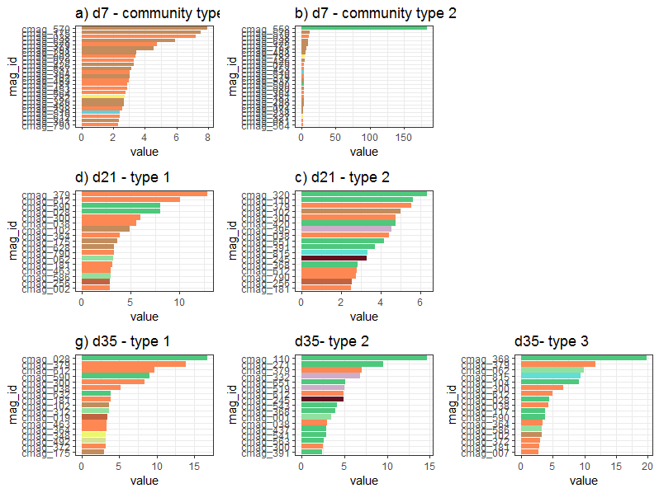

Supplementary Figure S2:

Relative abundances of each bacterial strain for the standard and distinct enterotypes for the three sampling points, 7, 21 and 35.

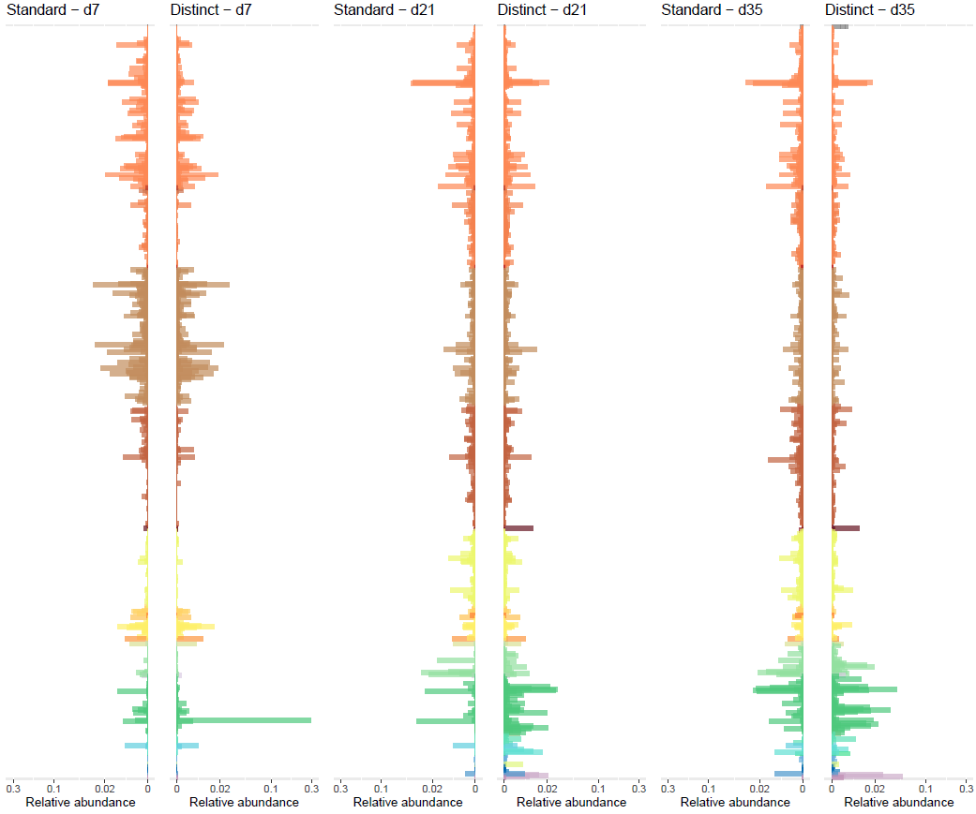

Supplementary figure S3:

Spanning tree of joint genome-scale metabolic network model between Campylobacter jejuni and C. coli. Campylobacter_D jejuni: ERR4836918_bin_11 Campylobacter_D coli: ERR4836965_bin_9.

https://fluxer.umbc.edu/model?id=f7dd951a9e005ee384ef401dda3e7c111a89d711_2d5898faefe218fd2c2bb5aba37f1a7e75398404_obj_merge#

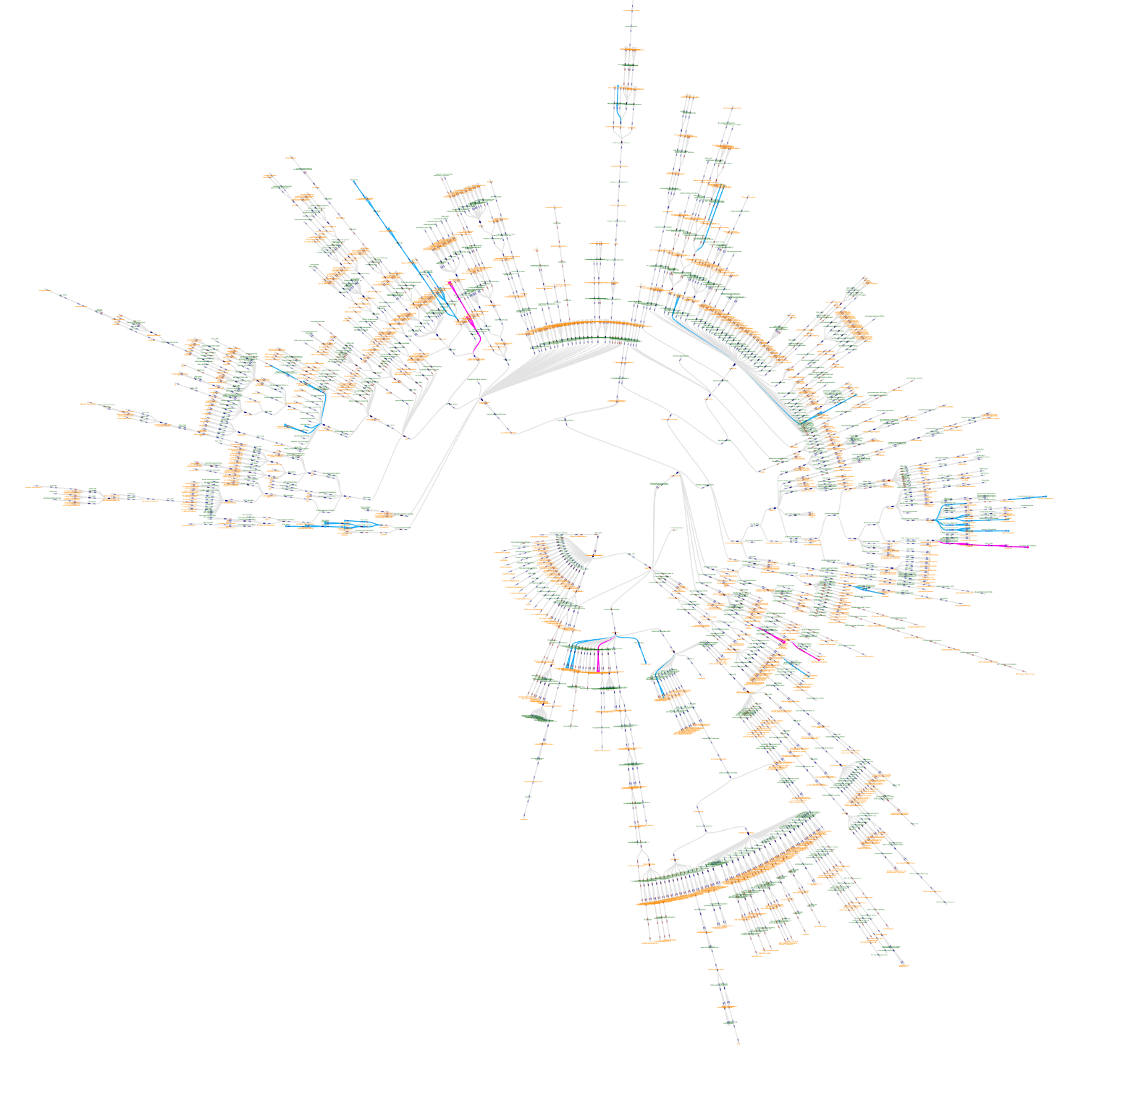

Supplementary Figure S4:
Body weight changes between experimental trials across the three sampling time points, days 7, 21 and 35. We used linear mixed effect models as implemented in the R package lme4 (Bates et al. 2014). Chicken body weight (g) was used as response variable and trial, chicken age, sex and genetic line were included as fixed explanatory variables. To account for the fact that chickens were nested within pens we included a pen-level random intercept (1|pen). Models were plotted separated by sampling time (a-c) and together (d). Different letters in panel a-c represent significant differences (p-value < 0.05) between groups, based on a Tukey’s HSD post hoc test.

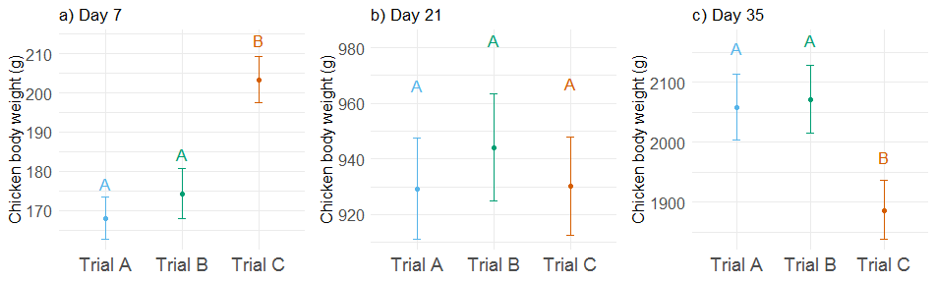

Supplementary Figure S5:
Volcano plots of Differential Gene Expression analyses carried out between both enterotypes in each one of the sampling periods. Points in red represent genes that are differentially expressed, i.e., had a corrected p-value under 0.05 through the Benjamini-Hochberg method.

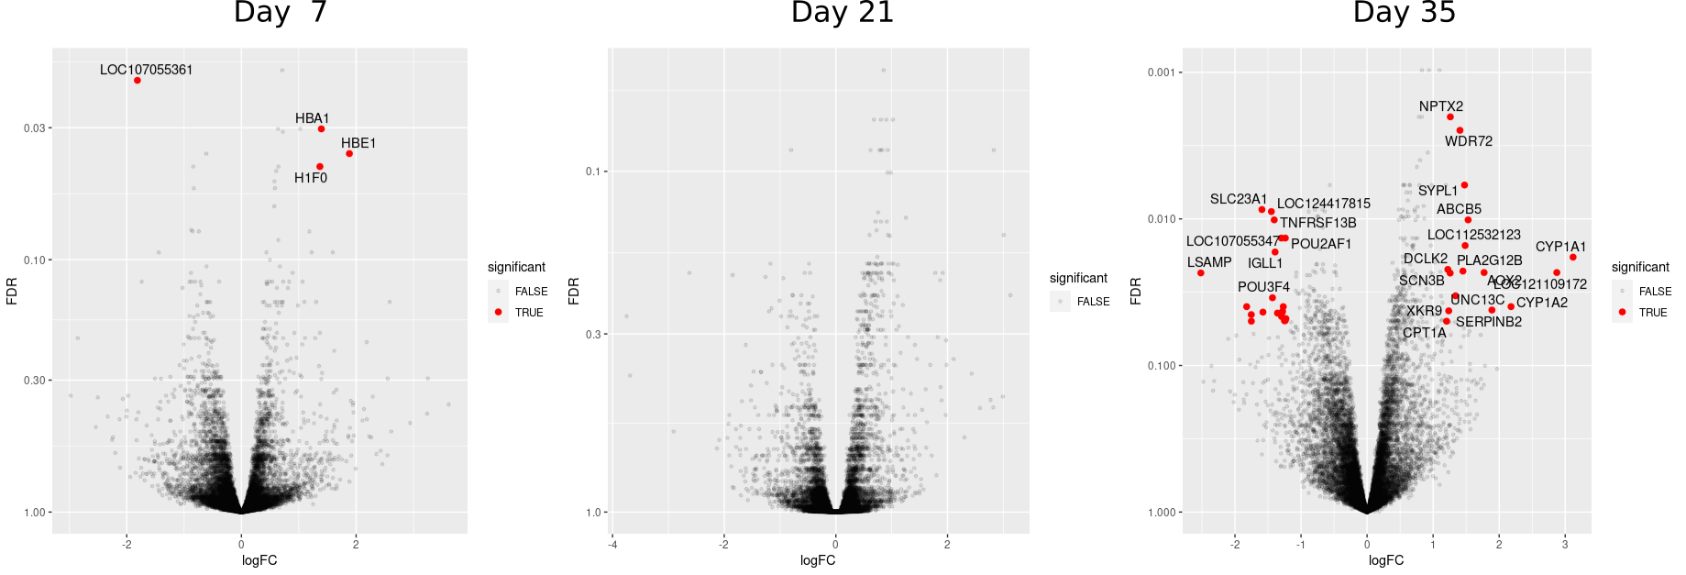

Figure S6:
Overall community MCI values between experimental trials across the three sampling time points, days 7, 21 and 35. We used linear mixed effect models as implemented in the R package glmmPQL() of R package MASS (Venables and Ripley 2002). Overall community MCI was used as response variable and trial, chicken age, sex and genetic line were included as fixed explanatory variables. We used a quasibinomial distribution with logit link function because the response variable was fractional (i.e. values were between 0 and 1). To account for the fact that chickens were nested within pens we included a pen-level random intercept (1|pen). Models were plotted separated by sampling time (a-c). Different letters in panel a-c represent significant differences (p-value < 0.05) between groups, based on a Tukey’s HSD post hoc test.

