Supporting Information

Bioorthogonal Chain-Growth Polymerization: Site-Specific Labeling of Artificial Polymers in Living Cells

Guoming Tong†,‡, Xiaojuan Liu†,‡, Liang Li†, Xuepu Feng†, Sheng Yang†, Yi Shi§, Guhuan Liu†,*, and Ronghua Yang†

†Key Laboratory of Chemical Biology & Traditional Chinese Medicine Research of Ministry of Education, Institute of Interdisciplinary Studies, College of Chemistry and Chemical Engineering, Hunan Normal University, Changsha, Hunan 410081, China

§School of Materials Science and Engineering, Key Laboratory for Polymeric Composite and Functional Materials of Ministry of Education, Sun Yat-Sen University, Guangzhou 510006, China

* To whom correspondence should be addressed. E-mail: ghliu@hunnu.edu.cn
‡ These authors contributed equally.

Materials.
4-Bromo-1,8-naphthalic anhydride, N-boc-ethylenediamine, 3-bromo-1-(trimethylsiyl)-1-propyne, dichlorobis(triphenylphosphine) palladium(II), copper(I) iodide, potassium carbonate (Greagent), trifluoroacetic acid, azidoacetic acid, 2,3,4,5,6-pentafluorophenol, 1-(3-Dimethylaminopropyl)-3-ethylcarbodiimide hydrochloride (EDCl), triethylene glycol, 3-bromopropyne, potassium hydroxide, p-toluenesulfonyl chloride, potassium azide, tetra-n-butylammonium iodide, triproparargylamine, 2-(2-boc-aminoethoxy) ethanol, tert-butyl 2-bromoacetate, 4-dimethylaminopyridine, bis[2-(2-hydroxyethoxy)ethyl]ether, tert-butyl-acrylate, propargylamine, 4-chloro-7-nitrobenzofurazan, sodium ascorbate, copper sulfate, triethylamine, tert-butyl N-(4-aminobutyl)carbamate, DPPE-DBCO (Confluore), Mito-Tracker Red CMXRos (Beyotime Biotechnology), methyl alcohol, acetonitrile, cyclohexane, dimethyl sulfoxide (DMSO) , N,N-dimethlformamide (DMF) , 1,2-dipalmitoyl-sn-glycero-3-phosphoethanolamine (Adamas) , 5-Ethynyl-2'-deoxyuridine (EDU, Bidepharm), ethidium bromide, 3-(4,5-dimethylthiazol-2-yl)-2,5-diphenyltetrazolium bromide (MTT) was purchased from Solarbio and used as received. Fetal bovine serum (FBS) was purchased from EVERY GREEN and used as received. Penicillin, streptomycin, and Dulbecco’s modified Eagle’s medium (DMEM) were purchased from GIBCO and used as received.

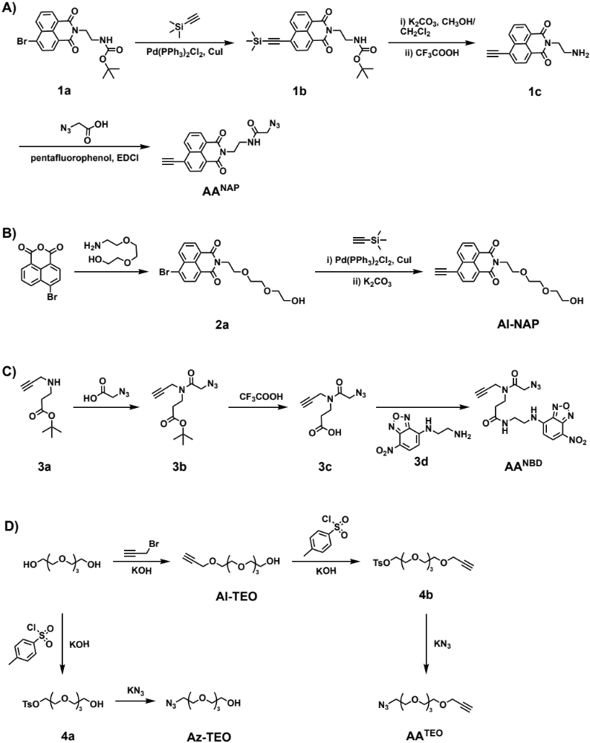
Scheme S1. Synthetic schemes employed for the preparation of (a) M^{NAP}, (b) Al-NAP, (c) M^{NBD}, and (d) M^{TEO}, Al-TEO, and Az-TEO.

Method
Synthesis of 2-azido-N-(2-(6-ethynyl-1,3-dioxo-1H-benzo[de]isoquinolin-2(3H)-yl)ethyl) acetamide (M^{NAP}). First, 4-bromo-1,8-naphthalic anhydride (1.49 g, 5.4 mmol), N-boc-ethylenediamine (0.86 g, 5.4 mmol), and 1,4-dioxane (15 mL) were charged into a reaction round-bottom flask (RBF) with a stir magneton and stirred at 105 °C for 16 h to obtain a dark red solution. After cooling at room temperature, 200 ml of brine was added to the reaction solution to form a yellow precipitate, which was then filtered and dried under vacuum. A yellow solid product 1a was obtained, which could be used directly without purification. (2.05 g, yield: 94 %).
In a nitrogen filled glove box, 1a (0.84 g, 2 mmol), 3-bromo-1-(trimethylsiyl)-1-propyne (0.24 g, 2.4 mmol), dichlorobis(triphenylphosphine) palladium(II) (0.14 g, 0.2 mmol), copper(I) iodide (0.076 g, 0.4 mmol), and THF (12 mL) were charged into an oven-dried 20 mL Schlenk tube equipped with a stir magneton. After being stirred for 12 h at 60 °C, the crude product was purified by silica gel column chromatography using ethyl acetate/n-hexane (v/v = 1/6) as the eluent, affording 1b as a yellow solid. (3.5 g, yield: 69 %). ¹H NMR (CDCl₃, δ, ppm): 8.78-8.66 (2H, aromatic protons), 8.63-8.57 (1H, aromatic proton), 8.02-7.96 (1H, aromatic proton), 7.93-7.84 (1H, aromatic proton), 5.06-4.88 (-CH₂-NH-), 4.44-4.37 (2H, -N-CH₂-CH₂-), 3.62-3.53 (2H, -CH₂-NH-), 1.36-1.27 (9H, -C(CH₃)₃), 0.45-0.38 (9H, -Si(CH₃)₃).
Add 1b (0.728g 1.67 mmol), K₂CO₃ (11.5 mg 0.0835 mmol) to 120 ml solution (methanol: CH₂Cl₂ =1:5, v/v) and stir at room temperature for 5h, monitor by TLC, add 5% K₂CO₃ again, continue stirring for 1h, monitor again with TLC the reaction is completed. The organic layer was washed with saturated NaHCO₃ solution (2 x 25 mL), water and brine. The organic layer was dried over anhydrous Na₂SO₄ and concentrated under reduced pressure, affording 1c as a white solid (3.5 g, yield: 60 %).
Add 1c (0.367 g, 1 mmol) and CH₂Cl₂ (10 ml) were charged into a reaction flask with a stir magneton. At room temperature, while stirring, add trifluoroacetic acid (2 g, 17.5 mmol) dropwise and stir for 4 h. At complete consumption of starting material as shown by TLC, the solvents were evaporated under reduced pressure. The residue was co-evaporated with anhydrous toluene (5 x 5 mL). A yellow solid product 1d was obtained and directly used for the next reaction without further purification.
In the last step, azidoacetic acid (0.303 g, 3 mmol) was dissolved in CH₂Cl₂ (5 mL), followed by the addition of 2,3,4,5,6-pentafluorophenol (0.662 g, 3.6 mmol) and EDCl (0.69 g, 3.6 mmol) then stirring overnight at room temperature. A solution of 1d (0.374 g, 1 mmol) in DMF (2 mL) and Et₃N (0.6 g, 6 mmol) were added successively. The reaction mixture was stirred at room temperature for 24 h. The organic layer was washed with water and brine. The organic layer was dried over anhydrous Na₂SO₄ and concentrated under reduced pressure. The residue was purified by column chromatography using ethyl acetate/n-hexane (v/v = 1:1) to obtain the compound M^{NAP} as a pale-yellow powder. (0.2 g, yield: 57 %). ¹H NMR (CDCl₃, δ, ppm): 8.78-8.66 (2H, aromatic protons), 8.63-8.57 (1H, aromatic proton), 8.02-7.96 (1H, aromatic proton), 7.93-7.84 (1H, aromatic proton), 7.06-6.93 (-CH2-NH-) 4.52-4.45 (2H, -N-CH₂-CH₂-), 3.94-3.88 (2H, -CH₂-N₃), 3.82-3.78 (1H, CH≡C-), 3.78-3.71(2H, -N-CH₂-CH₂-). ¹³C NMR (CDCl₃, δ, ppm): 168, 164, 134, 132, 131, 130, 127, 126, 122, 87, 80, 52, and 39. ESI-MS: m/z calc. for C₁₈H₁₃N₅O₃: 348.33 [M+H]⁺; found: 348.32.
Al-NAP was synthesized according to similar procedures, affording Al-NAP as a pale-yellow powder. (350 mg, yield: 60%). ¹H NMR (CDCl₃, δ, ppm): ¹H NMR (CDCl₃, δ, ppm): 8.78-8.62 (2H, aromatic protons), 8.61-8.50 (1H, aromatic proton), 8.06-7.94 (1H, aromatic proton), 7.92-7.80 (1H, aromatic proton), 4.55-4.40 (2H, -N-CH₂-CH₂-), 3.93-3.65 (9H, -O-CH₂-CH₂-O- and CH≡C-), 3.60-3.53(2H, -CH₂-CH₂-OH). ¹³C NMR (CD₃Cl, δ, ppm): 164, 163, 132, 131(3C), 130, 127(2C),126, 122(2C), 86, 80, 72, 70(2C), 68, 61 and 39. ESI-MS: m/z calc.for C₂₀H₁₉NO₅: 354.13 [M+H]⁺; found: 354.10.
Synthesis of M^{NBD}. Adding dropwise oxalyl chloride (0.4 mL, 4.73 mmol) to an ice-bath cooled solution of 3c (0.2 g, 0.946 mmol) and 10 µL of anhydrous DMF in CH₂Cl₂ (5 mL). After a few minutes, the mixture is allowed to reach room temperature and left under stirring overnight. Volatiles were removed under reduced pressure and the residue was azeotroped three times with 5 ml of CH₂Cl₂, each time. The resulting yellow crude residue was used without any further purification. The crude residue, 3d (0.314g 1mmol), Et₃N (0.15 g, 15 mmol), and DMAP (0.012g 0.1mmol) were added successively. The reaction mixture was stirred at room temperature for 12 h monitor with TLC the reaction is completed. The organic layer was washed with saturated NaHCO3 solution (3 x 25 mL). The organic layer was dried over anhydrous Na2SO4 and concentrated under reduced pressure. The crude product was purified by silica gel column chromatography using ethyl acetate/n-hexane (v/v = 1/2) as the eluent, affording M^{NBD} as a bright orange solid. (50 mg, yield: 24 %). ¹H NMR (DMSO-d6, δ, ppm): 8.55 (1H, aromatic proton), 8.20 (1H, aromatic proton), 6.53-6.39 (1H, -C(=O)-NH-CH₂-), 4.29-4.27 (1H, -C(=O)-NH-CH₂-CH₂-NH-), 4.23-4.13 (6H, -C=O-CH₂-CH₂-, CH≡C-CH₂-, and -CH₂-N₃), 3.60-3.46 (6H, -C(=O)-CH₂-CH₂- and -NH-CH2-). ESI-MS: m/z calc. for C₁₆H₁₇N₉O₅: 416.37 [M+H]⁺; found: 416.37.
Synthesis of 14-azido-3,6,9,12-tetraoxatetradec-1-yne (M^{TEO}). First, bis[2-(2-hydroxyethoxy) ethyl] ether (11.640 g, 60 mmol), KOH(1.23 g, 22 mmol) were charged into a reaction RBF with a stir magneton. After the mixture was stirred at 40 °C for 30 min, propargylamine (2.1 g, 20 mmol) was added. It was then stirred at 60 °C for 3 h, and the mixture was diluted with water and acidified to pH 1 with 1 M hydrochloric acid. The organic layer was washed with water and brine, the aqueous layer was extracted with EtOAc (3 x 150 mL),then merge the organic phase. The organic layer was dried over anhydrous Na₂SO₄ and concentrated under reduced pressure. The residue was purified by column chromatography using ethyl acetate/n-hexane (v/v = 1:2) to obtain the compound Al-TEO as a colorless oil. (4.3 g, yield: 92%). ¹H NMR (CDCl₃, δ, ppm): 4.21 (2H, CH≡C-CH₂-O-), 3.74-3.65 (14H, -CH₂-O-), 3.63-3.59 (2H, -CH₂-CH₂-OH), 2.45-2.42 (1H, CH≡C-CH₂-O-). ESI-MS: m/z calc. for C₁₁H₂₀O₅Na: 255.13 [M+Na]⁺; found: 255.11.
Then the Al-TEO (1.35g 5.82 mmol) was dissolved in DCM (10 mL), p-toluenesulfonyl chloride (1.2 g, 6.4 mmol) was added, and the mixture was cooled to 0 °C in an ice bath. KOH (1.3 g, 23.28 mmol) was added slowly and stirred vigorously for 2 h, then the mixture was poured into ice water and extracted with DCM (3 × 50 mL). The synthesized organic phase was washed with brine, dried over MgSO₄, and evaporated under reduced pressure without further purification to obtain 4b as a colorless oil. (2.2 g, yield: 98%). ¹H NMR (CDCl₃, δ, ppm): 4.21 (2H, CH≡C-CH₂-O-), 3.74-3.65 (14H, -CH₂-O-), 3.63-3.59(2H, -CH₂-CH2-OH), 2.45-2.42(1H, CH≡C-).
In the last step, 4b (1.83 g, 4.75 mmol) was dissolved in DMF (20 mL). Then, add KN₃ (0.42 g, 5.23 mmol) and tetra-n-butylammonium iodide (TBAI, 0.175 g, 0.475 mmol) and stir vigorously at 45 °C overnight. The organic layer was washed with saturated NaHCO₃ solution (3 x 25 mL). The organic layer was dried over anhydrous Na₂SO₄ and concentrated under reduced pressure. The crude product was purified by silica gel column chromatography using ethyl acetate/n-hexane (v/v = 1/3) as the eluent, affording M^{TEO} as a light-yellow oil. (340 mg, yield: 28%). ¹H NMR (CDCl₃, δ, ppm): 4.21 (2H, CH≡C-CH₂-O-), 3.76-3.59 (14H, -CH₂-O-), 3.44-3.32 (2H, -CH₂-CH₂-N₃), 2.46-2.38(1H, CH≡C-CH₂-O-). ¹³C NMR (CDCl₃, δ, ppm): 79, 74, 72, 72, 70, 69, 61, and 58. ESI-MS: m/z calc. for C₁₁H₁₉N₃O₄: 258.29 [M+H]⁺; found: 258.29.
Synthesis of 2-(2-(2-(2-azidoethoxy)ethoxy)ethoxy)ethan-1-ol (Az-TEO). The solution of 4a (2g, 5.7 mmol) and KN₃ (0.93 g, 11.4 mmol) in dry DMF (5 mL) were charged into a reaction RBF with a stir magneton, the reaction mixture was stirred for 24 hours at 50°C under nitrogen atmosphere. The organic layer was washed with water (2 x 50 mL) and brine (2 x 50 mL), the aqueous layer was extracted with EtOAc (3 x 150 mL),then merge the organic phase. The organic layer was dried over anhydrous Na₂SO₄ and concentrated under reduced pressure. The residue was purified by column chromatography using ethyl acetate/n-hexane (2:5, v/v) to obtain the compound Az-TEO as a colorless oil. (900 mg, yield: 72%). ¹H NMR (CDCl₃, δ, ppm): 3.78-3.74 (t, 2H, -CH₂-CH₂-OH), 3.74-3.68 (10H, -CH₂-CH₂-O-), 3.67-3.62 (2H, -CH₂-CH₂-OH), 3.46-3.40 (2H, -CH₂-CH₂-N₃). ¹³C NMR (CDCl3-d6, δ, ppm, Figure S3b): 165(2C), 143(3C), 125(3C), 83(2C), 72, 70(2C),69, 61,51(3C),50, 47,46 ,28(6C). ESI-MS: m/z calc. for C₈H₁₇N₃O4: 242.12 [M+Na]+; found: 242.11.

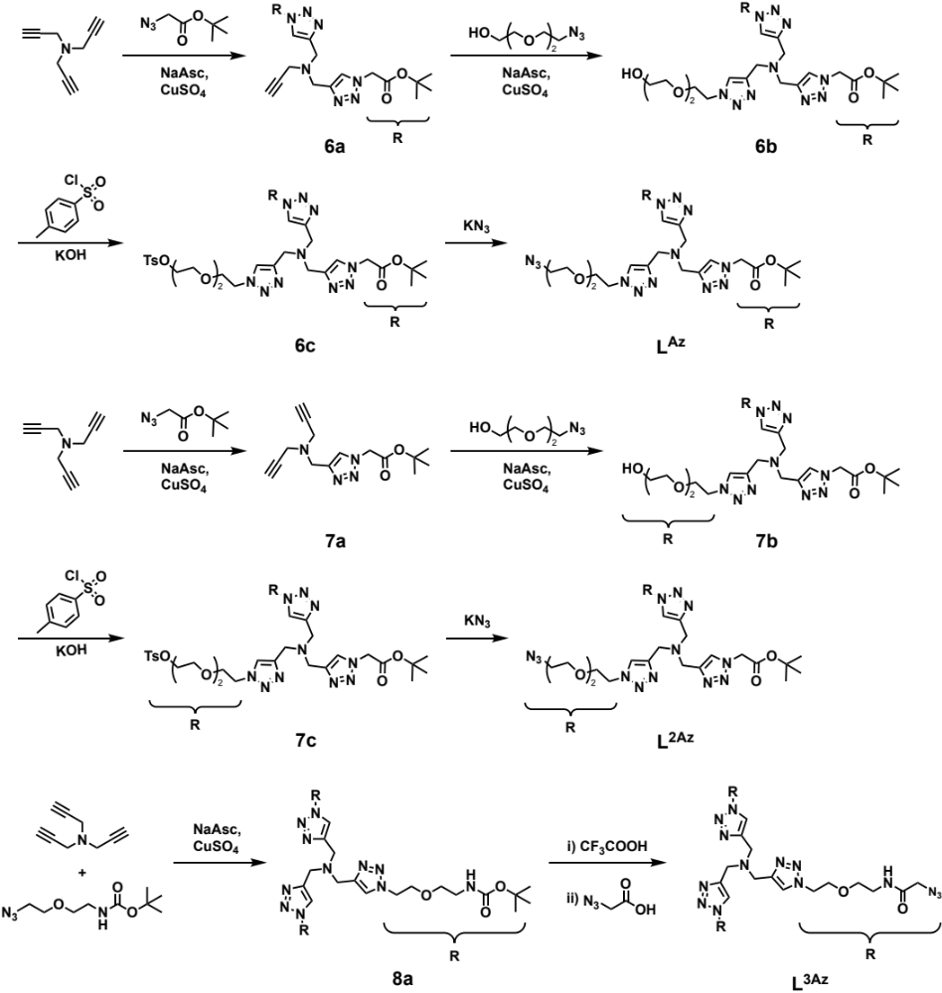
Scheme S2. Synthetic schemes employed for the ligands, L^{Az}, L^{2Az}, and L^{3Az}.

Synthesis of L^{Az}. First, a solution of tert-butyl (2-(2-azidoethoxy)ethyl)carbamate (1.74 g, 7.6 mmol), tripropargylamine (0.498 g, 3.8 mmol), sodium ascorbate (0.188 g 0.95 mmol), and CuSO₄ (0.03 g, 0.19 mmol) in a mixture of THF (16 ml) and H₂O (4 ml) were charged into a reaction RBF with a stir magneton, the reaction mixture was stirred for 48 hours at room temperature under nitrogen atmosphere. After the reaction was completed, it was concentrated to remove solvent. The organic layer was washed with brine (3 x 25mL), the aqueous layer was extracted with CH₂Cl₂ (3 x 50mL), then merge the organic phase. The organic layer was dried over anhydrous Na₂SO₄ and concentrated under reduced pressure. The residue was purified by column chromatography using CH₂Cl₂ and methanol (15:1, v/v) to obtain the compound 6a as a faint yellow solid. ¹H NMR (CDCl₃, δ, ppm): 7.73-7.40 (2H, -C=CH-N-), 5.09-5.06 (4H, -CH₂-(C=O)-), 3.95-3.93 (4H ,-N-CH₂-), 3.53-3.49 (2H, CH≡C-CH₂-N-), 2.41-2.34 (1H, CH≡C-CH₂-N-), 1.52-1.48 (18H, -O-C(CH₃)₃). ESI-MS: m/z calc. for C₂₁H₃₁N₇O₃: 446.52 [M+H]⁺; found: 446.52.
6b, 7a, and 7b were synthesized according to similar procedures.
6b:¹H NMR (CDCl₃, δ, ppm): 8.30-7.97 (3H, -C=CH-N-), 5.16-5.08 (4H, -N-CH₂-(C=O)-), 4.65-4.58 (2H, -N-CH₂-), 4.03-3.86 (8H, -N-CH₂- and -N-CH₂-CH₂-), 3. 83-3.78 (2H, -CH₂-CH₂-OH), 3.72-3.66 (4H ,-CH₂-O-), 3.66-3.61 (2H, -CH₂-CH₂-OH), 1.55-1.49 (18H, -O-C(CH₃)₃). ESI-MS: m/z calc. for C₂₇H₄₄N₁₀O₇: 643.71 [M+Na]⁺; found: 643.71.
7a: ¹H NMR (CDCl₃, δ, ppm): 7.73-7.40 (1H, -C=CH-N-), 5.09-5.06 (2H, -N-CH₂-(C=O)-), 3.95-3.93 (2H, -N-CH₂-CH₂-), 3.53-3.49 (4H, CH≡C-CH₂-N-), 2.41-2.34 (2H, CH≡C-CH₂-N-), 1.52-1.48 (9H, -O-C(CH₃)₃). ESI-MS: m/z calc. for C₁₅H₂₀N₄O₂: 288.35 [M+H]+; found: 288.36.
7b:¹H NMR (CDCl₃, δ, ppm): 8.16-7.97 (3H, -C=CH-N-), 5.08-5.05 (2H, ,-N-CH₂-C=O-), 4.59-4.54 (4H, -N-CH₂-CH₂-), 3.92-3.86 (4H, -N-CH₂-CH₂-), 3.85-3.78(6H, -N-CH₂-C=CH-N-), 3.77-3.72 (4H, -CH₂-CH₂-OH), 3.66-3.62 (8H ,-CH₂-O-), 3.60-3.56 (4H, -CH₂-CH₂-OH), 1.49-1.45 (9H, -O-C-(CH₃)₃). ESI-MS: m/z calc. for C₂₇H₄₆N₁₀O₈: 661.73 [M+Na]⁺; found: 661.73.
Toluene sulfonyl chloride (0.27 g, 1.4 mmol) added into solution of 6b (0.45 g 0.7 mmol) and Et₃N (0.4 g 4 mmol) in CH₂Cl₂ (5 mL) under 0 ºC. After 30 min, the mixture allowed to reach room temperature and left under stirring 48 h. Without further purification, KN₃ (121.5 mg 1.5mmol) was added. The reaction mixture stirred vigorously at 50 °C overnight. The organic layer was washed with saturated NaHCO₃ solution (3 x 25 mL). The organic layer was dried over anhydrous Na₂SO₄ and concentrated under reduced pressure. The crude product was purified by silica gel column chromatography using CH₂Cl₂ and methanol (v/v = 20:1) to obtain the compound L^{Az} as a faint white oil. ¹H NMR (CDCl₃, δ, ppm): 7.96-7.83 (3H, -C=CH-N-), 5.11-5.02 (4H, -N-CH₂-C=O-), 4.59-4.50 (2H, -N-CH₂-CH₂-), 3.95-3.86 (2H, -N-CH₂-CH₂-), 3.85-3.75(6H, -N-CH₂-C=CH-N-), 3. 67-3.57 (6H, -CH₂-O-), 3.38-3.32 (2H, -CH₂-CH₂-N₃), 1.51-1.42 (18H ,-O-C-(CH₃)₃). ¹³C NMR (CDCl₃-d₆, δ, ppm): 165(2C), 143(3C), 125(3C), 83(2C), 72, 70(2C), 69, 61, 51(3C), 50, 47, 46, 28(6C). ESI-MS: m/z calc. for C₂₇H₄₃N₁₃O₆: 668.73 [M+Na]⁺; found: 668.73.
Synthesis of L^{2Az}. L^{2Az} was synthesized according to similar procedures. (200 mg, yield: 41 %). ¹H NMR (CDCl₃, δ, ppm): 8.02-7.93 (3H, -C=CH-N-), 5.11-5.02 (2H, -N-CH₂-C=O-), 4.60-4.52 (4H, -N-CH₂-CH₂-), 3.95-3.88 (4H, ,-N-CH₂-CH₂-), 3.88-3.77 (6H, -N-CH₂-C=CH-N-), 3. 67-3.57 (12H, -CH₂-O-), 3.43-3.31 (4H, -CH₂-CH₂-N₃), 1.52-1.44 (9H, -O-C-(CH₃)₃). ESI-MS: m/z calc. for C₂₇H₄₄N₁₆O₆: 711.76 [M+Na]+; found: 711.15.
Synthesis of L^{3Az}. Azido acetic acid (0.303 g, 3 mmol) was dissolved in CH₂Cl₂ (5 mL), followed by the addition of 2,3,4,5,6-Pentafluorophenol (0.662 g, 3.6 mmol) and EDCl (0.69 g, 3.6 mmol) then stirring overnight at room temperature. A solution of 8a (0.861 g, 1 mmol) in CH₂Cl₂ (5 mL) and Et₃N (0.4 g, 4 mmol) were added successively. The reaction mixture was stirred at room temperature for 24 h. The organic layer was washed with brine (3 x 25mL). The product has certain water solubility and needs to be extracted several times with organic solvents. The organic layer was dried over anhydrous Na₂SO₄ and concentrated under reduced pressure. The residue was purified by column chromatography using CH₂Cl₂ and methanol (20:1, v/v) to obtain the compound L^{3Az} as a faint yellow solid. (80 mg, yield: 25%). ¹H NMR (CD₃OD, δ, ppm): 8.05-8.01 (3H, -C=CH-N-), 4.62-4.56 (6H, -N-CH₂-CH₂-), 3.90-3.83 (12H, -N-CH₂-C=CH-N- and -CH₂-N₃), 3.81-3.70 (6H, -CH₂-CH₂-O-), 3.58-3.49 (6H, -O-CH₂-CH₂-NH-), 3.41-3.34 (6H ,-O-CH₂-CH₂-NH-). ¹³C NMR (DMSO-d6, δ, ppm): 168(3C), 143(3C), 125(3C), 68(6C), 51(3C), 50(3C), 46(3C), 39(3C). ESI-MS: m/z calc. for C₂₇H₄₂N₂₂O₆: 793.78 [M+Na]⁺; found: 793.78.

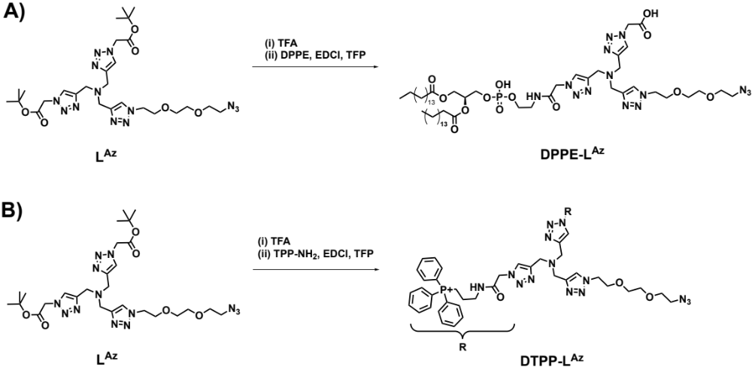
Scheme S3. Synthetic schemes employed for DPPE-L^{Az} (A) and DTPP-L^{Az} (B).

Synthesis of DPPE-L^{Az}. L^{Az} (38 mg, 60 µmol), trifluoroacetic acid (200 mg, 1.75 mmol), and CH₂Cl₂ (5 ml) were charged into a reaction flask and stirred for 4 h. At complete consumption of starting material as shown by TLC, the solvents were evaporated under reduced pressure and directly used for the next reaction without further purification. The crude product was dissolved in DCM (5 ml), NHS (7.1 mg, 60 µmol), and EDCl (11.5 mg, 60 µmol) were added and stirred for 6 h. Then 1,2-dipalmitoyl-sn-glycero-3-phosphoethanolamine (DPPE, 20 mg, 30.12 µmol), triethylamine (12 mg, 120 µmol), and DMAP (0.4 mg, 3 µmol) added into mixture. After the reaction is completed, the product is dialyzed and freeze-dried to obtain a yellow powdery product DPPE-L^{Az} (26 mg, yield: 72 %). ¹H NMR (CDCl₃, δ, ppm): 8.29-7.83 (3H, -C=CH-N-), 5.41-5.08 (4H ,-N-CH₂-C=O-), 4.45-4.25 (4H ,-O-CH₂-CH(O)- and -N-CH₂-CH₂-O-), 4.25-4.08 (4H ,-NH-CH2-CH₂-O-P- and -O-CH₂-CH(O)-) , 4.05-3.84 (t, 6H ,-N-CH₂-C=CH-N-), 3.77-3.57 (2H ,-N-CH₂-CH₂-), 3.53-3.37(2H ,-NH-CH₂-CH₂-O-P-), 3.36-3.11 (4H ,-O-CH₂-), 2.31-2.22(4H, -(C=O)-CHH₂-CH₂-), 1.86-1.77 (6H, -(C=O)-CH₂-CH₂- and N₃-CH₂-), 1.26-1.14 (52H,- CH₂-CH₂-), 0.86-0.78 (4H, -CH₂-CH₂). MALDI-TOF-MS: m/z calc. for C₅₆H₁₀₀N₁₄O₁₃: 1207.73 [M+H]⁺; found: 1207.45.
DPPE-L and DPPE^{Az} were synthesized according to similar procedures.
DPPE-L: ¹H NMR (CDCl₃, δ, ppm): 7.58-7.32 (2H, -C=CH-N-), 7.05-6.94 (1H, -C=CH-N-), 5.39-5.21 (4H, -N-CH₂-C=O-), 4.40-4.35 (4H, -O-CH₂-CH(O)- and -N-CH₂-CH₂-O-), 4.15-4.08 (4H, -NH-CH2-CH₂-O-P- and -O-CH₂-CH(O)-) , 3.98-3.94 (6H, -N-CH₂-C=CH-N-), 3.69-3.57 (5H, -N-CH₂-CH₂- and -CH₂-CH(CH₂)-O- and OH-CH₂-), 3.53-3.42 (2H, -NH-CH₂-CH₂-O-P-), 3.20-3.15 (4H, -O-CH₂-), 2.31-2.22 (4H, -(C=O)-CH₂-CH₂-), 1.86-1.77 (4H, -(C=O)-CH₂-CH₂-), 1.26-1.14 (52H, -CH₂-CH₂-), 0.87-0.85 (6H, -CH₂-CH₃).
DPPE^{Az}: ¹H NMR (CDCl₃, δ, ppm): 5.23-5.18 (2H, -P-O-CH₂-CH-), 4.41-4.34 (2H, -O-CH₂-CH, 4.17-4.10 (2H, -N-CH₂-CH₂-O-), 3.98-3.94 (2H, -CH₂-N₃) , 3.71-3.63 (3H, -NH-CH₂-CH₂-O- and -CH₂-CH(CH₂)-O-), 2.31-2.28 (4H, -(C=O)-CH₂-CH₂-), 1.59-1.55(4H, -(C=O)-CH₂-CH₂-), 1.30-1.24 (52H, -CH₂-CH₂-), 0.86-0.83 (6H, -CH₂-CH₃).
Synthesis of DTPP-L^{Az}. L^{Az} (23.6 mg, 38 µmol), trifluoroacetic acid (200 mg, 1.75 mmol), and CH₂Cl₂ (5 ml) were charged into a reaction flask and stirred for 4 h. At complete consumption of starting material as shown by TLC, the solvents were evaporated under reduced pressure and directly used for the next reaction without further purification. The crude product was dissolved in DCM (5 ml), NHS (9 mg, 80 µmol), and EDCl (10 mg, 80 µmol) were added and stirred for 6 h. Then (2-aminoethyl) triphenyl phosphonium bromide (25 mg, 80 µmol), triethylamine (12 mg, 120 µmol), and DMAP (0.4 mg, 3 µmol) added into mixture. After the reaction is completed, the product is dialyzed and freeze-dried to obtain a yellow powdery product DTPP-L^{Az} (5 mg, yield: 12 %).

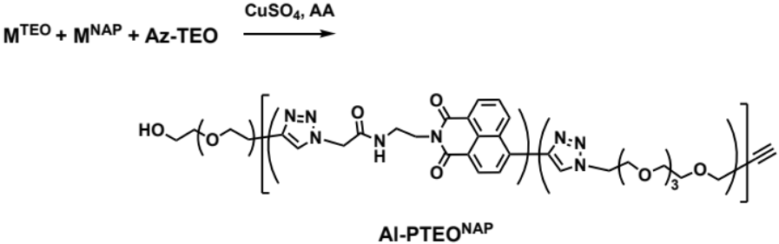
Scheme S4. Synthetic schemes employed for Al-PTEO^{NAP}.
Synthesis of Al-PTEO^{NAP}. A mixture of M^{TEO} (46.28 mg, 180 µmol), M^{NAP} (10.41 mg, 30 µmol), Al-TEO (2.32 mg, 10 µmol), CuSO₄ (10 µmol), and AA (1 mmol) in the DMF (3 ml) were charged into a reaction RBF with a stir magneton, the reaction mixture was stirred for 48 hours at room temperature under nitrogen atmosphere. crude product was dialyzed and freeze-dried to obtain Al-PTEO^{NAP} (29 mg, yield: 50 %). The molecular weight and molecular weight distribution of the product were determined by GPC using DMF as the eluent, revealing an M_{n} of 3,500 Da and M_{w}/M_{n} of 1.45 (Figure S20).

CPP polymerization in living cells. A typical experimental procedure was as follows: Hela cells were first cultured in Dulbecco’s modified Eagle medium (DMEM) supplemented with 10% fetal bovine serum (FBS), penicillin (100 units/mL), and streptomycin (100 µg/mL) in class bottom petri dish at 37 ºC in a CO₂/air (5:95) incubator for 1 day. DPPE-L^{Az} (1 µL, 2 mM in DMSO) was added. After incubating for 3 min, the medium was washed three times with PBS (1 ml) and replaced with 1 ml of fresh DMEM. Then, M^{NAP} (1 µL, 2 mM in DMSO), M^{TEO} (4 µL, 2 mM in PBS), CuSO₄ (5 µL, 2 mM in PBS), and ascorbic acid (4 µL, 100 mM in PBS) were added. The media was removed after polymerization for varying times and the cells were washed twice with 1 mL PBS, then covered with 1 mL PBS and the cells were imaged. After the staining, Images with 1024 × 1024 pixels were obtained with Inverted fluorescence microscope (Nikon, Nikon Eclipse Ti2-E, Japan) using a 60× oil ultraviolet objective. The following laser illumination and fluorescence emission detection were used for imaging: 405 nm laser excitation and emission detected between 425 nm and 475 nm (for NAP).
A typical experimental procedure for the isolation of polymers from cells was as follows: Hela cells were first cultured in Dulbecco’s modified Eagle medium (DMEM) supplemented with 10% fetal bovine serum (FBS), penicillin (100 units/mL), and streptomycin (100 µg/mL) in class bottom petri dish at 37 ºC in a CO₂/air (5:95) incubator for 1 day. DPPE-L^{Az} (1 µL, 2 mM in DMSO) was added. After incubating for 3 min, the medium was washed three times with PBS (1 ml) and replaced with 1 ml of fresh DMEM. Then, M^{TEO} (4 µL, 2 mM in PBS), CuSO₄ (5 µL, 2 mM in PBS), and ascorbic acid (4 µL, 100 mM in PBS) were added. The media was removed after polymerization for 2 h and the cells were washed twice with 1 mL PBS, then 1 ml of trypsin was added for digestion for 30 seconds. Cells were transferred to a 15 ml centrifuge tube. The cells were centrifuged at 1500 rpm for 5 min, then the medium was removed and 1 ml of cell lysate was added. Cell lysates were obtained and finally the target product was extracted with 300 ml dichloromethane and the product was characterized by MALDI-TOF MS.
CPP polymerization inside cell nucleus. A typical experimental procedure was as follows: HepG-2 cells were labeled with alkynyl groups by incubation with EdU for 48 h. The medium was washed three times with PBS (1 ml) and replaced with 1 ml of fresh DMEM. Then, L^{3Az} (1 µL, 2 mM in DMSO), CuSO₄ (5 µL, 2 mM in PBS), and ascorbic acid (4 µL, 100 mM in PBS) were added. After incubating for 4 h, the medium was washed three times with PBS (1 ml) and replaced with 1 ml of fresh DMEM. Then, M^{NAP} (1 µL, 2 mM in DMSO), M^{TEO} (4 µL, 2 mM in PBS), CuSO₄ (5 µL, 2 mM in PBS), and ascorbic acid (4 µL, 100 mM in PBS) were added. After incubating for 2 h, the media was removed and the cells were washed twice with 1 mL PBS, then covered with 1 mL PBS and the cells were imaged. After the staining, Images with 1024 × 1024 pixels were obtained with Inverted fluorescence microscope (Nikon, Nikon Eclipse Ti2-E, Japan) using a 100× oil ultraviolet objective. The following laser illumination and fluorescence emission detection were used for imaging: 405 nm laser excitation and emission detected between 425 nm and 475 nm (for NAP) and 488 nm laser excitation and emission detected between 500 nm and 550 nm (for AO).
In Vitro Cytotoxicity Assay. Hepg-2 cells were first cultured in Dulbecco’s modified Eagle medium (DMEM) supplemented with 10% fetal bovine serum (FBS), penicillin (100 units/mL), and streptomycin (100 µg/mL) at 37 ºC in a CO₂/air (5:95) incubator for 2 days. For cytotoxicity assay, Hepg-2 cells were seeded in a 96-well plate at an initial density of ca. 5000 cells/well in 100 µL of complete DMEM medium. After incubating for 24 h, DMEM was replaced with fresh medium, and the cells were treated with reaction system solution at varying concentrations. The treated cells were incubated in a humidified environment with 5% CO₂ at 37 ºC for 24 h. The MTT reagent (in 20 µL PBS, 5 mg/mL) was added to each well. The cells were further incubated for 4 h at 37 oC. The medium in each well was then removed and replaced with 100 µL DMSO. The plate was gently agitated for 15 min before the absorbance at 490 nm was recorded by a microplate reader (Thermo Fisher). Each experiment condition was done in quadruple and the data are shown as the mean value plus a standard deviation (± SD).
Characterization.
All nuclear magnetic resonance (NMR) spectra were recorded on a Bruker AV500 NMR 500 MHz spectrometer operated in the Fourier transform mode. DMSO-d₆ and CDCl₃ were used as the solvents. Molecular weights and molecular weight distributions were determined by gel permeation chromatography (GPC) equipped with Waters 1515 pump and Waters 2414 differential refractive index detector (set at 30 ºC). It used a series of two linear Styragel columns (HR2 and HR4) at an oven temperature of 45 ºC. The eluent was DMF at a flow rate of 1.0 mL/min. A series of low polydispersity polystyrene standards were employed for calibration. Confocal laser scanning microscopy (CLSM) images were acquired using a Leica TCS SP5 microscope. HPLC analysis was performed with a Shimadzu HPLC system, equipped with a LC-20AP binary pump, a SPD-20A UV-vis detector, and a Symmetry C18 column. The UV-vis detector was set at 260 nm linked to the software for data analysis. Fluorescence spectra were recorded on a F-7000 (Hitachi) spectroﬂuorometer. The slit widths were both set at 5 nm for excitation and emission. Electrospray ionization mass spectrometry (ESI-MS) experiment was performed on Thermo Scientific LTQ Orbitrap Mass Spectrometer equipped with an electrospray S17 interface.

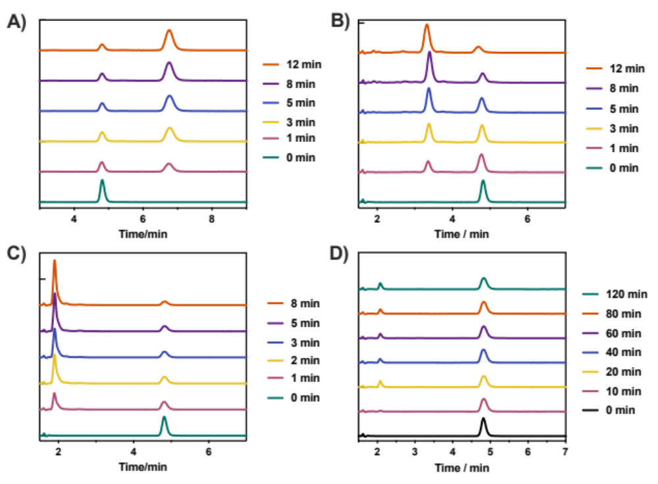
Figure S1. HPLC traces for CuAAC reaction of Al-NAP (20 μL) with (A) L^{Az} (20 μL), (B) L^{2Az} (20 μL), (B) L^{3Az} (20 μL), and (D) mixture of L (20 μL) and Az-TEO (20 μL) for varying times in presence of CuSO₄ (20 μM) and ascorbic acid (1 mM).

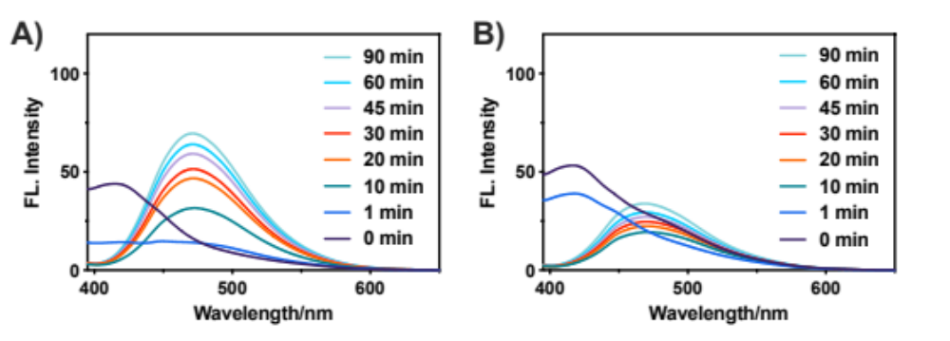
Figure S2. Evolution of fluorescence emission spectra (λ_{ex} = 385 nm) for CuAAC reaction of Al-NAP (20 μL) with (A) L^{2Az} (20 μL) and (B) L^{3Az} (20 μL) in presence of CuSO₄ (20 μM) and ascorbic acid (1 mM).

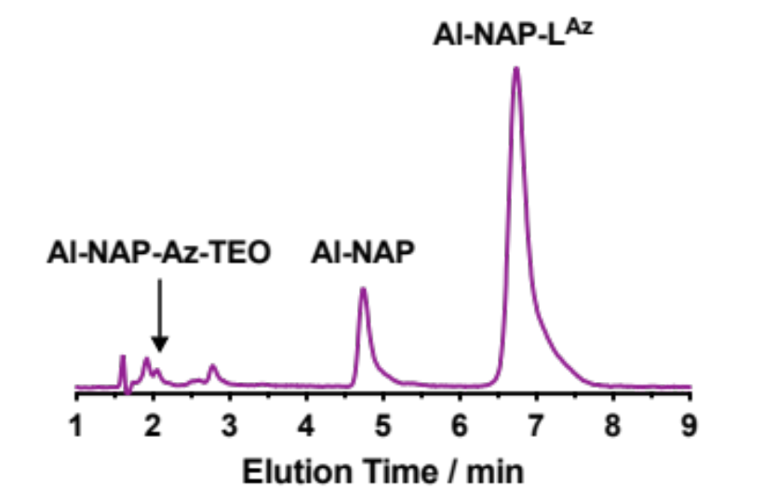
Figure S3. HPLC traces for CuAAC reaction of mixture of Al-NAP (20 μL), L^{Az} (20 μL), and Az-TEO (20 μL) for 15 min in presence of CuSO₄ (20 μM) and ascorbic acid (1 mM).

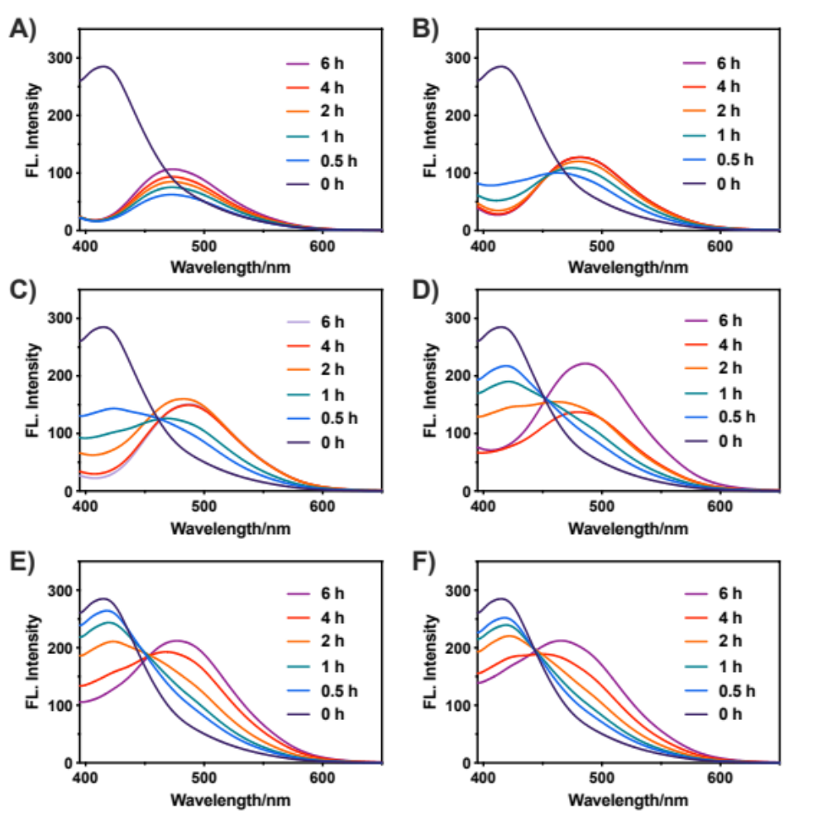
Figure S4. Evolution of fluorescence emission spectra (λ_{ex} = 385 nm) for CCP polymerization of M^{NAP} and M^{TEO} initiated by L^{Az} (20 μM) with [L^{Az}]₀:[M^{NAP}]₀:[M^{TEO}]₀ = 1:5:0 (A), 1:5:5 (B), 1:5:10 (C), and 1:5:20 (D) in presence of CuSO₄ (20 μM) and ascorbic acid (1 mM).

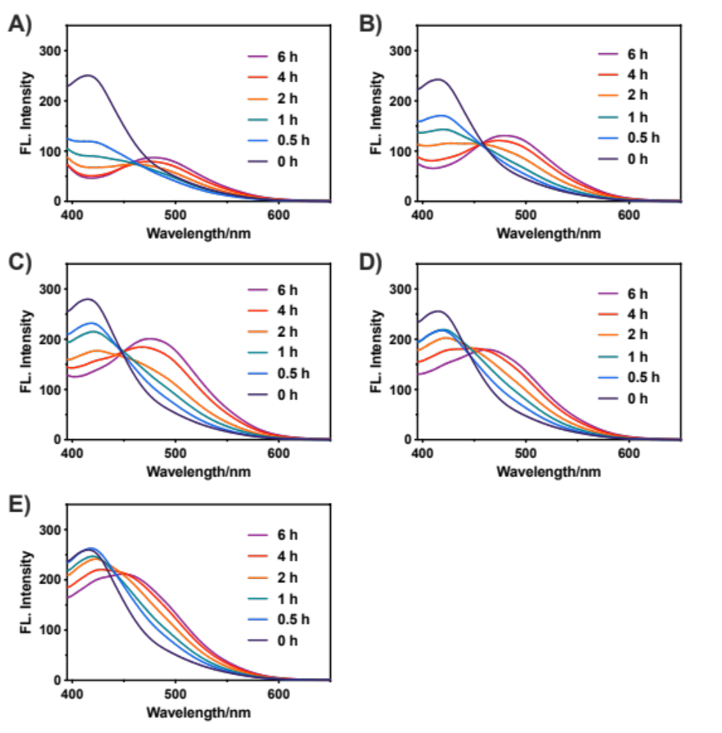
Figure S5. Evolution of fluorescence emission spectra (λ_{ex} = 385 nm) for CCP polymerization of M^{NAP} and M^{TEO} initiated by L (20 μM) with [L]₀:[M^{NAP}]₀:[M^{TEO}]₀ = 1:5:0 (A), 1:5:5 (B), 1:5:10 (C), 1:5:10 (D), and 1:5:20 (E) in presence of CuSO₄ (20 μM) and ascorbic acid (1 mM).

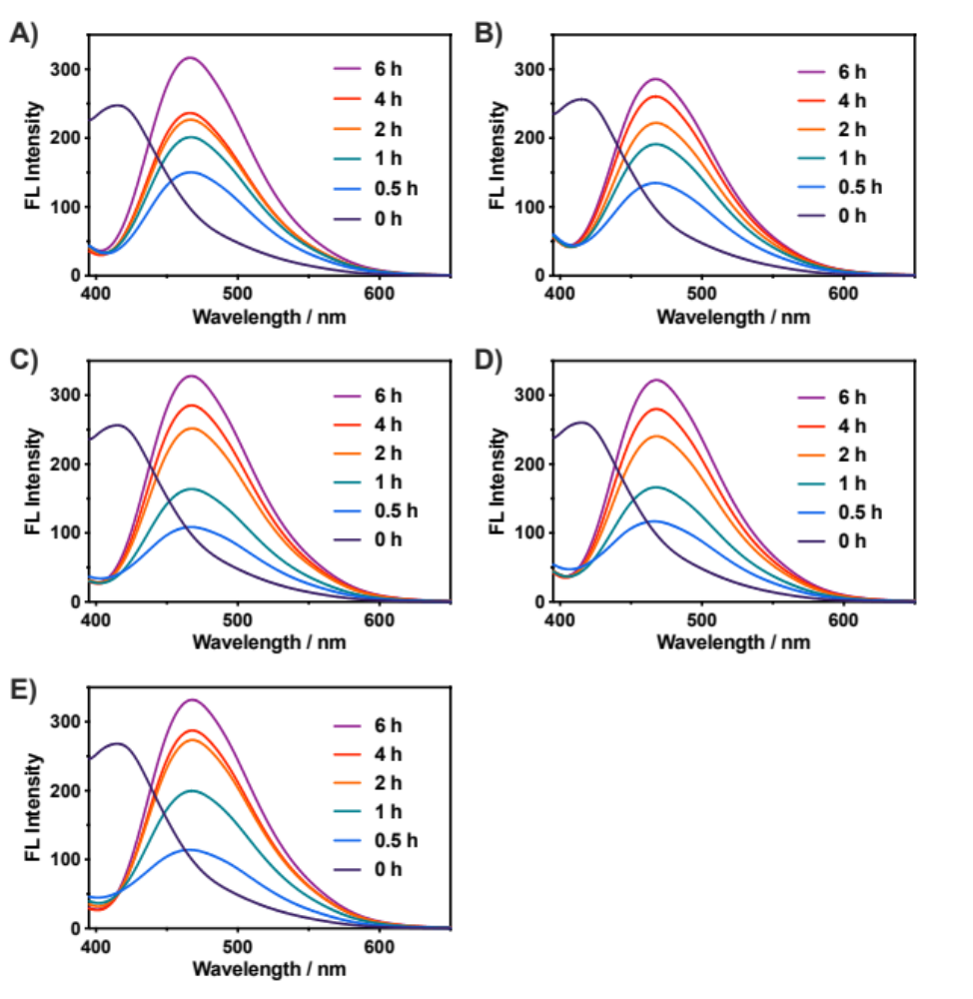
Figure S6. Evolution of fluorescence emission spectra (λ_{ex} = 385 nm) for CCP polymerization of M^{NAP} and M^{TEO} initiated by L^{3Az} (20 μM) with [L^{3Az}]₀:[M^{NAP}]₀:[M^{TEO}]₀ = 1:5:0 (A), 1:5:5 (B), 1:5:10 (C), 1:5:10 (D), 1:5:20 (E), and 1:5:30 (F) in presence of CuSO₄ (20 μM) and ascorbic acid (1 mM).
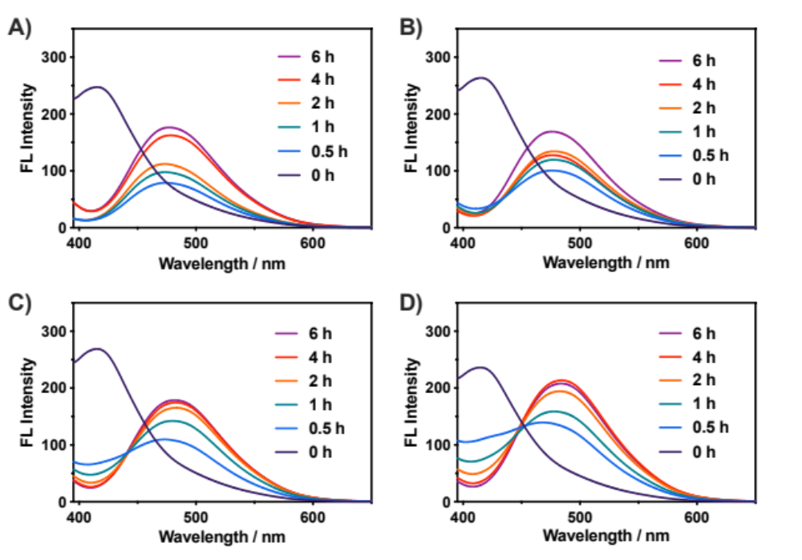
Figure S7. Evolution of fluorescence emission spectra (λ_{ex} = 385 nm) for CCP polymerization of M^{NAP} and M^{TEO} initiated by L^{2Az} (20 μM) with [L^{2Az}]₀:[M^{NAP}]₀:[M^{TEO}]₀ = 1:5:0 (A), 1:5:5 (B), 1:5:10 (C), and 1:5:20 (D) in presence of CuSO₄ (20 μM) and ascorbic acid (1 mM).

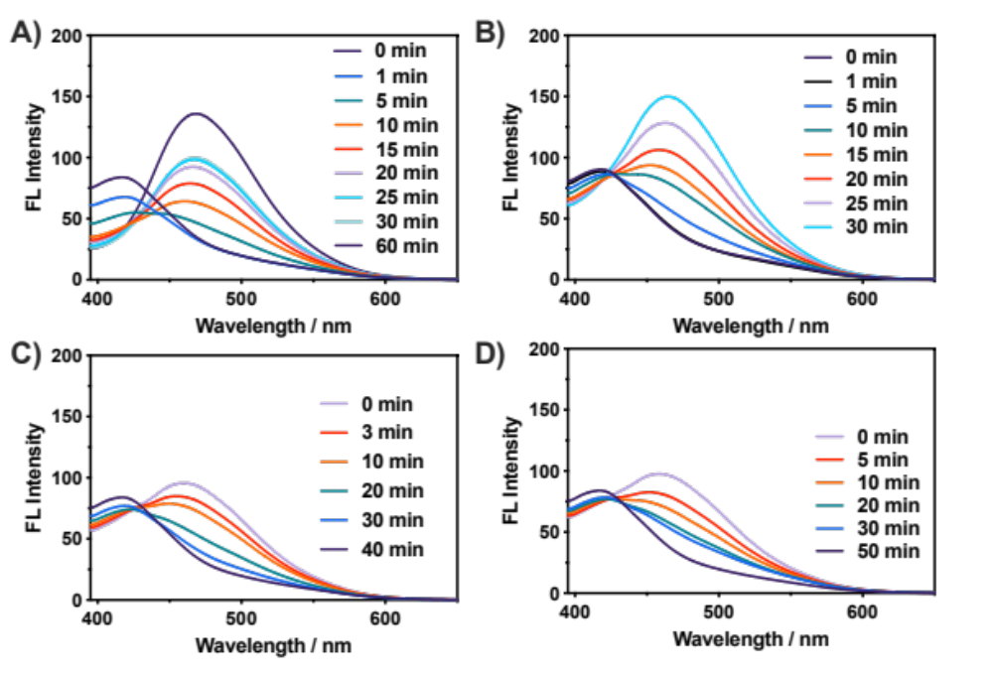
Figure S8. Evolution of fluorescence emission spectra (λ_{ex} = 385 nm) for CuAAC reaction of Al-NAP (20 μL) with PTEO after L^{Az}-initiated (20 μM) CCP polymerization of M^{TEO} with [L^{Az}]₀:[M^{TEO}]₀ = 1:5 (A), 1:10 (B), 1:20 (C), and 1:30 (D).

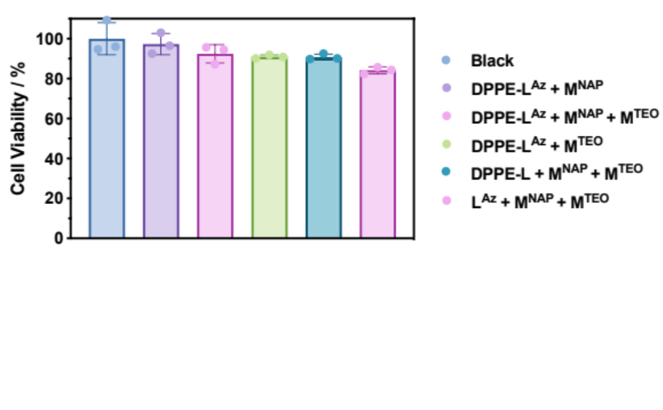
Figure S9. In vitro cytotoxicity determined by MTT assay against HeLa cells for CCP polymerization of M^{NAP} and M^{TEO}. The error bars indicate standard deviations from three parallel experiments.

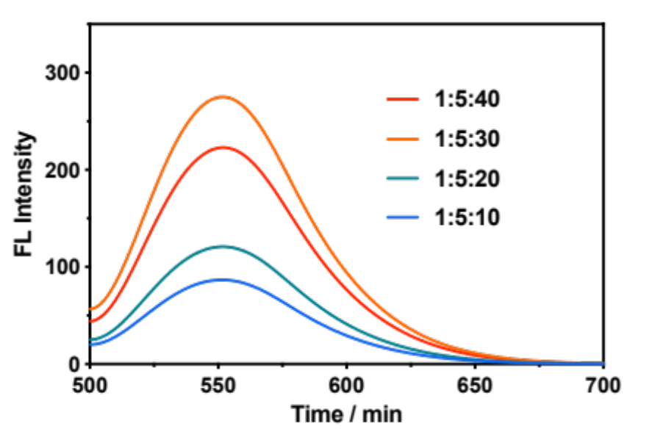
Figure S10. Fluorescence emission spectra (λ_{ex} = 480 nm) for CCP polymerization of M^{NBD} and M^{TEO} initiated by L^{Az} (20 μM) with [L^{Az}]₀:[M^{NBD}]₀:[M^{TEO}]₀ = 1:5:10, 1:5:20, 1:5:30, and 1:5:40 in presence of CuSO₄ (20 μM) and ascorbic acid (1 mM).

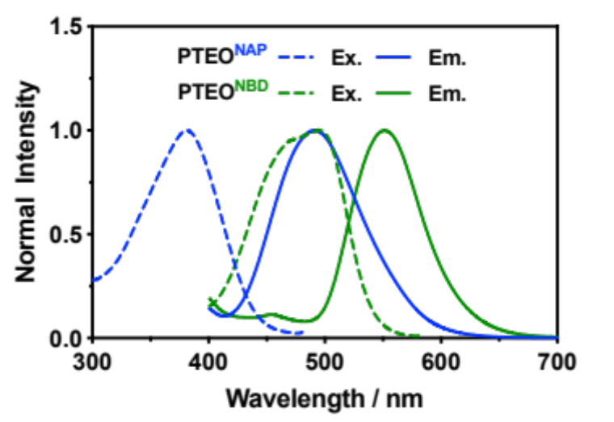
Figure S11. Fluorescence emission and excitation spectra recorded for PTEO^{NAP} (blue lines) and aqueous PTEO^{NBD} (green lines).

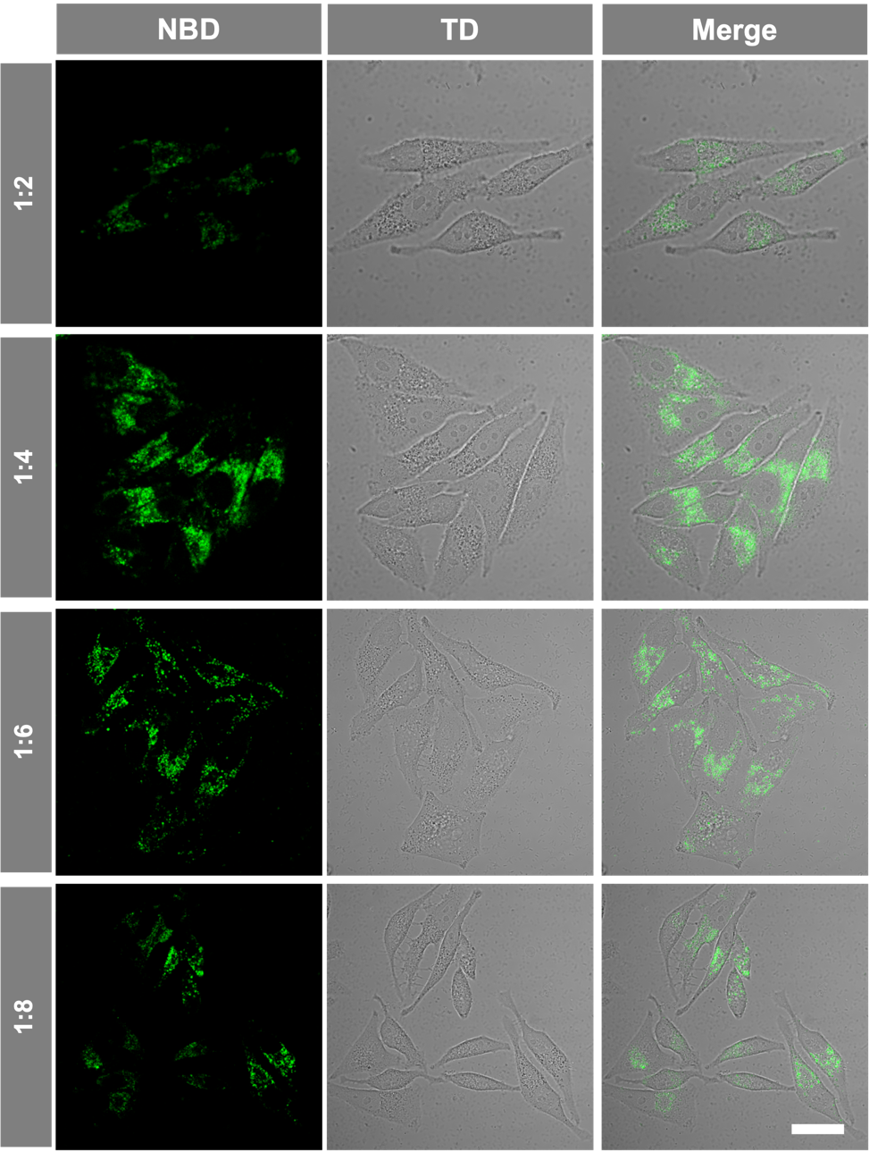
Figure S12. CLSM images of HeLa cells after copolymerization of M^{TEO} and M^{NBD} initiated by DPPE-L^{Az} for varing feed ratio ([M^{NBD}]₀/[M^{TEO}]₀). Scale bars, 20 μm.
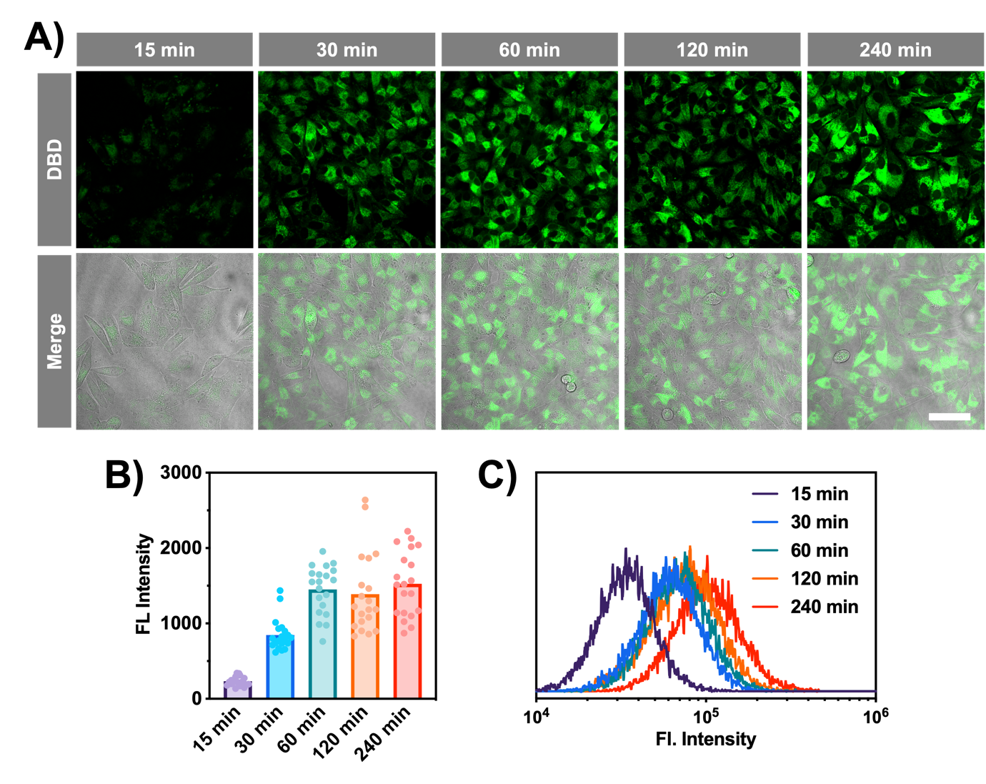
Figure S13. CLSM images of HeLa cells (A), NBD emission intensities quantified from CLSM results (B), and flow cytometry (C) after copolymerization of M^{TEO} and M^{NBD} initiated by DPPE-L^{Az} for varing times. Scale bars, 50 μm.

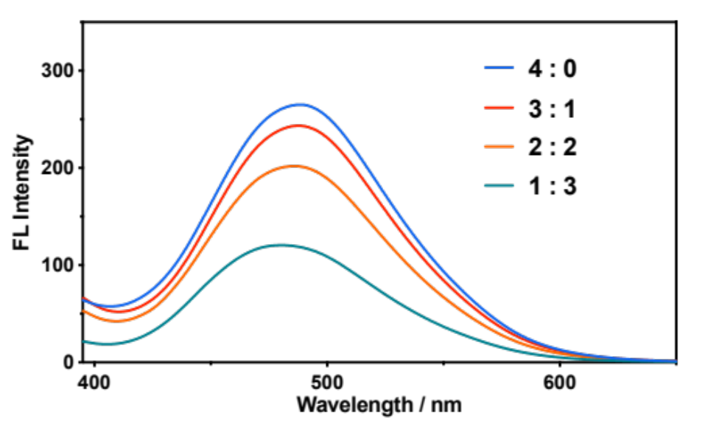
Figure S14. Fluorescence emission spectra (λ_{ex} = 480 nm) for CCP polymerization of M^{NAP} (100 μM), M^{TEO}, and Al-TEO ([M^{TEO}]₀+[Al-TEO]₀ = 400 μM) initiated by L^{Az} (20 μM) with [M^{TEO}]₀:[Al-TEO]₀ = 4 : 0, 3 : 1, 2 : 2, and 1 : 3 in presence of CuSO₄ (20 μM) and ascorbic acid (1 mM).

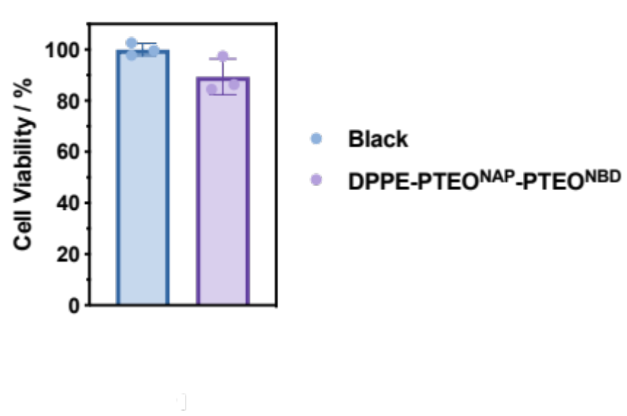
Figure S15. In vitro cytotoxicity determined by MTT assay against HeLa cells for CCP polymerization for preparing block copolymers. The error bars indicate standard deviations from three parallel experiments.

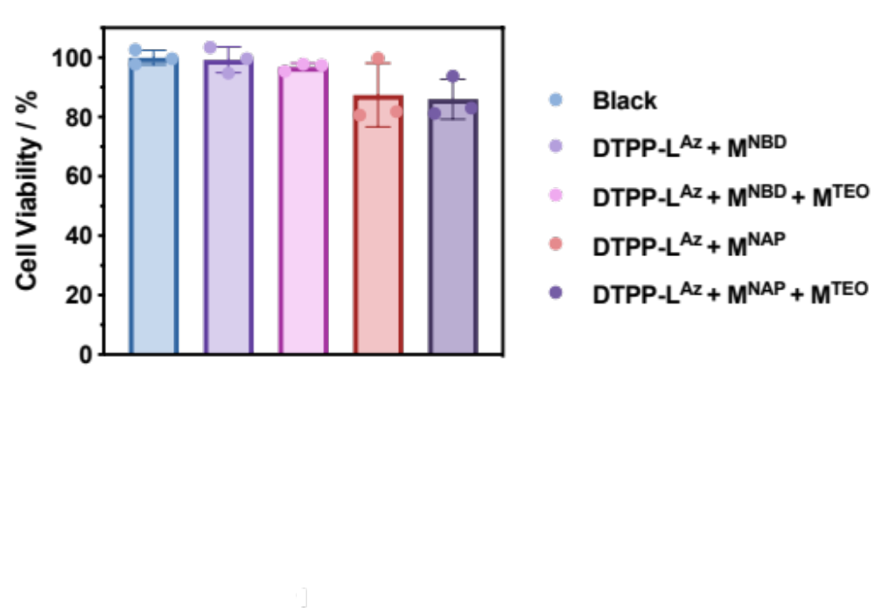
Figure S16. In vitro cytotoxicity determined by MTT assay against HeLa cells for CCP polymerization in mitochondria. The error bars indicate standard deviations from three parallel experiments.

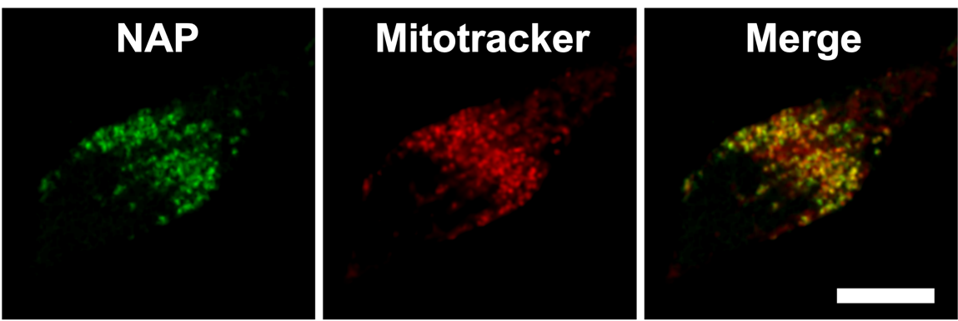
Figure S17. CLSM images of HeLa cells after copolymerization of M^{TEO} and M^{NAP} initiated by DTPP-L^{Az}. Scale bars, 20 μm.

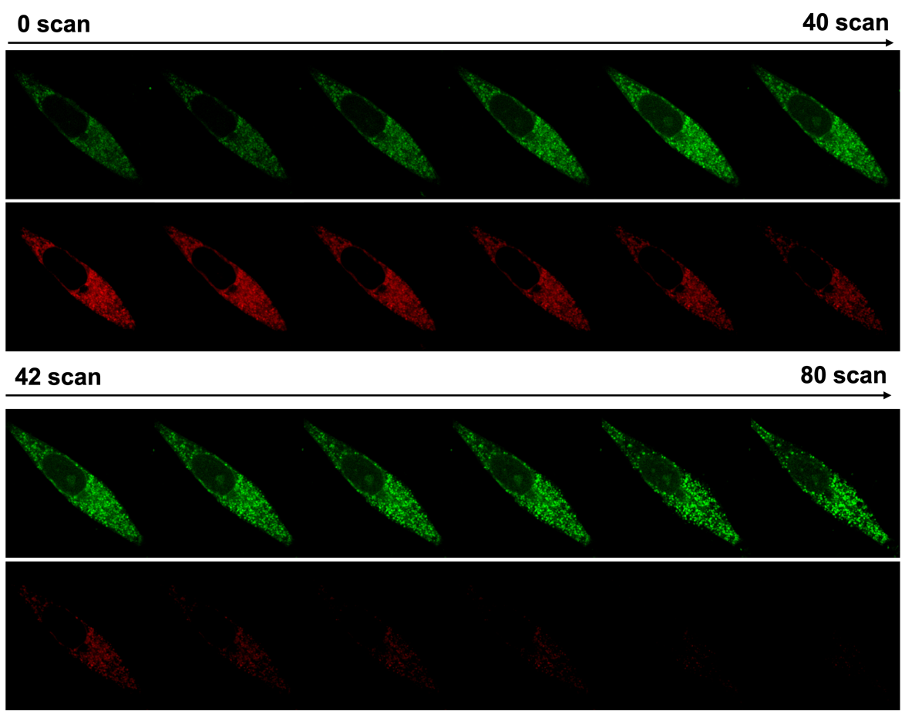
Figure S18. CLSM images of HeLa cells for DTPP-PTEO^{NBD} and Mitotracker with increasing number of scans after copolymerization of M^{TEO} and M^{NBD} initiated by DTPP-L^{Az}.

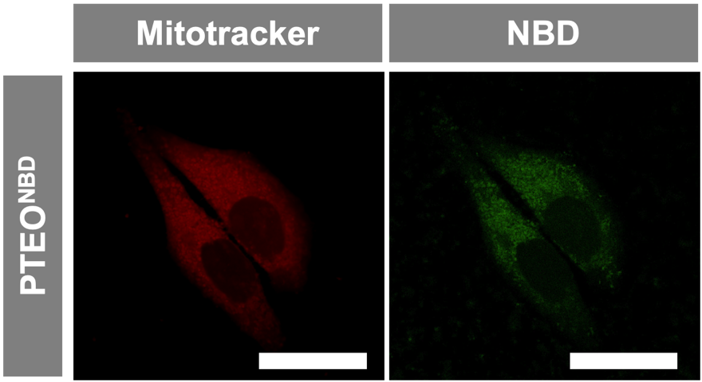
Figure S19. CLSM images of HeLa cells treating with m-chlorophenylhydrazone (CCCP, 20 μM) for 30 min after copolymerization of M^{TEO} and M^{NBD} initiated by DTPP-L^{Az}. Mito-chondria was stained with Mitotracker Red. Scale bars, 20 μm.

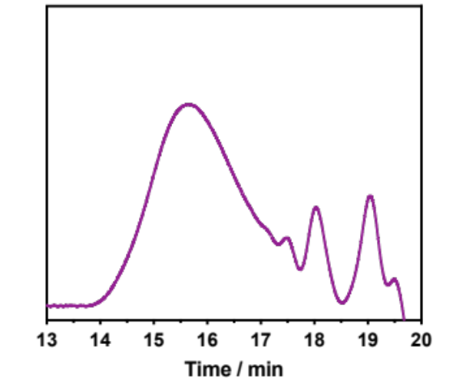
Figure S20. GPC trace (DMF as eluent) of Al-PTEO^{NAP}.

